DHL
DAC 3.0 CHALLENGE
AI-Enhanced Incident Reporting & Resolution System

SECJ3483 Web Technology | Scenario 2 | Section 3

HANAN OSAMA HUSSEIN SALAH
A22EC4042

Academic Session 2025/2026 — Universiti Teknologi Malaysia (UTM)

GitHub Repository:
https://github.com/Hanan20x/dhl-incident-reporting-system

Demo Video:
https://drive.google.com/file/d/1-Y05qVqsmvZFZz5mc4PzAbFxMlq2f_GU/view?usp=sharing

1. Introduction and Scenario Description

1.1 Background
This assignment is conducted in collaboration with DHL Global Finance Services – Asia Pacific through the DAC 3.0 Challenge. The objective is to design and develop a real-world web application integrated with Robotic Process Automation (RPA) to solve a logistics operational problem.

1.2 Scenario Description — Scenario 2
DHL Customer Support teams receive a high volume of incident reports every day from multiple inconsistent channels including email inboxes, Telegram/Teams chat messages, phone call notes, images/screenshots of damaged packages, and handwritten instructions from warehouse teams. Because the information is unstructured, incomplete, and inconsistent, it is difficult for DHL to identify issues, assign incidents, prioritize correctly, and track resolution progress.

1.3 Objectives
- A Laravel-based RESTful API backend with PostgreSQL database
- A React-based frontend user interface with DHL branding
- A UiPath RPA workflow for automated incident ingestion and reporting
- An AI Draft Builder powered by Claude AI for intelligent incident structuring

2. System Architecture

2.1 Overall Architecture
- User Interface Layer: React (Vite) running on localhost:8080
- API Layer: Laravel 13 (PHP 8.4) running on localhost:8000
- Database Layer: PostgreSQL 16 running on localhost:5432
- RPA Layer: UiPath Studio 2026 interacting via HTTP requests
- AI Layer: Claude API (Anthropic) for incident analysis and structuring

2.2 Technology Stack
Layer | Technology | Purpose
Frontend | React + Vite + TailwindCSS | User interface, forms, dashboard
Backend | Laravel 13 (PHP 8.4) | RESTful API, business logic, auth
Database | PostgreSQL 16 | Data persistence
Authentication | Laravel Sanctum | Token-based API authentication
AI | Claude API (Anthropic) | AI Draft Builder & Conflict Check
RPA | UiPath Studio 2026 | Automated incident ingestion
Version Control | GitHub | Source code management

2.3 Database Schema
Table | Key Fields | Purpose
users | id, name, email, password, role | System users (admin, agent, reviewer)
departments | id, name, email | DHL departments for assignment
incidents | id, title, description, type, source, status, priority, department_id, created_by | Core incident records
incident_logs | id, incident_id, action, old_status, new_status, changed_by | Audit trail for status changes

3. Technical Explanation (API, Data, JSON)

3.1 API Endpoints
Method | Endpoint | Description | Auth
POST | /api/register | Register a new user | No
POST | /api/login | Login and get Bearer token | No
GET | /api/incidents | List all incidents (filterable) | Yes
POST | /api/incidents | Create a new incident | Yes
GET | /api/incidents/{id} | Get incident details + logs | Yes
PUT | /api/incidents/{id} | Update incident | Yes
PATCH | /api/incidents/{id}/status | Update incident status | Yes
DELETE | /api/incidents/{id} | Delete incident | Yes
GET | /api/departments | List all departments | Yes
POST | /api/departments | Create department | Yes

3.2 JSON Data Structure
{ "id": 1, "title": "Late Delivery - Order #1234", "type": "late_delivery", "source": "email", "status": "draft", "priority": "high", "created_at": "2026-05-15T04:47:45.000000Z" }

3.3 Authentication
The system uses Laravel Sanctum for token-based authentication. Upon login, the API returns a Bearer token included in all subsequent requests as an Authorization header.

3.4 Database — pgAdmin View
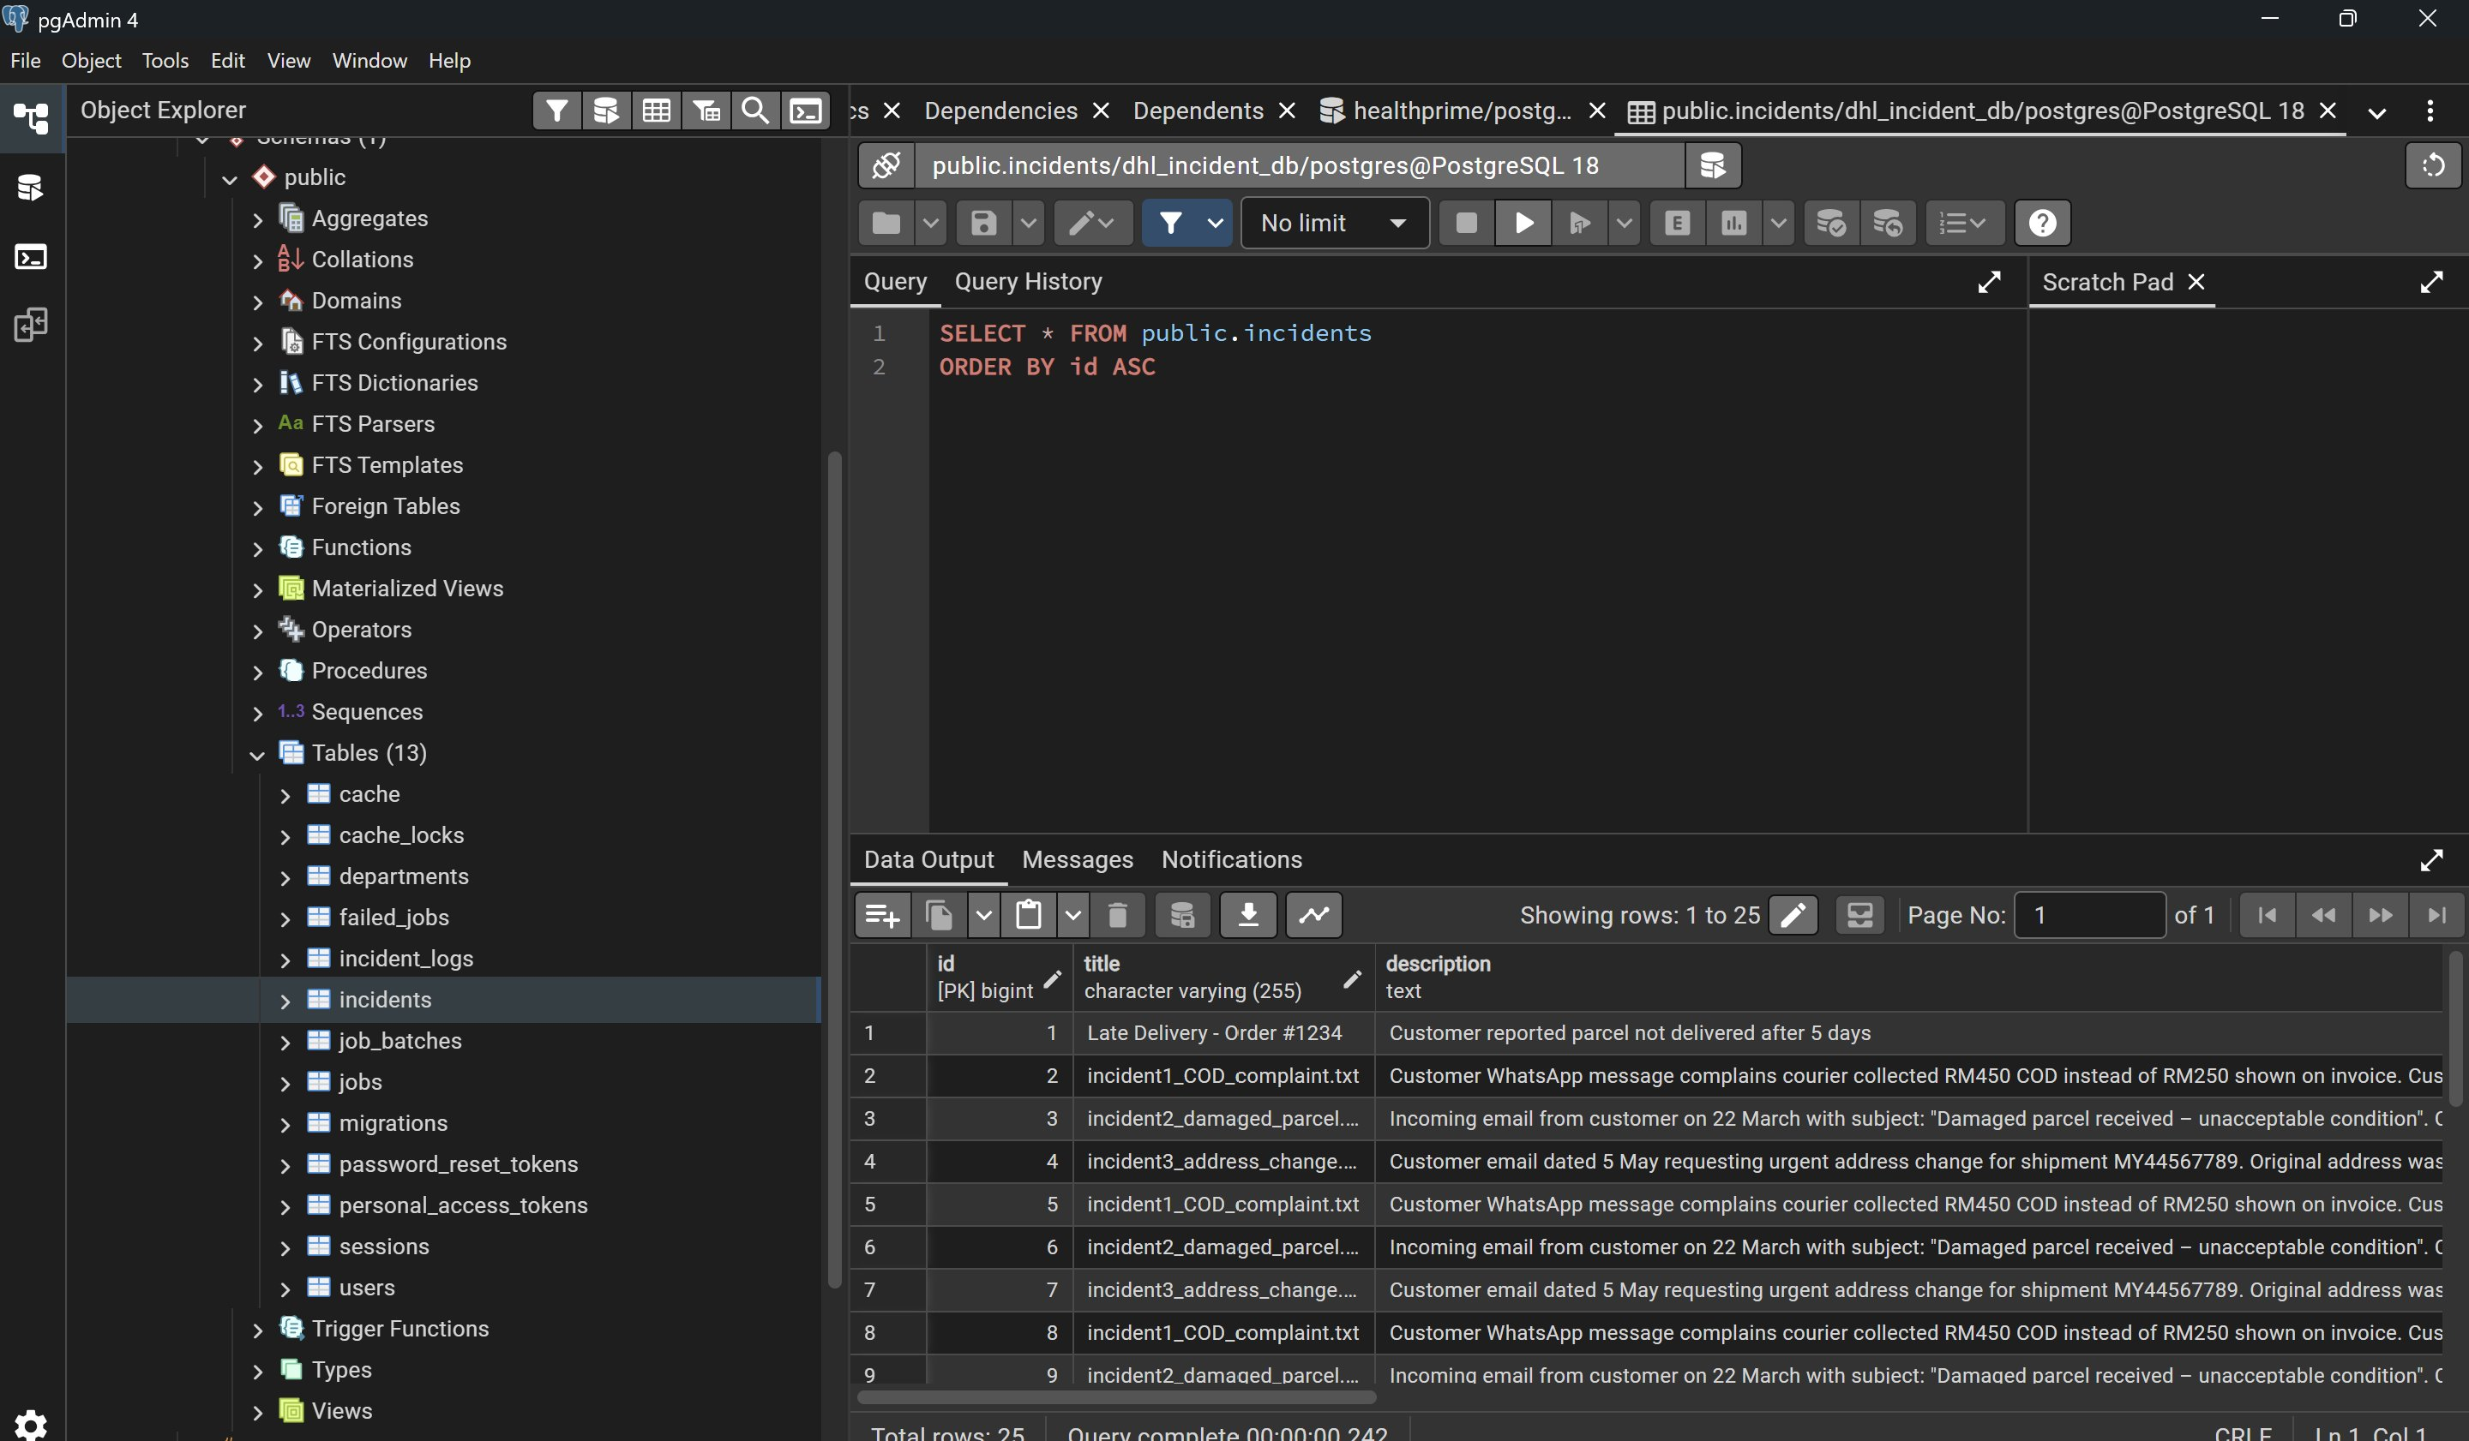
Figure 11: pgAdmin 4 — Database tables and incidents data (25 rows)

4. RPA Workflow and Automation Explanation

4.1 Workflow Steps
Step | Activity | Description
1 | Login & Auth | Sends POST to /api/login, extracts Bearer token
2 | Read Folder | Scans C:\DHL_Incidents folder for all .txt files
3 | Duplicate Check | Skips files processed within last 14 days
4 | Create Incident | POSTs to /api/incidents with file content
5 | Retry Mechanism | Retries failed requests up to 3 times
6 | Log Results | Writes timestamped entries to automation_log.txt
7 | Summary Email | Sends SMTP email with totals: created, skipped, failed

4.2 RPA Workflow — Part 1: Login & File Reading
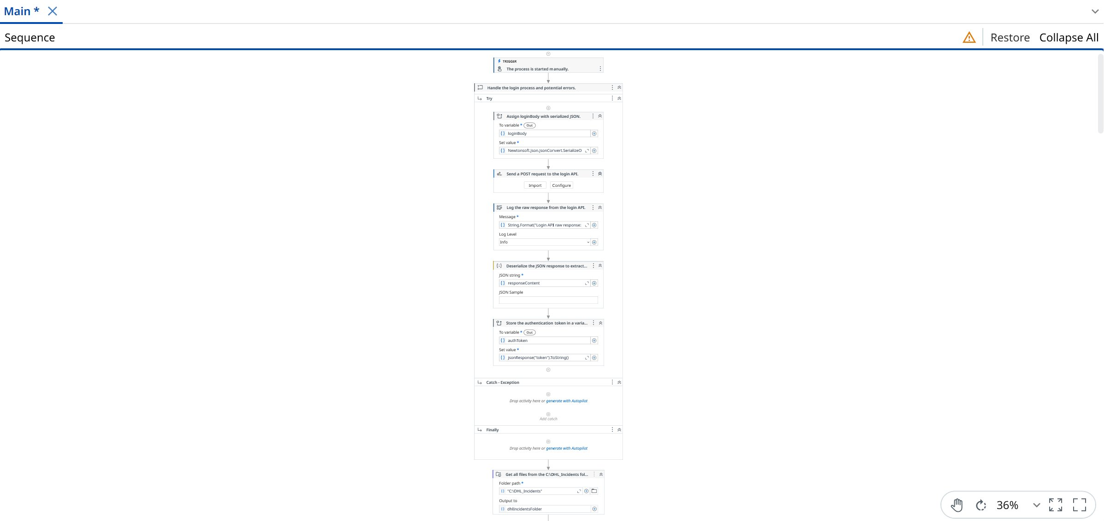
Figure 8: UiPath Workflow Part 1 — Login, token extraction and file reading

4.3 RPA Workflow — Part 2: File Processing & Duplicate Check
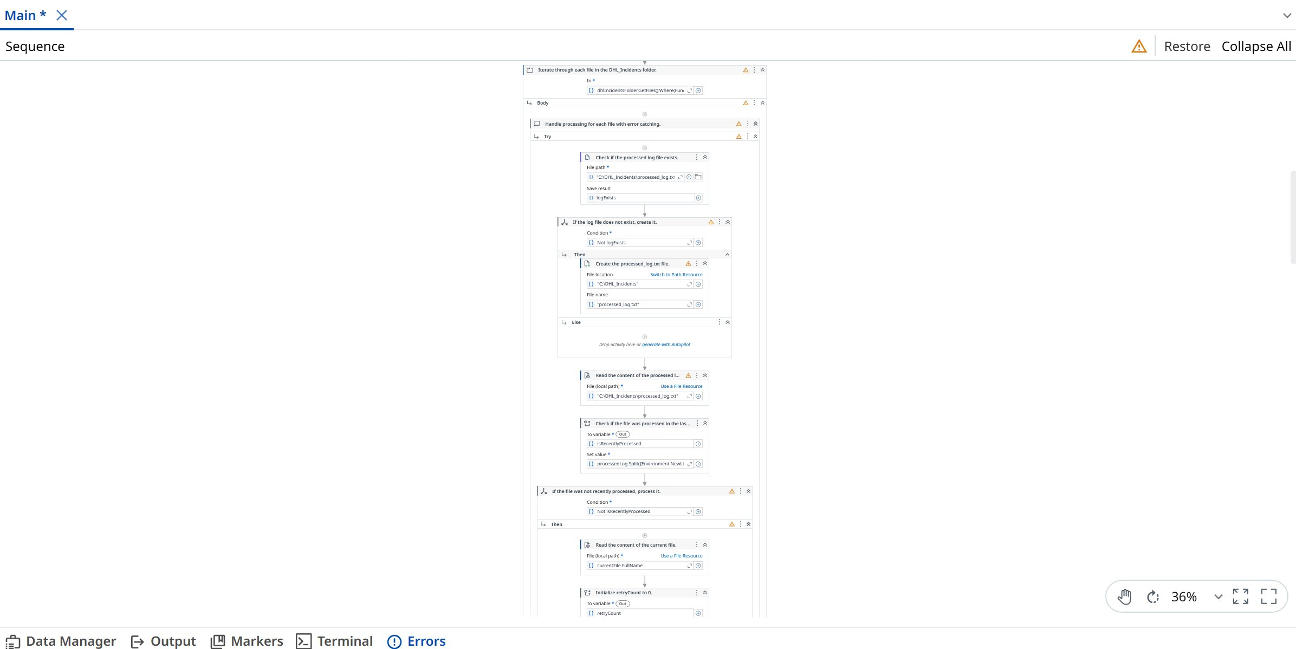
Figure 9: UiPath Workflow Part 2 — Per-file processing with duplicate check

4.4 RPA Workflow — Part 3: Summary Email
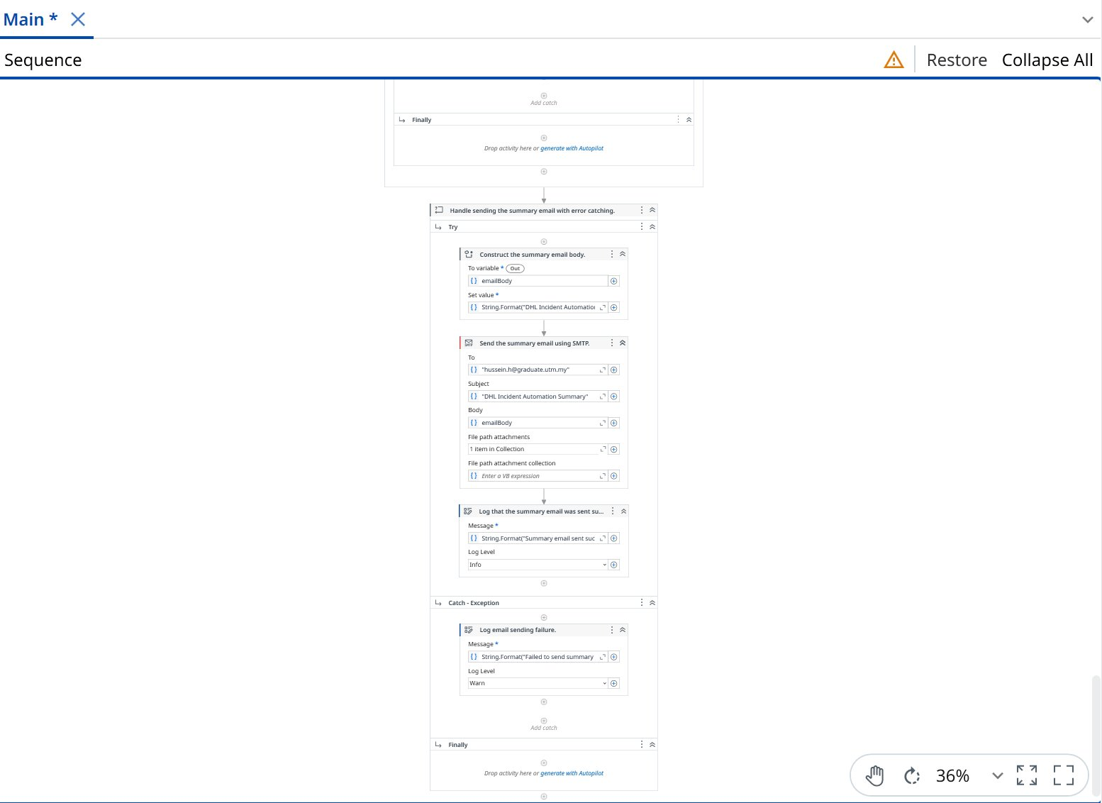
Figure 10: UiPath Workflow Part 3 — Summary email construction and SMTP sending

5. User Interface Screenshots and Description

5.1 Login Page
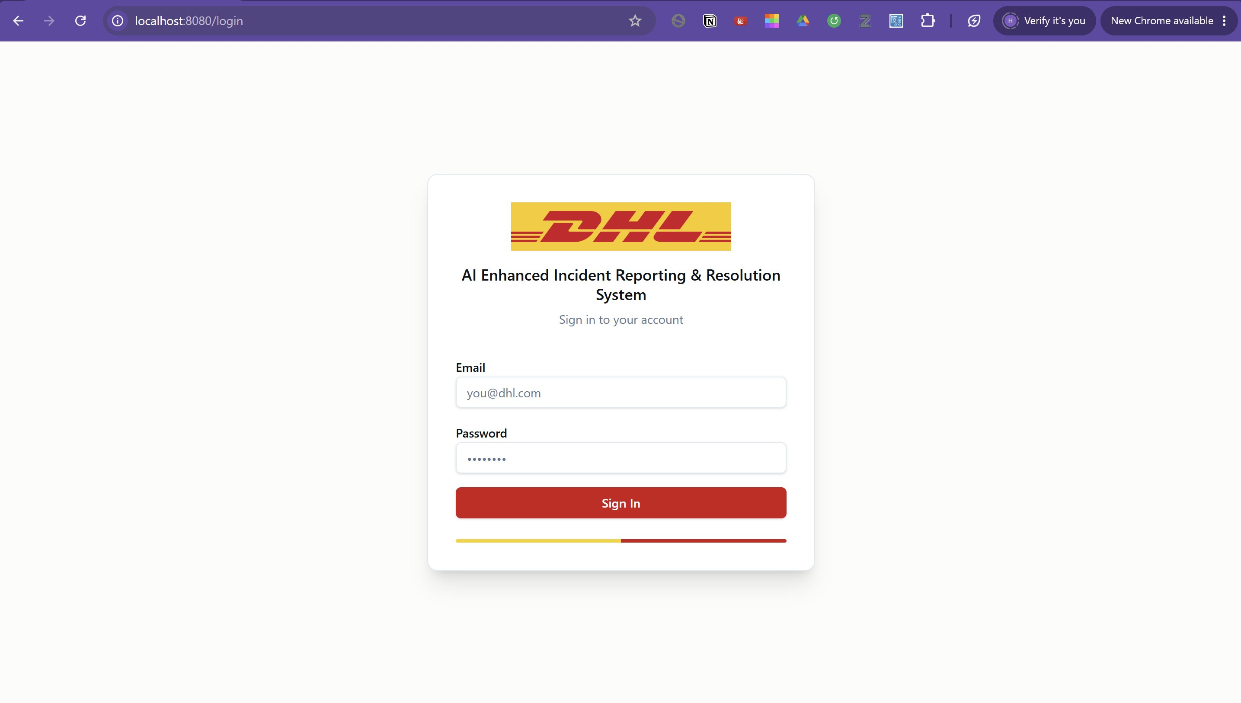
Figure 1: Login Page — DHL branded authentication

5.2 Landing / Home Page
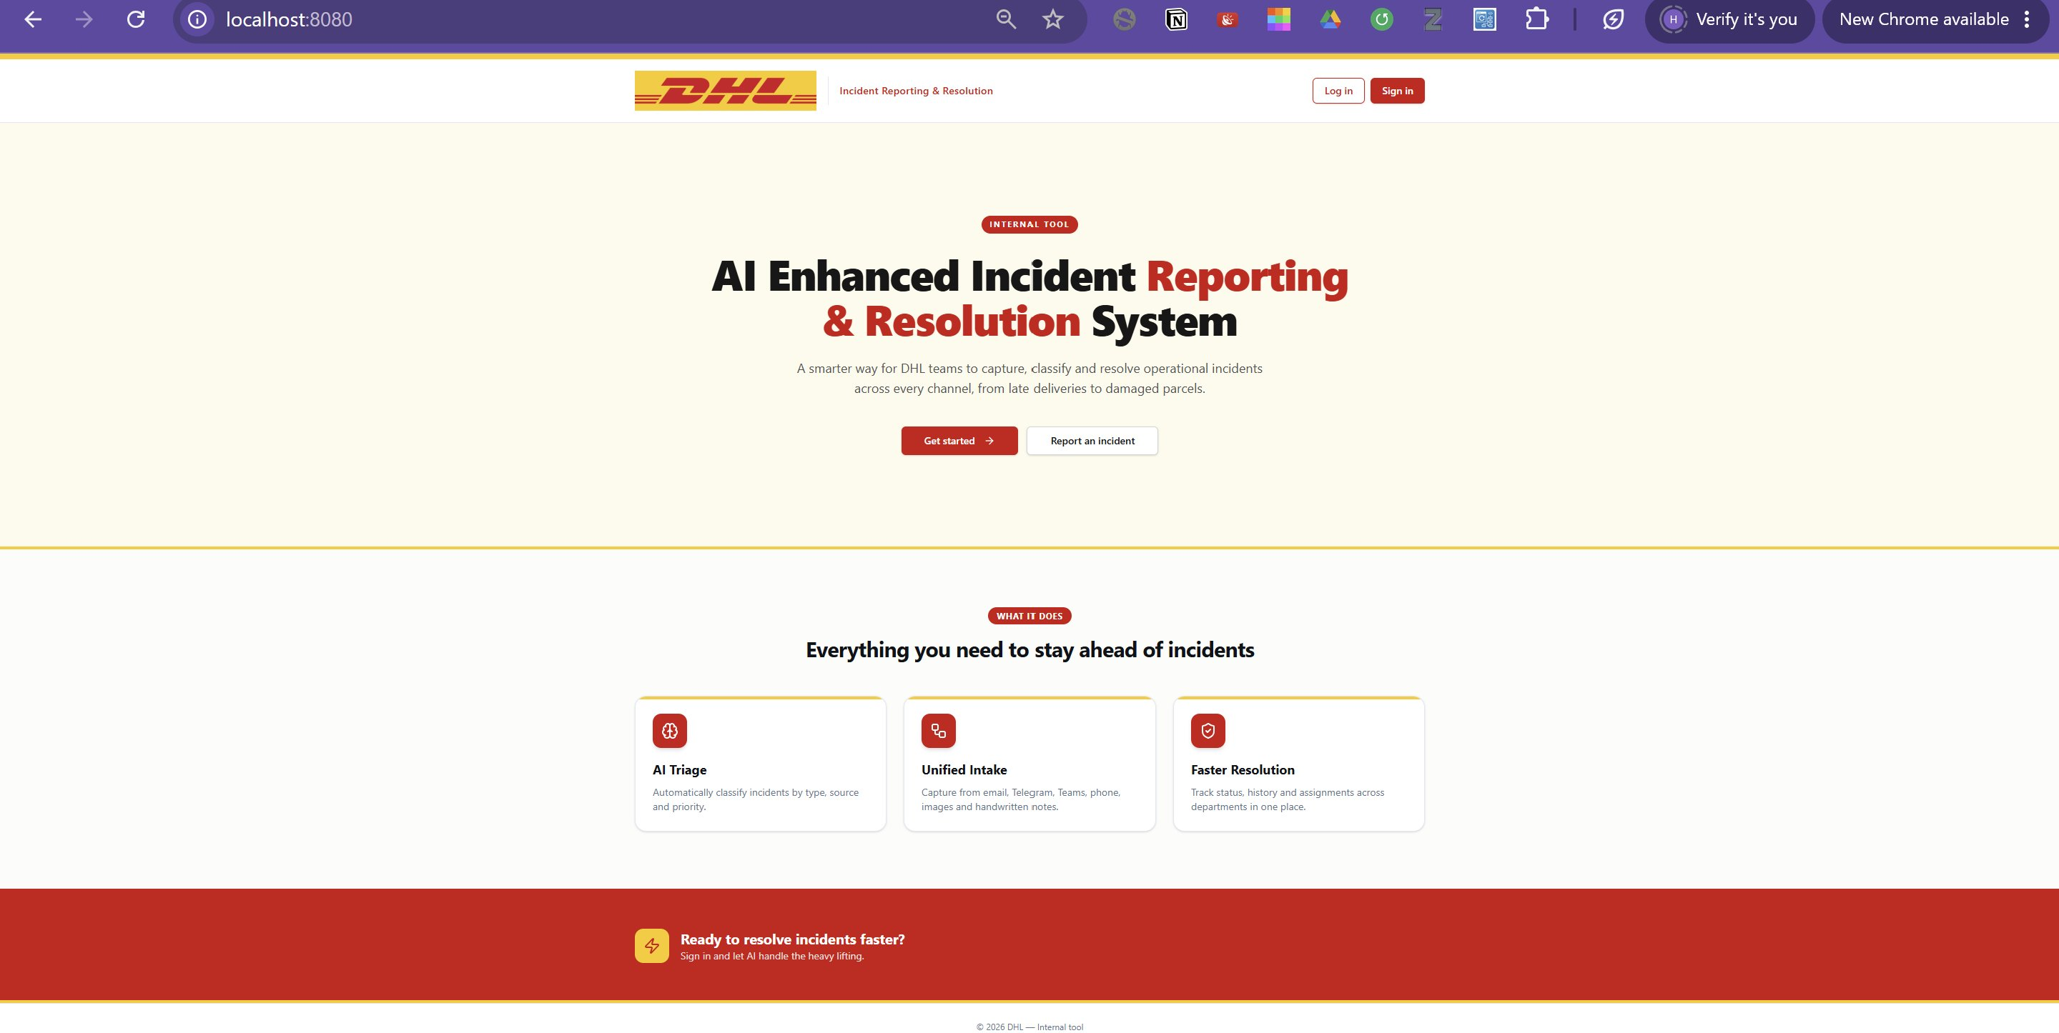
Figure 2: Landing Page — System overview

5.3 Incident Dashboard
The dashboard displays all incidents in a searchable, filterable list. Users can filter by status, priority, and type.
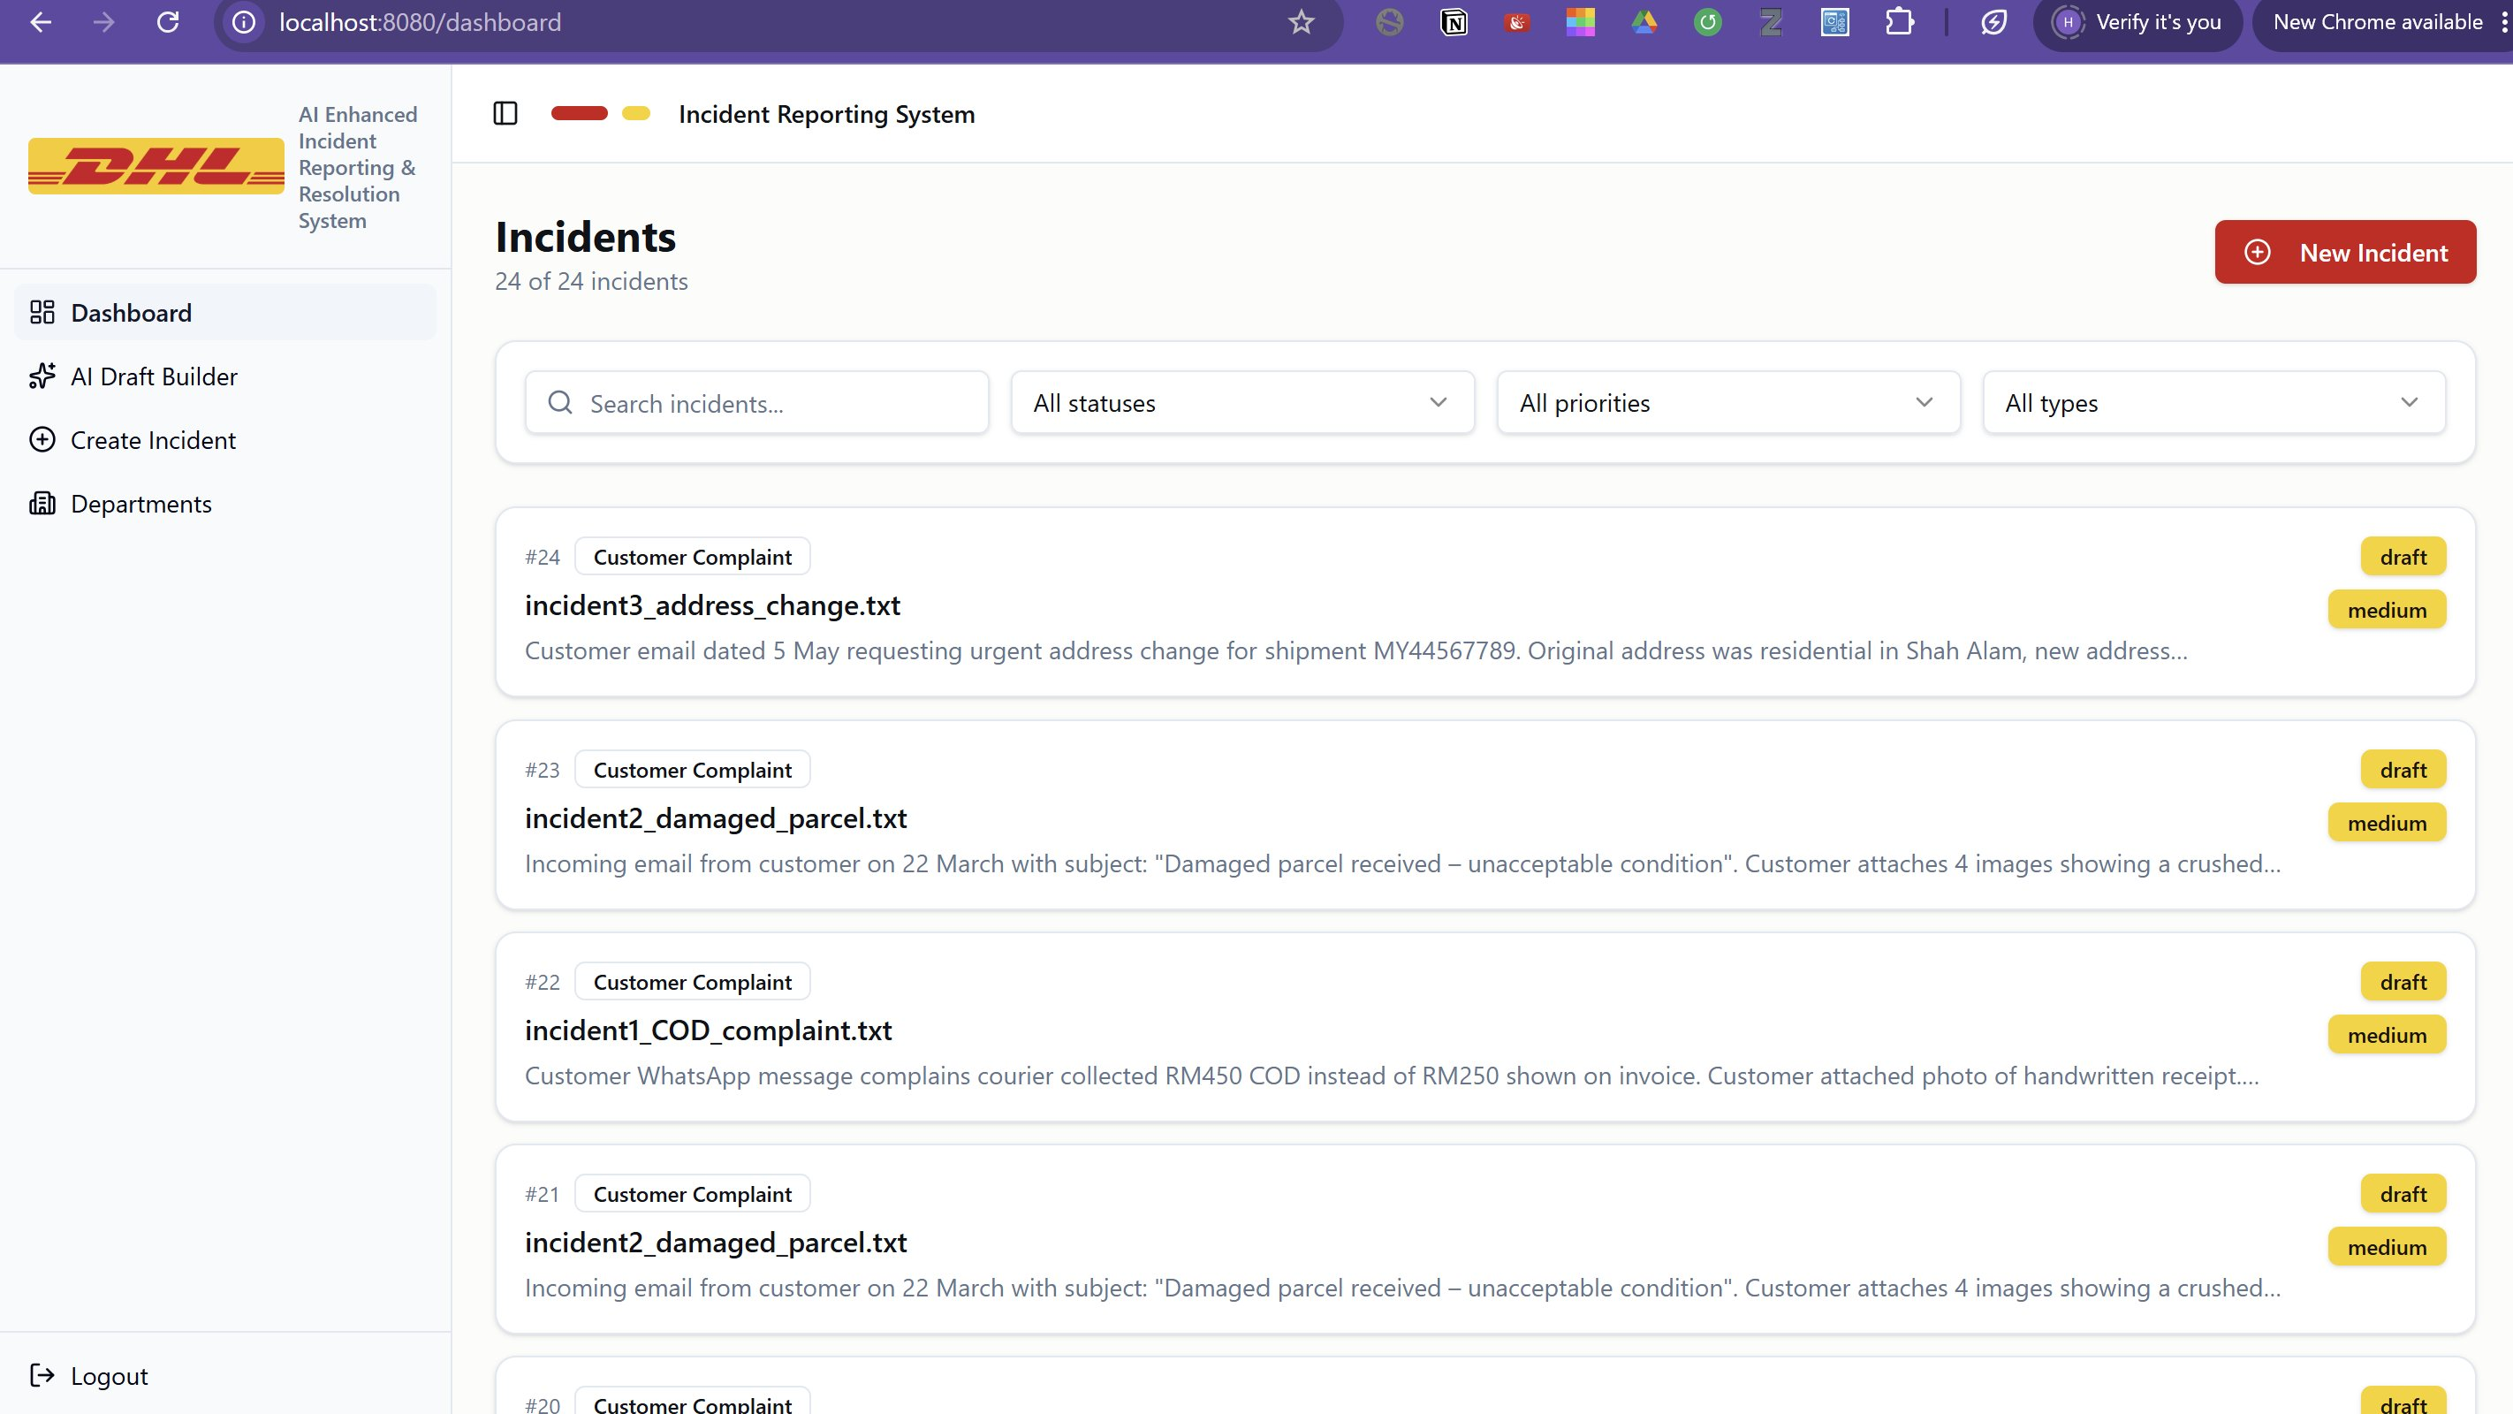
Figure 3: Dashboard — Incident list with search and filter functionality

5.4 Create Incident Page
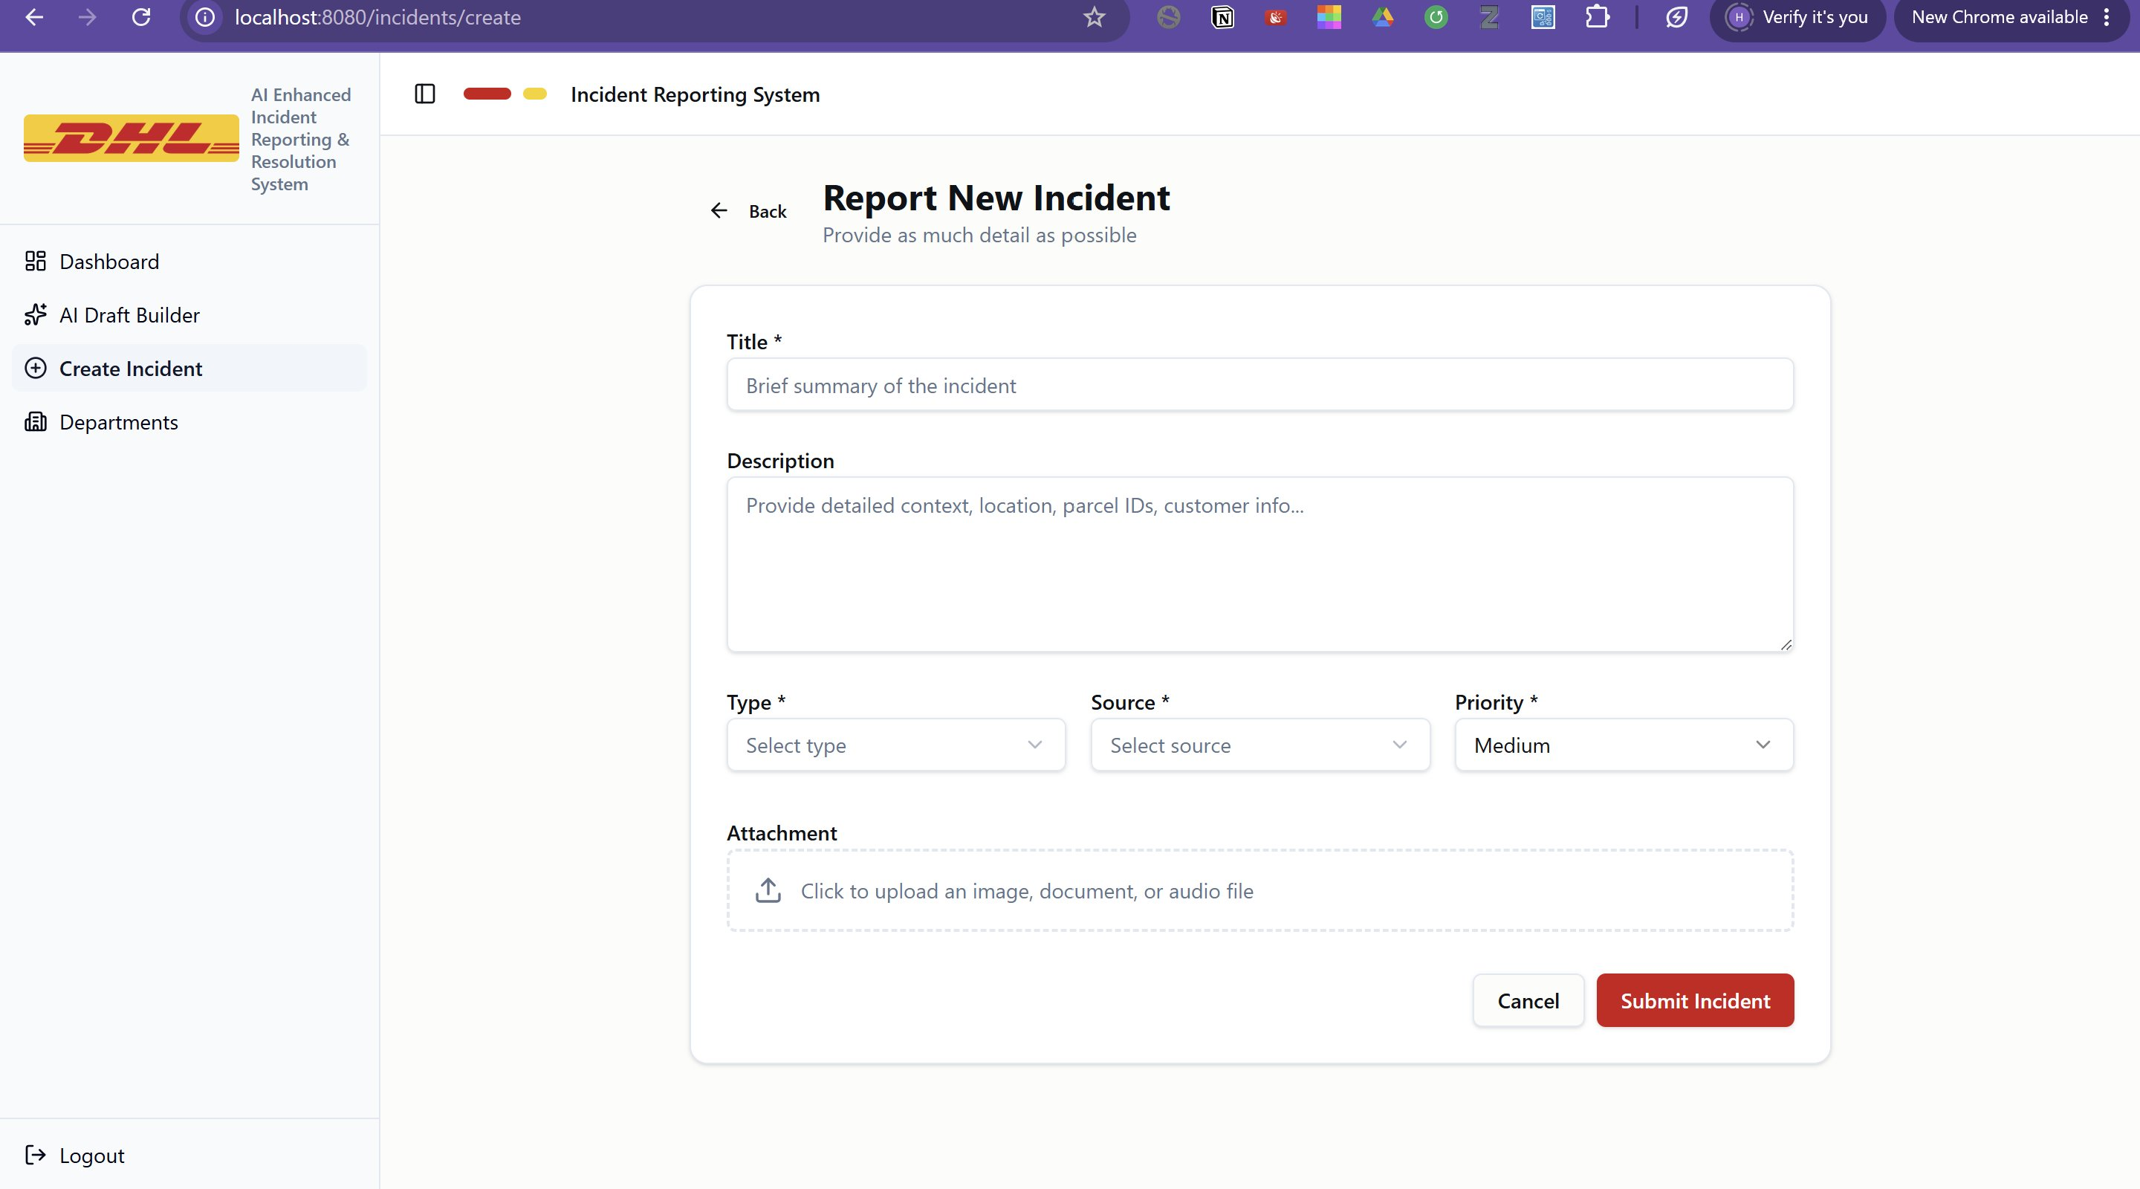
Figure 4: Create Incident Page — Manual incident reporting form

5.5 AI Draft Builder — Input
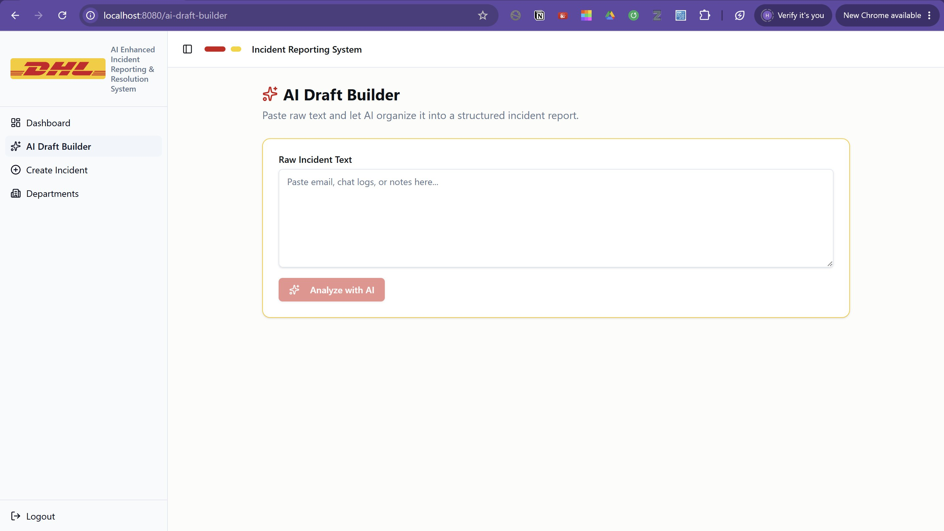
Figure 5: AI Draft Builder — Raw text input interface

5.6 AI Draft Builder — Result
Claude AI generates Title, Summary, Type, Source, Priority, Tags, and Suggested Resolution Steps automatically.
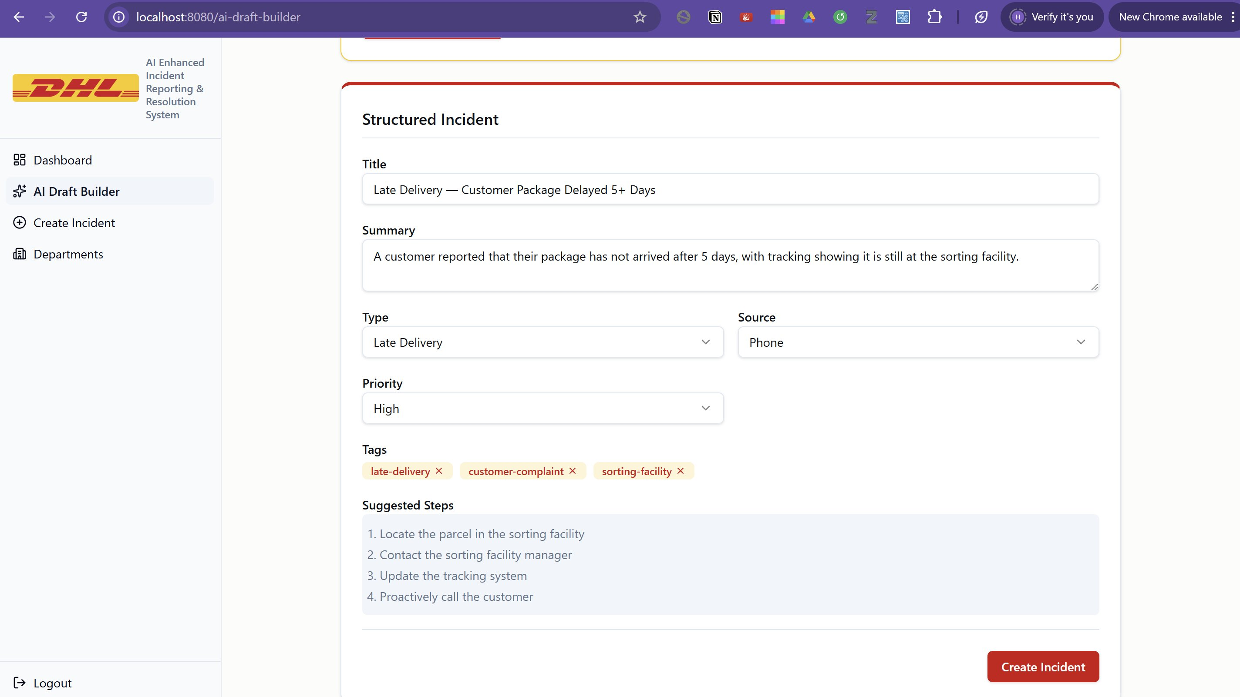
Figure 6: AI Draft Builder — AI-generated structured incident

5.7 Incident Detail Page
Shows full incident info, AI Conflict Check, Update Status control, and History timeline.
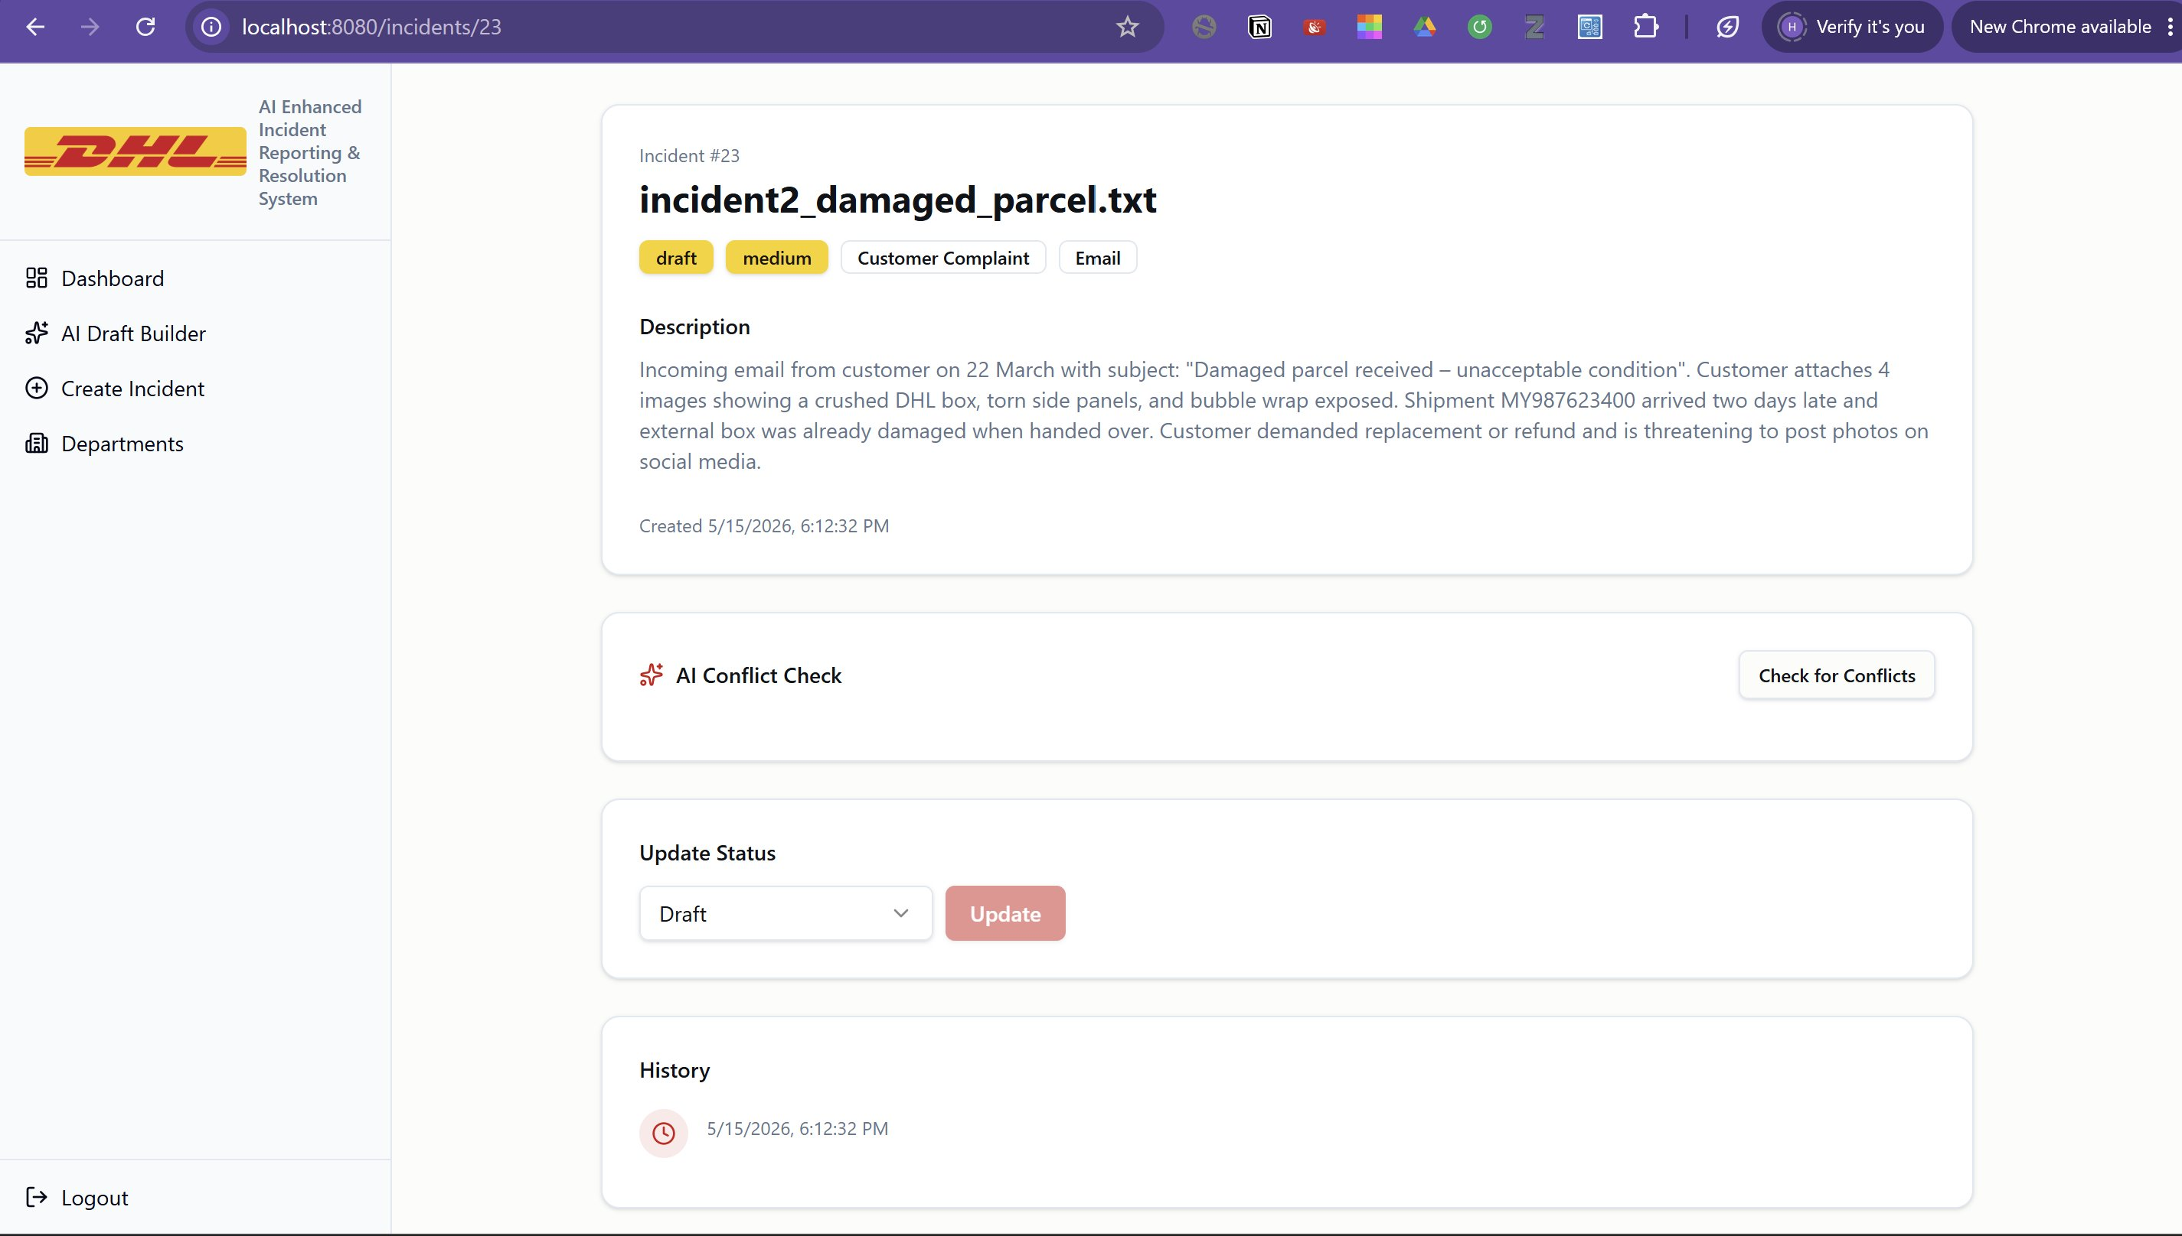
Figure 7: Incident Detail Page — Full view with AI Conflict Check

5.8 Departments Page
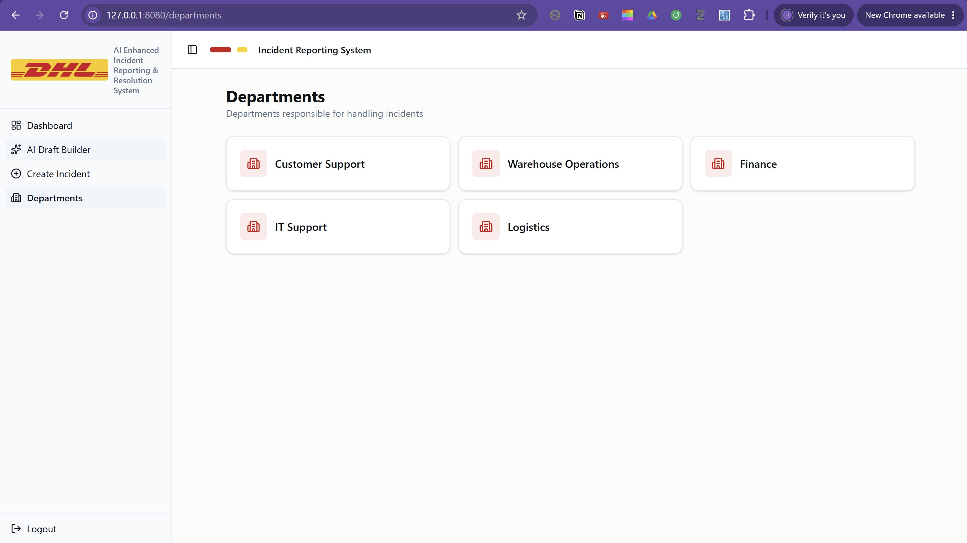
Figure 12: Departments Page — 5 DHL departments

6. User Manual

6.1 Prerequisites
- PHP 8.4+ with extensions: pdo_pgsql, pgsql, mbstring, fileinfo, openssl
- Composer, PostgreSQL 16+, Node.js 18+, UiPath Studio 2026, Git

6.2 Backend Setup
git clone https://github.com/Hanan20x/dhl-incident-reporting-system.git
cd backend && composer install && cp .env.example .env
php artisan key:generate && php artisan migrate && php artisan serve

6.3 Frontend Setup
cd frontend && npm install && npm run dev
Open http://localhost:8080 — Login: admin@dhl.com / password123

6.4 RPA Workflow
1. Create C:DHL_Incidents and place .txt files inside
2. Open rpa/DHL_Incident_RPA in UiPath Studio
3. Ensure Laravel runs on http://localhost:8000
4. Click Run — workflow creates incidents and sends summary email

6.5 Project Links
GitHub Repository:
https://github.com/Hanan20x/dhl-incident-reporting-system

Demo Video:
https://drive.google.com/file/d/1-Y05qVqsmvZFZz5mc4PzAbFxMlq2f_GU/view?usp=sharing

