
ADDIS ABABA UNIVERSITY
ADDIS ABABA INSTITUTE OF TECHNOLOGY
CENTER OF INFORMATION TECHNOLOGY AND SCIENTIFIC COMPUTING
Lecture One Based Assignment
Hanan Miftah
ATR/0720/11
Section -2
Submitted to: Mr Fitsum Alemu

February 27 2020
Addis Ababa, Ethiopia

Table of Contents
1. List of Figures 1
2. History of Network 2
1.1. History of Network 2
1.2. Internet 2
1.3. Internet hosts and usage 2
1.4. Internet and society: success and challenges 4
3. Web Archive 4
3.1. BBC 4
3.1. Amazon 6
3.2. Wikipedia 7
3.3. YouTube 8
3.4. Facebook 9
4. List of webs using web category 10
4.1. News 10
4.2. Informational 10
4.3. Educational 10
4.4. Social Networks 10
4.5. Marketing/Business 10
4.6. Entertainment 11
4.7. Blog 11
4.8. Personal 11
4.9. Content Aggregator 11
4.10. Wiki 11
4.11. Portals 12
4.12. Advocacy 12
5. Guideline for Website 12
5.1. Authority 12
5.2. Accuracy 12
5.3. Objectivity 12
5.4. Currency 13
5.5. Coverage 13
5.6. Appearance 13
6. References 14

List of Figures
Figure 1: Number of internet hosts form 1969 to 2006 3
Figure 2: Internet usage of the world 3
Figure 3: Capture of BBC website in Dec, 06, 1998 4
Figure 4: capture of BBC website on Mar, 06, 2014 5
Figure 5: capture of BBC website on Feb, 27, 2020 5
Figure 6: capture of Amazon website on Jan, 08, 2010 6
Figure 7: capture of Amazon website on Feb, 27, 2020 6
Figure 8: Wikipedia on Feb, 06, 2008 7
Figure 9: Wikipedia on Feb, 24, 2020 7
Figure 10: YouTube on Apr, 28, 2005 8
Figure 11: YouTube on Feb, 27, 2020 8
Figure 12: Facebook on Feb, 03, 2010 9
Figure 13: Facebook on Feb, 27, 2020 9

History of Network

History of Network
The history of Internet is very dependent on the history of network as the Internet itself is the network of networks, therefore we should look a little bit about evolution of network. The first network named ARPANET (Advanced Research Agency Network) is evolved in around 1969 in US and it was for sharing information and messages and playing long separation diversions and associating with individuals to share their perspectives. That time ARPANET connected 5 sites which are
- UCLA
- Stanford
- UC Santa Barbara
- University of Utah
- BBN
ARPANET is the basis for evolving internet since it was renamed the Internet in 1984, when it linked 1,000 hosts at university and corporate labs.

Internet
At first there was internet (Remark: this is small I internet) which is the network of local networks means networks in geographically limited or small areas. But because of the invention of Web in 1989 by Tim Berners-Lee (a British researcher at CERN), we are able to get Internet (Capital I Internet). Therefore
Internet = internet + WWW
The Internet architecture had two main elements.
- The first was a set of protocols called TCP/IP, or Transmission Control Protocol and Internet Protocol (Cerf and Kahn 1974).
- The second creative element was the use of special computers called gateways as the interface between different networks (Cerf 1979). Gateways are now commonly known as routers; as the name implies, they determine the route that packets should take to get from one network to another

Internet hosts and usage
The number of computers connected to the Internet has grown dramatically from the network's humble beginnings, when it connected four computers at university research labs.
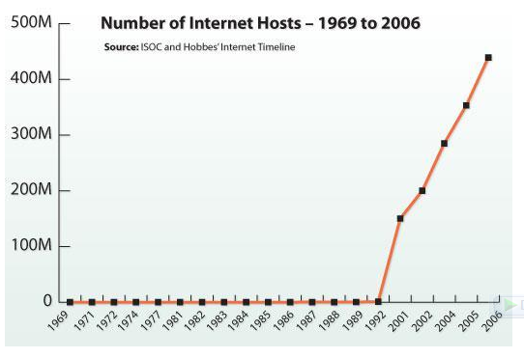
Figure 1: Number of internet hosts form 1969 to 2006
Internet usage has exploded since 1995, when researchers first started tracking this statistic.
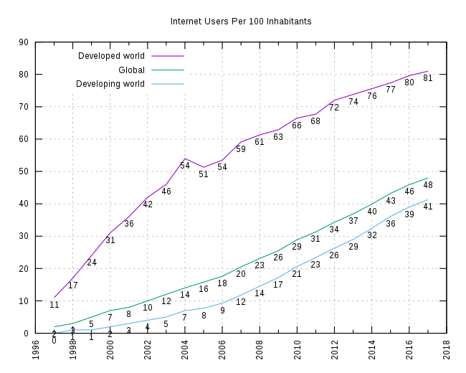
Figure 2: Internet usage of the world

Internet and society: success and challenges
After half a century of research and innovation, the Internet was firmly established as a widely available resource offering an array of potential benefits. Users had greater access to information of all kinds, and governments and businesses had a new platform for providing information and services. E-commerce brought economic growth, greater choices for consumers, and opportunities for producers in disadvantaged areas to reach new markets. A variety of communications options, from email to elaborate social networking sites, made it easier for friends and family to stay in touch over long distances and for strangers to form “virtual communities” around common interests. Grassroots organizers adopted the Internet for political and social activism and used it to mobilize worldwide responses to natural disasters and human rights abuses. Users of all ages embraced the Internet as a medium for personal expression, and new applications helped democratize the technology by making it easier for ordinary people to independently produce and disseminate news, information, opinion, and entertainment.
However, many challenges remained as the Internet entered the twenty-first century. Users faced abusive practices such as spam (unwanted commercial email), viruses, identity theft, and break-ins. Technical experts responded with solutions that attempted to minimize these on-going dangers, providing anti-virus systems, filters, secure web transactions, and improved security systems.

Web Archive
Web Archive is a website where we can see captures of millions of websites taken in different time and see the differences. I have chosen 5 websites to see on web archive.

BBC
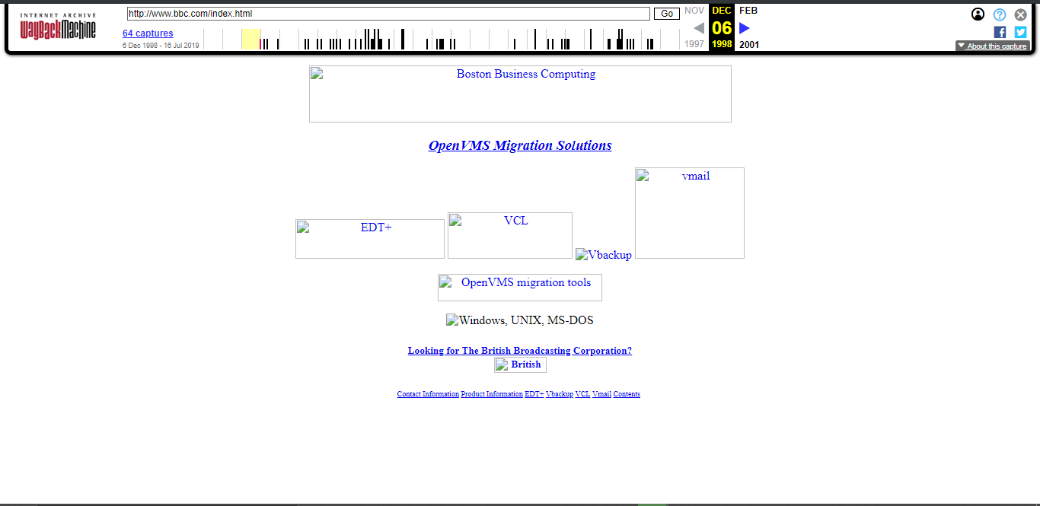
Figure 3: Capture of BBC website in Dec, 06, 1998
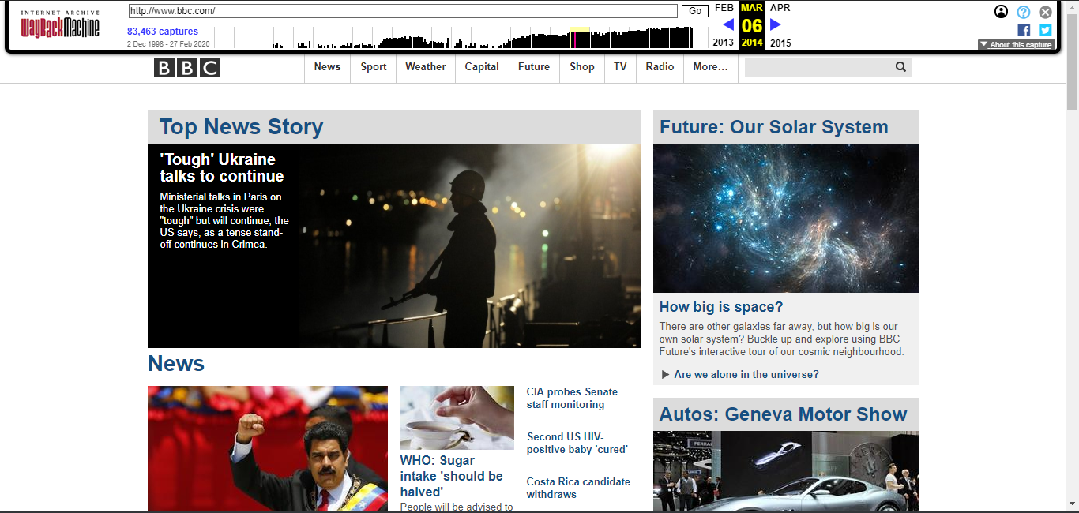
Figure 4: capture of BBC website on Mar, 06, 2014

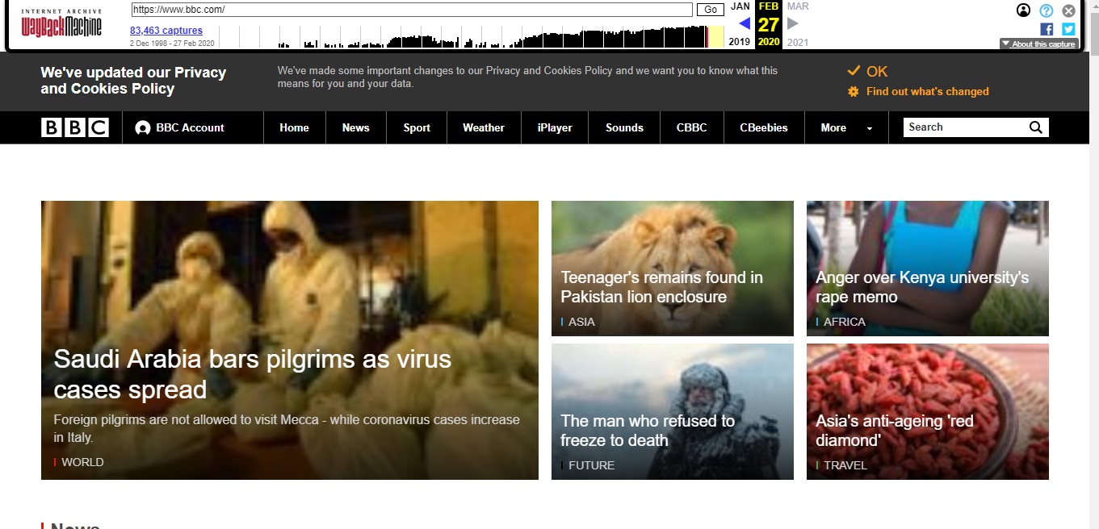
Figure 5: capture of BBC website on Feb, 27, 2020
- Observation and assessments
As we see in the above 3 pictures BBC website has been changed a lot .At the beginning, even it didn’t have visible pictures all we were texts which are linked to other page.
The capture at the middle is taken on Mar, 06, 2014. It is very changed compared to the first one. Although it didn’t cover all the screen because of margin left and right, it is relatively beautiful. It contains several images with text as heading, contains more pages than the previous captures.
In fig 5 we see the recent homepage of BBC. There is lots of staff changed these days. The heading is consisted of their logo with their pages like home, news, sport, weather, sounds… including the search bar. Their body part is consisted of Latest News with HD quality images with various text styles and so on.

Amazon
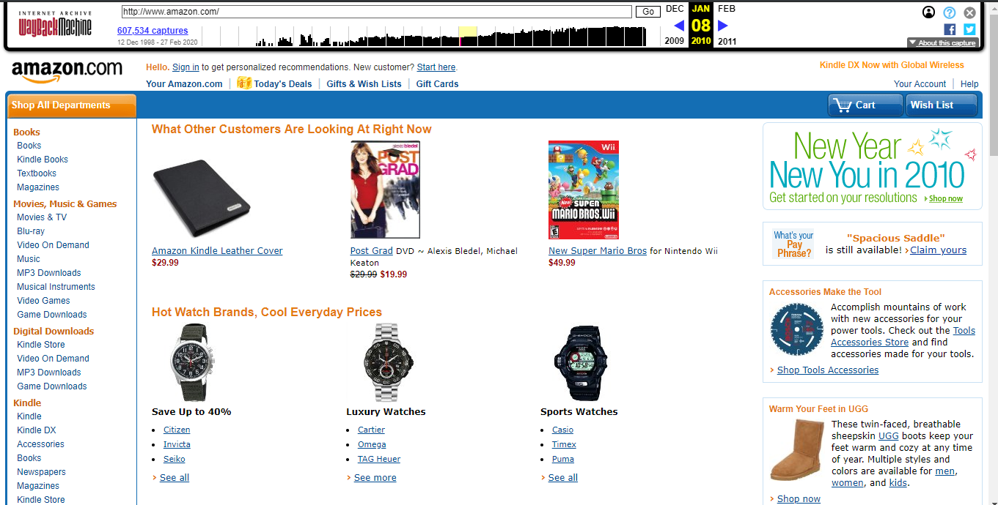
Figure 6: capture of Amazon website on Jan, 08, 2010
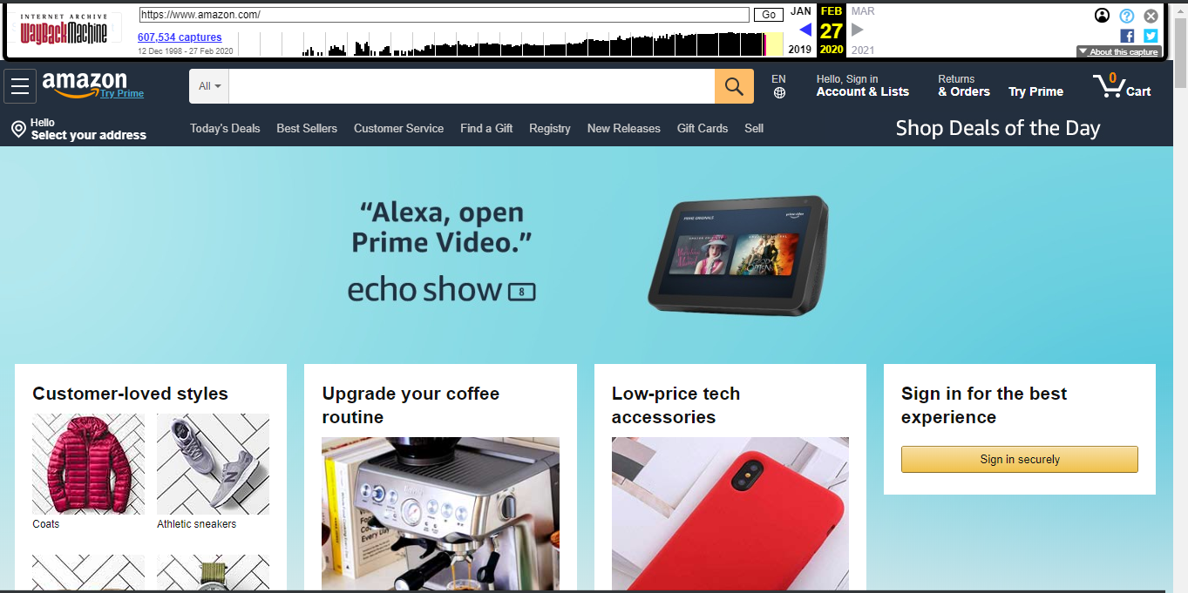
Figure 7: capture of Amazon website on Feb, 27, 2020
- Amazon has also changed its website numerous times. As it is shown in the above in fig 6 the website was good but not that mush. The layout of the website is not beautiful. The body part has 3 partitions, the one on the left has several links which they provide, the middle one has sample images of the products they sell and in the left it has some promotions.
The most recent website of amazon is shown above in fig 7. It is so eye catching with their HD images of their sample products for sell with nice colouring of the pages it consists and fonts of the texts.

Wikipedia
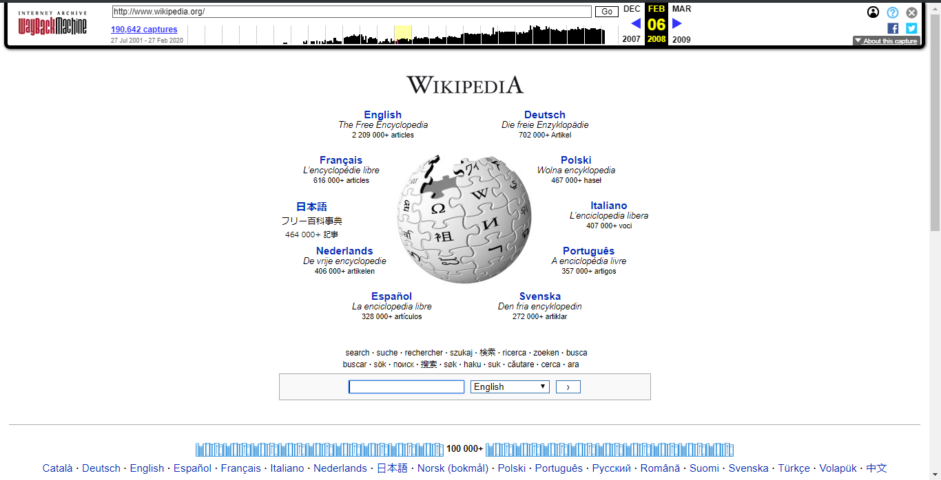
Figure 8: Wikipedia on Feb, 06, 2008
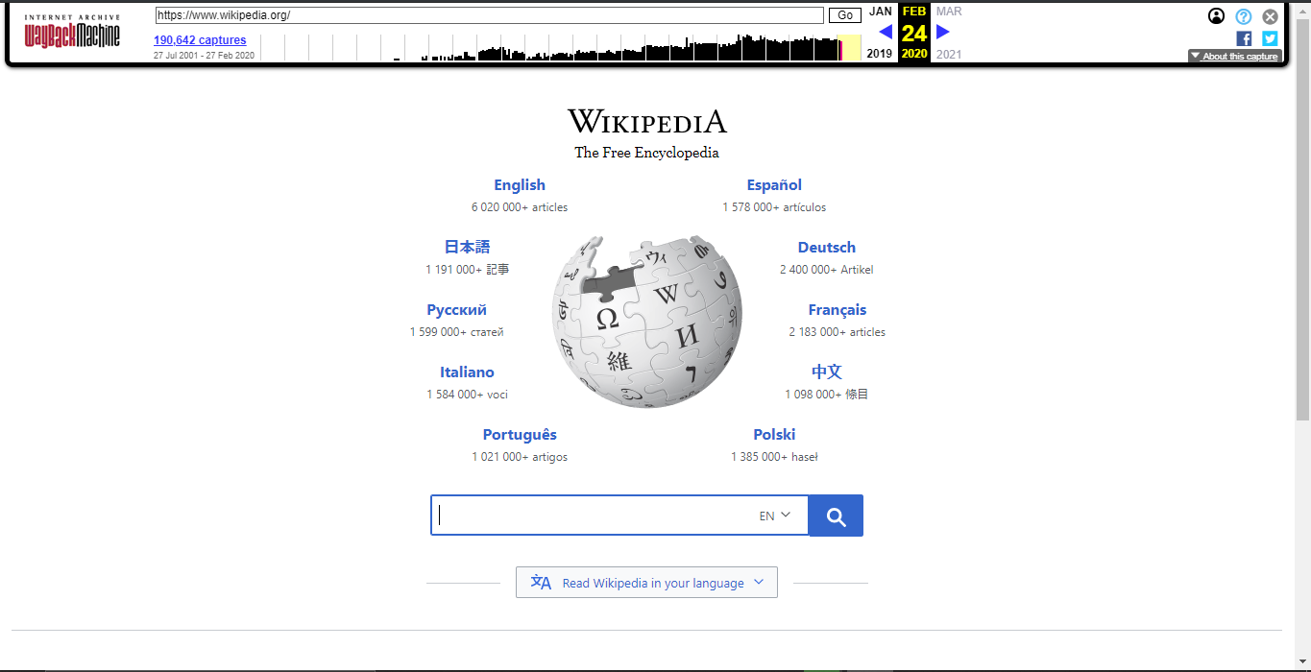
Figure 9: Wikipedia on Feb, 24, 2020
- As we see Wikipedia doesn’t changed that much though some changes are visible, the logo is changed, the search bar also looks different, they removes some texts and now it is comfortable for eye to see.

YouTube
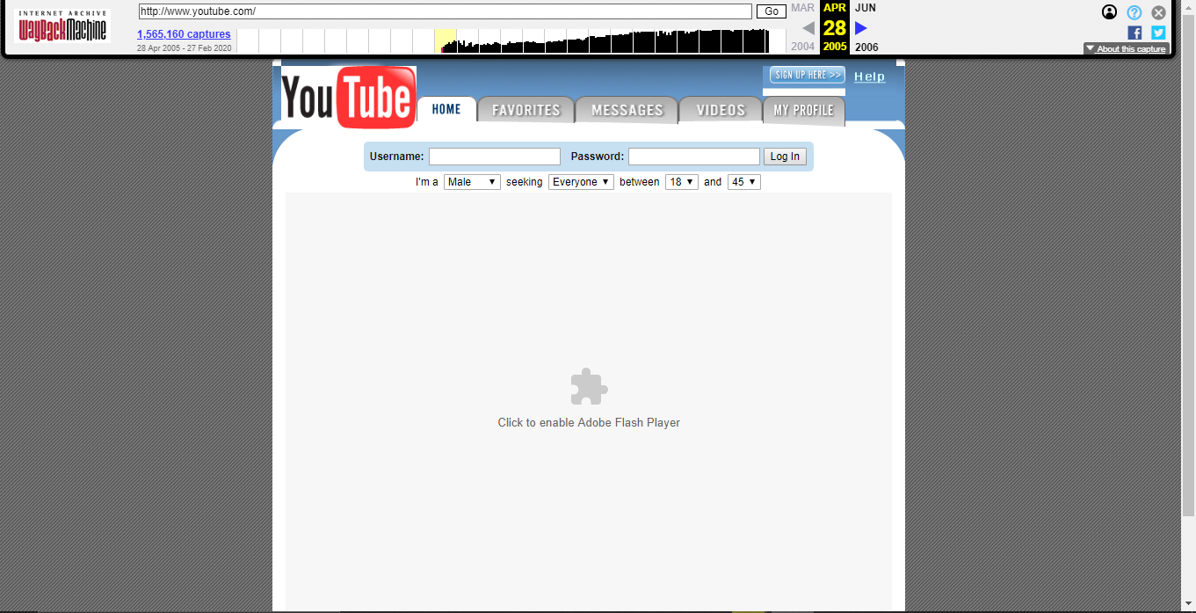
Figure 10: YouTube on Apr, 28, 2005
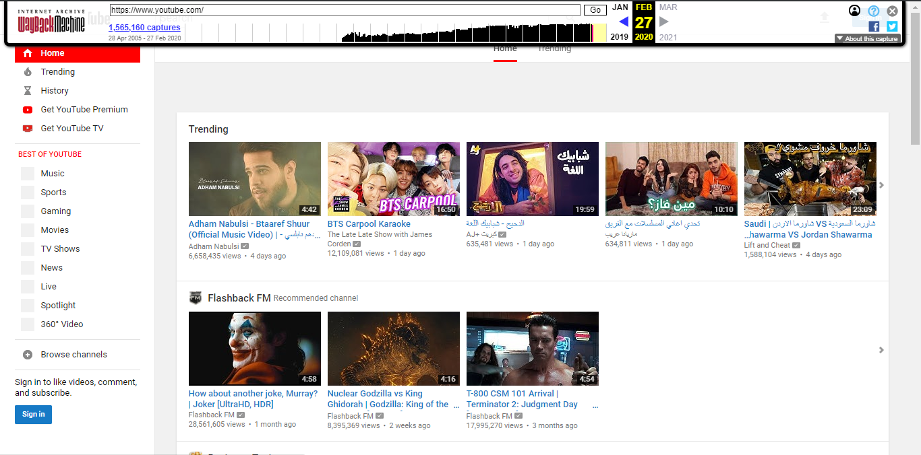
Figure 11: YouTube on Feb, 27, 2020
- As we see on the above to figures YouTube have made changes. The figures are very different. The capture which is taken on April 2005 is uncomfortable for eye and not eye catching. It has buttons at the header and fonts are not good.
The recent YouTube website is shown on the above fig 11. The body part has two partition, one is on the left with narrow width contains of menus and links to other related pages, the other partition is the wider consists videos of different types as a sample. So in my perspective the latest one is nice looking and comfortable.

Facebook

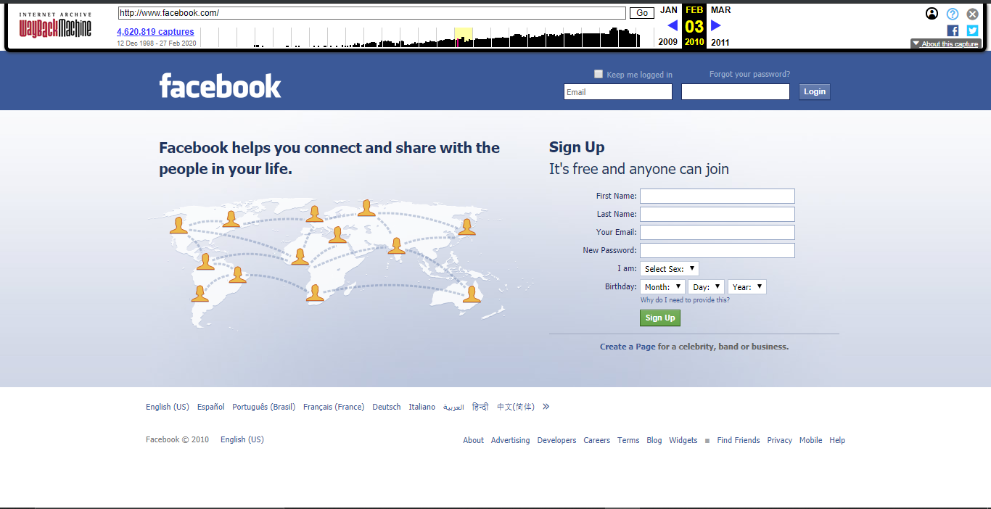
Figure 12: Facebook on Feb, 03, 2010
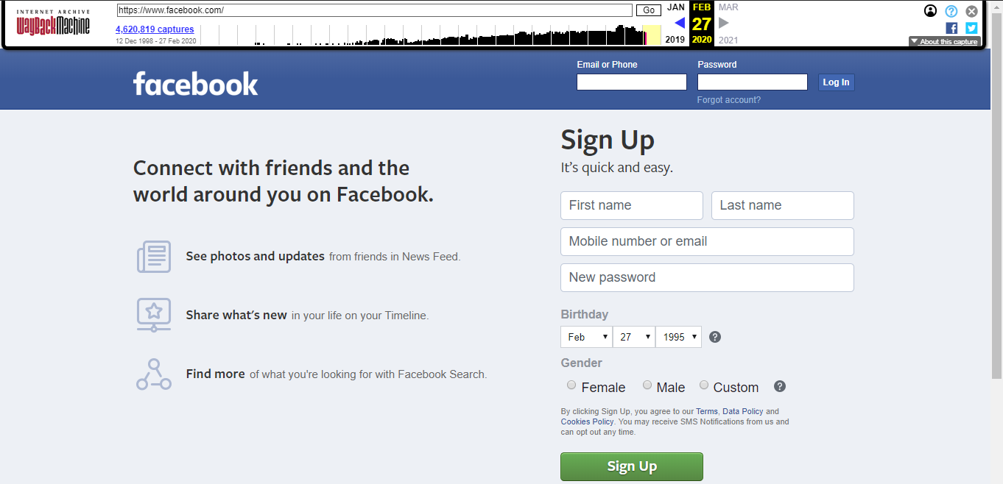
Figure 13: Facebook on Feb, 27, 2020
- Facebook also make some changes. As we see on the figures above fig 12 and 13 there is some change on the login part (they removed the placeholder inside the text field and make it above the field as solid text labels. They also work with font like size and font type. The signup form is also changed with suitable form with additional information to be added with is gender using radio buttons.

List of webs using web category
There are 12 categories of websites

News
- Yahoo News : https://news.yahoo.com/
- Google News: https://news.google.com/
- Huffington Post: https://www.huffpost.com/
- CNN: http://www.cnn.com/
- New York Times: https://www.nytimes.com/

Informational
- Wikipedia.org: www.wikipedia.org
- CNET.com: www.cnet.com
- WHO: who.int
- Nobelprize.org: www.nobelprize.org
- Stack overflow: stackoverflow.com

Educational
- Coursera
- Khan Academy
- Udemy
- Udacity
- EDX

Social Networks
- Facebook
- Twitter
- Instagram
- QZone
- Telegram

Marketing/Business
- hubspot.com
- gemius.com
- manychat.com
- socpublic.com
- zemanta.com

Entertainment
- youtube.com
- netflix.com
- imdb.com
- bilibili.com
- spotify.com

Blog
- WordPress.org
- Wix
- WordPress.com
- Squarespace
- Weebly

Personal
- http://www.ximenavengoechea.com/
- https://www.devonstank.com/
- http://redrussak.com/
- http://www.sarahlichang.com/
- http://ianenders.com/

Content Aggregator
- https://alltop.com/
- http://popurls.com/
- https://theweblist.net/
- http://wpnewsdesk.com/
- http://www.blogengage.com/

Wiki
- https://wikitravel.org/en/Main_Page
- https://www.wikihow.com/Main-Page
- https://en.wikibooks.org/wiki/Main_Page
- https://en.wiktionary.org/wiki/Wiktionary:Main_Page
- https://strangerthings.fandom.com/wiki/Stranger_Things_Wiki

Portals
- https://www.santanderbank.com/us/
- https://www.copperpoint.com/
- https://www.allianz.com/en.html
- http://www.uabmedicine.org/
- https://www.grants.gov/

Advocacy
- http://www.childrenintherapy.org/
- https://ahrp.org/about/
- https://www.barefootcollege.org/
- https://www.afj.org/
- https://www.americanbar.org/groups/public_interest/child_law/

Guideline for Website

Authority
- It must be clear that who is responsible for the contents of the page
- There must be a way of verifying the legitimacy of the organization, group, company or individual
- There must be any indication of the author’s qualifications for writing on a particular topic
- The information must be from reliable source

Accuracy
- The sources for the actual information must be clearly listed so they can be verified in another source
- The information must be free of grammatical, spelling, and other typographical errors

Objectivity
- If there is any advertising on the page, it must clearly differentiated from the informational content
- There should also be a link to a page describing the goals or purposes of the sponsoring organization or company
- The content should appear to contain any evidence of bias

Currency
- There must be dates on the page to indicate when the page was written, when the page was first placed on the web, or when the page was last revised

Coverage
- The website should successfully address the topics, covered with clearly presented arguments and adequate support to substantiate them.
- The work should update other sources, substantiate other materials you have read or add new information
- The target audience should be identified

Appearance
- The site should look well organized
- The links should work
- The site should appear well maintained
Let’s now try to evaluate two websites using the above guidelines
Facebook
- If we see the authority guideline for Facebook, in my view it doesn’t fulfil it. Because there is no way for indication of the author’s qualification for writing on particular topic like politics since anyone using Facebook can write whatever he/she wanted to write on their desired issue.
- Accuracy of Facebook is also not good, because usually the sources for the actual information are not clearly known; this is like fake news from anyone.
- Generally Facebook in my view is a good and most powerful social network with some limitations. Fake news is among cons on using Facebook, There must have a quick solution for those limitations so that everyone can use without hesitations of verifying you have written the contents.
YouTube
- I think you tube have fulfilled many of the guidelines listed above. The contents are well known from who they are released. This is the basis for Accuracy. The appearance is also nice as they well organized the look.
- I appreciate on their fulfilment of guideline Coverage, which is on section 4.5. They have made some restrictions on their videos based on several community guidelines. I think this should also apply for some other websites.

References
- https://www.geeksforgeeks.org/evolution-of-networks/
- https://www.networkworld.com/article/2870267/the-evolution-of-the-internet.html
- https://www.bbvaopenmind.com/en/articles/the-internet-global-evolution-and-challenges/
- https://liferay.dev/blogs/-/blogs/15-awesome-web-portal-examples
- http://www.ebizmba.com/articles/news-websites
- https://www.similarweb.com/top-websites/category/business-and-consumer-services/online-marketing
- https://firstsiteguide.com/tools/blogging/
- https://www.makeuseof.com/tag/13-popular-wikis-that-actually-work/
- https://liferay.dev/blogs/-/blogs/15-awesome-web-portal-examples
- https://www.library.wisc.edu/socialwork/research-help/social-issues-websites/advocacy-websites/
- https://lib.nmu.edu/help/resource-guides/subject-guide/evaluating-internet-sources

