AI

Installations Virtual Box:

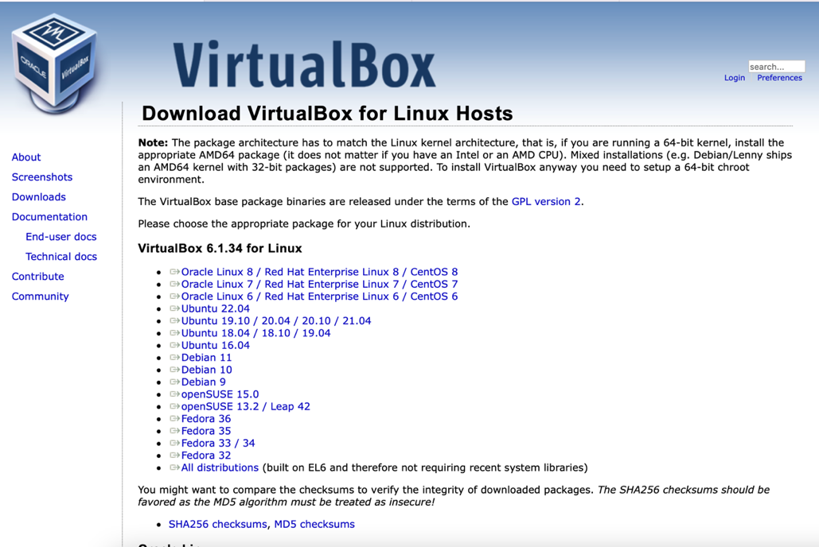

Click on new to create a new device 1-

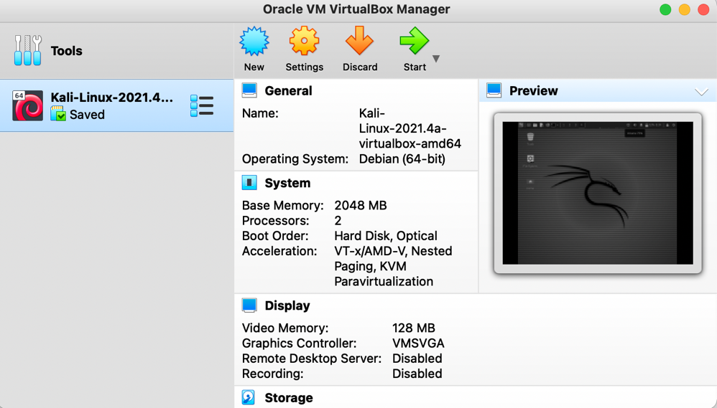

We name the device by any name.2-

Determine the appropriate space.3-

4-After that we work next

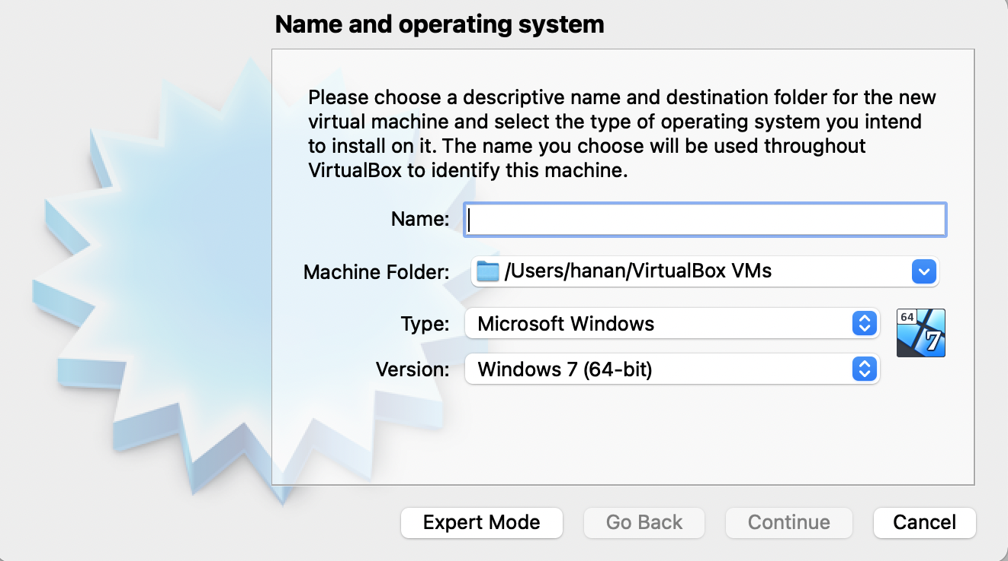

5- The device will be install

6- We click on the start button at the top of the menu

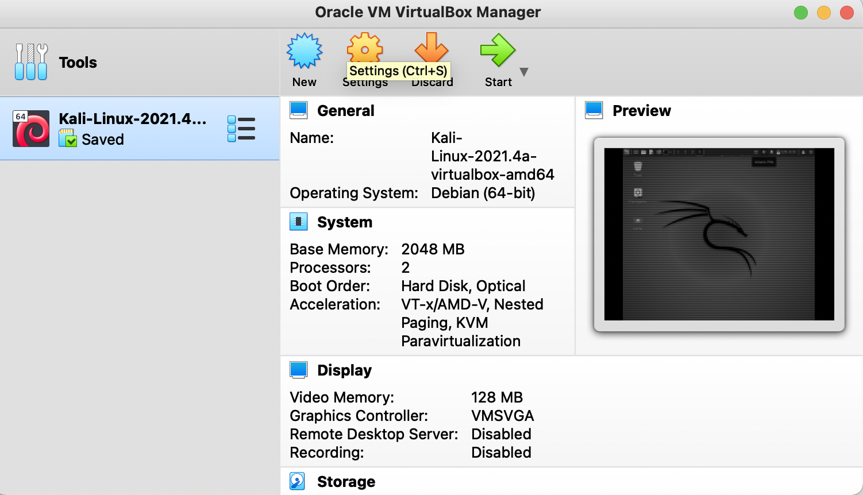

7- The new virtual machine is launched

8- Select the downloaded file by clicking on add

9- Then we choose the ubuntu file that was downloaded

10- Clicking on the start icon, then ubuntu will be launched

Install Ubuntu:

1- Click on Install Ubuntu

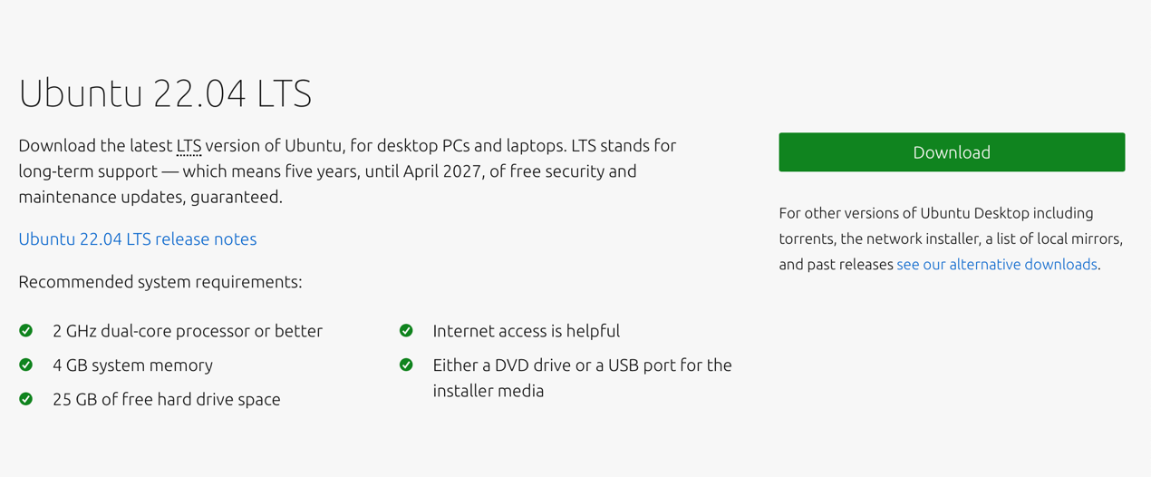

Leave the settings as come on and move using next.2-

Select the region and then click on next.3-

4- Enter the required information and click next.

5- Finally, the system is installed.

Ros installation steps on Ubuntu

<http://wiki.ros.org/noetic/Installation/Ubuntu>

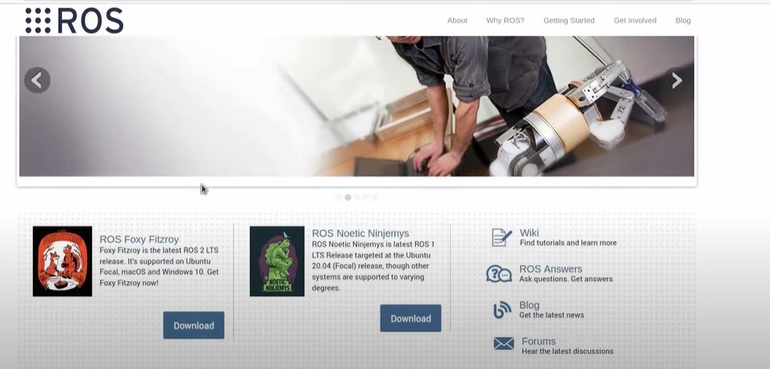

1. We choose the version compatible with your device's operating system and then download it.

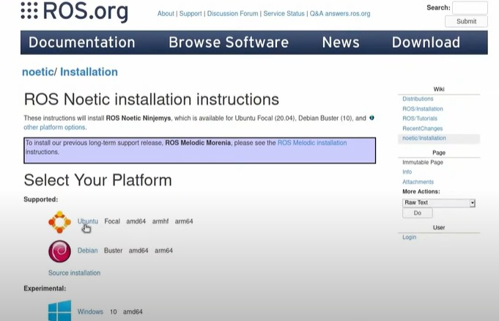

1. We choose the operating system Ubuntu،And we download it.

## **Installation**

After downloading the Ubuntu, we open the terminal and type the following commands step by step..

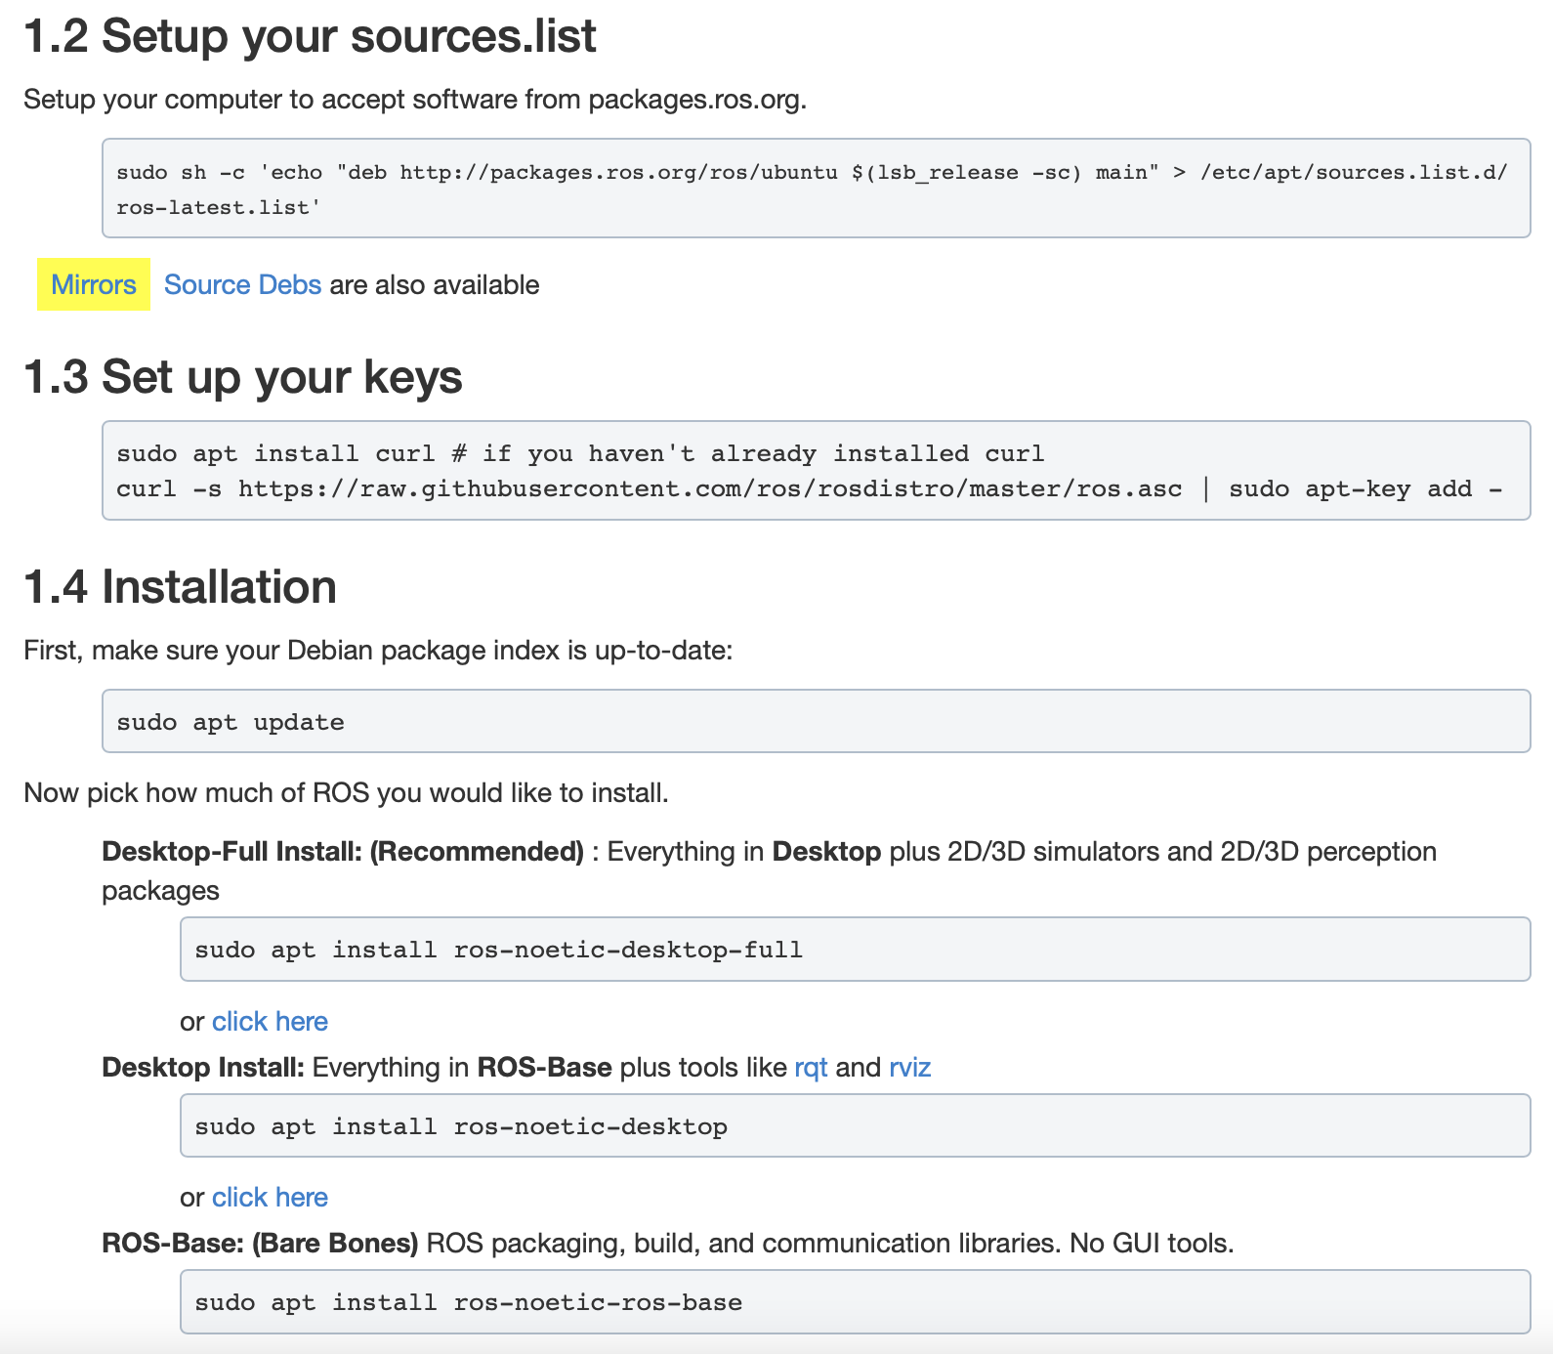

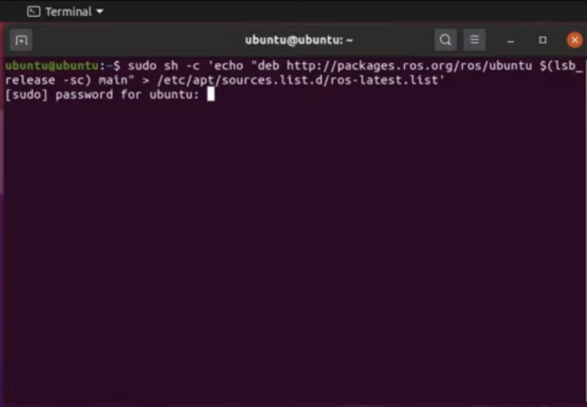

In the bashrc, we add the following command so that not every time we go back to the same previous commands when opening the terminal:

source ~/.bashrc

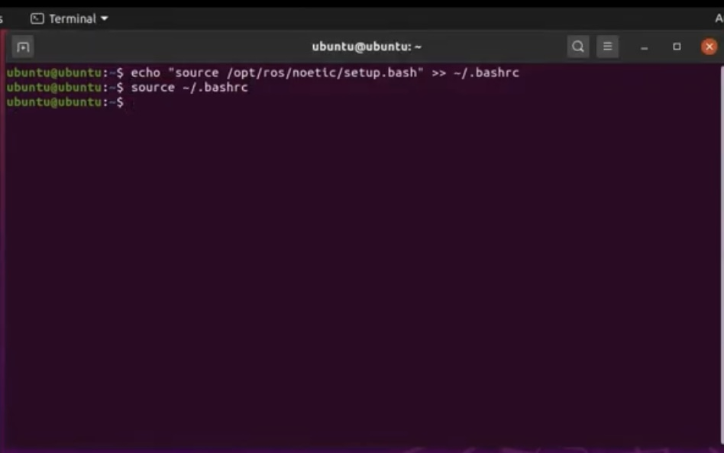

**XUbuntu installation steps on Jetson Nano**

## **download balena**

## <https://www.balena.io/etcher/>

after we download both Should be write xubuntu to flash or card useing balena

## **ros2 install**

## Set locale

Make sure you have a locale which supports UTF-8. If you are in a minimal environment (such as a docker container), the locale may be something minimal like POSIX. We test with the following settings. However, it should be fine if you’re using a different UTF-8 supported locale.

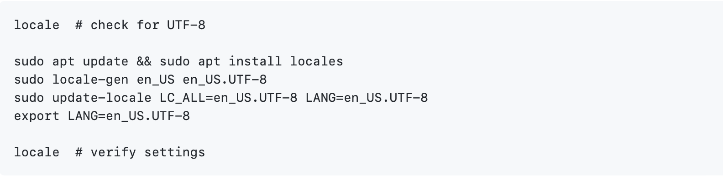

**Setup Sources**

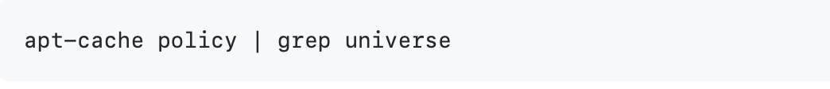

This should output a line like the one below:



If you don’t see an output line like the one above, then enable the Universe repository with these instructions.



-Now add the ROS 2 apt repository to your system.

sudo apt update && sudo apt install curl gnupg2 lsb-release

sudo curl -sSL https://raw.githubusercontent.com/ros/rosdistro/master/ros.key -o /usr/share/keyrings/ros-archive-keyring.gpg

-Then add the repository to your sources list.

echo "deb [arch=$(dpkg --print-architecture) signed-by=/usr/share/keyrings/ros-archive-keyring.gpg] http://packages.ros.org/ros2/ubuntu $(source /etc/os-release && echo $UBUNTU_CODENAME) main" | sudo tee /etc/apt/sources.list.d/ros2.list > /dev/null

## **Install ROS 2 packages**

Update your apt repository caches after setting up the repositories.



ROS 2 packages are built on frequently updated Ubuntu systems. It is always recommended that you ensure your system is up to date before installing new packages.

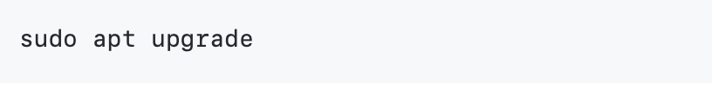

Desktop Install (Recommended): ROS, RViz, demos, tutorials.

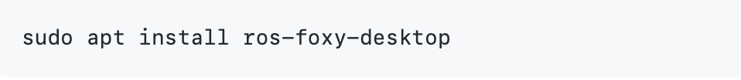

ROS-Base Install (Bare Bones): Communication libraries, message packages, command line tools. No GUI tools.

