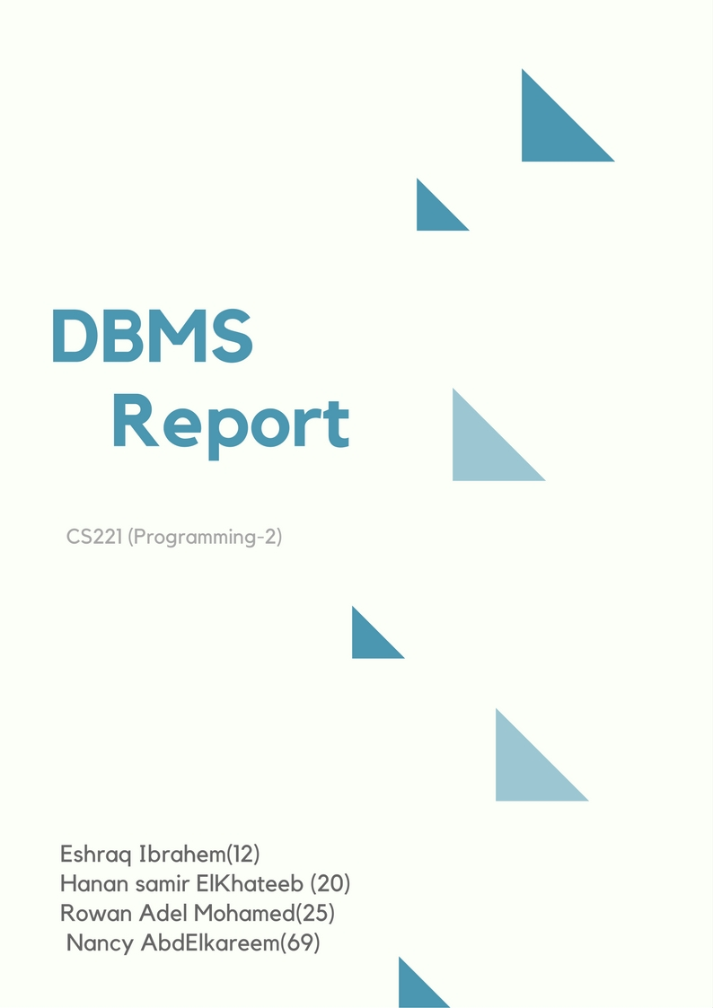

Table Of Contents.

**DESCRIBTION……………………………………………………………………………….3**

**DESIGN…………………………………………………………………………………………3**

**-** UML……………………………………………………………………………………………………...3

- Design Patterns………………………………………………………………………………………………4

**FEATURES……………………………………………………………………………………...5**

- GUI…………………………………………………………………………………………5

- CMD ……………………………………………………………………………………..6

**USER GUIDE……………………………………………………………………………………7**

**Description:**

A Computer Database is a structured collection of records or data that is stored in a computer system. On the other hand, a Database Management System (DBMS) is a complex set of software programs that controls the organization, storage, management, and retrieval of data in a database. DBMS are categorized according to their data structures or types. The DBMS accepts requests for data from the application program and instructs the operating system to transfer the

appropriate data.

**Design:**

**UML:**

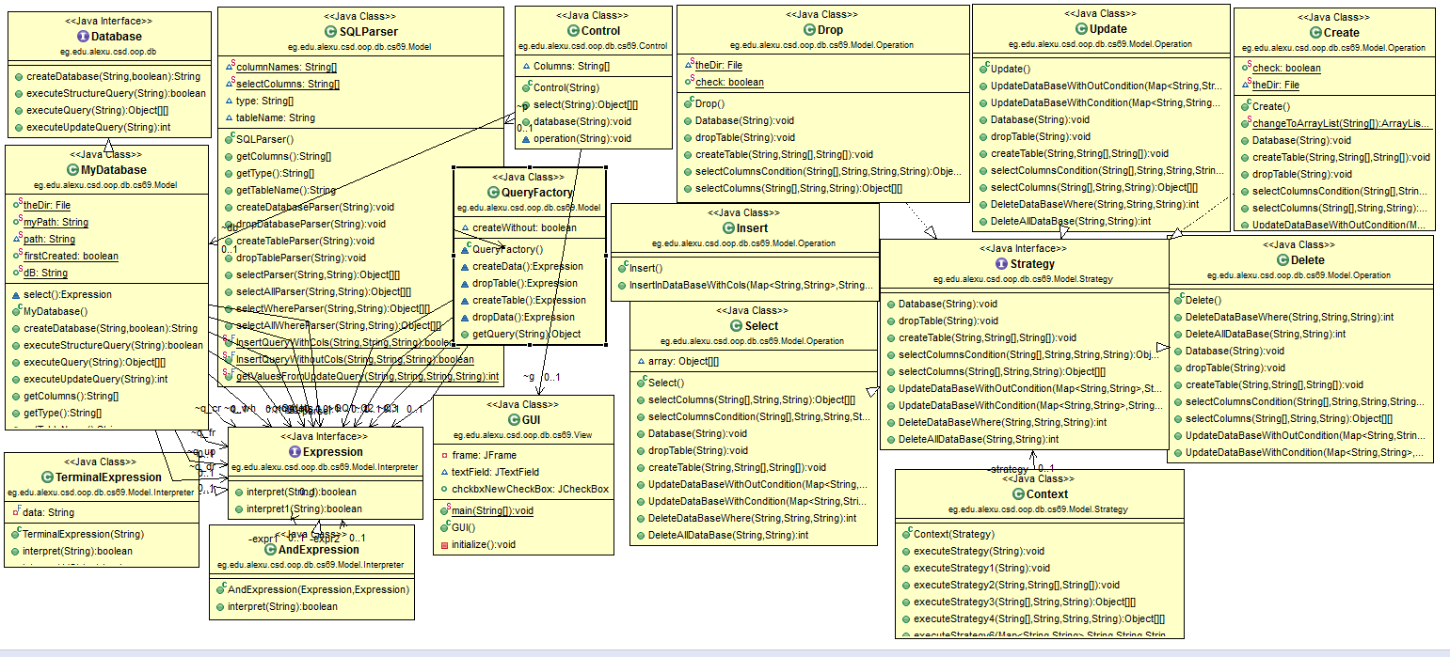

**Design Patterns:**

**MVC:**

**Model–view–controller** (**MVC**) is a software architectural pattern for implementing user interfaces on computers. It divides a given application into three interconnected parts. This is done to separate internal representations of information from the ways information is presented to, and accepted from, the user. The MVC design pattern decouples these major components allowing for efficient code reuse and parallel development.

So, The code is organized into three packages: View, Control, Model

Model: contains the class that implements the database interface, sql parser, statements (create, drop, update, insert, select, delete)

Control: controls the data flow into model object and updates the view whenever data changes.

View: represents the visualization of the data that model contains.

**Factory DP:**

Creates an instance of several derived classes . Used in return objects of create, drop classes.

**Strategy DP:** Encapsulates an algorithm inside a class.

**Interpreter DP:** Used in SQL parse.

**GUI:**

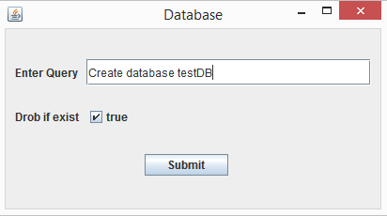

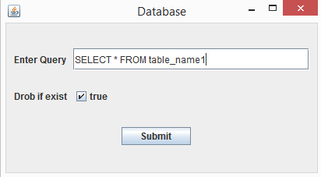

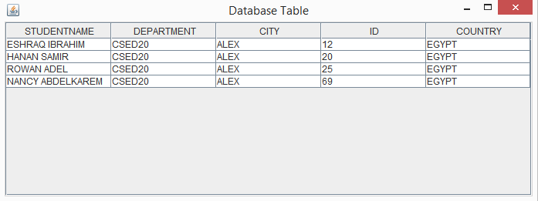

**User guide:**

**1**. Enter the query.

**2**. Select true or false if the database is existed.

**Command Line Interface:**



