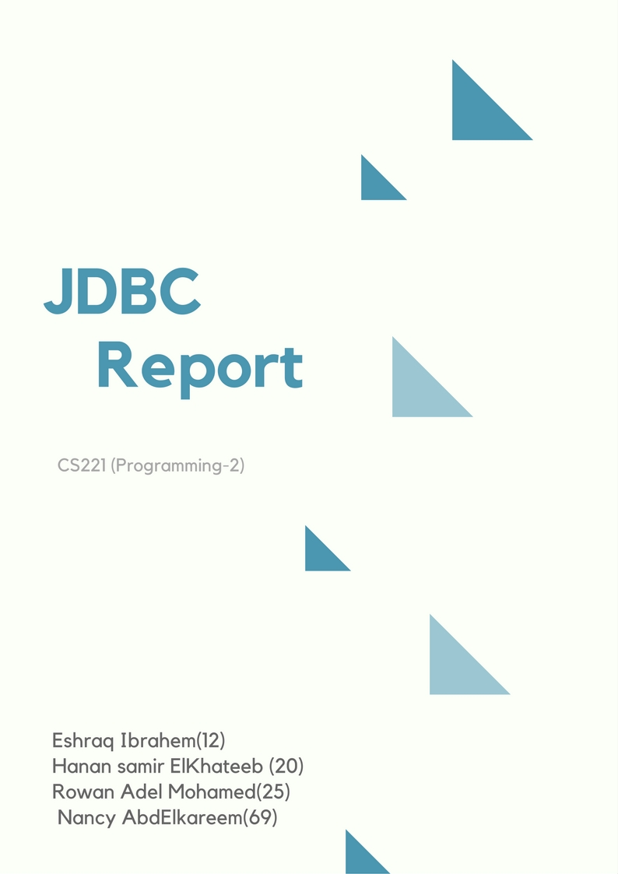

Table Of Contents.

**DESCRIBTION……………………………………………………………………………….3**

**DESIGN…………………………………………………………………………………………3**

**-** UML……………………………………………………………………………………………………...3

- Adaptor Design Pattern…………………………………………………………………………4

**FEATURES……………………………………………………………………………………...5**

- CMD……………………………………………………………………………………..6

**USER GUIDE……………………………………………………………………………………7**

**Description:**

Java Database Connectivity (JDBC) provides Java developers with a standard API that is used to access databases, regardless of the driver and database product. JDBC presents a uniform interface to databases - change vendors and your applications only need to change their driver.

**Design:**

**UML:**

**1. Class Diagram:**

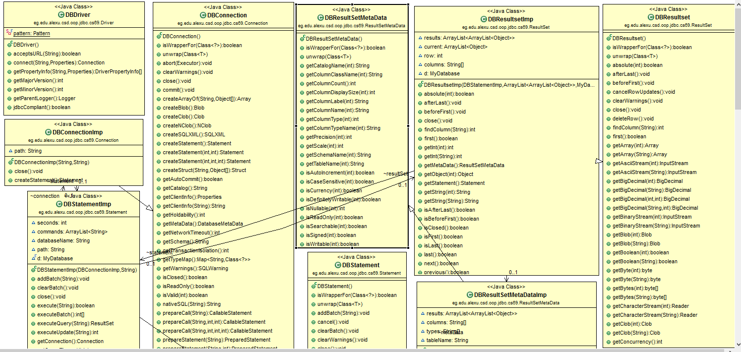

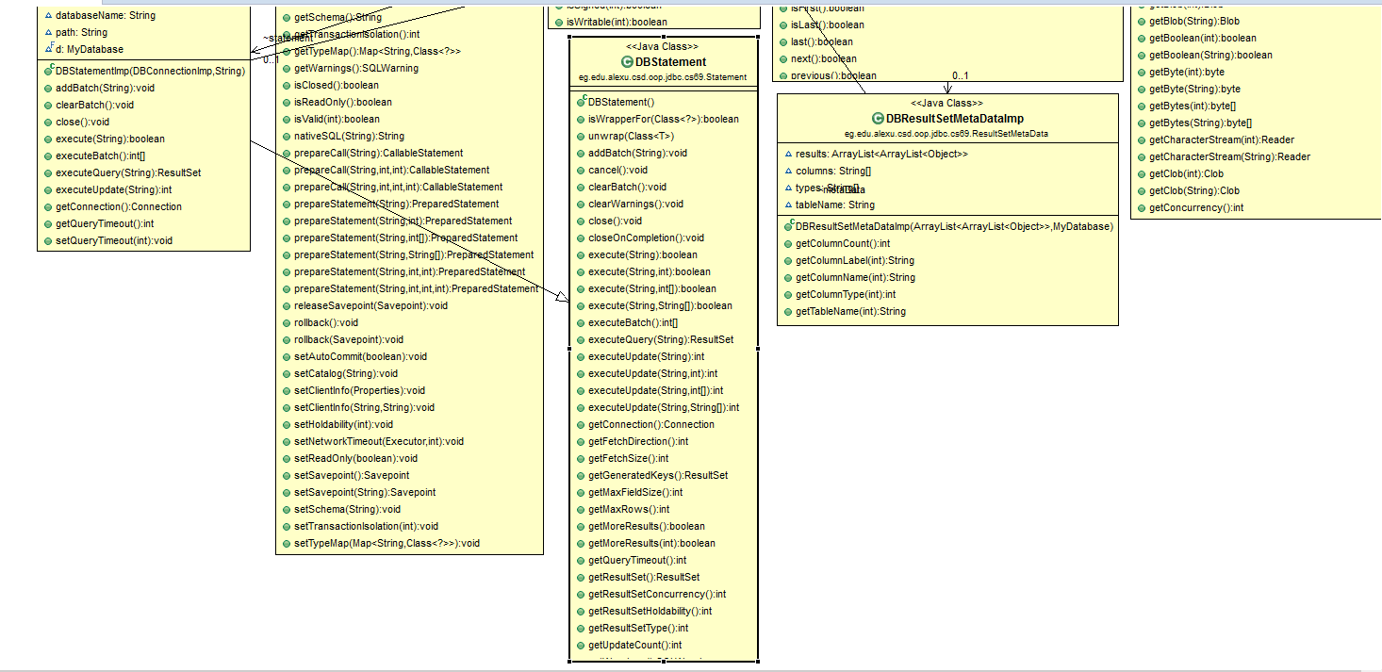

**2. Use case:**

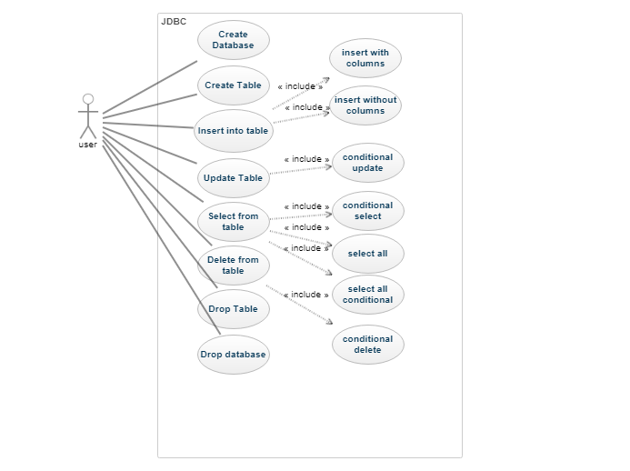

**3. Sequence diagram:**

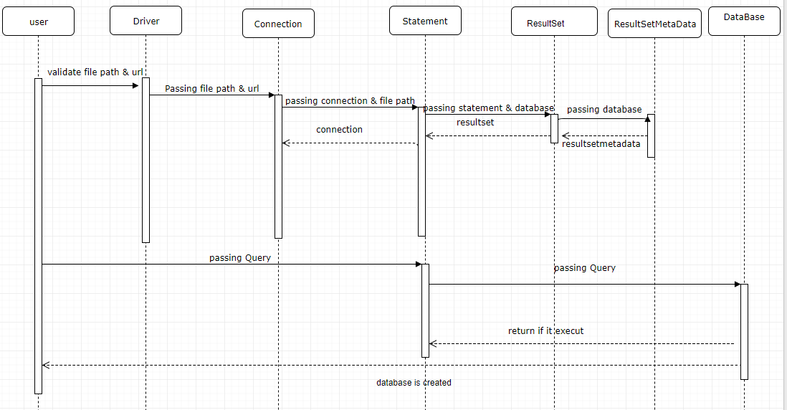

4. state diagram:

* 1. **scenario 1:**
  2. 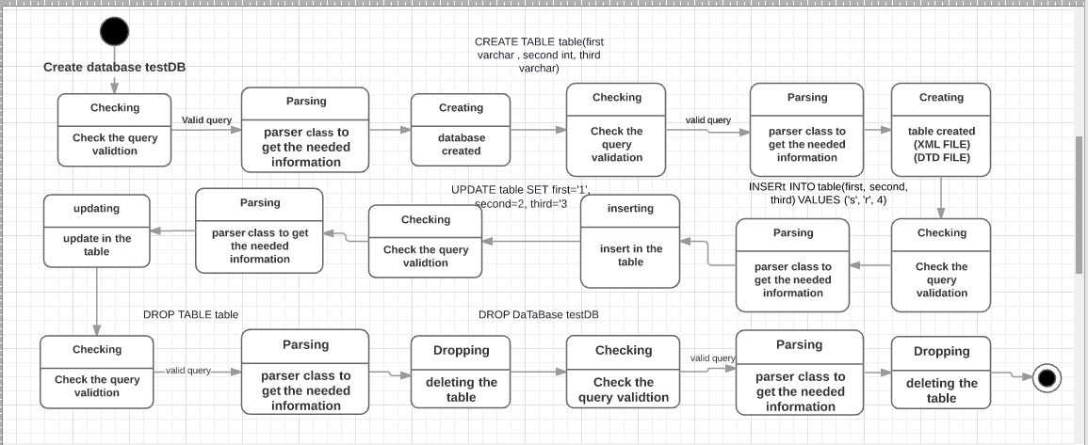

**Scenario 2:**

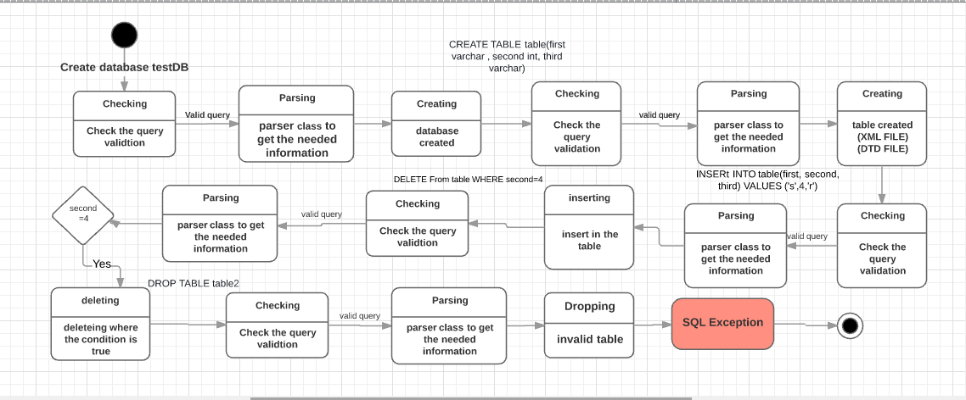

**Scenario 3:**

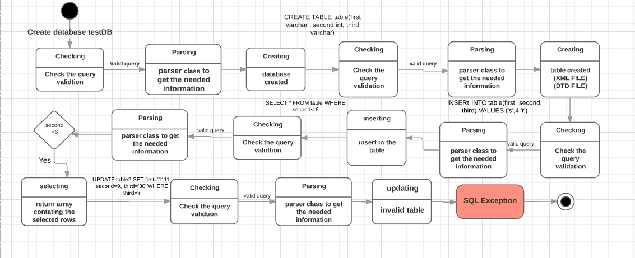

**Adaptor Design Pattern:**

Match interfaces of different classes: Driver, Connection, Statement, ResultSet, ResultSetMetaData.

**CMD:**

