CyberMorph: AI-Based Antivirus & Malware Detection System

GitHub Repository: https://github.com/HananZia/CyberMorph.git

Group Members:
- Muhammad Hanan Zia (515271)
- Kainat Naseem (510820)
- Muhammad Umer Tahir (507955)

Introduction
CyberMorph is a full-stack web application that combines machine learning-based malware classification with antivirus detection and prevention operations. Its purpose is to analyze PE files (Portable Executables) using a trained ML model and classify them as malicious or benign, while also actively monitoring the system for potential threats.

Scope of the Project
Key deliverables include:
- Machine learning malware classification using the EMBER dataset.
- Antivirus detection & prevention operations, including quarantine of malicious files.
- REST API backend to serve model predictions and antivirus logic.
- Interactive frontend for file uploads, results display, and user notifications.
- Nightwatcher agent for real-time system monitoring and automatic malware handling.

Feature Summary
Machine Learning Features
- Trained model classifies binaries as malicious or benign.
- Static feature extraction from PE files.
Backend Features
- REST endpoints for file upload, classification, and antivirus actions.
- Model loading and prediction logic.
- Support for quarantining detected malware.
Frontend Features
- File upload interface.
- Real-time display of classification results and antivirus alerts.
Agent (Nightwatcher)
- Continuously monitors the system for new or modified files.
- Automatically detects suspicious files.
- Quarantines malware to prevent infection.
- Interacts with backend to classify unknown files.

Flow Diagram:

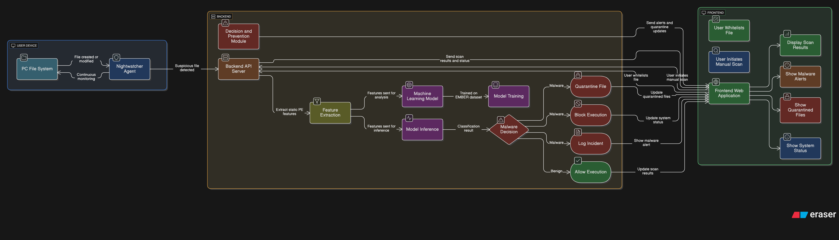

Task Division

Muhammad Hanan Zia -- Team Lead & Core ML/Backend Engineer
- Project planning, coordination, and integration.
- Developed ML model using EMBER dataset.
- Co-developed backend services for classification and antivirus operations.
- Coordinated integration between backend, frontend, and Nightwatcher agent.
- Supported version control and deployment setup

Kainat Naseem -- ML + Backend Developer
- Assisted in ML model training and evaluation.
- Shared backend development responsibilities with Hanan.
- Implemented backend logic for quarantining and antivirus detection.
- Integrated frontend with backend API
Muhammad Umer Tahir -- Frontend Developer
- Developed the web interface for file uploads, results, and alerts.

Future Improvements

- Extend classification to multi-class malware families.
- Add heuristic and behavioral detection features.
- Implement cloud-based threat intelligence updates.
- Improve agent efficiency and reduce resource usage.

