Department of Computing

School of Electrical Engineering and Computer Science

CS-250: Data Structure and Algorithms
Class: BSCS14 - ABC

Lab 3: Implementation of Linked List with its Operations

Date: 22th September, 2025
Time:
10:00am – 12:50pm
2:30pm – 4:50pm

Course Instructor: Dr. Ayesha Hakim

Lab Engineer: Ms Areeba Rameen

Name: Muhammad Umar Tahir

CMS ID: 507955

Lab 3: Implementation of Linked List with its Operations
Lab Tasks

Task 1 – Basic List Operations
Write a C++ program (using classes) to implement the following operations in a singly linked list:
- Insert a node at the head.
- Insert a node at a specific location in the list.
- Display the list.
- Count the number of nodes in the list.

//class of node
class Node {
public:
int value;
node *next;
};

void insertAtHead(int new_value);
void insertAtLocation(int location,int new_value)
void displayList()
void countList()

Solution
Solution
Task Code:
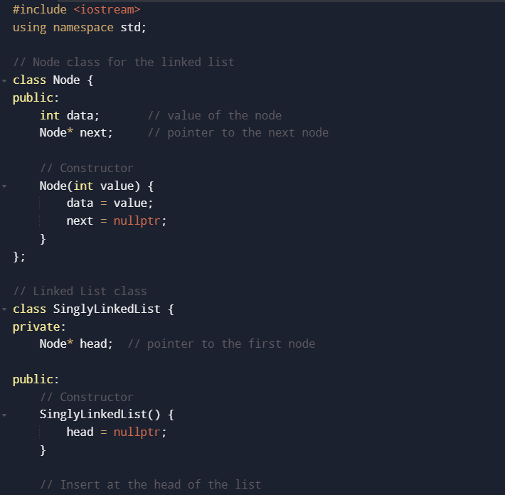
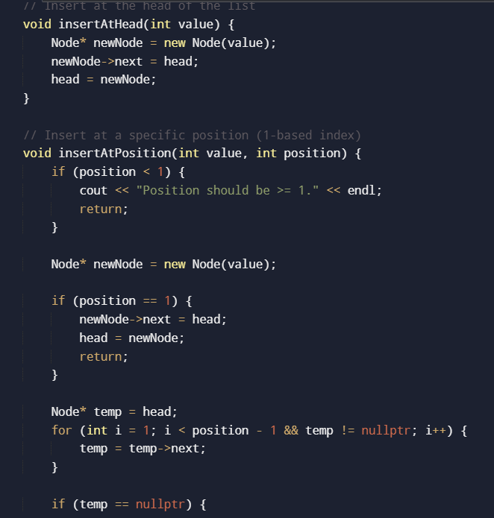
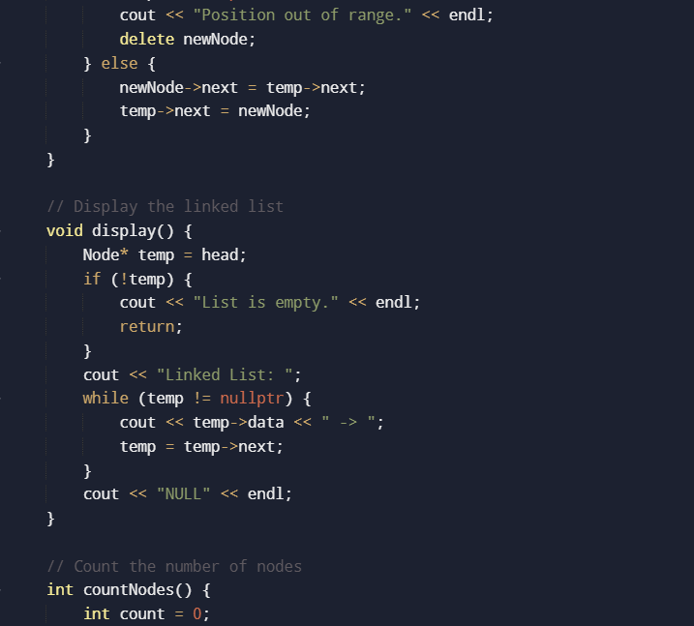
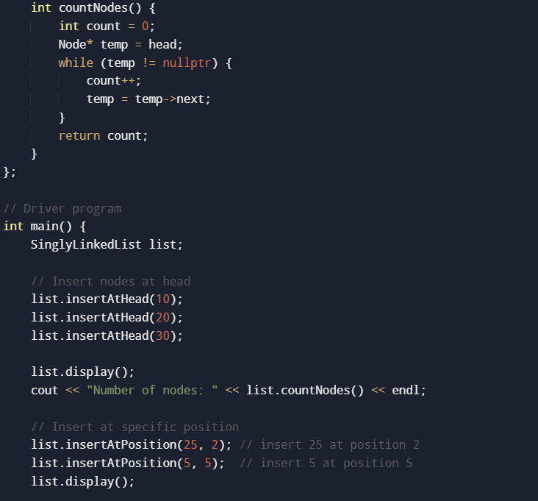
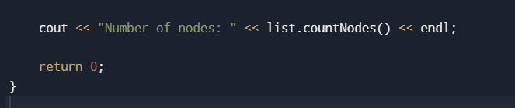
Task Output Screenshot:
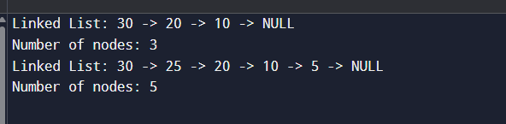

Task 2 – Deletion
Extend your singly linked list program to:
- Delete a node by value entered by the user.
- After deletion, display the updated list.
Solution
Solution
Task Code:
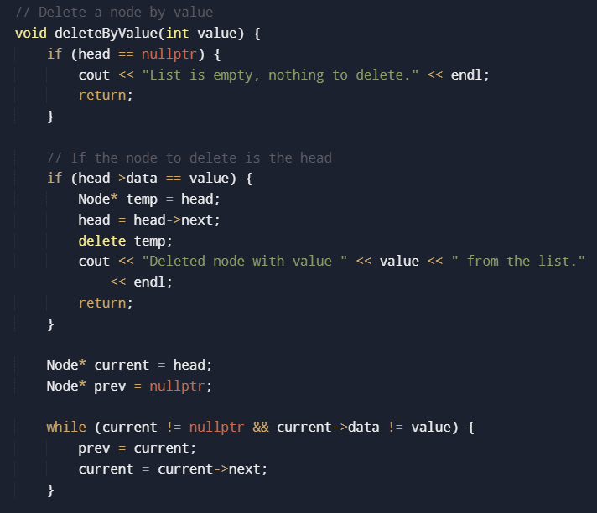
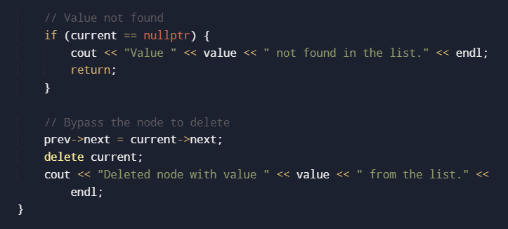
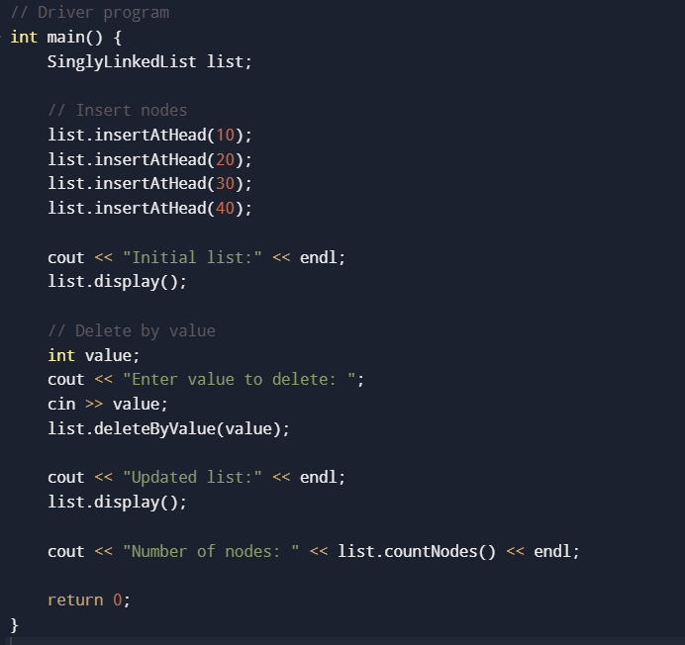
Task Output Screenshot:
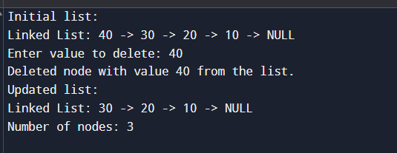

Task 3 – Palindrome check

Write a C++ program that implements a function to find out whether a linked list, containing words or numbers in its nodes, is a palindrome. Consider the entire linked list, not just the contents of each node
Examples:
- Numbers: 10 → 20 → 30 → 20 → 10 → Palindrome
- Words: "cat" → "dog" → "cat" → Palindrome
- Mixed (not palindrome)
Hint:
- Make a function isPalindrome() that returns true if the list is a palindrome, otherwise false.
- Test it on different lists (empty list, single node, even/odd number of nodes).
- You are checking the whole linked list order, not just each node’s content separately.
- Empty list or single-node list is always a palindrome.
Solution
Solution
Task Code:
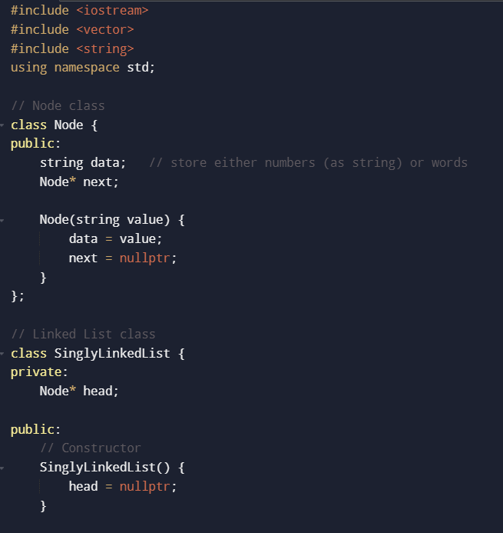
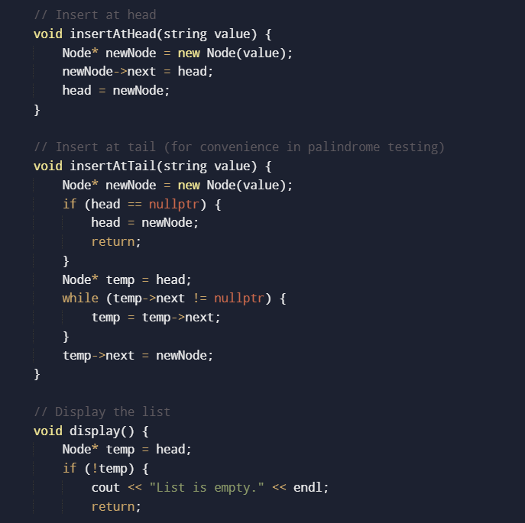
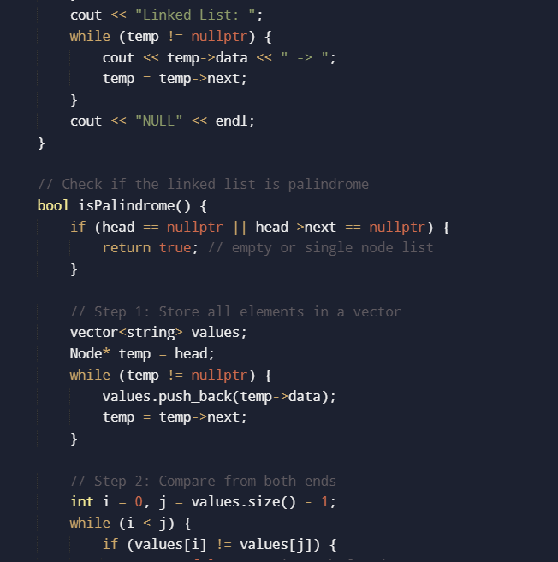
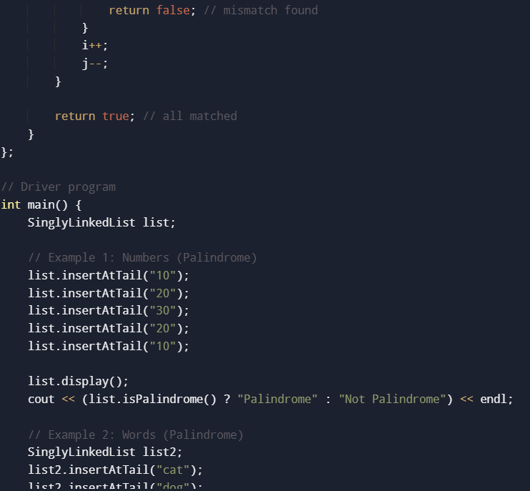
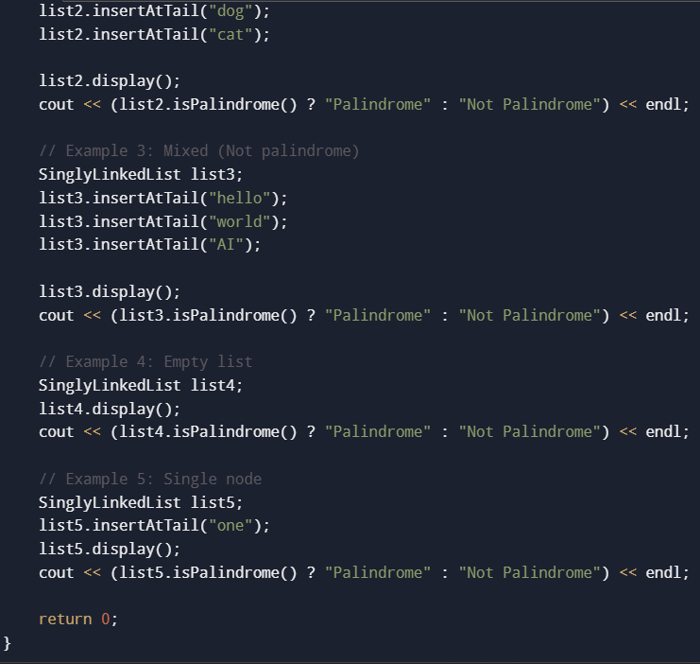
Task Output Screenshot:
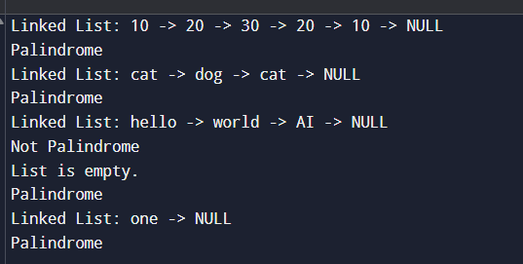

Task 4 – Rearrange List in Zigzag Order
Implement a C++ function that rearranges the elements of a singly linked list in a zigzag fashion such as L0 < L1 > L2 < L3 > ... (alternating increasing and decreasing values).
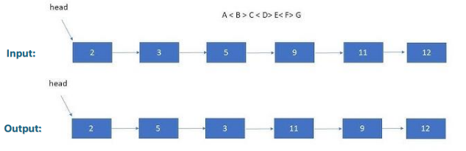
Example:
- Input: 4 → 3 → 7 → 8 → 6 → 2 → 1
- Output: 3 → 7 → 4 → 8 → 2 → 6 → 1
Hint:
- Traverse the list once and swap values between adjacent nodes when needed.
- Use one loop and at each step decide whether to swap or not.
Solution
Solution
Task Code:
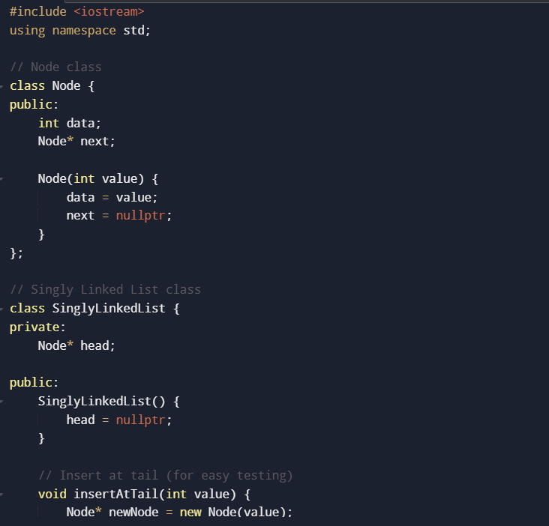
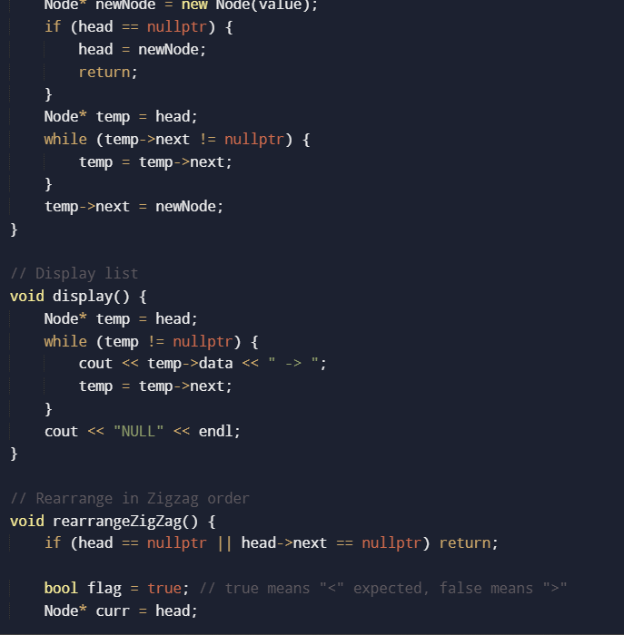
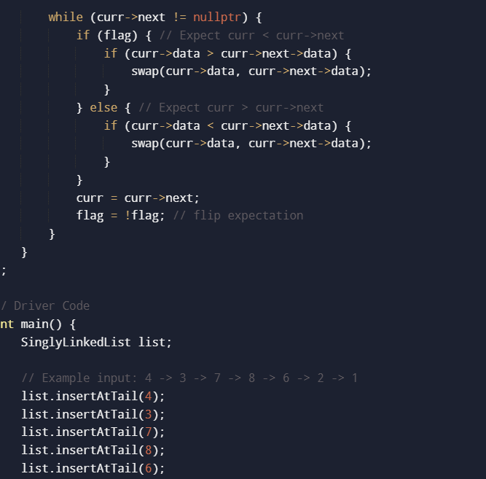
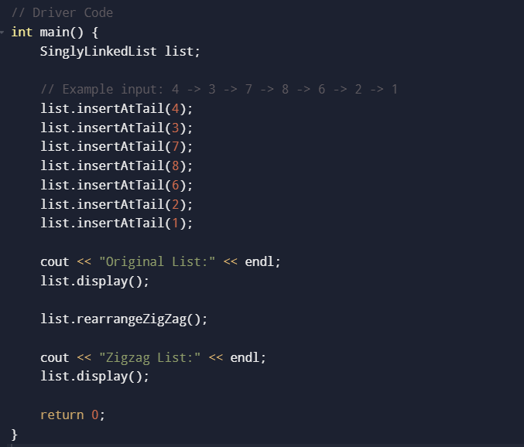
Task Output Screenshot:
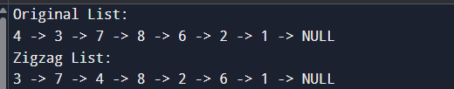

Doubly Linked List & Circular Linked List (CLL)
Home Tasks

Task 1
Generate an m x n matrix that contains the integers in the linked list presented
in spiral order (clockwise), starting from the top-left of the matrix. If there are remaining empty
spaces, fill them with -1.
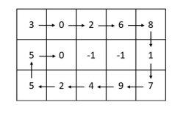
Source Code:
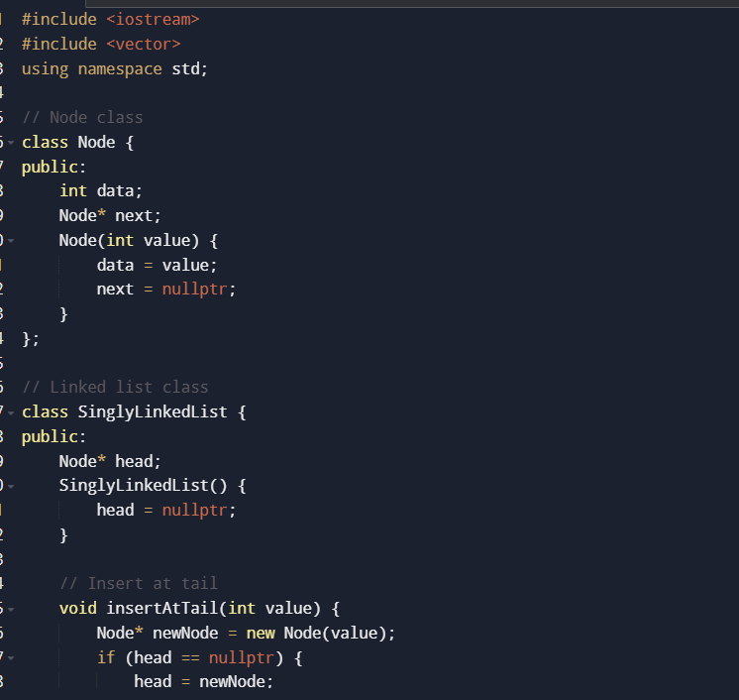
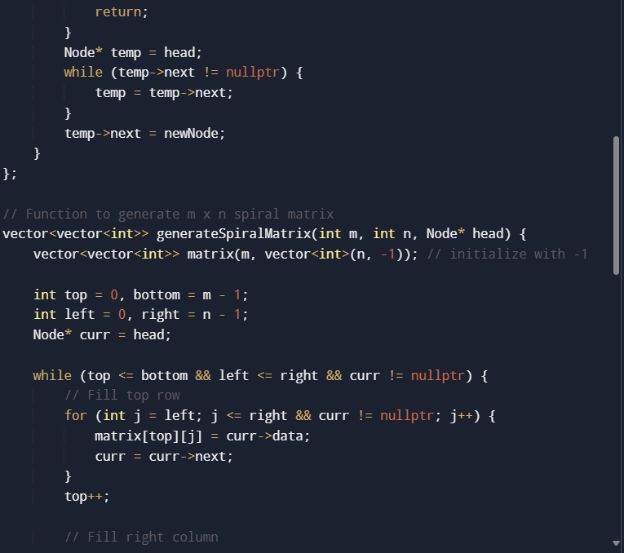
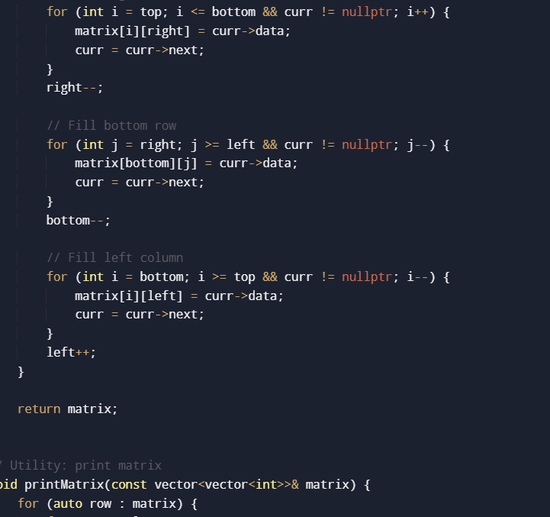
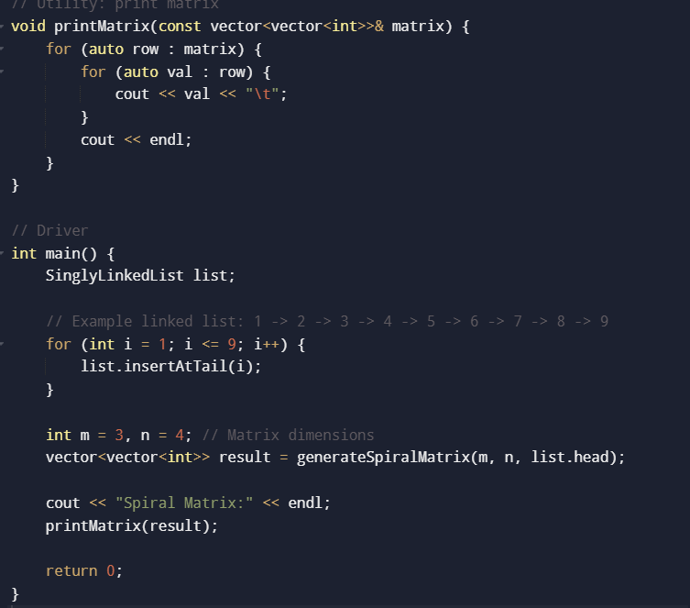

Output:

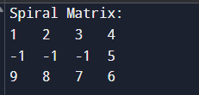

Task 2
Write a C++ program that flattens a multilevel doubly linked list where each node may have an additional child pointer pointing to another doubly linked list. The child nodes need to be inserted into the parent list at the appropriate place.
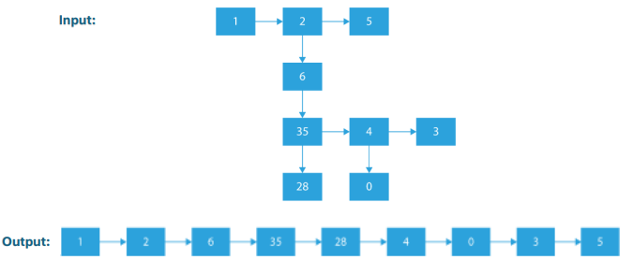

Source Code:
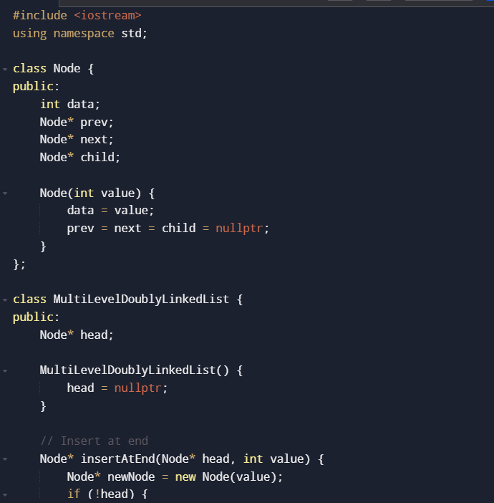
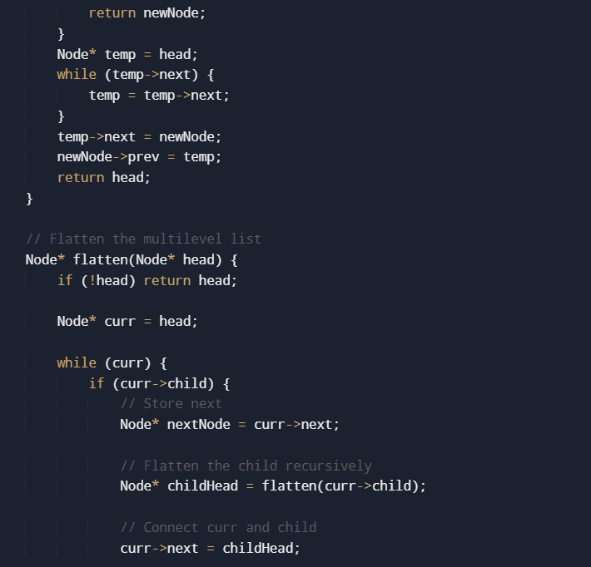
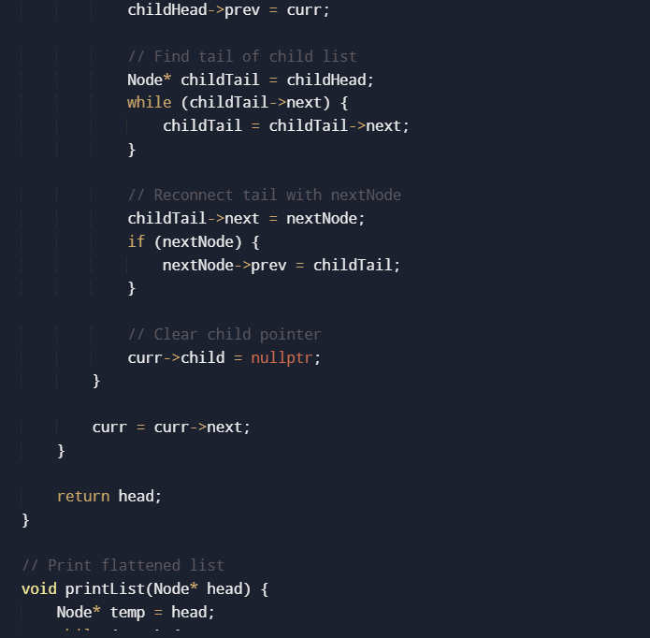
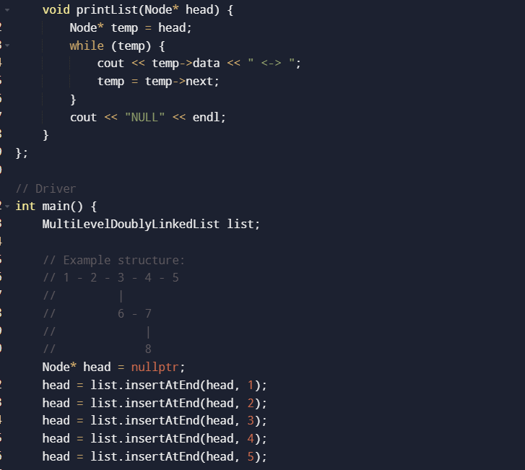
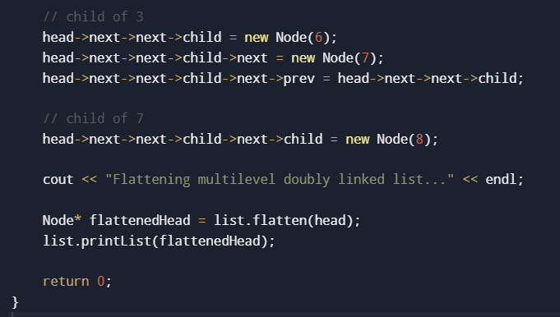
Output:
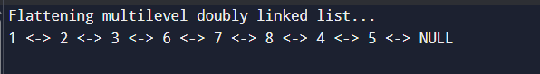
Task 3
Implement a function to rotate a singly circular linked list to the left by N terms.
Source Code:
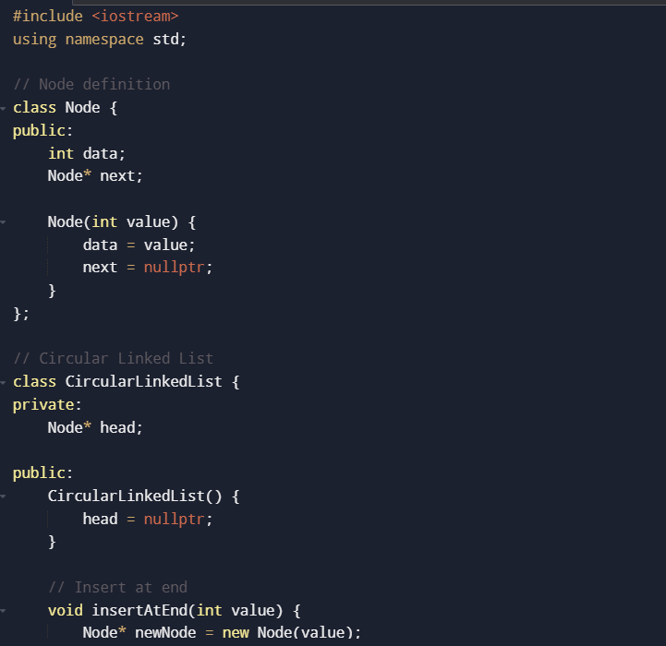
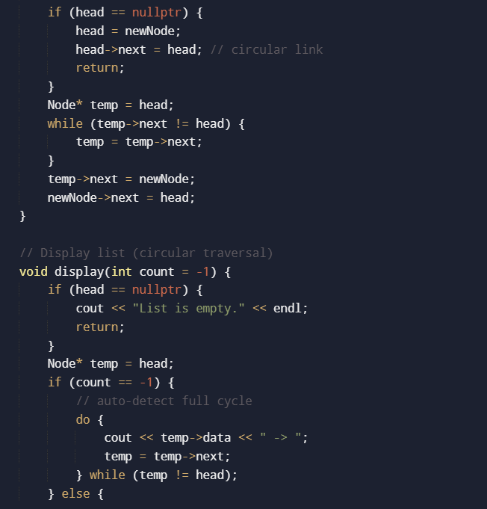
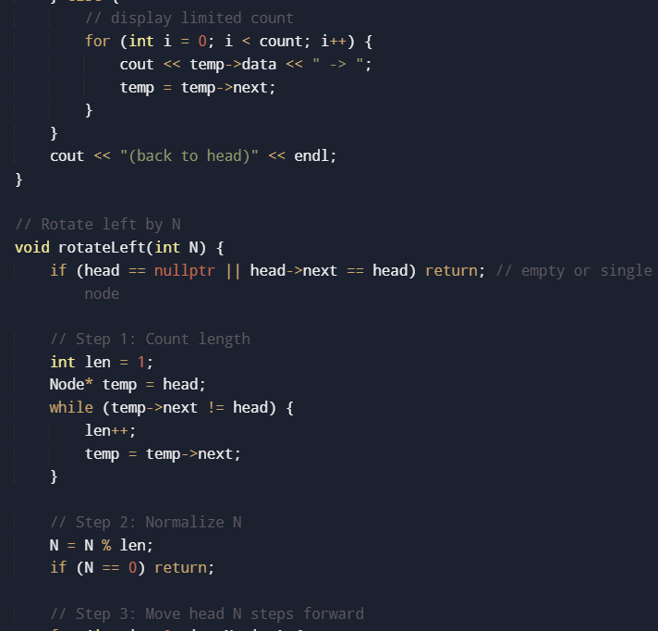
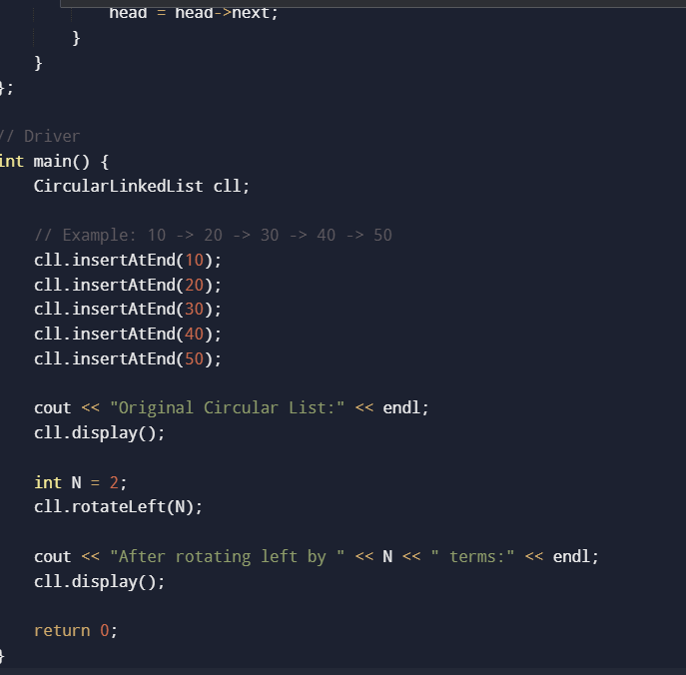
Output:
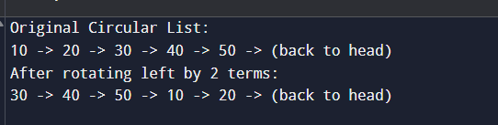

Task 4
Implement a C++ program that sorts a list of lists (2D vector) according to the length of the sublists. The list contains elements that are lists themselves. The task is to sort the elements of the list according to their length e.g. short lists first, longer lists later, or vice versa.

Source Code:
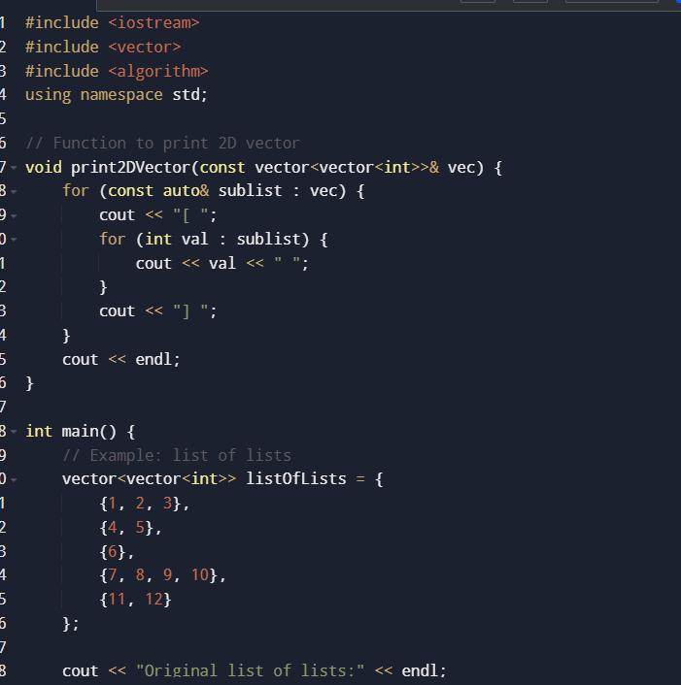
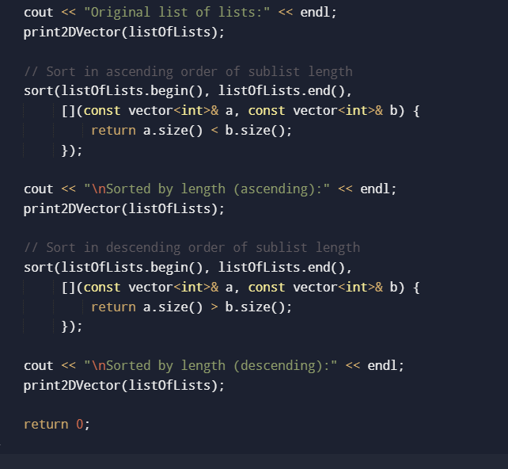
Output:
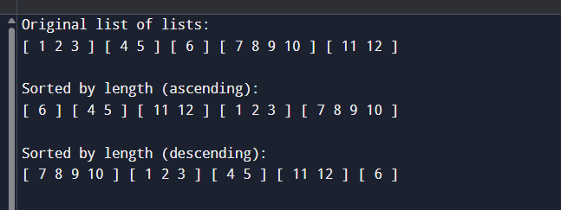
Task 5
Design a program that sorts a list of lists based on the frequency of their lengths i.e. in the default, sorting is done ascendingly, lists with rare lengths should appear first, and lists with more frequent lengths should come later.
Example:
scala> lsortFreq(List(List('a, 'b, 'c), List('d, 'e), List('f, 'g, 'h), List('d, 'e), List('i, 'j, 'k, 'l), List('m, 'n), List('o)))
res1: List[List[Symbol]] = List(List('i, 'j, 'k, 'l), List('o), List('a, 'b, 'c), List('f, 'g, 'h), List('d, 'e), List('d, 'e), List('m, 'n))

In the above example, the first two lists in the result have length 4 and 1 and both lengths appear just once. The third and fourth lists have length 3 and there are two list of this length. Finally, the last three lists have length 2. This is the most frequent length..

Source Code:
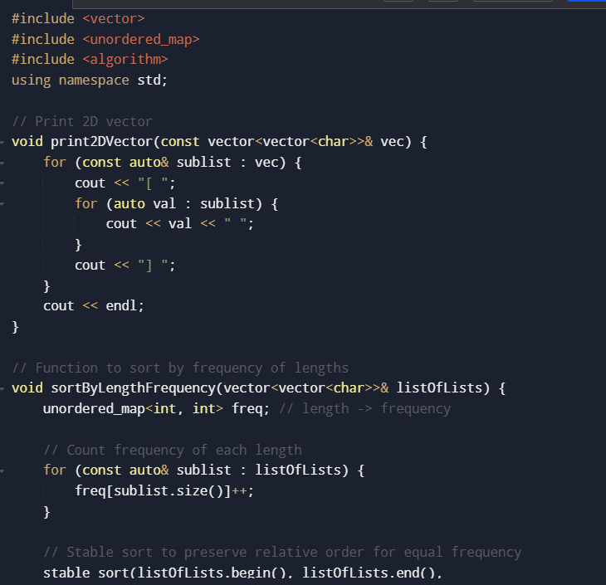
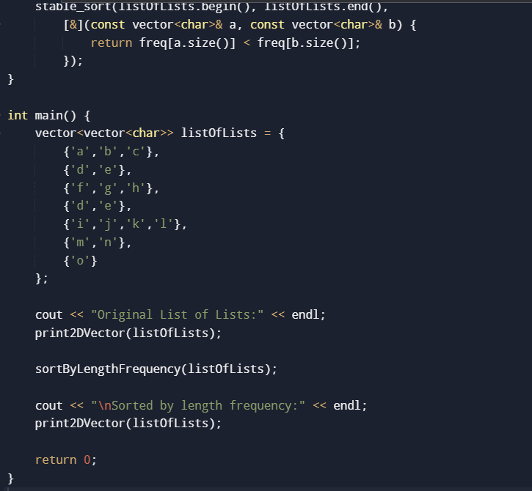
Output:
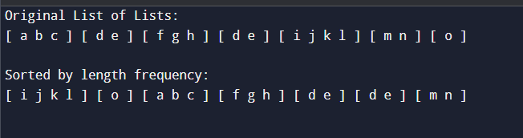

Deliverables
Compile a single word document by filling in the solution part and submit this Word file on LMS. Insert the solution/answer in this document. You must show the implementation of the tasks in the designing tool, along with your complete Word document to get your work graded. You must also submit this Word document on the LMS.

