DEPARTMENTOFCOMPUTING
CS-353: Information Security Class: BSCS-14ABC
Lab 08: Advanced Encryption Standard algorithm
CLO-3: Assembles information security solutions by applying key concepts using a variety of tools and techniques
Date: 29th Oct 2025
Time: 14:00 - 16:50 / 09:00 - 11:50
Muhammad Umer Tahir
507955
Lab Instructor: Mr. Moeed Ahmed
Class Instructor: Dr. Muhammad Ashraf
Lab-08: AES Algorithm
Lab Tasks:
Data Encryption
- Original data is encrypted using AES-256-ECB algorithm
- Each student receives unique encrypted data
Encryption Key
- All encryption keys are stored in an Excel file (ENC_KEYS.xlsx)
- Each key is encrypted using a Caesar cipher on hexadecimal digits (0-15)  The shift value is unknown to each student
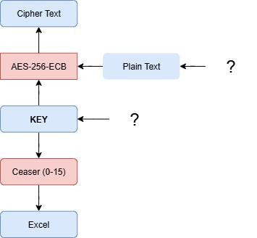
Steps:
- Extract encrypted keys from the Excel file
- Apply all possible Caesar cipher shifts (0-15) to each key
- Attempt decryption of the data using each potential key
- Identify the correct plaintext through brute-force testing
Deliverable:
- Create a report that shows your code for converting encrypted keys and decryption. Paste screenshots showing your steps for all tasks (don’t crop any screenshot).
- Submit your code files for Caesar shifting of keys and brute-force decryption of respective data.
- Finalize the document in a well structured manner. Save the file with your name and registration number and upload it on LMS under submission link before the deadline.

ScreenShots:

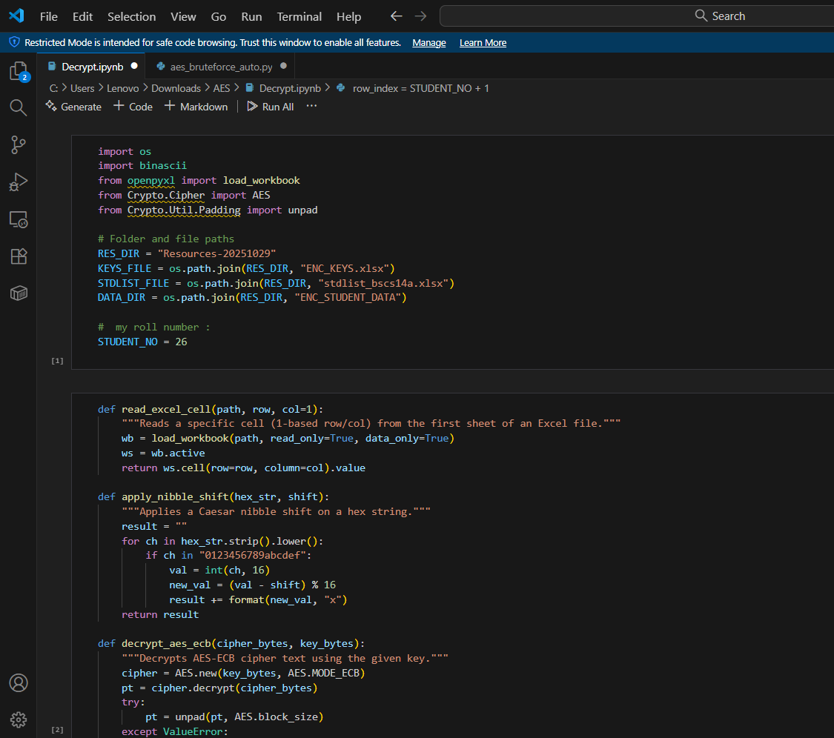

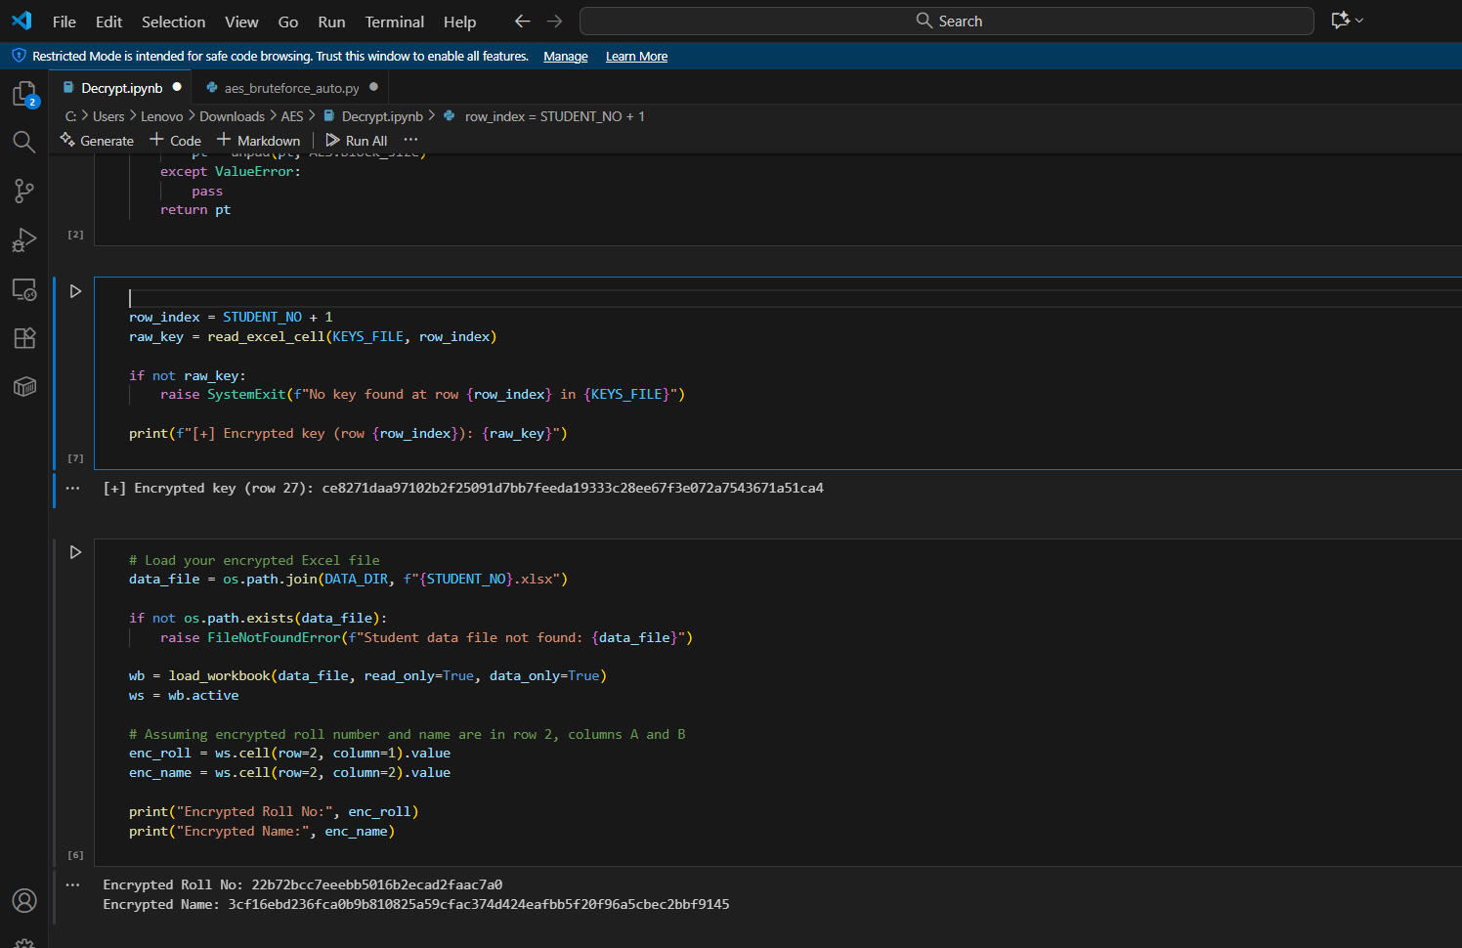

OUTPUT:

