

Course Name: Human Computer

Interaction

Course Code: HCI162

Dr. Sameh Abosamra

Research Project

Pharos University in Alexandria

Faculty of Engineering

Computer Engineering Department

Spring 2019 – 2020

***Group Name: M_Ismael***

1. ***Hager Mahmoud Moussa***
2. ***Hanan Fouad Ibrahim***
3. ***Menna Mohamed Ismael***
4. ***Mahmoud AbdelAzeim Mahmoud***

***Description***:

There is a civil engineer who wants to follow up her finishing operations of a 10 level tower. Currently, she has 3 types of operations in each level which are done by:

* Plumbers
* Painters
* Clean workers

This paper discusses the design of a web-based system to enable this engineer to follow up the operations needed.

***Solution:***

1. **An interview is conducted to discuss the users’ characteristics, needs, and goals.**

* **Interviewing the Manager(Civil Engineer):**

**Interviewer: Tell us more about your Management Company.**

**Manager: We seek out to handle a certain pool of resources owned by a given fund, normally managed by a team of experts. Our mission is to submit a professional design, construction, and maintenance of our buildings.**

**Interviewer: What is the purpose of this website?**

**Manager: My team and I are looking forward to manage/complete any given task using an automated service. As a manager, I’m looking for a website that allows me to monitor and navigate my work from home. I also want my website to help me assign tasks, and add/remove workers.**

**Interviewer: Do you want to converse with your workers via your website?**

**Manager: Yes, that would be very useful.**

1. **A System Sequence Diagram Scenario is created based on the client’s needs.**

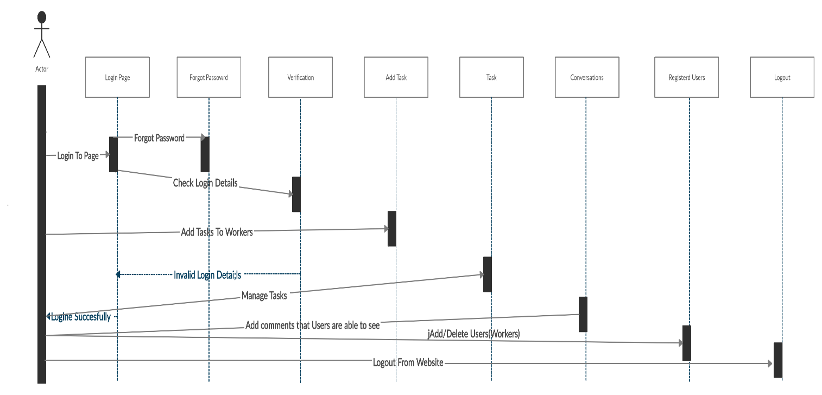

1. **The Initial Screen Design:**
2. **Signing In:**

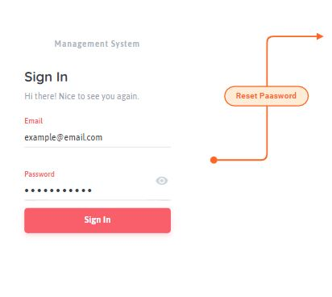

1. **Reset Password:**

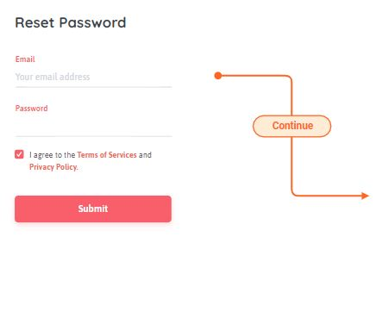

3) Main Page

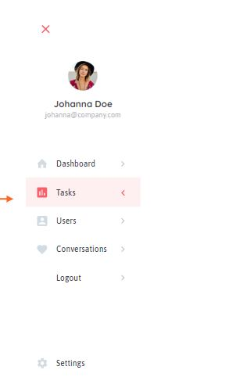

4) Pending Tasks

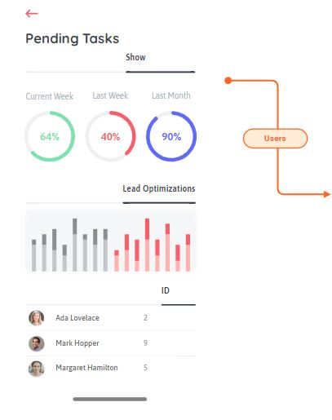

1. Manage Users

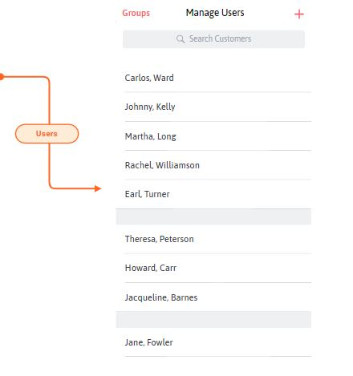

1. Connecting these Pages Together:

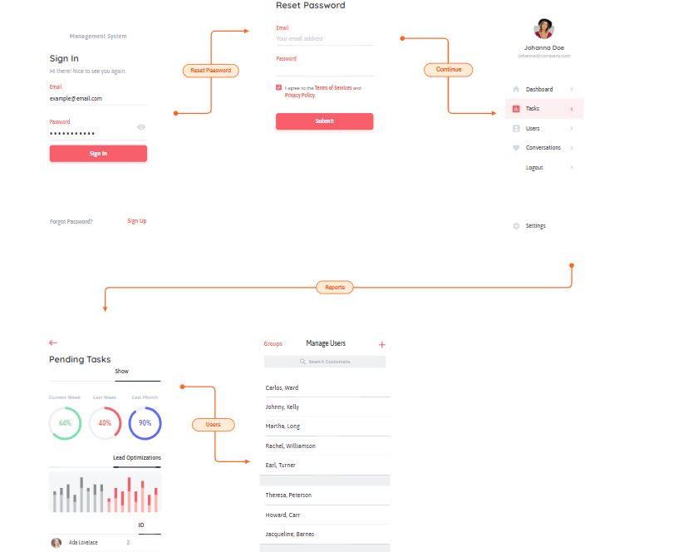

Designed using: <https://app.moqups.com/>