**Twitter, sentiment analysis and Denodo**

# Creating a custom function

1. **Install the trained classifier**
2. **Install eclipse**
3. Configure Eclipse to run with Java 11.
4. Installing Denodo4eEclipse Pulgin

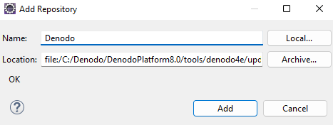

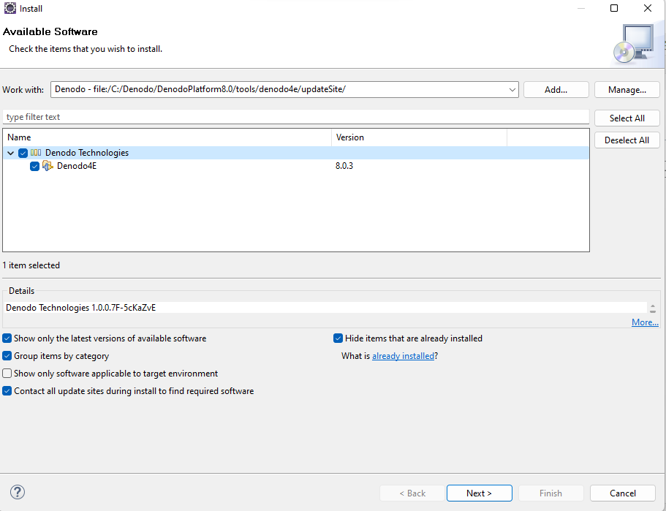

1. To create the Denodo Custom function project, go to File > New > Other and type denodo in the textbox.

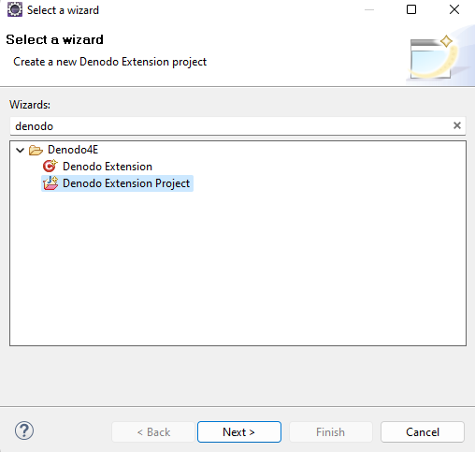

1. 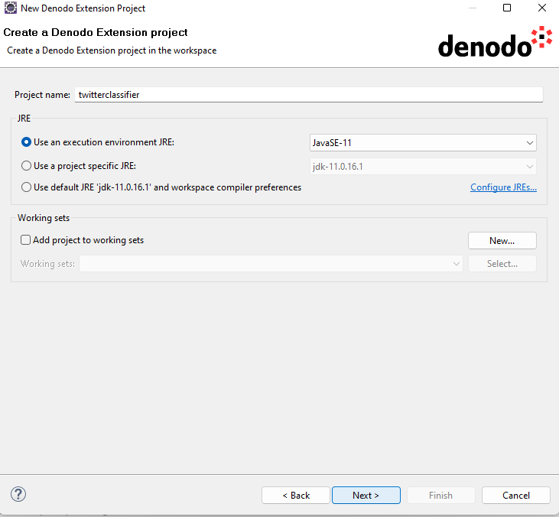
2. 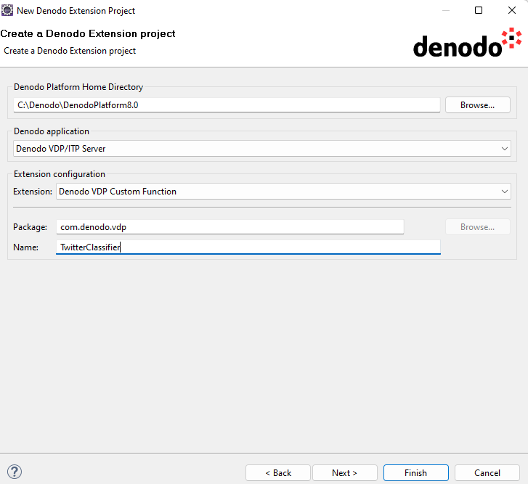
3. we need to import the following libraries jar files from the LingPipe distribution: ● lingpipe-4.1.0.jar ● log4j.jar

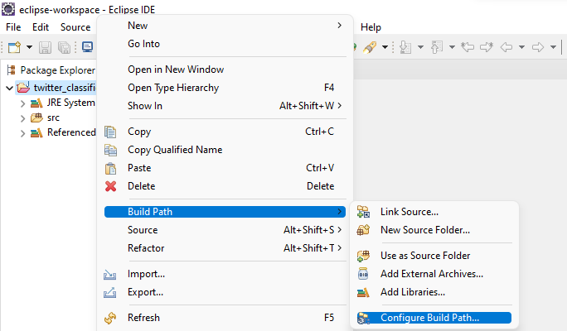

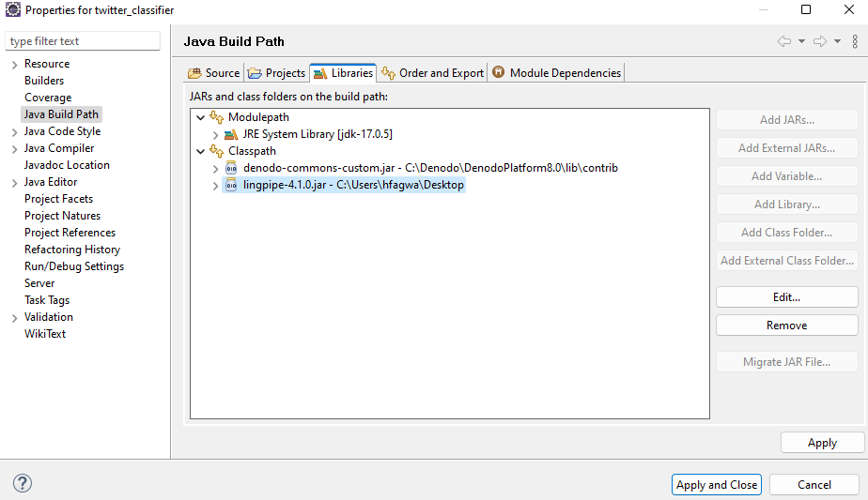

1. Back to the code of the custom function we will need define a constructor in our class to load the classifier as follows:

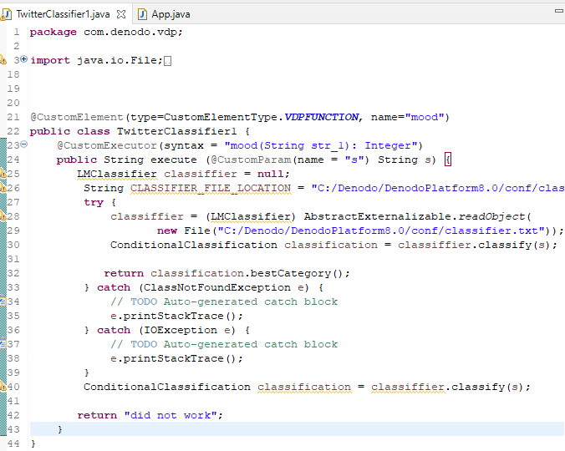

1. Debug

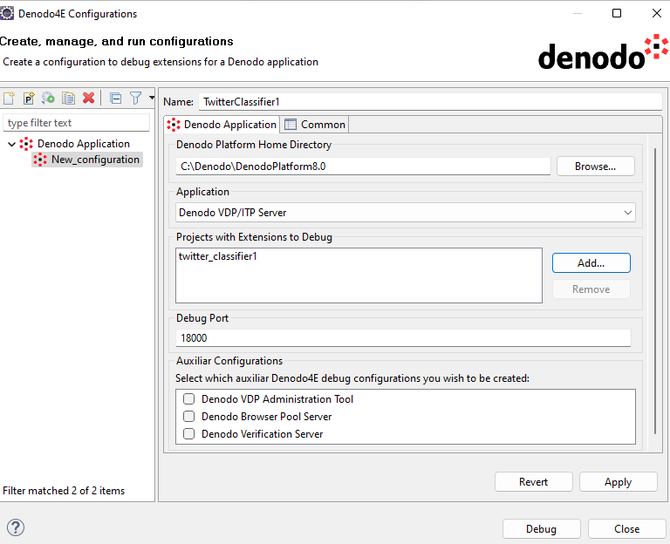

1. Export the project

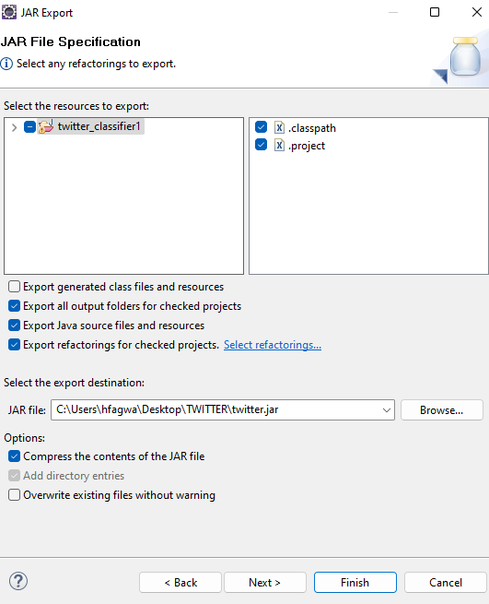

1. Import Extensions in Denodo

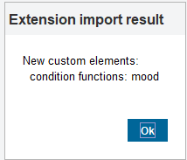

1. Test

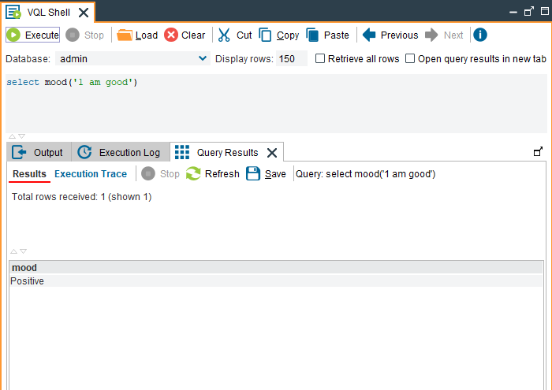

1. Create a JSON Datasource

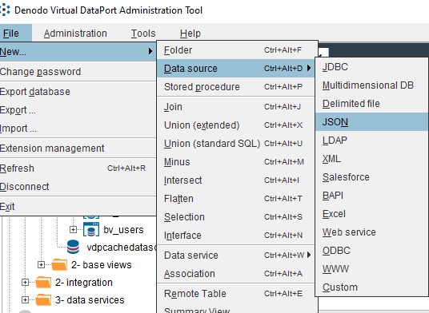

1. Connecting Denodo with Twitter

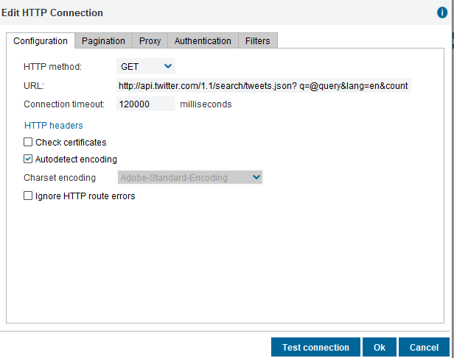

1. 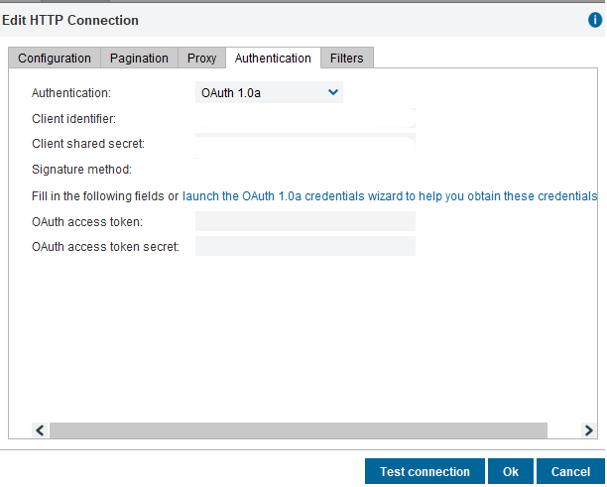
2. 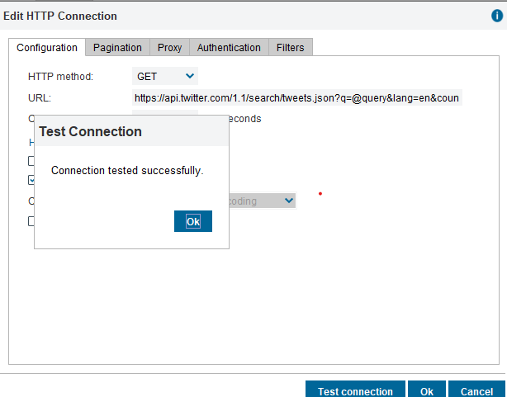
3. Create a base view

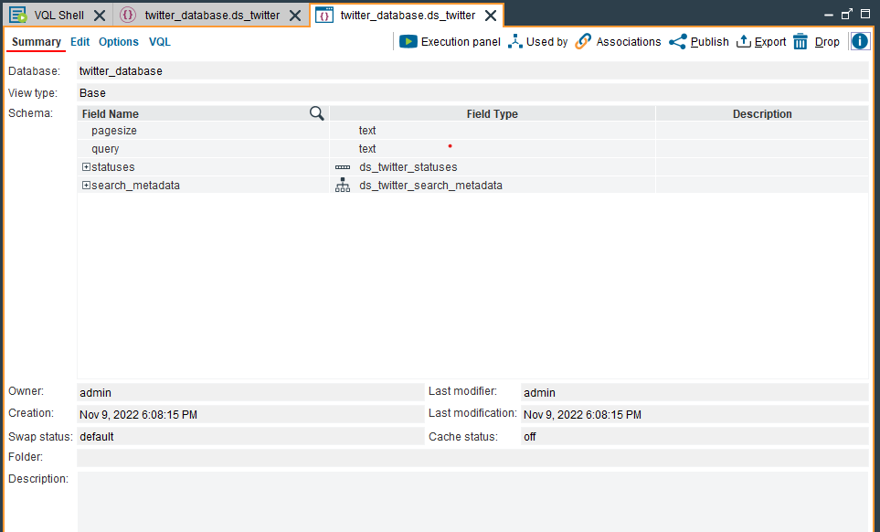

1. Create a flatten view

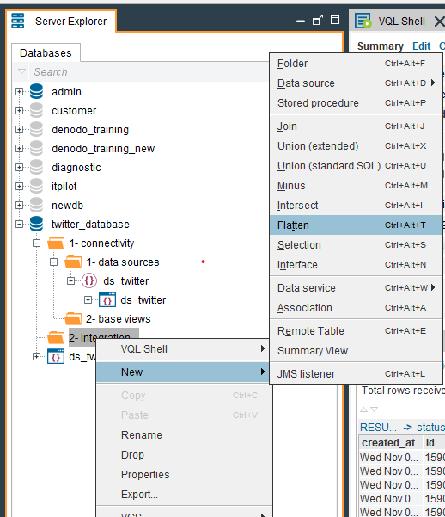

1. Add a new field sentiment with field expression mood(text)
2. 