Mobile App Design Document

# 1. Mobile App Title

App Title: '**Gordin's Butcher Shop App'**

# 2. App Goals and Objective

The 'Gordin's Butcher Shop App enables users to access online meat shopping either for people who love meat or individuals interested in healthy dietary choices. Through this app customers now possess a straightforward method to obtain premium meat goods from their mobile devices. The primary goals are:

The application should provide an easy-to-navigate interface to optimize customer product selection.

The app will establish safe payment methods which enable users to conduct transactions conveniently.

The platform will enable customers to communicate with the store though review submission combined with photo sharing.

The company aims at delivering superior customer service through prompt notifications about order developments.

# 3. Why are you developing this app?

Modern life speeds up consumers to buy products online since shopping for groceries belongs to this category of needs. Through the 'Gordin's Butcher Shop App' customers receive their quality fresh meats quickly since they no longer need physical store shopping. Technologically savvy customers constitute the target market for the platform because it provides them with easy premium product access anywhere.

# 4. Features for the App

The 'Gordin's Butcher Shop App' includes several essential characteristics as follows:

User Authentication functions through secure Login and Sign Up procedures that enable personalized shopping becomes possible.

Users can browse through product listings which display Beef Steak together with Lamb Chops among other items along with images and prices.

Every product shows detailed descriptions and its cost and includes a shopping cart addition tool.

Users can maintain a shopping cart through product addition which leads them to ordering procedures seamlessly.

Users maintain the ability to give product reviews and submit image documentation with annotations through the review system following their purchase completion.

Push Notifications: Updates on cart status, promotions, or order-related notifications.

Users access a profile management feature that enables them to see and alter information including name and email as well as phone number.

Advanced Features provide two key capabilities which include geolocation for store location identification and cloud storage for secure user data management and camera features for review.

# 5. Target Audience

The primary target audience for this app includes:  
• Meat Enthusiasts: People who prioritize high-quality meats in their diet.  
• Health-conscious Shoppers: Consumers who are looking for fresh and organic meats.  
• Busy Professionals: Individuals who prefer convenience and online shopping.  
• Tech-Savvy Users: Customers comfortable with using mobile apps for shopping.

# 6. Market Research

Several business entities operate in the developing online grocery market which focuses on fresh meat purchases. The delivery services provided by various existing apps target meat and grocery products but 'Gordin's Butcher Shop App' differentiates through its exclusive focus on first-class meat products. Customer demographics interested in fresh product quality as well as dealers will be attracted by the specialized offering. The designed application targets customers who prioritize smooth online ordering together with simple product assessment options. We stand apart from other companies because we serve premium meat products alongside a user-friendly interface for customers.

# 7. Sketches/Wireframe Screenshots

Additional media files show the arrangement of the application's interface design. The wireframes display structural information about the app together with navigation paths for users.

The screenshots are as follows:

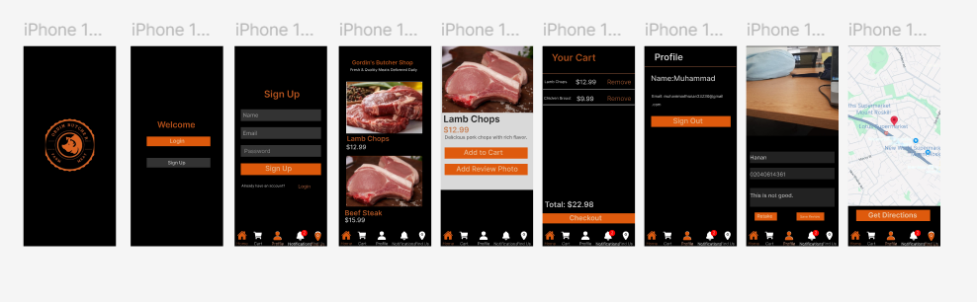

**Figma** Link: <https://www.figma.com/design/WLDWtRpLLZYVONW6GnnPWN/Gordins-Butcher-Shop?node-id=0-1&t=wPqIzVgctWaohJTG-1>

# 8. UX Design Overview

The application puts strong emphasis on delivering an excellent user experience. A modern attractive theme emerges through dark palette and orange touches that build a welcoming and contemporary atmosphere. The application displays an intuitive layout containing specific command buttons known as 'Add to Cart,' 'Sign Up' along with 'Add Review Photo.' Users can easily view their purchase items thanks to high-quality page images combined with clean content presentation.

# 9. App Testing Methods and Proof for Testing

Each testing stage of the app will validate correct operation and user experience flow before completion. The testing methods will include:

Unit Testing: Ensuring individual components like login, product display, and cart functionality work properly.

The testing checks different components including cart system and checkout process for integration functionality.

The app's functionality will be assessed by real users through User Acceptance Testing (UAT) which leads to continuous feedback so the app gets refined.

A device testing process involves checking the function of the app on different devices along with various screen sizes to ensure platform compatibility.

**Testing on Andriod Phone:**

 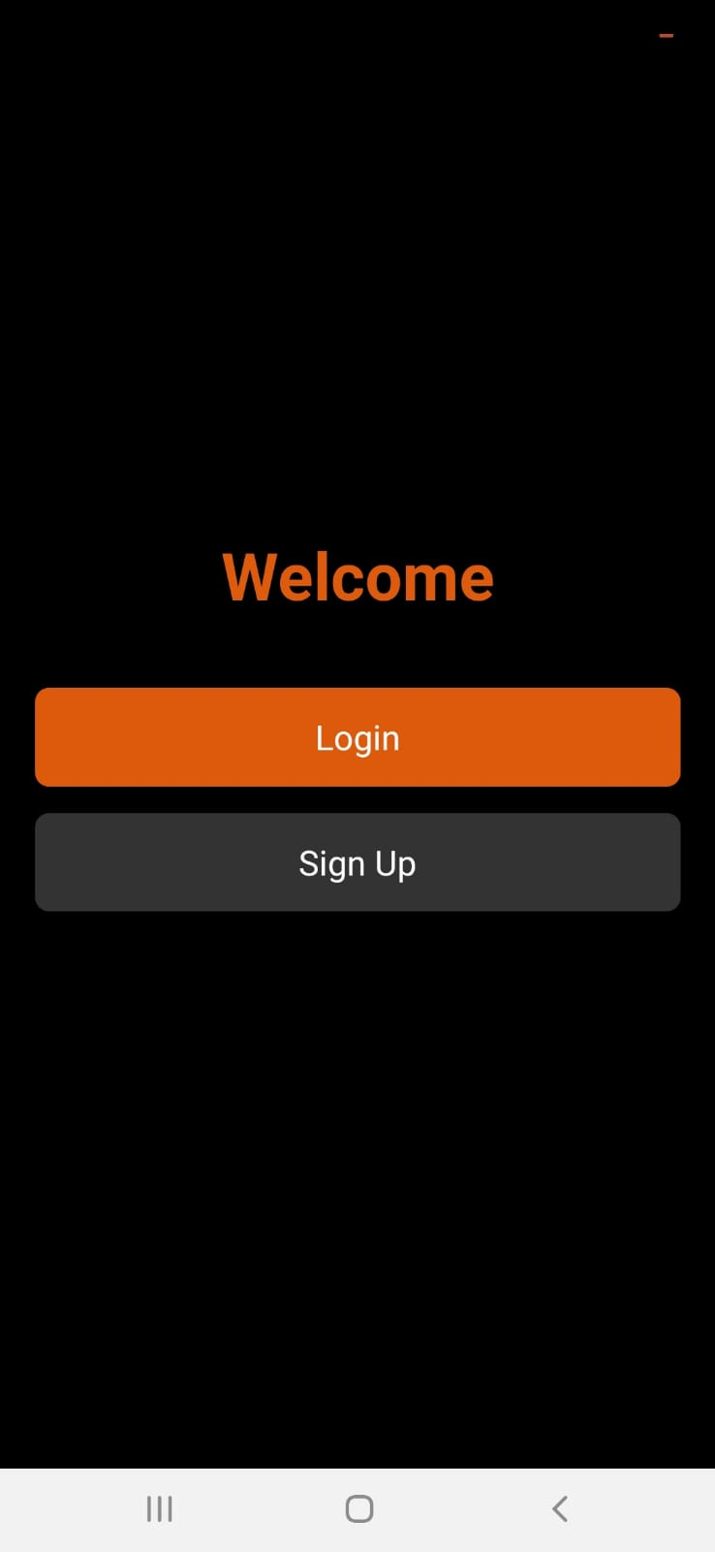 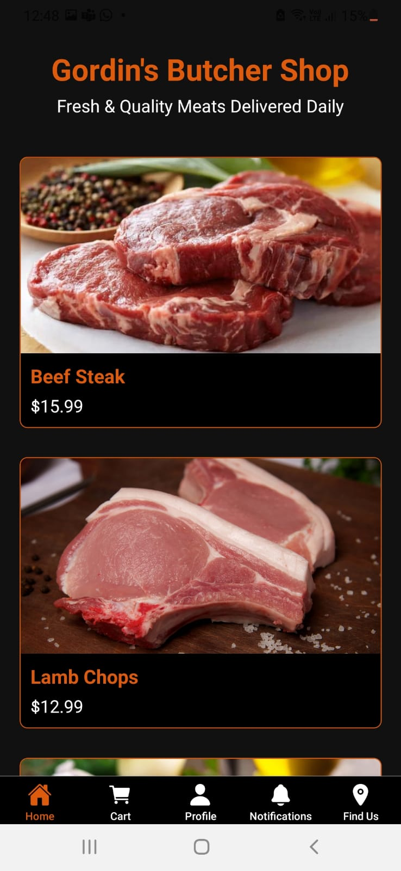 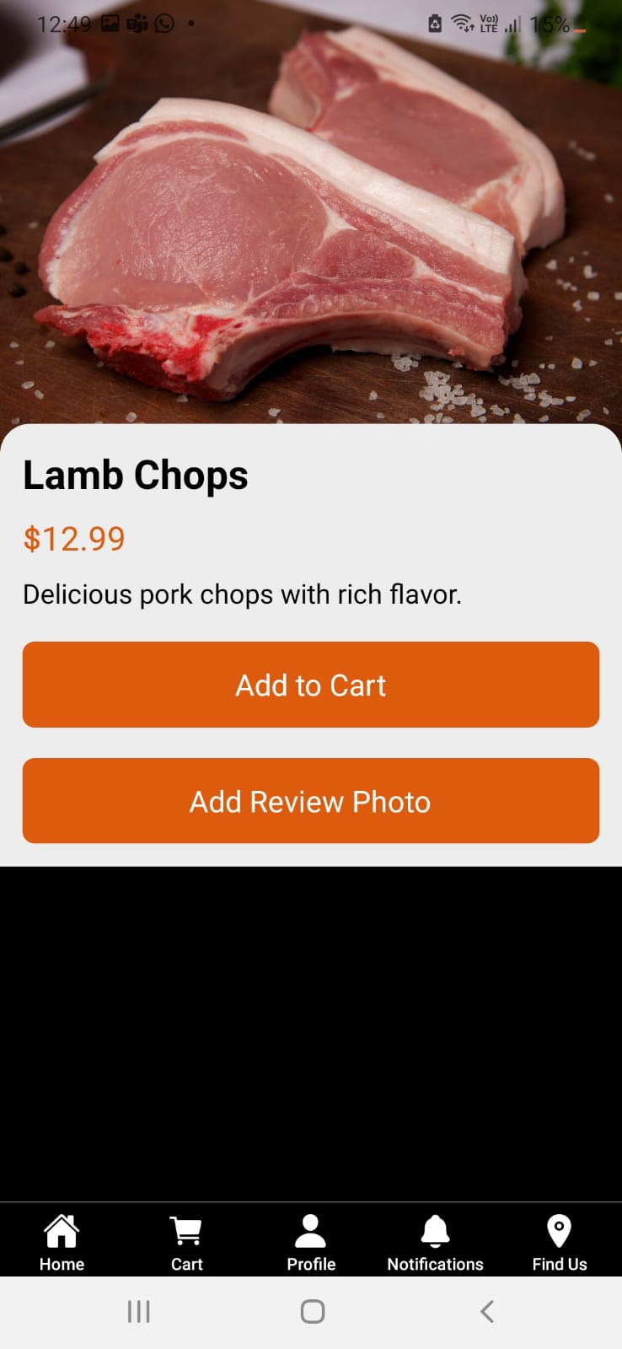 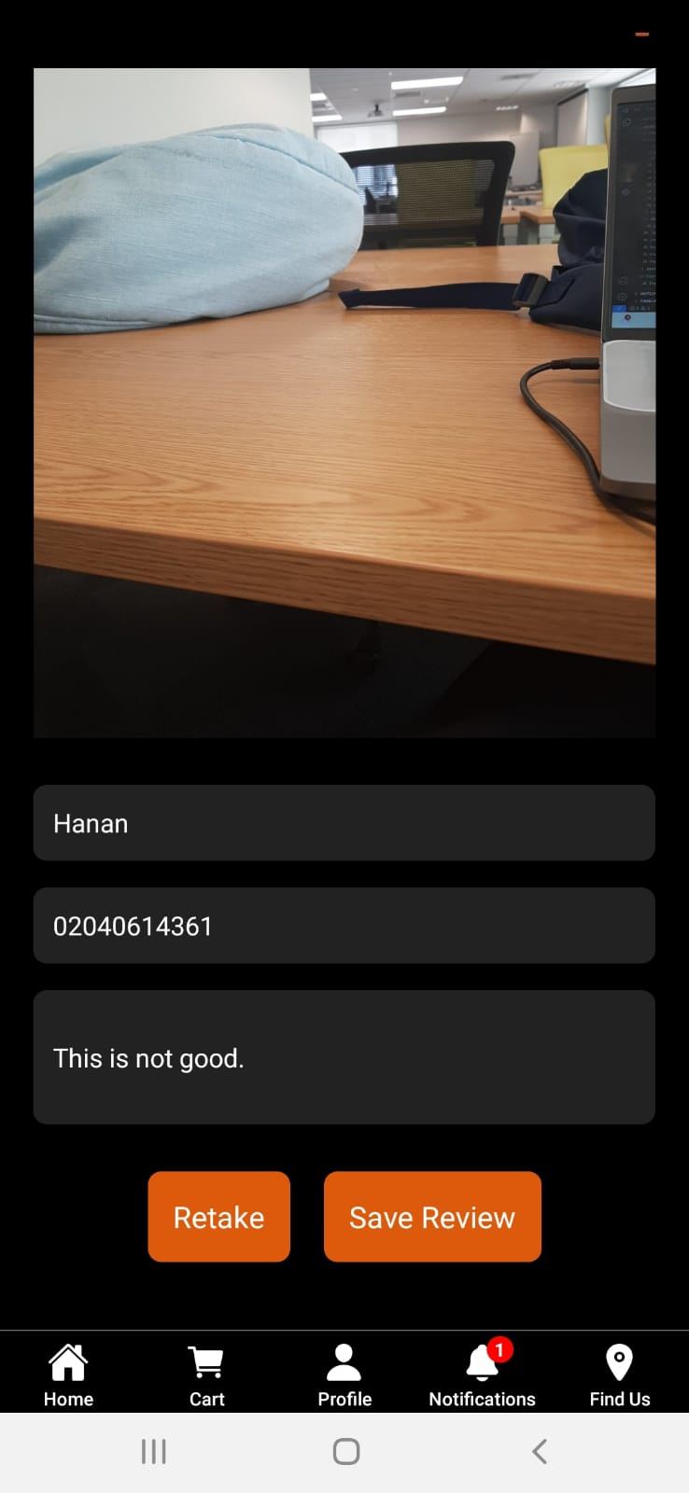 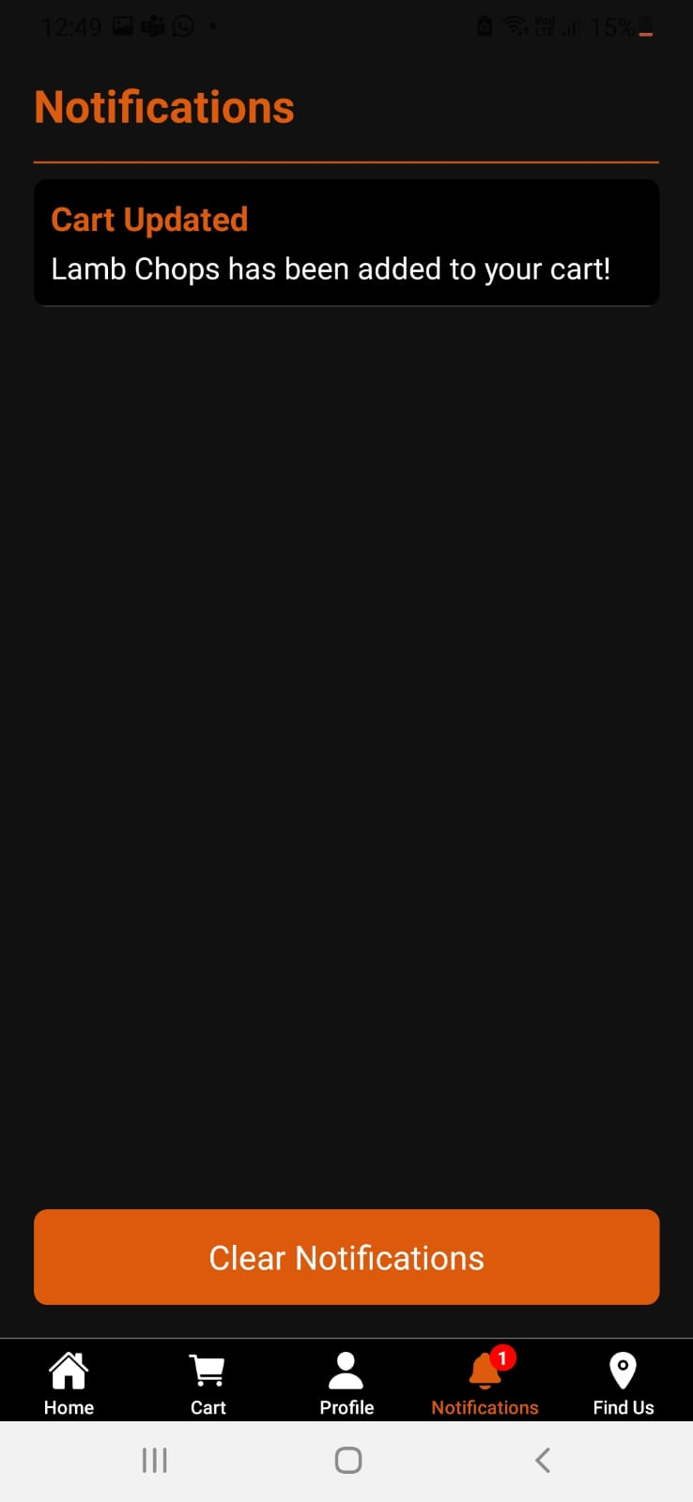 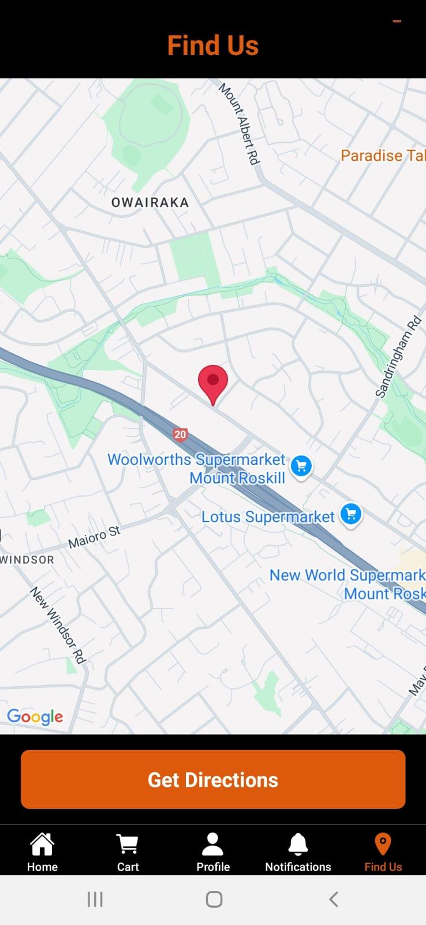 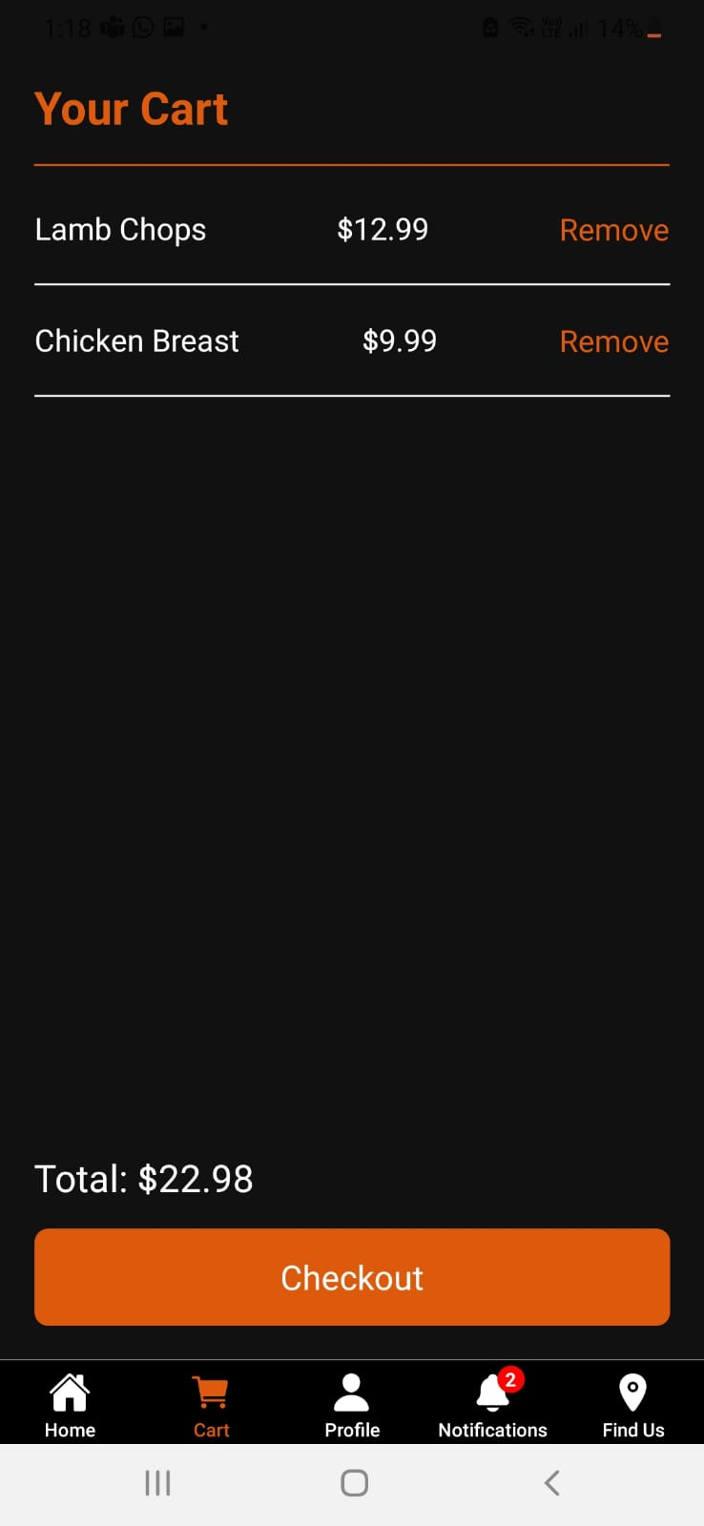 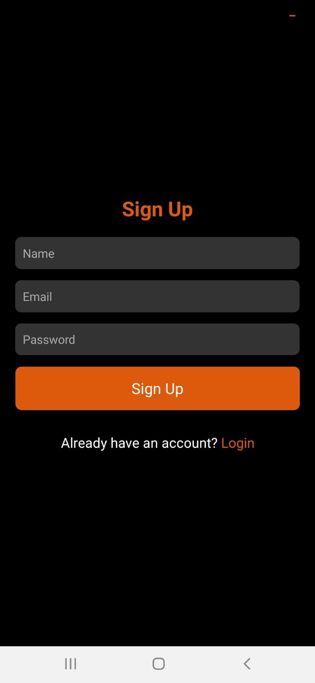

**Testing on Tab:**

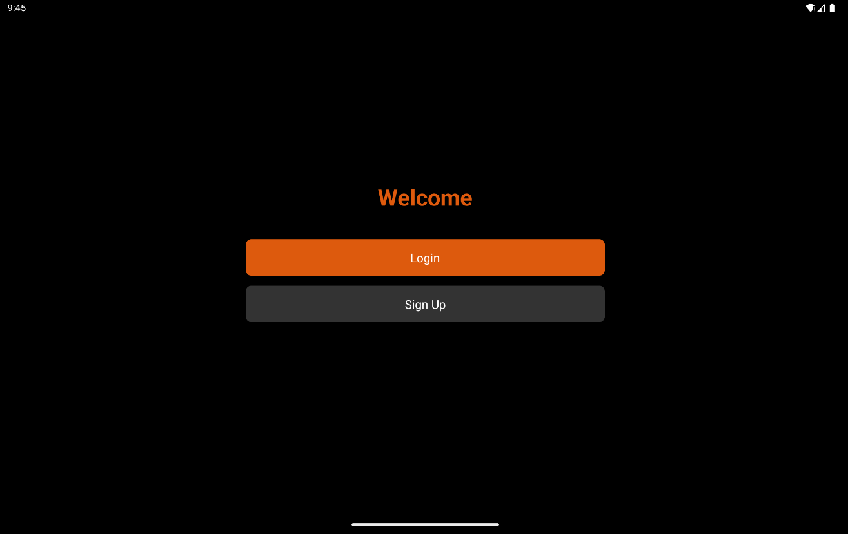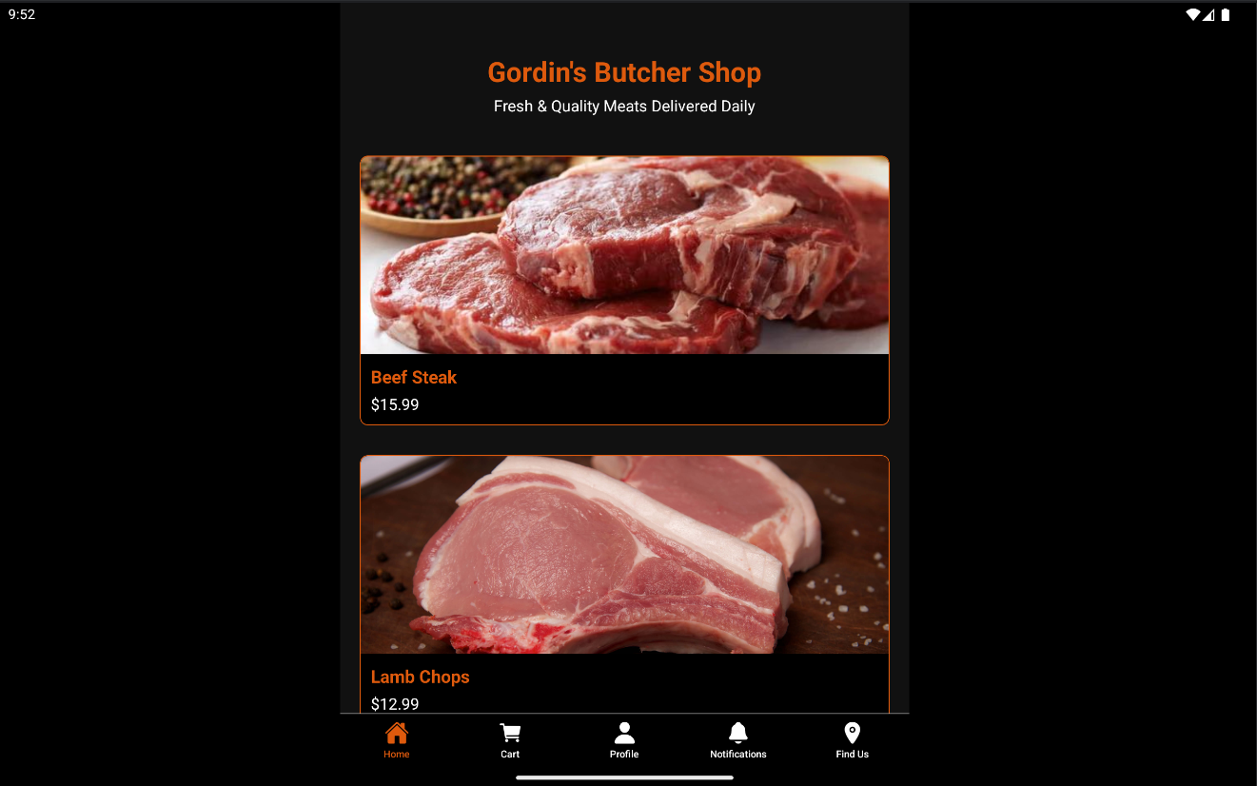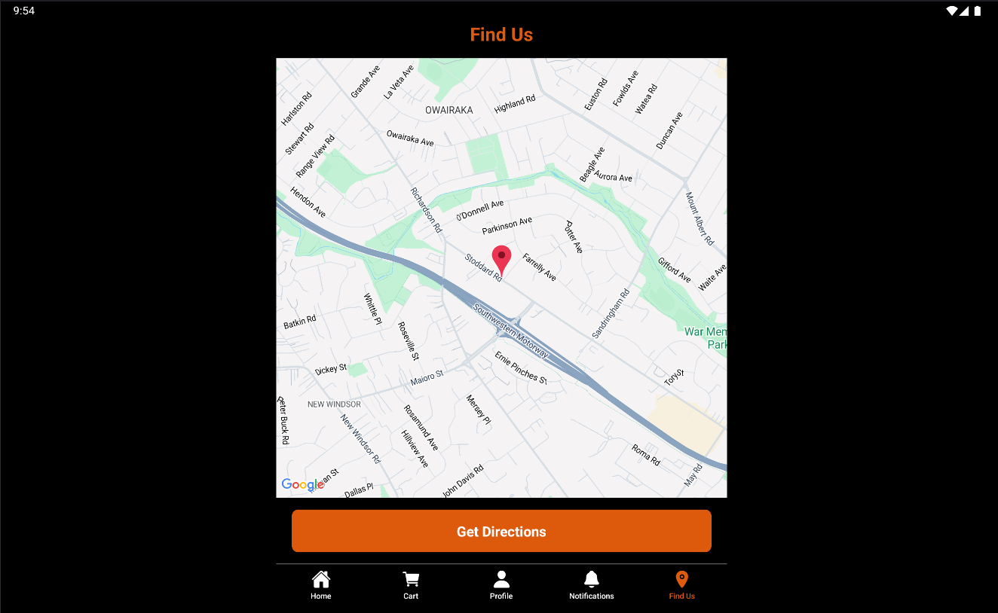

**Users feedback :**

1. **First User:**  The application is pretty easy to use but needs more work in the feedback system the feedback should be gone through the email.
2. **Second User:** The application is designed very great and very helpfull for the peoples looking for the quality meat and very impressive.

# 10. Advanced Features:

The app implements two key advanced features:  
• Geolocation: The app can identify the user's that where the actual store is located.

• Camera Review Capture: The app can capture the picture of the stuff that bought from the store and can provide the review and can save the image in the phone gallery.

• Push Notification: The app can provide the notification when something is added in the cart to make the people know on every click how much they are buying the stuff.

**References:**

**1.** [**https://www.freecodecamp.org/news/how-to-create-a-camera-app-with-expo-and-react-native/**](https://www.freecodecamp.org/news/how-to-create-a-camera-app-with-expo-and-react-native/)

**2.** [**https://docs.expo.dev/versions/latest/sdk/camera/**](https://docs.expo.dev/versions/latest/sdk/camera/)

**3.** [**https://docs.expo.dev/push-notifications/push-notifications-setup/**](https://docs.expo.dev/push-notifications/push-notifications-setup/)

**4.** [**https://levelup.gitconnected.com/push-notifications-with-react-native-expo-and-node-js-30aa824c7956**](https://levelup.gitconnected.com/push-notifications-with-react-native-expo-and-node-js-30aa824c7956)

**5.** [**https://clickup.com/lp?rdt_cid=4691484506497079592&utm_campaign=redd_cpc_mr_nnc_pro_trial_desktop_cpc_lp_x_all-departments_x_broadsubreddits-v2&utm_content=select_interest_redf_all-industries_all-features_all-use-cases_int-sub-broadsubreddits-v2_tier3-4&utm_medium=cpc&utm_source=reddit&utm_term=image_combo_x_5x4_learnmore_everything-app-hp-v1_2024-12-18**](https://clickup.com/lp?rdt_cid=4691484506497079592&utm_campaign=redd_cpc_mr_nnc_pro_trial_desktop_cpc_lp_x_all-departments_x_broadsubreddits-v2&utm_content=select_interest_redf_all-industries_all-features_all-use-cases_int-sub-broadsubreddits-v2_tier3-4&utm_medium=cpc&utm_source=reddit&utm_term=image_combo_x_5x4_learnmore_everything-app-hp-v1_2024-12-18)

**6.** [**https://supabase.com/docs/guides/getting-started/tutorials/with-expo-react-native**](https://supabase.com/docs/guides/getting-started/tutorials/with-expo-react-native)