**Figure. 3** The global distribution in current stigma storm(normalization of proportion)

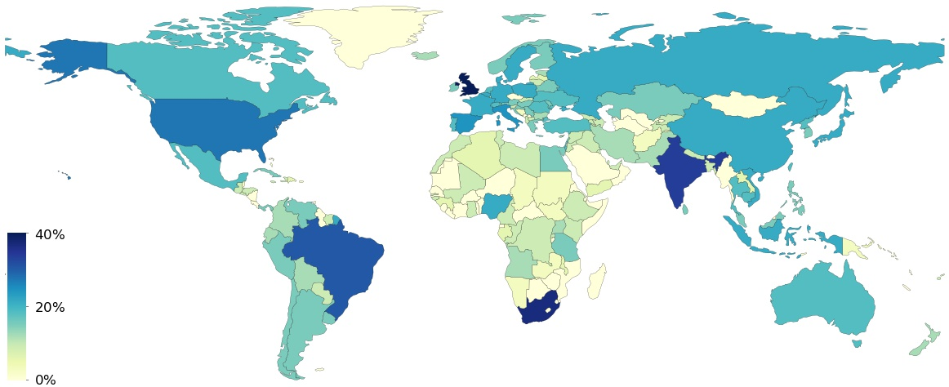

To demonstrate what countries in such stigmatized news is currently circulating,between 30 Dec 2019 and 30 May 2021. **Figure 3** first reveals that the vulnerable groups are exposing to contextualizing stigma in up to 151 countries between 30 Dec 2019 and 30 May 2021. (**Multimedia Appendix 1**).Among them, the victimized countries in highest degree involved in the current stigma storm are United Kingdom, South Africa, India, Brazil, United States, Italy, Spain, China, France, and Japan(In the map, the darker the color of the country, the more heavily it was affected by stigma Storm).