**User Manual for Multi-Integrator CLI**

**Step 1: Go to “Multi-Users_Integrator_CLI” folder.  
Step 2: Place data folders into “multi-data” folder.**Only files named below will be integrated:

1) <username>_records<number>.csv (This file is mandatory for every integration)   
2) visited_places.csv  
3) point_of_interest.csv  
4) garmin_gpx.gpx

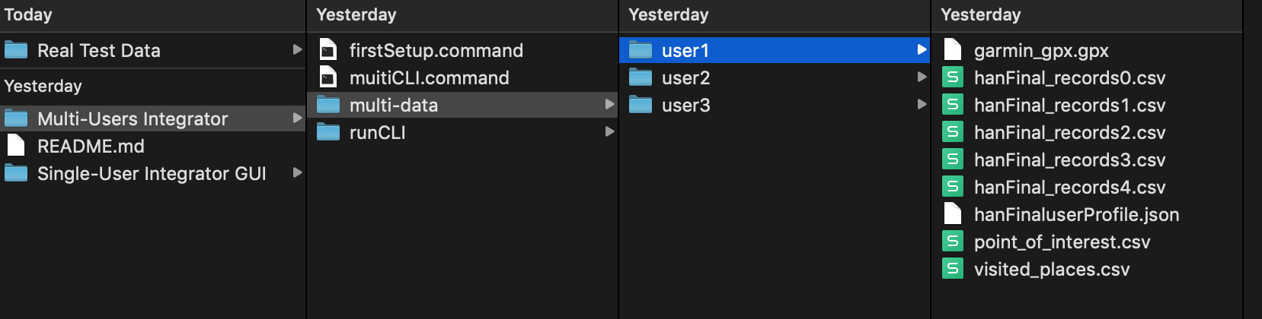 **Step 3: Double click <multiCLI.command>.   
A terminal will pop up and start intergrating data in “multi-data” folder.**

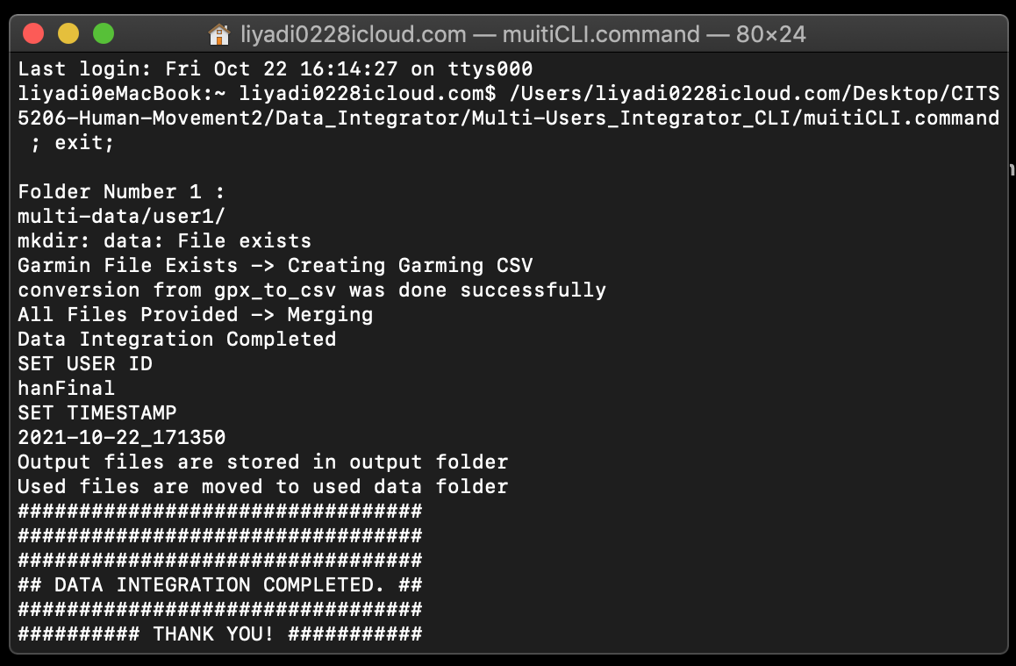

**Step 4: Go to <output> folder. You'll find the integrated data.**

Inside the output folder, The <username>Final<integration time> folder contains folder(s) for each integration. There are 3 files under this folder

1) garmin_<username>Final_<integration time>.csv is the data converted from the garmin GXP file, it contains all the health information and location data.   
2) <username>Final_<integration time>.csv is the data has has been integrated, including mobile data, garmin data, visited places and point of interest data.  
3) profile_<username>Final_<integration time>.json is the data the user used in the mobile app.

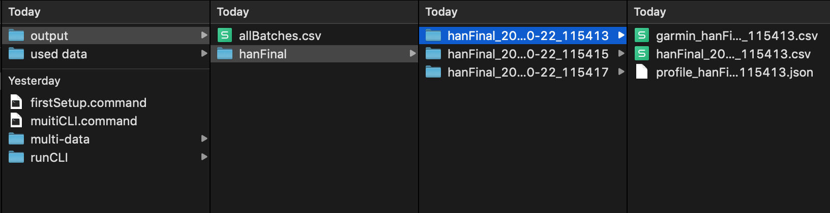

**Addition:**The data have been used for integration will be organised into a folder called “used data”. It will organise the used data according to the user and integration time



