Ant Attack!!

I started by developing enemy class (ClassEnemy). This consists of several members and methods for all enemies. Since its only used as a super-class for the different enemy types, it’s abstract and contains abstract methods like update (Line:79). I used vectors for the movement as I found them better to manipulate. The variables position, target and velocity determine the enemy’s movement (moves from position to target using velocity). The spawn needed to be around the border, so I created a getRandomBorder function to select a random side and location on the border for the enemy to spawn. 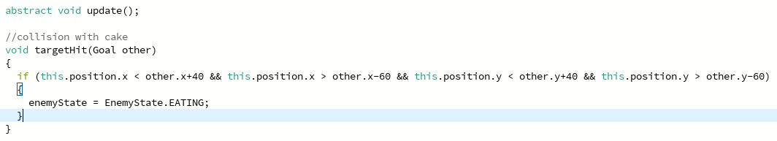
The velocity is calculated and the speed is applied; each frame the velocity is added to position until it reaches the cake (Line:82). The enemy will change to the eating state, stopping movement; I used an Enum and the state depends whether velocity is added. I created a collision function so the enemies’ vector would move back slightly when hitting another enemy (Line:91). 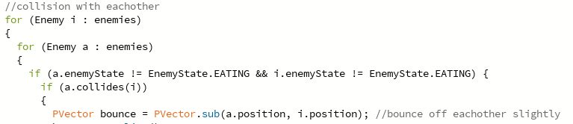
Each enemy has a 2D array used for images. Depending on the direction and frame, a different image is displayed.
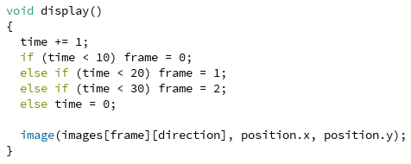
Three classes inherit enemy: ant, bee and fire-ant. Ant behaves the same way displayed in enemy class (subclassAnt). To implement the bee flying, I created a temporary offset for it to sometimes move towards, before moving to the goal (subclassBee). Target is first the offset and once the bee reaches this, the target becomes the cake.

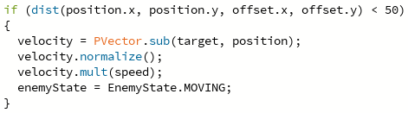
Fire-ants are meant to be avoided as they decrease the score, its different behaviour meant I needed to override some of the methods from enemy (subclassFireAnt). The target is set using getRandomBorder. The targetHit is overridden to apply a radians if the fire-ant is close to the cake, allowing it to move around it.
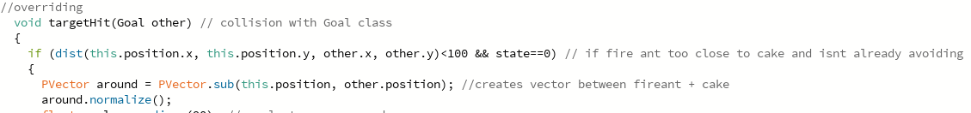
I used a polymorphic array list to hold all enemies, this is used when determining collisions with goal, enemies and player.
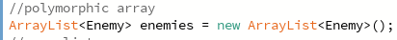
I created two methods, overGoal and overEnemy (classPlayer). These will detect when the mouse clicks either. When the cake is pressed, all enemies currently ‘eating’ will be removed (main), when an enemy is clicked, it’s removed from the array-list. Both will alter the score.
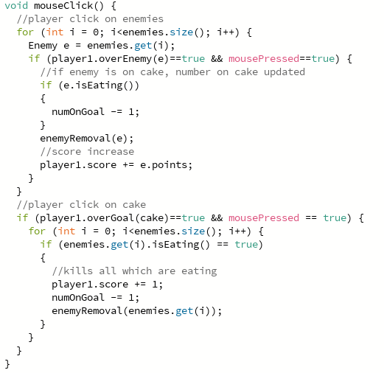
When removed, I implemented an object of class explosion and added to an array-list (Line:256). The animation is displayed at the death location before being removed from the array-list. Different parameters are used for each enemy explosion using an overloading constructor, green for good kills and red for bad – fire ants.
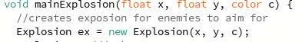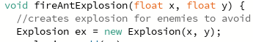
When the number of enemies is lower than the max, another will spawn at a randomly generated frame, when the frameCount hits the spawnFrame, the specific enemy will be spawned, and once all have been, the frameCount is reset (Line:152).
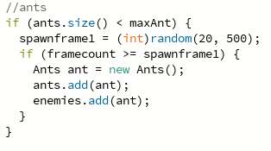
I implemented the goal so depending on how many enemies are ‘eating’, the speed that the cakes health decreases will increase, this is shown in the health bar and by the cake getting smaller as certain points in health are reached (classGoal).
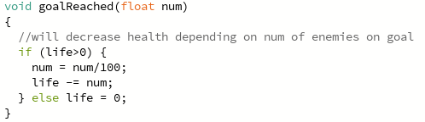
Once the game was complete, I used an Enum to set different game-states to create menus (main Line:449). Since the menus needed lots of buttons, I create class button to use with a display and clicked method (classButtons).
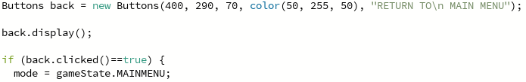
At the end of each game, I implemented a textbox to take input for the leaderboard, once enter is pressed, a bubble-sort is used to order the scores before saving to file (main). When main menu is loaded, each line of the file is stored in an array and then split into names and scores using a substring before and after the comma. Then, when the leaderboard is viewed, the new values are shown.
