Supplementary analyses and reproducibility record
This supplement accompanies Local Gaussian corrections for probabilistic continuation of hydrogel flow curves. Core model construction, comparator equations, optimization and score definitions appear in the main Methods. This supplement records additional frozen-output analyses, comparison boundaries and the unperformed evaluation design. Reference numbers match the main article.

S1 Paired formulation summaries
All paired differences are candidate minus comparator, averaged across the original three layouts within each formulation. Negative values favour the candidate. The saved 2000-draw formulation bootstrap resamples fixed predictions and does not rerun fitting or model selection. Its intervals describe the existing development collection; they are not confirmatory uncertainty intervals for new batches.
Table S1 Paired formulation CRPS summaries
Comparator | Mean difference | Descriptive 95% interval | Lower CRPS count
Coordinate GP | -0.011942 | [-0.014736, -0.009183] | 22/25
Generic bounded tilt | -0.008966 | [-0.011612, -0.006349] | 21/25
Curvature bounded tilt | -0.004976 | [-0.006614, -0.003177] | 22/25
Conditional Gaussian | -0.006975 | [-0.014525, -0.001754] | 16/25
Matched random Gaussian | −0.006631 | [−0.009569, −0.003581] | 20/25
Difference is Gaussian curvature correction minus comparator. Intervals resample fixed development predictions and omit selection and refitting uncertainty.
Figure 2b in the main article redraws the conditional-control comparison from unmodified saved per-query scores. For each P identity, three candidate CRPS values and three comparator values are averaged and subtracted. This reconstruction agrees with the frozen aggregate mean, median and count of 16 improved formulations. No target values are reopened and no predictive distribution is rescored. P0's 45.64% share of net gain is its paired difference divided by the sum of all 25 differences. This ratio describes an influential observation, not an independent effect estimate. Removing P0 only for sensitivity gives −0.003950; P0 remains in the official aggregate and every plot of the full collection.

S2 Layout scores and matched representation comparisons
Each original layout has six anchors and 33 targets. The following table retains the exact primary per-layout summaries rounded for reading. These are the numeric values behind main Figure 2a.
Table S2 Original layout-specific marginal CRPS
Layout | GP | Generic tilt | Curvature tilt | Conditional Gaussian | Gaussian curvature
Spread | 0.012883 | 0.012462 | 0.013048 | 0.012168 | 0.013203
Middle gap | 0.025196 | 0.024970 | 0.025129 | 0.020387 | 0.025835
One sided | 0.127579 | 0.119296 | 0.106581 | 0.118202 | 0.090792
Each row averages 25 formulations and all 33 hidden positions for that layout. The one sided row is not the future continuation only weighted endpoint.
The one-sided query includes ten internal hidden positions as well as 23 positions above the highest anchor. Main Table 2 decomposes this query after prediction freeze; it is not a newly fitted continuation experiment. The native target average is not a quadrature-weighted error integral over log shear rate.
Table S3 Available feature and correction-family comparisons
Feature representation | Bounded correction CRPS | Gaussian correction CRPS
Fixed random QR directions | 0.052243 | 0.049908
Fixed curvature contrasts | 0.048253 | 0.043277
All four cells are now available. Conditional Gaussian remains a separate context-specific baseline and is not the random-code Gaussian cell. Values are native-target, three-layout development CRPS on the same 25 formulations. The random code is one pre-fixed QR construction; the Gaussian comparison matches dimension, parameter count, bounds, regularization, optimizer start and training access.
Within the bounded family, curvature lowers CRPS by 7.64% relative to random directions; within the Gaussian family the reduction is 13.29%. The Gaussian candidate improves on the matched random-Gaussian control for 20 of 25 formulations. Its paired mean difference is −0.006631, with a descriptive fixed-forecast bootstrap interval of [−0.009569,−0.003581]. These are development comparisons conditional on one random construction. The difference of the two directional differences is −0.002641, but this arithmetic does not identify a causal representation-by-family interaction or overcome unequal cross-family penalty geometry. The new constitutive controls and fixed heavy-tail diagnostic are described in Section S7.

S3 Conditional residual interpretation
The main Methods give an explicit residual-conditioned decomposition. Setting a=0 and S=I gives reference posterior code moments $a_{O}$,0 and $S_{O}$,0. With the same reference residual, the changes in conditional target mean and covariance are $B_{H}$($a_{O}$−$a_{O}$,0) and $B_{H}$($S_{O}$−$S_{O}$,0)$B_{H}$ᵀ. The conditional covariance change therefore has rank at most two, while its complete covariance retains $D_{H}$. All 75 saved residual blocks are positive definite in 33 target dimensions, with smallest reported eigenvalue approximately 1.054 × ${10}^{−5}$.
Table S4 Allocation of uncertainty under the fixed model
Layout | Code covariance trace fraction | Code anchor information | Conditional code target information
Spread | 47.41% | 2.747 nats | 4.219 nats
Middle gap | 36.88% | 2.343 nats | 4.624 nats
One sided | 95.42% | 0.679 nats | 6.287 nats
These are saved model diagnostics, not explained physical variance or new performance estimates. The information sum is fixed by the common union of coordinates.
The trace ratio is coordinate dependent and model specific. It is not physical explained variance. Gaussian code–anchor information plus conditional code–target information is approximately 6.966 nats on average for each layout. The constant sum follows from the same anchor–target union, via the Gaussian information chain rule [38]. It is not a guarantee of accurate missing values or evidence that only two intrinsic material variables exist. No target-dependent information cutoff, curve rejection rule or adaptive measurement policy is introduced.

S4 Coverage and fixed case diagnostics
The candidate's 97.21% mean nominal 90% marginal coverage pools heterogeneous contexts. P0's middle-gap coverage is 8/33, compared with 20/33 for spread and 22/33 for one-sided anchors. The other 24 formulations average 99.16%. The complete heatmap and previously fixed P0/P1 cases are retained below, without dropping the difficult formulation.
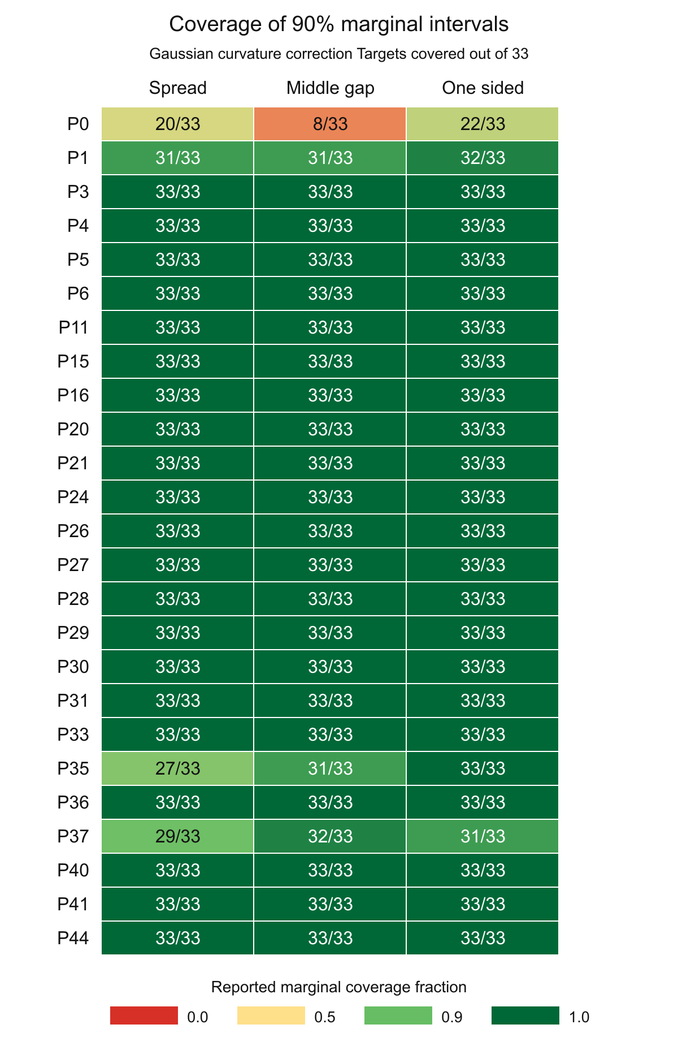
Figure S1 Marginal coverage for all 25 retained formulations and three layouts. Cells show saved coverage counts out of 33 targets. The original heatmap is retained; this vertical layout increases label size. No formulation is omitted from the official mean.

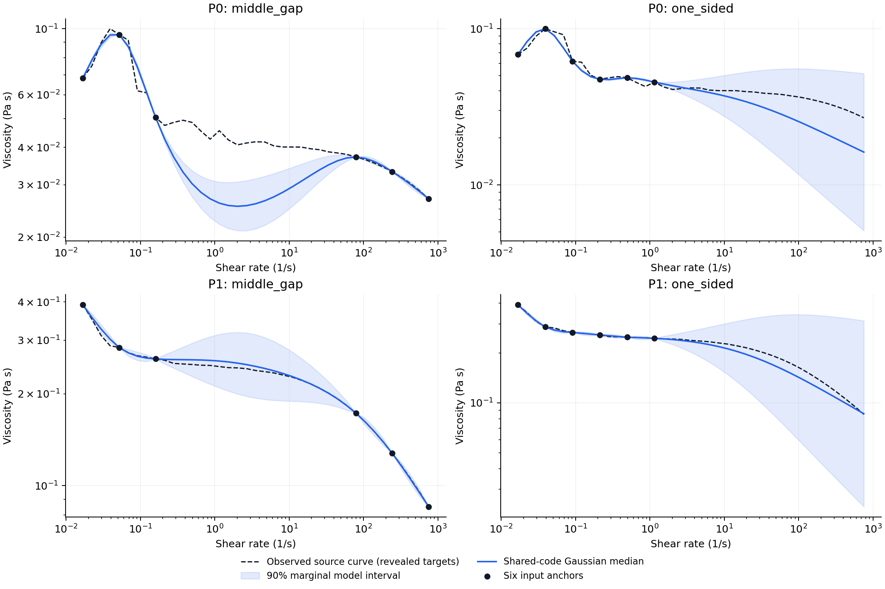
Figure S2 Complete fixed identity diagnostic for P0 and P1. Black dashed curves are the revealed source responses, blue curves are candidate medians and shaded regions are marginal model intervals. The page is landscape to retain readable labels.

Posthoc mean interval scores are 0.465734 for GP, 0.446204 for generic bounded tilt, 0.478976 for curvature bounded tilt, 0.406691 for conditional Gaussian and 0.467306 for candidate. These were computed from frozen predictions before this editorial revision; no interval-score tuning or calibration is added. For Gaussian fixed-parameter conditioning, covariance and entropy quantities do not respond to numerical anchor values [16]. This limitation does not uniquely diagnose the cause of P0's failure. The full fixed cases permit inspection of context-specific behaviour rather than selection of only visually favourable examples.

S5 Proposed independent evaluation and unresolved evidence
No new formulation, preparation batch or independent calibration cohort is reported. The matched random-Gaussian development comparison has been completed, as have two anchor-conditioned probabilistic constitutive controls and one fixed Student-t diagnostic. Their additional retrospective scores do not turn the same 25 formulations into independent confirmation. A future same-domain evaluation should freeze all selected methods before target reveal. Any relaxed bound, updated window, new prior or tuned degree of freedom defines a revised candidate and must be reported separately rather than replacing the frozen results.
For a continuation-focused evaluation, six coordinate-selected low-rate anchors would be revealed first and only positions strictly above the highest anchor would enter its new primary endpoint. Normalized trapezoidal weights over log shear rate could avoid overcounting densely sampled segments. This differs from the original three-layout native-point endpoint. A 39-position log-spaced grid from 0.02 to 500 s⁻¹ is an example inside the frozen support, not an experiment performed. Its number of continuation targets depends on the admitted grid and need not equal the retrospective 23.
Before target reveal, authors should fix material identities, preparation and measurement-state records, temperature, scan history, grouping, tolerances, sampling unit and sample size. New formulations, fresh preparations of existing formulations and external laboratory records support different generalization claims. All eligible units should receive predictions from every method or an explicit failure entry. Score trajectories, coverage, interval score and a dependence-sensitive score can then be considered jointly [34,37]. Experimental time or material savings require direct resource measurements, not masking of already measured curves.
Independent calibration must use data reserved from model choice. Conformalized quantile regression and jackknife+ require the relevant exchangeability assumptions and do not turn correlated curve positions into independent materials [44,45]. Marginal coverage would not establish simultaneous whole-curve coverage. This prospective design supplies no significance guarantee or justified numerical sample-size claim from the current development variance alone.

S6 Evidence bindings software and public-release status
The original complete scientific archive is hydrogel_confirmation_20261031_full.zip, SHA256 78dc67d62b5db30b1d6e1940610863d832f1e4a1b50490f58867bbcbd30792c2. The unchanged deployment model SHA256 is d72fc262fbae0e6fecc36568f0638166fe95e991bd5f7df100ab1434097d82d1. The subsequent control-study archive is hydrogel_controls_20261101T0641198159051Z_r2_full.zip, SHA256 a620ba6927ba54f6ee8e39aba09f986873bb8b8d7adb93c3f56d6c4af5ee24c1; it includes the original archive byte for byte and the new inputs, code, protocols, predictions, numerical failures and checks. These local identifiers do not constitute public deposition or a new license grant.
The present editorial companion binds the original manuscript, supplementary document, new control summaries and numerical receipts by source, byte count and SHA256. It distinguishes old five-method scores, subsequent control-study fits and the current saved-output diagnostic/editorial work. No control fit is repeated by the document builder, no hidden S response is reopened and no measured material is added. Figure and table construction reads saved results; its arithmetic checks do not constitute independent material validation.
All 26 original candidate fits are constrained solutions. A public frozen inference and manuscript checkpoint is now archived at https://github.com/Hancy5521/hydrogel_control, commit 05b2f221cd34e7ca2913dac10ba0be87bc06d060, also retained on archive/paper-2026-11-01. It contains the deployment runtime and weights, aggregate summaries and integrity manifests. It does not contain every original measurement or out-of-fold law required for full experiment replay. The complete local scientific archives remain preserved; reuse licensing and author publication declarations still require completion.

S7 Additional registered controls and uncertainty diagnosis
These controls were executed after the original five-method development analysis, on the same previously inspected 25 P formulations. Their registrations bind actual execution times, input and source hashes and finite numerical budgets; registration does not make the materials newly unobserved to the development process. Old references and the local-Gaussian candidate were reused unchanged.

S7 1 Matched random Gaussian control
The random representation reuses seed 20261030 and the same frozen QR directions as the bounded random control. The Gaussian family has two mean and three Cholesky parameters. Bounds, the 0.02 squared-norm penalty, zero cold start, optimizer settings and projected-gradient admission gate match the local-Gaussian fit. Twenty-five new outer code fits produce 75 frozen conditional laws; no reference or original candidate is refitted. Independent full-matrix objective, gradient and predictive checks passed.

S7 2 Constitutive priors and likelihood
For each query, five independent standard-normal coordinates z parameterize log η0 = yc+2ys z0; logit r = −2+2z1; log γc = tc+ts z2; Cross m = 2 sigmoid(z3) or Carreau n = sigmoid(z3); and log σ = log(max(σref,0.05ys))+z4. Here yc,ys,tc,ts are the original outer-reference normalization values and σref is its response-unit report-discrepancy SD. These are proper, prespecified priors, not empirical fits to the held targets. The six anchor log responses have independent Gaussian statistical discrepancy conditional on the shared curve parameters. The discrepancy is not certified measurement noise.
The initial five-dimensional SMC implementation failed predictive-replica agreement for Cross P1 one-sided and Carreau P3 one-sided and stopped before scoring. Analytic integration of the same Gaussian log-level prior yields the unchanged marginal likelihood under covariance σ²I+τ²11ᵀ. The predictive component covariance is σ²I+v11ᵀ, with v the log-level posterior variance. The final SMC uses two independent replicas, 48 random-walk moves per temperature and an ESS target of 0.8, initially 4096 particles per replica and at most 16384 on a failed precision check. Cross alone uses one additional registered 65536-particle-per-replica budget. The gate requires maximum predictive-mean disagreement and predictive-SD disagreement each no greater than 0.15 pooled predictive SD. Original failures are retained and no failed partial-case aggregate is scored.
Carreau completes 73 contexts with 8192 combined particles and two with 32768. Cross completes 66 with 8192, six with 32768 and three with 131072, including five earlier admitted laws reused unchanged in its numerical continuation. These numbers count posterior computations, not independent experiments or materials. Replica agreement does not establish exact posterior convergence or parameter identifiability.

S7 3 Scoring the physical mixtures
Predictive means, full joint densities and marginal CDFs use all frozen particles. The first CRPS expectation is analytic for Gaussian components; the second uses 131072 independent random pairs with 32 blocks for a sampling-only Monte Carlo standard error. The aggregate pair-only MCSEs are approximately 0.000032 for Cross and 0.000025 for Carreau; they do not include posterior approximation error. Independent checks compare nine selected component densities per context against explicit 33-dimensional covariance matrices, and first-target CDF-integral CRPS in the preselected P0/P1/P36 contexts. No Gaussian moment-match score substitutes for the frozen mixture.

S7 4 Fixed heavy tail control and anchor scale diagnosis
The sole Student-t diagnostic fixes prior ν=10 and preserves the Gaussian-fitted joint mean and covariance through a curve-specific inverse-gamma scale with mean one [46]. Conditional df is 16 for six anchors. Mean and kernel are not retrained, and ν is not selected from performance. The macro CRPS is 0.042906, mean joint log density 106.985, coverage 98.26% and interval score 0.443927. The original Gaussian interval score is 0.467306 and the conditional-Gaussian control remains stronger at 0.406691. One-sided CRPS worsens to 0.092948, and the posthoc 23-target continuation CRPS worsens from 0.127161 to 0.130609. It remains a diagnostic rather than a replacement model.
P0 middle-gap coverage increases from 8/33 to 26/33, while the control raises the conditional covariance by a factor 11.685 and its central 90% width by a factor 3.394. The corresponding one-sided factors are 21.111 and 4.562. Only 6, 6 and 7 of 25 formulations have covariance expansion in spread, middle-gap and one-sided layouts, respectively. This is an anchor-value calculation, not a causal diagnosis or independent reliability result. It explains how a scalar adaptation can respond to atypical anchors yet remain unable to change the conditional mean or covariance shape. Conditional Student-t joint density was checked through the full/anchor density ratio and marginal CRPS through independent CDF integration [48].

S8 Fixed pairwise difference diagnostic
The fixed diagnostic uses variogram order p=1, equal weights for all 528 unordered pairs of the original 33 target coordinates and all three original layouts. The protocol was registered before contrast expectations were frozen for the GP, conditional Gaussian, matched random Gaussian, frozen curvature Gaussian and fixed Student-t laws. There were 375 law-layout vectors and no fitting, forecast revision or exponent/weight search. Cross and Carreau mixtures were not part of this five-law diagnostic.
Table S5 Fixed order one variogram scores
Model | Spread | Middle gap | One sided | Macro score
Coordinate GP | 0.002232 | 0.003017 | 0.142191 | 0.049147
Conditional Gaussian | 0.002269 | 0.003601 | 0.240236 | 0.082035
Matched random Gaussian | 0.002223 | 0.003821 | 0.115087 | 0.040377
Frozen curvature Gaussian | 0.002245 | 0.003292 | 0.042980 | 0.016172
Fixed Student-t diagnostic | 0.002236 | 0.003349 | 0.084169 | 0.029918
Lower scores are better. The original CRPS primary endpoint and all retained material identities are unchanged. Spread interpolation is near tied; the candidate does not dominate every layout. The score combines relative-mean and covariance effects and does not isolate dependence independently of marginal prediction.
The candidate has lower formulation-averaged VS1 for 21/25 formulations against GP, 21/25 against conditional Gaussian, 20/25 against matched random Gaussian and 14/25 against fixed Student-t. P0 contributes 0.13%, 69.23%, −3.32% and 99.39% of the respective net mean gains. The negative contribution against random Gaussian means P0 is a loss in that comparison, not a reason to drop it. Its median paired gain against Student-t is only 0.0000485. Therefore the Student-t comparison does not establish broadly better Gaussian tails, and no formulation is removed from official scores.
The score is proper but not strictly proper and cannot detect common additive displacement or common-mode variance. It is not a whole-curve coverage guarantee. The independent numerical auditor imports neither the score implementation nor the scientific model core: Gaussian expectations use full contrast-matrix quadratic forms and folded-normal means; Student-t expectations use a 256-node generalized Laguerre Normal-Gamma mixture integral and 27 selected direct density integrals. All 375 scores and 20 layout/model macro summaries were reproduced. Maximum score-row error was 1.47×10⁻¹². This is an arithmetic audit of the same development data, not new material validation.

S9 Exact interpretations of the fixed Gaussian construction

S9 1 Relative potential in the two dimensional code
The Gaussian replacement admits an exact relative-potential interpretation. Let φ(z) be the standard-normal code density. For positive-definite S, the relative potential below satisfies φ(z) exp[−U_θ(z)] = N(z; a,S) exactly, including its normalizing constant. It changes the probability assigned to code configurations while leaving p_0(Y|z) unchanged. This potential is defined in probability space, rather than as a mechanical free energy or a microscopic force.
$U_{θ}(z) = \frac{1}{2}{(z−a)}^{T}S^{−1}(z−a) − \frac{1}{2}z^{T}z + \frac{1}{2}ln det S$ (S1)
Completing the Gaussian density ratio gives N(z;a,S) = φ(z)exp[−Uθ(z)] and Eφ exp[−Uθ(z)] = 1. The determinant term supplies the exact normalization. Although the relative potential can be unbounded or nonconvex, the total code log density has positive-definite precision S⁻¹. Its negative gradient is the following affine relative-score correction.
$g_{θ}(z) = −∇_{z}U_{θ}(z) = z − S^{−1}(z−a)$ (S2)
The field describes a change in statistical preference over code configurations. It is not a mechanical force, thermodynamic free energy or simulation of microscopic experiments. The actual implementation obtains the conditional Gaussian analytically and draws it through a matrix factorization; no iterative field integration is required.
$\frac{p_{θ}(Y)}{p_{0}(Y)} = E_{p_{0}(z|Y)}[e^{−U_{θ}(z)}]$ (S3)
Equation (S3) follows by multiplying the unchanged p₀(Y|z) by the Gaussian code density ratio, integrating over z and dividing by p₀(Y). It is a posterior expectation under the reference, not evaluation of Uθ on a deterministic two-dimensional encoding of a noisy observed curve. The latent support and retained conditional process remain stochastic. This is an exact reformulation of Eqs. (6)–(8), rather than another candidate model.

S9 2 Residual variance outside the adapted directions
For a fixed linear contrast v of the 33 targets, Eq. (17) implies
$Var(v^{T}Y_{H}|y_{O}) = v^{T}D_{H}v + {({B_{H}}^{T}v)}^{T}S_{O}({B_{H}}^{T}v) ≥ v^{T}D_{H}v$ (S4)
The inequality follows because S_O is positive definite. Rank-nullity gives dim ker(B_Hᵀ) = 33 − rank(B_H) ≥ 31. Within that nullspace, a nonzero v has variance exactly vᵀD_Hv, strictly positive when D_H is positive definite. The retained residual therefore preserves uncertainty in many target contrasts outside the adaptive code. This is a model statement, not a lower bound on actual error or a calibration guarantee; strict positivity is supported for the saved queries and is not asserted for every future query.

S9 3 Conditional risk targeted by training
The declared coordinate design and fitted reference are held fixed and suppressed in the following notation. Let p* be a data-generating law on the declared response variables, with finite relevant conditional entropies and cross-entropies. The expected unpenalized part of Eq. (18) can be written as
$R(θ) = C + \frac{1}{3}∑_{b=1…3}E_{p^{*}(Y_{O_{b}})} KL[p^{*}(Y_{H_{b}}|Y_{O_{b}}) ‖ p_{θ}(Y_{H_{b}}|Y_{O_{b}})]$ (S5)
Here C is the average conditional entropy and does not depend on θ. This standard cross-entropy identity explains the chosen training target. The finite 24-curve empirical objective additionally includes the declared squared-parameter penalty. Neither the population law nor its entropy is estimated in this editorial analysis, and the penalty is not a KL regularizer on the code law. Optimizing this conditional likelihood need not optimize every scoring rule or every missingness pattern. The three layouts are a designed task distribution, not an identified natural reporting mechanism.

S10 How layout differences combine in the primary score
The primary average first gives equal weight to the 33 native target positions in each query and then to each layout and formulation. The following arithmetic, computed only from the saved aggregate summaries in Table S2, makes the balance against the conditional Gaussian explicit. It does not rescore targets, change the endpoint or supply a new experiment.
Table S6 Layout contributions to the candidate minus conditional Gaussian difference
Layout | Candidate CRPS | Conditional Gaussian | Difference
Spread | 0.013203 | 0.012168 | +0.001036
Middle gap | 0.025835 | 0.020387 | +0.005448
One sided | 0.090792 | 0.118202 | −0.027410
Macro mean | 0.043277 | 0.050252 | −0.006975
Negative differences favour the candidate. The three layout differences are averaged, not added as separate independent effects. Equal weights do not make their absolute score scales equal. These CRPS values are in dimensionless natural-log response units, not Pa s or percentage viscosity error. The variogram diagnostic has squared log-response units, while joint log density is reported in nats per 33-target query. The one-sided primary query includes ten internal targets and 23 continuation targets; it is distinct from the proposed future continuation-only endpoint.

S11 Frozen inference workflow and observation semantics
A reproducible inference call begins with the archived deployment-model and source hashes, six positive viscosity–rate anchors and distinct requested rates inside the admitted support. The deployment model uses all 25 complete P curves and only the lawful anchors of 20 S records. It is not an outer-fold evaluation model. The supplied example anchors are synthetic reference-mean values and are labelled accordingly.
The implementation forms the common anchor–target joint mean and covariance using the fixed support and contrasts. It then applies Eqs. (9)–(10) using the numerical anchor values and factors the complete covariance of the unobserved targets. Each Gaussian draw is exponentiated as a whole vector, preserving its cross-rate dependence. Independent marginal sampling would not reproduce this law.
Analytic viscosity-scale summaries use exp(μ_j) for the median and exp[μ_j + Φ⁻¹(p)√V_jj] for a marginal p-quantile. The viscosity-scale mean is exp(μ_j+V_jj/2). These identities remove Monte Carlo error from marginal model summaries; they do not correct model misspecification or establish coverage. The legacy empirical quantile fields depend on the random draws and are distinguished from the analytic fields.
An exact request for a stored anchor repeats its known value in every draw because it refers to that same recorded observation. This is record completion, not prediction of a fresh replicate at the same rate. A new physical measurement would need a distinct observation identity and an appropriate discrepancy model. Generated outputs retain their model-generated label and must not be added to measured training records as if they were new experiments.
File checks and a successful inference call establish software identity and numerical execution. They do not validate a new batch or demonstrate experimental savings. The current public checkpoint and the complete local scientific archives have different scopes, as specified in Section S6. No additional fitting, target scoring or material measurement is introduced by this workflow description.

