Local Gaussian corrections for probabilistic continuation of hydrogel flow curves
Author names affiliations and corresponding author details to be completed

Abstract
Partial rheological records leave uncertainty about material response beyond measured conditions. We study six-anchor continuation of hydrogel precursor ink flow curves using a Gaussian process reference with a five-parameter correction to two fixed curvature contrasts. The complete reference residual is retained, and every anchor layout conditions the same corrected joint law. In a retrospective development study of 25 formulations and three layouts, mean marginal continuous ranked probability score is 0.043277, reductions of 21.63% against the reference and 13.88% against a conditional Gaussian control. A matched random-code Gaussian gives 0.049908; the curvature representation improves on it for 20 of 25 formulations. Gains concentrate beyond low-rate anchors, whereas the conditional control remains stronger for interpolation. Two declared anchor-conditioned probabilistic constitutive models do not match this continuation performance. Average nominal 90% coverage is 97.21%, but one middle-gap query covers only 8 of 33 targets. A fixed heavy-tail control raises that count to 26 while worsening one-sided CRPS and overall overcoverage. These results support a compact, residual-preserving continuation model within this ink family, with independent generalization and uncertainty calibration still to be established.
Keywords: AI for Materials; polymer rheology; Gaussian process; partial response curves; probabilistic continuation.

Introduction
The task considered here starts with an already specified hydrogel precursor ink and a partly observed viscosity–shear-rate curve. Six measured pairs provide a context from which the remaining response is to be predicted with uncertainty. Filling a missing interval between observations and continuing a curve beyond the highest observed rate are different inference problems, even when the number of observations is identical. We ask whether a small, shared change to a population response model can improve the latter task while preserving response variation outside the chosen shape directions. The prediction object is therefore the response curve of the same material, and the unit of evidence is a formulation. Additional masks and generated curves provide further views of that object without adding measured materials.
Materials informatics increasingly connects representations of composition and structure with measured properties. General-purpose descriptors and standardized benchmarks have made comparison of property predictors more systematic [1,2]. Polymer Genome and multitask polymer learning extend this direction to polymer property spaces [3,4]. Chemical language models such as polyBERT and TransPolymer learn representations for downstream predictions [5,6], while simulation–experiment fusion exploits relationships among gas transport properties and data fidelities [7]. These developments motivate a complementary question: when several measurements from one material already exist, how should they update a probability distribution over its unmeasured response conditions?
This question differs from generating a new material. Structure-constrained generation has been used for quantum materials discovery [8], and generative active learning has targeted polymer rheological profiles by changing architecture and solvophobicity [9]. Here the material identity remains fixed. Six observed viscosities are available, and the objective is continuation of the same flow curve. Correlated predictions matter because an entire rate-dependent response, rather than one scalar property, is missing. The intended use is recovery of incomplete material characterization within a compatible domain; discovery, autonomous experimentation and reduced measurement cost require separate evidence.
Rheological structure provides natural alternatives and inductive biases. Cross, Carreau and subsequent modified Carreau descriptions parameterize shear-dependent viscosity with compact constitutive families [10,11,12]. Physics-enforced neural networks embed empirical viscosity relations in prediction graphs [13]. RhINNs address forward and inverse problems for constitutive dynamics, and related work considers constitutive model selection [14,15]. These approaches motivate physically informed comparisons, but a curve model fitted from six anchors must handle parameter ambiguity and predictive uncertainty. Our fixed contrasts remove affine trends in log coordinates and isolate finite-scale bending. They encode where statistical adaptation acts; they do not enforce a constitutive law or monotonic shear thinning.
Gaussian processes provide joint laws at irregular coordinates [16]. Their use in soft-matter data superposition illustrates the relevance of probabilistic functional models to material responses [17], while sparse functional data analysis reconstructs trajectories from limited observations [18]. The proposed decomposition is closely related to inducing-variable Gaussian processes. Sparse variational methods combine a Gaussian distribution on inducing variables with a retained conditional process [19]; inter-domain methods allow inducing features to be linear functionals [20]. Scalable variational learning, process-level formulations and orthogonal residual decompositions further establish this framework [21,22,23]. A Gaussian update to a small code with a full residual is therefore an established distributional family. Our study concerns a specific choice of physical-coordinate contrasts and its conditional training objective across material curves.
Broader conditional models provide another context. Conditional and attentive neural processes map observed input–output contexts to predictions [24,25]. Arbitrary-conditioning variational autoencoders and partial VAEs accommodate subsets of observed variables [26,27]. Adversarial and diffusion imputation models offer learned conditional completion mechanisms [28,29]. Latent energy tilting and arbitrary conditional energy models establish further routes for adapting distributions [30,31]. We do not claim a general completion framework or benchmark superiority over these families. Instead, a small dataset motivates a transparent reference correction whose parameter count and observation access can be controlled.
We evaluate a two-contrast, five-parameter Gaussian correction on publicly reported ALG-Ph and HA-Ph precursor ink rheology [32,33]. Three six-anchor layouts separate interpolation from one-sided continuation. A matched comparison crosses fixed random and curvature representations with bounded and Gaussian corrections. Anchor-conditioned probabilistic Cross and Carreau controls examine constitutive alternatives, and one fixed Student-t sensitivity analysis tests whether observation-dependent scale can address a retained coverage failure. The aim is a useful local representation for coherent flow-curve continuation, with the full residual preserved rather than compressed away. All evidence comes from retrospective development on 25 previously inspected formulations.
The empirical question is whether concentrating distributional adaptation on these shape contrasts is useful when only a short low-rate segment is observed. We separate that question from the validity of the Gaussian construction itself. Representation controls test the chosen directions; conditional and constitutive controls test predictive alternatives; and the uncertainty diagnostics examine what remains unresolved after a favourable mean score. This organization ties the methodological contribution to a defined materials task rather than to a new general-purpose probability family.

Results

A shared joint correction with a small task-specific representation
Each formulation has 39 reported response positions. Twenty-five complete curves, denoted P, support training and retrospective evaluation; another 20 records, denoted S, contribute only six fixed anchors to the reference. In every outer fold, the held P formulation is excluded from reference fitting, normalization and correction training. Its six anchors enter after fitting (Fig. 1). Three layouts give 75 conditional queries but remain repeated views of 25 formulations. Their 2475 scored positions represent 950 unique formulation–position pairs, with unresolved physical batch independence.
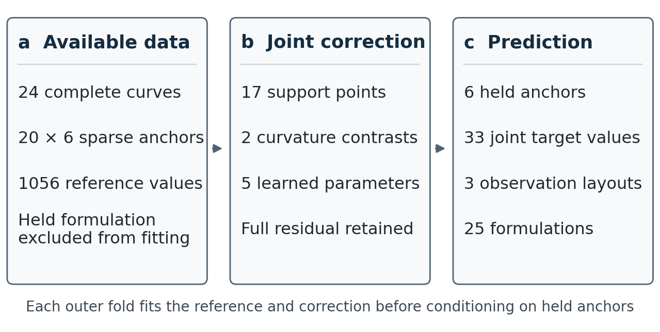
Figure 1 Information access in each leave-one-formulation-out fold. a, Reference fitting uses 24 complete P curves and 20 sparse anchor sets. b, Two fixed curvature contrasts define a five-parameter joint correction with a retained residual. c, Six held anchors enter conditioning after fitting, yielding 33 correlated targets.
Two fixed weighted second-difference contrasts are defined on 17 support coordinates in physical log shear rate and whitened under the reference. Replacing their standard Gaussian distribution by a Gaussian with a free mean and Cholesky covariance adds five parameters. The residual response process remains intact. This changes joint covariance by rank at most two without limiting the full response to a two-dimensional subspace. All layouts use the same corrected joint distribution, and ordinary Gaussian conditioning produces their correlated missing values. Parameter uncertainty is not separately integrated.
The five parameters count only the incremental correction, in addition to the fitted reference mean and covariance. The reference provides population variation across coordinates, the code changes the probability assigned to two shape summaries, and the observed anchors update the distribution for a particular curve. These roles are distinct: a compact correction does not imply that the complete fitted system has only five parameters or that all sources of uncertainty are integrated.
The construction suggests two distinct checks. If the chosen shape directions are useful, they should improve predictions relative to arbitrary directions within a common correction family. If the gain requires a complex code distribution, a Gaussian replacement in those same directions should lose that gain. The completed two-by-two comparison tests both questions for one fixed random construction. Shared-joint consistency additionally permits correlated curve draws; it is assessed separately from marginal predictive quality.

Mean score improves while formulation-level gains remain heterogeneous
Among the five original methods, the Gaussian curvature correction has the lowest primary mean marginal CRPS and pooled log-response RMSE (Table 1). CRPS reductions are 21.63% against the coordinate GP, 17.16% against the generic bounded tilt, 10.31% against the curvature bounded tilt and 13.88% against the conditional Gaussian control. The conditional control has the highest mean joint log density in that original comparison. Additional controls are reported separately below, including a heavy-tail diagnostic with lower overall CRPS but worse continuation. Proper scores assess different aspects of a predictive law [34]; the marginal ranking is not a ranking of every aspect of joint prediction.
Table 1 Original three layout development comparison
Model | CRPS | Log RMSE | Joint log density | Coverage 90% | Log width
Coordinate GP | 0.055219 | 0.196569 | 63.122 | 97.37% | 0.405326
Generic bounded tilt | 0.052243 | 0.185702 | 63.388 | 97.33% | 0.385359
Curvature bounded tilt | 0.048253 | 0.156631 | 63.450 | 97.29% | 0.418607
Conditional Gaussian | 0.050252 | 0.161703 | 82.926 | 96.61% | 0.364930
Gaussian curvature correction | 0.043277 | 0.119524 | 63.658 | 97.21% | 0.403654
Scores use y = ln[η/(1 Pa s)] with natural logarithms. CRPS, pooled RMSE and interval width are reported on this dimensionless log-response scale, not in Pa s; CRPS percentages compare score reductions, not percentage viscosity errors. CRPS averages 33 targets, three layouts and 25 formulations with equal weights. RMSE is the square root of the pooled mean squared log error. Joint log density is averaged over the 75 joint, 33-target queries and is reported in nats per query. Coverage is marginal target coverage, not simultaneous whole-curve coverage. All entries retain their retrospective development status.
The candidate improves on the conditional control for 16 of 25 formulations (Fig. 2b). Its paired mean CRPS difference is −0.006975 and median difference is −0.006906. A saved 2000-draw bootstrap of fixed formulation-level predictions gives a descriptive interval of [−0.014525, −0.001754] for the mean difference (Supplementary Table S1). This interval does not account for selection or refitting uncertainty. P0 contributes 45.64% of the net aggregate gain against this control. Removing P0 only for sensitivity leaves a mean difference of −0.003950 across the other 24; all official comparisons retain P0. The aggregate gain is thus accompanied by incomplete and uneven formulation-level improvement.

Low-rate anchors reveal a continuation-specific advantage
The anchor layout changes the method ranking (Fig. 2a; Supplementary Table S2). For one-sided anchors, candidate CRPS is 0.090792, compared with 0.127579 for the GP and 0.118202 for the conditional control. Against the latter, this is a 23.19% reduction. In contrast, the candidate is worse by 8.51% for spread anchors and 26.72% for the middle gap. Equal weighting of layouts does not equalize their absolute score scales: the larger continuation errors dominate the numerical aggregate difference.
The overall gain is the balance of different conditional tasks. Relative to the conditional Gaussian, the curvature model changes mean CRPS by +0.001036 for spread anchors, +0.005448 for the middle gap and −0.027410 for one-sided anchors. Equal averaging of these three changes gives the reported macro difference of −0.006975. The continuation improvement therefore more than offsets the interpolation losses. This identifies a use case for the representation: extending a low-rate segment, rather than uniformly improving every missingness layout.
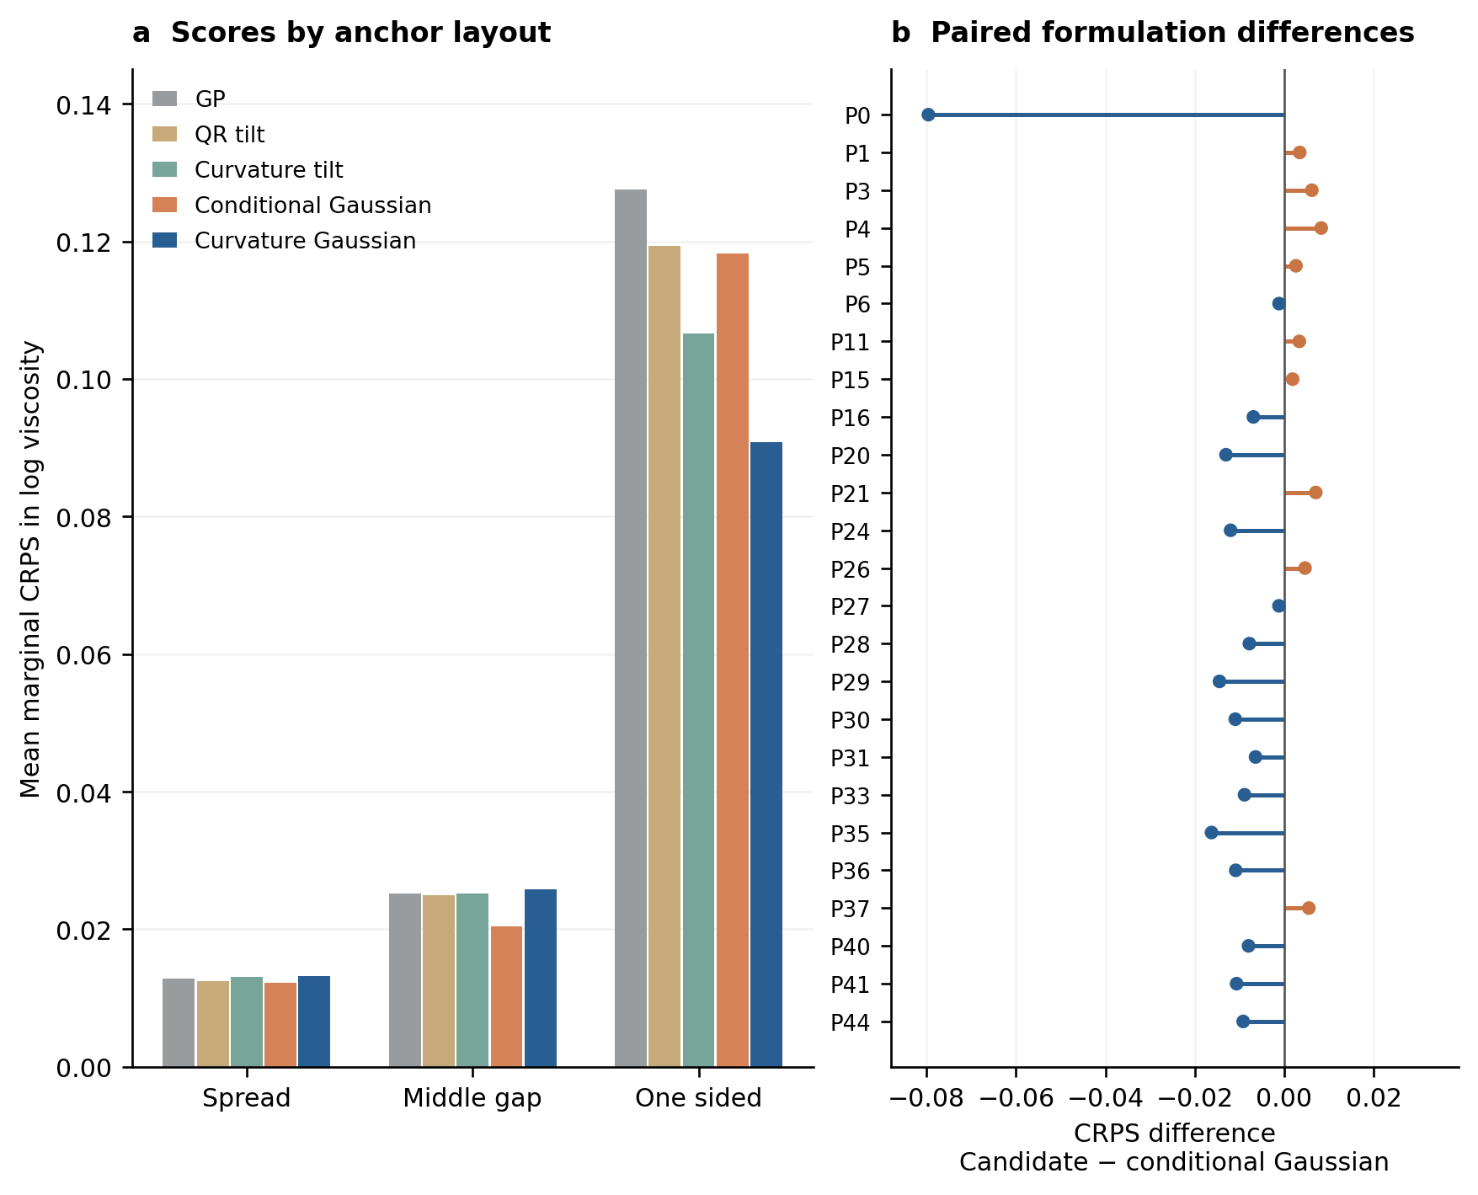
Figure 2 Layout and formulation dependence of the saved CRPS gain. a, Original mean marginal CRPS for five methods in each six-anchor layout; all 33 targets per query are included. b, Candidate minus conditional Gaussian CRPS for each of the 25 formulations, after averaging its three layouts. Negative values favour the candidate. Sixteen formulations improve; P0 remains in the aggregate and contributes 45.64% of net gain. Points are fixed-output differences, without refitting or confidence bars. GP, coordinate Gaussian process; QR tilt, generic bounded correction; curvature tilt, bounded curvature correction; conditional Gaussian, independently trained conditional control; curvature Gaussian, candidate.
Ten hidden positions in the one-sided layout lie inside the anchor range and 23 above the highest anchor. A posthoc decomposition of frozen scores gives candidate CRPS 0.007143 inside and 0.127161 beyond the anchors (Table 2). The corresponding conditional-control scores are 0.005667 and 0.167131; the beyond-anchor reduction is 23.92%. The GP gives 0.007155 and 0.179938. Improvement is concentrated in the continuation segment rather than uniformly distributed over the query. These positions remain inside the declared global coordinate support, approximately 0.0127877–754.5143 s⁻¹. They are outside the observed range of that formulation, not evidence of transfer beyond the training support or to new chemistry.
Table 2 Posthoc decomposition of the original one-sided layout
Model | Inside anchors 10 targets | Beyond anchors 23 targets
Coordinate GP | 0.007155 | 0.179938
Generic bounded tilt | 0.007114 | 0.168071
Curvature bounded tilt | 0.007159 | 0.149808
Conditional Gaussian | 0.005667 | 0.167131
Gaussian curvature correction | 0.007143 | 0.127161
CRPS in log viscosity, native positions equally weighted. Previously frozen posthoc arithmetic, not a new prediction or the proposed weighted confirmation endpoint. These targets remain inside the global coordinate support.

Matched representation controls support the local correction
The completed comparison separates the choice of directions from the choice of correction family. Curvature lowers CRPS within both families: from 0.052243 to 0.048253 for the bounded correction and from 0.049908 to 0.043277 for the Gaussian correction. Replacing the bounded correction by a Gaussian also improves both fixed representations, by 4.47% for the random code and 10.31% for the curvature code. Thus the observed benefit of the curvature representation does not require the evaluated bounded non-Gaussian law. The Gaussian random-versus-curvature comparison is the direct matched test of representation; the conditional Gaussian is a separate predictor and is not a cell of this two-by-two comparison. The same-code Gaussian improves on the bounded curvature model for 22 of 25 formulations, and the curvature Gaussian improves on the matched random Gaussian for 20 of 25. Gaussian comparisons hold code dimension, five trainable parameters, bounds, penalty, optimizer start and training access fixed. Only one frozen random construction is examined. Cross-family parameter counts do not equalize admissible distributions or penalty geometry, so this two-by-two arithmetic is not a causal interaction estimate.
The code accounts for 47.41%, 36.88% and 95.42% of the conditional target-covariance trace for spread, middle-gap and one-sided layouts, respectively. Its larger allocation in continuation is consistent with where improvement occurs. This is a decomposition under the fitted model in log coordinates, not a measured fraction of physical variance explained or an intrinsic dimension estimate. The conditional target residual remains positive definite in all 75 contexts, with dimension 33 and minimum reported eigenvalue about 1.054 × ${10}^{−5}$. The retained residual is therefore computationally substantive.

Anchor conditioned constitutive controls remain less accurate in continuation
We evaluated finite-plateau Cross and fixed-a=2 Carreau models using only the same six query anchors. Proper priors and a per-curve log-response discrepancy scale were included, with prior scales determined from outer training records. Whole-query-curve fitted source parameters were excluded. Their macro CRPS values are 0.111590 and 0.153763, with one-sided values of 0.230214 and 0.292701, respectively (Table 3). Thus the frozen Gaussian curvature model outperforms these two implementations on this collection.
The comparison has equal query-anchor access but does not equalize population shape learning: the GP learns such structure from training curves, whereas these constitutive controls use population normalization to scale their declared priors. Their performance therefore does not establish the best achievable performance of either constitutive family. The posterior computations also required numerical care. Failed five-dimensional calculations were retained without scoring; analytic integration of the Gaussian log-viscosity level left the same prior and likelihood but reduced the numerical dimension. Carreau then completed, while Cross required one additional registered particle budget. All 75 laws for each family passed a fixed two-replicate predictive-agreement gate and were frozen before scoring. Finite-replicate agreement is not proof of exact posterior inference.
Table 3 Additional retrospective probabilistic controls
Model | Macro CRPS | One sided CRPS | Joint log density | Coverage 90%
Gaussian curvature correction | 0.043277 | 0.090792 | 63.658 | 97.21%
Matched random Gaussian | 0.049908 | 0.111209 | 63.919 | 97.01%
Bayesian Cross | 0.111590 | 0.230214 | 57.200 | 93.62%
Bayesian Carreau a2 | 0.153763 | 0.292701 | 23.542 | 87.35%
Fixed Student-t diagnostic | 0.042906 | 0.092948 | 106.985 | 98.26%
All original formulations and layouts are retained. The random Gaussian is a matched representation control; the two constitutive rows are declared Bayesian implementations; the Student-t row is a fixed uncertainty sensitivity analysis. These are additional retrospective comparisons, not new independent materials. The Student-t law is not adopted solely on its lower macro CRPS.
The controls answer complementary questions. The GP measures the value of adapting the reference; the matched random Gaussian tests whether the chosen curvature directions matter within the same five-parameter joint family; and the conditional Gaussian tests a flexible context-specific correction. The latter remains stronger for interpolation, whereas the curvature joint model is stronger for low-rate continuation. The Bayesian Cross and fixed-a=2 Carreau controls ask whether the same six anchors, combined with the declared constitutive priors, suffice to recover the missing segment. Their weaker results support population-informed continuation for this collection, rather than a claim that Gaussian models supersede constitutive rheology.
A deterministic point baseline complements the probabilistic comparisons. The archived PCHIP endpoint-cubic control has pooled log-response RMSE 0.684640 across the same 75 queries. Its spread, middle-gap and one-sided values are 0.031561, 0.058481 and 1.183968, compared with 0.033548, 0.065566 and 0.193478 for the Gaussian curvature model. PCHIP is therefore competitive for interpolation but has much larger error in its declared continuation implementation. Supplementary Table S7 retains all ten methods on the same point-error scale. PCHIP is not assigned a predictive covariance, CRPS, interval or joint density. These are previously saved development scores, not new predictions.

Average coverage conceals a localized failure
Average nominal 90% marginal coverage is 97.21%, with mean log-interval width 0.403654. Yet the candidate covers only 8 of 33 P0 middle-gap targets, or 24.24% (Fig. 3). P0 coverage is 20 of 33 with spread anchors and 22 of 33 with one-sided anchors. Across the other 24 formulations the mean is 99.16%. High average coverage therefore coexists with severe localized undercoverage and widespread conservatism. P0 can drive a CRPS gain in the aggregate while retaining a serious failure in one layout.
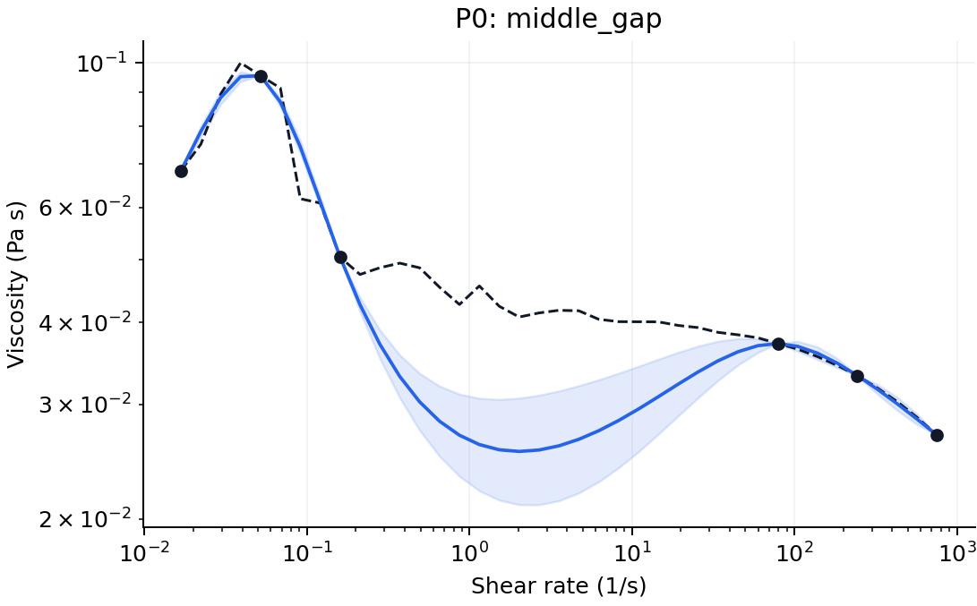
Figure 3 P0 middle gap failure. The dashed black curve is the revealed source response, black dots are six anchors, the blue curve is the candidate median and shading is its nominal 90% marginal interval. Only 8 of 33 targets are covered. All official aggregates retain this formulation.
The posthoc mean 90% interval score is 0.467306 for the candidate, 0.465734 for the GP and 0.406691 for the conditional control. The candidate's score is 14.90% worse than the control despite its lower CRPS. Calibration and sharpness are separate evaluation objectives [35], including in materials prediction [36]. Marginal CRPS, interval score and joint log density consequently support different conclusions. A fixed secondary variogram score now complements this marginal assessment [37].
A fixed variogram score of order one assesses predictions of absolute pairwise differences across all 528 pairs of the 33 missing coordinates, with equal weights and no order or weighting search (Fig. 5b). The candidate obtains a macro score of 0.016172, versus 0.049147 for the GP and 0.040377 for the matched random Gaussian. It improves the formulation-averaged score for 21/25 and 20/25 formulations, respectively. P0 contributes only 0.13% of the net gain against the GP and is a loss against random Gaussian. Its mean is also below the conditional Gaussian value of 0.082035, but P0 contributes 69.23% of that net gain. All formulations remain in the comparison (Supplementary Table S5).
The variogram score is proper but not strictly proper. It is sensitive to relative means and covariance together and is insensitive to a common additive shift and common-mode variance [37]. It does not isolate the copula or establish full-joint calibration. Relative to fixed Student-t, the candidate improves this score for 14/25 formulations, but 99.39% of the net mean gain comes from P0. Thus the diagnostic supports the declared continuation use without showing that Gaussian tails are generally better. The original CRPS endpoint remains unchanged.
For fixed Gaussian parameters and observation identities, conditional covariance depends on anchor coordinates, not numerical anchor values [16]. Unusual observations do not automatically widen intervals. The same restriction applies to the plotted Gaussian information quantities (Fig. 4), derived from standard entropy identities [38]. This property does not uniquely explain P0; it identifies a limitation of the uncertainty mechanism. All 25 admitted outer fits and the deployment fit also end with the second code mean and second log Cholesky diagonal at their lower bounds. The largest projected gradient norm is about 9.17 × ${10}^{−8}$. These are constrained stationary endpoints, not evidence of an unconstrained optimum.
This restriction is specific to conditioning a fixed joint Gaussian law. It does not apply to every predictor with Gaussian output: the conditional-Gaussian control explicitly uses the numerical anchor discrepancy h in both mean and covariance scale. The fixed Student-t diagnostic instead supplies observation-dependent scaling through a coherent curve-specific mixture.
A single fixed Student-t control tests the observation-value dependence missing from the Gaussian covariance [46]. The original Gaussian-fitted mean and kernel are unchanged. A positive scale is shared across coordinates within each curve, with prior degrees of freedom fixed at ten and no search over this choice. The resulting control has macro CRPS 0.042906 and mean joint log density 106.985. For the P0 middle gap, coverage increases from 8/33 to 26/33. However, overall coverage rises to 98.26% and one-sided CRPS worsens from 0.090792 to 0.092948. The frozen Gaussian model remains the continuation model; the heavy-tail result is a diagnostic trade-off rather than successful calibration.
The saved P0 anchor discrepancy is large under the fixed Gaussian mean and covariance. Its middle-gap squared Mahalanobis distance is 155.59, producing a conditional covariance multiplier of 11.685 and a central 90% width ratio of 3.394 in the fixed Student-t control. For one-sided anchors those values rise to 21.111 and 4.562. A shared scalar scale can respond to discordant anchors, but it cannot repair an incorrect conditional mean or the local shape of covariance. This identifies a concrete limitation of the uncertainty mechanism without assigning a physical cause to the unusual curve.
The fixed scale mixture changes covariance while preserving the conditional mean, explaining its identical log-response RMSE. With six anchors, covariance expands if the squared anchor Mahalanobis distance exceeds six and contracts if it is below six. Only 6, 6 and 7 of the 25 formulations trigger expansion in the spread, middle-gap and one-sided layouts. The diagnostic therefore probes observation-dependent uncertainty, rather than applying uniform interval widening.
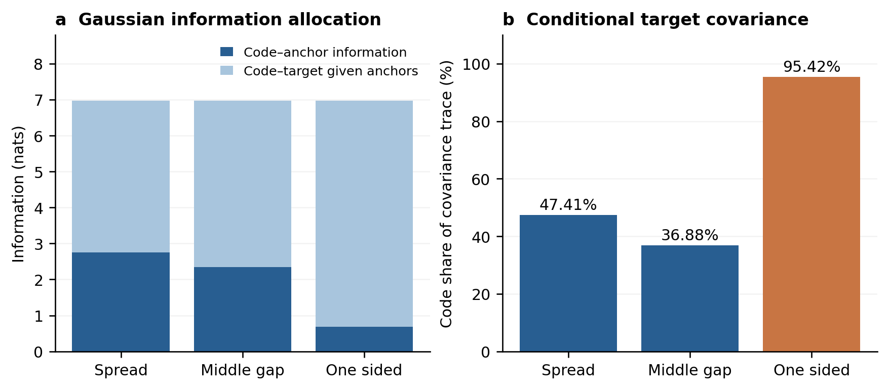
Figure 4 Conditional uncertainty allocation under the fixed candidate. a, Gaussian code information assigned to anchors and to targets conditional on anchors. Their total is fixed by the common coordinate union. b, Code shares of conditional target-covariance trace, averaged over 25 formulations. These model diagnostics describe neither physical explained variance nor prediction accuracy.
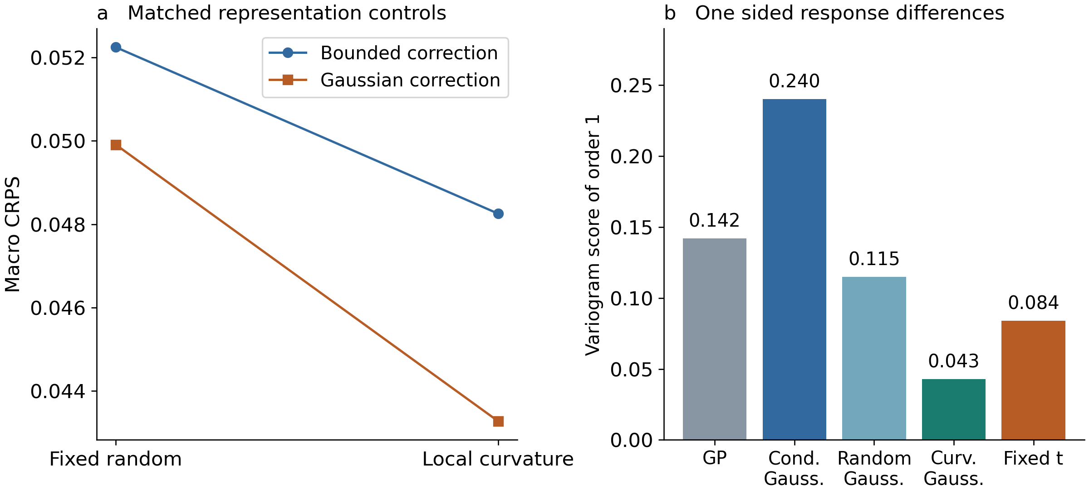
Figure 5 Matched representation controls and a pairwise continuation diagnostic. a, Completed two-by-two CRPS comparison of the fixed random and curvature codes with bounded and Gaussian correction. b, Fixed order-one variogram score for the original one-sided layout, using all 528 pairs of its 33 targets. Lower scores are better. The variogram score is proper but not strictly proper and is insensitive to shared shifts and common-mode variance. Comparisons retain all 25 development formulations; P0 influence is reported in the text. Cond. Gauss., conditional Gaussian; Curv. Gauss., curvature Gaussian.

Discussion
The results support a specific computational proposition: for partially observed flow curves within this ink family, a small correction allocated to fixed curvature contrasts can improve one-sided continuation while retaining a complete joint response model. The physical coordinate construction removes level and slope before adaptation; the reference and anchors already address these components. The residual retains response variation outside the chosen code. This is an economical allocation of learned distributional change, not a claim that two latent variables fully describe hydrogel rheology. The contrasts are statistical summaries of curve shape, with no demonstrated mapping to a unique polymer interaction or relaxation mechanism.
The closest methodological precedent is the inducing-variable Gaussian family [19,20,23]. After whitening linear inducing features, its retained conditional process and a Gaussian feature distribution yield the same form of joint mean and covariance used here. The present objective fits a shared population correction by masked conditional likelihood across training curves, rather than optimizing a sparse posterior approximation by the usual variational bound. Fixed finite-scale curvature windows define the task-specific representation. This objective and representation distinguish the implementation, while the Gaussian decomposition, full-residual principle and consistency under marginalization remain established results. A claim of a new general Gaussian generative framework would exceed the evidence.
The materials task differs from both chemistry-based property prediction and inverse polymer design [5,13,9]. No chemical sequence, composition descriptor or new architecture is generated. Six response measurements identify a context from which the remaining curve is inferred. The anchor-conditioned Cross and Carreau comparisons provide a constitutive reference for this task, with parameter uncertainty included [10,11,12,47]. They do not use the source's complete-curve fitted parameters. Their weaker scores support the present statistical continuation model under the declared priors and training resources, without showing that all constitutive modelling is inferior. A physically constrained mean or kernel remains reasonable when its assumptions are supported by the material and measurement state.
Six anchors can occupy a region where several constitutive parameter combinations fit similarly yet imply different continuations [47]. The probabilistic controls therefore propagate parameter and statistical discrepancy uncertainty, rather than comparing a candidate interval with a single extrapolated best-fit curve. Conversely, the corrected Gaussian model does not enforce monotonicity or a unique constitutive mechanism. The study compares their declared predictive laws under the same anchor and target identities; it does not settle modelling preference from parameter count alone.
The small learned update is also not necessarily a small prediction change. Anchor conditioning transforms the update through reference cross covariances and posterior code moments. Its effect can extend beyond the compact windows because the reference correlates response coordinates. Thus a finite support for the contrast weights is not a hard spatial cutoff on corrected predictions. The fitted trace allocation helps interpret where the reference leaves code-related uncertainty, but is insufficient to identify a physical mechanism for success or failure. Larger ablations of window location, width and code dimension would be developmental experiments requiring a new evaluation boundary, rather than evidence already contained in these scores.
The two scoring perspectives also have a direct response-curve interpretation. Marginal CRPS evaluates the distribution of log viscosity at each rate. In the order-one variogram diagnostic, a pairwise difference in log viscosity is the logarithm of a viscosity ratio, so the score assesses predicted magnitudes of relative response changes across rates. This provides information that the average marginal score alone does not retain. However, the diagnostic mixes relative-mean and covariance effects, is not strictly proper and is insensitive to a common additive displacement [37]. In viscosity units, such a displacement corresponds to multiplying the entire curve by a common factor. Its improvement therefore complements the pointwise assessment without certifying absolute viscosity levels, a correct copula or simultaneous whole-curve coverage.
The uncertainty results limit immediate use in measurement decisions. The fixed heavy-tail control improves one localized failure and joint density but worsens continuation CRPS and overall overcoverage. It is therefore retained as a sensitivity analysis, not selected as a new model from these development scores. Independent calibration procedures for materials regression require data reserved from model choice [39]. Repeated development can bias evaluation despite nominal cross-validation [40], and materials redundancy makes apparently separated records potentially dependent [41,42]. Leaving a formulation out prevents direct within-fold response leakage, but it cannot undo choices informed by the same 25 curves or establish independence of preparation batches.
Transfer and adaptive experimentation require additional evidence. Recent materials work warns that apparently suitable uncertainty estimates may fail under distribution shift and mislead active learning [43]. Nothing in the current offline masking study demonstrates better material discovery, autonomous selection of measurement coordinates or reduced experimental time. Gaussian code information is a model diagnostic, not a certificate of target accuracy. Its approximately constant total across layouts follows from a common union of coordinates and the information chain rule, so the three layouts are not independent discoveries of recoverable information. The strong conditional control also shows that shared-joint coherence alone does not ensure the best conditional score.
A next evaluation should freeze the continuation model, conditional Gaussian and GP before receiving genuinely unused native curves in the same measurement domain. New formulations, independent preparations of known formulations and external laboratory records support different claims and require separate grouping. Coordinates, temperature, scan history, practical tolerance and the sampling unit should be fixed before target reveal. A continuation-only endpoint weighted by log-rate span could address irregular sampling, but it is a new endpoint without results here. Conformalized quantile regression and jackknife+ are possible future coverage tools under appropriate exchangeability assumptions [44,45]; they have not been applied. The present evidence supports a compact continuation method and a complete account of its development comparisons, rather than verified transfer, calibrated whole-curve guarantees or measured experimental savings.

Methods

Source records and access roles
The starting point is a frozen working cache derived from version 0.0.2 of the public dataset [32] associated with Zhang and colleagues [33]. One identity-conflicting record was excluded during the documented provenance review, leaving 45 formulation records with 39 native shear-rate and viscosity positions each. Reported flow observations are kept distinct from fitted Cross parameters, regression outputs and simulated processing outputs in the source. This study uses material-response records only. Conditions attached to oscillatory measurements are not automatically assigned to steady-flow data, and the published instrument scan range is not substituted for the narrower admitted cache support.
The 25 P records provide complete curves previously accessible during development. The 20 S records provide only their six fixed anchors to the restricted cache; their hidden outcomes are not reopened. These are access roles, not certified independent experimental batches. Native column indices specify the layouts, but their physical shear-rate values can differ by formulation. The statistical unit for paired summaries is a formulation, with physical batch dependence unresolved. We do not count targets, masks or generated draws as new measured materials.

Coordinates layouts and nested information access
Let shear rate and viscosity be transformed to dimensionless natural logarithms using reference units of 1 s⁻¹ and 1 Pa s.
$t = ln(\frac{γ̇}{{γ̇}_{ref}}) , y = ln(\frac{η}{η_{ref}})$ (1)
Zero-based anchor indices are {0,7,15,23,31,38} for spread, {0,4,8,30,34,38} for middle gap and {0,3,6,9,12,15} for one-sided layouts. Each leaves 33 targets. The primary average weights each target, layout and formulation equally. In an outer fold, all 39 held P responses, including future anchors, are excluded from reference fitting and normalization. The other 24 P curves and 20 S anchor sets supply 24 × 39 + 20 × 6 = 1056 reference observations. Correction training uses the 24 complete P curves only, with the three specified conditional training tasks. The held anchors enter prediction after fitting. Saved outer references are reused unchanged for all correction comparisons.

Gaussian process reference and normalization
The reference has a fixed linear mean and independent random level, random slope, Matérn 3/2 and observation-discrepancy covariance components. Log rate is centered at the midpoint of visible reference coordinates and scaled by half their range. Log response is centered at the mean of visible reference responses and divided by their population standard deviation. The mean coefficients are profiled by generalized least squares. Positive covariance parameters are fitted by profiled maximum likelihood summed over independent formulation blocks in the statistical model; this is not restricted maximum likelihood. Saved fit configurations and parameters remain in the full reproducibility archive.
For normalized coordinates u and v the covariance is
$k_{0}(u,v) = {σ_{level}}^{2} + {σ_{slope}}^{2}uv + {σ_{smooth}}^{2}M_{3/2}(u,v) + {σ_{report}}^{2}δ_{obs}$
$M_{3/2}(u,v) = (1 + r)exp(−r) , r = \frac{√3 |u − v|}{ℓ}$ (2)
The diagonal discrepancy is indexed by reported observation identity. It is not a separately measured instrument-noise variance. Latent support values used for the code exclude this report discrepancy; covariance of reported Y includes it. All predictions and scores are returned to the declared log-response units. A scaled reference objective used in the archived implementation changes numerical scaling, not the Gaussian model. The statistical assumption of independent formulation blocks does not certify physical independence of their preparations.

Fixed finite-scale contrasts and whitening
Let Q contain 17 equally spaced coordinates over the fixed physical log-rate support. At each interior $q_{j}$ define positive adjacent spacings $a_{j}$ and $b_{j}$ and a second-difference row $D_{j}$ with nonzero entries
$D_{j,j−1} = \frac{2}{a_{j}(a_{j} + b_{j})} , D_{j,j} = \frac{−2}{a_{j}b_{j}} , D_{j,j+1} = \frac{2}{b_{j}(a_{j} + b_{j})}$ (3)
The two window centres lie one third and two thirds along the support, with half-width one third of its span. At an interior position, the unnormalized weight is (1−x²)³ for |x|<1, multiplied by quadrature width ($a_{j}$+$b_{j}$)/2; it is zero outside. Normalize each window to unit sum and form F = WD. Thus F annihilates constants and linear functions on Q up to floating-point error. This is a finite-scale contrast, not a classical second derivative of a Matérn path.
The contrasts have a direct interpretation on the log–log flow curve. An ideal global power-law profile has y(t) = α + (n−1)t, so both contrast responses vanish. The two adaptive coordinates therefore respond to finite-scale departures from an affine log–log profile rather than to its absolute viscosity level or overall slope. Level and slope variability remain in the reference process and are not discarded from predictions. This is a shape-focused representation; its coordinates are not identified constitutive parameters or unique signatures of polymer interactions.
If $K_{Q}$ is the latent reference covariance and $m_{Q}$ its mean, define
$P = FK_{Q}F^{T} , z = P^{−\frac{1}{2}}F(f_{Q} − m_{Q}) ∼ N(0, I_{2})$ (4)
The inverse square root is symmetric and requires a stably positive two-dimensional covariance. Support, windows and prior whitening do not depend on a query mask or its hidden responses. The code is not rewhitened after observing anchors. Its cross covariance with reported responses is
$C_{R} = K_{Y_R,f_Q}F^{T}P^{−\frac{1}{2}}$ (5)

Joint correction and relation to inducing-variable methods
For any finite reported response set R, the reference decomposes as
$Y_{R} = m_{R} + C_{R}z + ε_{R}$
$ε_{R} ∼ N(0, R_{R}) , R_{R} = K_{R} − C_{R}{C_{R}}^{T} , ε_{R} ⟂ z$ (6)
We retain the independent residual and replace only the code distribution. With two mean parameters, two log Cholesky diagonals and one off-diagonal entry,
$z ∼ N(a, S) , S = LL^{T} , L = \left[\begin{matrix}e^{λ_{0}} & 0 \\ c & e^{λ_{1}}\end{matrix}\right]$
$m_{θ} = m_{0} + Ca , K_{θ} = K_{0} + C(S − I_{2})C^{T}$ (7)
At zero correction, the reference is recovered. Equivalently, the model integrates the unchanged reference conditional law over a replacement Gaussian law on its linear features.
$p_{θ}(Y) = ∫ p_{0}(Y | z) N(z ; a, S) dz$ (8)
An equivalent quadratic relative-potential interpretation and the induced response-density ratio are given in Supplementary Section S9. They describe this same Gaussian replacement and do not add an energy-model fitting stage.
This is the same distributional form as retaining p(f|u) and changing q(u) in inducing-variable Gaussian methods [19,20]. The training objective and feature construction here differ from standard sparse variational posterior inference. The rank-two covariance update does not remove the high-dimensional residual. Positive semidefiniteness follows from the residual-plus-code decomposition, and finite subsets inherit consistent means and covariances from the same reference process. These are Gaussian construction properties, not empirical validation.
For anchors O and targets H the conditional law follows from the corrected full joint distribution.
$μ_{H|O} = m_{θ,H} + K_{θ,HO}{K_{θ,OO}}^{−1}(y_{O} − m_{θ,O})$ (9)
$V_{H|O} = K_{θ,HH} − K_{θ,HO}{K_{θ,OO}}^{−1}K_{θ,OH}$ (10)
Drawing from this Gaussian and exponentiating gives correlated predictions in viscosity units; draws remain model outputs. For fixed parameters and observation identities, simultaneous and sequential assimilation of the same anchors agree. Neither this consistency nor the choice of physical coordinates imposes monotonicity or guarantees accurate uncertainty.

Conditional residual and diagnostic quantities
To make residual conditioning explicit, write R = $K_{0}$ − CCᵀ. When its anchor block is positive definite, define
$R = K_{0} − CC^{T} , T = R_{HO}{R_{OO}}^{−1}$ (11)
$B_{H} = C_{H} − TC_{O}$ (12)
$D_{H} = R_{HH} − TR_{OH}$ (13)
The posterior code and target moments are
$S_{O} = {(S^{−1} + {C_{O}}^{T}{R_{OO}}^{−1}C_{O})}^{−1}$ (14)
$a_{O} = S_{O}[S^{−1}a + {C_{O}}^{T}{R_{OO}}^{−1}(y_{O} − m_{0,O})]$ (15)
$E(Y_{H} | y_{O}) = m_{0,H} + T(y_{O} − m_{0,O}) + B_{H}a_{O}$ (16)
$Cov(Y_{H} | y_{O}) = D_{H} + B_{H}S_{O}{B_{H}}^{T}$ (17)
In particular, $B_{H}$ generally differs from $C_{H}$ because residual anchor correlation also contributes. The candidate is conditioned from its full joint matrices; this equivalent expression explains the plotted decomposition. The code trace fraction is tr($B_{H}$ $S_{O}$ $B_{H}$ᵀ)/tr($D_{H}$+$B_{H}$ $S_{O}$ $B_{H}$ᵀ), computed per context and then averaged. Gaussian entropy identities yield code–anchor and conditional code–target information [38]. Their sum is fixed within each formulation because anchors and targets partition the same 39 coordinates. These diagnostics use the fitted distribution without target-dependent routing or rejection.
For a fixed target contrast v, Eq. (17) gives a residual variance contribution vᵀD_Hv plus a nonnegative code contribution. If B_Hᵀv is zero, the variance is exactly the residual term. With 33 targets and two code coordinates, at least 31 linearly independent contrast directions have this property. The positive residual blocks in the saved queries prevent uncertainty from collapsing in those directions; the statement concerns the fitted model, rather than its empirical calibration. Supplementary Section S9 gives the identity.

Conditional training and admission criteria
For each outer fold the shared correction is trained on the other 24 complete P curves, averaging their conditional log likelihoods over the three layouts.
$J(θ) = −\frac{1}{3N}∑_{i=1…N}∑_{b=1…3} ln p_{θ}(y_{i,Hb} | y_{i,Ob}) + 0.02 ‖θ‖²$ (18)
The penalty is 0.02 times squared parameter norm. Mean parameters and the off-diagonal Cholesky entry are bounded to [−1,1]; log diagonals to [−0.75,0.75]. Parameter order is $a_{0}$, $a_{1}$, log $L_{00}$, $L_{10}$, log $L_{11}$. One zero cold start is used with L-BFGS-B, maximum 400 iterations and 800 evaluations, ftol ${10}^{−14}$, gtol ${10}^{−7}$ and maxls 40. Admission requires solver success, finite outputs, improvement over zero correction and projected-gradient infinity norm no greater than ${10}^{−5}$. No automatic jitter, code rotation or post-result widening of bounds is used.
The unpenalized objective targets the three declared conditional log-loss tasks, rather than marginal CRPS directly. Equal layout weights specify the training design; they do not estimate how responses become missing in naturally collected records. Under finite conditional entropies, the corresponding expected risk is a conditional Kullback–Leibler projection plus a parameter-independent constant, as detailed in Supplementary Section S9. Three masks average tasks for each formulation without creating three independent specimens.
An initial direct high-dimensional likelihood implementation stopped with abnormal solver termination and was not admitted or scored. The archived diagnosis found analytic-gradient agreement alongside finite-difference noise from likelihood subtraction. A separately recorded continuation used an equivalent low-rank formula without changing labels, model, initialization, bounds, penalty or gates. With A, h, T and G defined by
$A = C^{T}{K_{0}}^{−1}C , h = C^{T}{K_{0}}^{−1}(y − m_{0})$ (19)
$T = S − I_{2} , G = {(I_{2} + TA)}^{−1}T$ (20)
the exact change in Gaussian negative log density from the reference is
$ΔNLL = \frac{1}{2}[ln det(I_{2} + TA) − 2a^{T}h + a^{T}Aa − {(h − Aa)}^{T}G(h − Aa)]$ (21)
The conditional objective subtracts the anchor expression from the full-response expression. Two-by-two determinant and Woodbury calculations stabilize the correction update; they do not remove reference solves or full conditional covariance work for draws. Direct full-matrix calculations independently checked saved objectives, gradients and distributions. Twenty-five outer fits and one subsequent deployment fit were admitted. At all 26 endpoints, $a_{1}$ = −1 and log $L_{11}$ = −0.75. The global code variance of z₂ conditional on z₁ is exp(−1.5) ≈ 0.22313; its marginal variance ranges from 0.44758 to 0.58337. Neither quantity is the response residual variance or the anchor-conditioned posterior variance.
The low-rank objective reduces the repeated correction calculation after reference quantities have been formed. Each full-response and anchor set supplies a two-by-two matrix A and a two-vector h in Eq. (19); subsequent correction evaluations operate on these summaries. This algebraic saving does not make the entire procedure two dimensional. Constructing the reference summaries, conditioning at target coordinates and factoring the full target covariance remain necessary. No measured training-time, instrument-time or laboratory-cost advantage is inferred from the parameter count.

Sampling law and interpretation in material units
The logarithmic transformation makes the declared reference units explicit. A Gaussian conditional mean in log viscosity exponentiates to a median, whereas a marginal mean in viscosity units also includes the variance contribution exp($V_{jj}$/2). The reported log-response RMSE and CRPS should therefore not be read as errors of a mean-viscosity estimator. Similarly, an interval symmetric in log units is generally asymmetric in viscosity. Changing to viscosity-scale scoring would change the evaluation target and potentially the ranking; it has not been done in this revision.
Correlated samples require a factorization of the full conditional target covariance. Independent draws from its 33 marginals would discard the joint dependence retained by the model, even though marginal CRPS would not detect that change. Joint density addresses this dependence under the assumed Gaussian law; it should not be replaced by a sum of marginal log densities. Positive joint log densities are possible because density is defined relative to the chosen continuous coordinate scale. Marginal coverage counts targets separately and does not measure the probability that all missing positions of a curve are simultaneously covered.
The reported predictive laws condition on the saved normalization, reference hyperparameters and five correction parameters. Their covariance represents uncertainty about unobserved reported responses under that fitted joint law; it does not average over alternative fitted references or correction parameters. The callable interface also distinguishes completion of an existing record from a fresh measurement replicate: a requested rate exactly matching a stored anchor returns that known response, whereas unobserved coordinates are sampled jointly. A future independent replicate at an already observed rate would require a new observation identity and an appropriate discrepancy term; this is not the query exposed by the current interface.

Baseline families and available comparisons
The coordinate GP is unchanged. The generic and curvature bounded tilts retain the reference residual and use amplitude one with five fixed linear, centered-quadratic and interaction features [30].
$E_{θ}(z) = tanh(θ^{T}ϕ(z)) , p_{θ}(z) ∝ p_{0}(z) exp[−E_{θ}(z)]$ (22)
$ϕ(z) = [z_{1}, z_{2}, \frac{{z_{1}}^{2} − 1}{√2}, \frac{{z_{2}}^{2} − 1}{√2}, z_{1}z_{2}]$ (23)
The generic code uses fixed random QR directions and the local code uses the same curvature contrasts as the candidate. Their saved directions, quadrature settings, parameters and protocols remain bound to the original experiment. Gaussian corrections are independently optimized, not obtained by moment matching a fitted tilt. The newly completed random-Gaussian cell reuses the same frozen random directions and matches the curvature Gaussian in dimension, five trainable parameters, bounds, penalty, cold start, optimizer and information access (Supplementary Table S3). It adds 25 outer correction fits; original references and candidate parameters remain unchanged.
The conditional Gaussian control starts from the same reference conditional mean m and covariance V. Let $s_{j}$ = √$V_{jj}$, normalize target coordinate $u_{j}$ over the fixed support, and define anchor discrepancy h as
$h = ln[1 + \frac{{(y_{O} − m_{0,O})}^{T}{K_{0,OO}}^{−1}(y_{O} − m_{0,O})}{|O|}]$ (24)
Its mean and covariance are
$m_{c,j} = m_{j} + s_{j}(α_{0} + α_{1}u_{j} + α_{2}h)$ (25)
$V_{c} = exp[2(β_{0} + β_{1}h)]V$ (26)
The three alpha parameters have bounds [−1,1], and the two beta parameters [−0.75,0.75]. The control minimizes the same averaged conditional negative log likelihood with penalty 0.02. It is a valid conditional predictor, although a common joint law across contexts is not imposed. Equal counts do not equalize function classes. The archived PCHIP point baseline is not assigned a fabricated covariance or probabilistic score. Anchor-conditioned probabilistic constitutive controls are specified below. Modern neural conditional generators are outside this small-data comparison.

Scores frozen predictions and descriptive resampling
The primary endpoint is mean marginal CRPS on log viscosity [34].
$CRPS(F,y) = ∫_{−∞}^{∞}{[ F(x) − 1\{x ≥ y\} ]}^{2} dx$ (27)
For a Gaussian marginal, with r = (y−μ)/σ, the analytic expression is
$CRPS(N(μ, σ^{2}),y) = σ[r(2Φ(r) − 1) + 2ϕ(r) − \frac{1}{√π}]$ (28)
The score is averaged over 33 native targets, three layouts and 25 formulations. Pooled RMSE is the square root of mean squared log error, not the average of per-query RMSEs. Joint log density scores each 33-dimensional target vector; it is scale dependent and can be positive. Nominal 90% marginal intervals use the 95th standard-normal quantile, and their exponentials are lognormal viscosity quantiles. Their average width is measured in log units. The posthoc interval score is
${IS}_{0.1}(l,u;y) = (u − l) + 20(l − y)1\{y < l\} + 20(y − u)1\{y > u\}$ (29)
The original 75 candidate conditional distributions were frozen before target scoring. Original comparator scores are inherited unchanged. The additional random-Gaussian, Cross, Carreau and Student-t laws were registered, computed and frozen separately before scoring, while all 25 formulations retained their previously inspected development role. Saved 2000-draw paired bootstrap intervals resample fixed formulation-level predictions and exclude historical selection, refitting and batch variation. The inside/beyond-anchor decomposition, interval scores, P0 sensitivity and paired plot are descriptive analyses of frozen outputs; none replaces the primary endpoint or adds independent materials. Physical-mixture CRPS uses an analytic first expectation and 131072 independent particle pairs in the second, with 32-block Monte Carlo standard errors that exclude posterior approximation error. A subsequently fitted deployment correction uses all 25 P curves and provides a callable generator, not another evaluation. Conformal calibration has not been applied.

Anchor conditioned constitutive controls
We use finite-plateau Cross and fixed-a=2 Carreau curves, parameterized by the low-rate viscosity, high-to-low plateau ratio, transition rate and shear-thinning exponent, with an independent statistical discrepancy in log viscosity [10,11,12]. This discrepancy is not a separately measured instrument-noise variance. Each query posterior conditions only on its six anchors; prior scales use outer training normalization and the saved reference discrepancy scale. The transformed parameters and numerical budget are given in Supplementary Section S7.
$η_{Cross}(γ) = η_{0} [r + \frac{1−r}{1 + {(γ/γ_{c})}^{m}}]$ (30)
$η_{Carreau}(γ) = η_{0} [r + (1−r){(1 + {(\frac{γ}{γ_{c}})}^{2})}^{\frac{n−1}{2}}]$ (31)
The Gaussian log-viscosity level is analytically integrated, leaving a four-dimensional posterior with the original proper prior and likelihood. Each predictive mixture component retains both an independent discrepancy term and a rank-one covariance from level uncertainty. Tempered sequential Monte Carlo uses two independent runs with a fixed agreement gate on predictive means and standard deviations. The original failures and the single additional Cross particle budget are retained. No prior, exponent range or scale was selected from target scores.

Fixed shared scale sensitivity analysis
We investigate one Student-t scale mixture with prior degrees of freedom ν=10 [46]. The scale is shared within a curve, not globally across materials. Its inverse-gamma prior is parameterized by shape and scale, so that its mean is one; unconditional Gaussian mean and covariance are preserved. The existing Gaussian-fitted code parameters are not refitted under a Student-t likelihood, and no degrees-of-freedom search is performed.
$τ ∼ InvGamma(\frac{ν}{2}, \frac{ν−2}{2}), Eτ = 1,$
$Y | τ ∼ N(m_{θ}, τK_{θ})$ (32)
For k observed anchors, let d be their squared Mahalanobis distance from the frozen Gaussian mean. Let μG and KG denote the original Gaussian conditional mean and covariance. The Student-t conditional law has degrees of freedom ν+k, unchanged mean and the following shape matrix; its covariance multiplies that shape by (ν+k)/(ν+k−2).
$Y_{H} | y_{O} ∼ t_{ν+k}(μ_{G}, \frac{ν−2+d}{ν+k}K_{G}),$
$d = {(y_{O}−m_{O})}^{T}{K_{OO}}^{−1}(y_{O}−m_{O})$ (33)
For k=6, the conditional covariance is KG(8+d)/14. All 75 laws are frozen before their retrospective score computation. Closed-form Student-t CRPS is checked against numerical integration of its CDF, and the conditional joint density is checked against the ratio of full and anchor densities [48]. The shared scale includes statistical discrepancy and does not constitute instrument calibration.

Fixed pairwise difference diagnostic
For each registered 33-dimensional target law F, the order-one variogram score [37] compares observed and expected absolute pairwise differences. All 528 unordered pairs have equal weight. The exponent and weights were fixed in an actual protocol before 375 analytic forecast-contrast vectors were frozen and scored; no order, weight or model search was conducted.
${VS}_{1}(F,y) = \frac{1}{528}∑_{i<j}{[ |y_{i}−y_{j}| − E_{F}|Y_{i}−Y_{j}| ]}^{2}$ (34)
Gaussian absolute-difference expectations use the folded-normal expression derived from each full joint covariance. The Student-t control uses its conditional pairwise t distribution. An independent audit checked all pair expectations through full contrast matrices, a Normal-Gamma mixture integral and selected direct density integrals. The score is a new secondary diagnostic on the same consumed development formulations, not a replacement primary endpoint or independent confirmation. The Cross and Carreau posterior mixtures were not included in this fixed five-law diagnostic.

Data availability
The source dataset is deposited as version 0.0.2 under DOI 10.5281/zenodo.19602891 [32]. The public computational-evidence checkpoint at https://github.com/Hancy5521/hydrogel_control, commit 79f3ae4feb84738962233923fe189591fe818733, includes derived score ledgers for the existing nine probabilistic methods, the fixed variogram diagnostic and the point-only PCHIP control. It does not redistribute raw response curves, the restricted processed cache or every original outer-fold predictive law. The original scientific archives preserve those assets and access roles; identifiers are given in Supplementary Section S6. Author-approved access and reuse terms for remaining processed reproducibility inputs still require completion.

Code availability
A versioned public checkpoint is available at https://github.com/Hancy5521/hydrogel_control, commit 79f3ae4feb84738962233923fe189591fe818733, retained on archive/computational-evidence-2026-11-01. It provides unchanged frozen deployment inference, a standard-library saved-score table replay, independent synthetic inference checks and a synthetic demonstration of the original five-parameter training primitive. Supplementary Section S13 defines their separate scopes. The deployment weights use all 25 complete P curves and lawful anchors of 20 S records and are not the outer-fold models underlying the paper. The new computational tools do not perform new material fitting or target scoring; full original raw-data, reference-fitting, posterior and out-of-fold replay is not claimed. Original-asset licensing and author publication declarations remain to be completed.

Acknowledgements
Acknowledgements and any funding information require author completion and confirmation.

Author contributions
Author identities, affiliations, correspondence and individual contributions require author completion. This draft does not assign contributions to unnamed investigators.

Competing interests
The authors must supply and confirm the competing interests statement.

References
[1] Ward L, Agrawal A, Choudhary A, Wolverton C. A general-purpose machine learning framework for predicting properties of inorganic materials. npj Computational Materials. 2016;2:16028. https://doi.org/10.1038/npjcompumats.2016.28.
[2] Dunn A, Wang Q, Ganose A, Dopp D, Jain A. Benchmarking materials property prediction methods: the Matbench test set and Automatminer reference algorithm. npj Computational Materials. 2020;6:138. https://doi.org/10.1038/s41524-020-00406-3.
[3] Kim C, Chandrasekaran A, Huan TD, Das D, Ramprasad R. Polymer Genome: A Data-Powered Polymer Informatics Platform for Property Predictions. Journal of Physical Chemistry C. 2018;122:17575–17585. https://doi.org/10.1021/acs.jpcc.8b02913.
[4] Kuenneth C, Rajan AC, Tran H, Chen L, Kim C, Ramprasad R. Polymer informatics with multi-task learning. Patterns. 2021;2:100238. https://doi.org/10.1016/j.patter.2021.100238.
[5] Kuenneth C, Ramprasad R. polyBERT: a chemical language model to enable fully machine-driven ultrafast polymer informatics. Nature Communications. 2023;14:4099. https://doi.org/10.1038/s41467-023-39868-6.
[6] Xu C, Wang Y, Barati Farimani A. TransPolymer: a Transformer-based language model for polymer property predictions. npj Computational Materials. 2023;9:64. https://doi.org/10.1038/s41524-023-01016-5.
[7] Phan BK, Shen KH, Gurnani R, Tran H, Lively R, Ramprasad R. Gas permeability, diffusivity, and solubility in polymers: Simulation-experiment data fusion and multi-task machine learning. npj Computational Materials. 2024;10:186. https://doi.org/10.1038/s41524-024-01373-9.
[8] Okabe R, Cheng M, Chotrattanapituk A, et al. Structural constraint integration in a generative model for the discovery of quantum materials. Nature Materials. 2026;25:223–230. https://doi.org/10.1038/s41563-025-02355-y.
[9] Jiang S, Webb MA. Generative active learning across polymer architectures and solvophobicities for targeted rheological behavior. npj Computational Materials. 2026;12:28. https://doi.org/10.1038/s41524-025-01900-2.
[10] Cross MM. Rheology of non-Newtonian fluids: A new flow equation for pseudoplastic systems. Journal of Colloid Science. 1965;20:417–437. https://doi.org/10.1016/0095-8522(65)90022-X.
[11] Carreau PJ. Rheological Equations from Molecular Network Theories. Transactions of the Society of Rheology. 1972;16:99–127. https://doi.org/10.1122/1.549276.
[12] Yasuda K, Armstrong RC, Cohen RE. Shear flow properties of concentrated solutions of linear and star branched polystyrenes. Rheologica Acta. 1981;20:163–178. https://doi.org/10.1007/BF01513059.
[13] Jain A, Gurnani R, Rajan A, Qi HJ, Ramprasad R. A physics-enforced neural network to predict polymer melt viscosity. npj Computational Materials. 2025;11:42. https://doi.org/10.1038/s41524-025-01532-6.
[14] Mahmoudabadbozchelou M, Jamali S. Rheology-Informed Neural Networks (RhINNs) for forward and inverse metamodelling of complex fluids. Scientific Reports. 2021;11:12015. https://doi.org/10.1038/s41598-021-91518-3.
[15] Saadat M, Mahmoudabadbozchelou M, Jamali S. Data-driven selection of constitutive models via rheology-informed neural networks (RhINNs). Rheologica Acta. 2022;61:721–732. https://doi.org/10.1007/s00397-022-01357-w.
[16] Rasmussen CE, Williams CKI. Gaussian Processes for Machine Learning. MIT Press; 2006. https://gaussianprocess.org/gpml/.
[17] Lennon KR, McKinley GH, Swan JW. A data-driven method for automated data superposition with applications in soft matter science. Data-Centric Engineering. 2023;4:e13. https://doi.org/10.1017/dce.2023.3.
[18] Yao F, Müller HG, Wang JL. Functional data analysis for sparse longitudinal data. Journal of the American Statistical Association. 2005;100:577–590. https://doi.org/10.1198/016214504000001745.
[19] Titsias M. Variational Learning of Inducing Variables in Sparse Gaussian Processes. Proceedings of AISTATS. PMLR. 2009;5:567–574. https://proceedings.mlr.press/v5/titsias09a.html.
[20] Lázaro-Gredilla M, Figueiras-Vidal AR. Inter-domain Gaussian Processes for Sparse Inference using Inducing Features. Advances in Neural Information Processing Systems. 2009;22. https://papers.nips.cc/paper_files/paper/2009/hash/5ea1649a31336092c05438df996a3e59-Abstract.html.
[21] Hensman J, Fusi N, Lawrence ND. Gaussian Processes for Big Data. Proceedings of UAI. 2013:282–290. https://arxiv.org/abs/1309.6835.
[22] Matthews AG de G, Hensman J, Turner RE, Ghahramani Z. On Sparse Variational Methods and the Kullback-Leibler Divergence between Stochastic Processes. Proceedings of AISTATS. PMLR. 2016;51:231–239. https://proceedings.mlr.press/v51/matthews16.html.
[23] Shi J, Titsias M, Mnih A. Sparse Orthogonal Variational Inference for Gaussian Processes. Proceedings of AISTATS. PMLR. 2020;108:1932–1942. https://proceedings.mlr.press/v108/shi20b.html.
[24] Garnelo M, Rosenbaum D, Maddison CJ, et al. Conditional Neural Processes. Proceedings of ICML. PMLR. 2018;80:1704–1713. https://proceedings.mlr.press/v80/garnelo18a.html.
[25] Kim H, Mnih A, Schwarz J, Garnelo M, Eslami SMA, Rosenbaum D, Vinyals O, Teh YW. Attentive Neural Processes. Proceedings of ICLR. 2019. https://arxiv.org/abs/1901.05761.
[26] Ivanov O, Figurnov M, Vetrov D. Variational Autoencoder with Arbitrary Conditioning. Proceedings of ICLR. 2019. https://openreview.net/forum?id=SyxtJh0qYm.
[27] Ma C, Tschiatschek S, Palla K, Hernández-Lobato JM, Nowozin S, Zhang C. EDDI: Efficient Dynamic Discovery of High-Value Information with Partial VAE. Proceedings of ICML. PMLR. 2019;97:4234–4243. https://proceedings.mlr.press/v97/ma19c.html.
[28] Yoon J, Jordon J, van der Schaar M. GAIN: Missing Data Imputation using Generative Adversarial Nets. Proceedings of ICML. PMLR. 2018;80:5689–5698. https://proceedings.mlr.press/v80/yoon18a.html.
[29] Tashiro Y, Song J, Song Y, Ermon S. CSDI: Conditional Score-based Diffusion Models for Probabilistic Time Series Imputation. Advances in Neural Information Processing Systems. 2021;34. https://proceedings.neurips.cc/paper_files/paper/2021/hash/cfe8504bda37b575c70ee1a8276f3486-Abstract.html.
[30] Xiao Z, Yan Q, Amit Y. Exponential Tilting of Generative Models: Improving Sample Quality by Training and Sampling from Latent Energy. arXiv:2006.08100v1. 2020. https://doi.org/10.48550/arXiv.2006.08100.
[31] Strauss RR, Oliva JB. Arbitrary conditional distributions with energy. Advances in Neural Information Processing Systems. 2021;34. https://proceedings.neurips.cc/paper_files/paper/2021/file/06c284d3f757b15c02f47f3ff06dc275-Paper.pdf.
[32] Zhang C. Dataset for Disentangled Generative AI-Guided Closed-Loop Optimization of Deposition Morphology for 3D Bioprinting Applications. Version 0.0.2. Zenodo; 2026. https://doi.org/10.5281/zenodo.19602891.
[33] Zhang C, Elvitigala K, Sakai S. Generative AI-guided in silico closed-loop optimisation of deposition morphology for 3D bioprinting applications. Virtual and Physical Prototyping. 2026;21:e2671497. https://doi.org/10.1080/17452759.2026.2671497.
[34] Gneiting T, Raftery AE. Strictly Proper Scoring Rules, Prediction, and Estimation. Journal of the American Statistical Association. 2007;102:359–378. https://doi.org/10.1198/016214506000001437.
[35] Gneiting T, Balabdaoui F, Raftery AE. Probabilistic Forecasts, Calibration and Sharpness. Journal of the Royal Statistical Society Series B. 2007;69:243–268. https://doi.org/10.1111/j.1467-9868.2007.00587.x.
[36] Tran K, Neiswanger W, Yoon J, et al. Methods for comparing uncertainty quantifications for material property predictions. Machine Learning: Science and Technology. 2020;1:025006. https://doi.org/10.1088/2632-2153/ab7e1a.
[37] Scheuerer M, Hamill TM. Variogram-Based Proper Scoring Rules for Probabilistic Forecasts of Multivariate Quantities. Monthly Weather Review. 2015;143:1321–1334. https://doi.org/10.1175/MWR-D-14-00269.1.
[38] Krause A, Singh A, Guestrin C. Near-Optimal Sensor Placements in Gaussian Processes: Theory, Efficient Algorithms and Empirical Studies. Journal of Machine Learning Research. 2008;9:235–284. https://www.jmlr.org/papers/v9/krause08a.html.
[39] Palmer G, Du S, Politowicz A, et al. Calibration after bootstrap for accurate uncertainty quantification in regression models. npj Computational Materials. 2022;8:115. https://doi.org/10.1038/s41524-022-00794-8.
[40] Cawley GC, Talbot NLC. On Over-fitting in Model Selection and Subsequent Selection Bias in Performance Evaluation. Journal of Machine Learning Research. 2010;11:2079–2107. https://www.jmlr.org/papers/v11/cawley10a.html.
[41] Li Q, Fu N, Omee SS, Hu J. MD-HIT: Machine learning for material property prediction with dataset redundancy control. npj Computational Materials. 2024;10:245. https://doi.org/10.1038/s41524-024-01426-z.
[42] Li K, Persaud D, Choudhary K, et al. Exploiting redundancy in large materials datasets for efficient machine learning with less data. Nature Communications. 2023;14:7283. https://doi.org/10.1038/s41467-023-42992-y.
[43] Dale AS, Li K, DeCost B, et al. When active learning fails, uncalibrated out of distribution uncertainty quantification might be the problem. npj Computational Materials. Published online 24 October 2026. https://doi.org/10.1038/s41524-026-02368-4.
[44] Romano Y, Patterson E, Candès EJ. Conformalized Quantile Regression. Advances in Neural Information Processing Systems. 2019;32. https://proceedings.neurips.cc/paper_files/paper/2019/hash/5103c3584b063c431bd1268e9b5e76fb-Abstract.html.
[45] Barber RF, Candès EJ, Ramdas A, Tibshirani RJ. Predictive inference with the jackknife+. Annals of Statistics. 2021;49:486–507. https://doi.org/10.1214/20-AOS1965.
[46] Shah A, Wilson A, Ghahramani Z. Student-t Processes as Alternatives to Gaussian Processes. Proceedings of AISTATS. PMLR. 2014;33:877–885. https://proceedings.mlr.press/v33/shah14.html.
[47] Gallagher MT, Wain RAJ, Dari S, Whitty JP, Smith DJ. Non-identifiability of parameters for a class of shear-thinning rheological models, with implications for haematological fluid dynamics. arXiv:1810.02292v1. 2018. https://doi.org/10.48550/arXiv.1810.02292.
[48] Jordan A, Krüger F, Lerch S. Evaluating Probabilistic Forecasts with scoringRules. Journal of Statistical Software. 2019;90(12). https://doi.org/10.18637/jss.v090.i12.

