Residual preserving Gaussian adaptation for probabilistic continuation of hydrogel flow curves
Author names affiliations and corresponding author details to be completed

Abstract
Scientific response curves are often observed only over part of their measurement range. We study six-anchor continuation of hydrogel precursor ink viscosity using a Gaussian process reference, two fixed finite-scale curvature contrasts and a shared five-parameter Gaussian correction. Retaining the complete reference residual avoids constraining the response to two dimensions, and all anchor layouts condition one joint law. On 25 previously inspected formulations and three layouts, retrospective mean marginal continuous ranked probability score is 0.043277, 21.63% below the reference and 13.88% below a conditional Gaussian control. The gain concentrates in one-sided continuation; interpolation and some uncertainty measures favour controls. A no-retraining transfer stress test contains 46 native curves from four public sources and 781 higher-rate targets. Under its original group weighting, Liverpool ink scores improve, but the other three sources lose to the reference and equal-family weighting reverses the Liverpool advantage over the conditional control. Probability intervals remain unreliable in some groups: Liverpool has 71.56% nominal 90% marginal coverage and four of fifteen curves have zero coverage. Its narrower intervals also have worse interval scores than both Gaussian controls. The study supports a low-capacity adaptation for a defined precursor-ink continuation task, while identifying boundaries of representation evidence, transfer and uncertainty calibration.
Keywords: scientific machine learning; hydrogel rheology; Gaussian process; partial response curves; probabilistic continuation.

Introduction
Scientific characterization often yields a partial response curve rather than one scalar property. Predicting the unmeasured conditions then requires uncertainty about a correlated function. Interpolation within observed conditions and continuation beyond them are distinct tasks. Here an already specified hydrogel precursor ink has six viscosity measurements; we predict its remaining viscosity–shear-rate response. The material identity is fixed, and the evidence unit is a formulation rather than a missing coordinate, mask or generated curve.
Materials informatics has developed standardized predictors and benchmarks [1, 2], polymer property platforms and multitask models [3, 4], chemical language representations [5, 6] and simulation–experiment fusion [7]. Material generation and polymer rheological design instead change structure or architecture [8, 9]. Our complementary problem conditions on measurements from the same material. It concerns incomplete characterization, rather than new-material discovery or demonstrated experimental savings.
Rheological structure suggests compact predictors and shape representations. Cross and Carreau families parameterize shear-dependent viscosity [10, 11, 12]; physics-enforced networks and rheology-informed learning use constitutive structure in prediction and inverse problems [13, 14, 15]. However, six low-rate anchors can leave continuation parameters weakly determined. We use finite-scale curvature contrasts in physical log shear rate: they remove an affine log–log profile and locate where a population model may adapt. They neither identify a unique polymer mechanism nor impose monotonic shear thinning.
Gaussian processes provide joint distributions at irregular coordinates [16], including soft-matter response superposition [17], while sparse functional analysis reconstructs partially observed trajectories [18]. Inducing-variable, inter-domain and orthogonal Gaussian methods already retain a conditional residual while replacing a feature distribution [19, 20, 21, 22, 23]. Reduced-response Gaussian metamodeling has also been applied to PVA-hydrogel constitutive identification [24], and differentiable rheology can infer constitutive closures from partial flow measurements [25]. Our contribution is not the Gaussian family itself. It is a task-specific allocation of a small correction to fixed flow-curve shape contrasts, trained by conditional likelihood across materials.
Neural processes [26, 27], arbitrary-conditioning variational models [28, 29], adversarial and diffusion imputation [30, 31], and energy-based conditional adaptation [32, 33] offer broader alternatives. We do not establish superiority over these untested families. Only 25 complete material records are available for development: 75 mask queries and 2475 correlated scored positions do not increase the number of distinct complete formulation records. This motivates a controlled comparison of five-parameter corrections to a strong reference, with explicit information-access rules. It does not imply that neural approaches cannot work on small data.
The study makes three linked contributions. It specifies partial hydrogel rheology as a probabilistic curve-continuation task with separate interpolation layouts. It adapts two finite-scale curvature summaries while preserving a complete high-dimensional reference residual and a shared joint law. Finally, capacity-matched controls, constitutive alternatives, uncertainty diagnostics and external transfer stress tests identify where that adaptation helps and fails. The original ALG-Ph/HA-Ph ink records [34, 35] support retrospective development; numerical verification and separately sourced curves serve different evidential roles.

Methods

Response coordinates and evidence domains
The working cache derives from public dataset version 0.0.2 [34] associated with Zhang and colleagues [35]. After one identity-conflicting record was excluded, 45 formulation records each retained 39 native positions. The 25 P records supply complete development curves; the 20 S records supply only six lawful fixed anchors to reference fitting. Hidden S outcomes are not used. Observed flow records remain distinct from fitted constitutive parameters, simulated outputs and conditions reported for different measurement modes. Physical preparation-batch independence and some acquisition metadata remain unresolved. Table 1 separates these evidence domains.
Table 1 Evidence domains and supported uses
Domain | Units and access | Role and limitation
Development | 25 complete P formulation records | Previously inspected; retrospective model comparison
Sparse reference | 20 S records with six lawful anchors each | Reference fitting only; hidden outcomes excluded
Transfer stress test | 46 native curves and 23 conservative groups from four sources | Source-inspected, no retraining; chemistry, state and protocol shift
Independent calibration | No reserved cohort in this study | No fitted calibration layer or coverage guarantee
Same domain confirmation | No unconsumed compatible preparation cohort | New formulations and new batches would support different claims
Experimental deployment | No measured resource comparison | No instrument time or sample saving demonstrated
We use dimensionless natural-log coordinates with reference units γ̇ref = 1 s⁻¹ and ηref = 1 Pa s:
$t = ln(\frac{γ̇}{{γ̇}_{ref}}) , y = ln(\frac{η}{η_{ref}})$ (1)
Zero-based anchor indices are {0,7,15,23,31,38} for spread, {0,4,8,30,34,38} for middle gap and {0,3,6,9,12,15} for one-sided layouts. Each query leaves 33 targets. In every outer leave-one-formulation-out fold, the held P record is excluded from reference fitting, normalization and correction training (Fig. 1). Its six anchors enter only after fitting. The other 24 P curves and 20 S anchor sets supply 1056 reference observations; correction training uses the 24 complete P curves. The 75 repeated queries yield 2475 scored positions but only 950 unique formulation–position pairs. All remain development evidence.
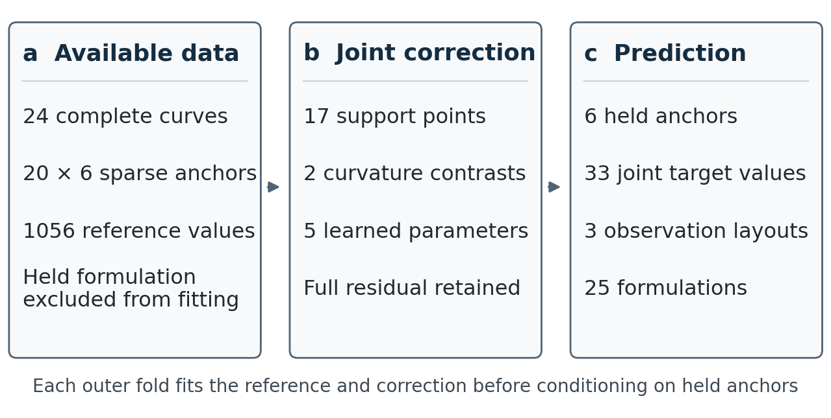
Figure 1 Information access in each leave-one-formulation-out fold. a, Reference fitting uses 24 complete P curves and 20 sparse anchor sets. b, Two fixed curvature contrasts define a five-parameter joint correction with a retained residual. c, Six held anchors enter conditioning after fitting, yielding 33 correlated targets.

Reference process and fixed curvature contrasts
The reference combines a linear mean, random level and slope, Matérn 3/2 variation and an observation-identity discrepancy. Log rate is centered and scaled by the visible reference range; log response uses the visible reference mean and population standard deviation. Generalized least squares profiles the mean, and profiled maximum likelihood fits positive covariance parameters over formulation blocks. This statistical block assumption does not certify physically independent preparations. For normalized coordinates u and v,
$k_{0}(u,v) = {σ_{level}}^{2} + {σ_{slope}}^{2}uv + {σ_{smooth}}^{2}M_{3/2}(u,v) + {σ_{report}}^{2}δ_{obs}$
$M_{3/2}(u,v) = (1 + r)exp(−r) , r = \frac{√3 |u − v|}{ℓ}$ (2)
The diagonal discrepancy belongs to reported-observation identity, not separately measured instrument noise. Latent support values for the shape code exclude it, while reported-response covariance includes it. Predictions and scores return to the declared log-response units.
Let Q contain 17 equally spaced physical log-rate coordinates over the fixed support. For positive adjacent spacings aj and bj, the second-difference row Dj has three nonzero entries:
$D_{j,j−1} = \frac{2}{a_{j}(a_{j} + b_{j})} , D_{j,j} = \frac{−2}{a_{j}b_{j}} , D_{j,j+1} = \frac{2}{b_{j}(a_{j} + b_{j})}$ (3)
Two windows are centered one third and two thirds along the support, each with half-width one third of its span. Interior weights are proportional to (1−x²)³ for |x|<1, times quadrature width (aj+bj)/2, and normalized to unit sum. With F = WD, constants and linear functions are annihilated. Thus an ideal global power-law viscosity profile has zero contrast response. Level and slope variation remain in the reference. These are finite-scale contrasts, not classical second derivatives of a Matérn path or identified constitutive parameters.
With latent reference covariance KQ and mean mQ, symmetric prior whitening defines the two-dimensional code and its cross covariance with any reported response set R:
$P = FK_{Q}F^{T} , z = P^{−\frac{1}{2}}F(f_{Q} − m_{Q}) ∼ N(0, I_{2})$ (4)
$C_{R} = K_{Y_R,f_Q}F^{T}P^{−\frac{1}{2}}$ (5)
The support, windows and whitening are fixed before query conditioning; hidden responses and the query mask do not rotate or rewhiten the code. The admitted global shear-rate support is [0.012787740677595104, 754.5143432617188] s⁻¹.

Residual preserving joint adaptation and training
The reference joint law decomposes into a code contribution and an independent residual:
$Y_{R} = m_{R} + C_{R}z + ε_{R}$
$ε_{R} ∼ N(0, R_{R}) , R_{R} = K_{R} − C_{R}{C_{R}}^{T} , ε_{R} ⟂ z$ (6)
Replacing only the code law adds two mean parameters and three Cholesky parameters while retaining the full residual:
$z ∼ N(a, S) , S = LL^{T} , L = \left[\begin{matrix}e^{λ_{0}} & 0 \\ c & e^{λ_{1}}\end{matrix}\right]$
$m_{θ} = m_{0} + Ca , K_{θ} = K_{0} + C(S − I_{2})C^{T}$ (7)
This rank-at-most-two covariance update does not restrict the response to a two-dimensional subspace. At a = 0 and S = I it recovers the reference. Equivalently,
$p_{θ}(Y) = ∫ p_{0}(Y | z) N(z ; a, S) dz$ (8)
This is the established retained-conditional Gaussian construction [19, 20, 23]. The present distinction is the fixed finite-scale rheological representation and a shared population correction trained for specified conditional tasks, rather than a usual sparse variational posterior objective. Positive semidefiniteness and consistency across finite coordinate subsets follow from the construction, not from material validation. A quadratic relative-potential interpretation and complete derivations appear in Supplementary Sections S9 and S16.
For anchors O and targets H, every layout conditions the same corrected joint matrices:
$μ_{H|O} = m_{θ,H} + K_{θ,HO}{K_{θ,OO}}^{−1}(y_{O} − m_{θ,O})$ (9)
$V_{H|O} = K_{θ,HH} − K_{θ,HO}{K_{θ,OO}}^{−1}K_{θ,OH}$ (10)
Exponentiating correlated Gaussian draws gives generated viscosity curves, not measurements. The exponentiated log mean is a marginal median, not the viscosity mean. Completing an existing record returns an exactly matching known anchor; a future measurement replicate would require a new observation identity. For fixed fitted parameters and coordinates, conditional covariance does not depend on numerical anchor values. Parameter-fitting uncertainty is not integrated.
In each fold, N = 24 complete training records and three masks define the penalized conditional likelihood:
$J(θ) = −\frac{1}{3N}∑_{i=1…N}∑_{b=1…3} ln p_{θ}(y_{i,Hb} | y_{i,Ob}) + 0.02 ‖θ‖²$ (11)
The five correction parameters share one zero start, fixed bounds and the same 0.02 penalty across Gaussian representation controls. Admission requires a successful finite solution, improvement over zero correction and a fixed projected-gradient gate. The exact optimizer settings, bounds, initially failed numerical path and stable low-rank objective remain in Section S16. They were not relaxed after observing scores. All 25 admitted outer fits and the deployment fit finish with two parameters at lower bounds, so the solutions are constrained rather than demonstrated unconstrained optima.

Controls and probability evaluation
The coordinate GP measures the value of correction. A two-by-two comparison crosses one fixed random QR representation and the curvature representation with bounded and Gaussian corrections. The two Gaussian cells match dimension, five parameters, bounds, penalty, start, optimizer and training access; only one random construction is evaluated. Equal parameter counts do not equalize bounded and Gaussian distribution families. The separate conditional Gaussian control uses anchor discrepancy to modify conditional mean and scale, without imposing a common joint law across contexts.
Bayesian Cross and fixed-a=2 Carreau controls use only the same six query anchors, proper priors and a statistical log-response discrepancy [10, 11, 12, 36]. Their population prior scaling differs from the GP’s learned population shape, which limits a blanket constitutive-versus-statistical claim. Posterior predictive laws were admitted and frozen before scoring; numerical failures and particle-budget decisions are retained in Sections S7 and S16. PCHIP is point-only and receives no invented probabilistic scores. One fixed Student-t mixture with prior degrees of freedom ten retains the Gaussian-fitted mean and unconditional covariance while allowing curve-specific observation-dependent scale [37]; it is a diagnostic, not a refitted candidate.
We distinguish point accuracy, marginal distribution quality, interval calibration and sharpness, and joint dependence [38, 39, 40, 41, 42]. Primary CRPS is on log viscosity, averaging targets, layouts and formulations equally. It jointly scores location and spread, rather than being a pure point-error measure. Pooled log RMSE scores point predictions. Nominal 90% marginal coverage and log width describe empirical interval behavior; interval score penalizes width and misses. Joint log density scores each full 33-target law, whereas a fixed order-one variogram diagnostic scores all 528 target pairs and is insensitive to common shifts and common-mode variance. It is proper but not strictly proper and does not isolate the copula. No whole-curve coverage guarantee follows from marginal intervals.
Saved paired bootstrap intervals resample fixed formulation-level scores and omit selection, refitting and preparation-batch uncertainty. Added controls and diagnostics retain the consumed status of the 25 P records. The deployment model uses all 25 P curves and lawful S anchors; its weights must not be used to reconstruct leave-one-formulation-out performance. Full score equations and computational checks are in Section S16. No conformal calibration or laboratory-resource comparison is performed.

No retraining transfer stress test
Four public sources supply Liverpool GG/peK inks [43], HA/CMHA solution records [44], granular hydrogel forward flow runs [45] and dynamic crosslinked-alginate flow sweeps [46]. Admission retains positive, finite native pairs with distinct rates in increasing acquisition order inside the frozen support, with at least twelve pairs per curve. The six lowest admitted native rates are anchors; the rest are targets. Reported means are not split into synthetic replicates, reverse paths are excluded from the forward cohort, duplicates are counted once and missing responses are not completed as truth. Liverpool viscosity is converted from mPa s to Pa s by division by 1000. Missing state or protocol metadata remains unknown.
The source-inspected protocol precedes frozen forecasts but does not establish blinding. The reference, candidate and conditional-Gaussian correction are not retrained. Additional point controls are PCHIP, a six-anchor ordinary least-squares power law and a last-two-anchor power law. Scores average native targets within each curve, curves within conservative groups, then groups equally within each source. Group-macro RMSE is the square root of the resulting mean squared error. Sources are reported separately. Subsequent family weighting and uncertainty summaries read saved score scalars only; they do not create forecasts, rescore targets or select an abstention threshold.

Software and generative AI assistance
Implementation verification is separate from material validation [47]. Versioned source, fixed weights, source-cell maps, scalar score ledgers and independent numerical checks are indexed in the repository. A standard-library entry reproduces reported scalar tables without opening raw measurements; complete original fitting replay requires additional author-approved processed assets. OpenAI Codex assisted literature discovery, coding, numerical-check orchestration and manuscript drafting. Scientific results remain tied to archived inputs, fixed model outputs and independently implemented checks. Generated or synthetic values are not represented as measured material data. The submitting authors must critically verify the complete work and confirm the tool and disclosure details before submission.

Results

Retrospective gains concentrate in one sided continuation
The Gaussian curvature correction has the lowest primary macro CRPS among the five original methods (Table 2): 0.043277 versus GP 0.055219 and conditional Gaussian 0.050252. These are 21.63% and 13.88% reductions in log-scale scores, not percentage viscosity errors. The conditional control has the highest mean joint log density in that comparison. No ranking is uniformly best across point, interval and joint criteria.
Table 2 Original three layout development comparison
Model | CRPS | Log RMSE | Joint log density | Coverage 90% | Log width
Coordinate GP | 0.055219 | 0.196569 | 63.122 | 97.37% | 0.405326
Generic bounded tilt | 0.052243 | 0.185702 | 63.388 | 97.33% | 0.385359
Curvature bounded tilt | 0.048253 | 0.156631 | 63.450 | 97.29% | 0.418607
Conditional Gaussian | 0.050252 | 0.161703 | 82.926 | 96.61% | 0.364930
Gaussian curvature correction | 0.043277 | 0.119524 | 63.658 | 97.21% | 0.403654
CRPS, RMSE and interval width are in dimensionless natural-log viscosity units. CRPS averages 33 targets, three layouts and 25 formulations equally; RMSE is the square root of pooled MSE. Joint density is in nats per 33-target query. Coverage is marginal rather than simultaneous curve coverage. All entries retain their retrospective development status.
The candidate improves on the conditional control for 16/25 formulations (Fig. 2b), with mean and median paired CRPS differences −0.006975 and −0.006906. The saved descriptive bootstrap interval is [−0.014525, −0.001754] but excludes model-selection and refitting uncertainty. P0 supplies 45.64% of the net aggregate gain. Removing it only for arithmetic sensitivity leaves −0.003950 across the other 24; every official comparison retains it (Table S1).
Layout changes the ranking. One-sided CRPS is 0.090792, versus GP 0.127579 and conditional Gaussian 0.118202, a 23.19% reduction against the latter. Candidate CRPS is instead worse than that control by 8.51% for spread anchors and 26.72% for middle gap. The one-sided loss scale is larger, so its gain more than offsets the interpolation losses in the equally weighted macro score (Fig. 2a; Section S10).
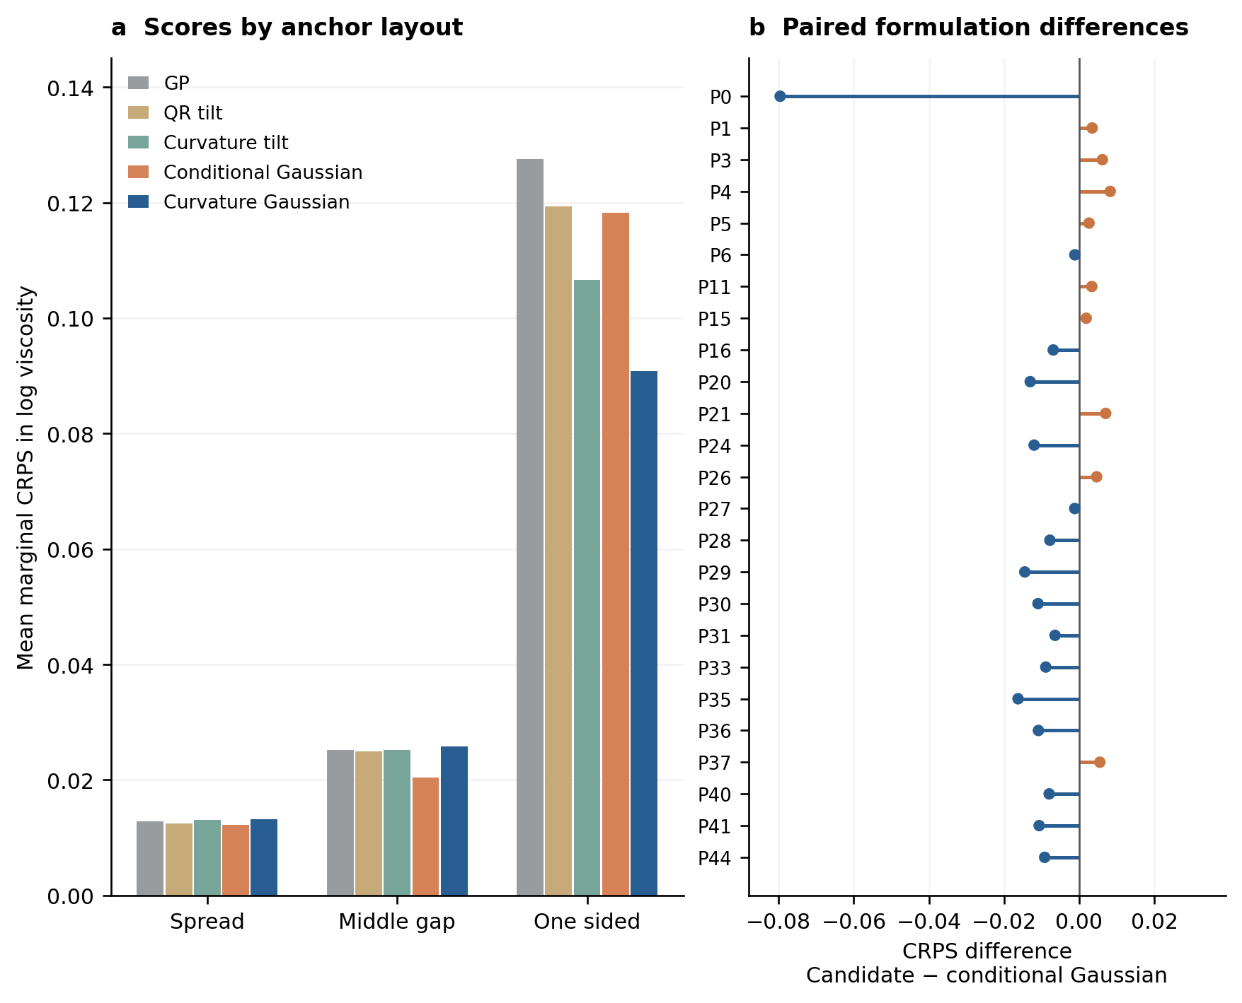
Figure 2 Layout and formulation dependence of the saved CRPS gain. a, Original mean marginal CRPS for five methods in each six-anchor layout; all 33 targets per query are included. b, Candidate minus conditional Gaussian CRPS for each of the 25 formulations, after averaging its three layouts. Negative values favour the candidate. Sixteen formulations improve; P0 remains in the aggregate and contributes 45.64% of net gain. Points are fixed-output differences, without refitting or confidence bars. GP, coordinate Gaussian process; QR tilt, generic bounded correction; curvature tilt, bounded curvature correction; conditional Gaussian, independently trained conditional control; curvature Gaussian, candidate.
The original one-sided mask hides ten positions inside the anchor range and twenty-three above it. Its saved posthoc decomposition gives candidate CRPS 0.007143 inside and 0.127161 beyond, versus 0.005667 and 0.167131 for conditional Gaussian and 0.007155 and 0.179938 for GP (Table S11). The 23.92% reduction against the conditional control is concentrated beyond the highest anchor. These positions remain inside global coordinate support: continuation of the same curve is not proof of out-of-support or new-chemistry generalization.

Matched representations and alternative predictors
Curvature lowers CRPS within both correction families: bounded scores change from 0.052243 to 0.048253, and Gaussian scores from 0.049908 to 0.043277 (Fig. 3a). The curvature Gaussian improves on its matched random Gaussian for 20/25 formulations and on the same-code bounded model for 22/25. Thus the evaluated benefit does not require the bounded non-Gaussian law. This comparison supports the specific chosen directions relative to one fixed random control; it does not establish superiority over a random-direction distribution, FPCA, other windows or dimensions.
The code accounts for 47.41%, 36.88% and 95.42% of conditional target-covariance trace in spread, middle-gap and one-sided queries. This fitted-model allocation is consistent with stronger continuation effects but is not physical variance explained. All 75 conditional residual blocks remain positive definite in 33 dimensions, with minimum reported eigenvalue about 1.054 × 10−5. Figure S5 and Sections S3 and S16 detail the residual and information diagnostics [48].
Bayesian Cross and fixed-a=2 Carreau obtain macro CRPS 0.111590 and 0.153763 and one-sided CRPS 0.230214 and 0.292701 (Table 3). They propagate declared parameter and discrepancy uncertainty from the same six anchors. Their weaker performance supports this population-informed continuation model under the stated priors and resources, rather than showing the best possible constitutive-family performance. Failed numerical attempts were not scored; the admitted laws passed fixed predictive-agreement gates.
Table 3 Additional retrospective probabilistic controls
Model | Macro CRPS | One sided CRPS | Joint log density | Coverage 90%
Gaussian curvature correction | 0.043277 | 0.090792 | 63.658 | 97.21%
Matched random Gaussian | 0.049908 | 0.111209 | 63.919 | 97.01%
Bayesian Cross | 0.111590 | 0.230214 | 57.200 | 93.62%
Bayesian Carreau a2 | 0.153763 | 0.292701 | 23.542 | 87.35%
Fixed Student-t diagnostic | 0.042906 | 0.092948 | 106.985 | 98.26%
All original formulations and layouts are retained. The random Gaussian is a matched representation control; the two constitutive rows are declared Bayesian implementations; the Student-t row is a fixed uncertainty sensitivity analysis. These are additional retrospective comparisons, not new independent materials. The Student-t law is not adopted solely on its lower macro CRPS.
PCHIP has pooled log RMSE 0.684640, versus 0.119524 for the candidate. It is competitive for interpolation: spread and middle-gap RMSE are 0.031561 and 0.058481 versus candidate 0.033548 and 0.065566. Its declared endpoint-cubic one-sided continuation gives 1.183968 versus 0.193478. Table S7 retains all ten methods on the common point-error scale without fabricating uncertainty for PCHIP.
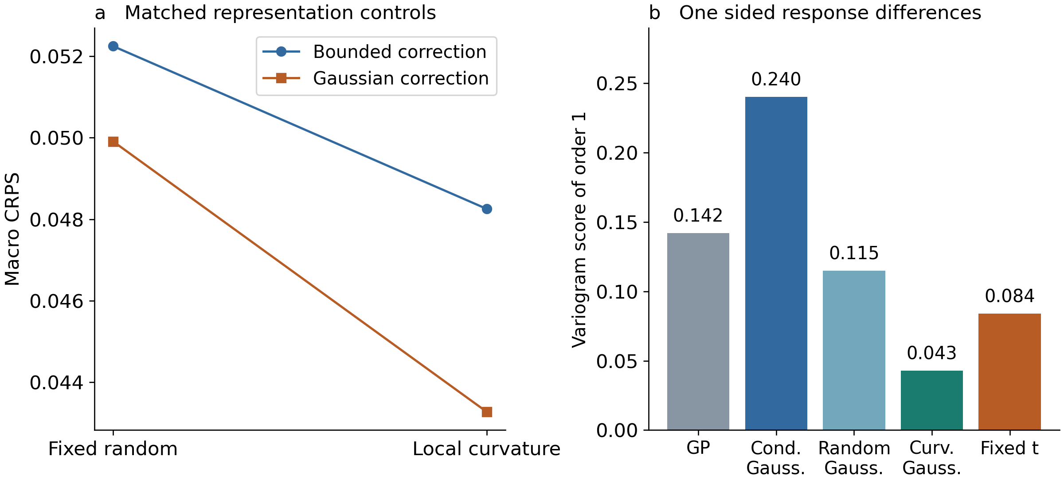
Figure 3 Matched representations and a pairwise response diagnostic. a, Fixed random and curvature codes crossed with bounded and Gaussian corrections. b, Order-one variogram score for the original one-sided layout, with all 528 pairs of 33 targets. All 25 development formulations are retained. The variogram score assesses relative-response changes but is not strictly proper or sensitive to shared shifts and common-mode variance. Abbreviations identify the conditional, curvature and reference Gaussian controls.

Probability quality is not summarized by CRPS alone
Candidate mean nominal 90% marginal coverage is 97.21%, with mean log width 0.403654, but only 8/33 P0 middle-gap targets are covered (Fig. 4). P0 coverage is 20/33 and 22/33 for spread and one-sided masks; the other 24 formulations average 99.16%. Broad conservatism therefore coexists with severe local undercoverage. Candidate interval score 0.467306 is 14.90% worse than conditional Gaussian 0.406691, despite its lower CRPS. Empirical coverage at one nominal level is not a calibration curve.
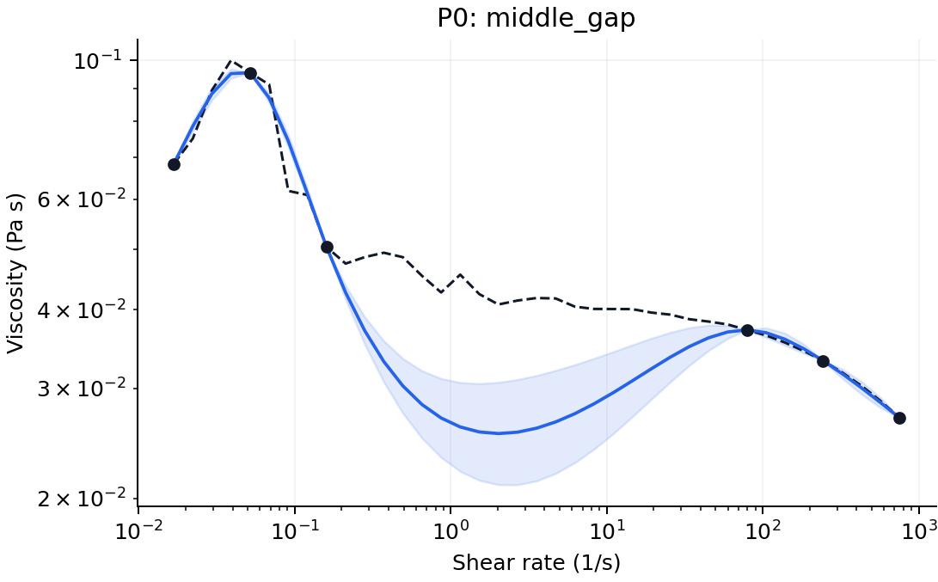
Figure 4 P0 middle gap failure. The dashed black curve is the revealed source response, black dots are six anchors, the blue curve is the candidate median and shading is its nominal 90% marginal interval. Only 8 of 33 targets are covered. All official aggregates retain this formulation.
The fixed variogram diagnostic yields macro score 0.016172, versus GP 0.049147 and matched random Gaussian 0.040377. Candidate formulation-averaged scores improve for 21/25 and 20/25, respectively; P0 supplies only 0.13% of the net GP gain and is a loss against the random Gaussian. The candidate also beats conditional Gaussian 0.082035 on average, but P0 supplies 69.23% of that gain. These diagnostics complement marginal quality without proving a correct copula or simultaneous curve coverage (Table S5).
The fixed Student-t control asks whether observation-dependent scale can repair local undercoverage. P0 middle-gap coverage rises from 8/33 to 26/33, and mean joint log density improves to 106.985. However, overall coverage rises to 98.26% and one-sided CRPS worsens from 0.090792 to 0.092948, although macro CRPS is slightly lower at 0.042906. This is a diagnostic trade-off, not adopted calibration. A shared scale can respond to unusual anchors but cannot repair a wrong conditional mean or local covariance shape. Detailed discrepancies, scale factors and numerical checks are retained in S7 and S16 [37, 49, 50].

Source dependent transfer and localized interval failure
The frozen deployment model was assessed on 46 native curves, 23 conservative analysis groups and 781 higher-rate targets from four sources (Table 4). These are source-inspected transfer stress tests under combined changes of chemistry, material state and acquisition, not blinded same-domain confirmation on independent preparations.
Table 4 No retraining external continuation results
Source | Curves / groups | Candidate CRPS | GP CRPS | Conditional G CRPS | Coverage %
Liverpool inks | 15 / 5 | 0.273635 | 0.327109 | 0.293629 | 71.56
HA and CMHA | 10 / 8 | 0.148457 | 0.137126 | 0.380441 | 78.26
Granular hydrogels | 16 / 5 | 0.297441 | 0.204039 | 0.215897 | 57.90
Dynamic alginate | 5 / 5 | 3.302394 | 3.176013 | 3.165265 | 2.44
Values use the original equal analysis group weighting within each source. Coverage is marginal for the candidate at nominal 90%. The sources are not pooled; groups are not certified independent preparation batches. All six methods are reported in Table S8.
Under original within-source equal-group weights, candidate Liverpool CRPS is 0.273635 versus GP 0.327109 and conditional Gaussian 0.293629. Group-macro log RMSE is 0.562155 versus 0.597078 and 0.607591. The three GG groups improve CRPS against both controls; both peK groups worsen. Candidate marginal coverage is only 71.56%, with zero target coverage in peK 10 wt%.
Organizing the saved interval scores reveals a further trade-off (Table S12). Candidate Liverpool log width is 0.730671 versus 0.780376 for GP and 1.488886 for conditional Gaussian, yet interval score is 3.377353 versus 3.136817 and 1.640179. Marginal negative log likelihood is also worse. Four of fifteen candidate native curves have zero target coverage, compared with none for the conditional control. Nine candidate curves have all targets inside their marginal bands, showing polarization rather than uniformly trustworthy intervals. These native-curve counts include related instrument runs and are not independent binomial trials or simultaneous-coverage guarantees.
The other three sources do not improve over GP: candidate versus GP CRPS is 0.148457 versus 0.137126 for HA/CMHA, 0.297441 versus 0.204039 for granular hydrogels and 3.302394 versus 3.176013 for dynamic alginate. The last source has 2.44% coverage and four of five curves with zero coverage. All adverse sources remain reported. These confounded domain shifts cannot isolate a unique material or algorithmic cause.
Liverpool ranking also depends on the averaged population. Original five-group weights assign 0.6 to GG; equal-family weighting assigns 0.5. The latter gives candidate CRPS 0.312928 versus GP 0.340916 and conditional Gaussian 0.295105, reversing the conditional-control ranking and removing the point-error advantage. This saved-score re-averaging does not change the original endpoint or select a deployment weight. Section S15 retains both populations and the complete sensitivity.

Discussion
The useful finding is a task-specific allocation of statistical adaptation: two fixed finite-scale shape contrasts can improve continuation of a short low-rate segment while a complete reference residual carries the other response directions. The full curve is not compressed into two numbers, and level and slope are not discarded. Conditioning can propagate a local code update beyond its contrast windows through reference correlations. Neither the representation nor its apparent success identifies two physical hydrogel mechanisms.
The inducing-feature Gaussian foundations are established [19, 20, 21, 22, 23]. Our objective learns a shared population correction from masked conditional likelihood, and the representation selects departures from affine log–log flow. This combination, its declared precursor-ink task and matched controls constitute the contribution. One fixed random representation does not establish general representation robustness. FPCA, multiple random codes and window sensitivity are worthwhile developmental comparisons, but they would require new fitted forecasts and an explicit evaluation boundary rather than reinterpreting this fixed comparison.
Point prediction, marginal distribution quality, interval reliability and dependence are distinct. The candidate’s continuation CRPS and variogram gains coexist with stronger conditional-control interpolation, interval scores and some joint densities. The Student-t diagnostic tests a concrete limitation of fixed-Gaussian covariance but does not solve calibration. Materials UQ studies likewise distinguish calibration from sharpness [40, 42], and better uncertainty metrics need not imply a better downstream acquisition policy [51, 50]. A lower mean CRPS alone is insufficient justification to replace a measurement with a credible interval.
The external stress test makes the applicability boundary visible without establishing a safe rejection rule. It supports a limited GG-rich ink benefit, not universal hydrogel transfer. Narrower Liverpool intervals conceal zeros and near-complete band inclusion across different runs, while dynamic crosslinked alginate fails severely. Chemistry, state and protocol change together. Per-curve anchor discrepancies were not stored in the public scalar replay, so we do not invent a validated risk–coverage threshold or claim that distance separates safe curves. Any trained scale or abstention rule would be a new candidate.
Retrospective leave-one-formulation-out evaluation prevents direct within-fold leakage but cannot undo development informed by the same 25 curves [52, 53, 54]. Independent reserved calibration and same-domain confirmation are separate missing evidence roles, not substitutes for numerical verification [47]. A future confirmation should freeze methods, anchors, grouping and endpoints before target access. New formulations, new preparations of known formulations and external laboratories support different claims. A continuation-only log-rate-weighted endpoint would be new, not a relabeling of the present native-point scores.
Conformal or jackknife-based layers could be evaluated with genuine material-level calibration units and appropriate calibration-to-deployment exchangeability [55, 56, 57, 58]. Marginal and whole-curve coverage targets must be distinguished; correlated coordinates are not extra calibration materials. The present study provides neither that guarantee nor measured instrument or sample savings. A future resource study would need actual sparse-versus-full workflow records. For now the method is a compact, reproducible continuation candidate with competitive retrospective scores and explicitly unresolved calibration and domain transfer.

Data availability
The original development source is dataset version 0.0.2, DOI 10.5281/zenodo.19602891 [34]. Public external source identifiers, versions, source-file hashes and reconstruction maps are recorded with the code [43, 44, 45, 46]. Scalar loss ledgers and generated prediction moments are public; they do not replace every original processed input or out-of-fold predictive law. Third-party assets retain their upstream terms. The granular archive is marked other-open without a named redistribution license, so its raw workbook and admitted measurement arrays have not been mirrored. Access and reuse arrangements for the remaining original processed inputs and complete fitting replay require author completion before submission. A bare available-upon-request statement is not presented as meeting the journal’s open-data requirement.

Code availability
The frozen runtime, deployment weights, saved-score replay and evidence are versioned at https://github.com/Hancy5521/hydrogel_control. The prior author-review baseline is commit 778d9372a9c5847205db3289e81a3c73aee45962. The current MLST draft and its table crosswalk are indexed by CHECKPOINT.json and MANIFEST.json; the reviewer entry in mlst/README.txt separates scalar replay, synthetic inference and original-data reconstruction. The deployment weights use all 25 P records and lawful S anchors, not the held-formulation models. Scientific weights, runtime and original scores are unchanged. A permanent archival DOI and original-asset reuse license have not been assigned by this editorial revision.

Acknowledgements
Author acknowledgements and funding details require completion.

Generative AI disclosure
OpenAI Codex assisted literature retrieval, software development, numerical-check orchestration and manuscript drafting and editing. This assistance extended beyond spelling and grammar. No AI-generated curve was treated as a measurement. The tool configuration and dates, the scientific use described in Methods and the complete manuscript require confirmation and critical review by the submitting authors, who retain responsibility for the work.

Author contributions
Author identities, affiliations, correspondence and individual contributions require author completion. This draft does not assign contributions to unnamed investigators.

Competing interests
The authors must supply and confirm the competing interests statement.

References
[1] Ward L, Agrawal A, Choudhary A, Wolverton C. A general-purpose machine learning framework for predicting properties of inorganic materials. npj Computational Materials. 2016;2:16028. https://doi.org/10.1038/npjcompumats.2016.28.
[2] Dunn A, Wang Q, Ganose A, Dopp D, Jain A. Benchmarking materials property prediction methods: the Matbench test set and Automatminer reference algorithm. npj Computational Materials. 2020;6:138. https://doi.org/10.1038/s41524-020-00406-3.
[3] Kim C, Chandrasekaran A, Huan TD, Das D, Ramprasad R. Polymer Genome: A Data-Powered Polymer Informatics Platform for Property Predictions. Journal of Physical Chemistry C. 2018;122:17575–17585. https://doi.org/10.1021/acs.jpcc.8b02913.
[4] Kuenneth C, Rajan AC, Tran H, Chen L, Kim C, Ramprasad R. Polymer informatics with multi-task learning. Patterns. 2021;2:100238. https://doi.org/10.1016/j.patter.2021.100238.
[5] Kuenneth C, Ramprasad R. polyBERT: a chemical language model to enable fully machine-driven ultrafast polymer informatics. Nature Communications. 2023;14:4099. https://doi.org/10.1038/s41467-023-39868-6.
[6] Xu C, Wang Y, Barati Farimani A. TransPolymer: a Transformer-based language model for polymer property predictions. npj Computational Materials. 2023;9:64. https://doi.org/10.1038/s41524-023-01016-5.
[7] Phan BK, Shen KH, Gurnani R, Tran H, Lively R, Ramprasad R. Gas permeability, diffusivity, and solubility in polymers: Simulation-experiment data fusion and multi-task machine learning. npj Computational Materials. 2024;10:186. https://doi.org/10.1038/s41524-024-01373-9.
[8] Okabe R, Cheng M, Chotrattanapituk A, et al. Structural constraint integration in a generative model for the discovery of quantum materials. Nature Materials. 2026;25:223–230. https://doi.org/10.1038/s41563-025-02355-y.
[9] Jiang S, Webb MA. Generative active learning across polymer architectures and solvophobicities for targeted rheological behavior. npj Computational Materials. 2026;12:28. https://doi.org/10.1038/s41524-025-01900-2.
[10] Cross MM. Rheology of non-Newtonian fluids: A new flow equation for pseudoplastic systems. Journal of Colloid Science. 1965;20:417–437. https://doi.org/10.1016/0095-8522(65)90022-X.
[11] Carreau PJ. Rheological Equations from Molecular Network Theories. Transactions of the Society of Rheology. 1972;16:99–127. https://doi.org/10.1122/1.549276.
[12] Yasuda K, Armstrong RC, Cohen RE. Shear flow properties of concentrated solutions of linear and star branched polystyrenes. Rheologica Acta. 1981;20:163–178. https://doi.org/10.1007/BF01513059.
[13] Jain A, Gurnani R, Rajan A, Qi HJ, Ramprasad R. A physics-enforced neural network to predict polymer melt viscosity. npj Computational Materials. 2025;11:42. https://doi.org/10.1038/s41524-025-01532-6.
[14] Mahmoudabadbozchelou M, Jamali S. Rheology-Informed Neural Networks (RhINNs) for forward and inverse metamodelling of complex fluids. Scientific Reports. 2021;11:12015. https://doi.org/10.1038/s41598-021-91518-3.
[15] Saadat M, Mahmoudabadbozchelou M, Jamali S. Data-driven selection of constitutive models via rheology-informed neural networks (RhINNs). Rheologica Acta. 2022;61:721–732. https://doi.org/10.1007/s00397-022-01357-w.
[16] Rasmussen CE, Williams CKI. Gaussian Processes for Machine Learning. MIT Press; 2006. https://gaussianprocess.org/gpml/.
[17] Lennon KR, McKinley GH, Swan JW. A data-driven method for automated data superposition with applications in soft matter science. Data-Centric Engineering. 2023;4:e13. https://doi.org/10.1017/dce.2023.3.
[18] Yao F, Müller HG, Wang JL. Functional data analysis for sparse longitudinal data. Journal of the American Statistical Association. 2005;100:577–590. https://doi.org/10.1198/016214504000001745.
[19] Titsias M. Variational Learning of Inducing Variables in Sparse Gaussian Processes. Proceedings of AISTATS. PMLR. 2009;5:567–574. https://proceedings.mlr.press/v5/titsias09a.html.
[20] Lázaro-Gredilla M, Figueiras-Vidal AR. Inter-domain Gaussian Processes for Sparse Inference using Inducing Features. Advances in Neural Information Processing Systems. 2009;22. https://papers.nips.cc/paper_files/paper/2009/hash/5ea1649a31336092c05438df996a3e59-Abstract.html.
[21] Hensman J, Fusi N, Lawrence ND. Gaussian Processes for Big Data. Proceedings of UAI. 2013:282–290. https://arxiv.org/abs/1309.6835.
[22] Matthews AG de G, Hensman J, Turner RE, Ghahramani Z. On Sparse Variational Methods and the Kullback-Leibler Divergence between Stochastic Processes. Proceedings of AISTATS. PMLR. 2016;51:231–239. https://proceedings.mlr.press/v51/matthews16.html.
[23] Shi J, Titsias M, Mnih A. Sparse Orthogonal Variational Inference for Gaussian Processes. Proceedings of AISTATS. PMLR. 2020;108:1932–1942. https://proceedings.mlr.press/v108/shi20b.html.
[24] Wang J, Li T, Cui F, Hui C-Y, Yeo J, Zehnder AT. Metamodeling of constitutive model using Gaussian process machine learning. Journal of the Mechanics and Physics of Solids. 2021;154:104532. https://doi.org/10.1016/j.jmps.2021.104532.
[25] Sunol AM, Roggeveen JV, Alhashim MG, Bae HS, Brenner MP. Learning constitutive models and rheology from partial flow measurements. arXiv:2510.24673v4. 2026. https://arxiv.org/abs/2510.24673v4.
[26] Garnelo M, Rosenbaum D, Maddison CJ, et al. Conditional Neural Processes. Proceedings of ICML. PMLR. 2018;80:1704–1713. https://proceedings.mlr.press/v80/garnelo18a.html.
[27] Kim H, Mnih A, Schwarz J, Garnelo M, Eslami SMA, Rosenbaum D, Vinyals O, Teh YW. Attentive Neural Processes. Proceedings of ICLR. 2019. https://arxiv.org/abs/1901.05761.
[28] Ivanov O, Figurnov M, Vetrov D. Variational Autoencoder with Arbitrary Conditioning. Proceedings of ICLR. 2019. https://openreview.net/forum?id=SyxtJh0qYm.
[29] Ma C, Tschiatschek S, Palla K, Hernández-Lobato JM, Nowozin S, Zhang C. EDDI: Efficient Dynamic Discovery of High-Value Information with Partial VAE. Proceedings of ICML. PMLR. 2019;97:4234–4243. https://proceedings.mlr.press/v97/ma19c.html.
[30] Yoon J, Jordon J, van der Schaar M. GAIN: Missing Data Imputation using Generative Adversarial Nets. Proceedings of ICML. PMLR. 2018;80:5689–5698. https://proceedings.mlr.press/v80/yoon18a.html.
[31] Tashiro Y, Song J, Song Y, Ermon S. CSDI: Conditional Score-based Diffusion Models for Probabilistic Time Series Imputation. Advances in Neural Information Processing Systems. 2021;34. https://proceedings.neurips.cc/paper_files/paper/2021/hash/cfe8504bda37b575c70ee1a8276f3486-Abstract.html.
[32] Xiao Z, Yan Q, Amit Y. Exponential Tilting of Generative Models: Improving Sample Quality by Training and Sampling from Latent Energy. arXiv:2006.08100v1. 2020. https://doi.org/10.48550/arXiv.2006.08100.
[33] Strauss RR, Oliva JB. Arbitrary conditional distributions with energy. Advances in Neural Information Processing Systems. 2021;34. https://proceedings.neurips.cc/paper_files/paper/2021/file/06c284d3f757b15c02f47f3ff06dc275-Paper.pdf.
[34] Zhang C. Dataset for Disentangled Generative AI-Guided Closed-Loop Optimization of Deposition Morphology for 3D Bioprinting Applications. Version 0.0.2. Zenodo; 2026. https://doi.org/10.5281/zenodo.19602891.
[35] Zhang C, Elvitigala K, Sakai S. Generative AI-guided in silico closed-loop optimisation of deposition morphology for 3D bioprinting applications. Virtual and Physical Prototyping. 2026;21:e2671497. https://doi.org/10.1080/17452759.2026.2671497.
[36] Gallagher MT, Wain RAJ, Dari S, Whitty JP, Smith DJ. Non-identifiability of parameters for a class of shear-thinning rheological models, with implications for haematological fluid dynamics. arXiv:1810.02292v1. 2018. https://doi.org/10.48550/arXiv.1810.02292.
[37] Shah A, Wilson A, Ghahramani Z. Student-t Processes as Alternatives to Gaussian Processes. Proceedings of AISTATS. PMLR. 2014;33:877–885. https://proceedings.mlr.press/v33/shah14.html.
[38] Gneiting T, Raftery AE. Strictly Proper Scoring Rules, Prediction, and Estimation. Journal of the American Statistical Association. 2007;102:359–378. https://doi.org/10.1198/016214506000001437.
[39] Gneiting T, Balabdaoui F, Raftery AE. Probabilistic Forecasts, Calibration and Sharpness. Journal of the Royal Statistical Society Series B. 2007;69:243–268. https://doi.org/10.1111/j.1467-9868.2007.00587.x.
[40] Tran K, Neiswanger W, Yoon J, et al. Methods for comparing uncertainty quantifications for material property predictions. Machine Learning: Science and Technology. 2020;1:025006. https://doi.org/10.1088/2632-2153/ab7e1a.
[41] Scheuerer M, Hamill TM. Variogram-Based Proper Scoring Rules for Probabilistic Forecasts of Multivariate Quantities. Monthly Weather Review. 2015;143:1321–1334. https://doi.org/10.1175/MWR-D-14-00269.1.
[42] Busk J, Jørgensen PB, Bhowmik A, Schmidt MN, Winther O, Vegge T. Calibrated uncertainty for molecular property prediction using ensembles of message passing neural networks. Machine Learning: Science and Technology. 2022;3:015012. https://doi.org/10.1088/2632-2153/ac3eb3.
[43] Duffy G, Liang H, Williams R, Black K. 3D reactive inkjet printing of peptide-based hydrogels for corneal tissue engineering. Data collection. University of Liverpool; 2021. https://doi.org/10.17638/datacat.liverpool.ac.uk/1296.
[44] Wendling RJ, Christensen AM, Quast AD, Atzet SK, Mann BK. Effect of Carboxymethylation on the Rheological Properties of Hyaluronan. PLOS ONE. 2016. https://doi.org/10.1371/journal.pone.0162849.
[45] Verheyen CA, Uzel SGM, Kurum A, Roche ET, Lewis JA. Integrated data-driven modeling and experimental optimization of granular hydrogel matrices. Matter. 2023. https://doi.org/10.1016/j.matt.2023.01.011. Associated data and code, version1.0: https://doi.org/10.5281/zenodo.7506819.
[46] Morgan FLC, Fernández-Pérez J, Moroni L, Baker MB. Tuning hydrogels by mixing dynamic cross-linkers: enabling cell-instructive hydrogels and advanced bioinks. Dataset. DataverseNL; 2021. https://doi.org/10.34894/HBKOLJ. Associated article: https://doi.org/10.1002/adhm.202101576.
[47] Jakeman JD, Barba LA, Martins JRRA, O'Leary-Roseberry T. Verification and Validation for Trustworthy Scientific Machine Learning. arXiv:2502.15496v2. 2025. https://arxiv.org/abs/2502.15496v2.
[48] Krause A, Singh A, Guestrin C. Near-Optimal Sensor Placements in Gaussian Processes: Theory, Efficient Algorithms and Empirical Studies. Journal of Machine Learning Research. 2008;9:235–284. https://www.jmlr.org/papers/v9/krause08a.html.
[49] Jordan A, Krüger F, Lerch S. Evaluating Probabilistic Forecasts with scoringRules. Journal of Statistical Software. 2019;90(12). https://doi.org/10.18637/jss.v090.i12.
[50] Thomas-Mitchell A, Hawe G, Popelier PLA. Calibration of uncertainty in the active learning of machine learning force fields. Machine Learning: Science and Technology. 2023;4:045034. https://doi.org/10.1088/2632-2153/ad0ab5.
[51] Dale AS, Li K, DeCost B, et al. When active learning fails, uncalibrated out of distribution uncertainty quantification might be the problem. npj Computational Materials. Published online 24 October 2026. https://doi.org/10.1038/s41524-026-02368-4.
[52] Cawley GC, Talbot NLC. On Over-fitting in Model Selection and Subsequent Selection Bias in Performance Evaluation. Journal of Machine Learning Research. 2010;11:2079–2107. https://www.jmlr.org/papers/v11/cawley10a.html.
[53] Li Q, Fu N, Omee SS, Hu J. MD-HIT: Machine learning for material property prediction with dataset redundancy control. npj Computational Materials. 2024;10:245. https://doi.org/10.1038/s41524-024-01426-z.
[54] Li K, Persaud D, Choudhary K, et al. Exploiting redundancy in large materials datasets for efficient machine learning with less data. Nature Communications. 2023;14:7283. https://doi.org/10.1038/s41467-023-42992-y.
[55] Palmer G, Du S, Politowicz A, et al. Calibration after bootstrap for accurate uncertainty quantification in regression models. npj Computational Materials. 2022;8:115. https://doi.org/10.1038/s41524-022-00794-8.
[56] Romano Y, Patterson E, Candès EJ. Conformalized Quantile Regression. Advances in Neural Information Processing Systems. 2019;32. https://proceedings.neurips.cc/paper_files/paper/2019/hash/5103c3584b063c431bd1268e9b5e76fb-Abstract.html.
[57] Barber RF, Candès EJ, Ramdas A, Tibshirani RJ. Predictive inference with the jackknife+. Annals of Statistics. 2021;49:486–507. https://doi.org/10.1214/20-AOS1965.
[58] Gopakumar V, Gray A, Oskarsson J, et al. Uncertainty quantification of surrogate models using conformal prediction. Machine Learning: Science and Technology. 2026;7:015025. https://doi.org/10.1088/2632-2153/ae2e7b.

