Supplementary analyses and reproducibility record
This supplement accompanies Residual preserving Gaussian adaptation for probabilistic continuation of hydrogel flow curves. The main Methods summarize the construction and evaluation; Section S16 retains the complete technical specification, comparator equations, optimizer and numerical history. This supplement records additional frozen-output analyses, comparison boundaries and the unperformed evaluation design. Reference numbers match the main article.

S1 Paired formulation summaries
All paired differences are candidate minus comparator, averaged across the original three layouts within each formulation. Negative values favour the candidate. The saved 2000-draw formulation bootstrap resamples fixed predictions and does not rerun fitting or model selection. Its intervals describe the existing development collection; they are not confirmatory uncertainty intervals for new batches.
Table S1 Paired formulation CRPS summaries
Comparator | Mean difference | Descriptive 95% interval | Lower CRPS count
Coordinate GP | -0.011942 | [-0.014736, -0.009183] | 22/25
Generic bounded tilt | -0.008966 | [-0.011612, -0.006349] | 21/25
Curvature bounded tilt | -0.004976 | [-0.006614, -0.003177] | 22/25
Conditional Gaussian | -0.006975 | [-0.014525, -0.001754] | 16/25
Matched random Gaussian | −0.006631 | [−0.009569, −0.003581] | 20/25
Difference is Gaussian curvature correction minus comparator. Intervals resample fixed development predictions and omit selection and refitting uncertainty.
Figure 2b in the main article redraws the conditional-control comparison from unmodified saved per-query scores. For each P identity, three candidate CRPS values and three comparator values are averaged and subtracted. This reconstruction agrees with the frozen aggregate mean, median and count of 16 improved formulations. No target values are reopened and no predictive distribution is rescored. P0's 45.64% share of net gain is its paired difference divided by the sum of all 25 differences. This ratio describes an influential observation, not an independent effect estimate. Removing P0 only for sensitivity gives −0.003950; P0 remains in the official aggregate and every plot of the full collection.

S2 Layout scores and matched representation comparisons
Each original layout has six anchors and 33 targets. The following table retains the exact primary per-layout summaries rounded for reading. These are the numeric values behind main Figure 2a.
Table S2 Original layout-specific marginal CRPS
Layout | GP | Generic tilt | Curvature tilt | Conditional Gaussian | Gaussian curvature
Spread | 0.012883 | 0.012462 | 0.013048 | 0.012168 | 0.013203
Middle gap | 0.025196 | 0.024970 | 0.025129 | 0.020387 | 0.025835
One sided | 0.127579 | 0.119296 | 0.106581 | 0.118202 | 0.090792
Each row averages 25 formulations and all 33 hidden positions for that layout. The one sided row is not the future continuation only weighted endpoint.
The one-sided query includes ten internal hidden positions as well as 23 positions above the highest anchor. Table S11 decomposes this query after prediction freeze; it is not a newly fitted continuation experiment. The native target average is not a quadrature-weighted error integral over log shear rate.
Table S3 Available feature and correction-family comparisons
Feature representation | Bounded correction CRPS | Gaussian correction CRPS
Fixed random QR directions | 0.052243 | 0.049908
Fixed curvature contrasts | 0.048253 | 0.043277
These four original cells are retained unchanged. Conditional Gaussian is a separate context-specific baseline. Values are native-target, three-layout development CRPS on the same 25 formulations. The original random code uses one fixed QR construction; the Gaussian comparison matches dimension, parameter count, bounds, regularization, optimizer and training access. Section S20 adds eight further fixed random codes and two deterministic representation diagnostics without rewriting this historical comparison.
Within the original bounded family, curvature lowers CRPS by 7.64% relative to its random directions; within the original Gaussian family the reduction is 13.29%. The original Gaussian candidate improves on the matched random Gaussian for 20/25 formulations; its fixed-forecast bootstrap interval is [−0.009569,−0.003581]. These summaries remain conditional on that one original construction. The difference of directional differences, −0.002641, does not identify a causal representation-by-family interaction. Newer multi-representation outcomes, including the stronger prior-KL control, are reported separately in Section S20.

S3 Conditional residual interpretation
Section S16 gives the explicit residual-conditioned decomposition. Setting a=0 and S=I gives reference posterior code moments $a_{O}$,0 and $S_{O}$,0. With the same reference residual, the changes in conditional target mean and covariance are $B_{H}$($a_{O}$−$a_{O}$,0) and $B_{H}$($S_{O}$−$S_{O}$,0)$B_{H}$ᵀ. The conditional covariance change therefore has rank at most two, while its complete covariance retains $D_{H}$. All 75 saved residual blocks are positive definite in 33 target dimensions, with smallest reported eigenvalue approximately 1.054 × ${10}^{−5}$.
Table S4 Allocation of uncertainty under the fixed model
Layout | Code covariance trace fraction | Code anchor information | Conditional code target information
Spread | 47.41% | 2.747 nats | 4.219 nats
Middle gap | 36.88% | 2.343 nats | 4.624 nats
One sided | 95.42% | 0.679 nats | 6.287 nats
These are saved model diagnostics, not explained physical variance or new performance estimates. The information sum is fixed by the common union of coordinates.
The trace ratio is coordinate dependent and model specific. It is not physical explained variance. Gaussian code–anchor information plus conditional code–target information is approximately 6.966 nats on average for each layout. The constant sum follows from the same anchor–target union, via the Gaussian information chain rule [52]. It is not a guarantee of accurate missing values or evidence that only two intrinsic material variables exist. No target-dependent information cutoff, curve rejection rule or adaptive measurement policy is introduced.

S4 Coverage and fixed case diagnostics
The candidate's 97.21% mean nominal 90% marginal coverage pools heterogeneous contexts. P0's middle-gap coverage is 8/33, compared with 20/33 for spread and 22/33 for one-sided anchors. The other 24 formulations average 99.16%. The complete heatmap and previously fixed P0/P1 cases are retained below, without dropping the difficult formulation.
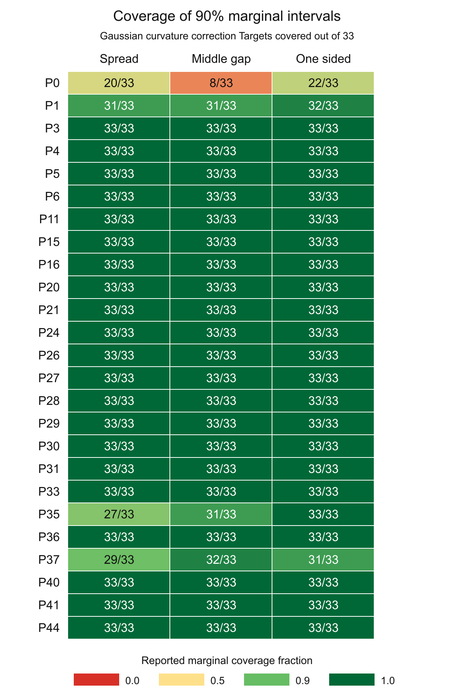
Figure S1 Marginal coverage for all 25 retained formulations and three layouts. Cells show saved coverage counts out of 33 targets. The original heatmap is retained; this vertical layout increases label size. No formulation is omitted from the official mean.

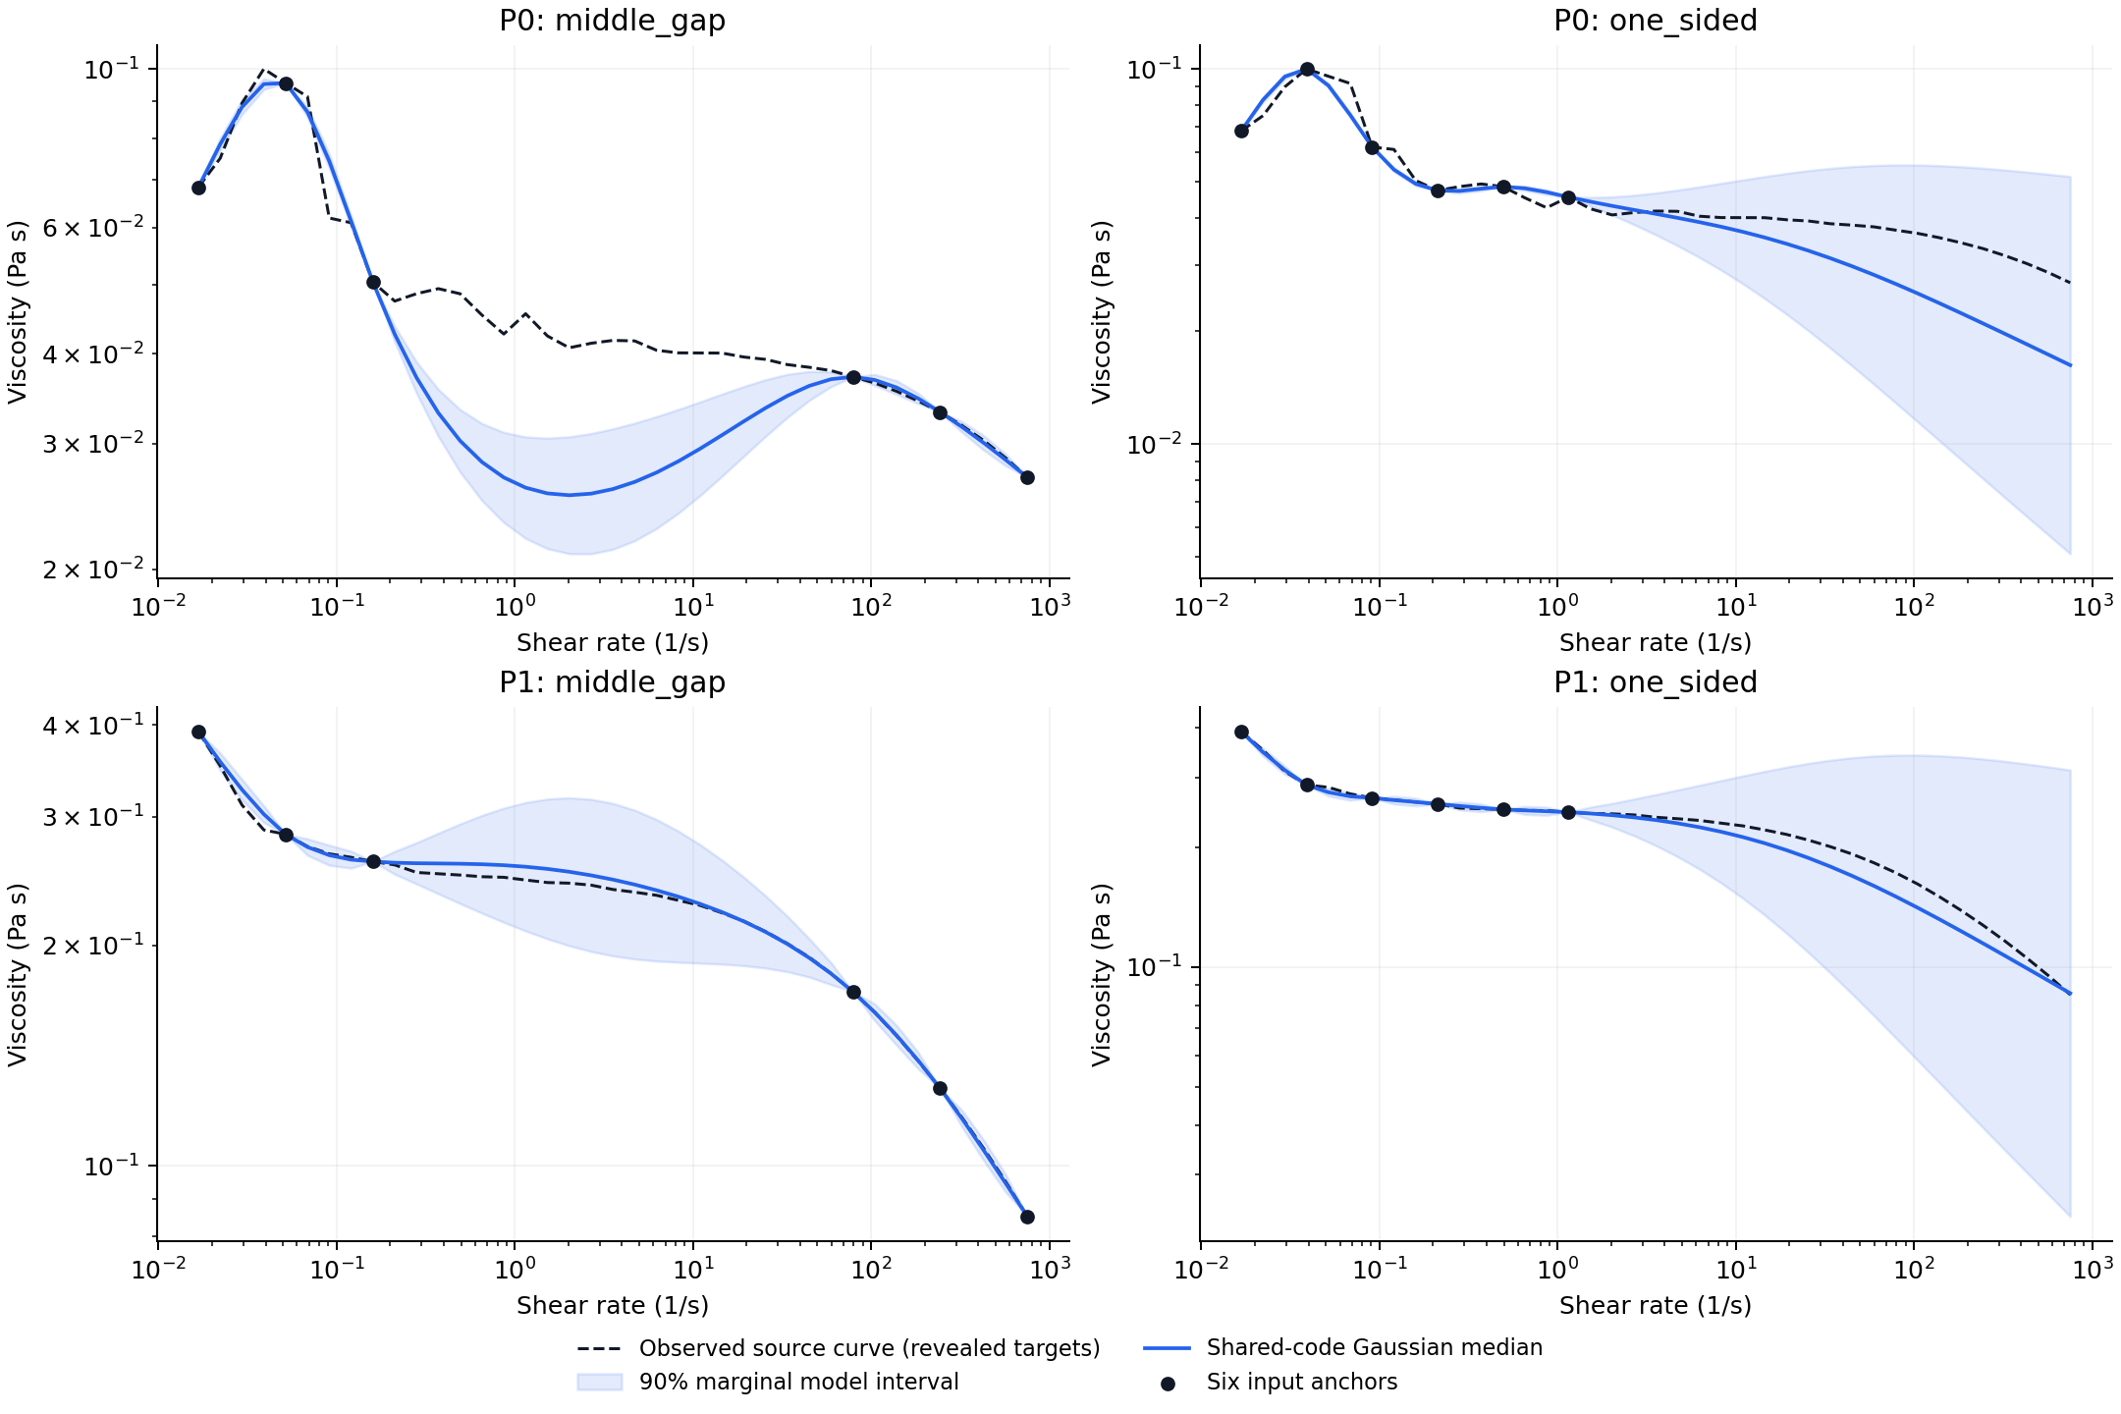
Figure S2 Complete fixed identity diagnostic for P0 and P1. Black dashed curves are the revealed source responses, blue curves are candidate medians and shaded regions are marginal model intervals. The page is landscape to retain readable labels.

Posthoc mean interval scores are 0.465734 for GP, 0.446204 for generic bounded tilt, 0.478976 for curvature bounded tilt, 0.406691 for conditional Gaussian and 0.467306 for candidate. These were computed from frozen predictions before this editorial revision; no interval-score tuning or calibration is added. For Gaussian fixed-parameter conditioning, covariance and entropy quantities do not respond to numerical anchor values [19]. This limitation does not uniquely diagnose the cause of P0's failure. The full fixed cases permit inspection of context-specific behaviour rather than selection of only visually favourable examples.

S5 Proposed independent evaluation and unresolved evidence
The original 25-formulation development cohort does not certify a new independent preparation batch or calibration cohort. Its matched random-Gaussian comparison, two anchor-conditioned probabilistic constitutive controls and fixed Student-t diagnostic remain retrospective development comparisons. The additional external source assessment is reported separately in Section S14: it adds separately reported measurements but not certified same-domain batches or a reserved calibration cohort. Any relaxed bound, updated window, new prior or tuned degree of freedom defines a revised candidate and must be reported separately rather than replacing the frozen results.
For a continuation-focused evaluation, six coordinate-selected low-rate anchors would be revealed first and only positions strictly above the highest anchor would enter its new primary endpoint. Normalized trapezoidal weights over log shear rate could avoid overcounting densely sampled segments. This differs from the original three-layout native-point endpoint. A 39-position log-spaced grid from 0.02 to 500 s⁻¹ is an example inside the frozen support, not an experiment performed. Its number of continuation targets depends on the admitted grid and need not equal the retrospective 23.
Before target reveal, authors should fix material identities, preparation and measurement-state records, temperature, scan history, grouping, tolerances, sampling unit and sample size. New formulations, fresh preparations of existing formulations and external laboratory records support different generalization claims. All eligible units should receive predictions from every method or an explicit failure entry. Score trajectories, coverage, interval score and a dependence-sensitive score can then be considered jointly [42, 45]. Experimental time or material savings require direct resource measurements, not masking of already measured curves.
Independent calibration must use data reserved from model choice. Conformalized quantile regression and jackknife+ require the relevant exchangeability assumptions and do not turn correlated curve positions into independent materials [62, 63]. Marginal coverage would not establish simultaneous whole-curve coverage. This prospective design supplies no significance guarantee or justified numerical sample-size claim from the current development variance alone.

S6 Evidence bindings software and public-release status
The original complete scientific archive is hydrogel_confirmation_20261031_full.zip, SHA256 78dc67d62b5db30b1d6e1940610863d832f1e4a1b50490f58867bbcbd30792c2. The unchanged deployment model SHA256 is d72fc262fbae0e6fecc36568f0638166fe95e991bd5f7df100ab1434097d82d1. The subsequent control-study archive is hydrogel_controls_20261101T0641198159051Z_r2_full.zip, SHA256 a620ba6927ba54f6ee8e39aba09f986873bb8b8d7adb93c3f56d6c4af5ee24c1; it includes the original archive byte for byte and the new inputs, code, protocols, predictions, numerical failures and checks. These local identifiers do not constitute public deposition or a new license grant.
For the original development/control record, the editorial companion binds the manuscript, supplement, control summaries and numerical receipts by source, byte count and SHA256. It distinguishes old five-method scores, subsequent control-study fits and saved-output diagnostics; no control fit is repeated by the document builder and no hidden S response is reopened. The later external assessment adds separately sourced measured response records under its own protocol and access roles, as described in Section S14. The new weighting analysis in Section S15 changes only saved-score aggregation. Neither figure/table construction nor arithmetic checking supplies another independent material evaluation.
All 26 original candidate fits are constrained solutions. A public frozen inference and manuscript checkpoint is now archived at https://github.com/Hancy5521/hydrogel_control, commit 05b2f221cd34e7ca2913dac10ba0be87bc06d060, also retained on archive/paper-2026-11-01. It contains the deployment runtime and weights, aggregate summaries and integrity manifests. It does not contain every original measurement or out-of-fold law required for full experiment replay. The complete local scientific archives remain preserved; reuse licensing and author publication declarations still require completion.

S7 Additional registered controls and uncertainty diagnosis
These controls were executed after the original five-method development analysis, on the same previously inspected 25 P formulations. Their registrations bind actual execution times, input and source hashes and finite numerical budgets; registration does not make the materials newly unobserved to the development process. Old references and the local-Gaussian candidate were reused unchanged.

S7 1 Matched random Gaussian control
The random representation reuses seed 20261030 and the same frozen QR directions as the bounded random control. The Gaussian family has two mean and three Cholesky parameters. Bounds, the 0.02 squared-norm penalty, zero cold start, optimizer settings and projected-gradient admission gate match the local-Gaussian fit. Twenty-five new outer code fits produce 75 frozen conditional laws; no reference or original candidate is refitted. Independent full-matrix objective, gradient and predictive checks passed.

S7 2 Constitutive priors and likelihood
For each query, five independent standard-normal coordinates z parameterize log η0 = yc+2ys z0; logit r = −2+2z1; log γc = tc+ts z2; Cross m = 2 sigmoid(z3) or Carreau n = sigmoid(z3); and log σ = log(max(σref,0.05ys))+z4. Here yc,ys,tc,ts are the original outer-reference normalization values and σref is its response-unit report-discrepancy SD. These are proper, prespecified priors, not empirical fits to the held targets. The six anchor log responses have independent Gaussian statistical discrepancy conditional on the shared curve parameters. The discrepancy is not certified measurement noise.
The initial five-dimensional SMC implementation failed predictive-replica agreement for Cross P1 one-sided and Carreau P3 one-sided and stopped before scoring. Analytic integration of the same Gaussian log-level prior yields the unchanged marginal likelihood under covariance σ²I+τ²11ᵀ. The predictive component covariance is σ²I+v11ᵀ, with v the log-level posterior variance. The final SMC uses two independent replicas, 48 random-walk moves per temperature and an ESS target of 0.8, initially 4096 particles per replica and at most 16384 on a failed precision check. Cross alone uses one additional registered 65536-particle-per-replica budget. The gate requires maximum predictive-mean disagreement and predictive-SD disagreement each no greater than 0.15 pooled predictive SD. Original failures are retained and no failed partial-case aggregate is scored.
Carreau completes 73 contexts with 8192 combined particles and two with 32768. Cross completes 66 with 8192, six with 32768 and three with 131072, including five earlier admitted laws reused unchanged in its numerical continuation. These numbers count posterior computations, not independent experiments or materials. Replica agreement does not establish exact posterior convergence or parameter identifiability.

S7 3 Scoring the physical mixtures
Predictive means, full joint densities and marginal CDFs use all frozen particles. The first CRPS expectation is analytic for Gaussian components; the second uses 131072 independent random pairs with 32 blocks for a sampling-only Monte Carlo standard error. The aggregate pair-only MCSEs are approximately 0.000032 for Cross and 0.000025 for Carreau; they do not include posterior approximation error. Independent checks compare nine selected component densities per context against explicit 33-dimensional covariance matrices, and first-target CDF-integral CRPS in the preselected P0/P1/P36 contexts. No Gaussian moment-match score substitutes for the frozen mixture.

S7 4 Fixed heavy tail control and anchor scale diagnosis
The sole Student-t diagnostic fixes prior ν=10 and preserves the Gaussian-fitted joint mean and covariance through a curve-specific inverse-gamma scale with mean one [41]. Conditional df is 16 for six anchors. Mean and kernel are not retrained, and ν is not selected from performance. The macro CRPS is 0.042906, mean joint log density 106.985, coverage 98.26% and interval score 0.443927. The original Gaussian interval score is 0.467306 and the conditional-Gaussian control remains stronger at 0.406691. One-sided CRPS worsens to 0.092948, and the posthoc 23-target continuation CRPS worsens from 0.127161 to 0.130609. It remains a diagnostic rather than a replacement model.
P0 middle-gap coverage increases from 8/33 to 26/33, while the control raises the conditional covariance by a factor 11.685 and its central 90% width by a factor 3.394. The corresponding one-sided factors are 21.111 and 4.562. Only 6, 6 and 7 of 25 formulations have covariance expansion in spread, middle-gap and one-sided layouts, respectively. This is an anchor-value calculation, not a causal diagnosis or independent reliability result. It explains how a scalar adaptation can respond to atypical anchors yet remain unable to change the conditional mean or covariance shape. Conditional Student-t joint density was checked through the full/anchor density ratio and marginal CRPS through independent CDF integration [53].

S8 Fixed pairwise difference diagnostic
The fixed diagnostic uses variogram order p=1, equal weights for all 528 unordered pairs of the original 33 target coordinates and all three original layouts. The protocol was registered before contrast expectations were frozen for the GP, conditional Gaussian, matched random Gaussian, frozen curvature Gaussian and fixed Student-t laws. There were 375 law-layout vectors and no fitting, forecast revision or exponent/weight search. Cross and Carreau mixtures were not part of this five-law diagnostic.
Table S5 Fixed order one variogram scores
Model | Spread | Middle gap | One sided | Macro score
Coordinate GP | 0.002232 | 0.003017 | 0.142191 | 0.049147
Conditional Gaussian | 0.002269 | 0.003601 | 0.240236 | 0.082035
Matched random Gaussian | 0.002223 | 0.003821 | 0.115087 | 0.040377
Frozen curvature Gaussian | 0.002245 | 0.003292 | 0.042980 | 0.016172
Fixed Student-t diagnostic | 0.002236 | 0.003349 | 0.084169 | 0.029918
Lower scores are better. The original CRPS primary endpoint and all retained material identities are unchanged. Spread interpolation is near tied; the candidate does not dominate every layout. The score combines relative-mean and covariance effects and does not isolate dependence independently of marginal prediction.
The candidate has lower formulation-averaged VS1 for 21/25 formulations against GP, 21/25 against conditional Gaussian, 20/25 against matched random Gaussian and 14/25 against fixed Student-t. P0 contributes 0.13%, 69.23%, −3.32% and 99.39% of the respective net mean gains. The negative contribution against random Gaussian means P0 is a loss in that comparison, not a reason to drop it. Its median paired gain against Student-t is only 0.0000485. Therefore the Student-t comparison does not establish broadly better Gaussian tails, and no formulation is removed from official scores.
The score is proper but not strictly proper and cannot detect common additive displacement or common-mode variance. It is not a whole-curve coverage guarantee. The independent numerical auditor imports neither the score implementation nor the scientific model core: Gaussian expectations use full contrast-matrix quadratic forms and folded-normal means; Student-t expectations use a 256-node generalized Laguerre Normal-Gamma mixture integral and 27 selected direct density integrals. All 375 scores and 20 layout/model macro summaries were reproduced. Maximum score-row error was 1.47×10⁻¹². This is an arithmetic audit of the same development data, not new material validation.

S9 Exact interpretations of the fixed Gaussian construction

S9 1 Relative potential in the two dimensional code
The Gaussian replacement admits an exact relative-potential interpretation. Let φ(z) be the standard-normal code density. For positive-definite S, the relative potential below satisfies φ(z) exp[−U_θ(z)] = N(z; a,S) exactly, including its normalizing constant. It changes the probability assigned to code configurations while leaving p_0(Y|z) unchanged. This potential is defined in probability space, rather than as a mechanical free energy or a microscopic force.
$U_{θ}(z) = \frac{1}{2}{(z−a)}^{T}S^{−1}(z−a) − \frac{1}{2}z^{T}z + \frac{1}{2}ln det S$ (S1)
Completing the Gaussian density ratio gives N(z;a,S) = φ(z)exp[−Uθ(z)] and Eφ exp[−Uθ(z)] = 1. The determinant term supplies the exact normalization. Although the relative potential can be unbounded or nonconvex, the total code log density has positive-definite precision S⁻¹. Its negative gradient is the following affine relative-score correction.
$g_{θ}(z) = −∇_{z}U_{θ}(z) = z − S^{−1}(z−a)$ (S2)
The field describes a change in statistical preference over code configurations. It is not a mechanical force, thermodynamic free energy or simulation of microscopic experiments. The actual implementation obtains the conditional Gaussian analytically and draws it through a matrix factorization; no iterative field integration is required.
$\frac{p_{θ}(Y)}{p_{0}(Y)} = E_{p_{0}(z|Y)}[e^{−U_{θ}(z)}]$ (S3)
Equation (S3) follows by multiplying the unchanged p₀(Y|z) by the Gaussian code density ratio, integrating over z and dividing by p₀(Y). It is a posterior expectation under the reference, not evaluation of Uθ on a deterministic two-dimensional encoding of a noisy observed curve. The latent support and retained conditional process remain stochastic. This is an exact reformulation of Eqs. (6)–(8), rather than another candidate model.

S9 2 Residual variance outside the adapted directions
For a fixed linear contrast v of the 33 targets, Eq. (A17) implies
$Var(v^{T}Y_{H}|y_{O}) = v^{T}D_{H}v + {({B_{H}}^{T}v)}^{T}S_{O}({B_{H}}^{T}v) ≥ v^{T}D_{H}v$ (S4)
The inequality follows because S_O is positive definite. Rank-nullity gives dim ker(B_Hᵀ) = 33 − rank(B_H) ≥ 31. Within that nullspace, a nonzero v has variance exactly vᵀD_Hv, strictly positive when D_H is positive definite. The retained residual therefore preserves uncertainty in many target contrasts outside the adaptive code. This is a model statement, not a lower bound on actual error or a calibration guarantee; strict positivity is supported for the saved queries and is not asserted for every future query.

S9 3 Conditional risk targeted by training
The declared coordinate design and fitted reference are held fixed and suppressed in the following notation. Let p* be a data-generating law on the declared response variables, with finite relevant conditional entropies and cross-entropies. The expected unpenalized part of Eq. (A18) can be written as
$R(θ) = C + \frac{1}{3}∑_{b=1…3}E_{p^{*}(Y_{O_{b}})} KL[p^{*}(Y_{H_{b}}|Y_{O_{b}}) ‖ p_{θ}(Y_{H_{b}}|Y_{O_{b}})]$ (S5)
Here C is the average conditional entropy and does not depend on θ. This standard cross-entropy identity explains the chosen training target. The finite 24-curve empirical objective additionally includes the declared squared-parameter penalty. Neither the population law nor its entropy is estimated in this editorial analysis, and the penalty is not a KL regularizer on the code law. Optimizing this conditional likelihood need not optimize every scoring rule or every missingness pattern. The three layouts are a designed task distribution, not an identified natural reporting mechanism.

S10 How layout differences combine in the primary score
The primary average first gives equal weight to the 33 native target positions in each query and then to each layout and formulation. The following arithmetic, computed only from the saved aggregate summaries in Table S2, makes the balance against the conditional Gaussian explicit. It does not rescore targets, change the endpoint or supply a new experiment.
Table S6 Layout contributions to the candidate minus conditional Gaussian difference
Layout | Candidate CRPS | Conditional Gaussian | Difference
Spread | 0.013203 | 0.012168 | +0.001036
Middle gap | 0.025835 | 0.020387 | +0.005448
One sided | 0.090792 | 0.118202 | −0.027410
Macro mean | 0.043277 | 0.050252 | −0.006975
Negative differences favour the candidate. The three layout differences are averaged, not added as separate independent effects. Equal weights do not make their absolute score scales equal. These CRPS values are in dimensionless natural-log response units, not Pa s or percentage viscosity error. The variogram diagnostic has squared log-response units, while joint log density is reported in nats per 33-target query. The one-sided primary query includes ten internal targets and 23 continuation targets; it is distinct from the proposed future continuation-only endpoint.

S11 Frozen inference workflow and observation semantics
A reproducible inference call begins with the archived deployment-model and source hashes, six positive viscosity–rate anchors and distinct requested rates inside the admitted support. The deployment model uses all 25 complete P curves and only the lawful anchors of 20 S records. It is not an outer-fold evaluation model. The supplied example anchors are synthetic reference-mean values and are labelled accordingly.
The implementation forms the common anchor–target joint mean and covariance using the fixed support and contrasts. It then applies Eqs. (9)–(10) using the numerical anchor values and factors the complete covariance of the unobserved targets. Each Gaussian draw is exponentiated as a whole vector, preserving its cross-rate dependence. Independent marginal sampling would not reproduce this law.
Analytic viscosity-scale summaries use exp(μ_j) for the median and exp[μ_j + Φ⁻¹(p)√V_jj] for a marginal p-quantile. The viscosity-scale mean is exp(μ_j+V_jj/2). These identities remove Monte Carlo error from marginal model summaries; they do not correct model misspecification or establish coverage. The legacy empirical quantile fields depend on the random draws and are distinguished from the analytic fields.
An exact request for a stored anchor repeats its known value in every draw because it refers to that same recorded observation. This is record completion, not prediction of a fresh replicate at the same rate. A new physical measurement would need a distinct observation identity and an appropriate discrepancy model. Generated outputs retain their model-generated label and must not be added to measured training records as if they were new experiments.
File checks and a successful inference call establish software identity and numerical execution. They do not validate a new batch or demonstrate experimental savings. The current public checkpoint and the complete local scientific archives have different scopes, as specified in Section S6. No additional fitting, target scoring or material measurement is introduced by this workflow description.

S12 Archived point prediction comparison
The following point-error table complements the probabilistic comparisons using already stored query mean-squared log errors. Every method retains the same 25 formulation identities, three six-anchor layouts and 33 targets per query. Each displayed RMSE is the square root of pooled target-level mean squared log error; the pooled column is not an arithmetic average of the three layout RMSEs.
Table S7 Pooled log response RMSE from archived point predictions
Model | Spread | Middle gap | One sided | Pooled
Coordinate GP | 0.033434 | 0.061926 | 0.333115 | 0.196569
Generic bounded tilt | 0.033264 | 0.062887 | 0.313679 | 0.185702
Curvature bounded tilt | 0.033593 | 0.062477 | 0.261854 | 0.156631
Conditional Gaussian | 0.033876 | 0.054387 | 0.272651 | 0.161703
Gaussian curvature correction | 0.033548 | 0.065566 | 0.193478 | 0.119524
Matched random Gaussian | 0.033414 | 0.071444 | 0.294642 | 0.176101
Bayesian Cross | 0.073283 | 0.143975 | 0.528100 | 0.318846
Bayesian Carreau a2 | 0.102374 | 0.172827 | 0.635368 | 0.384726
Fixed Student-t diagnostic | 0.033548 | 0.065566 | 0.193478 | 0.119524
PCHIP endpoint cubic | 0.031561 | 0.058481 | 1.183968 | 0.684640
PCHIP supplies point predictions only. It has the lowest spread-layout RMSE in this comparison and improves on the curvature Gaussian in the middle gap, while the conditional Gaussian is stronger than PCHIP for that gap. Its declared endpoint-cubic continuation is much weaker in the one-sided layout. This is one archived implementation, not an optimum over interpolation or extrapolation methods. Gaussian and fixed Student-t candidate rows share the same conditional mean and therefore the same RMSE. No predictive law or probabilistic score is fabricated for PCHIP.
These scalar results were exported from completed development outputs without reading raw response labels or recomputing predictive scores. They add transparency to an existing point baseline rather than a new material experiment or a new primary endpoint.

S13 Public result replay and computational checks
The computational-evidence checkpoint 79f3ae4feb84738962233923fe189591fe818733 adds three separated, documented modules. The reproducibility module publishes 675 existing probabilistic method-query score rows, 375 existing variogram rows and 75 point-only rows. These remain repeated views of 25 formulations. A Python standard-library replay rebuilds the earlier draft’s Tables 1–3 and Supplementary Tables S1, S2, S3, S5 and S6 and supplies numeric inputs for selected score plots and the coverage heatmap. It checks 238 reported comparison scalars. Original bootstrap endpoints retain their source identity and are not resampled.
The replay does not reconstruct the original response-curve panels, covariance-information diagnostics or all original fitting and posterior calculations. Independent arithmetic checks compared the ledger against its original saved scalars and reconstructed pooled RMSE through high-precision decimal arithmetic. Deterministic replay and the eight original integrity tests passed; the accompanying revision adds a ninth test and a direct Table S7 export. These checks certify score aggregation and export consistency, not source measurements or new material accuracy.
The separate inference-verification module builds the kernel, finite-scale contrasts, symmetric whitening, complete corrected joint law and dense conditioning independently from the public parameters. Ten tests and 33 numerical or status records passed, including analytic summaries, query ordering, appropriate batch marginals, anchor identity and input boundaries. The largest reported independent numerical difference is approximately 1.50 × 10⁻¹². The inputs are an explicitly declared synthetic function; this is numerical implementation evidence rather than independent materials validation.
The training demonstration uses eight explicitly synthetic 39-dimensional Gaussian vectors with a two-column cross covariance and positive-definite residual. Independent complete-matrix objective and five-parameter gradient checks at four fixed parameter vectors agree with the existing low-rank implementation. A pre-execution protocol precedes one original zero-start optimizer call, which passes its unchanged admission criteria without retry or parameter-setting changes. A third calculation checks the four fixed points through direct conditional Schur complements without another fit. The demonstration exposes the correction-training primitive; it does not fit a material reference GP, recover physical parameters or replay the original study.
The original frozen scientific model, runtime and development result values remain unchanged. The computational ledgers and checks reduce reproducibility gaps without supplying new physical measurements or certified preparation-batch independence. The separately executed external assessment and its later saved-score sensitivity analysis are defined in Sections S14 and S15; neither establishes independent calibration or measured experimental savings. Original measurement-state metadata, complete processed-data access, original-asset licensing and author declarations retain their separate completion requirements.

S14 External source assessment and data roles
This section reports the additional external assessment separately from the original 25-formulation development study. Table S8 summarizes source-level method results. Individual source identities, retained native records, proxy-group assignments and cell locations are documented in SOURCE_REGISTER.json and reproduction/SOURCE_CELL_MAP.json of the external assessment archive; exact file and vector hashes bind those records. The four sources provide 46 curves, 23 analysis groups, 1,057 complete native pairs and 781 continuation targets after six anchors per curve. These counts do not certify independent physical preparations. Dataset mirrors, repeated masks, group aliases and stored predicted curves are not counted as additional measurements.
The Liverpool workbook contains three instrument runs for each of five nominal compositions, not 15 independently certified preparations. Its combined and average/standard-deviation sheets are derivative summaries and are not extra native curves. The HA/CMHA source contributes 10 unique solution curves; duplicated HA and mock-control figure arrays are counted once, and a row with rate but missing response is not completed. Some reported values are means over source samples, which cannot be split into synthetic replicates. Granular-hydrogel runs are related through recorded file, trial and composition/state identities; forward scans are evaluated separately from excluded reverse trajectories. Dynamic-alginate measurements are crosslinked-gel flow sweeps after a time sweep, rather than the original precursor-ink state. The exact coordinate and row admission decisions precede forecasts.
The original execution protocol is recorded at 2026-11-01 13:02:14 UTC (SHA256 348d507321a41b60edf97f1da757f62f0a68c0d926b89696bfa4eeba0e50f4bd), before the 13:02:55 UTC prediction freeze (SHA256 cbf89a6b81c911da1e9bb32c4732c18d9b3895ee72a4cc358f5361da54d0bbaa). Scoring is subsequently executed once for 276 method–curve rows. Source inspection had exposed the responses; the protocol therefore fixes execution without retroactively making the study blind. The candidate and reference are not retrained, and no scored source is removed. Original P and hidden S outcomes are not reopened.
Supplementary Table S8 retains all three Gaussian laws and all three point controls. The group-macro endpoint assigns equal weight to groups, then equal weight to their native curves or conditions and to targets within each curve. A square root is applied only after aggregation of squared errors. Table S8 must not be merged arithmetically with the development endpoint, whose material domain, layouts, fitted outer models and pooled-RMSE definition differ. The external cohort is a test of the frozen deployment model, not another set of original outer folds.
Candidate probability and mean-error gains in Liverpool coexist with coverage failure and do not extend consistently across sources. The GG groups have 100% marginal coverage, but peK 10 wt% has 0% and peK 20 wt% has 57.78%; the source average is 71.56%. The dynamic-alginate source has 2.44% average coverage. A wider conditional-Gaussian interval can improve coverage while worsening CRPS or point error. All these trade-offs are retained, rather than treating an improved mean CRPS as evidence of calibrated uncertainty.
Independent arithmetic and numerical checks reconstruct all 276 rows and their group summaries, check Gaussian CRPS using a separate absolute-normal-moment expression and 12 fixed CDF integrals, and independently reconstruct full Gaussian moments for a representative curve from each source. All 4,398 bounded checks pass; representative mean and covariance differences are at most approximately 8.88 × 10⁻¹² and 5.23 × 10⁻¹². These are implementation checks, not additional material validation. A non-numeric cell map also reconstructs all 46 vectors, 1,057 pairs and 2,114 scalar floating-point values exactly from eight numeric source files. Re-executing that reconstruction is reproducibility, not another independent confirmation.
Table S8 All methods on all four external sources
Source | Method | CRPS | Log RMSE | Coverage % | Log width
Liverpool inks | Curvature Gaussian | 0.273635 | 0.562155 | 71.56 | 0.730671
Liverpool inks | Reference GP | 0.327109 | 0.597078 | 57.27 | 0.780376
Liverpool inks | Conditional Gaussian | 0.293629 | 0.607591 | 88.70 | 1.488886
Liverpool inks | PCHIP | — | 21.708516 | — | —
Liverpool inks | Six anchor power law | — | 0.636172 | — | —
Liverpool inks | Last two power law | — | 0.804197 | — | —
HA and CMHA | Curvature Gaussian | 0.148457 | 0.300875 | 78.26 | 0.828070
HA and CMHA | Reference GP | 0.137126 | 0.263966 | 83.89 | 0.833206
HA and CMHA | Conditional Gaussian | 0.380441 | 0.286370 | 96.88 | 4.763057
HA and CMHA | PCHIP | — | 5.954547 | — | —
HA and CMHA | Six anchor power law | — | 0.657350 | — | —
HA and CMHA | Last two power law | — | 0.372731 | — | —
Granular hydrogels | Curvature Gaussian | 0.297441 | 0.540774 | 57.90 | 0.689945
Granular hydrogels | Reference GP | 0.204039 | 0.410706 | 78.70 | 0.811755
Granular hydrogels | Conditional Gaussian | 0.215897 | 0.450333 | 84.44 | 0.991602
Granular hydrogels | PCHIP | — | 0.779800 | — | —
Granular hydrogels | Six anchor power law | — | 0.353593 | — | —
Granular hydrogels | Last two power law | — | 0.414263 | — | —
Dynamic alginate | Curvature Gaussian | 3.302394 | 4.191144 | 2.44 | 1.677766
Dynamic alginate | Reference GP | 3.176013 | 4.106656 | 3.90 | 1.830409
Dynamic alginate | Conditional Gaussian | 3.165265 | 4.256123 | 3.90 | 2.596729
Dynamic alginate | PCHIP | — | 276.593547 | — | —
Dynamic alginate | Six anchor power law | — | 4.200151 | — | —
Dynamic alginate | Last two power law | — | 5.675397 | — | —
Log RMSE is the square root of equal group mean squared log error. Point controls have no probability law and therefore no CRPS, coverage or interval width. Dashes denote unavailable metrics, not zero.
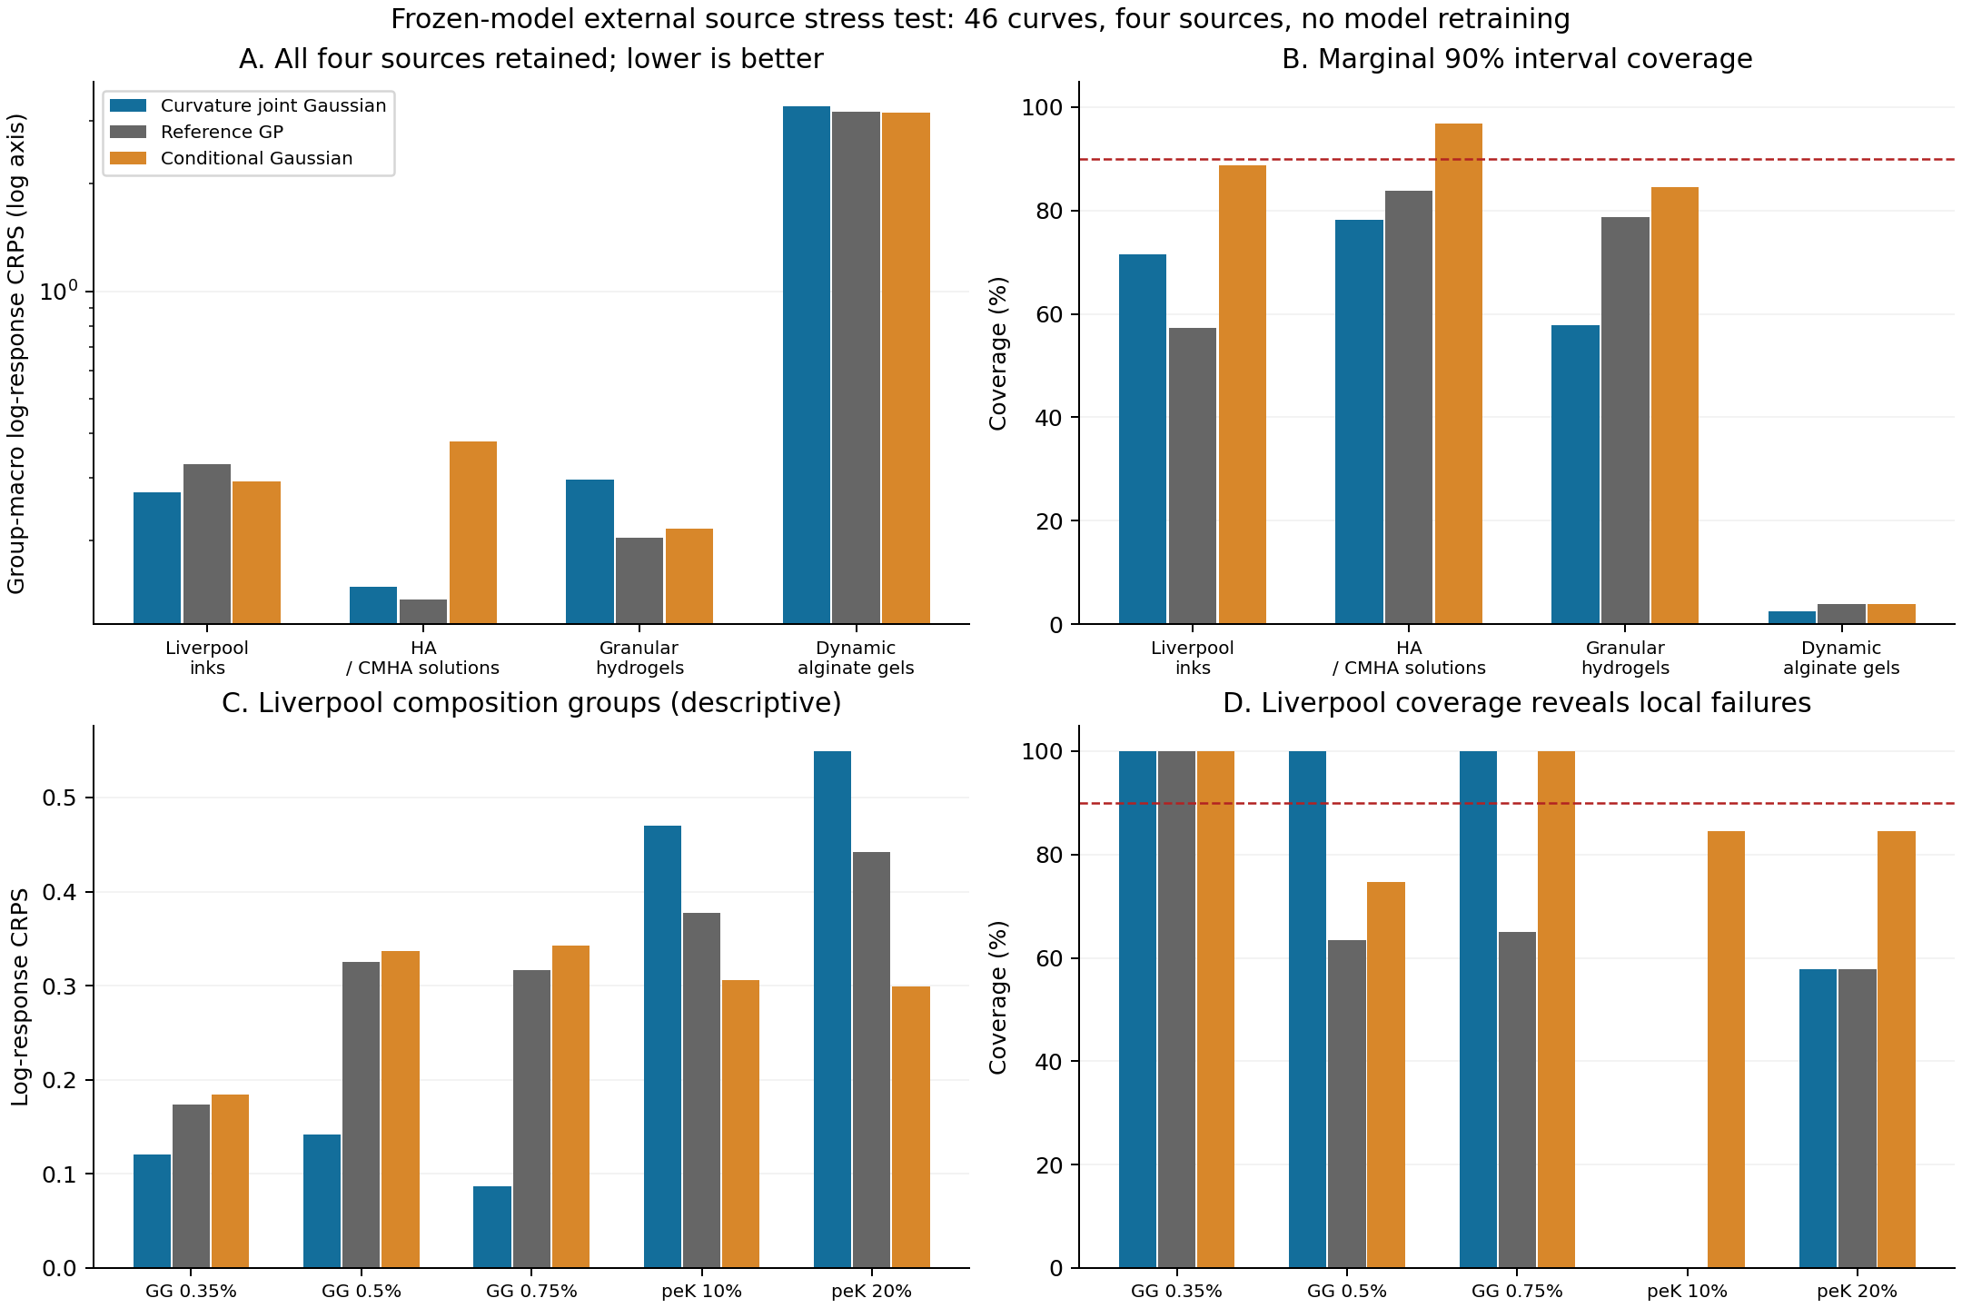
Figure S3 Four source external assessment and Liverpool composition heterogeneity. All admitted curves and conditions are retained. Nominal 90% intervals are marginal rather than a simultaneous whole curve guarantee. Group decomposition is descriptive.

S15 Material family weighting and saved group influence
This analysis uses only the already saved Liverpool scores and is explicitly descriptive. Under the original five-group weighting the GG family receives weight 3/5 and peK 2/5. For an alternative GG family weight w, the saved-score mean is R(w) = w R_GG + (1−w) R_peK, with equal weights among the groups within each family. The same calculation applies to saved MSE before taking its square root. This constructs a transparent sensitivity curve over evaluation populations; no target response, predictive distribution or model parameter is changed.
At equal family weights, the candidate has CRPS 0.312928, compared with 0.340916 for GP and 0.295105 for the conditional Gaussian (Table S9). It remains better than GP in CRPS, but no longer outperforms the conditional control. Its group-macro log-RMSE becomes 0.616247, compared with 0.610641 for GP, 0.608899 for the conditional Gaussian and 0.601002 for the six-anchor power law. Its marginal coverage becomes 64.44%. The apparent external point-error advantage therefore also depends on which material-family population is averaged.
The candidate's saved CRPS is lower than GP when the GG family weight exceeds approximately 0.390181 and lower than the conditional Gaussian when it exceeds approximately 0.547129. These crossover values summarize the observed source; they are not tuned deployment thresholds, uncertainty intervals or evidence that a future material mixture will share the same risks. The original primary weight 0.6 and the alternative 0.5 are reported together, not selected according to which yields the desired ranking.
Table S10 re-averages fixed group scores after arithmetically omitting each group in turn. Every prediction remains the same. This is an influence check on the original source mean, not leave-one-group-out training, held-out inference, cross-validation or an additional external evaluation. Five nominal groups within two material families provide limited population information; numerical stability under one arithmetic omission cannot establish independent-batch or future-family generalization.
Table S9 Liverpool primary and equal family summaries
Method | Primary CRPS | Family CRPS | Primary RMSE | Family RMSE | Family coverage %
Curvature Gaussian | 0.273635 | 0.312928 | 0.562155 | 0.616247 | 64.44
Reference GP | 0.327109 | 0.340916 | 0.597078 | 0.610641 | 52.54
Conditional Gaussian | 0.293629 | 0.295105 | 0.607591 | 0.608899 | 87.99
PCHIP | — | — | 21.708516 | 24.125625 | —
Six anchor power law | — | — | 0.636172 | 0.601002 | —
Last two power law | — | — | 0.804197 | 0.852246 | —
Primary means five analysis groups weighted equally. Family means GG and peK each receive one half. RMSE is computed after weighted MSE aggregation. These are different descriptive populations using identical saved predictions.
Table S10 Arithmetic influence of omitting one saved group
Omitted saved group | Candidate CRPS | Candidate minus GP | Candidate minus conditional G
GG 0.35 wt% | 0.311911 | -0.053635 | -0.009106
GG 0.5 wt% | 0.306559 | -0.020926 | 0.023651
GG 0.75 wt% | 0.320312 | -0.009405 | 0.038923
peK 10 wt% | 0.224652 | -0.089823 | -0.065884
peK 20 wt% | 0.204738 | -0.093584 | -0.087558
Negative differences favour the candidate. Omission reaverages fixed scores only. It is not leave one group out fitting, cross validation or a new confirmation experiment.
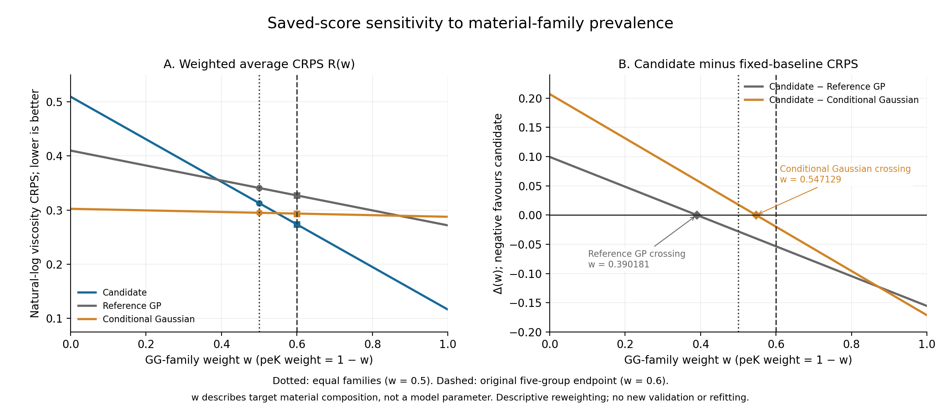
Figure S4 Saved score sensitivity to the GG family weight. The source primary weight is 0.6 and the alternative equal family weight is 0.5. Rankings change with the evaluation population. No weight is selected for deployment.

S16 Full technical specification and numerical history
This section retains the complete technical Methods from the preceding author-review draft, with unchanged mathematical objects and numeric settings. Equation labels A1–A34 identify that specification; main Eqs. (1)–(11) give the compact construction. Existing Section S9 equations S1–S5 remain distinct. This relocation does not change fitting, forecasts or scores.

Source records and access roles
The starting point is a frozen working cache derived from version 0.0.2 of the public dataset [37] associated with Zhang and colleagues [38]. One identity-conflicting record was excluded during the documented provenance review, leaving 45 formulation records with 39 native shear-rate and viscosity positions each. Reported flow observations are kept distinct from fitted Cross parameters, regression outputs and simulated processing outputs in the source. This study uses material-response records only. Conditions attached to oscillatory measurements are not automatically assigned to steady-flow data, and the published instrument scan range is not substituted for the narrower admitted cache support.
The 25 P records provide complete curves previously accessible during development. The 20 S records provide only their six fixed anchors to the restricted cache; their hidden outcomes are not reopened. These are access roles, not certified independent experimental batches. Native column indices specify the layouts, but their physical shear-rate values can differ by formulation. The statistical unit for paired summaries is a formulation, with physical batch dependence unresolved. We do not count targets, masks or generated draws as new measured materials.

Coordinates layouts and nested information access
Let shear rate and viscosity be transformed to dimensionless natural logarithms using reference units of 1 s⁻¹ and 1 Pa s.
$t = ln(\frac{γ̇}{{γ̇}_{ref}}) , y = ln(\frac{η}{η_{ref}})$ (A1)
Zero-based anchor indices are {0,7,15,23,31,38} for spread, {0,4,8,30,34,38} for middle gap and {0,3,6,9,12,15} for one-sided layouts. Each leaves 33 targets. The primary average weights each target, layout and formulation equally. In an outer fold, all 39 held P responses, including future anchors, are excluded from reference fitting and normalization. The other 24 P curves and 20 S anchor sets supply 24 × 39 + 20 × 6 = 1056 reference observations. Correction training uses the 24 complete P curves only, with the three specified conditional training tasks. The held anchors enter prediction after fitting. Saved outer references are reused unchanged for all correction comparisons.

Gaussian process reference and normalization
The reference has a fixed linear mean and independent random level, random slope, Matérn 3/2 and observation-discrepancy covariance components. Log rate is centered at the midpoint of visible reference coordinates and scaled by half their range. Log response is centered at the mean of visible reference responses and divided by their population standard deviation. The mean coefficients are profiled by generalized least squares. Positive covariance parameters are fitted by profiled maximum likelihood summed over independent formulation blocks in the statistical model; this is not restricted maximum likelihood. Saved fit configurations and parameters remain in the full reproducibility archive.
For normalized coordinates u and v the covariance is
$k_{0}(u,v) = {σ_{level}}^{2} + {σ_{slope}}^{2}uv + {σ_{smooth}}^{2}M_{3/2}(u,v) + {σ_{report}}^{2}δ_{obs}$
$M_{3/2}(u,v) = (1 + r)exp(−r) , r = \frac{√3 |u − v|}{ℓ}$ (A2)
The diagonal discrepancy is indexed by reported observation identity. It is not a separately measured instrument-noise variance. Latent support values used for the code exclude this report discrepancy; covariance of reported Y includes it. All predictions and scores are returned to the declared log-response units. A scaled reference objective used in the archived implementation changes numerical scaling, not the Gaussian model. The statistical assumption of independent formulation blocks does not certify physical independence of their preparations.

Fixed finite-scale contrasts and whitening
Let Q contain 17 equally spaced coordinates over the fixed physical log-rate support. At each interior $q_{j}$ define positive adjacent spacings $a_{j}$ and $b_{j}$ and a second-difference row $D_{j}$ with nonzero entries
$D_{j,j−1} = \frac{2}{a_{j}(a_{j} + b_{j})} , D_{j,j} = \frac{−2}{a_{j}b_{j}} , D_{j,j+1} = \frac{2}{b_{j}(a_{j} + b_{j})}$ (A3)
The two window centres lie one third and two thirds along the support, with half-width one third of its span. At an interior position, the unnormalized weight is (1−x²)³ for |x|<1, multiplied by quadrature width ($a_{j}$+$b_{j}$)/2; it is zero outside. Normalize each window to unit sum and form F = WD. Thus F annihilates constants and linear functions on Q up to floating-point error. This is a finite-scale contrast, not a classical second derivative of a Matérn path.
The contrasts have a direct interpretation on the log–log flow curve. An ideal global power-law profile has y(t) = α + (n−1)t, so both contrast responses vanish. The two adaptive coordinates therefore respond to finite-scale departures from an affine log–log profile rather than to its absolute viscosity level or overall slope. Level and slope variability remain in the reference process and are not discarded from predictions. This is a shape-focused representation; its coordinates are not identified constitutive parameters or unique signatures of polymer interactions.
If $K_{Q}$ is the latent reference covariance and $m_{Q}$ its mean, define
$P = FK_{Q}F^{T} , z = P^{−\frac{1}{2}}F(f_{Q} − m_{Q}) ∼ N(0, I_{2})$ (A4)
The inverse square root is symmetric and requires a stably positive two-dimensional covariance. Support, windows and prior whitening do not depend on a query mask or its hidden responses. The code is not rewhitened after observing anchors. Its cross covariance with reported responses is
$C_{R} = K_{Y_R,f_Q}F^{T}P^{−\frac{1}{2}}$ (A5)

Joint correction and relation to inducing-variable methods
For any finite reported response set R, the reference decomposes as
$Y_{R} = m_{R} + C_{R}z + ε_{R}$
$ε_{R} ∼ N(0, R_{R}) , R_{R} = K_{R} − C_{R}{C_{R}}^{T} , ε_{R} ⟂ z$ (A6)
We retain the independent residual and replace only the code distribution. With two mean parameters, two log Cholesky diagonals and one off-diagonal entry,
$z ∼ N(a, S) , S = LL^{T} , L = \left[\begin{matrix}e^{λ_{0}} & 0 \\ c & e^{λ_{1}}\end{matrix}\right]$
$m_{θ} = m_{0} + Ca , K_{θ} = K_{0} + C(S − I_{2})C^{T}$ (A7)
At zero correction, the reference is recovered. Equivalently, the model integrates the unchanged reference conditional law over a replacement Gaussian law on its linear features.
$p_{θ}(Y) = ∫ p_{0}(Y | z) N(z ; a, S) dz$ (A8)
An equivalent quadratic relative-potential interpretation and the induced response-density ratio are given in Supplementary Section S9. They describe this same Gaussian replacement and do not add an energy-model fitting stage.
This is the same distributional form as retaining p(f|u) and changing q(u) in inducing-variable Gaussian methods [22, 23]. The training objective and feature construction here differ from standard sparse variational posterior inference. The rank-two covariance update does not remove the high-dimensional residual. Positive semidefiniteness follows from the residual-plus-code decomposition, and finite subsets inherit consistent means and covariances from the same reference process. These are Gaussian construction properties, not empirical validation.
For anchors O and targets H the conditional law follows from the corrected full joint distribution.
$μ_{H|O} = m_{θ,H} + K_{θ,HO}{K_{θ,OO}}^{−1}(y_{O} − m_{θ,O})$ (A9)
$V_{H|O} = K_{θ,HH} − K_{θ,HO}{K_{θ,OO}}^{−1}K_{θ,OH}$ (A10)
Drawing from this Gaussian and exponentiating gives correlated predictions in viscosity units; draws remain model outputs. For fixed parameters and observation identities, simultaneous and sequential assimilation of the same anchors agree. Neither this consistency nor the choice of physical coordinates imposes monotonicity or guarantees accurate uncertainty.

Conditional residual and diagnostic quantities
To make residual conditioning explicit, write R = $K_{0}$ − CCᵀ. When its anchor block is positive definite, define
$R = K_{0} − CC^{T} , T = R_{HO}{R_{OO}}^{−1}$ (A11)
$B_{H} = C_{H} − TC_{O}$ (A12)
$D_{H} = R_{HH} − TR_{OH}$ (A13)
The posterior code and target moments are
$S_{O} = {(S^{−1} + {C_{O}}^{T}{R_{OO}}^{−1}C_{O})}^{−1}$ (A14)
$a_{O} = S_{O}[S^{−1}a + {C_{O}}^{T}{R_{OO}}^{−1}(y_{O} − m_{0,O})]$ (A15)
$E(Y_{H} | y_{O}) = m_{0,H} + T(y_{O} − m_{0,O}) + B_{H}a_{O}$ (A16)
$Cov(Y_{H} | y_{O}) = D_{H} + B_{H}S_{O}{B_{H}}^{T}$ (A17)
In particular, $B_{H}$ generally differs from $C_{H}$ because residual anchor correlation also contributes. The candidate is conditioned from its full joint matrices; this equivalent expression explains the plotted decomposition. The code trace fraction is tr($B_{H}$ $S_{O}$ $B_{H}$ᵀ)/tr($D_{H}$+$B_{H}$ $S_{O}$ $B_{H}$ᵀ), computed per context and then averaged. Gaussian entropy identities yield code–anchor and conditional code–target information [52]. Their sum is fixed within each formulation because anchors and targets partition the same 39 coordinates. These diagnostics use the fitted distribution without target-dependent routing or rejection.
For a fixed target contrast v, Eq. (A17) gives a residual variance contribution vᵀD_Hv plus a nonnegative code contribution. If B_Hᵀv is zero, the variance is exactly the residual term. With 33 targets and two code coordinates, at least 31 linearly independent contrast directions have this property. The positive residual blocks in the saved queries prevent uncertainty from collapsing in those directions; the statement concerns the fitted model, rather than its empirical calibration. Supplementary Section S9 gives the identity.

Conditional training and admission criteria
For each outer fold the shared correction is trained on the other 24 complete P curves, averaging their conditional log likelihoods over the three layouts.
$J(θ) = −\frac{1}{3N}∑_{i=1…N}∑_{b=1…3} ln p_{θ}(y_{i,Hb} | y_{i,Ob}) + 0.02 ‖θ‖²$ (A18)
The penalty is 0.02 times squared parameter norm. Mean parameters and the off-diagonal Cholesky entry are bounded to [−1,1]; log diagonals to [−0.75,0.75]. Parameter order is $a_{0}$, $a_{1}$, log $L_{00}$, $L_{10}$, log $L_{11}$. One zero cold start is used with L-BFGS-B, maximum 400 iterations and 800 evaluations, ftol ${10}^{−14}$, gtol ${10}^{−7}$ and maxls 40. Admission requires solver success, finite outputs, improvement over zero correction and projected-gradient infinity norm no greater than ${10}^{−5}$. No automatic jitter, code rotation or post-result widening of bounds is used.
The unpenalized objective targets the three declared conditional log-loss tasks, rather than marginal CRPS directly. Equal layout weights specify the training design; they do not estimate how responses become missing in naturally collected records. Under finite conditional entropies, the corresponding expected risk is a conditional Kullback–Leibler projection plus a parameter-independent constant, as detailed in Supplementary Section S9. Three masks average tasks for each formulation without creating three independent specimens.
An initial direct high-dimensional likelihood implementation stopped with abnormal solver termination and was not admitted or scored. The archived diagnosis found analytic-gradient agreement alongside finite-difference noise from likelihood subtraction. A separately recorded continuation used an equivalent low-rank formula without changing labels, model, initialization, bounds, penalty or gates. With A, h, T and G defined by
$A = C^{T}{K_{0}}^{−1}C , h = C^{T}{K_{0}}^{−1}(y − m_{0})$ (A19)
$T = S − I_{2} , G = {(I_{2} + TA)}^{−1}T$ (A20)
the exact change in Gaussian negative log density from the reference is
$ΔNLL = \frac{1}{2}[ln det(I_{2} + TA) − 2a^{T}h + a^{T}Aa − {(h − Aa)}^{T}G(h − Aa)]$ (A21)
The conditional objective subtracts the anchor expression from the full-response expression. Two-by-two determinant and Woodbury calculations stabilize the correction update; they do not remove reference solves or full conditional covariance work for draws. Direct full-matrix calculations independently checked saved objectives, gradients and distributions. Twenty-five outer fits and one subsequent deployment fit were admitted. At all 26 endpoints, $a_{1}$ = −1 and log $L_{11}$ = −0.75. The global code variance of z₂ conditional on z₁ is exp(−1.5) ≈ 0.22313; its marginal variance ranges from 0.44758 to 0.58337. Neither quantity is the response residual variance or the anchor-conditioned posterior variance.
The low-rank objective reduces the repeated correction calculation after reference quantities have been formed. Each full-response and anchor set supplies a two-by-two matrix A and a two-vector h in Eq. (A19); subsequent correction evaluations operate on these summaries. This algebraic saving does not make the entire procedure two dimensional. Constructing the reference summaries, conditioning at target coordinates and factoring the full target covariance remain necessary. No measured training-time, instrument-time or laboratory-cost advantage is inferred from the parameter count.

Sampling law and interpretation in material units
The logarithmic transformation makes the declared reference units explicit. A Gaussian conditional mean in log viscosity exponentiates to a median, whereas a marginal mean in viscosity units also includes the variance contribution exp($V_{jj}$/2). The reported log-response RMSE and CRPS should therefore not be read as errors of a mean-viscosity estimator. Similarly, an interval symmetric in log units is generally asymmetric in viscosity. Changing to viscosity-scale scoring would change the evaluation target and potentially the ranking; it has not been done in this revision.
Correlated samples require a factorization of the full conditional target covariance. Independent draws from its 33 marginals would discard the joint dependence retained by the model, even though marginal CRPS would not detect that change. Joint density addresses this dependence under the assumed Gaussian law; it should not be replaced by a sum of marginal log densities. Positive joint log densities are possible because density is defined relative to the chosen continuous coordinate scale. Marginal coverage counts targets separately and does not measure the probability that all missing positions of a curve are simultaneously covered.
The reported predictive laws condition on the saved normalization, reference hyperparameters and five correction parameters. Their covariance represents uncertainty about unobserved reported responses under that fitted joint law; it does not average over alternative fitted references or correction parameters. The callable interface also distinguishes completion of an existing record from a fresh measurement replicate: a requested rate exactly matching a stored anchor returns that known response, whereas unobserved coordinates are sampled jointly. A future independent replicate at an already observed rate would require a new observation identity and an appropriate discrepancy term; this is not the query exposed by the current interface.

Baseline families and available comparisons
The coordinate GP is unchanged. The generic and curvature bounded tilts retain the reference residual and use amplitude one with five fixed linear, centered-quadratic and interaction features [35].
$E_{θ}(z) = tanh(θ^{T}ϕ(z)) , p_{θ}(z) ∝ p_{0}(z) exp[−E_{θ}(z)]$ (A22)
$ϕ(z) = [z_{1}, z_{2}, \frac{{z_{1}}^{2} − 1}{√2}, \frac{{z_{2}}^{2} − 1}{√2}, z_{1}z_{2}]$ (A23)
The original generic code uses fixed random QR directions, and the local code uses the original curvature contrasts. Their saved directions, quadrature settings, parameters and protocols retain their original bindings. Gaussian corrections are independently optimized rather than moment matched from bounded tilts. The original random-Gaussian cell adds 25 outer fits under the same dimension, five coefficients, bounds, penalty, zero start, optimizer and information access (Table S3). Section S20 adds a separate registered representation study with 250 additional outer fits and no reference or candidate refit.
The conditional Gaussian control starts from the same reference conditional mean m and covariance V. Let $s_{j}$ = √$V_{jj}$, normalize target coordinate $u_{j}$ over the fixed support, and define anchor discrepancy h as
$h = ln[1 + \frac{{(y_{O} − m_{0,O})}^{T}{K_{0,OO}}^{−1}(y_{O} − m_{0,O})}{|O|}]$ (A24)
Its mean and covariance are
$m_{c,j} = m_{j} + s_{j}(α_{0} + α_{1}u_{j} + α_{2}h)$ (A25)
$V_{c} = exp[2(β_{0} + β_{1}h)]V$ (A26)
The three alpha parameters have bounds [−1,1], and the two beta parameters [−0.75,0.75]. The control minimizes the same averaged conditional negative log likelihood with penalty 0.02. It is a valid conditional predictor, although a common joint law across contexts is not imposed. Equal counts do not equalize function classes. The archived PCHIP point baseline is not assigned a fabricated covariance or probabilistic score. Anchor-conditioned probabilistic constitutive controls are specified below. Modern neural conditional generators are outside this small-data comparison.

Scores frozen predictions and descriptive resampling
The primary endpoint is mean marginal CRPS on log viscosity [42].
$CRPS(F,y) = ∫_{−∞}^{∞}{[ F(x) − 1\{x ≥ y\} ]}^{2} dx$ (A27)
For a Gaussian marginal, with r = (y−μ)/σ, the analytic expression is
$CRPS(N(μ, σ^{2}),y) = σ[r(2Φ(r) − 1) + 2ϕ(r) − \frac{1}{√π}]$ (A28)
The score is averaged over 33 native targets, three layouts and 25 formulations. Pooled RMSE is the square root of mean squared log error, not the average of per-query RMSEs. Joint log density scores each 33-dimensional target vector; it is scale dependent and can be positive. Nominal 90% marginal intervals use the 95th standard-normal quantile, and their exponentials are lognormal viscosity quantiles. Their average width is measured in log units. The posthoc interval score is
${IS}_{0.1}(l,u;y) = (u − l) + 20(l − y)1\{y < l\} + 20(y − u)1\{y > u\}$ (A29)
The original 75 candidate conditional distributions were frozen before target scoring. Original comparator scores are inherited unchanged. The additional random-Gaussian, Cross, Carreau and Student-t laws were registered, computed and frozen separately before scoring, while all 25 formulations retained their previously inspected development role. Saved 2000-draw paired bootstrap intervals resample fixed formulation-level predictions and exclude historical selection, refitting and batch variation. The inside/beyond-anchor decomposition, interval scores, P0 sensitivity and paired plot are descriptive analyses of frozen outputs; none replaces the primary endpoint or adds independent materials. Physical-mixture CRPS uses an analytic first expectation and 131072 independent particle pairs in the second, with 32-block Monte Carlo standard errors that exclude posterior approximation error. A subsequently fitted deployment correction uses all 25 P curves and provides a callable generator, not another evaluation. Conformal calibration has not been applied.

Anchor conditioned constitutive controls
We use finite-plateau Cross and fixed-a=2 Carreau curves, parameterized by the low-rate viscosity, high-to-low plateau ratio, transition rate and shear-thinning exponent, with an independent statistical discrepancy in log viscosity [10, 11, 12]. This discrepancy is not a separately measured instrument-noise variance. Each query posterior conditions only on its six anchors; prior scales use outer training normalization and the saved reference discrepancy scale. The transformed parameters and numerical budget are given in Supplementary Section S7.
$η_{Cross}(γ) = η_{0} [r + \frac{1−r}{1 + {(γ/γ_{c})}^{m}}]$ (A30)
$η_{Carreau}(γ) = η_{0} [r + (1−r){(1 + {(\frac{γ}{γ_{c}})}^{2})}^{\frac{n−1}{2}}]$ (A31)
The Gaussian log-viscosity level is analytically integrated, leaving a four-dimensional posterior with the original proper prior and likelihood. Each predictive mixture component retains both an independent discrepancy term and a rank-one covariance from level uncertainty. Tempered sequential Monte Carlo uses two independent runs with a fixed agreement gate on predictive means and standard deviations. The original failures and the single additional Cross particle budget are retained. No prior, exponent range or scale was selected from target scores.

Fixed shared scale sensitivity analysis
We investigate one Student-t scale mixture with prior degrees of freedom ν=10 [41]. The scale is shared within a curve, not globally across materials. Its inverse-gamma prior is parameterized by shape and scale, so that its mean is one; unconditional Gaussian mean and covariance are preserved. The existing Gaussian-fitted code parameters are not refitted under a Student-t likelihood, and no degrees-of-freedom search is performed.
$τ ∼ InvGamma(\frac{ν}{2}, \frac{ν−2}{2}), Eτ = 1,$
$Y | τ ∼ N(m_{θ}, τK_{θ})$ (A32)
For k observed anchors, let d be their squared Mahalanobis distance from the frozen Gaussian mean. Let μG and KG denote the original Gaussian conditional mean and covariance. The Student-t conditional law has degrees of freedom ν+k, unchanged mean and the following shape matrix; its covariance multiplies that shape by (ν+k)/(ν+k−2).
$Y_{H} | y_{O} ∼ t_{ν+k}(μ_{G}, \frac{ν−2+d}{ν+k}K_{G}),$
$d = {(y_{O}−m_{O})}^{T}{K_{OO}}^{−1}(y_{O}−m_{O})$ (A33)
For k=6, the conditional covariance is KG(8+d)/14. All 75 laws are frozen before their retrospective score computation. Closed-form Student-t CRPS is checked against numerical integration of its CDF, and the conditional joint density is checked against the ratio of full and anchor densities [53]. The shared scale includes statistical discrepancy and does not constitute instrument calibration.

Fixed pairwise difference diagnostic
For each registered 33-dimensional target law F, the order-one variogram score [45] compares observed and expected absolute pairwise differences. All 528 unordered pairs have equal weight. The exponent and weights were fixed in an actual protocol before 375 analytic forecast-contrast vectors were frozen and scored; no order, weight or model search was conducted.
${VS}_{1}(F,y) = \frac{1}{528}∑_{i<j}{[ |y_{i}−y_{j}| − E_{F}|Y_{i}−Y_{j}| ]}^{2}$ (A34)
Gaussian absolute-difference expectations use the folded-normal expression derived from each full joint covariance. The Student-t control uses its conditional pairwise t distribution. An independent audit checked all pair expectations through full contrast matrices, a Normal-Gamma mixture integral and selected direct density integrals. The score is a new secondary diagnostic on the same consumed development formulations, not a replacement primary endpoint or independent confirmation. The Cross and Carreau posterior mixtures were not included in this fixed five-law diagnostic.

External source assessment and saved score sensitivity analysis
The external assessment uses native numerical records from the Liverpool GG/peK ink collection [47], author-supplied HA/CMHA solution figure data [48], the raw Flow worksheet of the granular-hydrogel archive [49], and original flow-sweep exports for dynamic crosslinked alginate [50]. Fitted constitutive parameters, model predictions, digitized plots, duplicated figure aliases and interpolated target labels are not treated as new measurements. Liverpool per-run viscosities are converted from mPa·s to Pa·s by division by 1000. The HA/CMHA data include reported sample means; these do not supply new independent replicates. In the granular source, related forward runs form conservative proxy groups, and reverse paths are excluded from the forward continuation cohort. In the dynamic-alginate source, one nonmonotone rate trajectory is excluded before forecasting. Unknown preparation identities, temperatures and scan histories remain unknown. The accepted counts are 15/5, 10/8, 16/5 and 5/5 curves/groups, respectively.
Admission requires at least 12 complete, positive, finite native pairs with unique rates, increasing acquisition order and coordinates inside the exact support [0.012787740677595104, 754.5143432617188] s⁻¹. The lowest six admitted rates provide anchors and the remainder provide targets. A local pre-execution protocol fixes the cohort and methods before forecast freezing; source inspectors have already examined the responses, so this timing does not imply blinding. The same frozen reference supports the candidate, GP and existing conditional Gaussian. The point controls are log-coordinate PCHIP, an ordinary least-squares power law fitted only to the six anchors, and a power law through the last two anchors. Point methods receive no invented covariance, CRPS or coverage. The 46 anchor-only OLS estimates do not retrain the reference or correction.
External CRPS and mean squared log error first average target positions within each native curve, then native curves or conditions within an analysis group, then groups within the source. The four sources are reported separately. External group-macro log-RMSE is the square root of this weighted MSE, whereas the development tables retain their original pooled-RMSE definition. The generic saved-record term “replicate curves” is interpreted as curves/conditions within a group: concentration variants are not experimental replicates. The frequency with which every target lies inside its marginal 90% band is not a simultaneous 90% coverage guarantee. All admitted curves and all six methods remain in the saved results, with no source removal or correction-parameter tuning after scoring.
The later weighting diagnostic reads saved score scalars only, using the original group definitions. It performs no new fit, forecast or target scoring. Equal-family weighting and arithmetic omission of saved groups are descriptive population and influence analyses; neither replaces the source endpoint or constitutes new cross-validation.

S17 Relocated decomposition and uncertainty allocation
The following two retained development diagnostics also preserve the numerical mathematical objects embedded in the earlier Results text. They are fitted-model summaries, not new physical measurements.
The code accounts for 47.41%, 36.88% and 95.42% of the conditional target-covariance trace for spread, middle-gap and one-sided layouts, respectively. Its larger allocation in continuation is consistent with where improvement occurs. This is a decomposition under the fitted model in log coordinates, not a measured fraction of physical variance explained or an intrinsic dimension estimate. The conditional target residual remains positive definite in all 75 contexts, with dimension 33 and minimum reported eigenvalue about 1.054 × ${10}^{−5}$. The retained residual is therefore computationally substantive.
For fixed Gaussian parameters and observation identities, conditional covariance depends on anchor coordinates, not numerical anchor values [19]. Unusual observations do not automatically widen intervals. The same restriction applies to the plotted Gaussian information quantities (Fig. S5), derived from standard entropy identities [52]. This property does not uniquely explain P0; it identifies a limitation of the uncertainty mechanism. All 25 admitted outer fits and the deployment fit also end with the second code mean and second log Cholesky diagonal at their lower bounds. The largest projected gradient norm is about 9.17 × ${10}^{−8}$. These are constrained stationary endpoints, not evidence of an unconstrained optimum.
Table S11 Posthoc decomposition of the original one sided layout
Model | Inside anchors 10 targets | Beyond anchors 23 targets
Coordinate GP | 0.007155 | 0.179938
Generic bounded tilt | 0.007114 | 0.168071
Curvature bounded tilt | 0.007159 | 0.149808
Conditional Gaussian | 0.005667 | 0.167131
Gaussian curvature correction | 0.007143 | 0.127161
CRPS in log viscosity, native positions equally weighted. Previously frozen posthoc arithmetic, not a new prediction or the proposed weighted confirmation endpoint. These targets remain inside the global coordinate support.
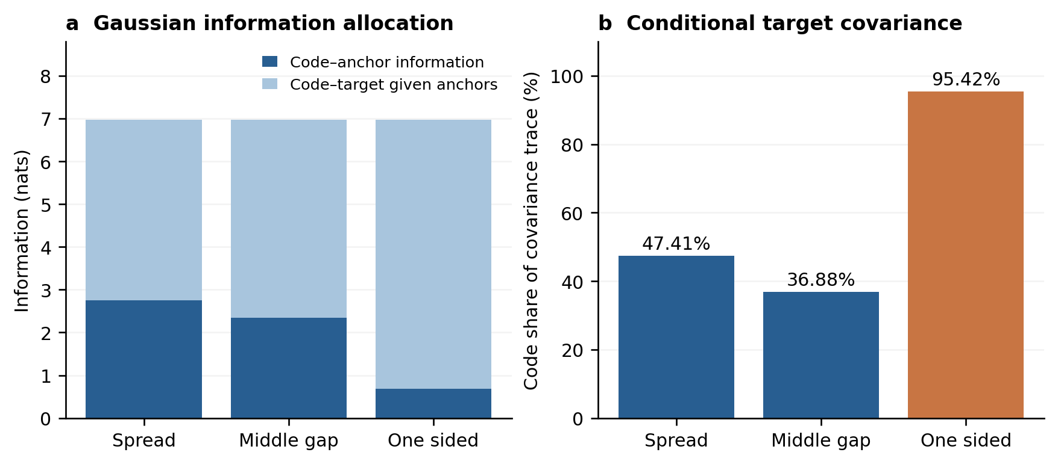
Figure S5 Conditional uncertainty allocation under the fixed candidate. a, Gaussian code information assigned to anchors and targets conditional on anchors; their total is fixed by the common coordinate union. b, Code shares of conditional target-covariance trace averaged over formulations. These are fitted-model diagnostics rather than physical explained variance or accuracy measures.

S18 Saved external uncertainty summaries
This additional analysis was registered on 4 November 2026 before executing a fixed saved-scalar aggregation. It reads the original external SCORES.json only, retaining all source, curve and group identities and original equal-group weights. It neither evaluates a target value nor changes a predictive law. All three probability methods and all four sources are reported, without pooling sources, calibrating intervals or selecting a risk threshold. A separate high-precision implementation audits the results.
Table S12 Saved interval quality and native curve failures
Source | Method | Log width | Interval score | Zero coverage | All in bands
Liverpool inks | Curvature G | 0.730671 | 3.377353 | 4/15 | 9/15
Liverpool inks | GP | 0.780376 | 3.136817 | 4/15 | 3/15
Liverpool inks | Conditional G | 1.488886 | 1.640179 | 0/15 | 8/15
HA and CMHA | Curvature G | 0.828070 | 1.239689 | 0/10 | 3/10
HA and CMHA | GP | 0.833206 | 1.032636 | 0/10 | 3/10
HA and CMHA | Conditional G | 4.763057 | 4.898642 | 0/10 | 9/10
Granular hydrogels | Curvature G | 0.689945 | 3.276073 | 2/16 | 8/16
Granular hydrogels | GP | 0.811755 | 1.741213 | 1/16 | 10/16
Granular hydrogels | Conditional G | 0.991602 | 1.635985 | 1/16 | 11/16
Dynamic alginate | Curvature G | 1.677766 | 56.715286 | 4/5 | 0/5
Dynamic alginate | GP | 1.830409 | 53.362431 | 4/5 | 0/5
Dynamic alginate | Conditional G | 2.596729 | 48.889148 | 3/5 | 0/5
Width and interval score average native curves within their original groups and groups equally within sources. Counts describe native curves and are not group-weighted probabilities, independent preparation trials or simultaneous 90% guarantees. The HA/CMHA data include reported means; Liverpool and granular sources include related runs. All-target inclusion refers to all recorded targets inside their separate nominal marginal bands. The replay also supplies marginal NLL, coverage ranges and unrounded source-method values.
Liverpool illustrates polarization: the curvature model has 4/15 zero-coverage curves and 9/15 curves entirely inside marginal bands. Its conditional Gaussian comparator has 0/15 and 8/15, respectively. The candidate width is smaller, but both interval score and marginal NLL are worse than both Gaussian controls. Candidate zero-coverage counts for HA/CMHA, granular and dynamic alginate are 0/10, 2/16 and 4/5. These are descriptive analyses of consumed outcomes, not a calibration repair or independent transfer confirmation.

S19 Table crosswalk and publication data access
Main Table 1 is the new evidence-domain table. Main Table 2 is the original development Table 1; main Table 3 retains the original additional controls; main Table 4 retains external source results. The original main Table 2 is now Table S11. Original main Figure 4 is Figure S5, original main Figure 5 is now main Figure 3, and original main Figure 3 is now main Figure 4. All other original scientific tables and numerical cells are retained. The reviewer scalar command replays the historic table identities and writes this crosswalk so old receipts are not silently relabeled.
The public repository permits score-summary replay and frozen inference. Complete original fitting and outer-fold reproduction still requires the relevant lawful processed inputs, provenance and original predictive assets. Publication data access, the authors’ software/model/manuscript reuse terms and any third-party exception must be completed before submission under the MLST-specific open-data policy. Public visibility, an internal ZIP and a Git commit do not by themselves supply those permissions or a permanent dataset DOI.

S20 Additional representation controls on consumed development formulations
A new protocol was registered at actual UTC 2026-11-04T15:55:54.584157+00:00 before execution. The fixed list contains eight random seeds 20261105–20261112, the top two latent prior-KL modes and a fixed 45 degree rotation of the original curvature basis. All 250 new correction fits were admitted; 750 new conditional laws were frozen globally before their target scores. No original reference, candidate or deployment fit was repeated. The 25 formulations, three layouts, native target positions, score weights and response scale are unchanged. This is retrospective development, not a new material cohort.
Random bases follow the original 17 by 2 standard-normal QR construction. Prior-KL uses the largest two eigenvectors of the latent 17 point support covariance, with the largest-magnitude component made positive, and converts them into prior-whitened coordinates. No responses select these directions. The rotation preserves the curvature span; it probes coordinate-dependent constraints. Every correction has the original five coefficients, one zero start, bounds, penalty 0.02 and optimizer. Equal counts do not make the bounded mean/Cholesky parameter spaces invariant under rotation. No failed fit, fallback, retry or best-seed selection occurs.
Table S13 Additional representation comparison with original controls
Representation and correction | Macro CRPS | Spread CRPS | Middle gap CRPS | One sided CRPS | Coverage 90%
Coordinate GP | 0.055219 | 0.012883 | 0.025196 | 0.127579 | 97.37%
Generic bounded tilt | 0.052243 | 0.012462 | 0.024970 | 0.119296 | 97.33%
Curvature bounded tilt | 0.048253 | 0.013048 | 0.025129 | 0.106581 | 97.29%
Conditional Gaussian | 0.050252 | 0.012168 | 0.020387 | 0.118202 | 96.61%
Frozen curvature Gaussian | 0.043277 | 0.013203 | 0.025835 | 0.090792 | 97.21%
Original random Gaussian | 0.049908 | 0.012383 | 0.026131 | 0.111209 | 97.01%
Random Gaussian 20261105 | 0.065362 | 0.013042 | 0.024279 | 0.158764 | 96.77%
Random Gaussian 20261106 | 0.057051 | 0.012860 | 0.024622 | 0.133672 | 96.48%
Random Gaussian 20261107 | 0.049848 | 0.012503 | 0.023288 | 0.113752 | 97.49%
Random Gaussian 20261108 | 0.051601 | 0.012103 | 0.025094 | 0.117606 | 96.65%
Random Gaussian 20261109 | 0.056238 | 0.012031 | 0.026421 | 0.130263 | 97.13%
Random Gaussian 20261110 | 0.059454 | 0.012584 | 0.023515 | 0.142264 | 97.21%
Random Gaussian 20261111 | 0.060127 | 0.012683 | 0.024279 | 0.143419 | 96.77%
Random Gaussian 20261112 | 0.053039 | 0.013432 | 0.026837 | 0.118847 | 96.77%
Prior-KL Gaussian | 0.037139 | 0.012902 | 0.025231 | 0.073284 | 97.33%
Curvature Gaussian 45 degrees | 0.043156 | 0.013133 | 0.025370 | 0.090966 | 97.25%
All rows retain the original 25 formulation development role. The first six rows are imported historical scores, not target rescoring. The last ten rows are the fixed new comparisons. Every entry averages all native targets and all stipulated formulations; no seed or formulation is selected for the table. Unrounded values, pooled log RMSE, joint log density and interval widths are retained in the score ledger.
The eight new random macro scores range from 0.049848 to 0.065362, all above the original curvature 0.043277. Prior-KL obtains 0.037139 macro CRPS, 0.098648 pooled log RMSE and 0.073284 one-sided CRPS, but its mean joint log density 63.327985 is below curvature 63.658108 and conditional Gaussian 82.925879. Overall KL wins 19/25 formulations. In the middle gap, however, it wins only 8/25 and loses 17/25; its mean difference is −0.00060448 but median difference is +0.00083818. Arithmetic removal of P0 leaves a mean difference of only −0.00002107; all official results retain P0. KL covers 11/33 P0 middle-gap targets versus 8/33 for curvature. This does not repair local reliability.
The 45 degree rotation obtains macro CRPS 0.043156 and one-sided CRPS 0.090966, compared with original curvature 0.043277 and 0.090792. It changes the constrained fit while preserving the span, so it is not evidence of new physical information. The prior-KL and rotation controls are not new deployment models, have no external results, and are not selected for adoption from this consumed development set.
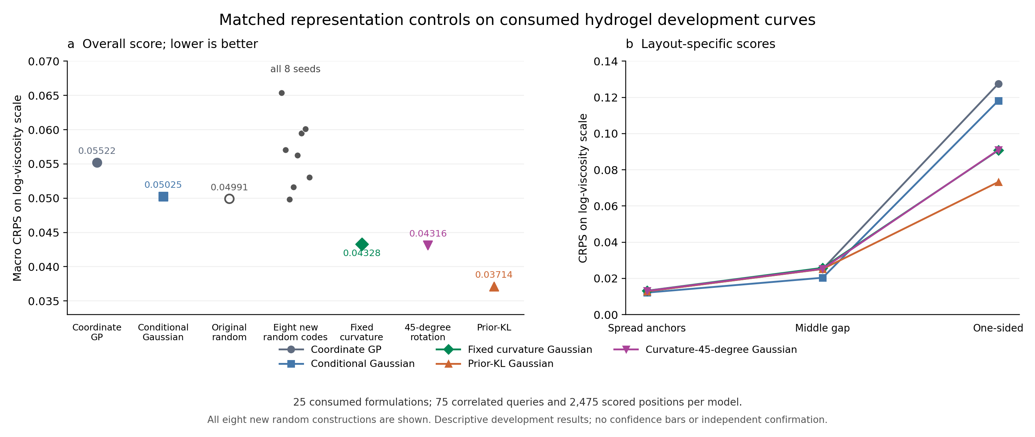
Figure S6 Additional fixed representation controls. All eight random constructions are shown, together with the prior-KL and rotated-curvature controls and retained original reference scores. The protocols use the same 25 development formulations. The random range is descriptive, not a confidence interval, and prior-KL is not an independently confirmed deployment replacement.

S21 Posthoc allocation under the reference conditional covariance
This explanation was registered only after seeing the completed representation CRPS, at actual UTC 2026-11-04T16:02:18.046344+00:00. It reads 150 frozen covariance/index records and 50 existing fit receipts, without opening TRAIN, decoding response values or recomputing target scores. Let A be the remaining standardized-code covariance given reference anchors, B the code–target cross covariance and V0 the remaining reference target covariance. The code-explained block is B A⁻¹ Bᵀ. This is a reference conditional-Gaussian decomposition before learning, unlike the fitted-model summaries in Section S17.
Table S14 Reference conditional covariance allocation after anchors
Layout | KL trace fraction | Curvature 45 degree trace fraction | KL mean point fraction | Curvature 45 degree mean point fraction
Spread | 0.170054 | 0.485347 | 0.156009 | 0.448609
Middle gap | 0.911354 | 0.409909 | 0.546811 | 0.348154
One sided | 0.988047 | 0.952996 | 0.648716 | 0.629642
Trace fractions divide the trace of the code-explained block by trace(V0); mean point fractions average the 33 diagonal ratios. They weight positions differently. For example, prior-KL one-sided allocation 0.988047 does not mean 98.80% accuracy, physical information recovered or physical variance explained. All 150 conditional code covariances have rank 2; no eigenmode is discarded, no jitter is added, and every residual is positive definite. The analysis states explicit machine-precision rank/support tolerances and retains all results. It cannot prove prediction quality, calibration, physical identifiability or new-batch transfer.
All 25 prior-KL fits and all 25 rotated-curvature fits hit the lower bound of the second log Cholesky diagonal. The rotated version also hits the first mean lower bound in 16 folds and the second in one fold. This describes constrained endpoints; no bounds are relaxed in response. Independent checks reconstruct all 150 covariance rows and 50 parameter receipts without importing the producer. These are numerical verification and posthoc explanation, not additional material experiments.

