**Deploy Static Website on**

**AWS**

**Udacity Project-1**

**-Gaurav Handa**

**Introduction:**

The cloud is perfect for hosting static websites that only include HTML, CSS, and JavaScript files that require no server-side processing. In this project, you will deploy a static website to AWS. First, you will create a S3 bucket and upload the website files to your bucket. Next, you will configure the bucket for website hosting and secure it using IAM policies. Next, you will speed up content delivery using AWS’ content distribution network service, CloudFront. Lastly, you will access your website in a browser using the unique CloudFront endpoint.

**Prerequisites:**

* AWS Account
* [Student-ready starter code](https://drive.google.com/open?id=15vQ7-utH7wBJzdAX3eDmO9ls35J5_sEQ)

**Topics Covered:**

* S3 bucket creation
* S3 bucket configuration
* Website distribution via CloudFront
* Access website via web browser

**Dependencies:**

**1. Cloud Services:**

* Amazon Web Services S3 - Resource hosting and deployments
* AWS CloudFront - CDN for SPA
* AWS EKS - Backend API
* AWS DynamoDB - Persistent Datastore
* AWS Cognito - User Authentication

**2. Performance Tracking and DevOps Tools:**

* AWS CloudWatch - Performance and Health checks
* Sentry - Bug Reporting
* Google Analytics - Usage Reporting
* Travis (CI/CD)

**3. Frameworks:**

* Ionic (Javascript) (Frontend)
* Node.js (Javascript) (Backend)

**Website Files**

**1.Create S3 Bucket:**

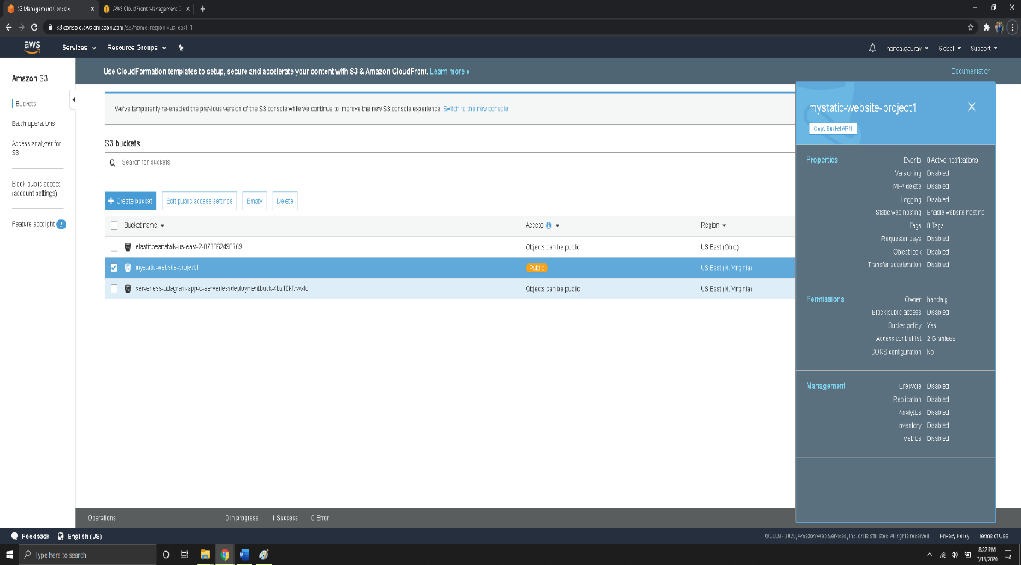

**2. Upload files to S3**

**3. Bucket Configuration**

**4. Permission Access**

**Website Distribution**

**Cloudfront**

**Web Browser Access**

<http://d1hcbda29nw6o0.cloudfront.net/index.html>

**Reviews:**