Link figma : https://www.figma.com/file/CgHfPeRPlGVObIE4pdCcye/DeweTour?type=design&node-id=0-1&t=1m3ovCao0PbVtASJ-0

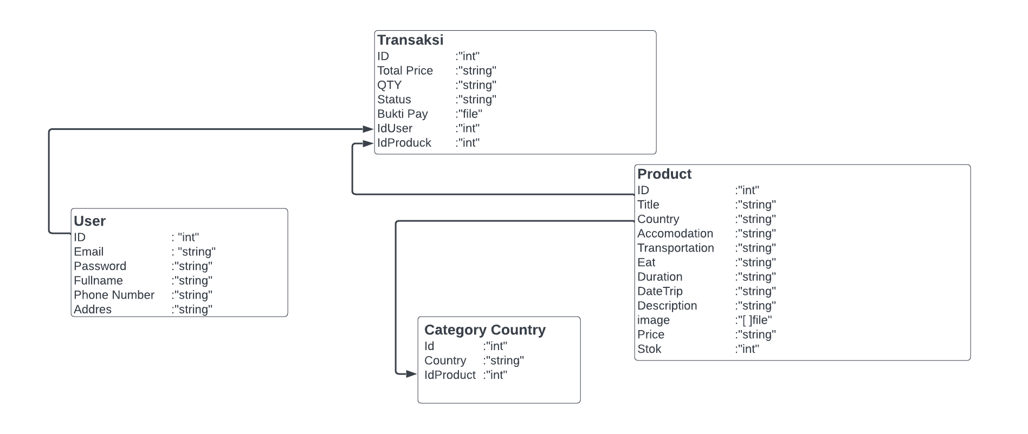

Untuk DTO

1.Login : url = API/V1/Login

Body {

Email “string”

Password “string”

}

Response BE terhadap request FE

{

Image Profil “string” berupa url

Token “string”

}

2. Register : url = API/V1/register

Body {

Fullname “string”

Email “string”

Password “string”

Phone number “string”

Addres “string”

}

Response BE terhadap request FE

{

}

3. Get All Trip: url = API/V1/Producks

Body {

}

Response BE terhadap request FE

{

Title trip “string”

Duration day “string”

Duration night “string”  
 image “file” berupa url  
 stok “string”

Quota “string”

Country “string”

}

4.Get Produck By Id: url = API/V1/DetailProduck/:id

Body {

Id “int”

}

Response BE terhadap request FE

{

Duration day “string”

Duration Night “string”

Title trip “string”

Country “string”

Image “[ ]string” berupa url

Accomodation “string”

Transportation “string”

Eat “string”

Duration “string”

Date Trip “time.time”

Description “string”

Price “string”

}

5.Create New Transaktion : url = API/V1/NewPayment/:id

Body {

IdTrip “int”

Total Price “string”

QTY “string”

}

Response BE terhadap request FE

{

Duration day “string”

Duration Night “string”

Title trip “string”

Country “string”

StatusPayment “string”

Date Trip “time.time”

Duration “string”

Accomodation “string”

Transportation “string”

QTY “string”

Total Price “string”

}

6. Get Unpaid All Transaktion : url = API/V1/transaktions

Body {

}

Response BE terhadap request FE

{

}

7. Update status transaction : url = API/V1/TransactionStatus

Body {

ImageBuktiBooking “file”

}

Response BE terhadap request FE

{

StatusBooking “string”

}

8. Get User By Id: url = API/V1/Profile/:id

Body {

IdUser “int”

Total Price “string”

QTY “string”

}

Response BE terhadap request FE

{

Fullname “string”

Email “string”

Phone number “string”

Addres “string”

ImageProfile “file”

Idtransaction “int”

Duration day “string”

Duration Night “string”

Title trip “string”

Country “string”

Date Trip “time.time”

Duration “string”

Accomodation “string”

Transportation “string”

QTY “string”

Total Price “string”

}

9.Update User Foto profile: url = API/V1/Profile/update

Body {

ImageProfile “file”

}

Response BE terhadap request FE

{

ImageProfile “file”

}

10. Get All Transaction != waiting payment : url = API/V1/transactionts

Body {

Status “string”

}

Response BE terhadap request FE

{

UserName “string”

DurationDay “string”

DurationNight “string”

ImageBuktiBooking “string” nama imagenya

StatusPayment “string”

}

11. Update Status Transaction : url = API/V1/transactionts/Update

Body {

IDtransaction “int”

StatusPayment “string”

}

Response BE terhadap request FE

{

Duration day “string”

Duration Night “string”

Title trip “string”

Country “string”

StatusPayment “string”

Date Trip “time.time”

Duration “string”

Accomodation “string”

Transportation “string”

QTY “string”

Total Price “string”

}

12. Create New Time : url = API/V1/addtrip/

Body {

idTrip “int”

Title trip “string”

Country “string”

Accomodation “string”

Transportation “string”

Eat “string”

Duration day “string”

Duration Night “string”

Date Trip “time.time”

Price “int”

Quota “int”

Description “string”

Image “[ ]string” berupa url

}

Response BE terhadap request FE

{

}