1. **White Box**

Flowchart

Administrator

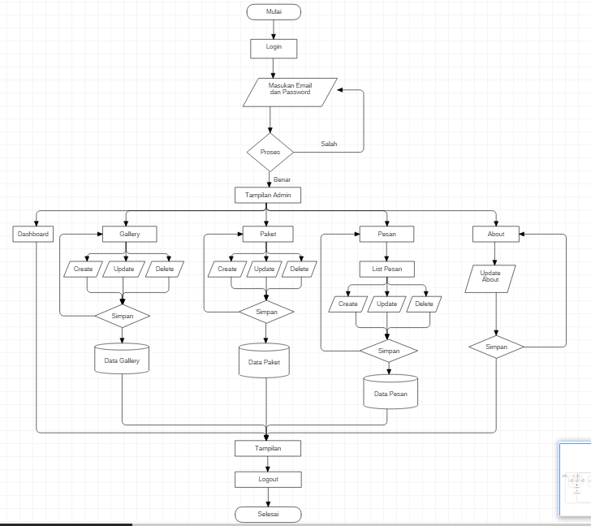

User ( Pengguna )

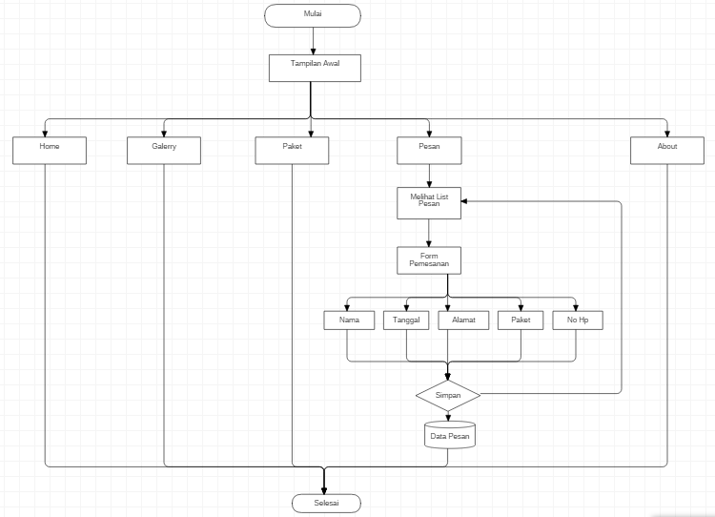

1. Control Flow Graph

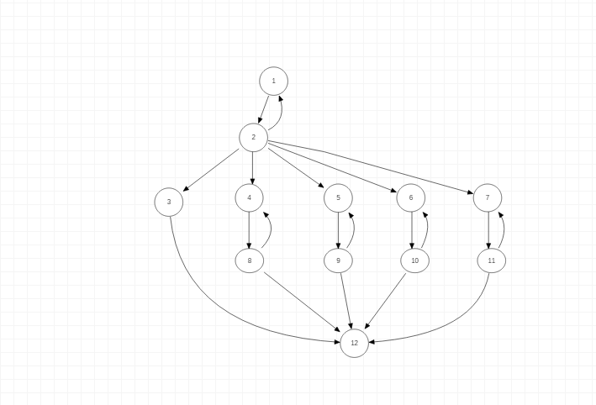

1. Cyclomatic Complexity

VG =link-node+2;

VG= 20-12=8+2=10;

1. Path Pengujian

Path1 = 1-2-3-12

Path2 = 1-2-4-8-12

Path3 = 1-2-5-9-12

Path4 = 1-2-6-10-12

Path5 = 1-2-7-11-12

2. **Black Box**

1. Equivslence Partitioning

A. Modul Otentikasi Admin

* Validasi untuk Usernamel Admin Login

|  |  |  |
| --- | --- | --- |
| Invalid | Valid | Invalid |
| ..,-1,0 | 1,2,3,…30 | 31,32,…. |

* Validasi untuk Password Admin Login

|  |  |  |
| --- | --- | --- |
| Invalid | Valid | Invalid |
| ..,-1,0 | 1,2,3,…20 | 21,22,…. |

B. Modul Gambar

* Validasi untuk nama paket

|  |  |  |
| --- | --- | --- |
| Invalid | Valid | Invalid |
| …,-1,0 | 1,2,3,...30 | 31,32,…. |

* Validasi untuk description

|  |  |  |
| --- | --- | --- |
| Invalid | Valid | Invalid |
| …,-1,0 | 1,2,3,...50 | 51,52,…. |

* Validasi untuk gambar(dalam mb)

|  |  |  |
| --- | --- | --- |
| Invalid | Valid | Invalid |
| …,-1,0 | 1,2 | 3,4…. |

1. Modul Paket

* Validasi untuk nama paket

|  |  |  |
| --- | --- | --- |
| Invalid | Valid | Invalid |
| …,-1,0 | 1,2,3,...30 | 31,32,…. |

* Validasi untuk gambar(dalam mb)

|  |  |  |
| --- | --- | --- |
| Invalid | Valid | Invalid |
| …,-1,0 | 1,2 | 3,4…. |

1. Tabel Kebenaran

* Validasi Untuk login admin

|  |  |  |  |  |
| --- | --- | --- | --- | --- |
| Email | F | F | T | T |
| Password | F | T | F | T |
|  | error | Error | error | Berhasil |

* Validasi Untuk Tambah Galerry

|  |  |  |  |
| --- | --- | --- | --- |
| Nama | Description | Gambar |  |
| T | T | T | Berhasil |
| T | T | F | Error |
| T | F | T | Error |
| F | T | T | Error |
| F | T | F | Error |

* Validasi Untuk Edit Galerry

|  |  |  |  |
| --- | --- | --- | --- |
| Nama | Description | Gambar |  |
| T | T | T | Berhasil |
| T | T | F | Error |
| T | F | T | Error |
| F | F | T | Error |
| F | T | T | Error |

* Validasi Untuk Tambah Paket

|  |  |  |
| --- | --- | --- |
| Nama Paket | Gambar Paket |  |
| T | T | Berhasil |
| T | F | Error |
| F | F | Error |
| F | T | Error |

* Validasi Untuk Edit Paket

|  |  |  |
| --- | --- | --- |
| Nama Paket | Gambar Paket |  |
| T | T | Berhasil |
| T | F | Error |
| F | T | Error |
| F | F | Error |