**Team Project Proposal**

**Subject: Object Oriented Design Pattern**

1. **Team member list**

**21400361 Dabin Seo 21200610 Hansung Lee 21200029 Yohan Ko**

1. **Overview of topic**

**<Design Pattern For A Calendar>**

1. **Definition of Our Design Pattern**Visitor Pattern  
   For adding new functions to variable objects. (but we don’t think capsulation is important)
2. **What do we make a project?**The topic is a calendar. The calendar is displayed on the java applet. Then, calendar has some special function (for example, memo, alarm, and so on.)
3. **Expected Result**

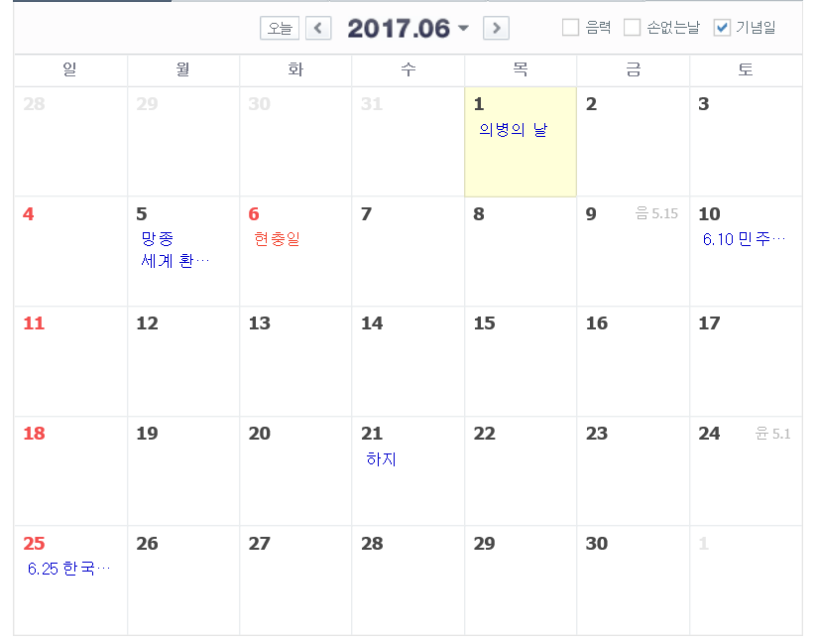

1. **Time table**

14th week: Make basic environment for our Calendar.

15th week: Make visible design for our Calendar.

16th week: Feedback and revising