Seal Escape

# QT6JAR – Hajdu András BN2307

# Component diagram

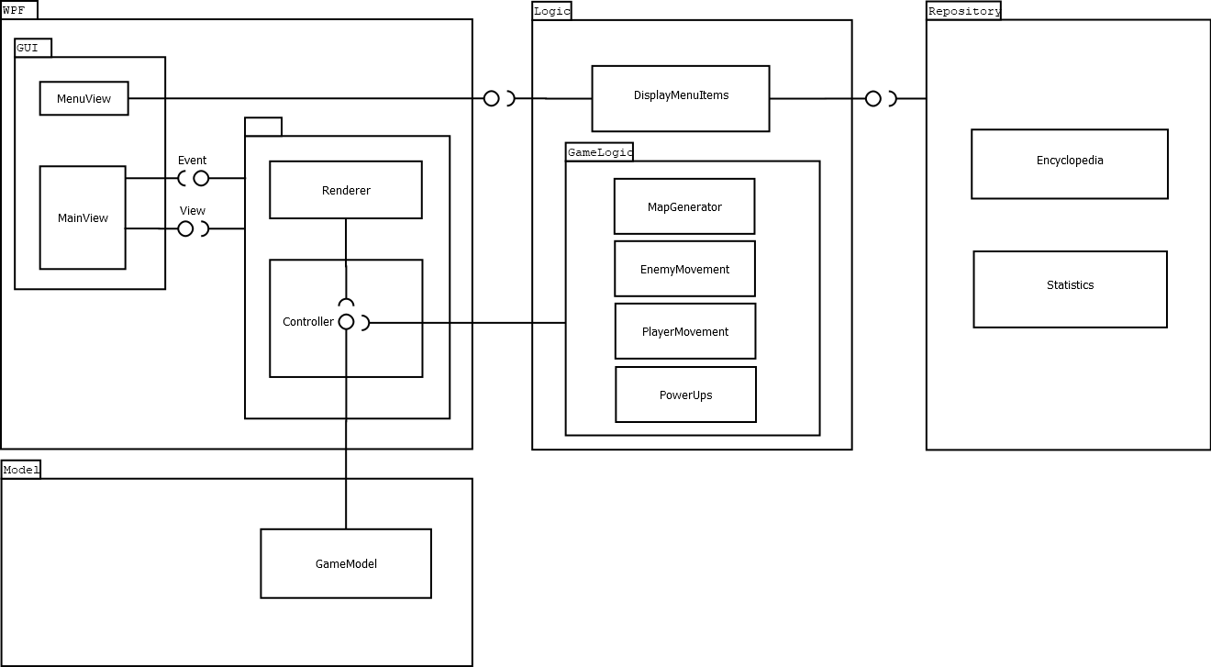

# Sequence diagrams

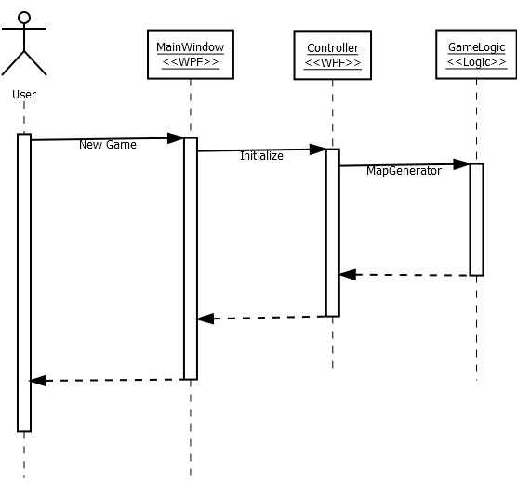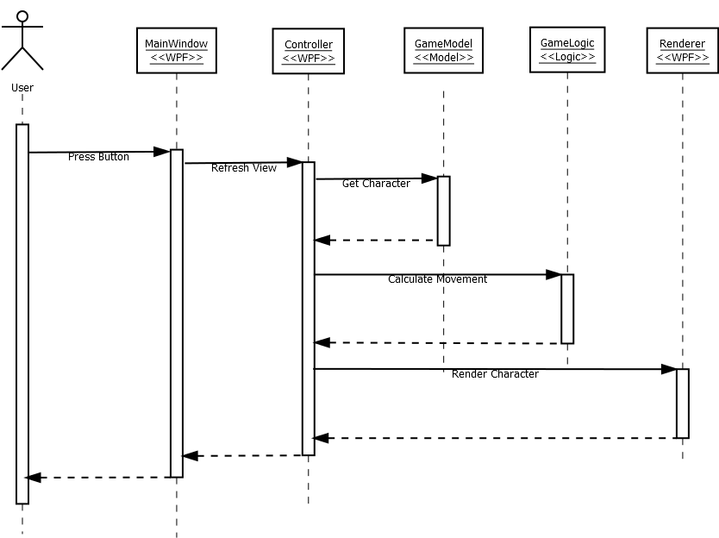

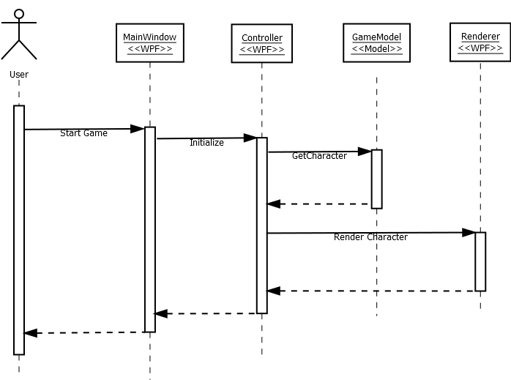

Interfaces

# Model

## IGameModel

Properties:

* string PlayerName
* int Highscore
* int Score
* int FoodCollected
* int GravityStrength
* int Difficulty

## IGameElementModel

Properties:

* double XPosition
* double YPosition

Methods:

* void ChangeX(double x)
* void ChangeY(double y)
* void SetXY(double x, double y)

## IEnemyModel : IGameElementModel

Properties:

* int Damage
* int Speed
* bool HasAimBot

## IFoodModel : IGameElementModel

Properties:

* int Value

## IPlayerModel : IGameElementModel

Properties:

* int LivesLeft
* int LivesTotal

# Logic

## IGameLogic

Methods:

* void GenerateMap()
* void LoadMap()
* void SaveMap()
* void SetHighscore(int highscore)
* void LoadHighscore()
* void SaveHighscore()
* void IncreaseScore(int diff)
* void IncreaseFoodCollected(int diff)

## IEnemyLogic

Methods:

* void HorizontalApproach()
* void RandomApproach()
* void AimBotApproach()

## IFoodLogic

Methods:

* void HorizontalApproach()

## IPlayerLogic

Methods:

* void Descend()
* void Ascend()
* void DecreaseLivesLeft()

## IMenuLogic

Methods:

* void DisplayLeaderboard()
* void DisplayEncyclopedia()
* void SetPlayerName()

# Repository

## IRepoInterface

Properties:

* string LeaderboardFilePath
* string SaveFilePath
* string EncyclopediaPath

Methods:

* T Read()
* void Overwrite(T content)