Bookdown Template

subtitle here

Jack Dougherty

Ilya Ilyankou

2020-05-21

# Preface

This test book was last updated on 21 May 2020

Insert additional preface items below (acknowledgements, etc.), with non-numbering symbols {-} to ensure that the preface is not numbered, and the first chapter is properly numbered as chapter one.

Reminder: Bookdown does not auto-number figures in the index.Rmd file, which serves as a “preface” file.

### Acknowledgements

Cupcake ipsum dolor sit amet jelly beans wafer pudding. Bear claw lemon drops carrot cake pie wafer chocolate jelly cheesecake. Chocolate cheesecake chocolate bar sugar plum sweet dessert tart. Tootsie roll bear claw chocolate bar wafer powder sugar plum tiramisu bear claw gummies. Tart macaroon pastry lemon drops candy tootsie roll chocolate candy canes lollipop. Pudding fruitcake bear claw sweet cake cupcake. Chupa chups pudding candy canes chupa chups powder jujubes chocolate cake cotton candy jelly.

# Publishing with Bookdown

This open-access book is built with free-to-use, open-source tools—primarily [Bookdown](https://bookdown.org), [GitHub](http://github.com), and [Zotero](http://zotero.org)—and this chapter explains how, so that readers may do it themselves and share their knowledge to improve the process. The broad goal is an efficient workflow to compose one document in the easy-to-write [Markdown format](https://en.wikipedia.org/wiki/Markdown) that Bookdown generates into multiple book products: an HTML web edition to read online, a PDF print edition for traditional book publishing, a Microsoft Word edition for editors who request it for copyediting, and option for other formats as desired.

Since Bookdown is an [R code package](https://www.r-project.org/), we composed the book manuscript in R-flavored Markdown, with one file (.Rmd) for each chapter. We use Bookdown to build these files in its GitBook style as a set of static HTML pages, which we upload to our GitHub repository. Readers can view the open-access web edition of the book at our custom domain: <https://HandsOnDataViz>.

We also use Bookdown to build additional book outputs (PDF, MS Word, Markdown) and upload these to the docs folder of our GitHub repository, so that our O’Reilly Media editor may download and comment on the manuscript as we revise.

We also have the option to use [Pandoc](https://pandoc.org) alone to convert the full-book Markdown file (.md) into an AsciiDoc file (.asciidoc) for easier importing into the [O’Reilly Atlas platform](https://docs.atlas.oreilly.com/writing_in_asciidoc.html). See some caveats and workarounds below.

### File Organization and Headers

We organized the [GitHub repository for this book](http://github.com/handsondataviz/book) as a set of .Rmd files, one for each chapter. As co-authors, we are careful to work on different chapters of the book, and to regularly push our commits to the repo. Only one of us regularly builds the book with Bookdown to avoid code merge conflicts.

Bookdown assigns a default ID to each header, which can be used for cross-references. The default ID for # Introduction is {#introduction}, and the default ID for ## Part One is {#part-one}, where spaces are replaced by dashes. But we do *not* rely on default IDs because they might change due to editing or contain duplicates across the book.

Instead, we *manually assign a unique ID* to each first- and second-level header in the following way. Note that the {-} symbol, used alone or in combination *with a space* and a unique ID, prevents auto-numbering in the second- thru fourth-level headers:

# Top-level chapter title {#unique-name}  
## Second-level section title {- #unique-name}  
### Third-level subhead {-}  
#### Fourth-level subhead {-}

Also, we match the unique ID keyword to the file name for top-level chapters this way: 01-introduction.Rmd to keep our work organized. Unique names should contain only *alphanumeric* characters (a-z, A-Z, 0-9) or dashes (-).

In the Bookdown index.Rmd for the HTML book output and the PDF output, the toc_depth: 2 setting displays chapter and section headers down to the second level in the Table of Contents.

The split_by: section setting divides the HTML pages at the second-level header, which creates shorter web pages with reduced scrolling for readers. For each web page, the unique ID becomes the file name, and is stored in the docs subfolder.

The number_sections setting is true for the HTML and PDF editions, and given the toc_depth: 2, this means that they will display two-level chapter-section numbering (1.1, 1.2, etc.) in the Table of Contents. Note that number_sections must be true to display Figure and Table numbers in x.x format, which is desired for this book. See relevant settings in this excerpt from index.Rmd:

output:  
 bookdown::gitbook:  
 ...  
 toc_depth: 2  
 split_by: section  
 number_sections: true  
 split_bib: true  
 ...  
bookdown::pdf_book:  
 toc_depth: 2  
 number_sections: true

Note that chapter and section numbering do *not* appear automatically in the MS Word output unless you supply a reference.docx file, as described below:

* <https://bookdown.org/yihui/rmarkdown/word-document.html>
* <https://stackoverflow.com/questions/52924766/numbering-and-referring-sections-in-bookdown>
* <https://stackoverflow.com/questions/50609212/caption-styles-for-word-document2-in-bookdown>

In the _bookdown.yml settings, all book outputs are built into the docs subfolder of our GitHub repo, as shown in this excerpt:

output_dir: "docs"  
book_filename: "bookdown-template"  
language:  
 label:  
 fig: "Figure "  
chapter_name: "Chapter "

In our GitHub repo, we set GitHub Pages to publish to the web using master/docs, which means that visitors can browse the source files at the root level, and view the HTML web pages hosted in the docs subfolder. We use the GitHub Pages custom domain setting so that the HTML edition is available at <https://HandsOnDataViz.org>.

The docs subfolder also may contain the following items, which are *not* generated by Bookdown and need to be manually created:

* CNAME file for the custom domain, generated by GitHub Pages.
* .nojekyll invisible empty file to ensure speedy processing of HTML files by GitHub Pages.
* 404.html custom file to redirects any mistaken web addresses under the domain back to the index.html page.

One more option is to copy the Google Analytics code for the web book, paste it into an HTML file in the book repo, and include this reference in the index.Rmd code:

output:  
 bookdown::gitbook:  
 ...  
 includes:  
 in_header: google-analytics.html

## Style Guide

View the source code to better understand how this page was composed at: <https://github.com/HandsOnDataViz/bookdown-template/blob/master/01-bookdown.Rmd>

This book is composed in R-flavored Markdown (.Rmd), and each paragraph begins on a separate line. O’Reilly style guide prefers *italics* rather than bold. Use single back tics to display a monospaced code word.

Insert an embedded link to [O’Reilly](https://www.oreilly.com/). This appears as a colored clickable link in HTML and Word editions, and a non-colored but clickable link in the PDF edition. According to O’Reilly Atlas documentation, the AsciiDoc version should automatically unfurl for the printed edition.

For lists, always insert a blank line *before* the items, unless they appear directly after hashtag header.

* unordered
* list

1. ordered
2. list

Dashes:

* Use a hyphen (1 dash) for hyphenated words, such as two-thirds or dog-friendly hotel.
* Use an en-dash (2 dashes) for ranges, such as the May–September magazine issue.
* Use an em-dash (3 dashes) to insert an additional thought—like this—in a sentence.

Insert TODO to note items to finish or review with co-author or editor.

Insert three back tics to insert a code block. Check character line length limits in [O’Reilly style guide](http://oreillymedia.github.io/production-resources/styleguide/#line-length):

<link rel="stylesheet" href="https://unpkg.com/leaflet@1.6.0/dist/leaflet.css" />  
<script src="https://unpkg.com/leaflet@1.6.0/dist/leaflet.js"></script>

### Conditional Formatting

Conditional formatting offers the option to display text or images in some editions, but not other editions. Options:

1. Insert a HTML code comment <!-- Comment --> in the .Rmd file to hide a few lines of text. This appears as commented-out text in the HTML and .md formats, is not displayed in the HTML browser, and does not appear in any way in the PDF, MS Word or AsciiDoc formats.

Demo:

1. R package function is_[html/latex]_output allows conditional output for different book products, such as text that should appear in the HTML edition but not the PDF edition, or vice versa.

Demos:

This line appears in the PDF and Word versions, and is commented-out in the HTML and Markdown and AsciiDoc versions.

This line appears in the HTML, Word, Markdown, and AsciiDoc versions, and is commented-out in the PDF version.

TODO: Create conditional formatting that displays *only* in the HTML edition, and allows the inclusion of R code-chunks to conditionally display images. See links for more complex conditional formatting:

* <https://stackoverflow.com/questions/56808355/how-to-conditionally-process-sections-in-rmarkdown>
* <https://bookdown.org/yihui/rmarkdown-cookbook/latex-html.html>
* <https://blog.earo.me/2019/10/26/reduce-frictions-rmd/>
* <https://stackoverflow.com/questions/53861244/html-specific-section-in-bookdown>
* <https://stackoverflow.com/questions/41084020/add-a-html-block-above-each-chapter-header>
* <https://stackoverflow.com/questions/45360998/code-folding-in-bookdown>

1. Option to customize the style.css code for the HTML book.
2. Option to add headers, footers, preambles to the HTML or LaTeX versions.
3. Build different versions of the HTML and LaTeX (PDF) books using different chapters by listing them in order in the _bookdown.yml file:

rmd_files:  
 html: ["index.Rmd", "abstract.Rmd", "intro.Rmd"]  
 latex: ["abstract.Rmd", "intro.Rmd"]

### Cross-references

In order to cross-reference in Bookdown, assign a unique name or R code-chunk label to each chapter, section, figure, and table. Unique names and labels should contain only *alphanumeric* characters (a-z, A-Z, 0-9) or dashes (-).

To cross-reference any *chapter or section*, and allow readers to jump there, use a HTML link with the unique name, such as index.html or style-guide.html. Demos:

* See [Preface](index.html)
* See [“Style Guide” in Chapter x](style-guide.html).

Contrary to the [Bookdown manual](https://bookdown.org/yihui/bookdown/cross-references.html), *avoid* using Bookdown unique ID links to cross-reference chapters or sections, because these create extraneous and imprecise URLs, such as this example: Chapter 1 “Style Guide”

To cross-reference figures and tables, and display their auto-number and allow readers to jump there, write a call-out with a Bookdown reference to a code-chunk label, such as See Figure <a href="#fig:sample-map">2</a> or See Table <a href="#tab:left-table">1</a>. Demos:

* See Figure 1.
* See Table 1.

Cross-reference interactivity varies by output:

* In HTML, all cross-refs are clickable.
* In PDF, all cross-refs are clickable (except chapter-level HTML links).
* In Word, no cross-refs are clickable (unless this varies with reference.docx).
* TBA with Markdown (.md) and AsciiDoc.

When writing cross-references in the text, the [O’Reilly Style Guide](http://oreillymedia.github.io/production-resources/styleguide/#considering_electronic_formats) prefers live cross references (e.g., “see Figure 2-1”), but if not feasible, use “preceding” or “following” because physical placement of elements may vary across print and digital formats. *Avoid* using “above” or “below.”

## Images

Create high-resolution color static images in .jpg or .png format, and animated .gif files, and save them into the images subfolder by chapter. Make sure that color images can be rendered into grayscale by the publisher for the print book. Write file names in lowercase with dashes (not spaces) and begin with keyword of relevant section to keep related images grouped together. Despite being in separate folders, avoid duplicate image file names across the book. Avoid numbering images since they may not match the final sequence. Add -original to the end of the file name prior to resizing or adding more text or artwork.

Use Photoshop or a similar photo-editing tool (*not* Preview) to add any additional text or artwork if desired. Try to maintain a high resolution (300 dpi) and reduce size if desired to fit into the HTML book (measured in pixels) and PDF book (measured in inches). Save into the same folder with the same file name, minus -original, like this:

images/05-chart/design-no-junk-original.png  
images/05-chart/design-no-junk.png

When inserting image filenames into the text, use the version minus -original. If creating images to appear as the same size in sequence, add a code-comment with the image width, height, and resolution as a reminder to make others match up, like this:

<!-- Images below are 200x200 at 300 resolution -->

In this book, use *Markdown formatting only for images that appear inside tables* or *do not require captions or figure numbering*, and leave the caption field blank, like this example:

|  |  |
| --- | --- |
| Co-Authors | About Us |
|  | About [Jack Dougherty](http://jackdougherty.org) |
|  | About [Ilya Ilyankou](https://github.com/ilyankou) |

Although Markdown formatting offers a simple syntax that easily converts into other formats with Bookdown/Pandoc, there is no auto-numbering in the HTML edition, while auto-numbering appears in the PDF edition, and numbered figures are required by the publisher. Furthermore, Markdown formatting does not allow conditional output.

For these reasons, this book *primarily uses R code-chunk formatting for images*. The syntax is more complex but supports auto-numbering in HTML and PDF, and conditional output for interactive and static images. Note that R code-chunk images do *not* easily convert with Pandoc from Markdown to AsciiDoc, but “Figure x Caption” appears as a placeholder.

Auto-numbering appears in Figure x.x format in HTML and PDF, but Figure x format in MS Word. TODO: Check if Word formatting can be changed with reference.docx.

Note that images in PDF output will “float” by design and may appear before or after the desired page, so always add a cross-reference call-out.

Write R code-chunk labels that follow the image file name, and avoid duplicate labels across the book:

ref:design-no-junk  
  
images/05-chart/design-no-junk.png

Do not insert spaces inside the ref:chunk-label for the caption, but add a blank line to separate it from the code-chunk. After the code-chunk, add another blank line.

### Demo: R code-chunk for static image

…as shown in Figure 1.



Figure 1: Caption here. Markdown embedded links are acceptable.

R code-chunks allow more complex conditional formatting, where an interactive map or animated GIF or YouTube video clip appears in the web version, and a static image with an embedded link appears in the PDF and MS Word outputs. Also note the option to change the default iframe height (400px) and width with settings in the custom-scripts.html file, with a code comment reminder.

### Demo: R code-chunk for HTML iframe and static image

…as shown in Figure 2.

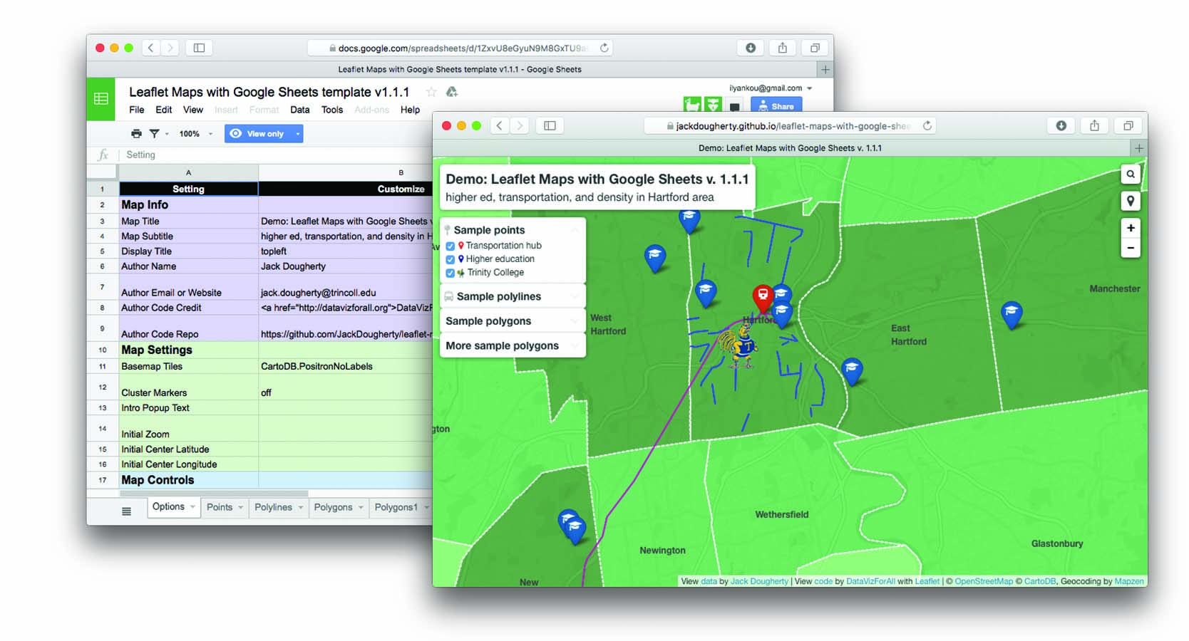

Figure 2: Caption here, and add embedded link to explore the [full-screen interactive map](https://handsondataviz.github.io/leaflet-maps-with-google-sheets/).

### Demo: R code-chunk for GIF animation and static image

TODO: FIX: the custom script 50% width setting works in Chrome, but not FFox, perhaps because it’s not really an iframe?

…as shown in Figure 3.

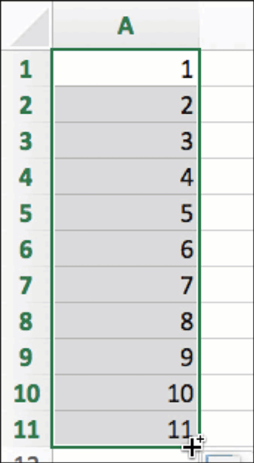

Figure 3: Caption here, with embedded link to [animated GIF](https://handsondataviz.org/images/02-spreadsheet/excel-drag-consec.gif).

### Demo: R code-chunk for Youtube video and static image

Be sure to use the *embed* link from the YouTube *share* button.

…as shown in the video 4.

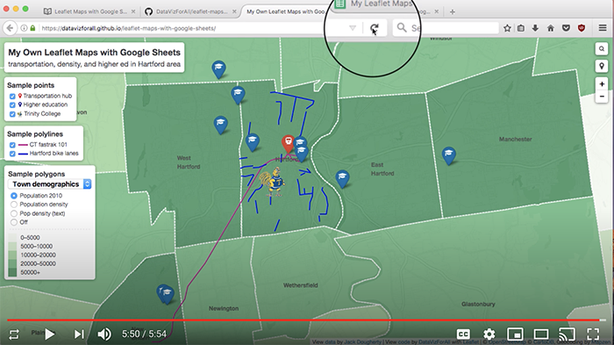

Figure 4: Caption here, with embedded link to the [YouTube video](https://youtu.be/-nGdrzMuUnI).

This Bookdown index.Rmd file includes an R code-chunk setting immediately after the first header, which displays each code-chunk image without a code echo. Read more about this feature and related options in this [Bookdown chapter](https://bookdown.org/yihui/bookdown/figures.html).

{r setup, include=FALSE}  
knitr::opts_chunk$set(echo = FALSE)

## Tables

Create tables in Markdown format, since it produces good output for HTML, PDF, Word, and Markdown. Use a tool such as [Tables Generator](https://www.tablesgenerator.com/markdown_tables) to import significant table data in CSV format, format the column alignment as desired, and press Generate button to create table in Markdown format. For significant table data, save the CSV version in a GitHub repo for potential later use.

Add the Markdown table code shown below to auto-number (Table x) in HTML, PDF, Word.

Table 1: Left-justify content, remember blank Line

|  |  |  |
| --- | --- | --- |
| Much Much Longer Header | Short Header | Short Header |
| Left-justify text content with left-colons | Less | Here |
| Use more hyphens to grant more space to some columns | Less | Here |

Table 2: Right-justify content, remember blank line

|  |  |  |
| --- | --- | --- |
| Header1 | Header2 | Header3 |
| 123 | 456 | 789 |
| Right-justify | numerical content | with right-colons |
| Use equal hyphens | to make equal space | for all columns |

Workaround for Markdown-to-AsciiDoc: Currently, our attempt to use Pandoc to directly convert a Bookdown-generated Markdown file to AsciiDoc fails because Bookdown creates the .md file with tables in .html format, not Markdown. Our workaround is to paste the individual Markdown-formatted tables directly from the .Rmd into the large .md file prior to converting with Pandoc to AsciiDoc.

## Notes and Bibliography

This book displays endnotes for each chapter in the HTML book, and footnotes at the bottom of pages for the PDF and MS Word books, followed by an alphabetized bibliography of all references cited on the last page. The notes and bibliography also appear in the full-book Markdown file.

To create notes, insert citation keys in the text, such as @huffHowLieStatistics1954, which are generated by [Zotero bibliographic database](http://zotero.org) with the [Better BibTex extension](https://retorque.re/zotero-better-bibtex/), and export these in the *Better BibLaTeX* format into the dataviz.bib in the book repo. The repo also contains .csl file to generate the notes and bibliography in a specific Chicago-style format, downloaded from the [Zotero Styles Repository](https://www.zotero.org/styles). These instructions are referenced in the index.Rmd file for both the HTML and PDF formats, as shown in these excerpts:

bibliography: dataviz.bib  
citation-style: chicago-fullnote-bibliography.csl  
...  
output:  
 bookdown::gitbook:  
 ...  
 pandoc_args: [ "--csl", "chicago-fullnote-bibliography.csl" ]  
  
 bookdown::pdf_book:  
 ...  
 citation_package: none  
 pandoc_args: [ "--csl", "chicago-fullnote-bibliography.csl" ]

Here’s a text-only note, with no Zotero citation.[1]

To create a note with citations only, separate Zotero/BibTeX citation keys with semi-colons:[2]

Since notes also may include text and punctuation in Markdown syntax, always insert a caret symbol prior to the brackets to demarcate a note:[3]

Note that the chicago-fullnote-bibliography.csl format automatically shortens the note after it its first reference.

### Pandoc Conversion

* Download [Pandoc](https://pandoc.org)
* TODO: Ask Ilya about my Pandoc PATH and/or overwriting older version
* Set Bookdown to build the book as one large Markdown file (docs folder, suffix .md)
* Use command line to navigate to subfolder with pwd and cd.
* Convert with: pandoc bookdown-template.md --from markdown --to asciidoc --standalone --output bookdown-template-modified.asciidoc
* Confirm if AsciiDoc file matches [O’Reilly Atlas import style](https://docs.atlas.oreilly.com/writing_in_asciidoc.html).

# Supplements

Cupcake ipsum dolor sit amet jelly beans wafer pudding. Bear claw lemon drops carrot cake pie wafer chocolate jelly cheesecake. Chocolate cheesecake chocolate bar sugar plum sweet dessert tart. Tootsie roll bear claw chocolate bar wafer powder sugar plum tiramisu bear claw gummies. Tart macaroon pastry lemon drops candy tootsie roll chocolate candy canes lollipop. Pudding fruitcake bear claw sweet cake cupcake. Chupa chups pudding candy canes chupa chups powder jujubes chocolate cake cotton candy jelly.

## Section Header

Cupcake ipsum dolor sit amet jelly beans wafer pudding. Bear claw lemon drops carrot cake pie wafer chocolate jelly cheesecake. Chocolate cheesecake chocolate bar sugar plum sweet dessert tart. Tootsie roll bear claw chocolate bar wafer powder sugar plum tiramisu bear claw gummies. Tart macaroon pastry lemon drops candy tootsie roll chocolate candy canes lollipop. Pudding fruitcake bear claw sweet cake cupcake. Chupa chups pudding candy canes chupa chups powder jujubes chocolate cake cotton candy jelly.



Figure 5: Caption for sample static image using R code-chunk method.

### A Third-Level Section

Cupcake ipsum dolor sit amet jelly beans wafer pudding. Bear claw lemon drops carrot cake pie wafer chocolate jelly cheesecake. Chocolate cheesecake chocolate bar sugar plum sweet dessert tart. Tootsie roll bear claw chocolate bar wafer powder sugar plum tiramisu bear claw gummies. Tart macaroon pastry lemon drops candy tootsie roll chocolate candy canes lollipop. Pudding fruitcake bear claw sweet cake cupcake. Chupa chups pudding candy canes chupa chups powder jujubes chocolate cake cotton candy jelly.

# References

Huff, Darrell. *How to Lie with Statistics*. W. W. Norton & Company, 1954–2010. <http://books.google.com/books?isbn=0393070875>.

Monmonier, Mark S. *How to Lie with Maps*. 2nd ed. University of Chicago Press, 1996. <http://books.google.com/books?isbn=0226534219>.

1. This is a note, with no bibliographic reference.
2. Darrell Huff, *How to Lie with Statistics* (W. W. Norton & Company, 1954–2010), <http://books.google.com/books?isbn=0393070875>; Mark S. Monmonier, *How to Lie with Maps*, 2nd ed. (University of Chicago Press, 1996), <http://books.google.com/books?isbn=0226534219>
3. Compare how “lying” is justified by Huff, *How to Lie with Statistics*, pp. 10-11 and Monmonier, *How to Lie with Maps*, pp. 11-12.