Bookdown testing

subtitle here

Jack Dougherty

Ilya Ilyankou

2020-05-18

# Preface

This test book was last updated on 18 May 2020

Insert additional preface items below (acknowledgements, etc.) to ensure that the first chapter is properly numbered as chapter one. If subheaders are used, they will appear as separate HTML files, which is fine.

Reminder: Bookdown does not auto-number figures in the index.Rmd file, which serves as a “preface” file.

# Title of Chapter Here

### Goals

The broad goal is to create one efficient workflow for the authors to produce three versions of the book: HTML pages; PDF/MS Word; AsciiDoc.

1. Authors will compose chapters and sections of the book manuscript as individual R-flavored Markdown files, and use Bookdown to build our open-source web edition as a set of static HTML pages, one for each chapter and each section. Readers of the web edition prefer shorter web pages (one per book section) rather than longer ones (one per book chapter).
2. Also, authors will set Bookdown to build the book as one PDF file and also one MS Word file, to allow the editor to easily comment on the manuscript.
3. Also, authors have the option to set Bookdown to build the book as one large Markdown file, and use [Pandoc](https://pandoc.org/try/) to convert it into one large AsciiDoc file, to enable easier importing into the [O’Reilly Atlas platform](https://docs.atlas.oreilly.com/writing_in_asciidoc.html).

### Structure of the book files

We have organized our [book repository](http://github.com/handsondataviz/book) as a set of individual files for each chapter and each section. Chapter files are named 01-topic, 02-topic, etc., and section files are named 01.1-subtopic, 01.2-subtopic, etc. As co-authors, this structure gives us maximum flexibility as we create different pieces of the book, since it allows us to add, remove, and edit different sections of the same chapter at the same time.

Reminder: Our preferred file structure (multiple section files for each chapter) works in Bookdown but produces this warning message, which we ignore: You have 4 Rmd input file(s) but only 3 first-level heading(s). Did you forget first-level headings in certain Rmd files?

* should we keep number_sections: true and use {-} after 3-hashtag headers to avoid numbering those, or set to false and insert all numbers manually?
* keep chapter_name: "Chapter " – or make blank and insert manually?

## Style Guide

Header list (always insert blank line unless directly after hashtag header)

* top-level chapter title (A) = 1 hashtag followed by {#unique-name}
* second-level section title (B) = 2 hashtags followed by {#unique-name}
* third-level header (C) = 3 hashtags followed by {-} to avoid numbering
* fourth-level header (D) = 4 hashtags followed by {-} to avoid numbering

Each paragraph begins on a separate line. O’Reilly style guide prefers *italics* rather than bold. Use single back tics to display a monospaced code word.

Insert an embedded link to [O’Reilly](https://www.oreilly.com/). This appears as a colored clickable link in HTML and Word editions, and a non-colored but clickable link in the PDF edition. According to O’Reilly Atlas documentation, the AsciiDoc version should automatically unfurl for the printed edition.

Insert three back tics to insert a code block. Check character line length limits in [O’Reilly style guide](http://oreillymedia.github.io/production-resources/styleguide/#line-length):

<link rel="stylesheet" href="https://unpkg.com/leaflet@1.6.0/dist/leaflet.css" />  
<script src="https://unpkg.com/leaflet@1.6.0/dist/leaflet.js"></script>

### Cross-references

The cross-reference strategies below require unique names to be assigned to each chapter, section, figure, and table.

* All cross-refs are clickable and auto-numbered (except chapter) in HTML.
* All (except chapter) are clickable and auto-numbered in PDF.
* All are auto-numbered (except chapter) in Word, but none are clickable.
* TBA with AsciiDoc.

Demos:

* To another *chapter* with HTML link: See [chapter 2](chapter2.html).
* To another *section* with Bookdown ID ref: See section 1.1.
* To figure in any chapter/section with Bookdown ID ref: Figure 2, or Figure 3.
* To table in any chapter/section with Bookdown ID ref: Table 1.

Bookdown: If you want to cross-reference figures or tables generated from a code chunk, please make sure the chunk label only contains *alphanumeric* characters (a-z, A-Z, 0-9), slashes (/), or dashes (-).

[O’Reilly Style Guide](http://oreillymedia.github.io/production-resources/styleguide/#considering_electronic_formats): Using live cross references (e.g., “see Figure 2-1”) is best, but when that’s not possible, use “preceding” or “following,” as the physical placement of elements could be different in reflowable formats. *Avoid* using “above” or “below.” See also <http://oreillymedia.github.io/production-resources/styleguide/#cross_references>

### Conditional Formatting

Conditional formatting offers the option to display text or images in some editions, but not other editions.

Demo: Simple HTML code comment in .Rmd file (does *not* appear in MS Word or PDF or AsciiDoc):

The R package function is_[html/latex]_output allows authors to produce conditional output for different book products, such as text that should appear in the HTML edition but not the PDF edition, or vice versa.

Demos:

This line appears in the PDF and Word versions, and is commented-out in the HTML and Markdown and AsciiDoc versions.

This line appears in the HTML, Word, Markdown, and AsciiDoc versions, and is commented-out in the PDF version.

See more complex syntax for conditional formatting at:

* <https://stackoverflow.com/questions/56808355/how-to-conditionally-process-sections-in-rmarkdown>
* <https://bookdown.org/yihui/rmarkdown-cookbook/latex-html.html>
* <https://blog.earo.me/2019/10/26/reduce-frictions-rmd/>
* <https://stackoverflow.com/questions/53861244/html-specific-section-in-bookdown> This hack no longer works, and was only a partial solution
* <https://stackoverflow.com/questions/41084020/add-a-html-block-above-each-chapter-header>
* <https://stackoverflow.com/questions/45360998/code-folding-in-bookdown>

### Images

TODO: Decide pros and cons of two methods, and probably use one method consistently (unless there’s a strong reason for hybrid usage). Note that auto-numbering may be a problem if we display different images for HTML versus O’Reilly products

1. Markdown formatting
   * Simple syntax
   * Converts easily with Pandoc into AsciiDoc format
   * No auto-numbering in HTML or Word editions
   * Auto-numbering in PDF edition
   * TODO: Can this be compatible with R code-chunk conditional formatting to make certain images appear only in HTML edition?
2. R code-chunk formatting:
   * More complex syntax
   * Handles conditional formatting to insert iframe into HMTL edition and static image for Word/PDF editions
   * Image does *not* convert to AsciiDoc format, but caption and static number (Figure x) appears as placeholder.
   * Figures are auto-numbered, but varies by format: Figure x.x in HTML, PDF, but Figure x in Word; static Figure x in AsciiDoc.

#### Markdown demo for static image



Caption in simple Markdown format. No auto-numbered reference in HMTL or Word, but auto-numbered as Figure x.x in PDF. Note that image in PDF edition may “float” and appear before after page, so PDF would need live cross-reference in text.

#### R code-chunk demo for static image



Figure 1: Caption for sample static image using R code-chunk method. Auto-numbered as Figure x.x in HMTL and PDF, but as Figure x in Word. Note that image in PDF edition may “float” and appear before or after page, so needs cross-reference.

#### R code-chunk demo for sample interactive HTML iframe and static image

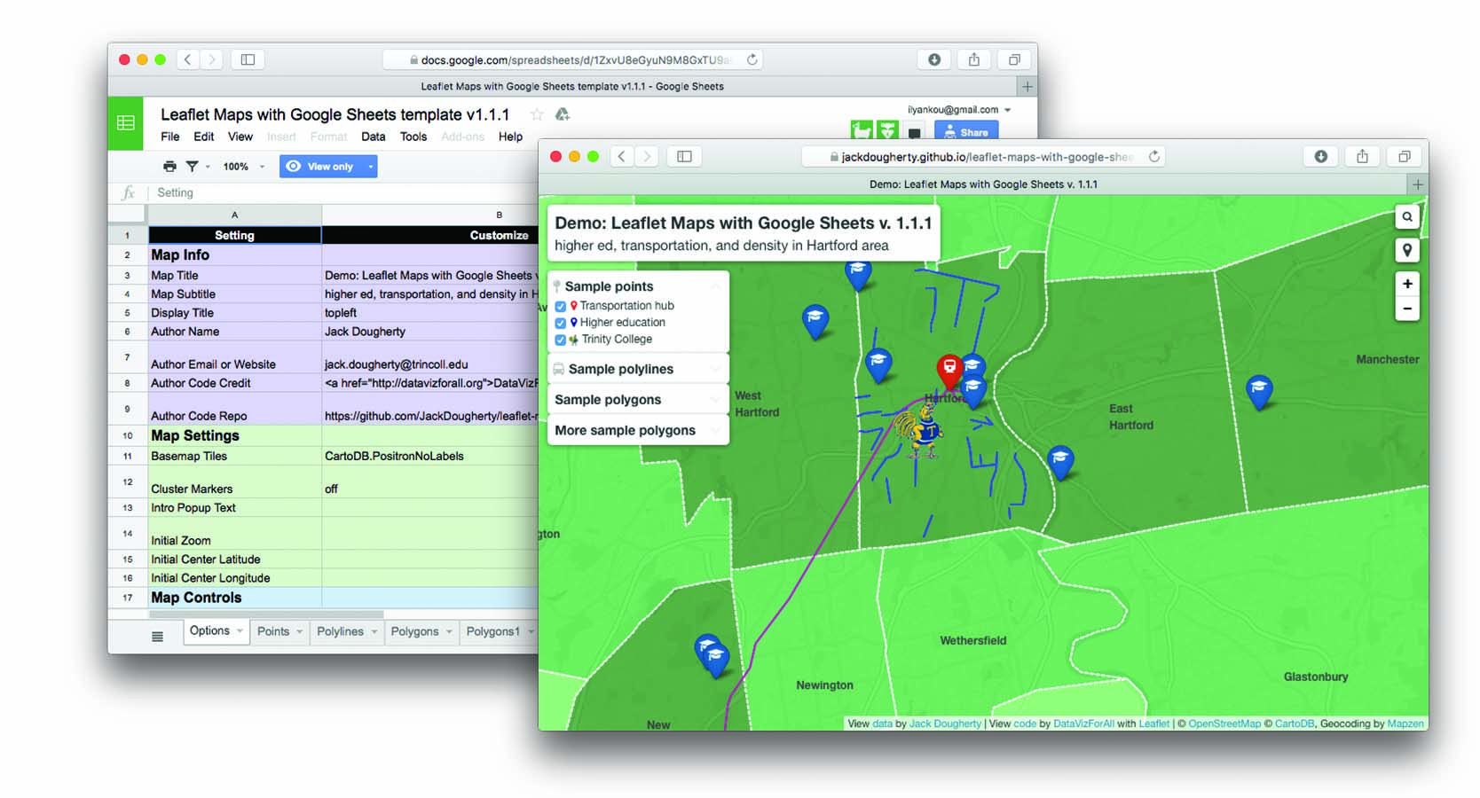

Figure 2: Insert caption here, with embedded link to explore the [full-screen interactive map](https://handsondataviz.github.io/leaflet-maps-with-google-sheets/) Auto-numbered as Figure x.x in HTML and PDF, but as Figure x in Word. Note that image in PDF edition may “float” and appear before or after page, so needs cross-reference.

### Tables

Create tables in Markdown format, since it produces good output for HTML, PDF, Word, and Markdown. Use a tool such as [Tables Generator](https://www.tablesgenerator.com/markdown_tables) to import significant table data in CSV format, format the column alignment as desired, and press Generate button to create table in Markdown format. For significant table data, save the CSV version in a GitHub repo for potential later use.

Add the Markdown table code shown below to auto-number (Table x) in HTML, PDF, Word.

Table 1: Left-justify content, remember blank Line

|  |  |  |
| --- | --- | --- |
| Much Much Longer Header | Short Header | Short Header |
| Left-justify text content with left-colons | Less | Here |
| Use more hyphens to grant more space to some columns | Less | Here |

Table 2: Right-justify content, remember blank line

|  |  |  |
| --- | --- | --- |
| Header1 | Header2 | Header3 |
| 123 | 456 | 789 |
| Right-justify | numerical content | with right-colons |
| Use equal hyphens | to make equal space | for all columns |

Workaround: Currently, our attempt to use Pandoc to directly convert a Bookdown-generated Markdown file to AsciiDoc fails because Bookdown creates the .md file with tables in .html format, not Markdown. One workaround is to paste the individual Markdown-formatted tables directly from the .Rmd into the large .md file prior to converting with Pandoc to AsciiDoc.

### Bibliographic references

TODO: Set up Zotero to use Chicago-style footnotes (check O’Reilly style guide)

### Pandoc Conversion

* Download [Pandoc](https://pandoc.org)
* TODO: Ask Ilya about my Pandoc PATH and/or overwriting older version
* Set Bookdown to build the book as one large Markdown file (docs folder, suffix .md)
* Use command line to navigate to subfolder with pwd and cd.
* Convert with: pandoc bookdown-testing.md --from markdown --to asciidoc --standalone --output bookdown-testing.asciidoc
* Confirm if AsciiDoc file matches [O’Reilly Atlas import style](https://docs.atlas.oreilly.com/writing_in_asciidoc.html).

# Another Chapter Title

More text here

### Another subheader

More text here



Figure 3: Caption for sample static image using R code-chunk method. Auto-numbered as Figure x.x in HMTL and PDF, but as Figure x in Word. CHECK OTHERS. Note that image in PDF edition may “float” and appear before or after page, so needs cross-reference.