**State-Space Tracking Algorithm for Model-Based Control in Matlab/Simulink**

**Benjamin Spivey, Ph.D., 2011**

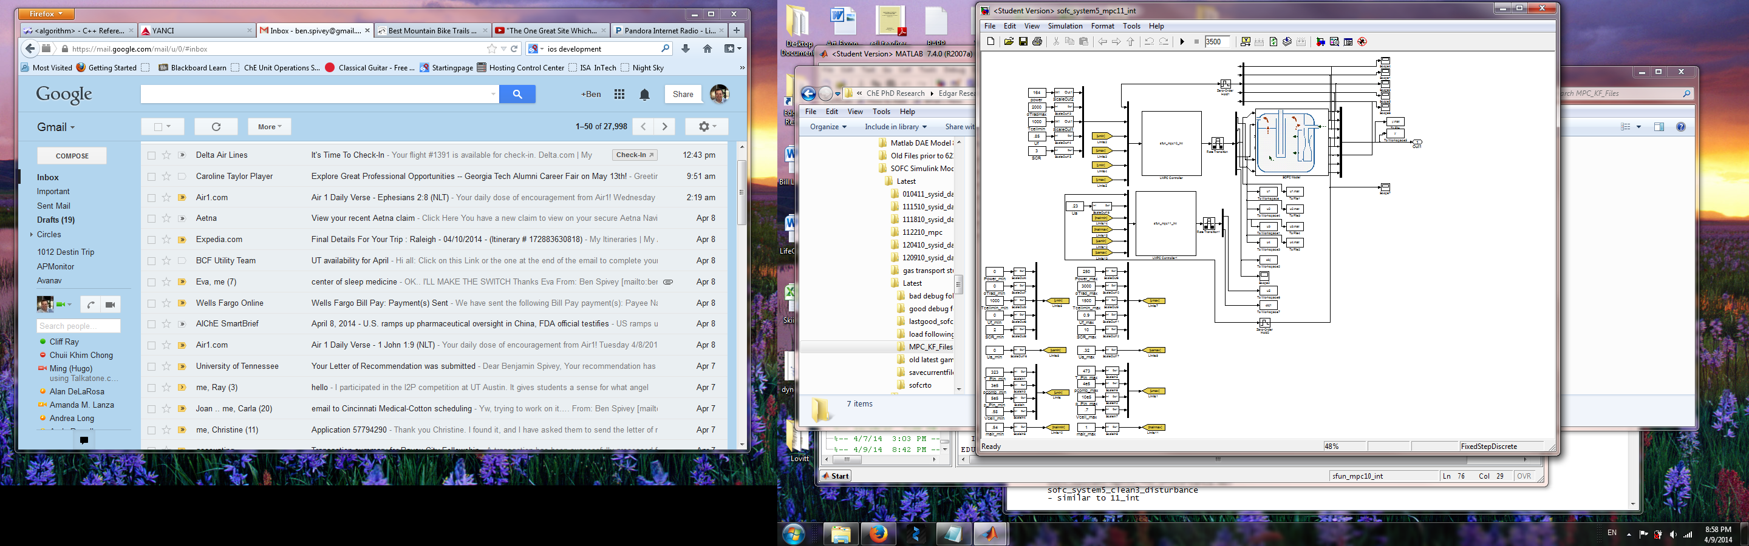

Key features of the State-Space Tracking algorithm:

* Algorithm designed to use a **linear-time-invariant state-space model** derived from transfer function models identified with Matlab System Identification Toolbox.
* Incorporated integral action using an **augmented state-space** model.
* The trajectory-tracking **nonlinear objective function** is designed to minimize output error, suppress control moves, and suppress use of **slack variables** – soft constraints on the output variables.
* Uses **analytical derivatives** of the **objective function** derived using matrix calculus to aid the **nonlinear programming** **solver**.
* Solver is chosen as **fmincon** to handle a nonlinear objective function, whereas quadprog could be used with a quadratic objective.
* Uses the **interior point method** for constraints. Interior point satisfies bounds at all iterations uses a **large-scale algorithm** that stores **sparse matrices** and uses sparse linear algebra.
* Feedback **state estimation** is provided via Kalman Filter.