计算机与信息科学学院 软件学院
课程过程性考核命题记录表
（适用于平时作业等过程性考核）

（ 2023 － 2024 学年第 2 学期）

课程名称 | 操作系统原理 | 任课教师 | 赵恒军
年级/专业 /班级 | 2022级软件工程1-4班 | 考核时间 | 2024.5.27
考核点对应教学内容（如章/节编号、名称） |  | Ch5, ch9, ch12
本次过程性考核内容（如作业题目、题目序号、调研内容）
- Which of the following scheduling algorithms could result in starvation?
a. First-come, first-served
b. Shortest job first
c. Round robin
d. Priority

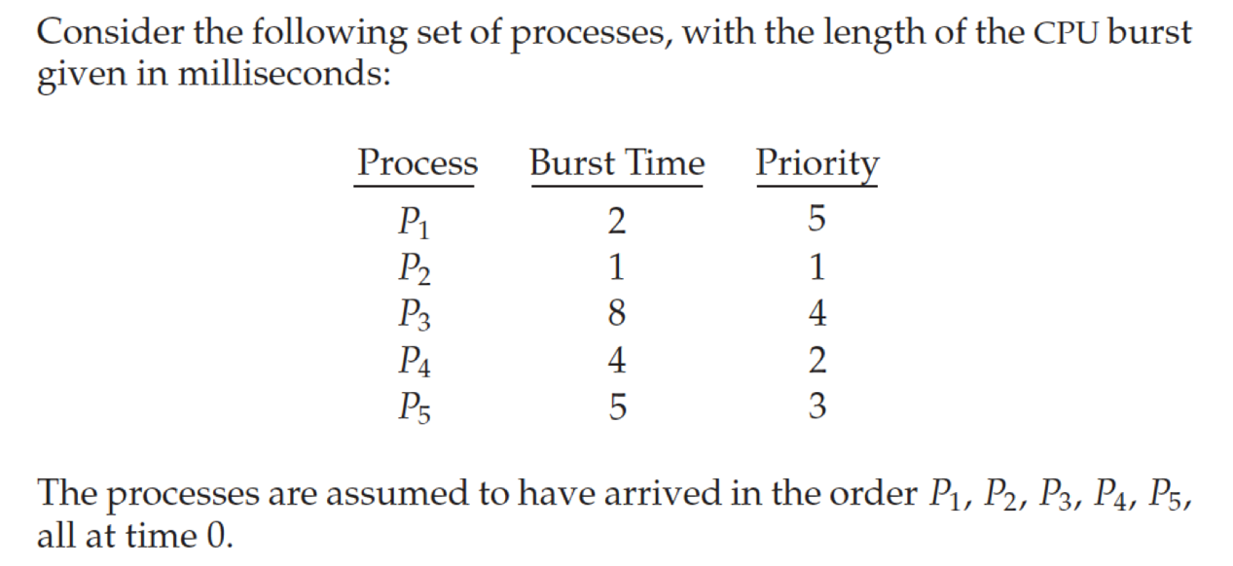
Draw the Gantt charts that illustrate the execution of these processes using the RR algorithm with time slice = 2. What is the waiting time of each process?

Consider the following page reference string:
7, 2, 3, 1, 2, 5, 3, 4, 6, 7, 7, 1, 0, 5, 4, 6, 2, 3, 0, 1.
Assuming demand paging with three frames, how many page faults would occur for the following replacement algorithms?
• LRU replacement
• FIFO replacement
• Optimal replacement

The page table shown in the following figure is for a system with 16-bit virtual and physical addresses and with 4,096-byte pages. The reference bit is set to 1 when the page has been referenced. Periodically, a thread zeroes out all values of the reference bit. A dash for a page frame indicates the page is not in memory. The page-replacement algorithm is localized LRU, and all numbers are provided in decimal.
a. Convert the following virtual addresses (in hexadecimal) to the equivalent physical addresses. You may provide answers in either hexadecimal or decimal. Also set the reference bit for the appropriate entry in the page table.
• 0xE12C
• 0x3A9D
• 0xA9D9
• 0x7001
• 0xACA1
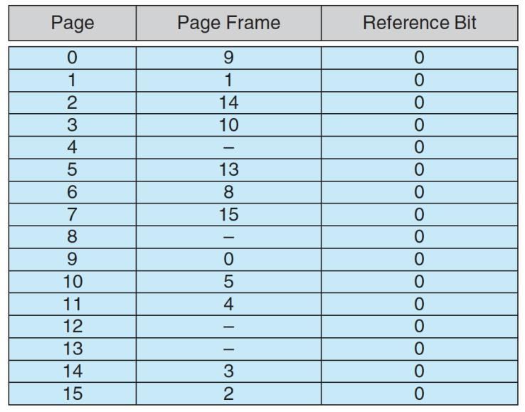
b. Using the above addresses as a guide, provide an example of a logical address (in hexadecimal) that results in a page fault.
c. From what set of page frames will the LRU page-replacement algorithm choose in resolving a page fault?
- Suppose that a disk drive has 5,000 cylinders, numbered 0 to 4,999. The drive is currently serving a request at cylinder 2,150, and the previous request was at cylinder 1,805. The queue of pending requests, in FIFO order, is:
2,069, 1,212, 2,296, 2,800, 544, 1,618, 356, 1,523, 4,965, 3681
Starting from the current head position, what is the total distance (in cylinders) that the disk arm moves to satisfy all the pending requests for each of the following disk-scheduling algorithms?
a. FCFS
b. SSTF
c. SCAN
6. Consider a file system that uses index blocks for space allocation. Disk blocks are 8 KB in size, and a pointer to a disk block requires 4 bytes. This file system has 12 direct disk blocks, as well as single, double, and triple indirect disk blocks. What is the maximum size of a file that can be stored in this file system?

请将答案写在下方：

- b,d

2.
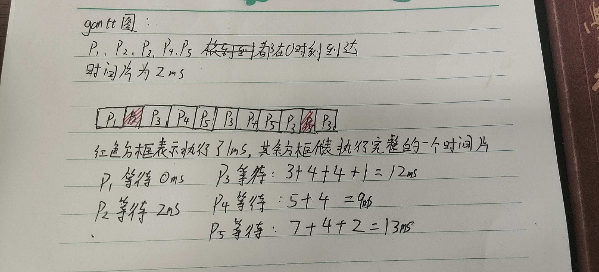

3.
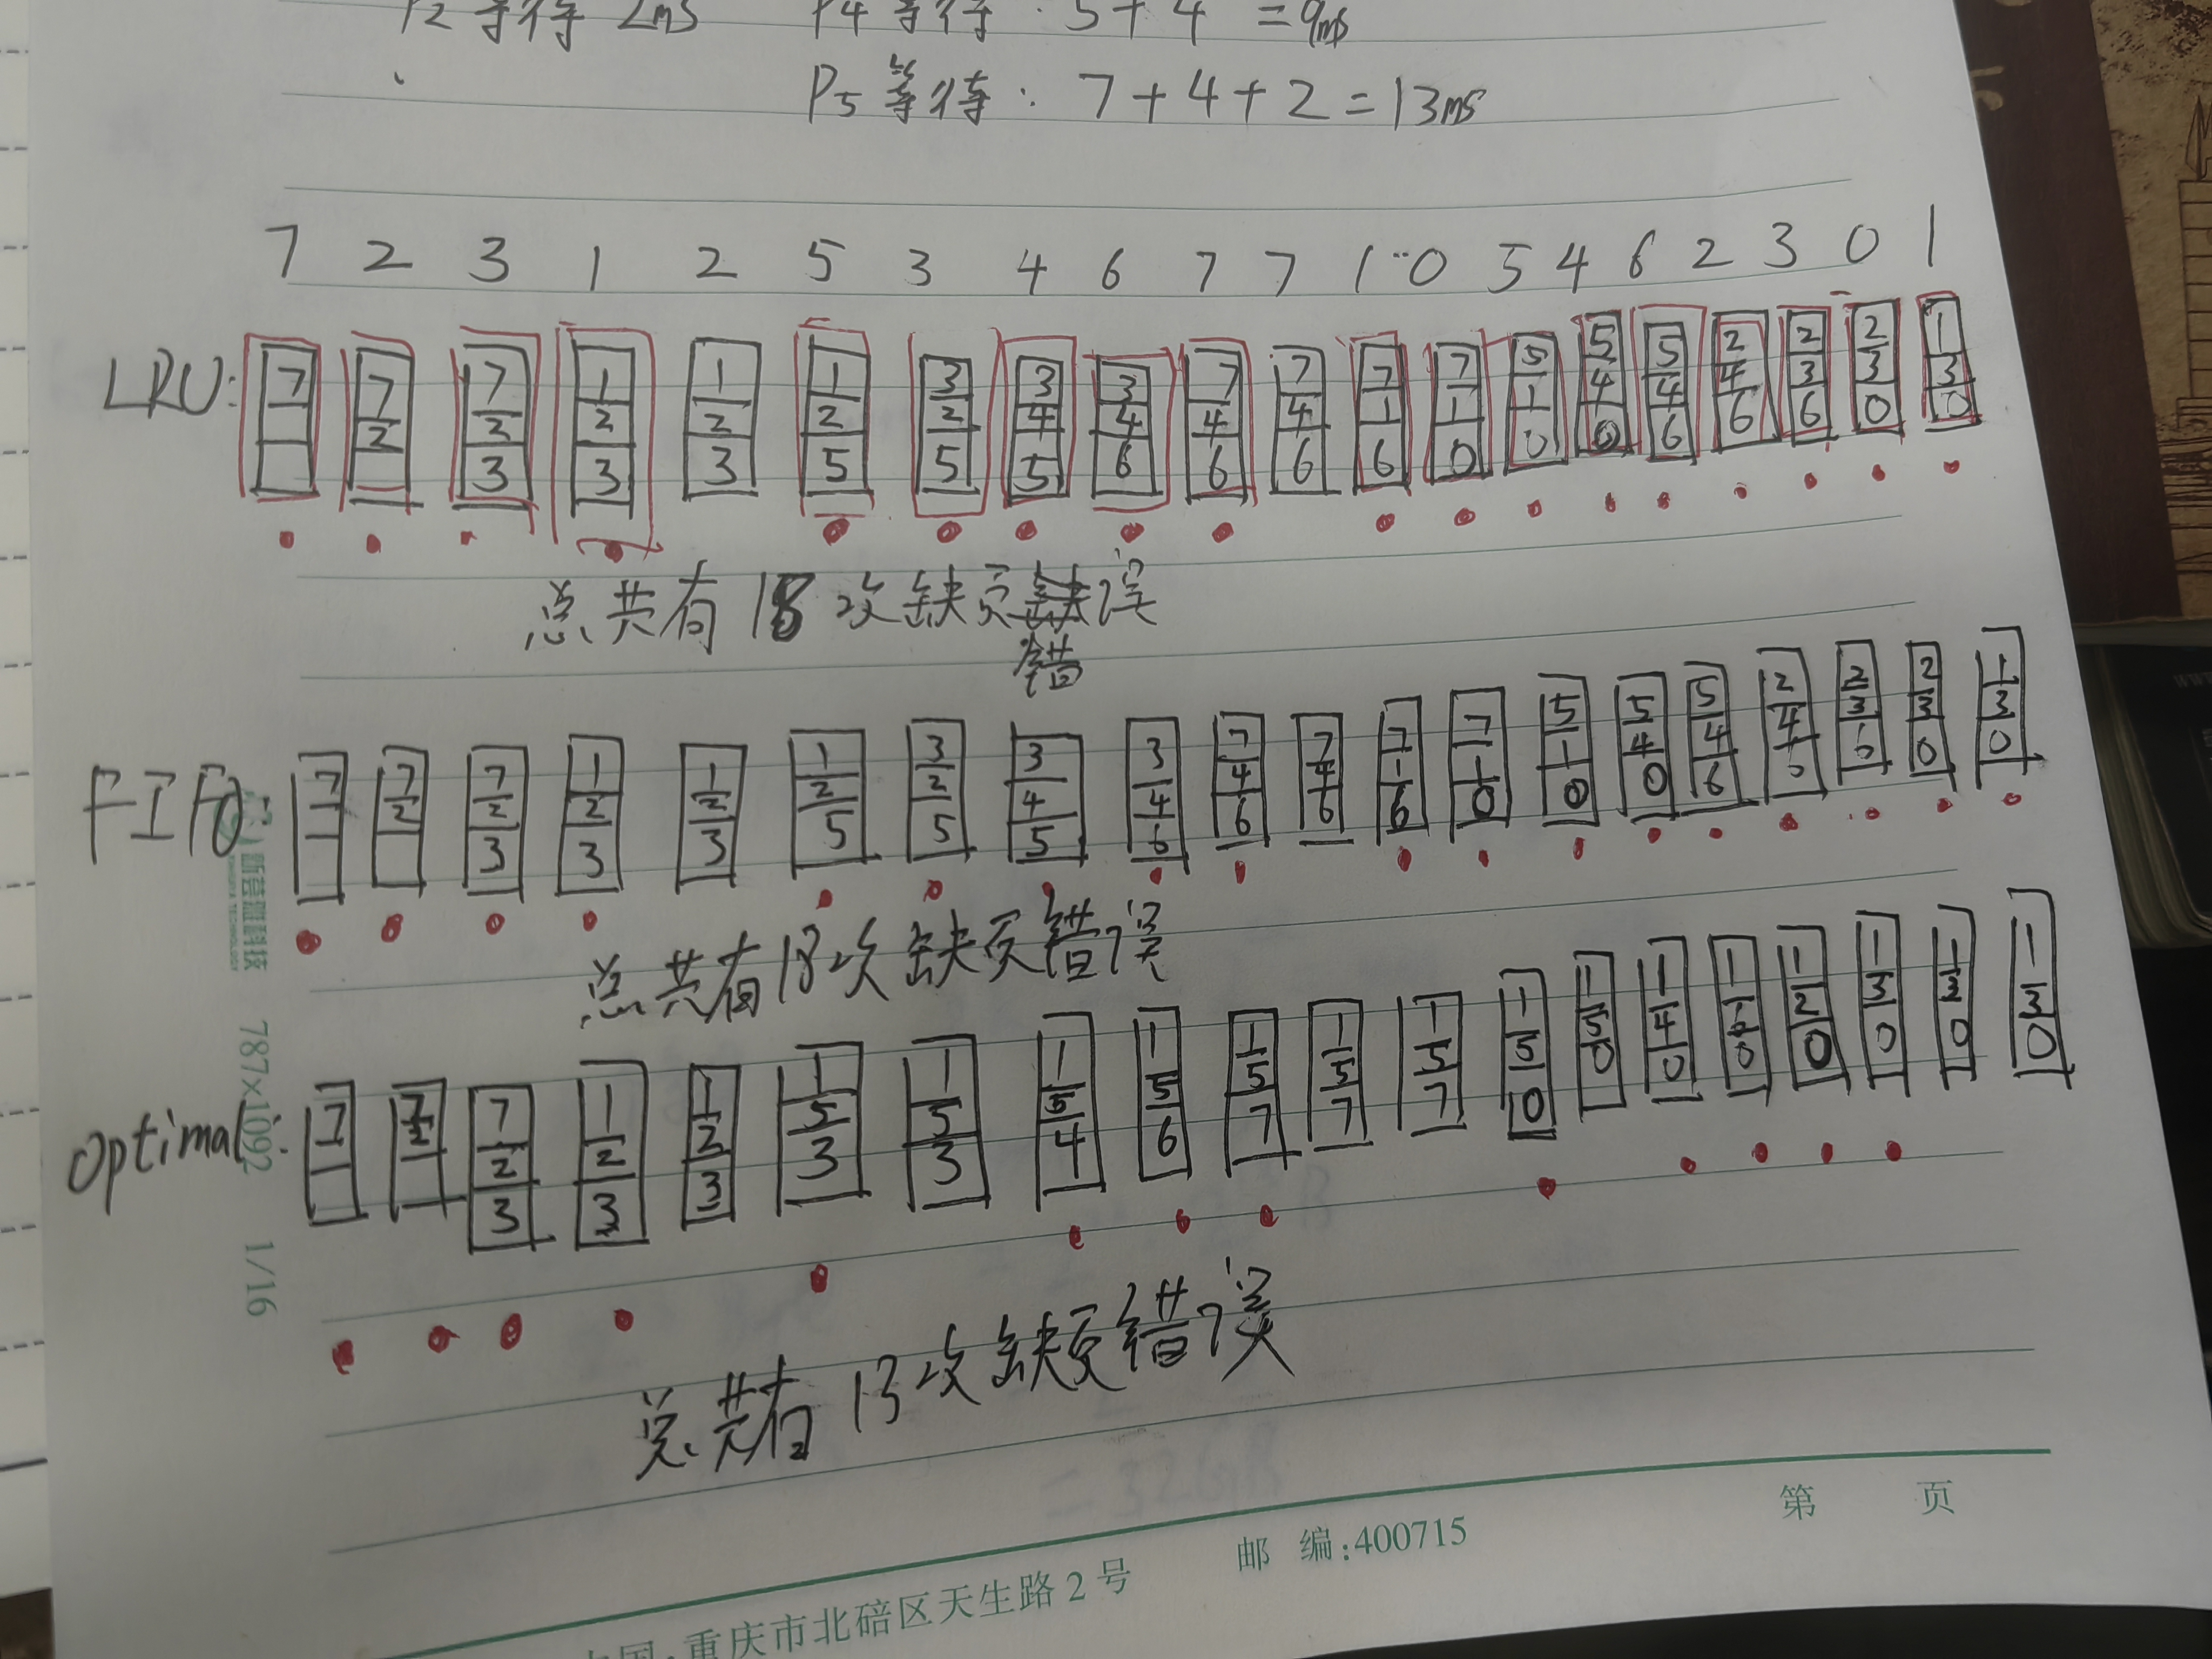
上图第二个FIFO有错，应该是17次缺页错误。
4.
a:
• 0xE12C -> 物理地址：312C（16） page14 的reference bit设置为1
• 0x3A9D -> 物理地址：AA9D(16) page3 的reference bit设置为1
• 0xA9D9 -> 物理地址：59D9(16) page10 的reference bit设置为1
• 0x7001 -> 物理地址：F001(16) page7 的reference bit设置为1
• 0xACA1 -> 物理地址：5CA1(16) page10 的reference bit设置为1
b:0x4A9D
c:
LRU会替换掉最长时间没有使用的页面
在b的例子下，则会把在磁盘上的页面调入到内存中

5.
a:
调度顺序：
- >2069->1212->2296->2800->544->1618->356->1523->4965->3681
81+857+1084+504+2256+1074+1262+1167+3442+1284=13011
b:
调度顺序：
2150->2069->2296->2800->3691->4965->1618->1523->1212->544->356
81+2896+4609=7586
c:
调度顺序(前面的柱面是1805，所以此时磁头向柱面增大的方向移动)：
2150->2296->2800->3681->4965->2069->1618->1523->1212->544->356
4965-2150+4965-356=7424

6.
一个直接块可以存放8KB，一个一级间接块可以存放16MB，一个二级间接块可以存放32GB，一个三级间接块可以存放64TB
整个文件系统有12个直接块，12个一级间接块，12个二级间接块，12个三级间接块
则总共可以存放的最大大小为：825036570720KB≈786816GB≈768.3TB
命题教师
签 字

年 月 日

