Southwest University

“Introduction to Web Development” Experiment Report

School：School of Computer & information Science
Major：Software engineering
Class： Soft Engineering 2
Name: Fu Ruoxuan
Student Number：222019321062060
Experiment Report
1.Objective：
- Learn the usage of iframe elements
- Use iframe and <a> elements to make a self introduction
2.Detailed requirements：
Ex1(Inline framework)：
- Use iframe elements
- Present my self introduction,my hometown and my university in one website
3.Procedure:
Ex1（Inline framework）
1)These codes in order to create a table with borders and titles in a certain size
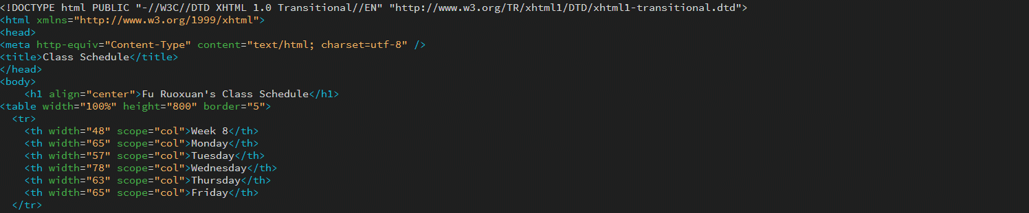
<html xmlns="http://www.w3.org/1999/xhtml">
<head>
<meta http-equiv="Content-Type" content="text/html; charset=utf-8" />
<title>Class Schedule</title>
</head>
<body>
<h1 align="center">Fu Ruoxuan's Class Schedule</h1>
<table width="100%" height="800" border="5">
<tr>
<th width="48" scope="col">Week 8</th>
<th width="65" scope="col">Monday</th>
<th width="57" scope="col">Tuesday</th>
<th width="78" scope="col">Wednesday</th>
<th width="63" scope="col">Thursday</th>
<th width="65" scope="col">Friday</th>
</tr>
2) These codes are used to present the content of the schedule 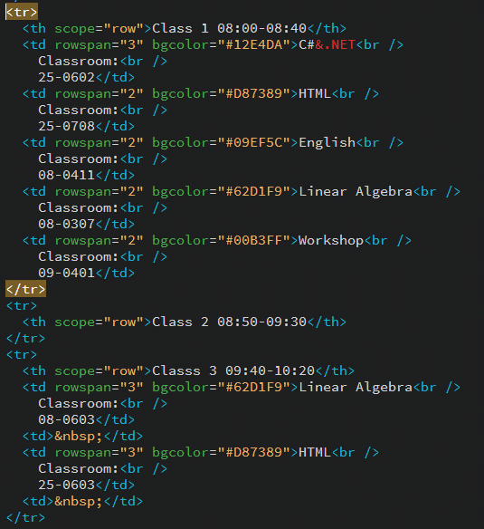
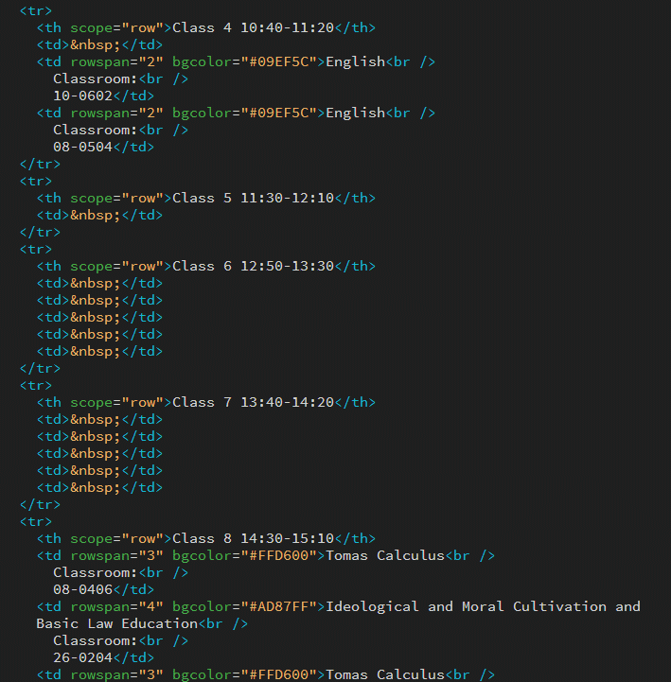
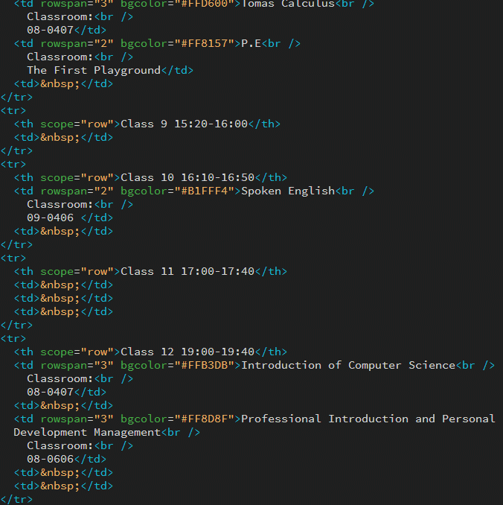

Ex 2（Movie Information）:
1）Use table and <a> elements to create the home page.
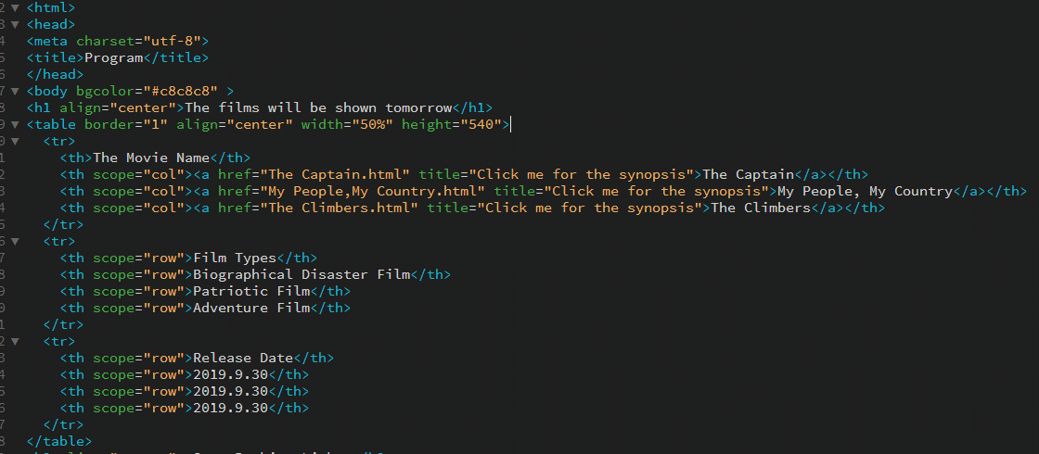
For instance, <table border="1" align="center" width="50%" height="540"> is used to define the style of the table. <a href="The Captain.html" title="Click me for the synopsis"> can create a blank page and then achieve jumping to the introduction page
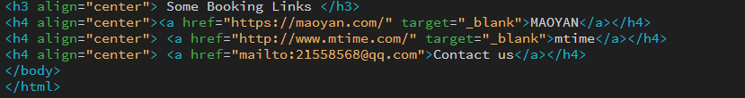
These codes are used to jump to online pages and the outlook.
2)To make the page jump, I make other introduction pages by using <figure> and <a> elements
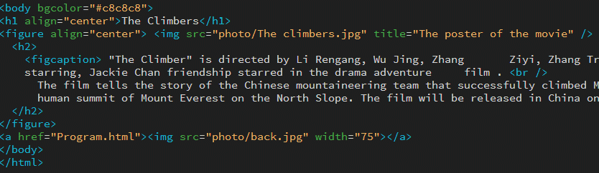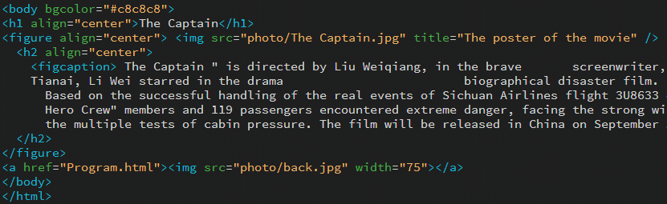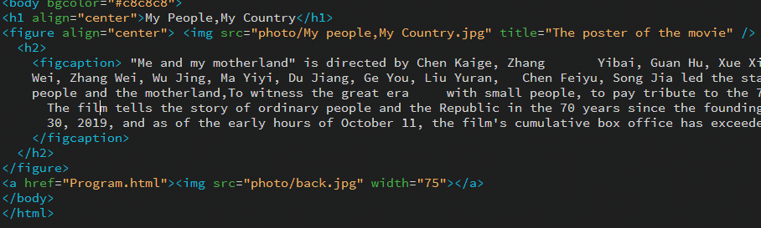
For example，<figure align="center"> <img src="photo/My people,My Country.jpg" title="The poster of the movie" /> is to make the photo
align center. <a href="Program.html"><img src="photo/back.jpg" width="75"></a> gives a way to return to homepage.

Ex 3（Admission Form）：
1）Use some form elements such as <field> <label> <legend> <select> to create loads of type of forms
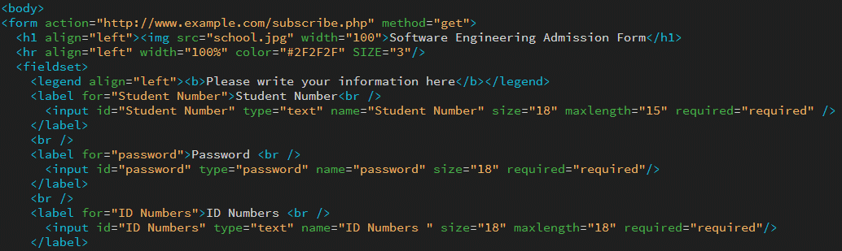
This part aim to allow users to enter data and transfer data to server
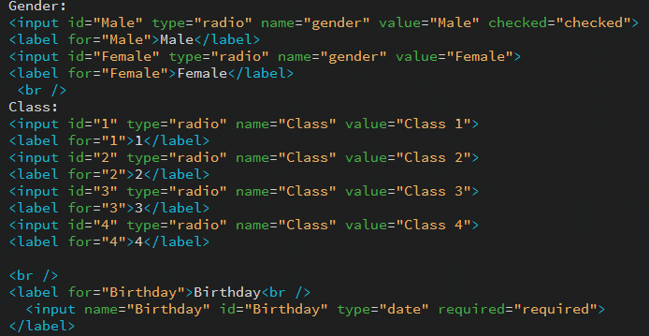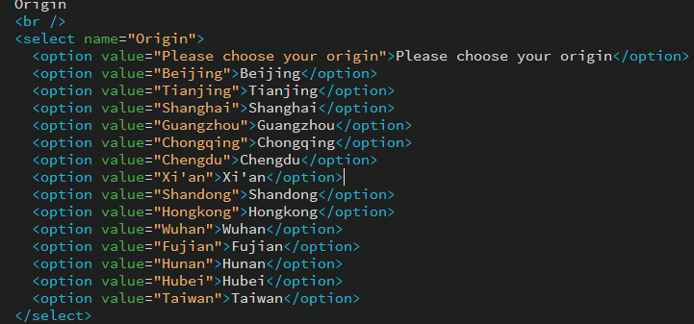
These codes allow users to make a choice.
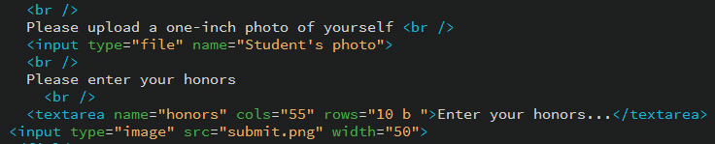
This part give permission to users to submit a photo and type in some
text. Also, create a submit button.
4.Results
Ex 1(Class Schedule)
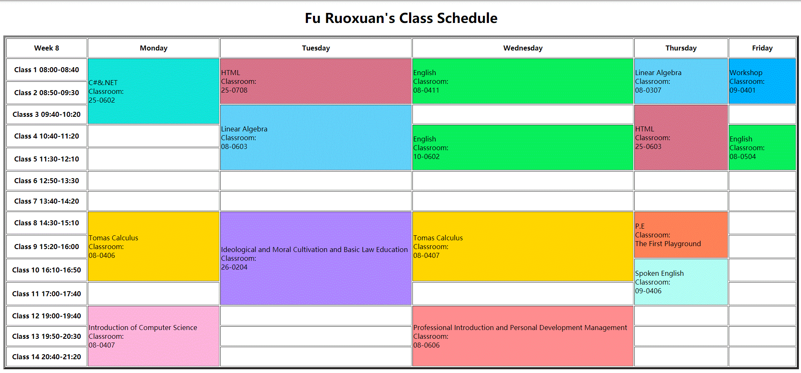Ex 2(Movie Information)
Homepage
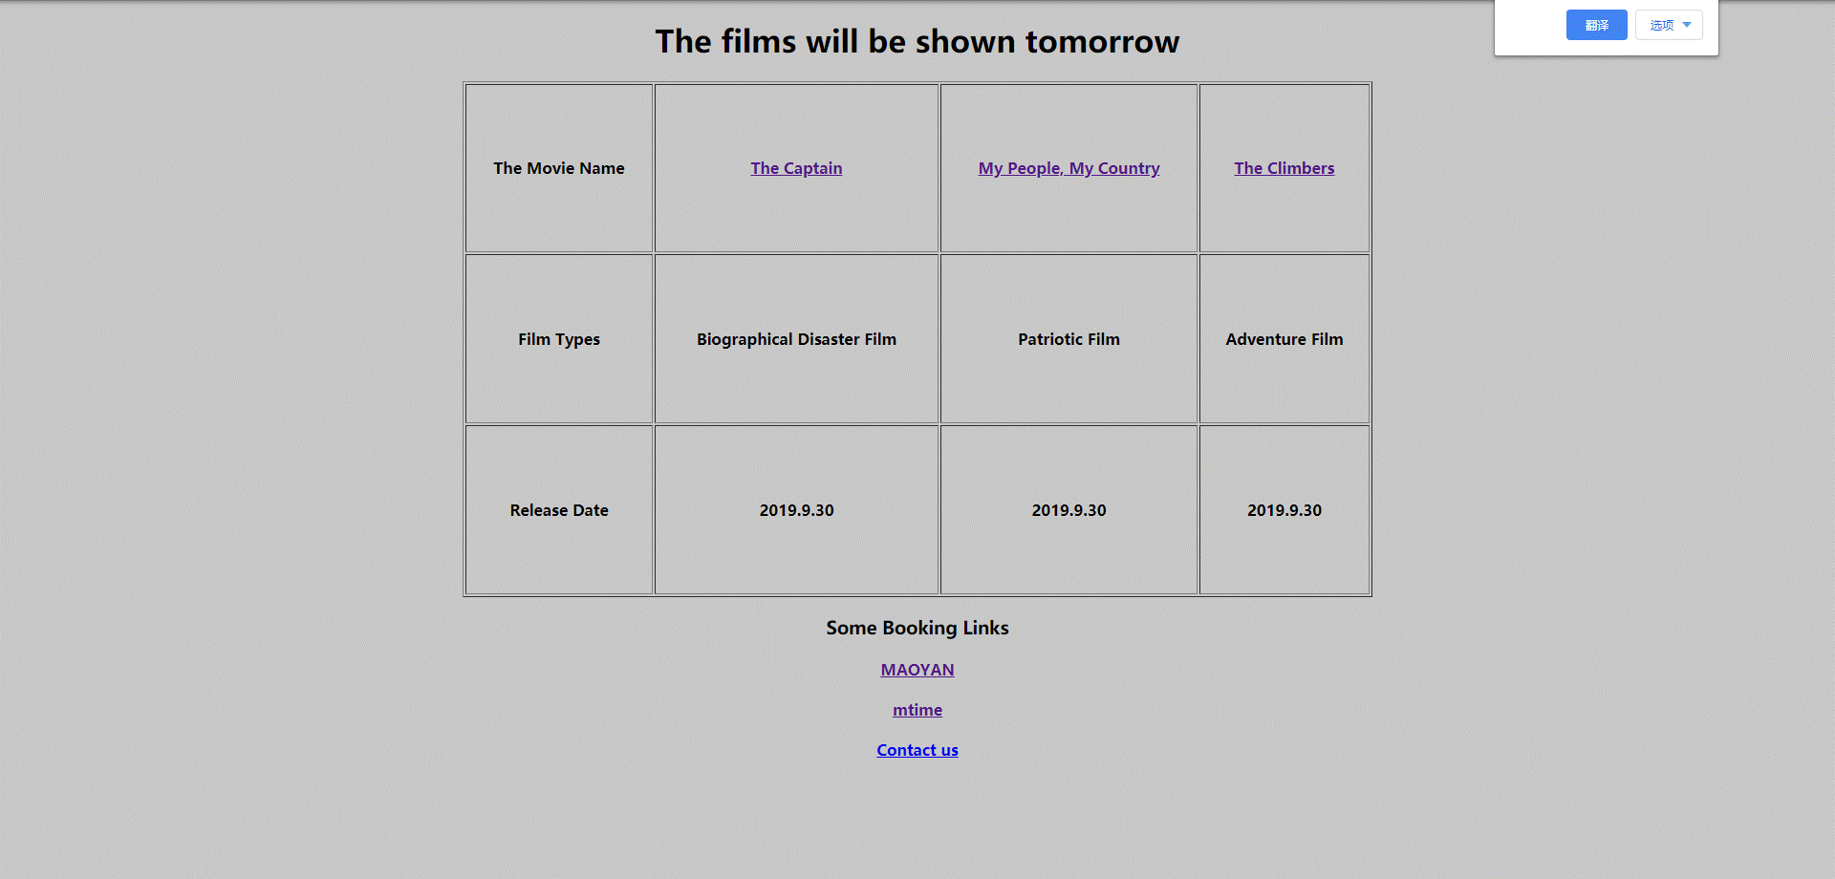

Introduction pages
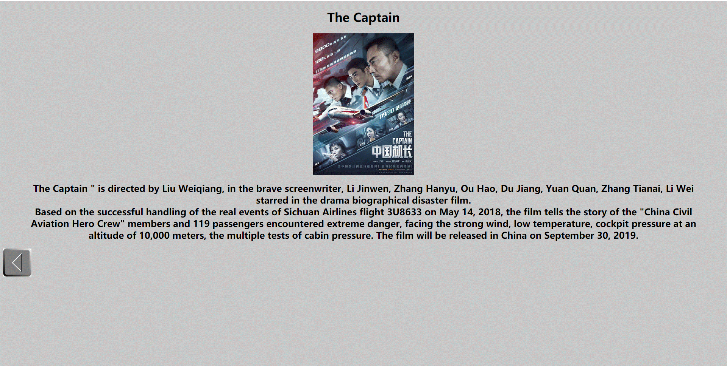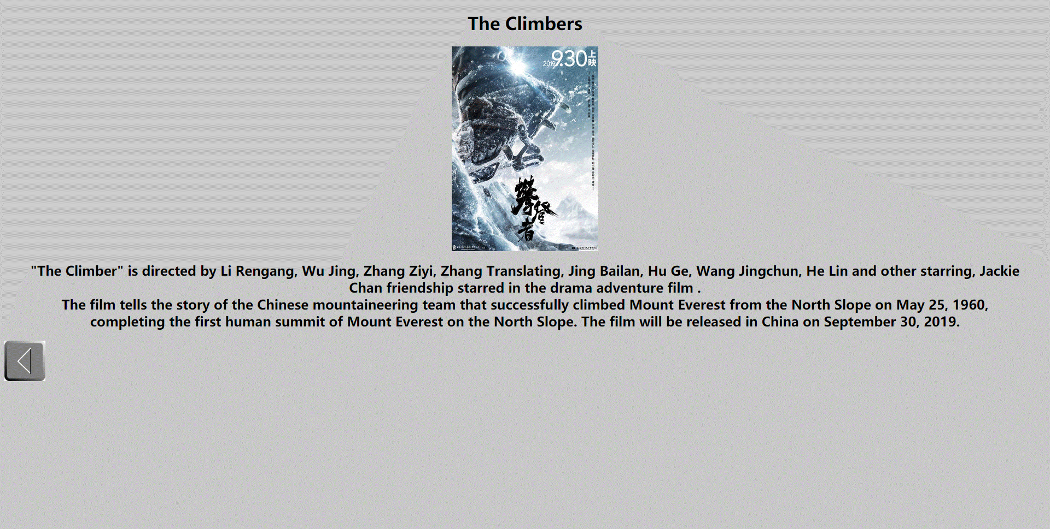

Ex 3(Admission Form)
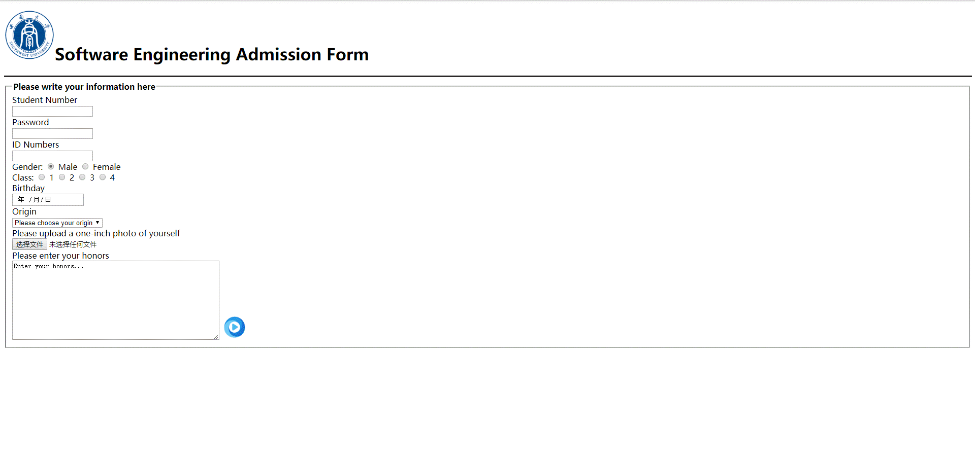
5.Analysis：
Ex 1:
I was inspired by the schedule app. I use the elements to imitate the existing design But the problem is that I can’t make complicated design like fine alignment， rectangular table with rounded corners by using learned knowledge.

Ex 2:
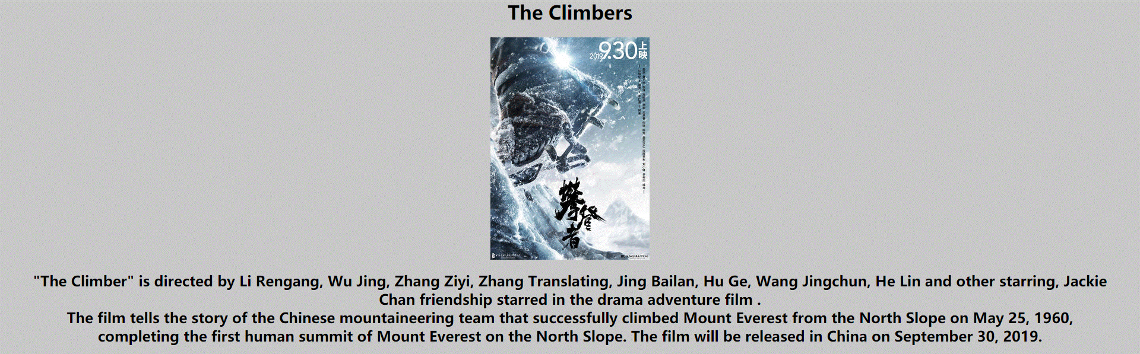
I choose to make 4 pages to achieve page jumps. The page jumps were
successful though I can not control the text. I want it to be place in the middle, but the paragraph design become a mess.
Ex3: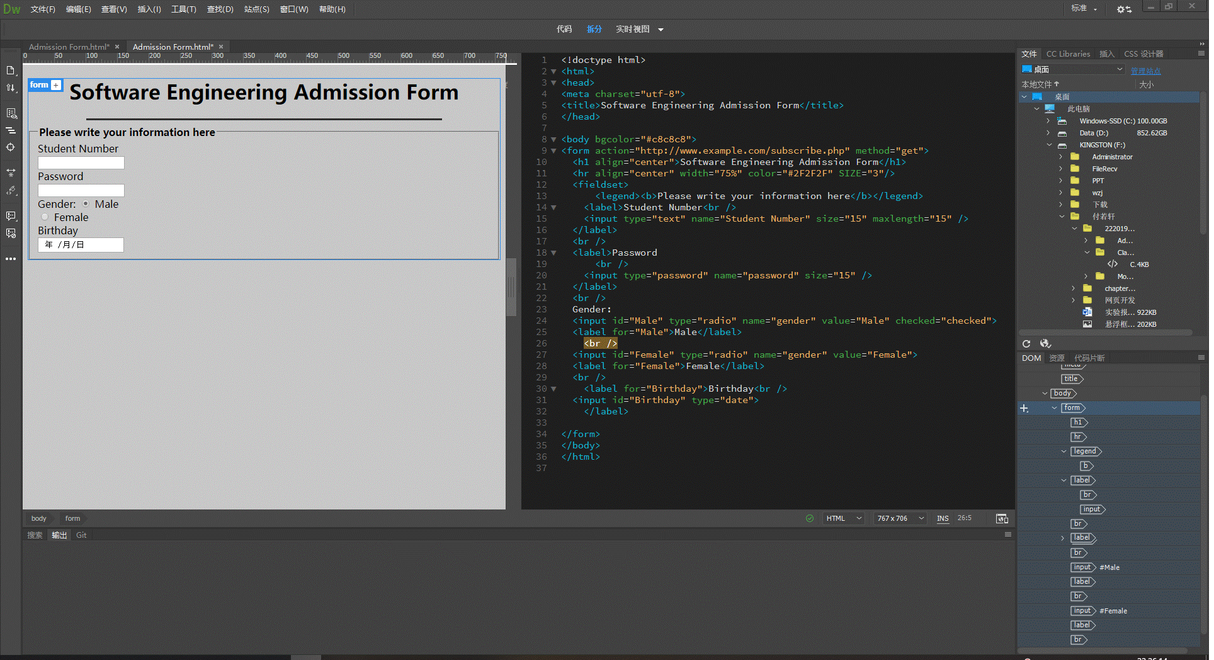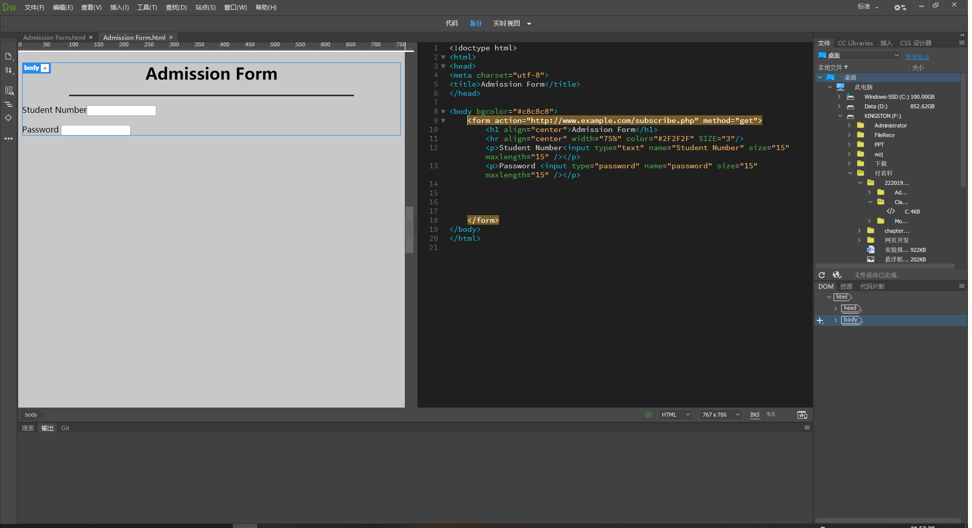
In this exercise, the alignment troubles me. To solve it, I choose to
make contents arranged vertically. Although it is still not perfect, it
looks better than before.
Total:
1. Basically master the use of forms and form elements through experiments
2. Learn how to use forms to design and make curriculum schedule and movie videos and how to use forms and form labels to realize the registration form
3. In the process of the experiment, there are some mistakes in the code writing due to the lack of awareness of the code, which will be overcome by more practice in the future.

