**Brief overview of the project and objectives:**

The project is related to social media platforms, I choose this topic because it’s a trend nowadays.

The objectives is:

Track metrics related to reach, engagement rate.

Summarize sum, average and count for metrics such as likes, comments, shares, and engagement rate to understand how they works.

Track metrics related to follower age, engagement times, and sentiment analysis.

**KPIs:**

Reach: Measure the total number of people who have seen the content (reach)

Engagement Rate: Calculate the percentage of people who engaged with your content (likes, comments, shares) relative to the total number of people who saw it.

Sentiment Analysis: Analyse the sentiment (positive, negative, neutral) of comments and mentions related to your brand to gauge public perception and sentiment trends over time.

Regional Engagement: Assess how engagement metrics vary across different regions. Are certain regions more active or responsive to the content?

**Dataset Collection, transformation and studying of the data contents:**

While I am searching for a good dataset for my project, I thought about something related to reality and has people`s interest, so I used dataset about social media, I collected it from a website called Kaggle,

This data seemed cleaned and doesn’t need much cleaning or transformation, the things I did to it is:

Removing not useful columns which will not help me in my visualization like: Post ID, Campaign ID, Influencer ID, post contents and post timestamp, as well for Time columns

(because there is related column I will use like (date) so I don`t find timestamp column useful to me) also I removed Time column because I have the time period which is categorical datatype which is more useful and understood.

There are missing values in sentiment attribute so I filled them with mixed after searching of the best alternatives.

So, after removing them I started to understand the rest of the columns and what the data say , that’s what I found :

This data is about social media platforms.

This data contains the each platform containing the post type there and the time of posting.

The columns of (likes, comments, share) show the people interactions when see the post in that platform.

The columns (Impressions, Reach, Engagement Rate) These metrics are important summary for assessing the performance and effectiveness of social media platforms and the contents there.

The columns (Audience Age, Audience Gender, Audience Location, Audience Interests, Sentiment )these columns provide valuable insights about audience demographics, preferences, and attitudes, allowing to optimize social media strategy for maximum engagement and impact, Analysing this will help in understanding how the audience interpret (making sense of something based on individual perspective) your content and allows to make adjustments accordingly to improve engagement of audience, and make them satisfy.

**Dashboard Creation:**

I used the power BI app to develop a creative dashboard in order to represent the data visually so the managers can make a decision based on it . 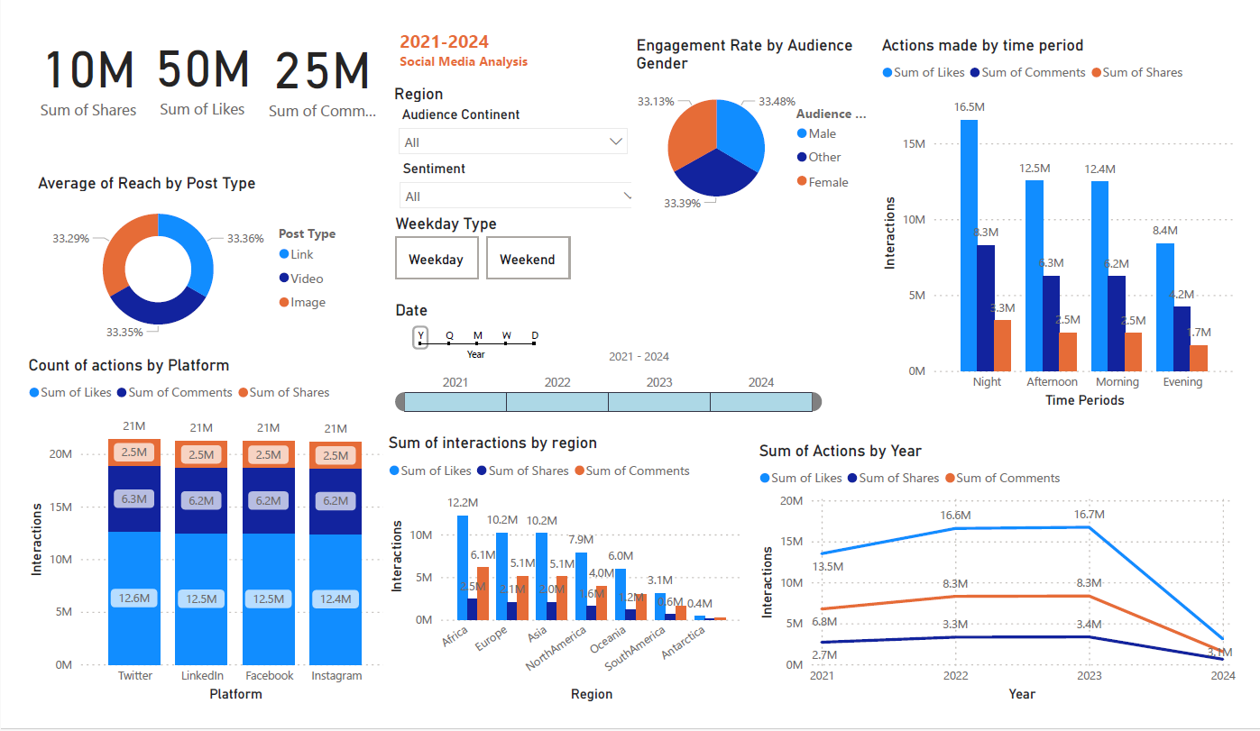

**Insights and Analysis: Key findings, trends, and insights derived from the dashboard visualizations.**

From Dashboard the insights and analysis that provided:

* Donut chart: It seems that the Average of post reach not depends on post type, from the chart, I conclude that whatever the post type the average of post reach is quietly the same.
* Clustered bar chart: Between these Actions (likes comments and shares) it seemed that the likes action has the highest sum comparing of other Actions, so it seems that people like to do likes than other actions, from that we conclude that the share`s action is the lowest one. From this the managers may decide to not based on share action to do marketing to their company or whatever.

Note : there is no relationship between platform type and count of interactions .

* Pie chart: Engagement rate are equal between all genders, which measures the rate of engagement that users do depends on their gender.
* Line chart: The sum of interactions taken go down by year, from that we can conclude that the people tend to be lazier about doing interaction in the post from this that may affect the reach rate or other factors by time. So, they might find a new ways to attract people, by advertising or other key.
* Bar chart: interactions by region showed that Africa has the most sum of interactions compared to other regions. This may arise a question of why this region specifically?
* Slicers helped to summarize the data based on the region, the sentiment, and year.

So if I applied the slicer of the year 2024 comparing to year 2021 we will found that the 2024 has lower overall interactions than 2021.(negative relationship)

From the slicer of the weekday type, it seemed that people in weekday tend to do likes (or other interactions) half in average more than the weekend. Especially at night.

So, from that the manager could decide to not make many posts during weekend because people tend to interact on weekday more.

**Conclusion: Summary of the project outcomes, challenges faced, and lessons learned.**

the project outcomes:

* Engagement Trends: The analysis revealed that there is a decline in the overall interactions (likes, comments, shares) over the years, indicating a potential decrease in audience engagement with social media content. This trend suggests the need for strategies to re-engage the audience and maintain interest over time.
* Preference for Likes: The analysis showed that likes are the most common form of interaction across all post types, while shares have the lowest frequency. This suggests that users are more inclined to engage with content by liking it rather than sharing it. As a result, marketing strategies may focus more on encouraging likes rather than shares.
* Gender-neutral Engagement Rate: The engagement rate was found to be consistent across all genders, indicating that the level of engagement with social media content is similar regardless of gender. This insight suggests that content strategies should be inclusive and appeal to a diverse audience.
* Regional Engagement Differences: The analysis revealed variations in engagement levels across different regions, with Africa showing the highest sum of interactions. This suggests that there may be regional differences in audience behaviour and preferences that should be taken into account when tailoring content and marketing strategies.
* Weekday vs. Weekend Engagement: The analysis showed that people tend to engage more with social media content during weekdays compared to weekends, particularly during the night. This insight can inform decisions about the timing of content posting and marketing campaigns to maximize engagement.
* The social media is a huge aspect to discuss needs a huge amount of data to make a conclusion about something why happens, or might be happen
* Analysing the data by powerBI helped in visualize the roughed rows and columns to something understood and clear
* The decision making by managers will be easier with this visualization.

Challenging faced:

* One of the primary challenges is ensuring the quality and reliability of the data.
* Analysing social media data involves dealing with large volumes of data, complex relationships between variables, and diverse types of analysis techniques.
* Challenge in deal with relationships between attributes.
* Tried to make correlation using excel first to find a relationship between variables.
* You have to define clear objectives and selecting relevant key metrics, so you can create a social media report dashboard that provides actionable insights and helps guide the social media strategy towards achieving the business goals.

Thank You...!