LUMINUS TECHNICAL UNIVERSITY COLLEGE
Department of ASAC | Applied Analytical Models

NovaMart Customer Retention
and Campaign Optimization
Final Course Project Report

Item | Details
Course code | 30772343
Project type | Individual applied analytical modelling project
Submission period | September 2026
Repository | github.com/HaneenDahbour/novamart-customer-retention

End-to-end analytical workflow: data quality -> descriptive analytics -> predictive modelling -> model improvement -> customer scoring -> retention optimization

Executive Summary
NovaMart is a Jordanian retailer operating through physical stores and an online platform. The project analyzes historical customer behaviour, develops a churn model, scores current customers, and converts predicted churn risk into a retention campaign constrained by business economics.
After cleaning, the historical dataset contained 1,200 unique customers. The overall historical churn rate was 20.83%. Exploratory analysis found the strongest practical churn signals around purchase recency, complaints, support demand, lower satisfaction, weaker email engagement, and lack of prior campaign response.
Key result | Value | Business meaning
Final model | Class-weighted Logistic Regression | Higher churn recall with stable generalization
Held-out ROC-AUC | 0.7822 | Good ranking of higher-risk vs lower-risk customers
Held-out recall | 68.0% | Detected 34 of 50 churners in the test set
Current customers scored | 300 | Full current customer base evaluated
Predicted to churn | 105 (35.0%) | Risk flagged using required 0.50 threshold
Recommended campaign | Top 50 eligible customers | Highest expected net benefit under the supplied assumptions
Expected campaign net benefit | JD 7,609.35 | Model-based expected value, not a guaranteed outcome

Important limitation. The final weighted logistic model overestimates absolute churn probabilities on the held-out test set (mean predicted probability 43.87% vs observed churn 20.83%). Calibration improved probability reliability but reduced recall sharply at the assignment-mandated 0.50 threshold. Therefore financial outputs should be interpreted as model-based expected values under the supplied campaign assumptions.

1. Business Problem and Objectives
NovaMart management observed that some customers stop purchasing without warning. The analytical objective was to answer four business questions:
- What happened in the historical customer data?
- Which customer characteristics and behaviours are associated with churn?
- Which current customers are most likely to churn?
- How should NovaMart allocate a limited retention budget?

2. Data Understanding
Dataset | Raw rows | Clean rows | Columns | Purpose
Historical customers | 1,215 | 1,200 | 20 | Develop, validate and improve the churn model
Current customers | 300 | 300 | 19 | Score current customers and design the retention campaign
Each record represents one customer. Customer_ID is an identifier and was excluded from modelling. Churn is the binary target in the historical file; the other 18 shared variables are candidate predictors.
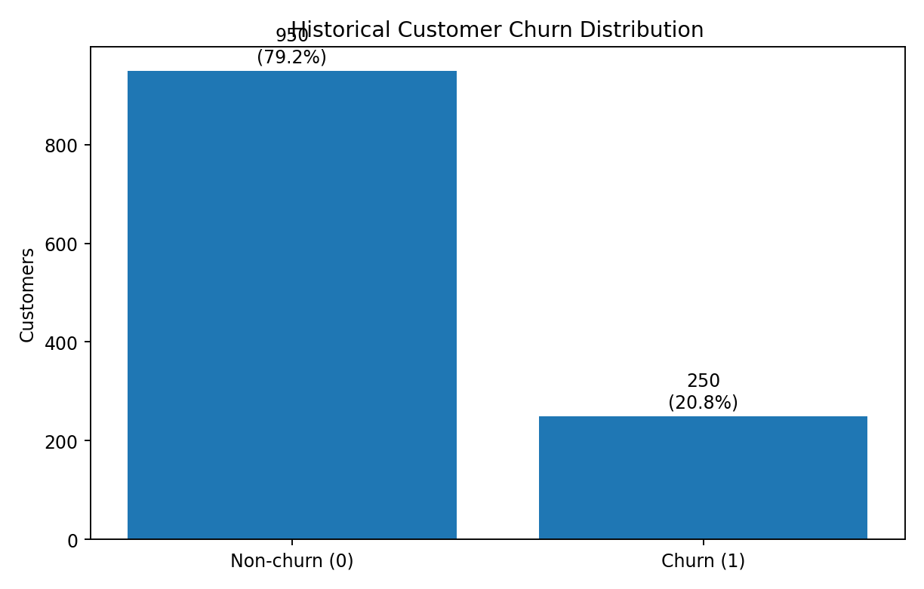
Figure 1. Historical churn distribution after data preparation: 950 non-churn customers and 250 churn customers.

2.1 Attribute Classification
Attribute | Role | Analytical type | Measurement type
Customer_ID | Identifier | Qualitative | Nominal
Age | Predictor | Quantitative | Ratio
Gender | Predictor | Qualitative | Nominal
Region | Predictor | Qualitative | Nominal
Membership_Level | Predictor | Qualitative | Ordinal
Tenure_Months | Predictor | Quantitative | Ratio / integer
Monthly_Income_JD | Predictor | Quantitative | Ratio
Monthly_Spend_JD | Predictor | Quantitative | Ratio
Total_Orders | Predictor | Quantitative | Ratio / integer
Average_Order_Value_JD | Predictor | Quantitative | Ratio
Days_Since_Last_Purchase | Predictor | Quantitative | Ratio / integer
Website_Visits_Last_30_Days | Predictor | Quantitative | Ratio / integer
Email_Engagement_Rate | Predictor | Quantitative | Ratio
Discount_Usage_Rate | Predictor | Quantitative | Ratio
Satisfaction_Score | Predictor | Qualitative | Ordinal
Support_Tickets_Last_6_Months | Predictor | Quantitative | Ratio / integer
Complaint_Flag | Predictor | Qualitative | Binary
Last_Campaign_Response | Predictor | Qualitative | Binary
Payment_Method | Predictor | Qualitative | Nominal
Churn | Target | Qualitative | Binary
The analytical classification is distinct from pandas storage type. For example, binary flags may be stored as integers but are treated as qualitative binary variables in interpretation.

3. Data Preparation and Quality
Data quality was assessed across completeness, uniqueness, consistency, validity, accuracy where assessable, and timeliness where applicable. The source files intentionally contained quality issues.
Issue | Historical | Current | Treatment
Missing Age | 26 | 6 | Historical median = 44
Missing Region | 17 | 4 | Historical mode = Amman
Missing Monthly_Income_JD | 22 | 4 | Historical median after invalid handling
Missing Monthly_Spend_JD | 21 | 5 | Historical median after invalid handling
Missing Email_Engagement_Rate | 26 | 6 | Historical median = 0.4165
Missing Satisfaction_Score | 20 | 5 | Historical median = 4
Exact duplicate rows | 15 | 0 | Removed from historical data
Noncanonical category labels | 70 total across 4 fields | 20 total | Standardized case / whitespace
Invalid ages | 3 | 3 | Converted to missing, then imputed
Negative income / spend | 3 | 3 | Converted to missing, then imputed
Invalid satisfaction scores | 2 | 2 | Outside 1-5; converted to missing

3.1 Outlier Decision
Statistical outliers in income, spending, website visits and support tickets were retained because they were unusual but still plausible. For example, a high-value customer may legitimately spend more than the IQR fence, and repeated support tickets may represent a genuine churn signal. The final decision therefore distinguished invalid values from legitimate extreme observations rather than automatically capping them.
Final prepared datasets contained zero missing values, zero exact duplicate rows, zero duplicate customer IDs, canonical categories, and compatible predictor schemas. Timeliness could not be independently verified because the files contain no extraction timestamp.

4. Descriptive Analytics and Exploratory Data Analysis
Historical analysis combined measures of central tendency and dispersion, group comparisons, churn-rate aggregation, and visual analysis. The overall churn rate was 20.83%.
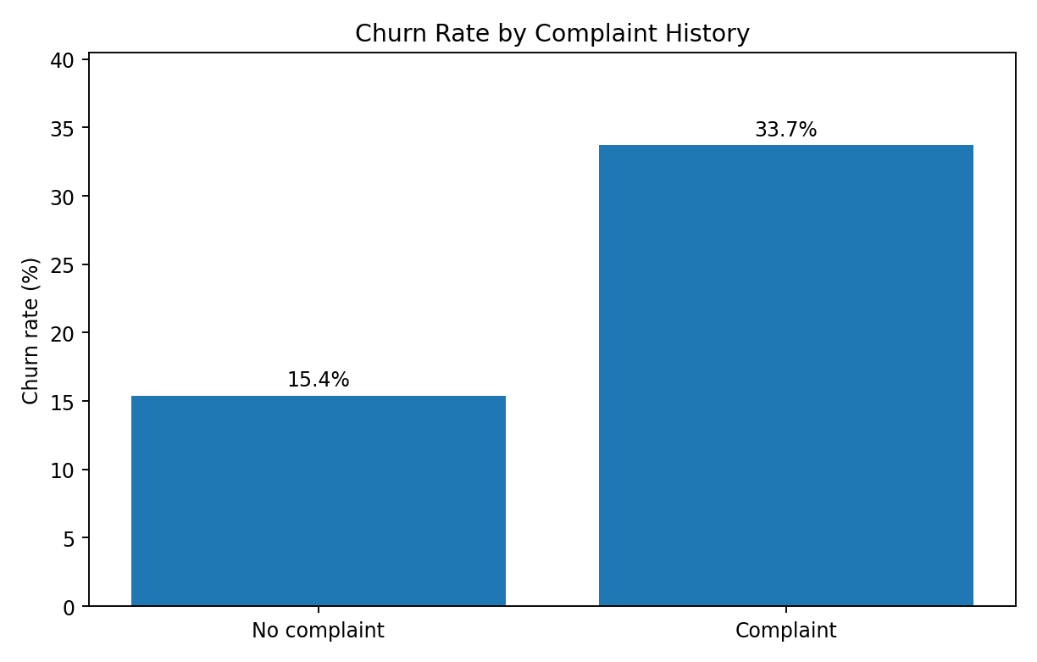
Figure 2. Customers with complaints showed more than double the historical churn rate of customers without complaints.
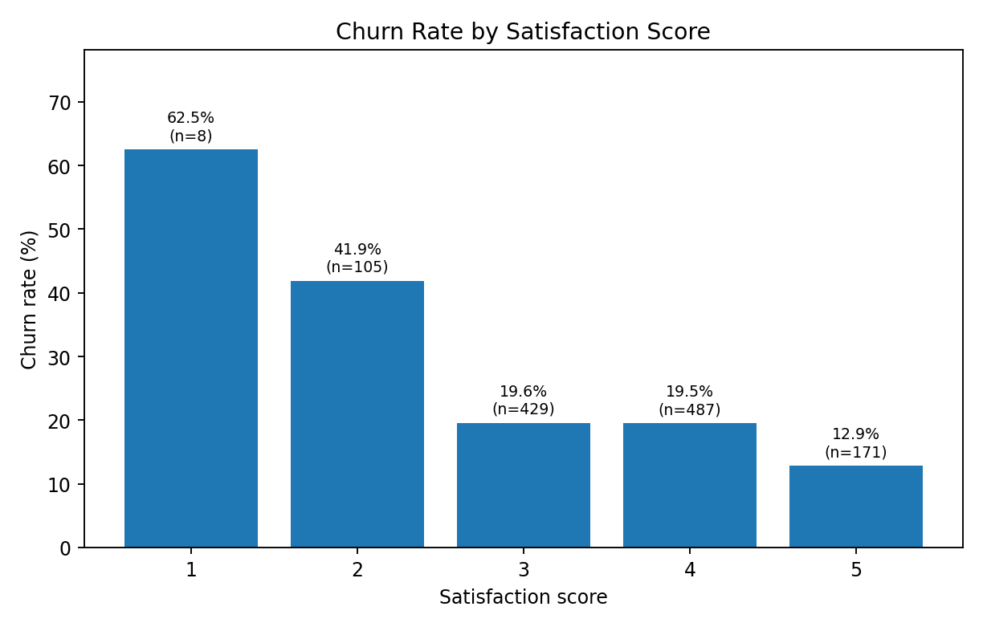
Figure 3. Lower satisfaction is associated with higher churn. Score 1 has only eight customers and should be interpreted cautiously.

4.1 Key Business Findings
- Complaint history: customers with Complaint_Flag=1 had 33.71% churn, compared with 15.40% without complaints.
- Campaign response: previous non-responders had 24.03% churn, compared with 15.97% among responders.
- Membership: Basic members had 24.20% churn, compared with 13.53% among Platinum members.
- Purchase recency: the highest-recency quartile had 37.67% churn, compared with 13.67% in the most recent-purchase quartile.
- Average purchase recency was 66.61 days for churned customers versus 36.28 days for non-churned customers.
- Email engagement: the lowest engagement quartile had 28.67% churn, compared with 17.33% in the highest quartile.
- Satisfaction: customers scoring 2 had 41.90% churn, compared with 12.87% for customers scoring 5.
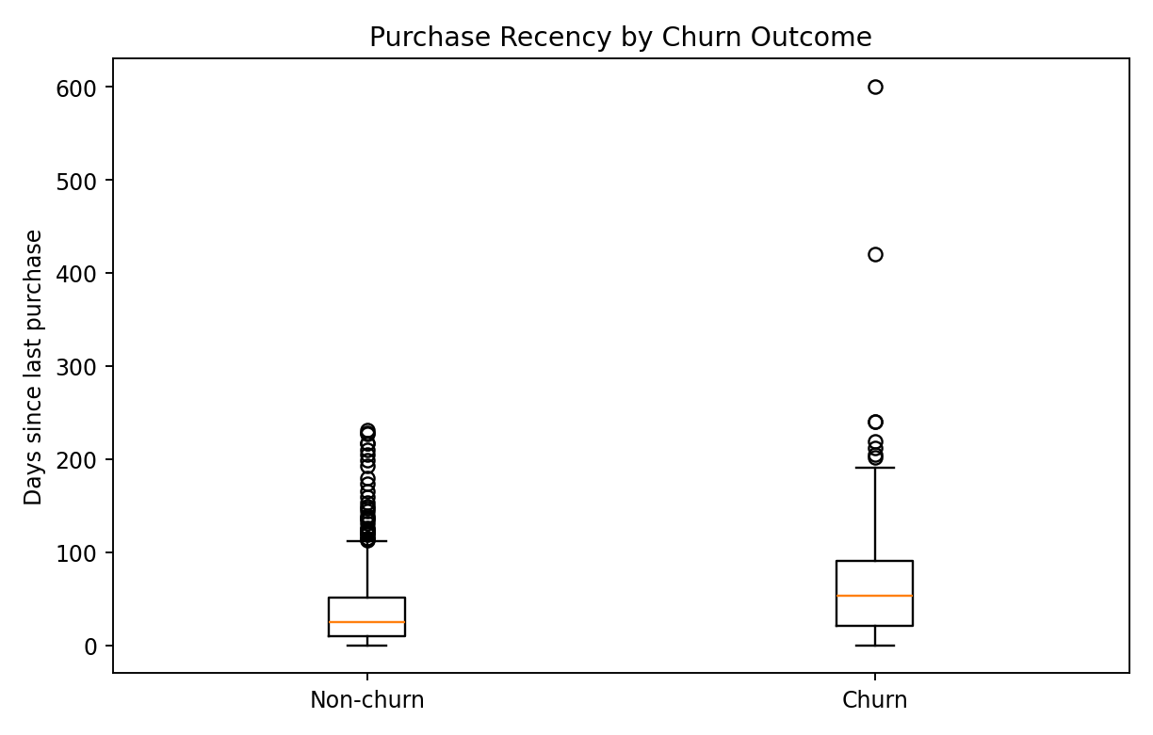
Figure 4. Churned customers typically had longer periods since their most recent purchase.

4.2 Relationships and Correlation
Variable | Correlation with Churn | Interpretation
Days_Since_Last_Purchase | +0.2688 | Positive association with churn
Support_Tickets_Last_6_Months | +0.2191 | Higher support demand associated with churn
Complaint_Flag | +0.2059 | Complaint history associated with churn
Satisfaction_Score | -0.1489 | Higher satisfaction associated with lower churn
Last_Campaign_Response | -0.0972 | Prior response associated with lower churn
Email_Engagement_Rate | -0.0862 | Higher engagement modestly associated with lower churn
Correlation indicates statistical association and does not by itself establish causation. The historical data is observational, so these relationships should be treated as signals for targeting and further investigation rather than causal effects.
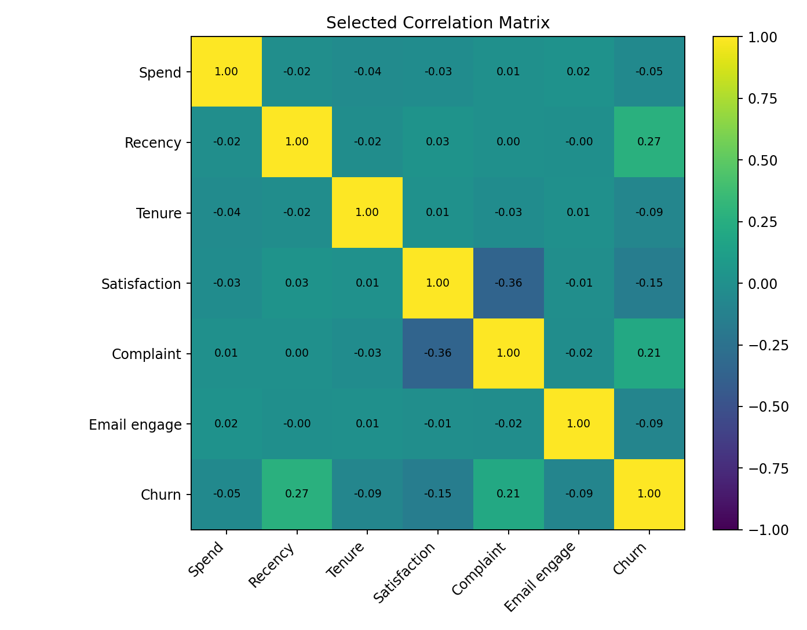
Figure 5. Selected correlation matrix for important behavioural and churn variables.

5. Predictive Model Development and Validation
The cleaned historical data was split into 960 training rows and 240 held-out test rows using an 80/20 stratified split (random_state=42). Both partitions retained a 20.83% churn rate. Customer_ID was excluded and the current-customer file was not used.

5.1 Leakage-Safe Preprocessing
- 14 numerical predictors and 4 categorical predictors were used.
- Categorical variables were one-hot encoded with handle_unknown="ignore".
- Numerical variables were standardized for Logistic Regression.
- All learned preprocessing was contained inside scikit-learn pipelines fitted only on training data.
Baseline model | Accuracy | Precision | Recall | F1 | ROC-AUC
Logistic Regression | 0.8042 | 0.5714 | 0.2400 | 0.3380 | 0.7792
Random Forest | 0.7875 | 0.4444 | 0.0800 | 0.1356 | 0.7211
Logistic Regression was the stronger baseline on every held-out metric. The baseline Random Forest showed severe overfitting: training performance was perfect while held-out churn recall was only 8%.
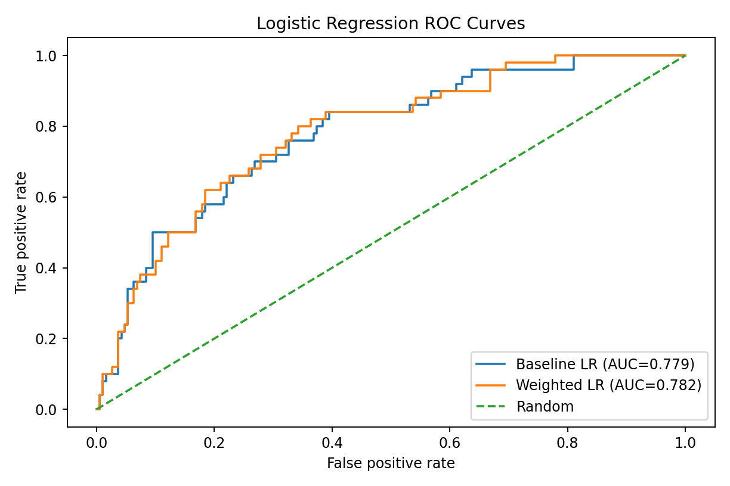
Figure 6. Baseline vs class-weighted Logistic Regression ROC curves on the held-out test set.

6. Model Improvement and Final Selection
Two justified improvement techniques were applied: class weighting to address the 79.17%/20.83% class imbalance, and training-only hyperparameter tuning using five-fold StratifiedKFold with GridSearchCV. ROC-AUC was the primary tuning objective, while recall, F1, precision and accuracy were also monitored.
Model | Version | Accuracy | Precision | Recall | F1 | ROC-AUC
Logistic Regression | Baseline | 0.8042 | 0.5714 | 0.2400 | 0.3380 | 0.7792
Logistic Regression | Improved - balanced | 0.7208 | 0.4000 | 0.6800 | 0.5037 | 0.7822
Random Forest | Baseline | 0.7875 | 0.4444 | 0.0800 | 0.1356 | 0.7211
Random Forest | Improved - tuned | 0.8042 | 0.5319 | 0.5000 | 0.5155 | 0.7799

6.1 Final Model: Class-Weighted Logistic Regression
- ROC-AUC: 0.7822 vs 0.7799 for the tuned Random Forest.
- Recall: 68.0% vs 50.0%; the weighted logistic model detected 34 of 50 held-out churners.
- More stable train/CV/test behaviour and lower overfitting risk.
- Greater interpretability and appropriate complexity for 1,200 historical records.
- Supports predict_proba, which is required for customer scoring and financial expected-value calculations.
The tuned Random Forest retained advantages in accuracy, precision and F1. The final model was selected because NovaMarts retention use case places high value on identifying likely churners while maintaining good ranking performance and lower generalization risk.
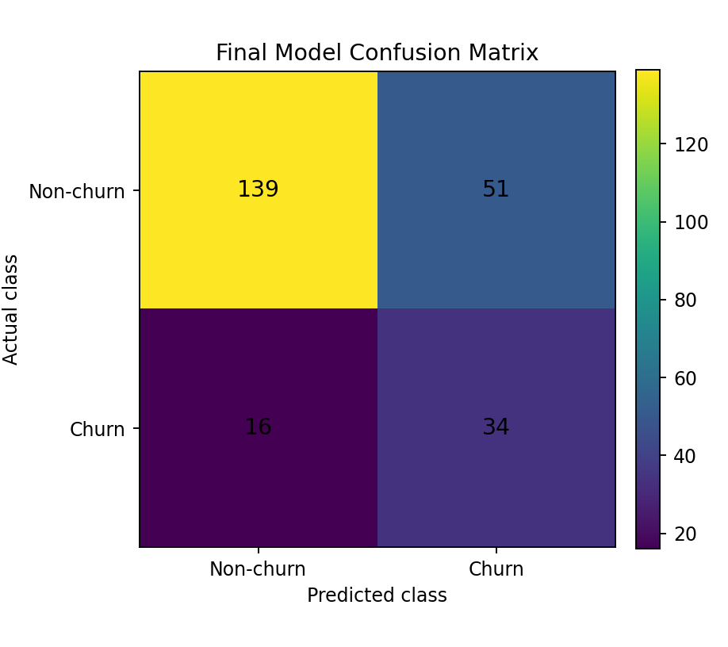
Figure 7. Final weighted Logistic Regression confusion matrix: 34 of 50 churners detected at the required 0.50 threshold.

6.2 Probability Calibration Review
Model | Brier score | ROC-AUC | Recall | F1 | Mean predicted probability
Weighted Logistic Regression | 0.1923 | 0.7822 | 0.6800 | 0.5037 | 43.87%
Sigmoid calibrated LR | 0.1383 | 0.7819 | 0.1200 | 0.1905 | 20.77%
The observed churn rate in the held-out test set was 20.83%. Sigmoid calibration materially improved Brier score and aligned the mean predicted probability with the observed rate, while discrimination stayed nearly unchanged. However, at the mandatory 0.50 classification threshold, recall fell from 68% to 12% and F1 from 0.5037 to 0.1905. The same recall deterioration was observed in training-only nested cross-validation.
The uncalibrated class-weighted Logistic Regression was therefore retained as the final model. This decision favors operational churn detection under the assignment threshold, but it creates an important limitation: probability-based financial values may be optimistic. Campaign economics should therefore be interpreted as model-based expected values and validated in a real pilot before operational scaling.

7. Current Customer Scoring
Measure | Result
Customers scored | 300
Minimum churn probability | 2.66%
Mean churn probability | 43.22%
Median churn probability | 37.29%
Maximum churn probability | 99.99%
Predicted churners | 105 (35.00%)
Eligibility rule | Predicted_Churn=1 AND Expected_Net_Benefit_JD>0
Eligible customers | 105
Final selected customers | 50
The final model was refitted on all 1,200 cleaned historical customers and applied to the 300 cleaned current customers. Predicted_Churn followed the assignment rule exactly: probability >= 0.50.
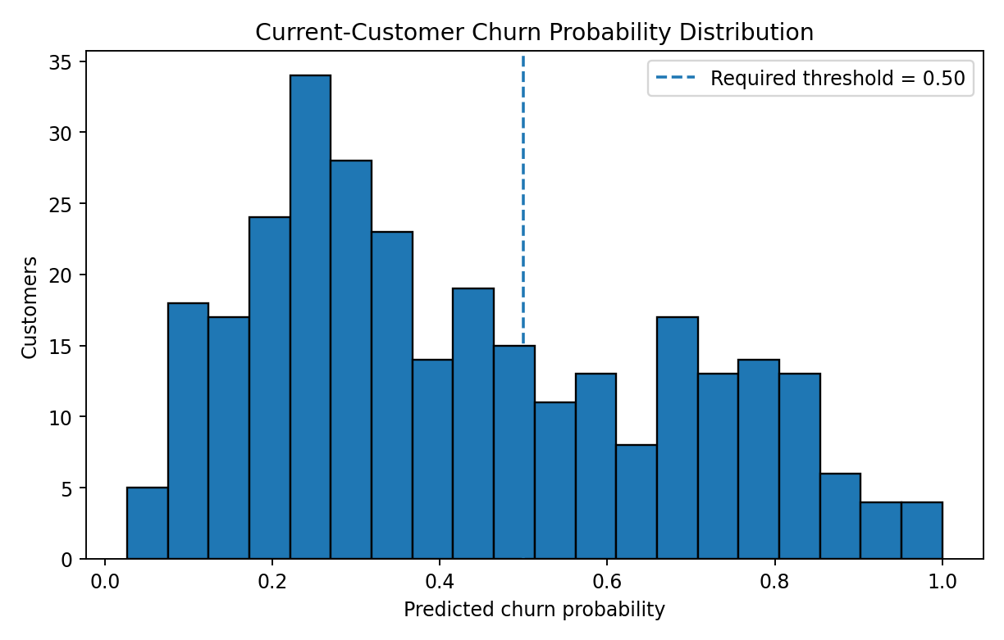
Figure 8. Current-customer predicted churn probabilities. The dashed line shows the required 0.50 classification threshold.

8. Prescriptive Retention Campaign
The assignment supplied the following business assumptions and formulas:
Measure | Formula
Annual spending | Monthly_Spend_JD x 12
Annual profit | Annual_Spending_JD x 0.25
Expected saved profit | Churn_Probability x 0.35 x Annual_Profit_JD
Expected net benefit | Expected_Saved_Profit_JD - 20
A customer was eligible only if Predicted_Churn=1 and Expected_Net_Benefit_JD>0. Eligible customers were ranked by expected net benefit, and the final campaign selected the top 50.
Customer | Churn prob. | Monthly spend | Annual profit | Expected saved | Expected net
C20099 | 0.7390 | 410.91 | 1232.73 | 318.83 | 298.83
C20072 | 0.6882 | 440.06 | 1320.18 | 318.01 | 298.01
C20008 | 0.7946 | 349.86 | 1049.58 | 291.89 | 271.89
C20149 | 0.7778 | 355.54 | 1066.62 | 290.36 | 270.36
C20011 | 0.8038 | 327.16 | 981.48 | 276.13 | 256.13
C20267 | 0.9946 | 249.22 | 747.66 | 260.26 | 240.26
C20154 | 0.5820 | 403.03 | 1209.09 | 246.29 | 226.29
C20215 | 0.7566 | 307.05 | 921.15 | 243.93 | 223.93
C20007 | 0.9881 | 227.77 | 683.31 | 236.30 | 216.30
C20193 | 0.8000 | 274.04 | 822.12 | 230.20 | 210.20
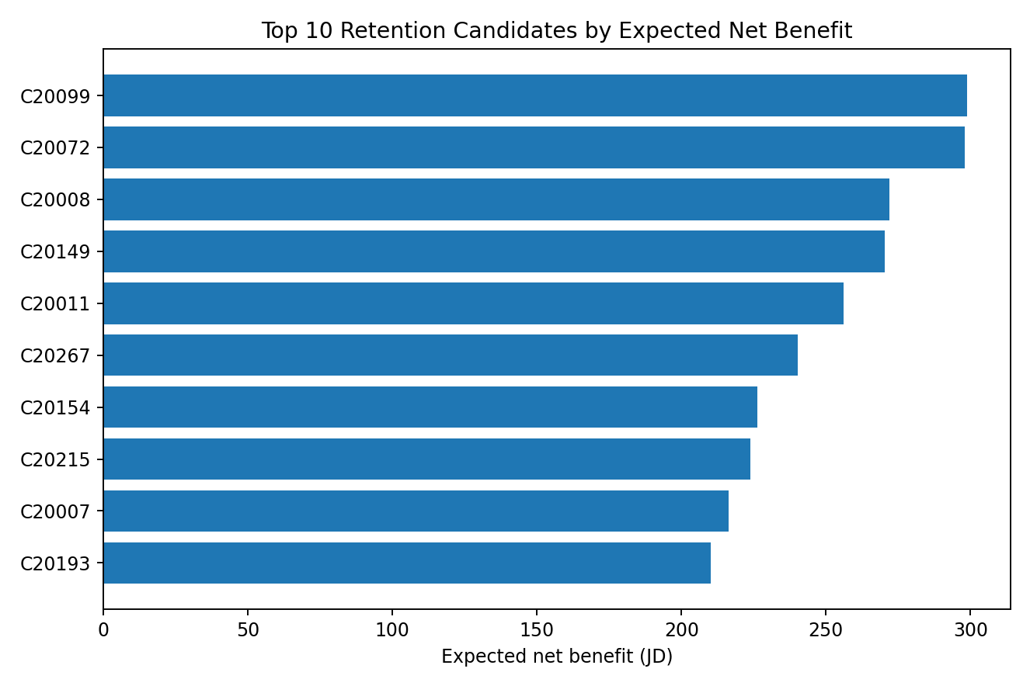
Figure 9. Highest-value retention candidates after combining predicted risk with expected financial value.

9. What-if Analysis: Top 25 vs Top 50
Scenario | Contacted | Cost (JD) | Expected retained | Saved profit (JD) | Net benefit (JD)
Top 25 | 25 | 500.00 | 6.70 | 5,346.51 | 4,846.51
Top 50 | 50 | 1,000.00 | 13.35 | 8,609.35 | 7,609.35

9.1 Incremental Economics
- Additional campaign cost from Top 25 to Top 50: JD 500.00.
- Additional expected customers retained: approximately 6.66.
- Additional expected saved profit: JD 3,262.84.
- Additional expected net benefit: JD 2,762.84.
Recommendation: Scenario B - Top 50. Under the assignment assumptions, the additional JD 500 budget produces a substantial positive incremental expected net benefit. Because the final probabilities are imperfectly calibrated, NovaMart should treat the estimate as a decision-support value and validate realized retention lift and profitability after launch.
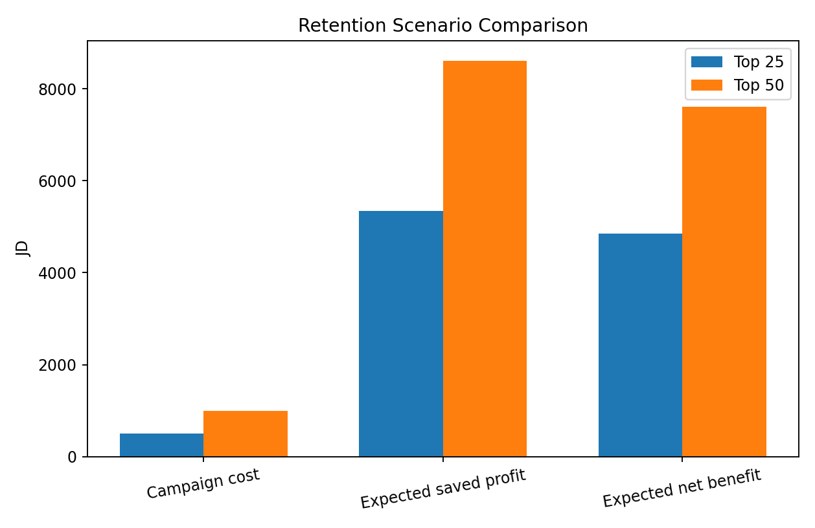
Figure 10. Top-50 targeting requires more budget but produces a substantially higher expected net benefit.

10. Conclusions and Business Recommendations
- Prioritize customers with long purchase recency, complaints, repeated support needs, lower satisfaction and weaker engagement for retention attention.
- Use the class-weighted Logistic Regression as the operational screening model because it identifies substantially more churners than the baseline at the required threshold.
- Target the top 50 economically eligible customers rather than targeting by churn probability alone.
- Track realized retention, campaign response and actual profit after launch; compare actual outcomes with the model-based expected values.
- Recalibrate or retrain the model when more labelled outcomes become available, especially if probability-based financial planning becomes operational.

11. Limitations
- The historical sample is relatively small (1,200 cleaned customer records).
- Historical associations are observational and do not establish causation.
- The final weighted Logistic Regression overestimates absolute churn probabilities on the held-out data.
- The 25% profit margin, JD 20 campaign cost and 35% retention effectiveness are supplied assumptions rather than experimentally validated NovaMart estimates.
- Expected saved profit and expected net benefit are estimates, not guaranteed financial outcomes.
- Model performance should be monitored after deployment and updated as new customer outcomes become available.

12. References
Luminus Technical University College, Department of ASAC. Applied Analytical Models - Final Course Project: NovaMart Customer Retention and Campaign Optimization. Course Code 30772343.
pandas documentation - data manipulation and analysis library (pandas.pydata.org).
scikit-learn User Guide - preprocessing, Logistic Regression, Random Forest, model evaluation, cross-validation and calibration (scikit-learn.org).
Matplotlib documentation - analytical visualization library (matplotlib.org).

GitHub repository: https://github.com/HaneenDahbour/novamart-customer-retention

