AI Ethics & Responsible Usage Declaration
I hereby declare that:
- The dataset used in this assignment is properly cited and ethically sourced.
- I have analyzed potential biases present in the dataset and model.
- I have considered privacy implications related to the data used.
- I understand the responsible and ethical usage of the developed system/model.
- This work adheres to institutional guidelines on ethical AI practices.

Dataset Details:
Source: NSE’s official website
Type of Data: NSE historical data
Contains Personal/Sensitive Data? (Yes/No): No
If Yes, describe anonymization steps: Not applicable

Identified Bias (if any):
The ARIMA model is trained only on historical stock price data, which may contain inherent market biases such as periods of high volatility, external economic shocks, and limited representation of future market conditions. Additionally, the model does not consider real-world factors like news sentiment, political events, or macroeconomic changes, which can introduce forecasting bias.

Responsible Usage Statement:
This project is developed strictly for academic and educational purposes. The predictions generated by the ARIMA model are statistical forecasts based on historical data and should not be interpreted as financial advice. Users should not rely on these predictions for real-world trading decisions. Responsible use includes understanding the limitations of time series models and acknowledging that stock markets are influenced by unpredictable external factors.

Student Details:
Student Name: Haneen Dalvi
UIN: 242A002
Course: AIDS
Date: 19-04-2026
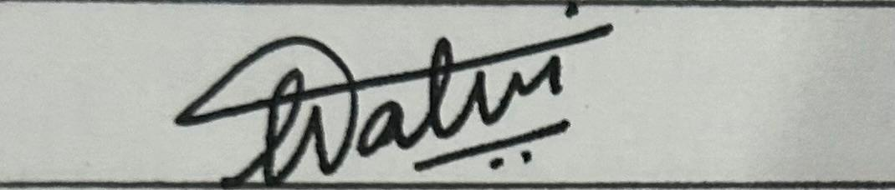
Signature: ______________________________________________

