1. Login Screen

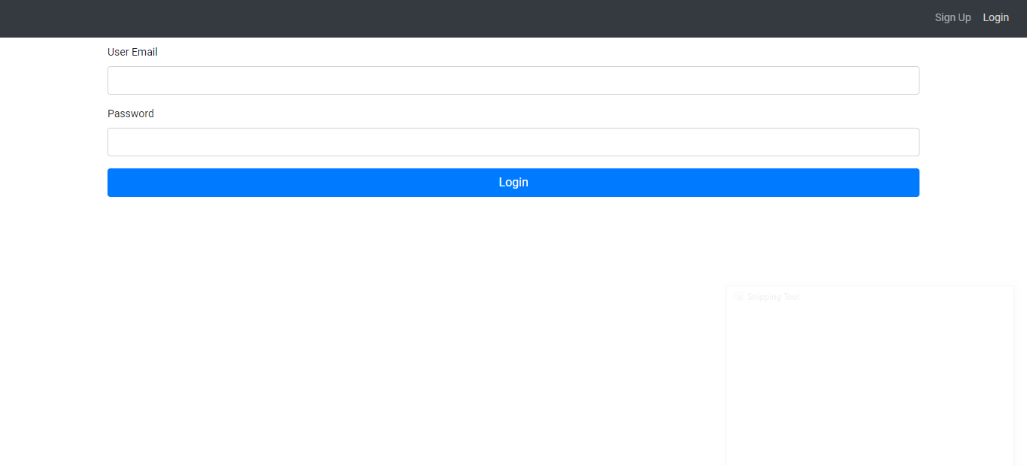

1. Signup Screen

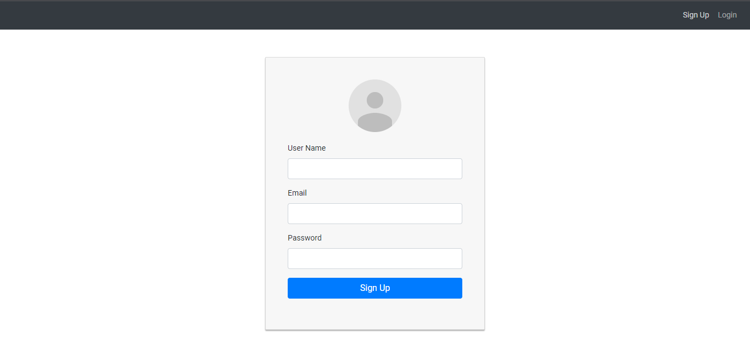

1. User Successful Creation message

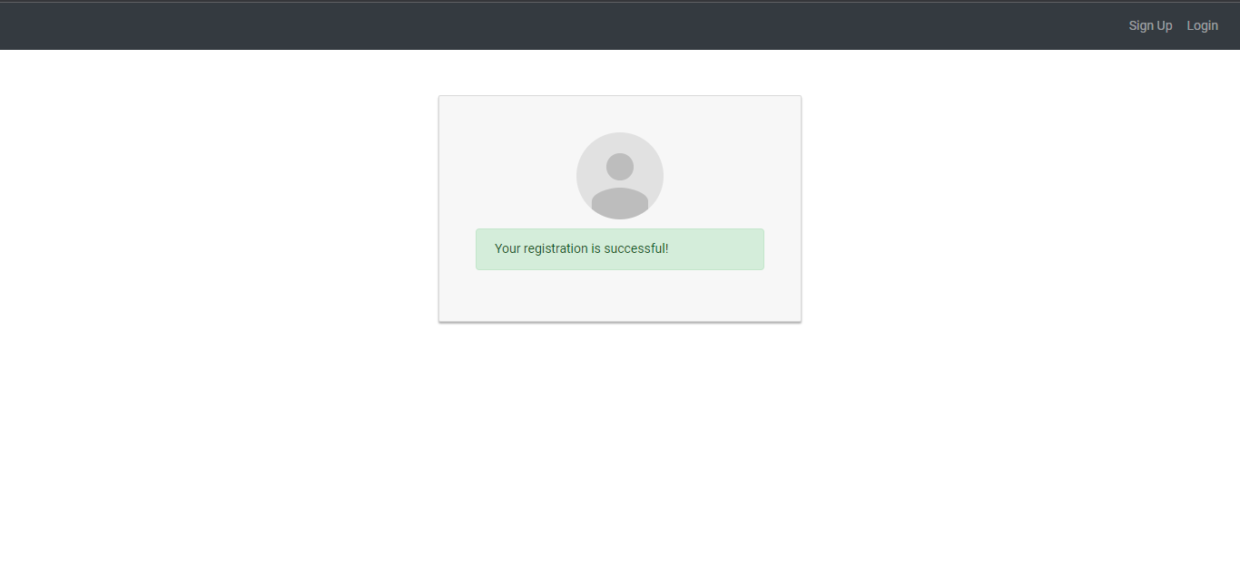

1. After Successful Login

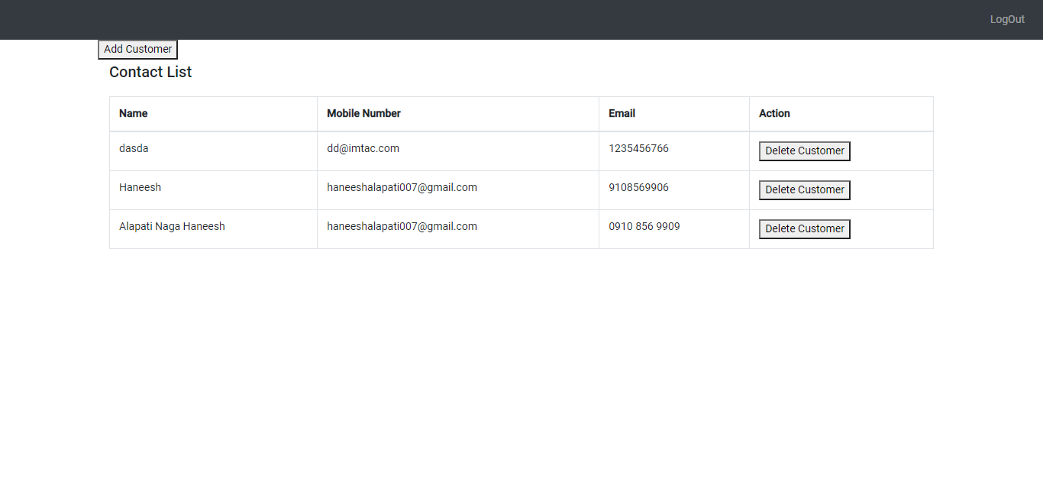

1. Add Contact

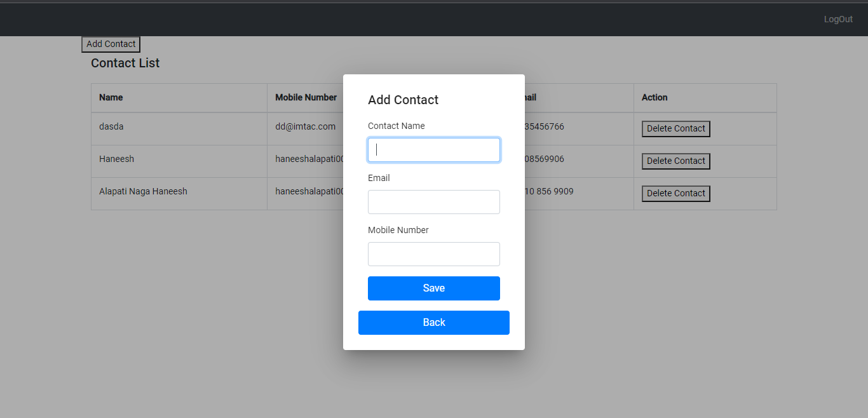

1. After Successful Adding in Db

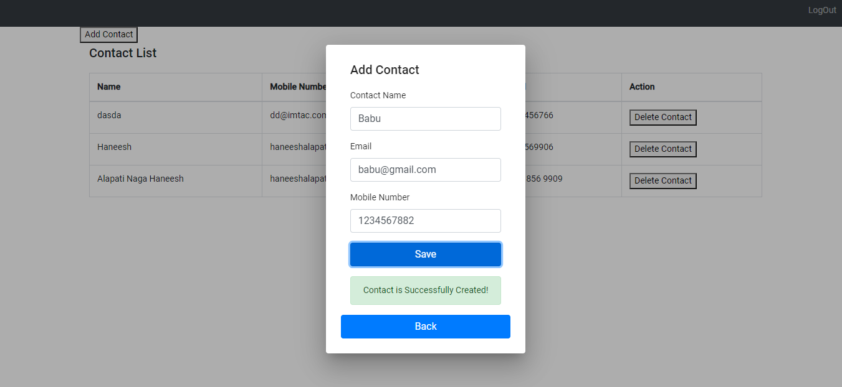

1. After adding new record in contact list

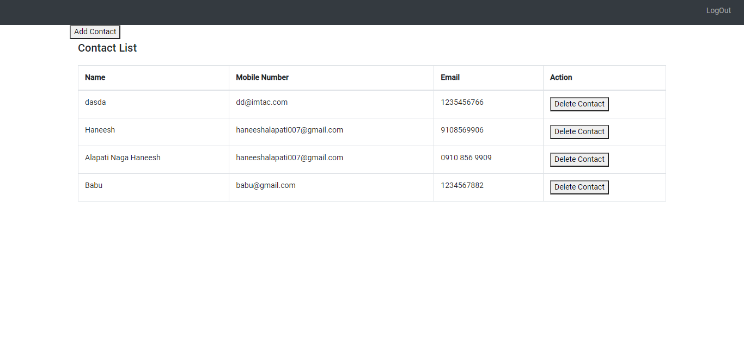

1. Delete contact list

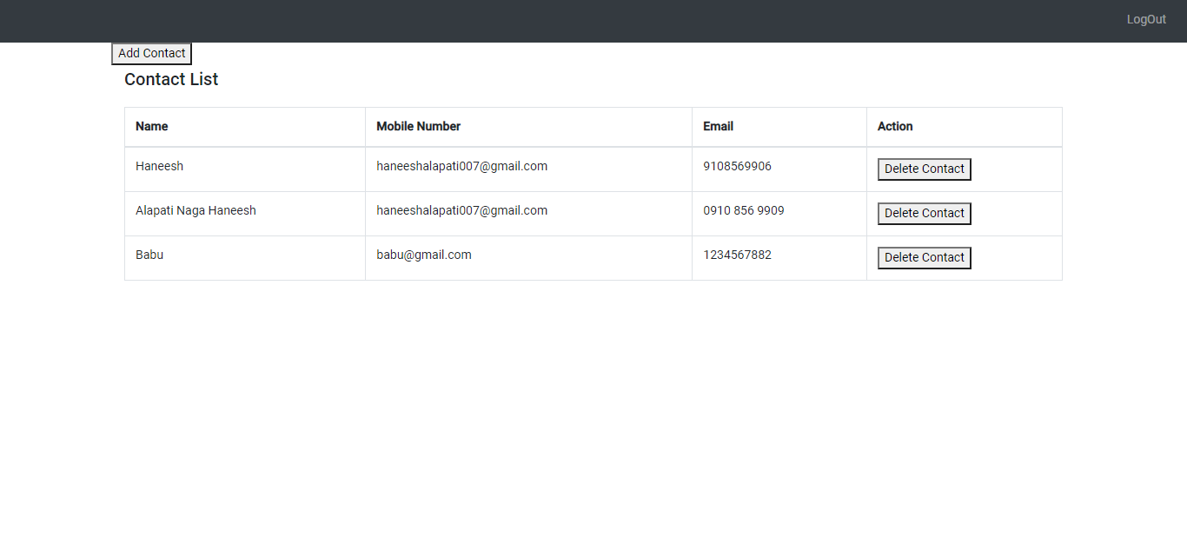

**Data Base Tables**

create table users (

users_id serial,

users_name varchar,

users_email varchar,

users_password varchar)

create table Contacts_list (

Contacts_id serial,

Contacts_name varchar,

Contacts_email varchar,

Contacts_number varchar,

users_id int8,

record_status boolean)

**Note**: While creating user API, please add your Personnel Email and password