SIMATS ENGINEERING
CO1-ASSESSMENT TOOL 1-Constrain Based Problem
COURSE NAME: R PROGRAMMING COURSE CODE: ITA04
COURSE OUTCOME COVERED
CO: Apply R programming fundamentals including data structures, vectors, matrices, arrays, and class types to perform mathematical operations and manage data effectively. (Bloom Level -BL2- BL4)
Assessment Tool Weightage: 20%
QUESTIONS: Total Marks: 100
Name / Register No:KANDATH HANEESH(192324084)

1. Student Mark Analysis using Vectors
Create an R program to store the marks of 10 students in a vector. Perform the following operations:
a) Display the marks
b) Calculate total and average
c) Find maximum and minimum marks
d) Display the marks greater than 50 using logical-vector operations
e) Display the position of the highest mark.
Problem Understanding
- Input: 10 numeric marks stored in a vector.
- Output: marks, total, average, maximum, minimum, marks greater than 50, position of the highest mark.
- Constraints: exactly 10 values, each between 0 and 100.
Pseudocode
START
READ marks vector
IF length(marks) != 10 OR any mark outside 0-100 THEN
DISPLAY error and STOP
FOR each student i
DISPLAY marks[i]
total <- SUM(marks)
average <- total / 10
DISPLAY MAX(marks), MIN(marks)
logical_vector <- marks > 50
DISPLAY marks[logical_vector]
DISPLAY position where marks = MAX(marks)
END

Program (RStudio Source Editor)
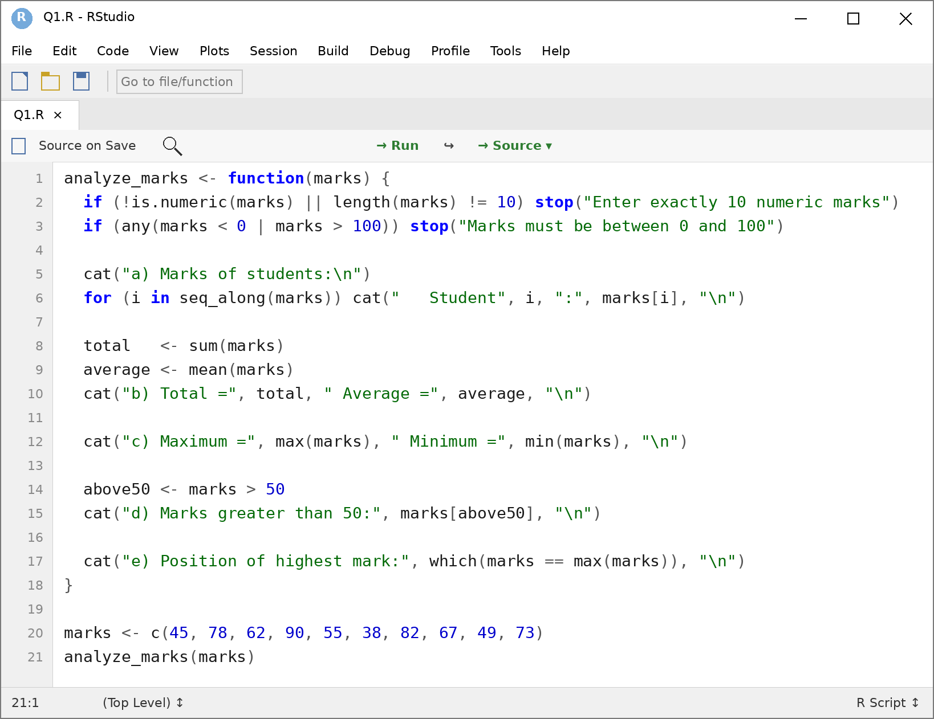

Output
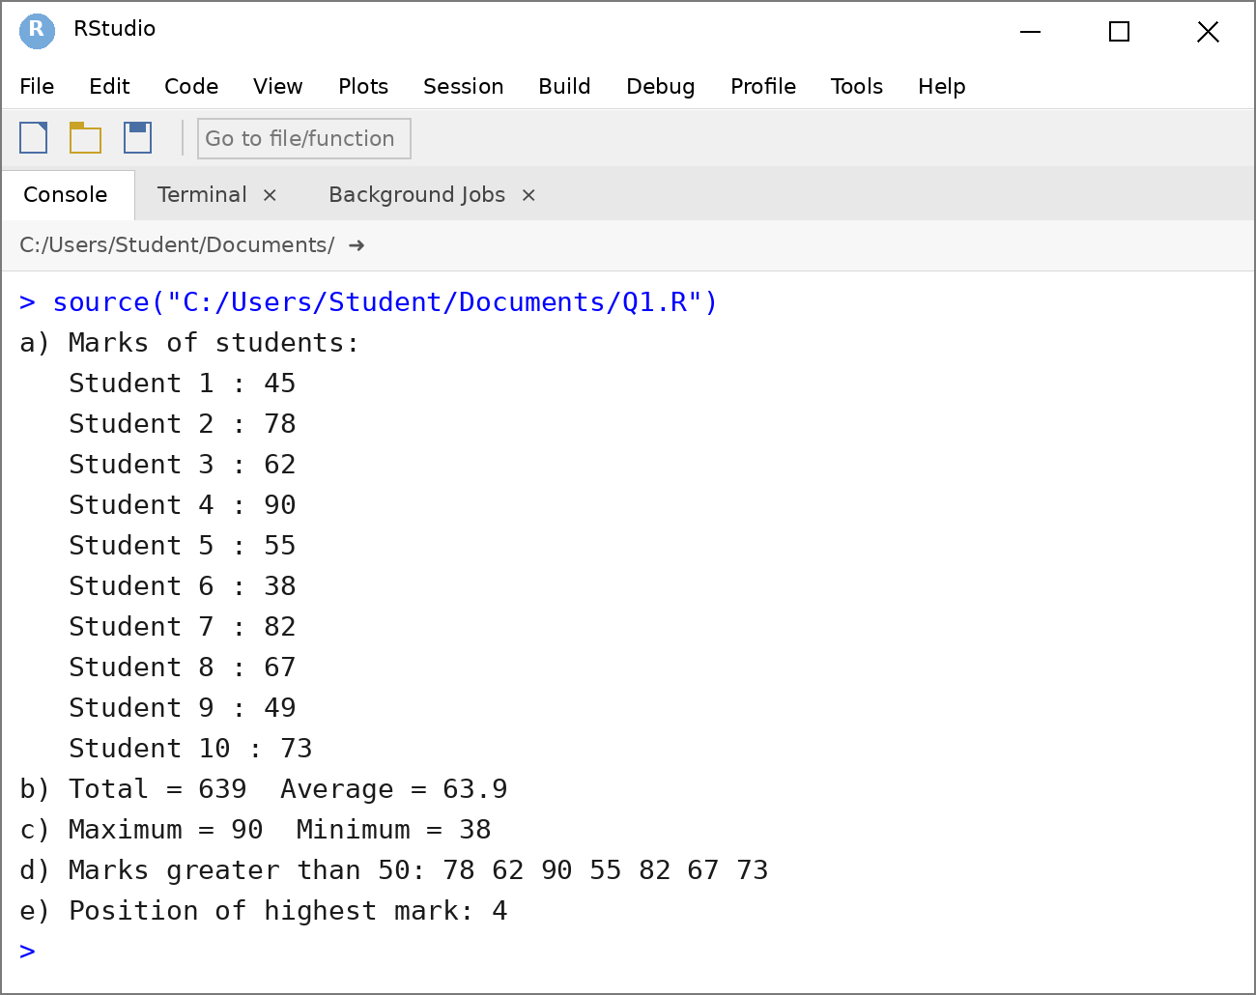

2. Student Information using Different Data Types
Develop an R program to store student information such as student name, register number, age, gender, marks, and pass/fail status using appropriate R data types. Display each variable, its value, and its data type. Explain the suitability of each data type.
Problem Understanding
- Input: student name, register number, age, gender, marks and pass/fail status.
- Output: each variable with its value, class and type, followed by the suitability of each data type.
- Constraints: the most appropriate R data type must be used for every variable.
Pseudocode
START
CREATE student_name as character
CREATE reg_no as character
CREATE age as integer
CREATE gender as factor
CREATE marks as numeric
pass_status <- (marks >= 40) [logical]
STORE all variables in a list
FOR each variable in the list
DISPLAY name, value, class, typeof
DISPLAY suitability of each data type
END

Program (RStudio Source Editor)
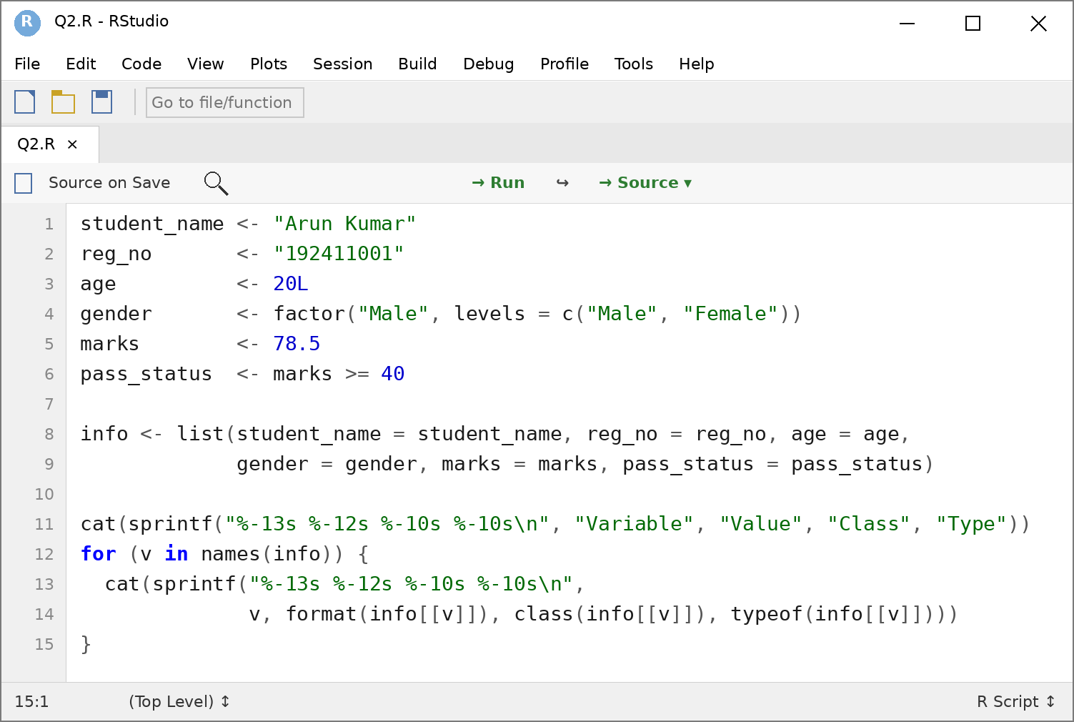
Output
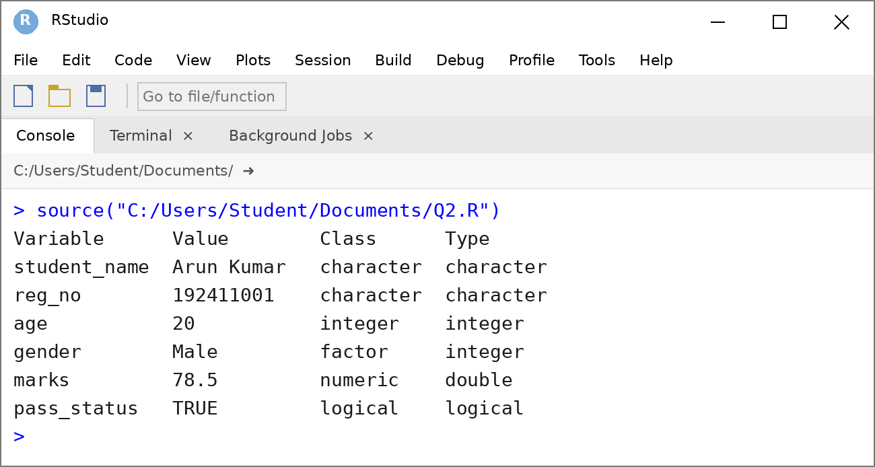
Suitability of each data type
Variable | Data Type | Reason for suitability
Student name | character | Names are text values.
Register number | character | It is an identifier, not used in calculations, and leading zeros are preserved.
Age | integer | Age is a whole number and integers use less memory.
Gender | factor | Gender has a fixed set of categories with defined levels.
Marks | numeric | Marks may contain decimals and are used in calculations.
Pass/Fail status | logical | Only two states (TRUE/FALSE) and can be used directly in conditions.

3. Matrix Operations in R
Create two matrices representing marks obtained by students in two different subjects. Write an R program to perform matrix addition, subtraction, multiplication, transpose, and extraction of selected elements. Explain the operations with suitable output.
Problem Understanding
- Input: two 3 x 3 matrices A and B holding the marks of three students in three tests for two subjects.
- Output: sum, difference, product, transpose and selected elements of the matrices.
- Constraints: addition and subtraction need matrices of equal dimensions; multiplication (%*%) needs ncol(A) = nrow(B).
Pseudocode
START
CREATE matrices A and B
IF dim(A) = dim(B) THEN
DISPLAY A + B and A - B
ELSE DISPLAY error
IF ncol(A) = nrow(B) THEN
DISPLAY A %*% B
ELSE DISPLAY error
DISPLAY t(A)
EXTRACT single element, row, column and elements > 85
END
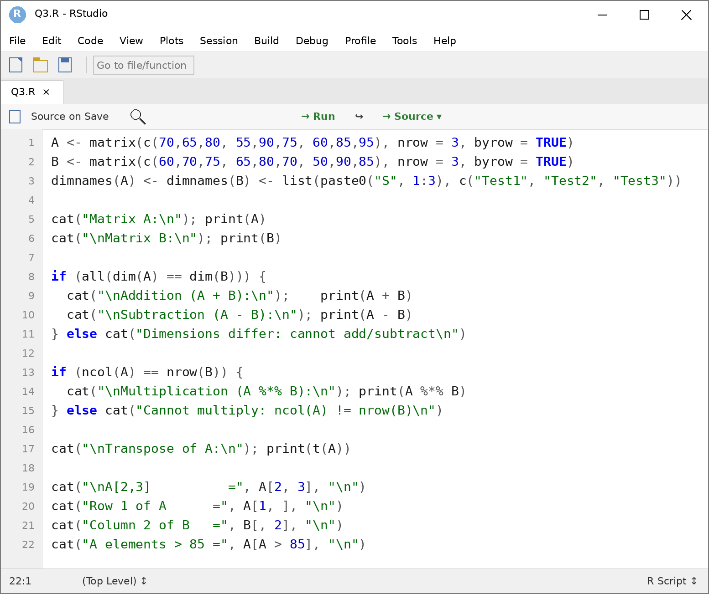
Output (RStudio Console)
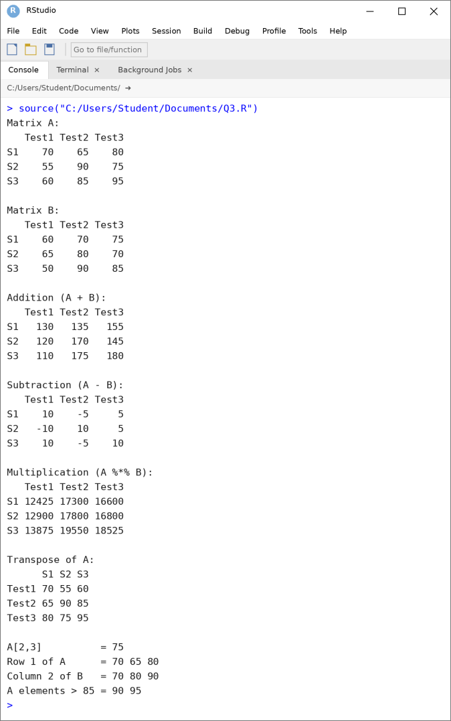
Explanation of the operations
- Addition and subtraction: performed element by element (A + B, A - B), for example S1-Test1: 70 + 60 = 130 and 70 - 60 = 10.
- Multiplication: A %*% B is true matrix multiplication (row x column), for example S1-Test1: 70x60 + 65x65 + 80x50 = 12425. The operator * would multiply element by element.
- Transpose: t(A) interchanges rows and columns, so the 3 x 3 matrix has students as columns and tests as rows.
- Extraction: A[2, 3] gives one element (75), A[1, ] gives a row, B[, 2] gives a column and A[A > 85] returns all elements satisfying the condition (90, 95).

4. Employee Salary Analysis using Lists
Create an R list containing an employee’s name, employee ID, department, basic salary, allowances, and deductions. Write an R program to calculate the gross salary and net salary and display the individual components of the list.
Problem Understanding
- Input: name, employee ID, department, basic salary, allowances and deductions.
- Output: gross salary, net salary and every component of the list.
- Constraints: the data has mixed types, so a list is required; salary values must not be negative. Gross = Basic + Allowances; Net = Gross - Deductions.
Pseudocode
START
CREATE list emp
IF basic, allowances or deductions < 0 THEN
DISPLAY error and STOP
gross <- basic + allowances
net <- gross - deductions
FOR each component in emp
DISPLAY component name and value
DISPLAY gross, net
END

Program (RStudio Source Editor)
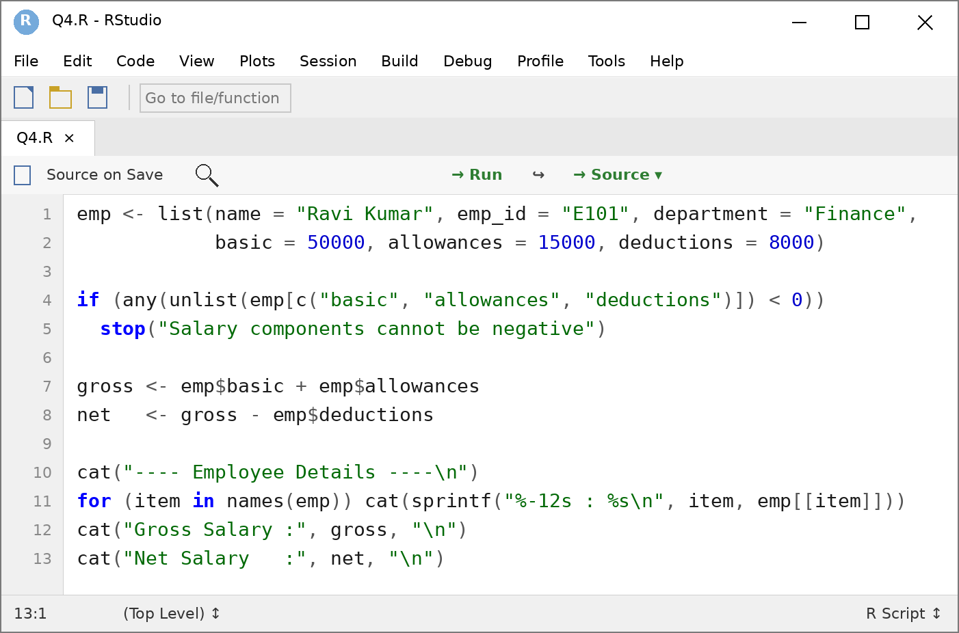
Output (RStudio Console)
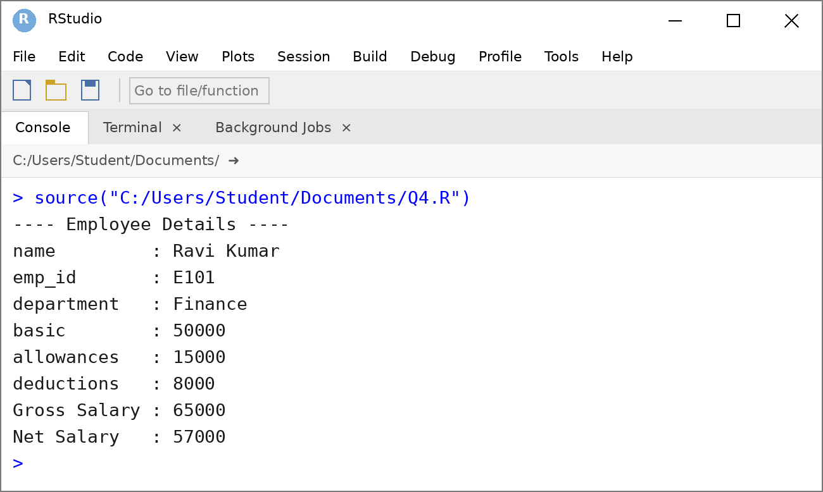 5.Product Sales using Arrays
Create a three-dimensional array to store the sales of three products for two branches over two months. Write an R program to create the array, assign suitable dimension names, access individual values, and calculate the total sales.
Problem Understanding
- Input: sales of 3 products for 2 branches over 2 months (12 values).
- Output: the named 3-D array, individual values, total sales and totals per product, branch and month.
- Constraints: dimensions are c(3, 2, 2), so exactly 12 values are required and they are filled column-wise.
Pseudocode
START
READ 12 sales values
IF number of values != 12 THEN
DISPLAY error and STOP
CREATE array with dim = (3, 2, 2)
ASSIGN dimnames (Product, Branch, Month)
DISPLAY array
ACCESS individual values
total <- SUM(array)
COMPUTE totals per product, branch and month
END

Program (RStudio Source Editor)
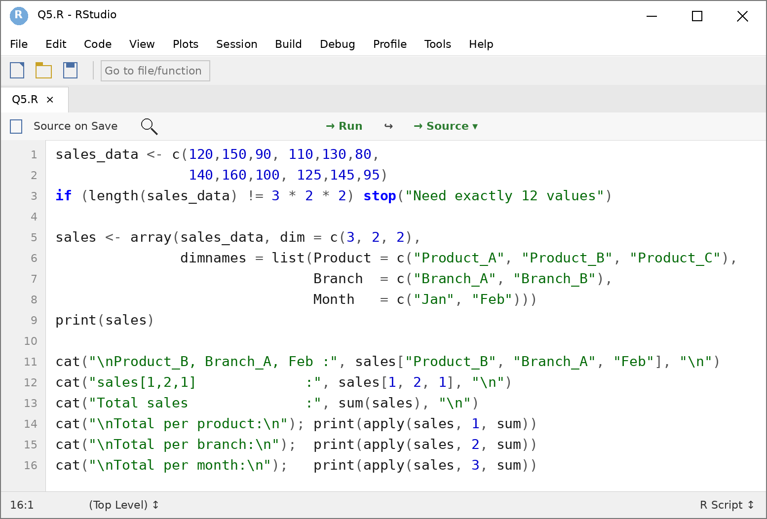
Output (RStudio Console)
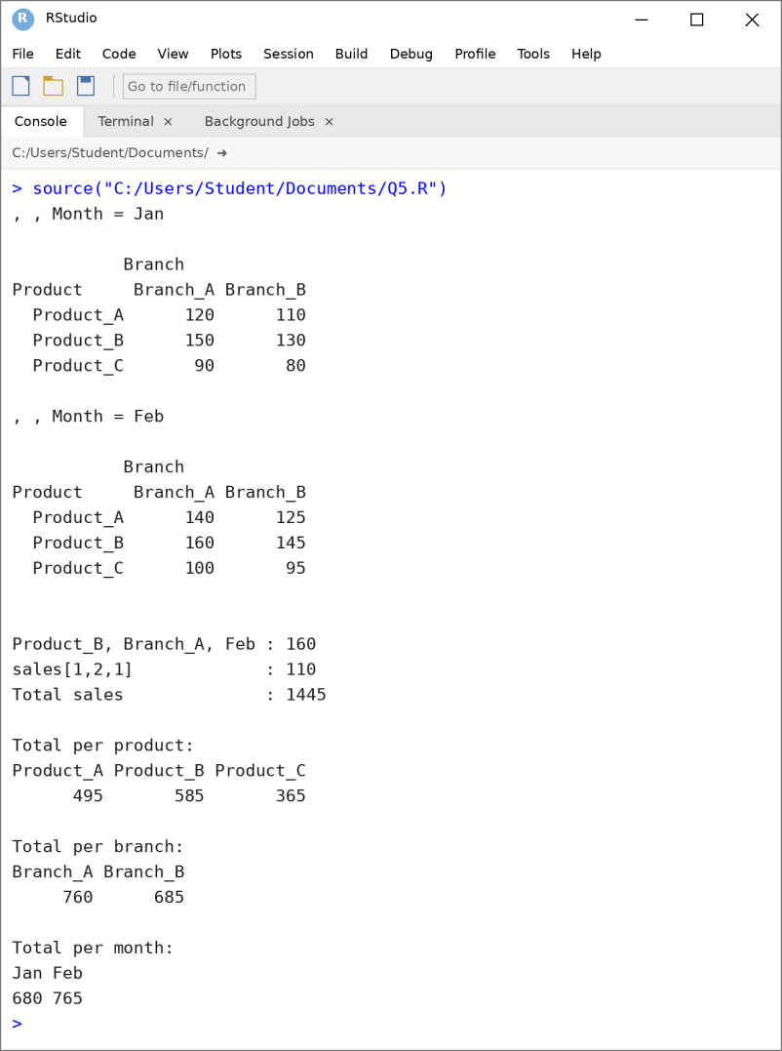

6. Student Grade Analysis using Factors
Create a factor containing the grades obtained by 10 students (A, B, C, D). Write an R program to display the factor levels, count the number of students in each grade, and access individual factor elements. Explain why a factor is suitable for representing categorical data.
Problem Understanding
- Input: grades of 10 students (A, B, C, D).
- Output: factor levels, number of students in each grade and individual factor elements.
- Constraints: only grades A, B, C and D are valid.
Pseudocode
START
READ grades of 10 students
IF any grade is not in {A, B, C, D} THEN
DISPLAY error and STOP
CONVERT grades to an ordered factor
DISPLAY levels
DISPLAY table of counts
ACCESS elements by position and condition
END

Program (RStudio Source Editor)
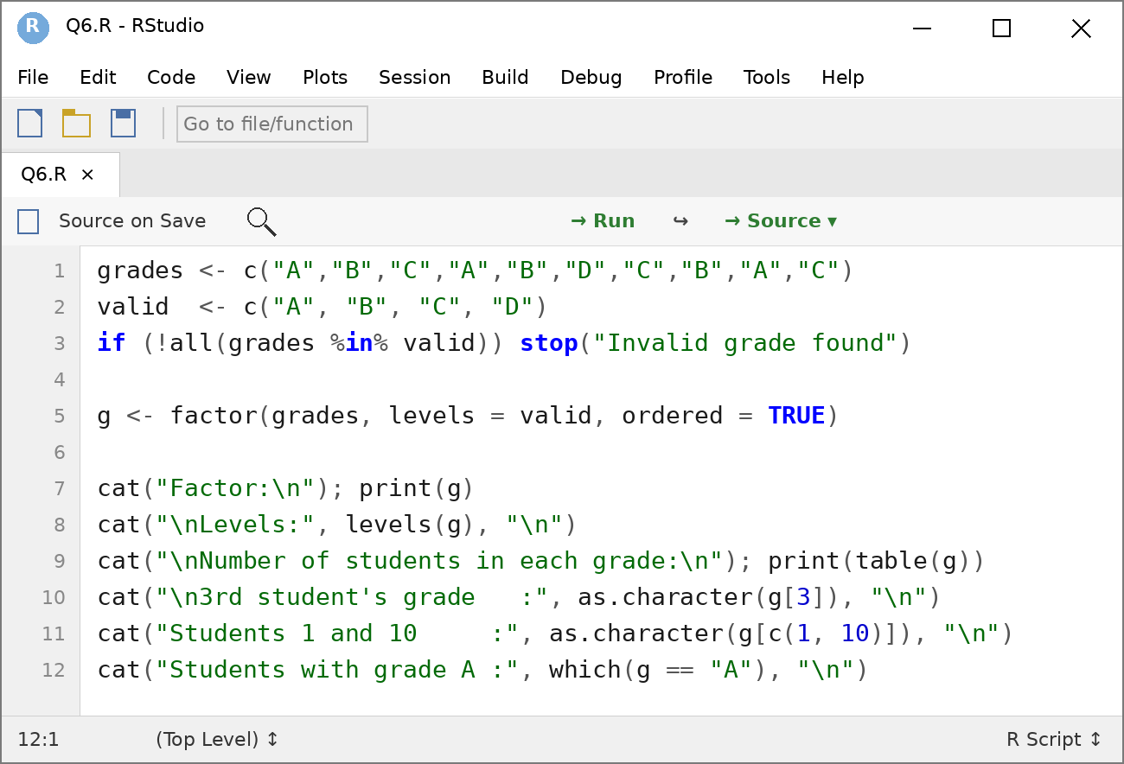
Output (RStudio Console)
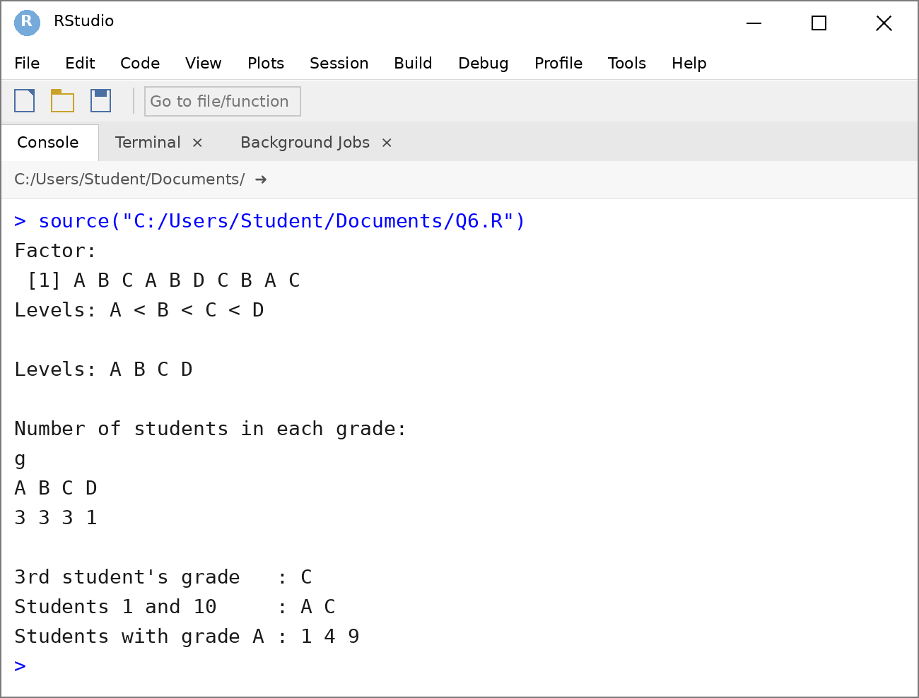
Why a factor is suitable for categorical data
- Fixed categories: grades come from a limited set of labels, which a factor stores as levels.
- Efficient storage: values are stored as integer codes with labels, which saves memory.
- Data validation: a value outside the defined levels is not accepted (it becomes NA).
- Ordering: ordered factors preserve the ranking A < B < C < D.
- Analysis support: functions such as table(), summary() and plots treat factors as categories directly.

7. Student Data Frame Problem
Create a data frame containing Student ID, Name, Age, Department, Gender, and Marks for five students. Write an R program to create the data frame, display its contents, access individual columns and rows, and calculate the average, maximum, and minimum marks.
Problem Understanding
- Input: Student ID, Name, Age, Department, Gender and Marks of five students.
- Output: the data frame, selected columns and rows, and the average, maximum and minimum marks.
- Constraints: all columns must have the same length (5).
Pseudocode
START
CREATE vectors ID, Name, Age, Dept, Gender, Marks
IF lengths of the vectors differ THEN
DISPLAY error and STOP
BUILD data frame from the vectors
DISPLAY data frame
ACCESS columns, rows and conditional rows
COMPUTE MEAN, MAX, MIN of Marks
DISPLAY results
END

Program (RStudio Source Editor)
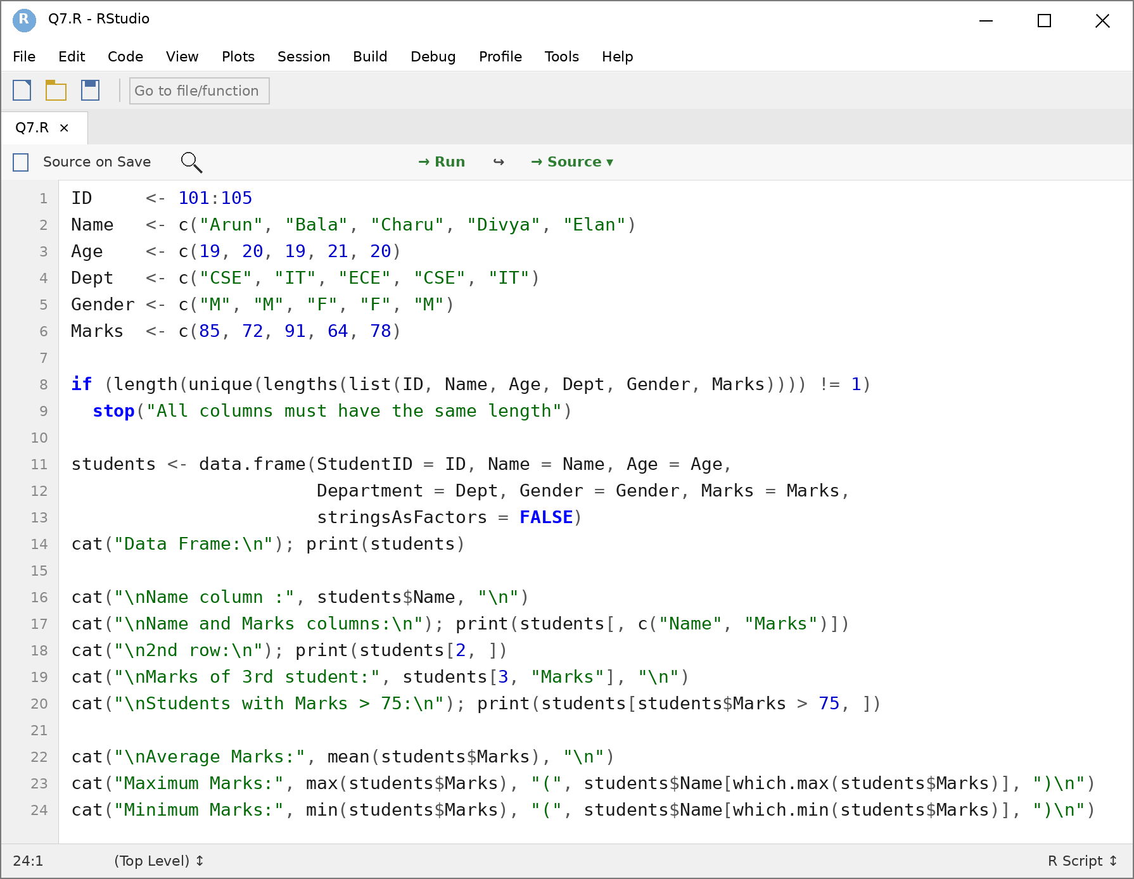
Output (RStudio Console)
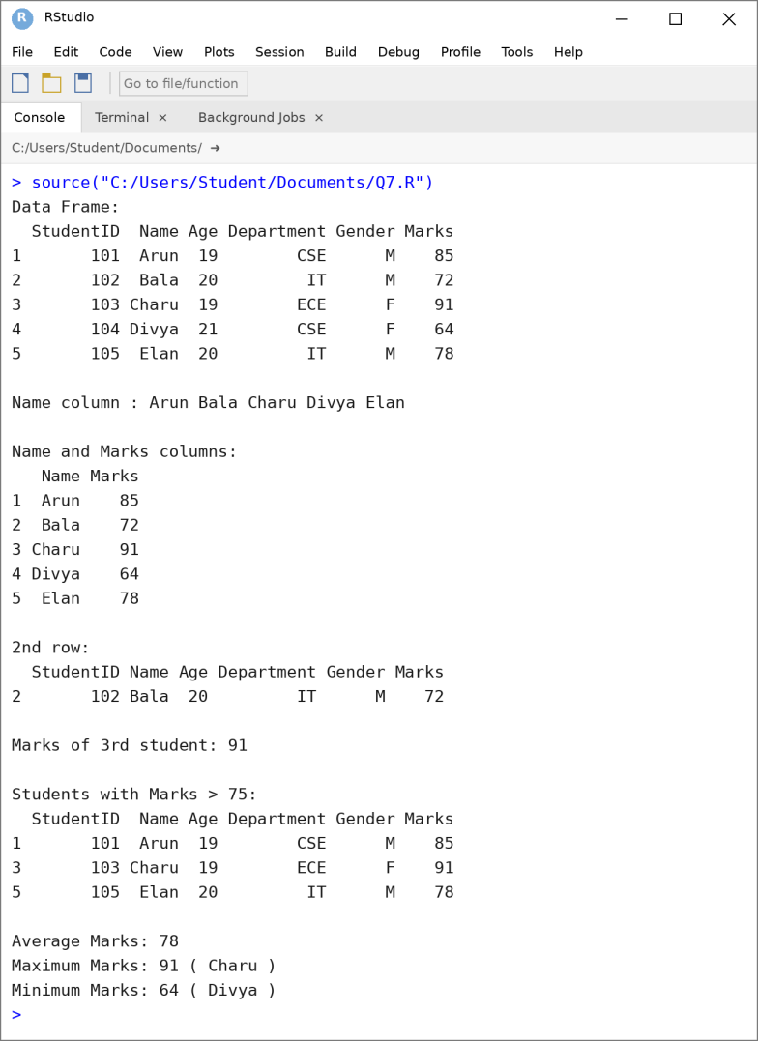
8. Logical Vector-Based Student Selection
Create a vector containing the marks of 15 students. Using logical-vector operations, write an R program to identify students who:
a) scored above 75
b) scored between 50 and 75
c) scored below 50
d) passed the examination.
Display the corresponding marks for each category.
Problem Understanding
- Input: marks of 15 students.
- Output: the marks and count for each category (above 75, between 50 and 75, below 50, passed).
- Constraints: 15 values in the range 0 to 100; pass mark is 50; “between 50 and 75” is inclusive so every mark falls in one category.
Pseudocode
START
READ marks of 15 students
IF length != 15 OR any mark outside 0-100 THEN
DISPLAY error and STOP
above75 <- marks > 75
between <- marks >= 50 AND marks <= 75
below50 <- marks < 50
passed <- marks >= 50
FOR each category
DISPLAY marks[condition] and count
END

Program (RStudio Source Editor)
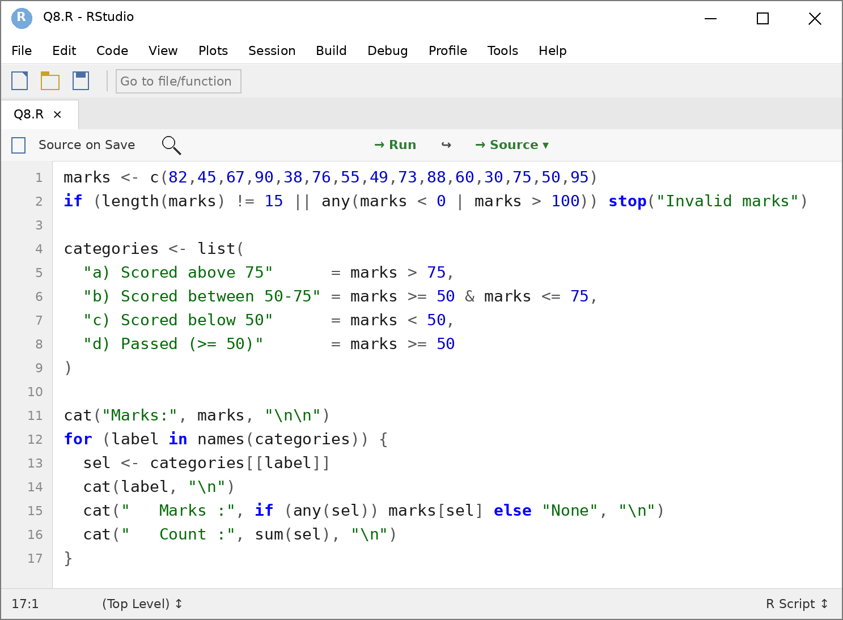
Output (RStudio Console)
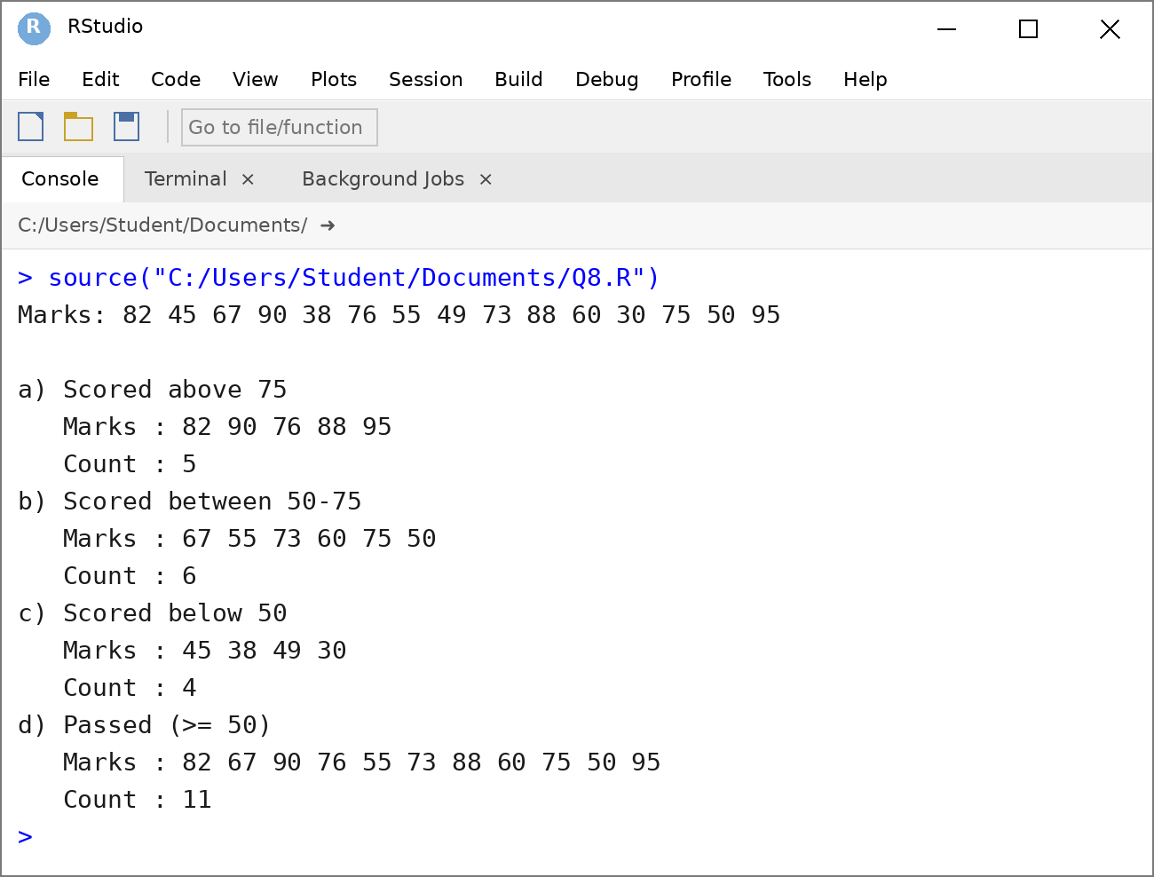
9. Data Structure Problem
Develop an R program to represent student information using vectors, lists, matrices, factors, and data frames. Demonstrate how each structure is created and accessed. Explain which type of information is most suitable for each data structure.
Problem Understanding
- Input: student information of different kinds (marks, profile, subject marks, grades, complete records).
- Output: creation and access of a vector, list, matrix, factor and data frame, with the most suitable use of each.
- Constraints: the structure must be chosen according to the data type and the number of dimensions.
Pseudocode
START
CREATE vector (marks)
CREATE list (student profile)
CREATE matrix (subject-wise marks)
CREATE factor (grades)
CREATE data frame (complete records)
ACCESS each structure using index, name, $ or [row, col]
DISPLAY results and suitability explanation
END

Program (RStudio Source Editor)
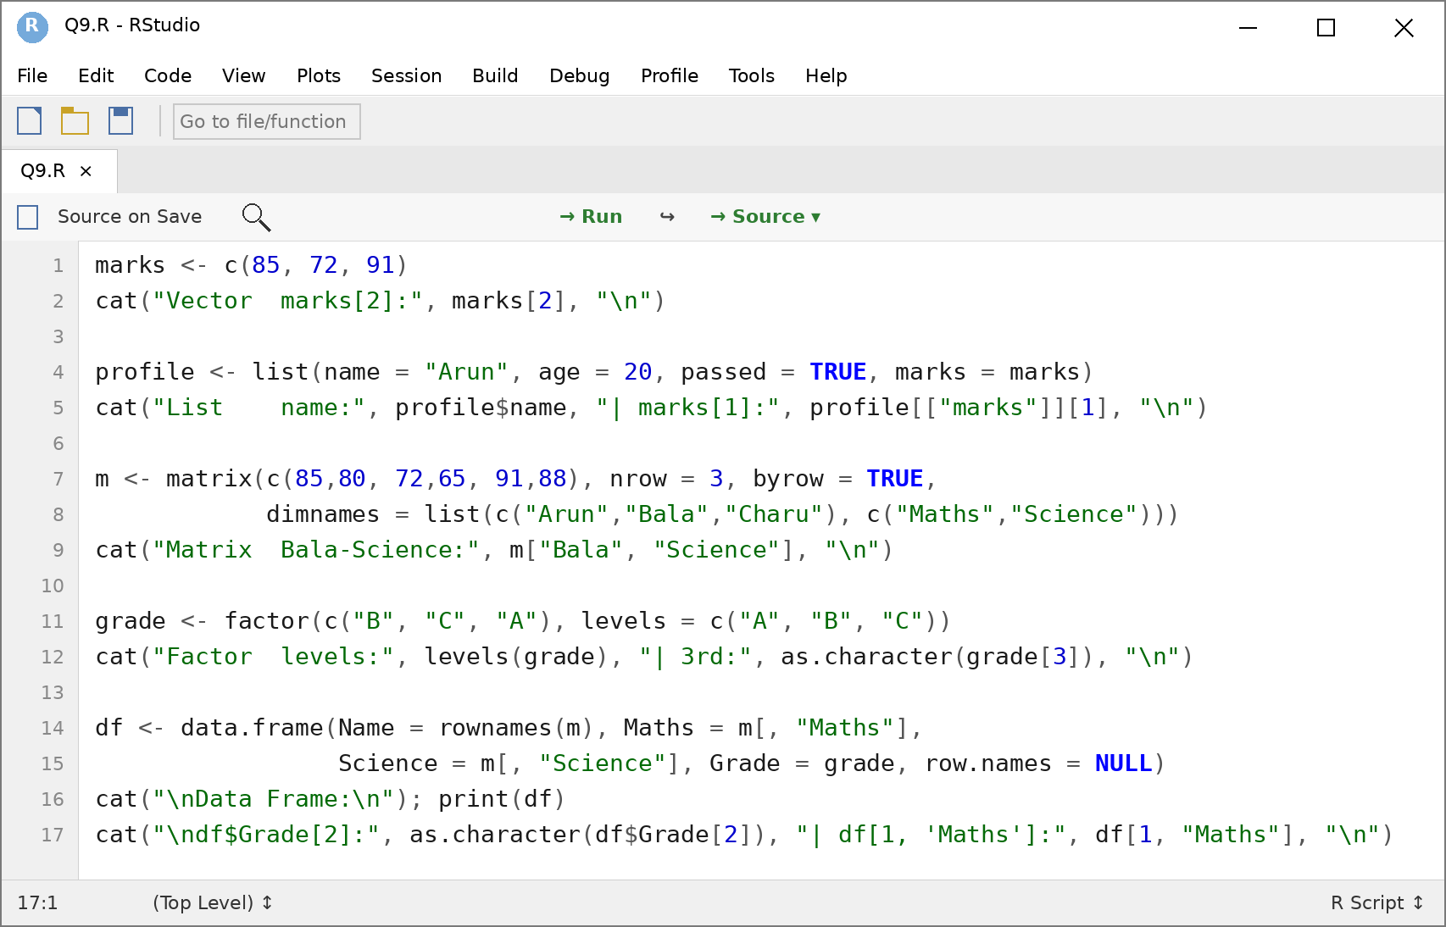
Output (RStudio Console)
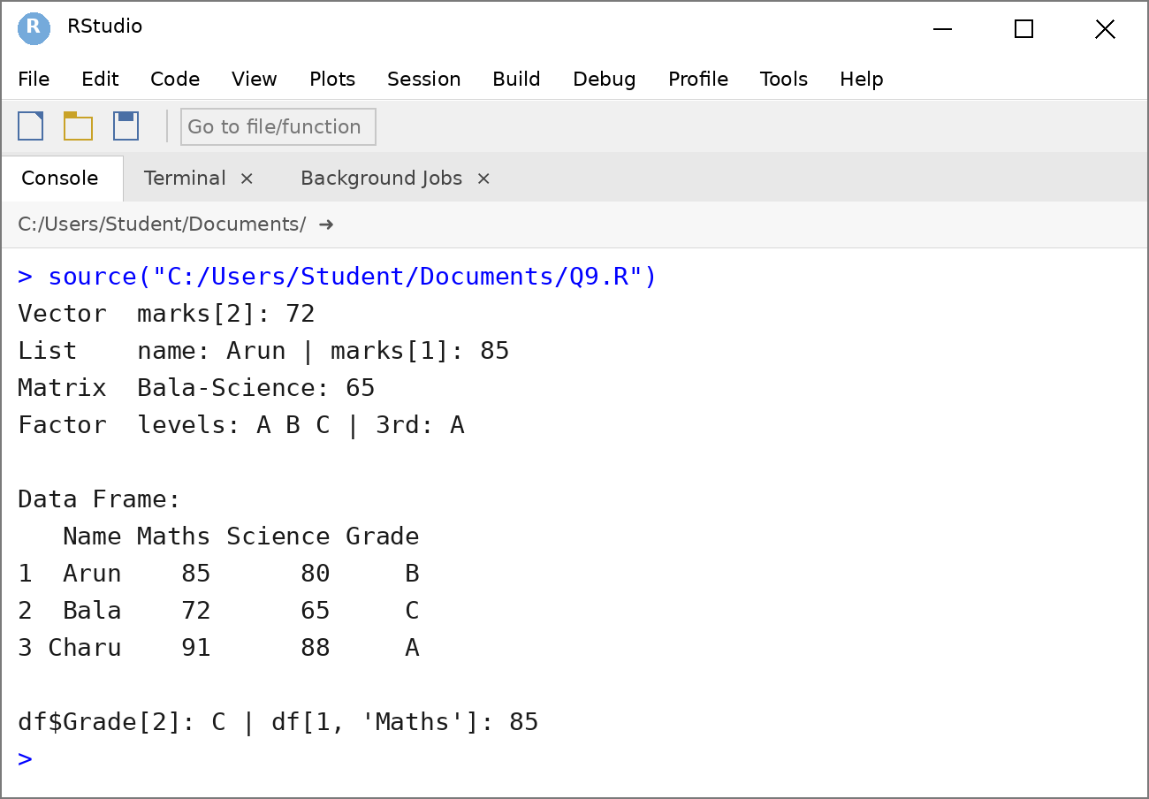

10. R Calculation and Data Structure Problem
Write an R program for a small student result-processing application. Store the marks of five students in vectors, calculate total and average marks, create a result matrix, assign grades using factors, and organize the complete student information in a data frame. Display the final result.
Problem Understanding
- Input: names and marks of five students in three subjects, stored in vectors.
- Output: total, average, result matrix, grade factor and the final data frame.
- Constraints: marks 0 to 100; pass needs at least 40 in every subject; grade by average: A >= 90, B >= 75, C >= 60, D >= 50, otherwise F.
Pseudocode
START
READ name, maths, science, english vectors
IF vector lengths differ OR any mark outside 0-100 THEN
DISPLAY error and STOP
total <- maths + science + english
average <- total / 3
BUILD result matrix (subjects, total, average)
grade <- CUT average into factor levels F, D, C, B, A
FOR each student i
IF all subject marks >= 40 THEN status <- "Pass"
ELSE status <- "Fail"
BUILD data frame with all information
DISPLAY result matrix and final data frame
END
Program (RStudio Source Editor)
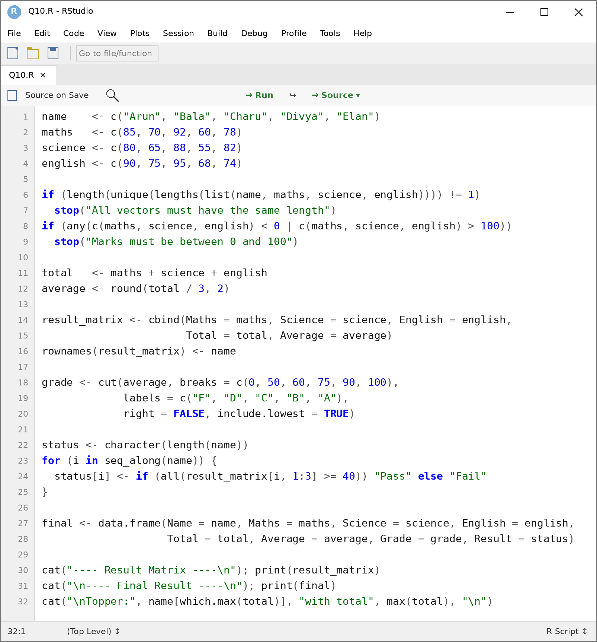
Output (RStudio Console)
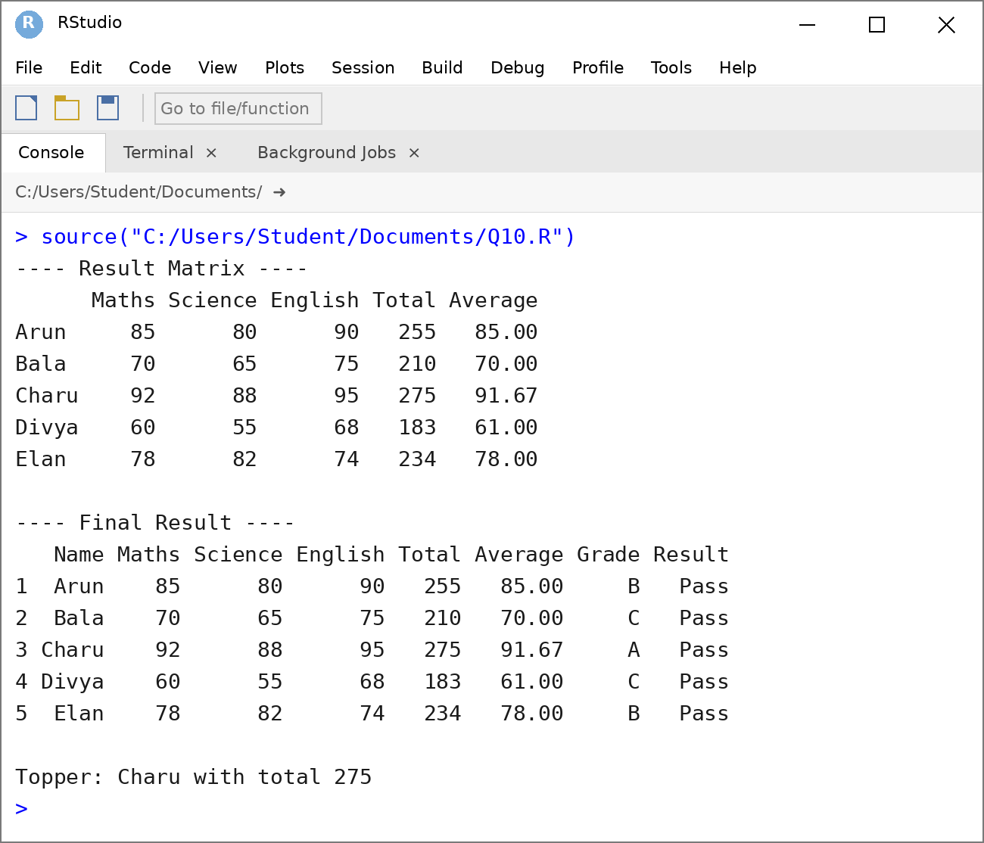

Code of Conduct:
I Kandath Haneesh 192324084 certify that this submission is my original work and that I have adhered to the guidelines specified for this assessment.
I understand that any violation of academic integrity rules will result in disciplinary action.
Signature of the student:Kandath Haneesh

Evaluation Rubric
Criteria | Weightage | Level 4 – Exemplary | Level 3 – Proficient | Level 2 – Developing | Level 1 – Beginning
Problem Understanding | 20% | Identifies all inputs, outputs, constraints accurately | Minor missing elements | Partial understanding | Incorrect interpretation
Algorithm Design | 30% | Complete, correct, and logically sound solution | Minor logical gaps | Partially correct logic | Incorrect approach
Use of Control Structures | 20% | Efficient and appropriate use of loops, conditions, functions/modules | Minor inefficiencies | Limited or basic usage | Incorrect or missing constructs
Pseudocode Structure | 10% | Well-structured, clear, consistent format, easy to follow | Mostly clear with minor issues | Difficult to follow in parts | Poorly structured and unclear
Completeness | 20% | Handles all cases; optimized approach | Handles most cases; reasonable efficiency | Handles basic cases only | Incomplete or inefficient

