INDIAN INSTITUTE OF INFORMATION TECHNOLOGY RAICHUR
PROJECT DOCUMENT
13-Class White Blood Cell Classification for Cancer Screening
Dataset Verification, Exploratory Data Analysis (EDA),
and Computer Networks Integration

Team Members | A. Haneeth  Nivrutha Varshini
Course | Digital Image Processing  Computer Networks
Faculty / Guides | Dr. Mehbub Alam  Dr. Koushiki Roy
Dataset | WBCBench 2026
Dataset Source | Hugging Face — Xin-Tian/wbcbench2026
Academic Year | 2026

Prepared for project work covering dataset verification, EDA and CN integration

1. Project Overview
The project investigates automated classification of peripheral-blood white blood cell (WBC) images into 13 fine-grained cell classes. The work is motivated by the potential use of WBC image analysis in leukemia screening and hematological research; the classification system is not presented as a standalone clinical diagnostic tool.
The project combines Digital Image Processing (DIP) activities—dataset inspection, image-level exploratory analysis and subsequent preprocessing—with a Computer Networks (CN) component in which a client can transmit a WBC image to a server for classification and receive the predicted class.

1.1 Objectives
- Obtain and inspect the WBCBench 2026 13-class WBC dataset from Hugging Face.
- Verify the class distribution against the reference paper before applying any cleaning or preprocessing.
- Perform exploratory data analysis (EDA) on the raw images and available metadata.
- Identify class imbalance, image-format information and image-quality characteristics.
- Define a DIP workflow for later cleaning, preprocessing and classification.
- Integrate Computer Networks concepts through a client–server image transmission and classification architecture.

2. Dataset Description
The selected dataset is WBCBench 2026 – Robust White Blood Cell Classification, hosted on Hugging Face as Xin-Tian/wbcbench2026. The dataset card describes it as a 13-class WBC image classification benchmark containing pristine and degraded images for robustness evaluation.
The dataset card identifies the following 13 labels: SNE, LY, MO, EO, BA, VLY, BNE, MMY, MY, PMY, BL, PC and PLY. It also records image bytes, image ID, class label, official split, severity, original image ID for degraded samples and a patient hash.
Code | WBC class | Description
SNE | Segmented neutrophil | Mature segmented neutrophil
LY | Lymphocyte | Lymphocyte
MO | Monocyte | Monocyte
EO | Eosinophil | Eosinophil
BA | Basophil | Basophil
VLY | Variant lymphocyte | Variant/atypical lymphocyte
BNE | Band-form neutrophil | Band-form neutrophil
MMY | Metamyelocyte | Metamyelocyte
MY | Myelocyte | Myelocyte
PMY | Promyelocyte | Promyelocyte
BL | Blast cell | Blast cell
PC | Plasma cell | Plasma cell
PLY | Prolymphocyte | Prolymphocyte

2.1 Dataset Structure and Metadata
- The Hugging Face release provides pristine and degraded configurations.
- Official splits include phase1_train, phase2_train, phase2_eval and phase2_test as applicable to each configuration.
- The image field contains JPEG image bytes and can be decoded as a PIL image using the Hugging Face Datasets library.
- The dataset card reports 493 unique patients and patient-level disjointness across official splits.
- The official ranking metric is macro-averaged F1 across all 13 classes.
- The degraded configuration contains pristine, mild, moderate and extreme severity levels.

3. Reference Paper and Distribution Verification
The uploaded reference paper is “Synergizing Deep Learning and Biological Heuristics for Extreme Long-Tail White Blood Cell Classification.” It states that WBCBench 2026 contains 55,012 peripheral blood smear images across 13 fine-grained WBC classes. Its Figure 1 shows the class distribution of the training set.
A crucial distinction is that the 13 bar values displayed in Figure 1 sum to 38,535. Therefore, the Figure 1 distribution should be treated as the reported training-set distribution, not as the total 55,012 images in the complete dataset.
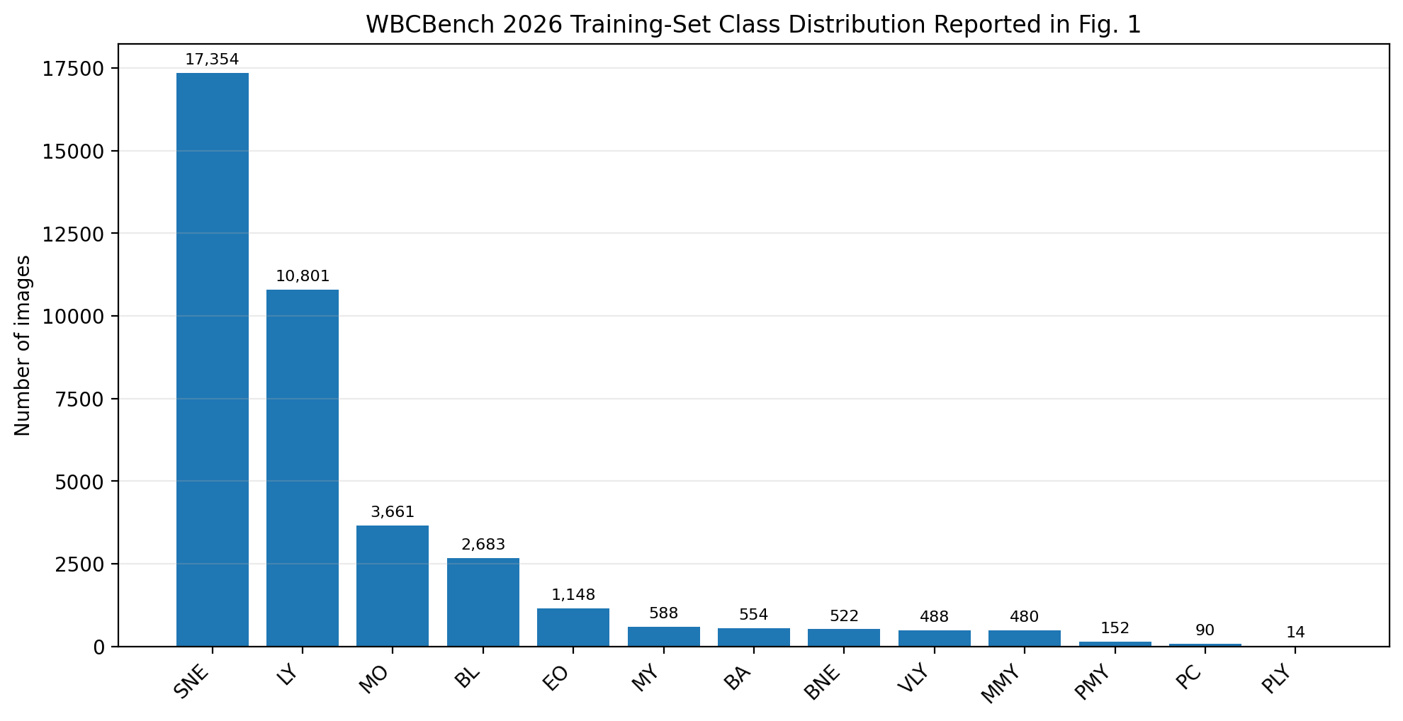
Figure 1. Training-set class distribution reported in the reference paper.
Class | Paper Fig. 1 count | Approx. share of Fig. 1 total | Verification status
SNE | 17,354 | 45.03% | Reference value
LY | 10,801 | 28.03% | Reference value
MO | 3,661 | 9.50% | Reference value
BL | 2,683 | 6.96% | Reference value
EO | 1,148 | 2.98% | Reference value
MY | 588 | 1.53% | Reference value
BA | 554 | 1.44% | Reference value
BNE | 522 | 1.35% | Reference value
VLY | 488 | 1.27% | Reference value
MMY | 480 | 1.25% | Reference value
PMY | 152 | 0.39% | Reference value
PC | 90 | 0.23% | Reference value
PLY | 14 | 0.04% | Reference value
The Figure 1 values sum to 38,535 images. The largest reported class is SNE with 17,354 images and the smallest is PLY with 14 images. The exact ratio between these two reported counts is approximately 1239.6:1, consistent with the paper's description of an approximately 1,200-fold long-tail imbalance.

3.1 Local-Copy Verification
The team's local analysis has now been completed for eight unique Parquet files across the analyzed official splits. These files contain 55,002 rows, and the 13 class labels and their counts were extracted programmatically. This local total covers the analyzed splits and should not be treated as the same scope as the 38,535-sample training distribution shown in Figure 1.
The reference-paper distribution is retained as a separate benchmark. The local all-split class distribution has been counted and plotted; further comparison with Figure 1 must account for the different data scope rather than treating the totals as directly equivalent.
Local counts from the eight unique analyzed Parquet files (55,002 rows): SNE 25,532; LY 15,100; MO 5,194; BL 3,568; EO 1,640; BA 857; MY 792; VLY 711; MMY 650; BNE 648; PMY 192; PC 102; PLY 16. These counts describe the analyzed local splits and are not a replacement for the reference-paper Figure 1 training-split values.

4. Exploratory Data Analysis (EDA)
EDA begins with the raw dataset so that its original characteristics are documented before any cleaning or preprocessing. The local row count and class distribution have been extracted; image-level checks, including resolution, channels and visual quality, remain to be completed.

4.1 Class Distribution
The reference training distribution is strongly long-tailed. The team's local analysis of eight unique Parquet files also shows an imbalanced distribution across the 13 classes. The local counts are kept distinct from the reference-paper Figure 1 counts because they cover a different scope of dataset splits.

4.2 Visual Inspection
- Inspect representative raw images from all 13 classes.
- Look for differences in staining, brightness, contrast and background.
- Check whether the target WBC is clearly visible and whether other blood cells or artifacts are present.
- Identify blur, noise, incomplete cells, overlapping cells and unusual crops.
- Do not remove suspicious images during the first inspection; record them first.

4.3 Resolution and Channel Analysis
The local Parquet files have been inspected and the label column has been counted. Image-level resolution and channel statistics still need to be calculated from decoded images; visual inspection is also required before cleaning or preprocessing.
EDA variable | What to calculate | Status
Resolution | Unique width × height combinations and counts | Pending: calculate from local images
Channels | RGB / grayscale / other channel configurations | Pending: calculate from local images
File/image format | JPEG and any other formats present after extraction | Check extracted image files
Image quality | Blur, noise, contrast, artifacts and cropping observations | Pending: visual inspection

4.4 Class Imbalance
Class imbalance is a central property of WBCBench 2026. The paper reports an approximately 1,200-fold difference between the dominant and rare classes. For the Figure 1 values, the exact SNE-to-PLY ratio is 17,354/14 ≈ 1,239.6.
This imbalance must be considered later during model training and evaluation. Accuracy alone would not adequately represent performance across all 13 classes; macro-F1 is the official WBCBench evaluation metric.

4.5 EDA Summary
Item | Finding from available sources | Next local-data action
Number of classes | 13 labels identified in local copy | Class labels and counts extracted
Overall dataset size | 55,002 rows across eight unique analyzed Parquet files | Local count completed; scope differs from paper total
Figure 1 training distribution | 38,535 samples across 13 classes in paper Figure 1 | Retain separately from local all-split count
Class imbalance | Extreme long-tail; local counts also imbalanced | Consider imbalance during later training/evaluation
Image representation | JPEG image bytes in Hugging Face schema | Decode representative images
Resolution | Resolution not yet summarized | Calculate width/height histogram
Visual quality | Paper notes background/staining artifacts | Inspect representative samples

5. Boundary Before Cleaning
Cleaning should begin only after dataset identity and distribution have been verified. The first cleaning stage can then address issues discovered during EDA, such as unreadable files, accidental duplicates, corrupted images or clearly invalid samples. Cleaning decisions should be documented so that the original dataset remains traceable.
- Do not resize images merely to make them uniform before recording the original dimensions.
- Do not remove minority-class samples simply because the class is small.
- Do not perform augmentation before establishing the raw class distribution.
- Keep a record of every removed, corrected or transformed sample.
- Preserve the original dataset separately from the cleaned/preprocessed copy.

6. Proposed DIP Workflow
- Acquire/load the WBCBench 2026 dataset.
- Verify the 13 class labels and class counts against the reference paper.
- Perform EDA on the raw images.
- Apply documented cleaning only after EDA.
- Standardize image dimensions during preprocessing if required by the selected classifier.
- Apply suitable normalization and, where justified, augmentation.
- Train a 13-class WBC image classifier.
- Evaluate using class-wise metrics and macro-F1 in addition to overall accuracy.
- Analyse confusion between visually similar WBC classes.

7. Computer Networks Integration
The CN component is designed as a client–server extension of the WBC classification system. The image-processing/classification model remains the application logic, while the network layer provides communication between the image-sending client and the classification server.
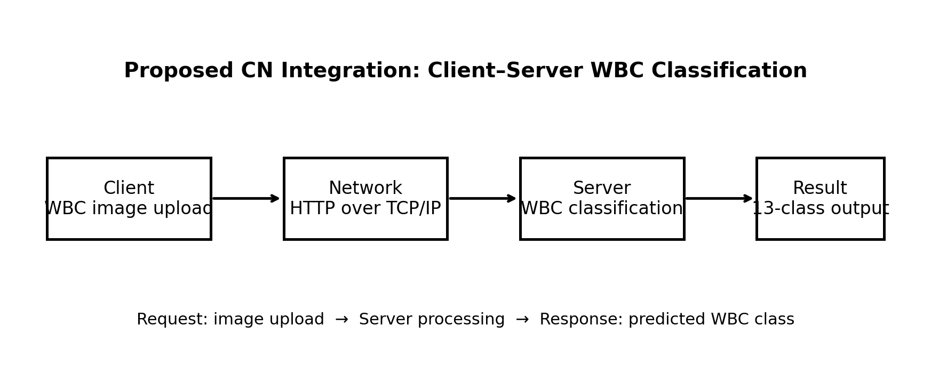
Figure 2. Proposed client–server architecture for CN integration.

7.1 Client Side
- The client selects or uploads a WBC image.
- The client sends the image to the server as an application-layer request.
- The client waits for the classification response.
- The received WBC class is displayed to the user.

7.2 Server Side
- The server receives the image request.
- The server performs the required preprocessing.
- The trained 13-class WBC classifier processes the image.
- The server returns the predicted class and, optionally, confidence information.

7.3 CN Concepts Demonstrated
CN concept | Project implementation | Purpose
Client–server model | Client uploads image; server classifies it | Separates user interface from processing
Application layer | HTTP request/response API | Transfers image and prediction
Transport layer | TCP carries the HTTP connection | Reliable delivery of image data
Internet layer | IP addressing between client and server | Logical host-to-host delivery
Performance | Measure request/response latency and throughput | Relate network performance to application use

7.4 Proposed Communication Sequence
- Client establishes communication with the server.
- Client sends an HTTP request containing the WBC image.
- TCP provides reliable transport for the HTTP data.
- Server receives and decodes the image.
- Server runs the WBC classification pipeline.
- Server sends the predicted class in an HTTP response.
- Client displays the classification result.
- Optional: record network latency, response size and throughput for CN analysis.

8. Current Status and Next Work
The dataset identity, local Parquet structure and 13 class labels have been checked. Eight unique local Parquet files across the analyzed official splits contain 55,002 rows. The local class counts were extracted programmatically and a descending class-distribution graph with count labels was generated. The reference-paper Figure 1 training distribution is retained separately because it represents 38,535 samples rather than the local all-split total.
Image-level EDA remains in progress. Resolution and channel statistics, along with representative visual inspection across the 13 classes, still need to be completed. Cleaning, preprocessing, classifier training and evaluation have not been recorded as completed in this document.

Immediate next actions
- Sample images from every class and record visual observations.
- Generate image-resolution and channel statistics from the local copy.
- Record any image-quality issues without deleting images yet.
- Review the raw EDA findings and document any required cleaning decisions.
- Proceed to cleaning and preprocessing only after the raw EDA baseline is preserved.
- Design and train the 13-class WBC image classifier.
- Evaluate with class-wise metrics and macro-F1 in addition to overall accuracy.
- Implement the proposed client–server CN module after the classifier interface is stable.

Appendix A. Dataset Counting and Basic EDA Code
The following code follows the dataset card's Hugging Face loading approach. It is intended for the team's authenticated local environment and should be run on the exact split being used for the project.
from datasets import load_dataset
from collections import Counter
import numpy as np
REPO = "Xin-Tian/wbcbench2026"
ds = load_dataset(REPO, "pristine", split="phase2_train")
counts = Counter(ds["label"])
print("Total images:", len(ds))
print("\nClass counts:")
for label, count in sorted(counts.items()):
print(f"{label}: {count}")
print("\nResolutions:")
resolution_counts = Counter()
channel_counts = Counter()
for row in ds:
img = row["image"]
resolution_counts[img.size] += 1
channel_counts[len(img.getbands())] += 1
print(resolution_counts)
print("\nChannels:", channel_counts)

Appendix B. Reference Distribution Values
These values are transcribed from Figure 1 of the uploaded reference paper and are used for the local-copy verification step.
SNE 17,354 | LY 10,801 | MO 3,661 | BL 2,683 | EO 1,148 | MY 588 | BA 554 | BNE 522 | VLY 488 | MMY 480 | PMY 152 | PC 90 | PLY 14.

References
- Tian, X., Ma, X., Yang, T., Achim, A., Papiez, B., Watanaboonyongcharoen, P., & Anantrasirichai, N. “WBCBench 2026: A Challenge for Robust White Blood Cell Classification Under Class Imbalance.” 2026 IEEE International Symposium on Biomedical Imaging (ISBI), 2026.
- Nguyen, D. T., Nguyen, H.-L., & Pham, H.-H. “Synergizing Deep Learning and Biological Heuristics for Extreme Long-Tail White Blood Cell Classification.” arXiv:2603.16249v4, 2026. This is the uploaded reference paper used for Figure 1 distribution verification.
- WBCBench 2026 Hugging Face dataset: https://huggingface.co/datasets/Xin-Tian/wbcbench2026
Pending Documentation Update

