**User Stories – Iteration 1**

Feature: Manage Users Page

Scenario: Access Manage Users Page

Given I am an administer of the AggieSTEM website

When I am on the Home Page

Then I should see the Manage Users button

When I press the Manage Users button

Then I should be on the Manage Users page

Feature: Manage Users Page

Scenario: View Manage Users Page

Given I am an administer of the AggieSTEM website

When I am on the Manage Users Page

Then I should see the Message Users button

And I should see table of all website users

And I should see add and delete buttons

Feature: Message Users

Scenario: View Message Users Page

Given I am an administer of the AggieSTEM website

When I am on the Manage Users Page

Then I should see the Message Users button

When I press the Message Users button

Then I should be on the Message Users Page

Feature: Message Users

Scenario: Send Message

Given I am an administer of the AggieSTEM website

When I am on the Message Users Page

Then I should see TO text box

And I should see Message text box

And I should see Send button

When I type username or email into TO text box

And I type message into Message text box

And I press Send button

Then a SMS messages to users listed in TO text box with body from Message text box

Feature: Message Users

Scenario: Send Scheduled Message

Given I am an administer of the AggieSTEM website

When I am on the Message Users Page

Then I should see Scheduled Send button

When I press Scheduled Send button

Then I should be on Scheduled Send page

And I should see time field boxes

And I should see send button

**Storyboard/LoFi mockups**

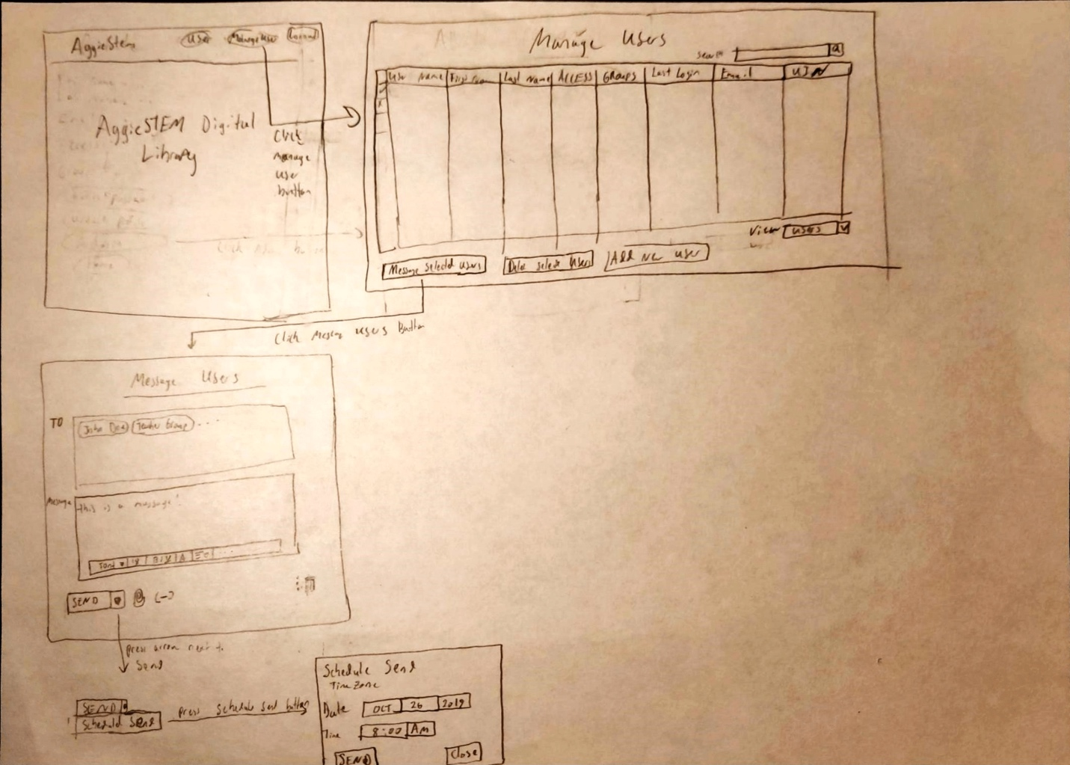

**User Stories**: Manage Group

Feature: Manage Group Page

Scenario: Access Manage Groups Page with admin privilege

Given I login as an administer of the AggieSTEM website

When I am on the Home Page

Then I should see the Manage Group button

When I press the Manage Group button

Then I should be on the Manage Groups page

Feature: Manage Group Page

Scenario: Access Manage Groups Page Without admin privilege

Given I am a normal user of the AggieSTEM website

When I am on the Home Page

Then I should NOT see the Manage Group button

Feature: Create New Group

Scenario: Create a new group in manage group page

Given I am on the Manage Group Page

Then I should see the Create New Group button

When I press the Create New Group button

Then I should see a new group being created on the Mange Group Page

Feature: Duplicate a Group

Scenario: Create a new group by duplicating an existing group

Given I am on the Manage Group Page

Then I should see a list of groups

When I click on a group

and I should see a Duplicate Group button

When I press the Duplicate Group Button

Then I should see a duplicate of that group shown on the page

Feature: Add New Member

Scenario: Select a new member to be added to the group

Given I am on the Manage Group Page

Then I should see a list of groups

When I select a group

Then I should see an Add New Member Button

When I press the Add New Member Button

Then I should see a list of users

When I select a user

Then I should see that user being added to the group

Feature: Delete a Group Member

Scenario: Select a group member to be deleted from the group

Given I am on the Manage Group Page

Then I should see a list of groups

When I click on a group

Then I should see a list of group members

and I should see a Delete Group Member button

When I press the Delete Group Member Button

Then I should see that user being removed from the group

**Storyboard/LoFi mockups**

**Updated Story/LoFi (Iteration 0) Base on Customer Feedback**

Feature: Register new user

Scenario: User registers a new account

Given I am a new user on the AggieSTEM login/register page

When I fill in all account credentials including ~~first/last name~~ **username (first initial + last name),** password, **phone number**, and email.

And I press “Register”

Then I should be on the AggieSTEM home page

And I should see an “New user created, check your email to complete registration” message

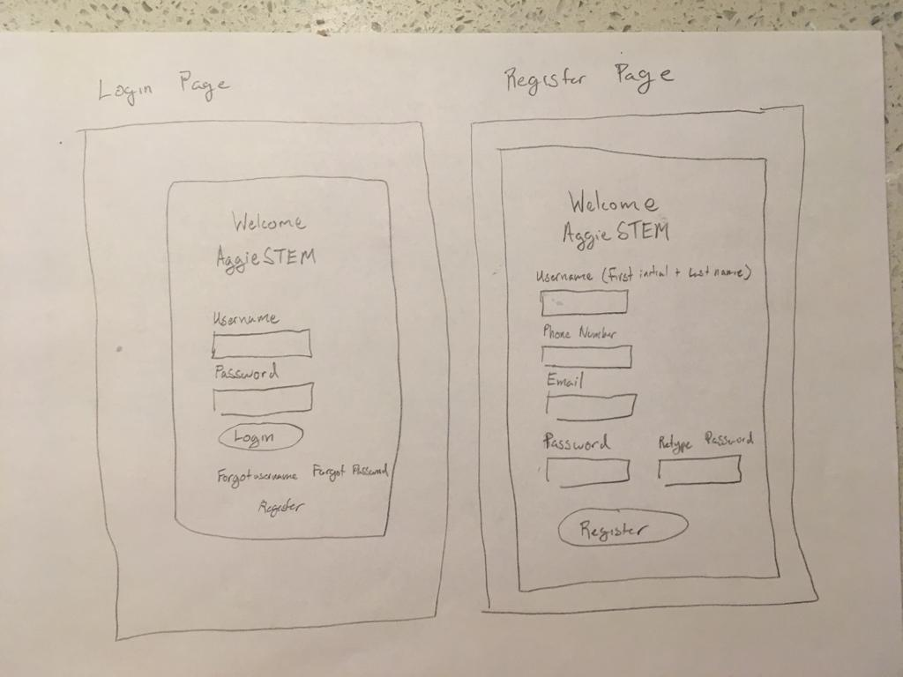

Login and Register are now separate pages instead of two tabs on a single page.