**Name**: Haneen Mahmoud Said Mansour

**B.N**: 308

**Topic**: Programming languages

**GitHub Link:** [**https://github.com/HanenMahmoud/ECE001**](https://github.com/HanenMahmoud/ECE001)

**GitHub Page:** <https://hanenmahmoud.github.io/ECE001/>.

*Programming languages:*

[Programming languages](https://www.britannica.com/technology/computer-programming-language) are the languages with which a programmer [implements](https://www.merriam-webster.com/dictionary/implements) a piece of [software](https://www.britannica.com/technology/software) to run on a computer. The earliest programming languages were [assembly languages](https://www.britannica.com/technology/assembly-language), not far removed from the [binary](https://www.britannica.com/science/binary-number-system)-encoded instructions directly executed by the computer. By the mid-1950s, programmers began to use higher-level languages.

programming language for AI applications. Successors to LISP in the AI community include Scheme, Prolog, and C and C++ (see below). Scheme is similar to LISP except that it has a more formal mathematical definition*.*

*Applications of Programming languages:*

Programming languages and computer coding have made life simpler for us. Whether it’s automobiles, banks, home appliances, or hospitals, every aspect of our lives depends on codes. No wonder, coding is one of the core skills required by most well-paying jobs today. Coding skills are especially of value in the IT, data analytics, research, web designing, and engineering segments.

*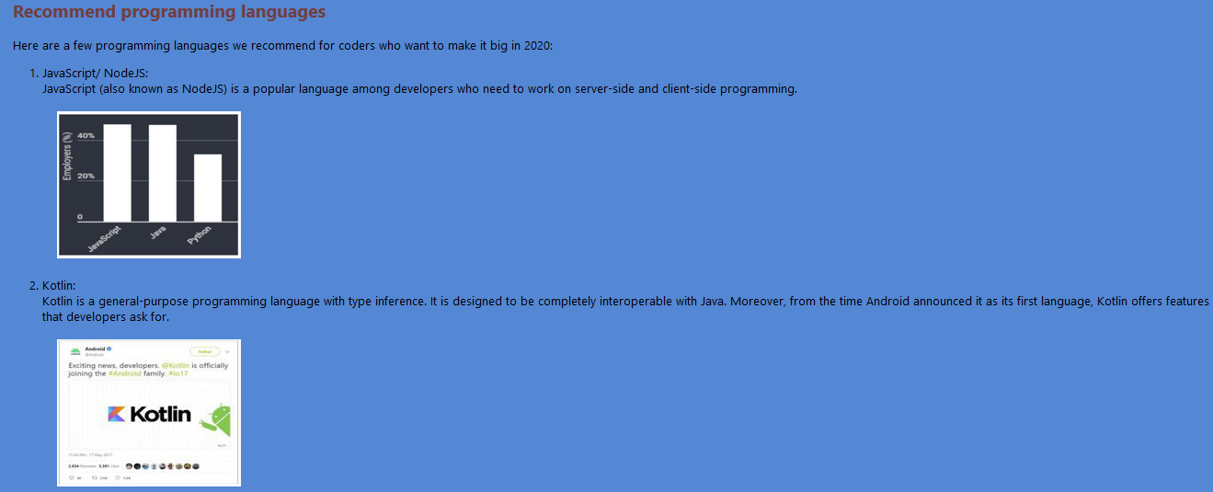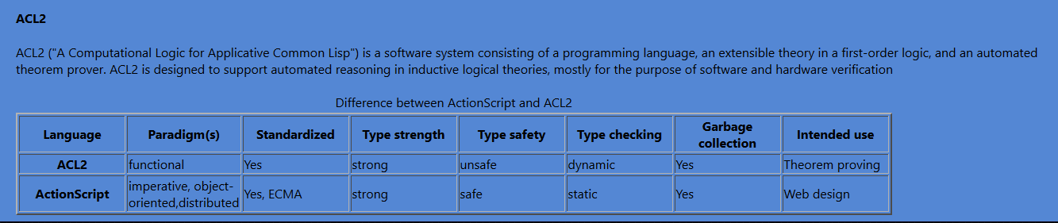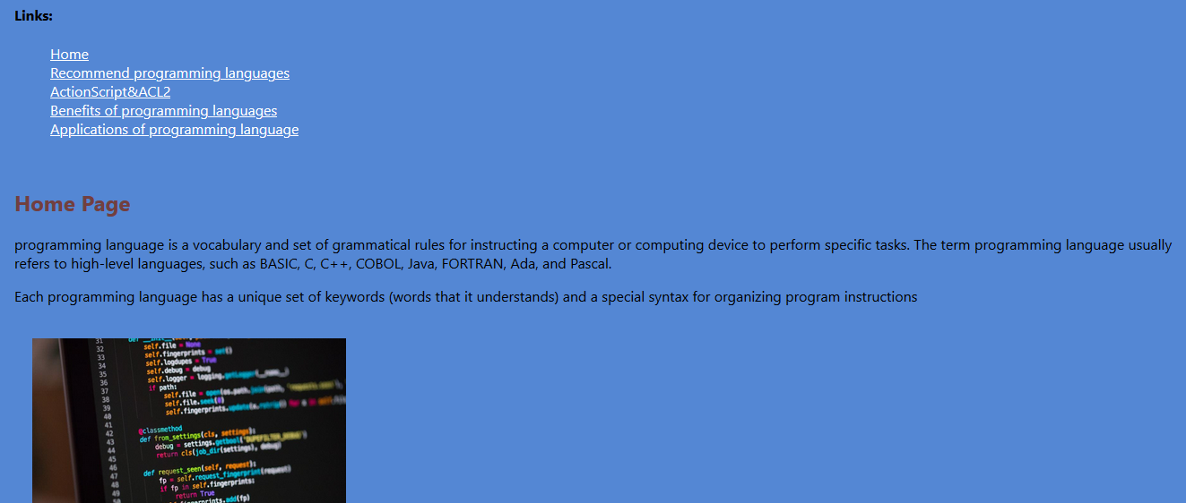Screenshots:*

*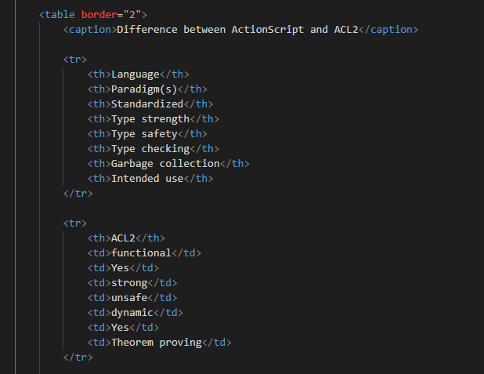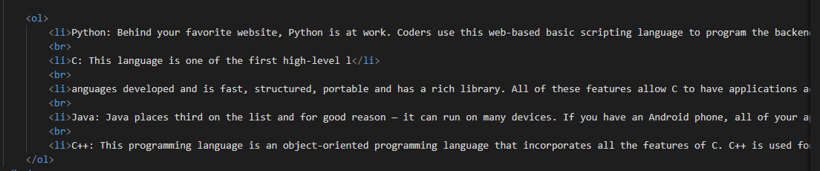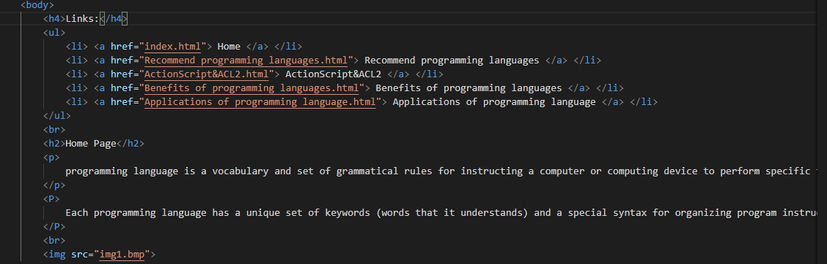Source Code:*