Exercise 1: Control Structures

Scenario 1: The bank wants to apply a discount to loan interest rates for customers above 60 years old.
Question: Write a PL/SQL block that loops through all customers, checks their age, and if they are above 60, apply a 1% discount to their current loan interest rates.
Schema to be created:
CREATE TABLE Customers (
CustomerID NUMBER PRIMARY KEY,
Name VARCHAR2(100),
DOB DATE,
Balance NUMBER,
LastModified DATE
);

CREATE TABLE Accounts (
AccountID NUMBER PRIMARY KEY,
CustomerID NUMBER,
AccountType VARCHAR2(20),
Balance NUMBER,
LastModified DATE,
FOREIGN KEY (CustomerID) REFERENCES Customers(CustomerID)
);

CREATE TABLE Transactions (
TransactionID NUMBER PRIMARY KEY,
AccountID NUMBER,
TransactionDate DATE,
Amount NUMBER,
TransactionType VARCHAR2(10),
FOREIGN KEY (AccountID) REFERENCES Accounts(AccountID)
);

CREATE TABLE Loans (
LoanID NUMBER PRIMARY KEY,
CustomerID NUMBER,
LoanAmount NUMBER,
InterestRate NUMBER,
StartDate DATE,
EndDate DATE,
FOREIGN KEY (CustomerID) REFERENCES Customers(CustomerID)
);

CREATE TABLE Employees (
EmployeeID NUMBER PRIMARY KEY,
Name VARCHAR2(100),
Position VARCHAR2(50),
Salary NUMBER,
Department VARCHAR2(50),
HireDate DATE
);

Example Scripts for Sample Data Insertion

INSERT INTO Customers (CustomerID, Name, DOB, Balance, LastModified)
VALUES (1, 'John Doe', TO_DATE('1985-05-15', 'YYYY-MM-DD'), 1000, SYSDATE);

INSERT INTO Customers (CustomerID, Name, DOB, Balance, LastModified)
VALUES (2, 'Jane Smith', TO_DATE('1990-07-20', 'YYYY-MM-DD'), 1500, SYSDATE);

INSERT INTO Accounts (AccountID, CustomerID, AccountType, Balance, LastModified)
VALUES (1, 1, 'Savings', 1000, SYSDATE);

INSERT INTO Accounts (AccountID, CustomerID, AccountType, Balance, LastModified)
VALUES (2, 2, 'Checking', 1500, SYSDATE);

INSERT INTO Transactions (TransactionID, AccountID, TransactionDate, Amount, TransactionType)
VALUES (1, 1, SYSDATE, 200, 'Deposit');

INSERT INTO Transactions (TransactionID, AccountID, TransactionDate, Amount, TransactionType)
VALUES (2, 2, SYSDATE, 300, 'Withdrawal');

INSERT INTO Loans (LoanID, CustomerID, LoanAmount, InterestRate, StartDate, EndDate)
VALUES (1, 1, 5000, 5, SYSDATE, ADD_MONTHS(SYSDATE, 60));

INSERT INTO Employees (EmployeeID, Name, Position, Salary, Department, HireDate)
VALUES (1, 'Alice Johnson', 'Manager', 70000, 'HR', TO_DATE('2015-06-15', 'YYYY-MM-DD'));

INSERT INTO Employees (EmployeeID, Name, Position, Salary, Department, HireDate)
VALUES (2, 'Bob Brown', 'Developer', 60000, 'IT', TO_DATE('2017-03-20', 'YYYY-MM-DD'));
Program:
SET SERVEROUTPUT ON;

DECLARE
v_age NUMBER;
v_name Customers.Name%TYPE;
v_loan_count NUMBER;
v_updated BOOLEAN := FALSE;
BEGIN
FOR cust IN (SELECT CustomerID, Name, DOB FROM Customers) LOOP
-- Calculate age
v_age := TRUNC(MONTHS_BETWEEN(SYSDATE, cust.DOB) / 12);

IF v_age > 60 THEN
-- Count loans for the customer
SELECT COUNT(*) INTO v_loan_count
FROM Loans
WHERE CustomerID = cust.CustomerID;
IF v_loan_count > 0 THEN
-- Apply 1% discount to interest rate
UPDATE Loans
SET InterestRate = InterestRate - 1
WHERE CustomerID = cust.CustomerID;
-- Show output
DBMS_OUTPUT.PUT_LINE('Customer "' || cust.Name || '" (Age: ' || v_age || ') received a 1% interest rate discount.');
v_updated := TRUE;
END IF;
END IF;
END LOOP;
IF NOT v_updated THEN
DBMS_OUTPUT.PUT_LINE('No customers over 60 with active loans found.');
END IF;
COMMIT;
END;
/
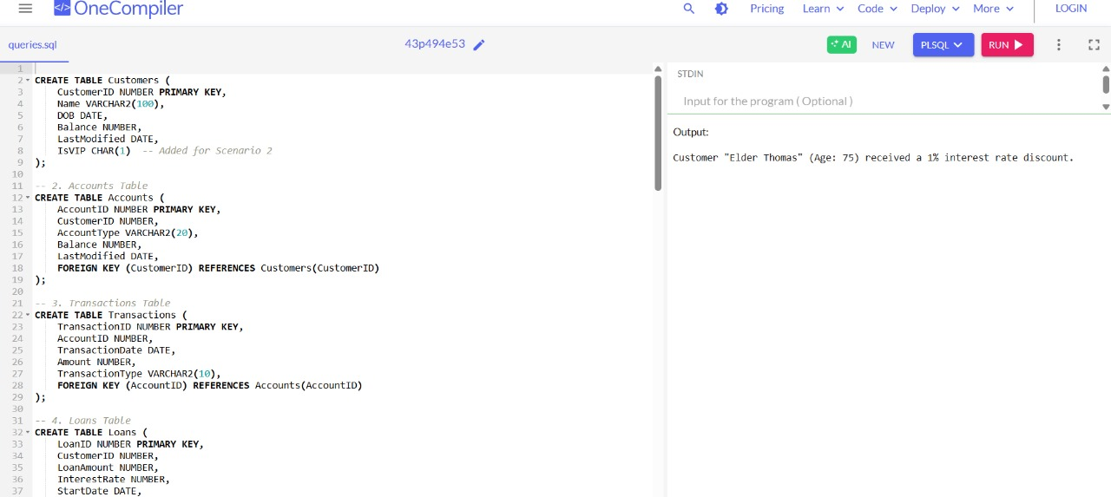
Scenario 2: A customer can be promoted to VIP status based on their balance.
Question: Write a PL/SQL block that iterates through all customers and sets a flag IsVIP to TRUE for those with a balance over $10,000.
Program:
SET SERVEROUTPUT ON;
BEGIN
FOR cust IN (SELECT CustomerID, Name, Balance FROM Customers) LOOP
IF cust.Balance > 10000 THEN
UPDATE Customers
SET IsVIP = 'Y'
WHERE CustomerID = cust.CustomerID;

DBMS_OUTPUT.PUT_LINE('Customer "' || cust.Name || '" marked as VIP.');
END IF;
END LOOP;
COMMIT;
END;
/
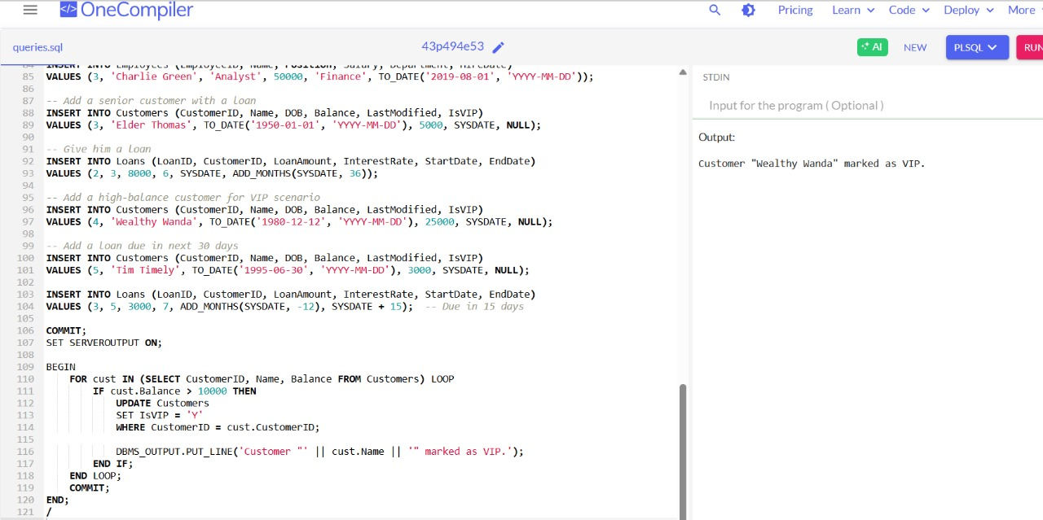

Scenario 3: The bank wants to send reminders to customers whose loans are due within the next 30 days.
Question: Write a PL/SQL block that fetches all loans due in the next 30 days and prints a reminder message for each customer.
Program:
SET SERVEROUTPUT ON;
BEGIN
FOR loan IN (
SELECT L.LoanID, C.Name, L.EndDate
FROM Loans L
JOIN Customers C ON C.CustomerID = L.CustomerID
WHERE L.EndDate BETWEEN SYSDATE AND SYSDATE + 30
) LOOP
DBMS_OUTPUT.PUT_LINE('Reminder: Loan #' || loan.LoanID || ' for customer "' || loan.Name ||
'" is due on ' || TO_CHAR(loan.EndDate, 'YYYY-MM-DD') || '.');
END LOOP;
END;
/
