Exercise 3: Stored Procedures

Scenario 1: The bank needs to process monthly interest for all savings accounts.
Question: Write a stored procedure ProcessMonthlyInterest that calculates and updates the balance of all savings accounts by applying an interest rate of 1% to the current balance.
Schema to be created:
CREATE TABLE Customers (
CustomerID NUMBER PRIMARY KEY,
Name VARCHAR2(100),
DOB DATE,
Balance NUMBER,
LastModified DATE
);

CREATE TABLE Accounts (
AccountID NUMBER PRIMARY KEY,
CustomerID NUMBER,
AccountType VARCHAR2(20),
Balance NUMBER,
LastModified DATE,
FOREIGN KEY (CustomerID) REFERENCES Customers(CustomerID)
);

CREATE TABLE Transactions (
TransactionID NUMBER PRIMARY KEY,
AccountID NUMBER,
TransactionDate DATE,
Amount NUMBER,
TransactionType VARCHAR2(10),
FOREIGN KEY (AccountID) REFERENCES Accounts(AccountID)
);

CREATE TABLE Loans (
LoanID NUMBER PRIMARY KEY,
CustomerID NUMBER,
LoanAmount NUMBER,
InterestRate NUMBER,
StartDate DATE,
EndDate DATE,
FOREIGN KEY (CustomerID) REFERENCES Customers(CustomerID)
);

CREATE TABLE Employees (
EmployeeID NUMBER PRIMARY KEY,
Name VARCHAR2(100),
Position VARCHAR2(50),
Salary NUMBER,
Department VARCHAR2(50),
HireDate DATE
);

Example Scripts for Sample Data Insertion

INSERT INTO Customers (CustomerID, Name, DOB, Balance, LastModified)
VALUES (1, 'John Doe', TO_DATE('1985-05-15', 'YYYY-MM-DD'), 1000, SYSDATE);

INSERT INTO Customers (CustomerID, Name, DOB, Balance, LastModified)
VALUES (2, 'Jane Smith', TO_DATE('1990-07-20', 'YYYY-MM-DD'), 1500, SYSDATE);

INSERT INTO Accounts (AccountID, CustomerID, AccountType, Balance, LastModified)
VALUES (1, 1, 'Savings', 1000, SYSDATE);

INSERT INTO Accounts (AccountID, CustomerID, AccountType, Balance, LastModified)
VALUES (2, 2, 'Checking', 1500, SYSDATE);

INSERT INTO Transactions (TransactionID, AccountID, TransactionDate, Amount, TransactionType)
VALUES (1, 1, SYSDATE, 200, 'Deposit');

INSERT INTO Transactions (TransactionID, AccountID, TransactionDate, Amount, TransactionType)
VALUES (2, 2, SYSDATE, 300, 'Withdrawal');

INSERT INTO Loans (LoanID, CustomerID, LoanAmount, InterestRate, StartDate, EndDate)
VALUES (1, 1, 5000, 5, SYSDATE, ADD_MONTHS(SYSDATE, 60));

INSERT INTO Employees (EmployeeID, Name, Position, Salary, Department, HireDate)
VALUES (1, 'Alice Johnson', 'Manager', 70000, 'HR', TO_DATE('2015-06-15', 'YYYY-MM-DD'));

INSERT INTO Employees (EmployeeID, Name, Position, Salary, Department, HireDate)
VALUES (2, 'Bob Brown', 'Developer', 60000, 'IT', TO_DATE('2017-03-20', 'YYYY-MM-DD'));
Program:
CREATE OR REPLACE PROCEDURE ProcessMonthlyInterest IS
BEGIN
FOR acc IN (
SELECT AccountID, Balance
FROM Accounts
WHERE AccountType = 'Savings'
) LOOP
UPDATE Accounts
SET Balance = acc.Balance * 1.01,
LastModified = SYSDATE
WHERE AccountID = acc.AccountID;
END LOOP;

COMMIT;
DBMS_OUTPUT.PUT_LINE('Interest applied to all savings accounts.');
END;
/
To run:
BEGIN
ProcessMonthlyInterest;
END;
/
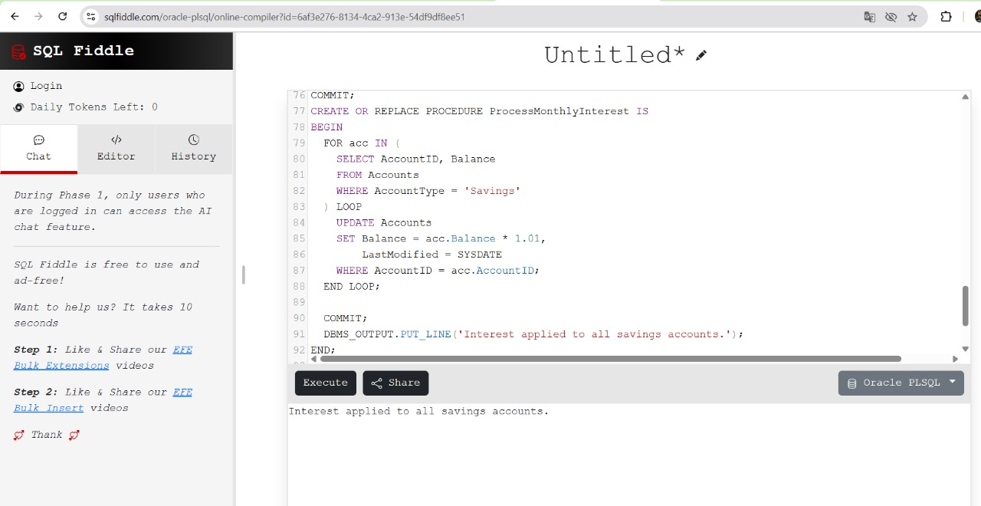

Scenario 2: The bank wants to implement a bonus scheme for employees based on their performance.
Question: Write a stored procedure UpdateEmployeeBonus that updates the salary of employees in a given department by adding a bonus percentage passed as a parameter.
Program:
CREATE OR REPLACE PROCEDURE UpdateEmployeeBonus (
dept_name IN VARCHAR2,
bonus_percent IN NUMBER
) IS
BEGIN
UPDATE Employees
SET Salary = Salary + (Salary * bonus_percent / 100)
WHERE Department = dept_name;

COMMIT;
DBMS_OUTPUT.PUT_LINE('Bonus applied to department: ' || dept_name);
END;
/
To run:
BEGIN
UpdateEmployeeBonus('IT', 10); -- Adds 10% bonus to IT department salaries
END;
/
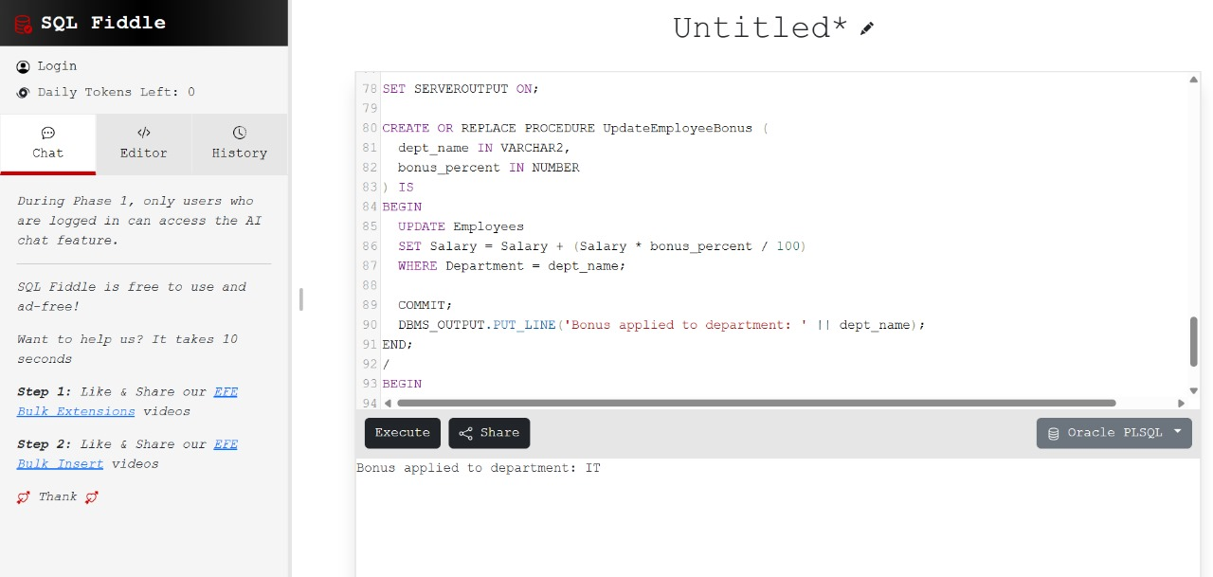

Scenario 3: Customers should be able to transfer funds between their accounts.
Question: Write a stored procedure TransferFunds that transfers a specified amount from one account to another, checking that the source account has sufficient balance before making the transfer.
Program:
CREATE OR REPLACE PROCEDURE TransferFunds (
from_account_id IN NUMBER,
to_account_id IN NUMBER,
transfer_amount IN NUMBER
) IS
insufficient_balance EXCEPTION;
src_balance Accounts.Balance%TYPE;
BEGIN
-- Get source balance
SELECT Balance INTO src_balance FROM Accounts WHERE AccountID = from_account_id FOR UPDATE;

-- Check balance
IF src_balance < transfer_amount THEN
RAISE insufficient_balance;
END IF;

-- Deduct from source
UPDATE Accounts
SET Balance = Balance - transfer_amount,
LastModified = SYSDATE
WHERE AccountID = from_account_id;

-- Add to destination
UPDATE Accounts
SET Balance = Balance + transfer_amount,
LastModified = SYSDATE
WHERE AccountID = to_account_id;

COMMIT;

DBMS_OUTPUT.PUT_LINE('Transfer of $' || transfer_amount || ' completed from Account ' || from_account_id || ' to Account ' || to_account_id);

EXCEPTION
WHEN insufficient_balance THEN
DBMS_OUTPUT.PUT_LINE('Transfer failed: insufficient funds in Account ' || from_account_id);
ROLLBACK;
WHEN NO_DATA_FOUND THEN
DBMS_OUTPUT.PUT_LINE('Transfer failed: one of the account IDs not found.');
ROLLBACK;
END;
/
To run:
BEGIN
TransferFunds(1, 2, 100); -- Transfers $100 from Account 1 to 2
END;
/
