The Eye of AI: Embedded AI Reality Bridge
AI之眼：连接现实世界的多模态 AI 原型机

Group member(s): ________________________________

1.1 The Background and Motivation of System
After a long cycle of development, AI has evolved from IDE-based code completion tools, to web chatbots such as ChatGPT, and then to desktop agents represented by Codex that can read files, browse the web, and manipulate local workspaces. However, most AI systems are still trapped inside the computer screen. They can reason about the world, but they cannot directly perceive and respond to the physical world around users. Based on this limitation, our project proposes The Eye of AI, a multimodal embedded prototype that gives AI an 'eye' and a 'bridge' to reality. Instead of building a final smart-glasses product, we focus on validating the core abilities that smart glasses should possess: scene perception, voice interaction, physical triggering, cloud reasoning, and local feedback. By combining Raspberry Pi, NUCLEO, camera, microphone, LCD, status light, keypad, Qwen, and DeepSeek, the system enables AI to observe the current environment, understand speech commands, make decisions, and return synchronized feedback on embedded hardware and desktop software. Therefore, the project demonstrates a meaningful transition from screen-bound AI to embodied AI interaction.
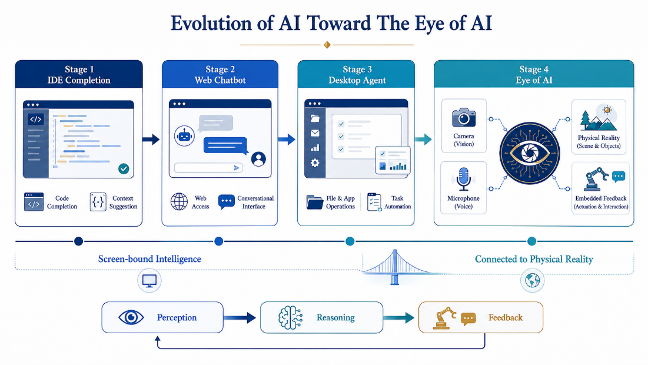
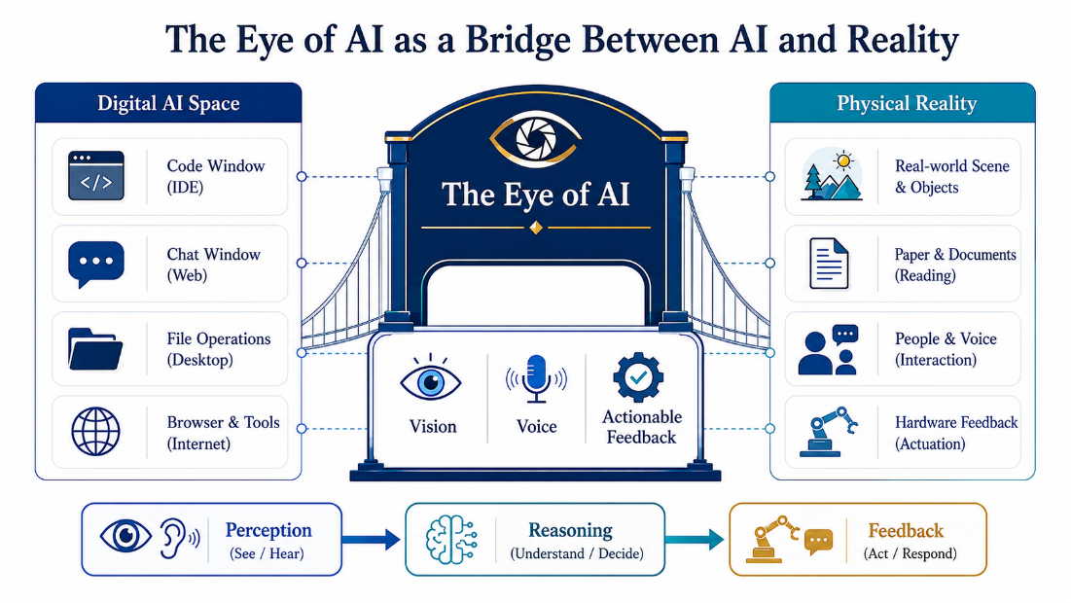
1.2 System Objectives
1.2.1 Basic Process
The subject of the system is an embedded multimodal AI prototype. The basic process of using the system is: physical trigger - voice capture - scene capture - multimodal understanding - final reasoning - embedded/Desktop feedback - ready for the next trigger.
Trigger:
The user presses the three-key keypad K-B or the NUCLEO blue button to start a new interaction cycle. The trigger is transmitted to the Raspberry Pi bridge through serial communication.
Perception:
After the trigger, the Raspberry Pi activates Logitech C270 to capture voice and image data. Qwen ASR converts speech to text, and Qwen Vision interprets the current frame when visual context is required.
Reasoning:
DeepSeek receives the text-only or multimodal prompt and is responsible for final answer composition, continuous dialogue context, and high-level decision making.
Feedback:
The system outputs synchronized results to the Raspberry Pi terminal, the LCD attached to the prototype, the status light, and the Windows Control Center. The user can then trigger another round, forming a complete interaction loop.
The desktop control center functions are as follows.
Real-time conversation area: display synchronized user input, current image, and final AI answer.
History area: save completed sessions and allow users to resume an earlier conversation.
Connection diagnostics area: inspect SSH, serial, camera, microphone, API configuration, LCD, keypad, and recent files.
Agent interaction area: accept free-form user requests and support both plain-text and multimodal question answering.
1.2.2 Flowchart of partial function implementation
(A) Deployment topology of the prototype system.
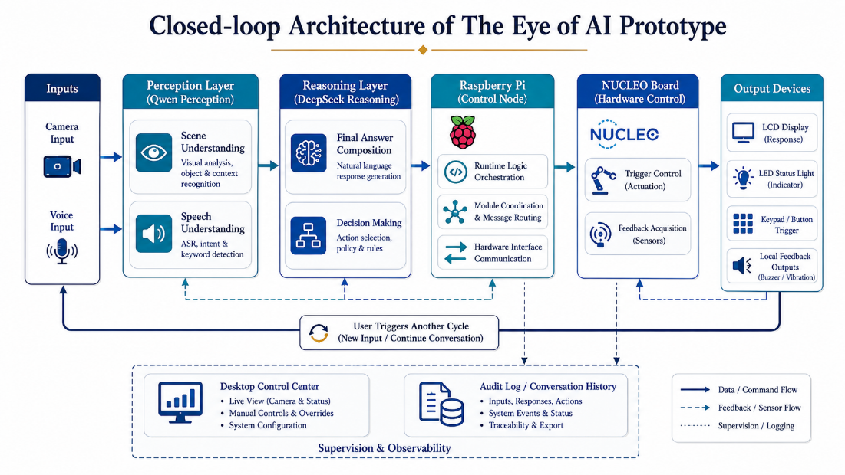
(B) Single interaction workflow and fallback path.
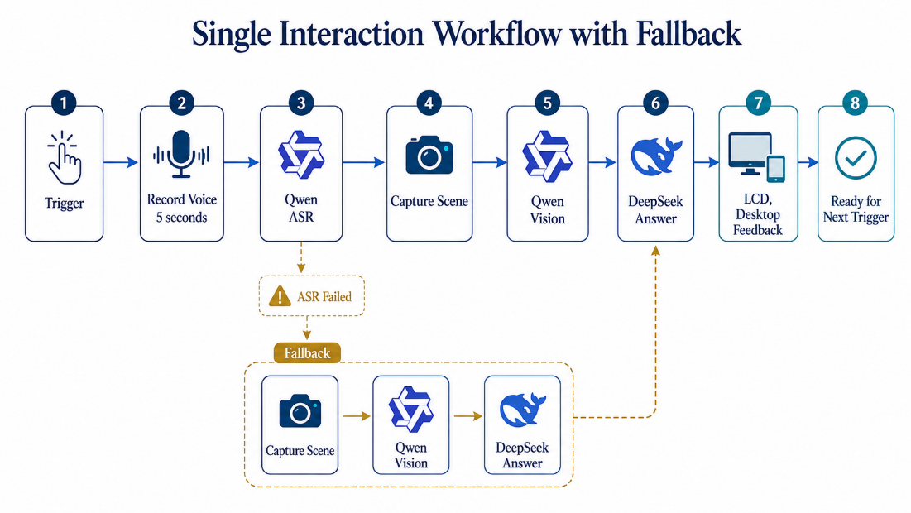
(C) Prototype scope and current boundary of validated functions.
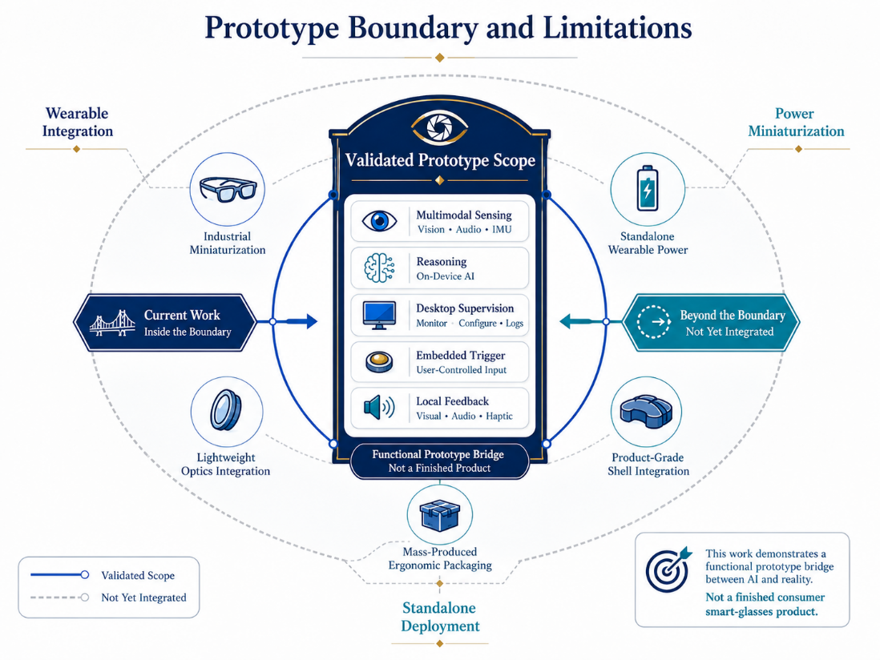
(D) Demonstration evidence of hardware setup, captured scene, and system feedback.
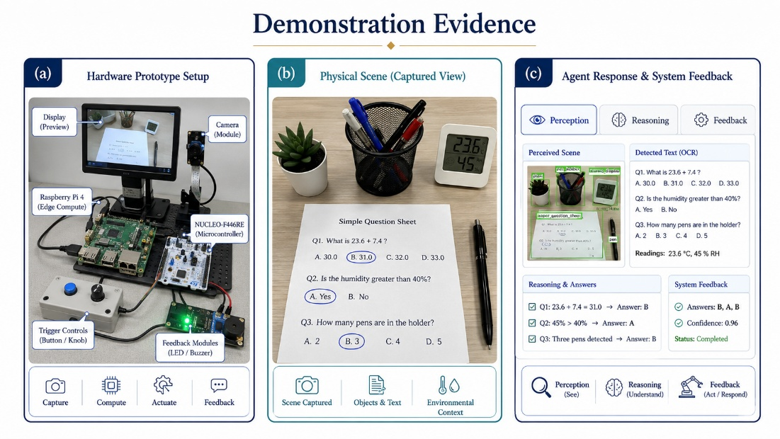
1.2.3 Other objectives.
(A) Interface design objectives.
Page content: The desktop application should present the AI workflow clearly, keep the conversation area immersive, and keep hardware diagnosis readable in presentation scenarios.
Navigation structure: The page must allow users to switch quickly among real-time dialogue, history, camera view, logs, settings, and diagnostics.
Technical environment: The software should run on Windows and communicate with Raspberry Pi through SSH while preserving readability and stable rendering.
Artistic style: The interface should be modern and visually impressive, because one of the project goals is to make the AI-to-reality bridge intuitive during classroom demonstrations.
(B) Response requirements:
When a user triggers the system, the prototype should enter the recording state immediately, provide visible status feedback, and return the final answer within an acceptable interactive delay under normal network conditions. The desktop side should keep the display synchronized with the Raspberry Pi side.
(C) Security and persistence requirements:
The system should separate API key files from the source repository, keep chat sessions and captured media readable for demonstration review, and maintain stable recovery when SSH, serial, or model calls fail.
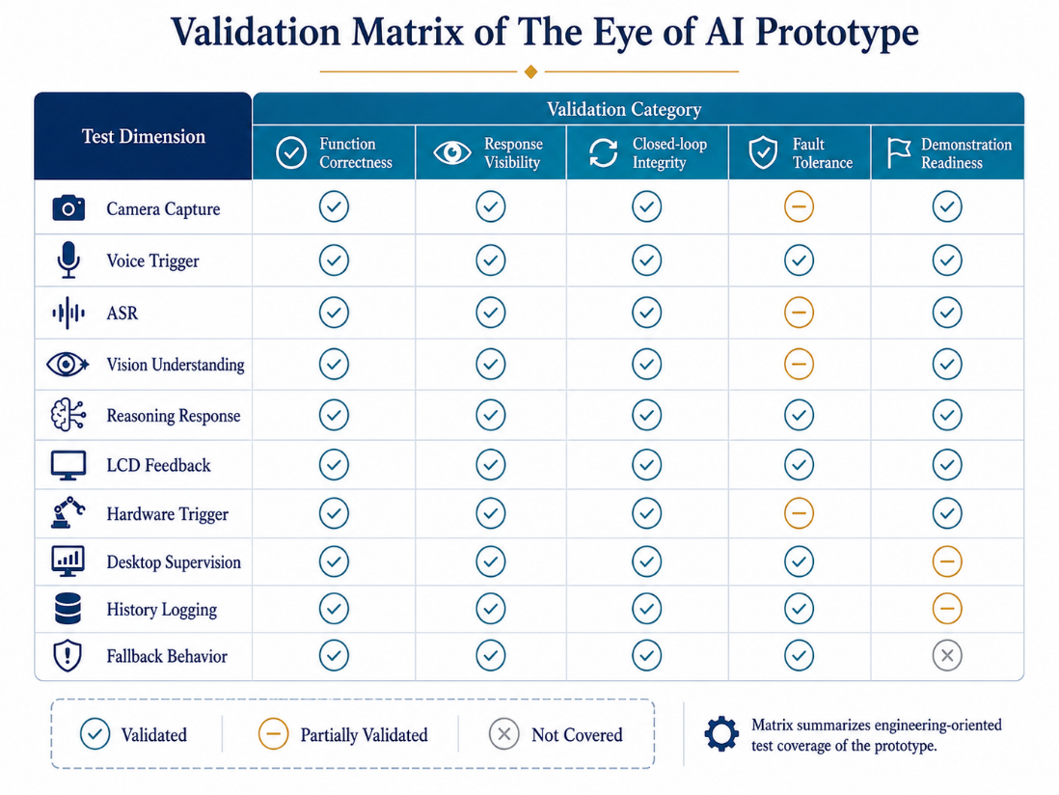
1.2.4 Diagram of C++ inheritance used in the project.
The project intentionally uses object-oriented C++ design to satisfy coursework requirements while preserving real engineering value. Abstract interfaces such as AiVisionService, AudioRecorder, and OutputDevice define extensible device or service contracts, while concrete subclasses such as QwenVisionService and ShellAudioRecorder provide platform-specific implementations. This design also supports polymorphic expansion for future hardware modules.
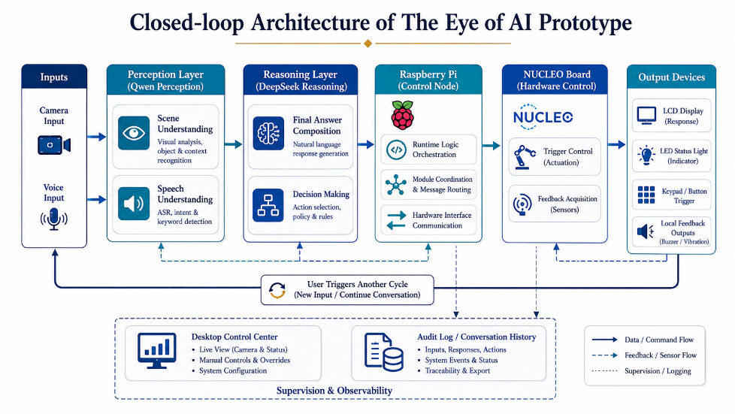
2.1 Key Issues for System
(A) The coordination of multimodal perception and cloud reasoning
The most essential problem is how to let hardware-triggered real-world inputs be converted into stable multimodal prompts. The system must coordinate camera capture, microphone recording, Qwen ASR, Qwen Vision, and DeepSeek so that the final answer remains coherent and useful.
(B) The cooperation among Raspberry Pi, NUCLEO, and desktop software
The second key issue is distributed coordination. Raspberry Pi handles runtime logic and model calls, NUCLEO handles physical triggering and local feedback, and the Windows Control Center acts as the supervision surface. The challenge is to ensure that the three layers remain synchronized and debuggable.
(C) The design of desktop agent interaction
Since the project demonstrates not only hardware but also an AI desktop experience, the interface must support conversation history, rendering, diagnostics, and multimodal reasoning without becoming a simple static showcase page. It should feel like a real agent workbench.
(D) Future Prospect
The current work is a reproducible prototype instead of a final smart-glasses device. In future work, the same interaction loop can be migrated into a smaller wearable form, with onboard networking, better power management, lighter sensors, and more compact human-computer interaction modules.
2.2 Duty Assignments
Person | Duty
Member A | System design, project integration, and proposal/report coordination.
Member B | Raspberry Pi bridge, Qwen / DeepSeek API workflow, camera and microphone integration.
Member C | NUCLEO firmware, keypad / LCD / status light control, and serial protocol design.
Member D | Windows Control Center, session history, diagnostics, UI polishing, and testing.

