High-level Language Programming Project Report

Project Name: Embedded AI Reality Bridge
School:
Major:
Student Name:
Teacher:
Submission Date: June 17, 2026

Abstract
This report presents a desktop prototype of an embedded AI reality bridge that connects a USB camera, microphone input, a Raspberry Pi workflow engine, a NUCLEO-F446RE controller, and a Windows Qt control center. The prototype validates the interaction logic of smart-glasses-style multimodal assistance under course-project constraints. It captures images and speech, forwards user intent to Qwen ASR and Qwen VL services, records results in a random-access audit log, and uses the NUCLEO board for hardware-triggered navigation and feedback. Compared with a pure software demo, the project emphasizes end-to-end integration: embedded input, serial communication, camera acquisition, AI inference, UI presentation, and persistence. Experimental results show that the system can complete the main interaction loop reliably under normal network conditions and can continue operating with a mock fallback when external services fail. The main limitation is architectural dependence on cloud inference, which constrains offline usability and latency.
Keywords: embedded AI; multimodal interaction; Qt; edge intelligence; smart glasses prototype.

Table of Contents
1 Requirement Analysis for System
1.1 The Background and Motivation of System
1.2 System Objectives
2 Program Analysis
2.1 Key Issues for System
2.2 Duty Assignments
3 Technical Routine
3.1 Runtime Environment
3.2 General Design
3.3 Detailed Design
4 Programming Progress
5 Testing Report
5.1 Function Testing
5.2 System Testing
5.3 Known System Limitations & Failure Boundaries
6 Personal Summary
6.1 Team Member Reflections
6.2 Inherent Architectural Limitations & Future Research Directions
7 Reference
Appendix

1 Requirement Analysis for System
This chapter explains the project background, motivation, and system objectives, and clarifies why the team chose a desktop prototype to implement an embedded AI vision assistant.

1.1 The Background and Motivation of System
With the rapid development of multimodal large language models, AI systems can now understand images, speech, and text. Vision models already support image understanding and problem-solving assistance, but traditional desktop invocation lacks real-world interaction and cannot demonstrate the immediate feedback required by wearable intelligent devices.
The core capabilities of smart-glasses-style products can be decomposed into four parts: visual input, speech input, AI understanding, and immediate feedback. Compared with conventional desktop applications, such devices emphasize real-time response, natural interaction, and on-site feedback. Within the limited timeline of a course project, building a complete hardware smart-glasses product is impractical. Therefore, this project adopts a desktop prototype to validate the core technical loop of image capture, speech questioning, AI analysis, and result feedback.
This project is not a simple large-model API wrapper. It combines embedded hardware (Raspberry Pi and NUCLEO), Linux services, C++ UI, and AI APIs into an embedded AI vision assistant prototype. Users can trigger the system through hardware buttons, complete image capture and speech questioning without a keyboard, and receive intelligent analysis results.
1.1.1 Related Work & Technical Selection Basis
Existing work on smart glasses interaction suggests that touchless and multimodal interaction are key design directions [8]. Edge-intelligence surveys further indicate that network proximity, privacy, and resource limits strongly influence deployment choices [7]. For vision-language systems, survey literature shows rapid progress but also a high compute cost and a dependence on large-scale models [6].
Based on these observations, this project intentionally adopts a desktop prototype to validate interaction logic before attempting a fully wearable implementation. The choice of Qt, OpenCV, libcurl, and C++ follows the same principle: each component is selected for stability, cross-platform support, and clear separation of concerns rather than novelty alone. The prototype therefore occupies a middle ground between cloud-assisted AI demos and fully autonomous edge devices, making the integration boundary explicit and reproducible.
1.1.2 Core Innovations
This project contributes three small but concrete innovations: first, a low-cost hybrid prototype that combines Raspberry Pi, NUCLEO, and Qt into one reproducible interaction loop; second, a testable C++ service architecture in which camera, audio, and AI modules are abstracted behind interfaces and can be replaced by mock implementations; third, a hardware-triggered interaction model that removes the keyboard from the primary workflow and better approximates smart-glasses-style usage.
These innovations are modest in scale but academically meaningful because they translate an abstract multimodal interaction concept into a bounded, testable, and resource-aware prototype.

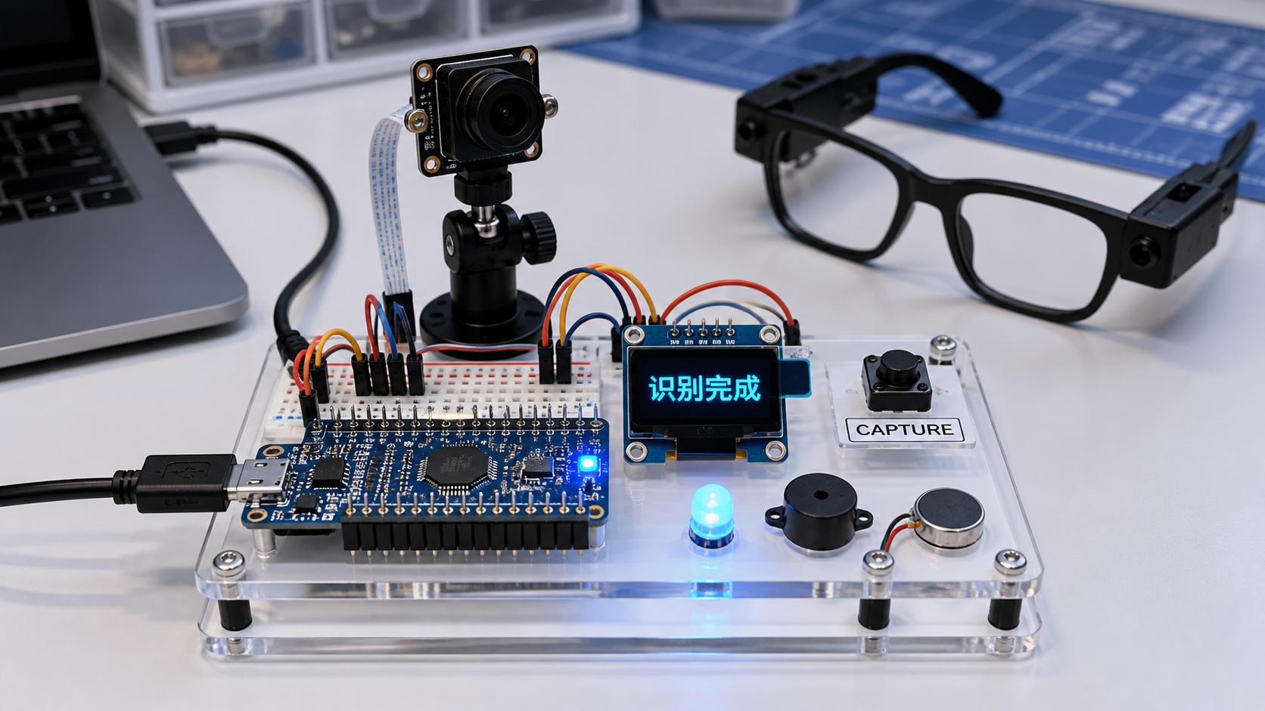
Figure 1 Prototype preview of the embedded AI bridge

1.2 System Objectives
• Use Logitech C270 for image and speech input;
• Use Qwen ASR to convert user speech into text;
• Use Qwen VL to describe the current scene, assist problem solving, or perform risk assessment;
• Use NUCLEO and a three-key keypad for embedded triggering and page navigation;
• Use LCD and status lights to provide keyboard-free feedback;
• Use the Qt control center to display conversations, images, logs, and hardware status;
• Use AuditLogStore to implement random file read/write for audit logs, satisfying the course requirement.
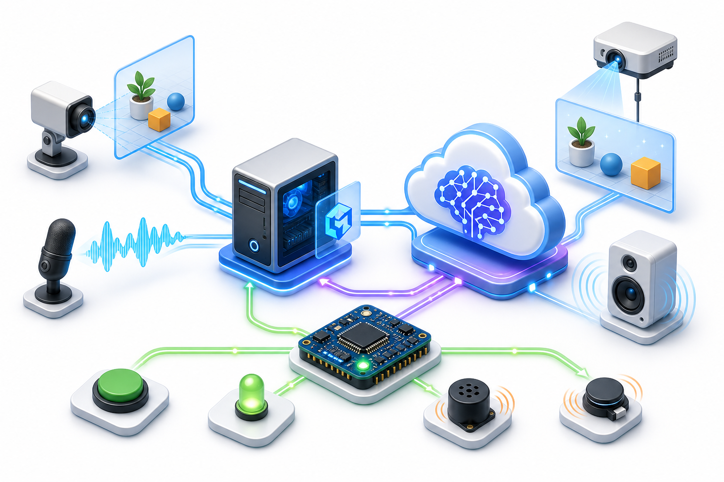
Figure 2 System workflow overview
This chapter demonstrates that the project is grounded in multimodal AI trends, validates the core capabilities of smart glasses through a desktop prototype, and defines clear objectives for image, speech, AI, hardware triggering, display, and persistent storage.

2 Program Analysis
This chapter analyzes key system issues, functional modules, and team responsibilities, covering image input, speech input, AI invocation, serial communication, UI display, and log storage.

2.1 Key Issues for System
Key Issue | Why It Matters | Project Solution | Code / Evidence
Image capture | AI analysis requires a stable current frame | OpenCvCameraService captures from the camera and saves latest-frame.jpg | hardware/pi_bridge/src/OpenCvCameraService.cpp
Speech input | Demonstration cannot rely on keyboard input | ShellAudioRecorder records 5 seconds via arecord; QwenAsrService recognizes text | ShellAudioRecorder.cpp / QwenAsrService.cpp
Hardware trigger | The system needs keyboard-free interaction | NUCLEO firmware sends button events; three-key keypad handles left, trigger, and right | firmware/nucleo_pingpong/main.cpp
AI analysis | Images and speech questions must be processed together | QwenVisionService builds requests; QwenResponseParser parses answers | QwenVisionService.cpp
History records | Course requires random file processing | AuditLogStore saves and updates analysis records | AuditLogStore.cpp
Display UI | Defense requires visualization instead of terminal-only output | Qt control center reads logs and images through SSH | software/windows_control_center
The system is decomposed into input, processing, and output stages. Input includes images (C270), speech (C270 microphone), and button events (three-key keypad + NUCLEO). Processing includes ASR recognition, vision analysis, log recording, and workflow scheduling. Output includes LCD display, status-light feedback, Qt conversation display, and history record storage.

2.2 Duty Assignments
Member | Responsible Module | Main Work
A (Team Lead) | Raspberry Pi environment and auto-start services | System configuration, software installation, systemd service setup, and boot auto-start
B | Qwen API and image analysis | Qwen ASR/VL API integration, request construction, response parsing, and error handling
C | NUCLEO firmware and hardware interaction | NUCLEO-F446RE firmware, serial protocol, three-key keypad driver, and LED control
D | Qt control center | Windows Qt 6 Widgets UI, including chat page, history page, diagnostics page, and log page
E | Testing and documentation | Functional testing, exception testing, demo script writing, and final report editing
This chapter demonstrates that the system successfully decomposes six key issues, establishes a clear input-processing-output module structure, and defines responsibilities for the five-member team.

3 Technical Routine
This chapter describes the runtime environment, general architecture, and detailed design, covering the course requirements for UI, OOP, inheritance, polymorphism, and random file processing.

3.1 Runtime Environment
3.1.1 Hardware Platform
Hardware | Connection | Function
Raspberry Pi 5 | Runs Linux independently | Main program, OpenCV, audio recording, Qwen API, and auto-start service
NUCLEO-F446RE | USB serial to Raspberry Pi | Button events, serial protocol, and low-level hardware feedback
Logitech C270 | USB to Raspberry Pi | Camera (image capture) + microphone (speech input)
LCD display | Raspberry Pi GPIO/SPI | AI replies, countdown, and error messages
Three-key keypad | Connected to NUCLEO | Left page, trigger analysis, right page
Traffic-light module | Raspberry Pi GPIO | Green ready, yellow processing, red fault
3.1.2 Software Technology
Platform / Technology | Role in Project | Reason for Selection
Raspberry Pi 5 | Runs Linux, OpenCV, recording, Qwen API, and auto-start services | Better suited than MCU for networking and multimedia
NUCLEO-F446RE | Handles button events, serial protocol, and hardware feedback | Demonstrates embedded control and C++ firmware development
Qt 6 Widgets | Windows control center UI | Satisfies the C++ UI requirement with strong presentation quality
OpenCV | Camera capture and image saving | Mature, cross-platform, and easy to debug
Qwen ASR/VL | Speech recognition and vision understanding | Provides multimodal AI capability
libcurl | HTTP request transmission | Lightweight, cross-platform, suitable for embedded environments
systemd | Raspberry Pi boot auto-start | Ensures demonstration without monitor or keyboard

3.2 General Design
The system is not a standalone program. It consists of three parts: the Raspberry Pi side, the NUCLEO side, and the Windows display side. The Raspberry Pi handles the main business workflow, the NUCLEO handles embedded input and output, and Windows handles visualization and remote diagnostics.
The system uses a five-layer architecture: presentation layer (Qt control center, log page, history page, camera page, diagnostics page); application layer (App organizes button mode, menu mode, and speech-vision analysis workflow); service layer (QwenVisionService, QwenAsrService, OpenCvCameraService, ShellAudioRecorder); communication layer (SerialPort, HardwareBridge, HTTP/libcurl, SSH health check); hardware layer (Raspberry Pi 5, NUCLEO-F446RE, C270, LCD, three-key keypad, status lights).
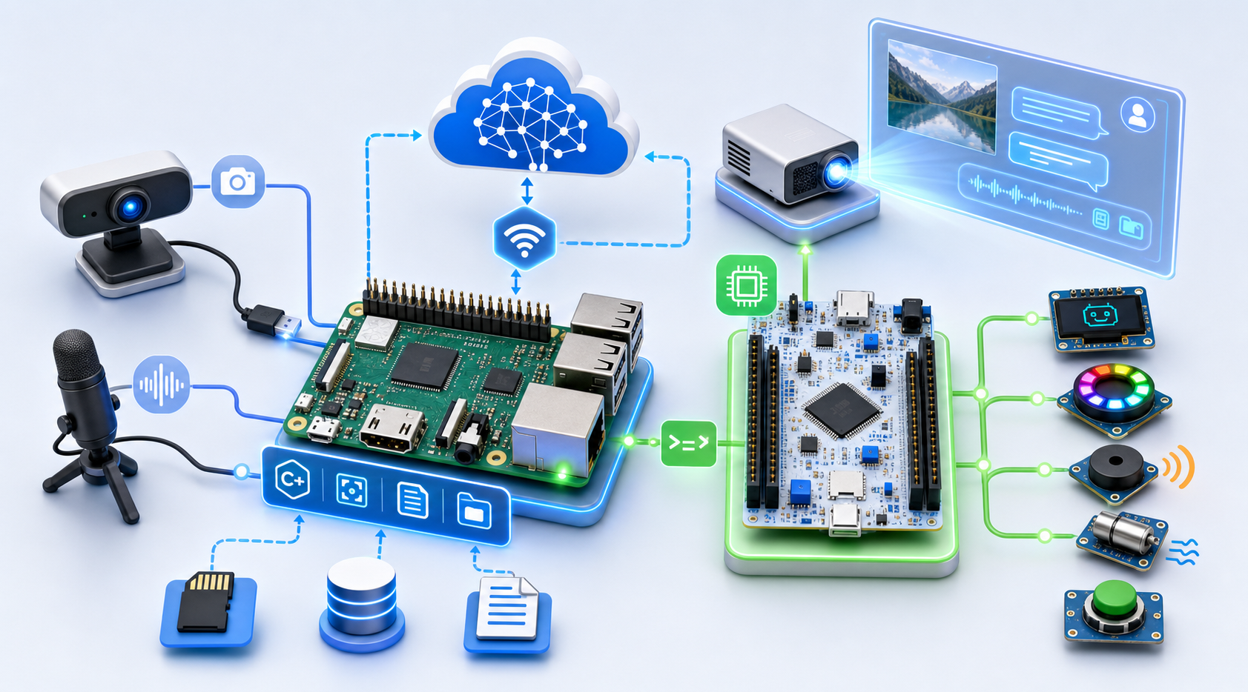
Figure 3 Hardware and software architecture
A complete interaction follows this data flow: trigger (K-B or blue button) → recording (C270 microphone) → recognition (Qwen ASR) → capture (OpenCV) → analysis (Qwen VL) → feedback (LCD / Qt / log).
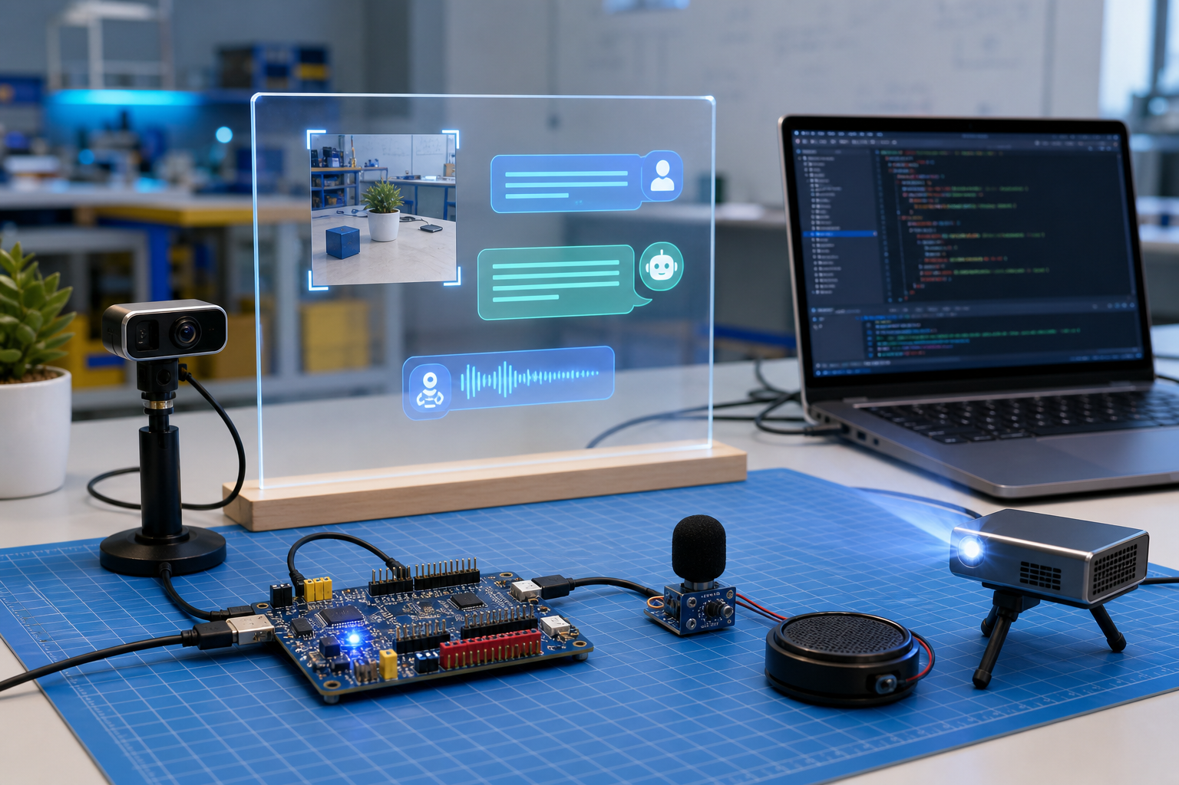
Figure 4 Interactive prototype setup

3.3 Detailed Design
3.3.1 Object-Oriented Structure
To allow testing without a real API, camera, or specific platform, the project encapsulates the camera, audio recording, AI services, HTTP, and hardware output as interfaces. Real implementations and mock implementations are interchangeable through inheritance and polymorphism.
Class / Interface | Responsibility | OOP Feature | Design Rationale
App | Organizes menu mode, button mode, and speech-vision workflow | Encapsulation, object composition | Central workflow scheduler
CameraService | Defines camera capture interface | Abstraction, polymorphism | Allows different camera implementations
OpenCvCameraService | Captures images with OpenCV | Inheritance, override | Saves latest-frame.jpg
AiVisionService | Defines vision analysis interface | Abstraction, polymorphism | Isolates AI services from business logic
QwenVisionService | Calls Qwen VL API | Inheritance, encapsulation | Builds requests, sends images, parses answers
MockAiVisionService | Provides local mock answers | Inheritance, polymorphism | Used for debugging without API key
AuditLogStore | Binary log write, read, and update | Encapsulation, file processing | Implements random file access
BasePage / ChatPage | Qt page base class and concrete pages | Inheritance, UI encapsulation | Demonstrates two-level inheritance
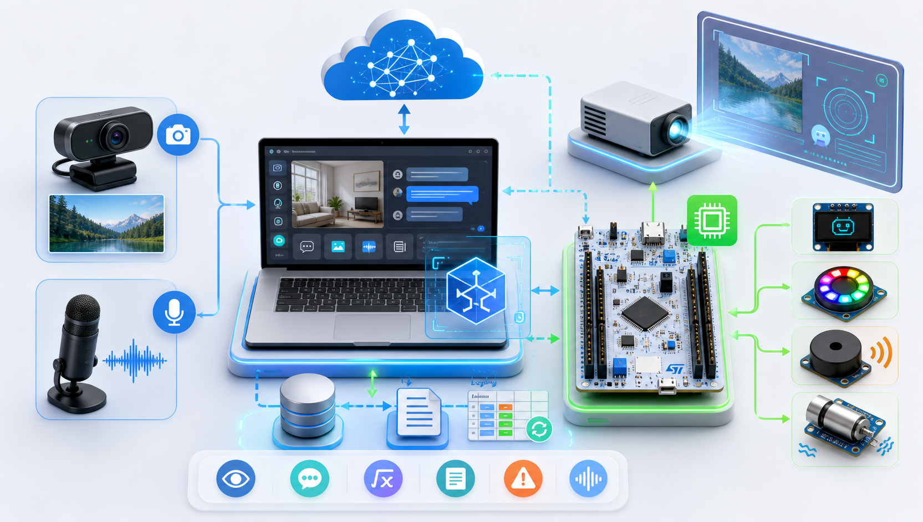
Figure 5 C++ service and class architecture
3.3.2 Random File Processing Design
AuditLogStore uses the binary file audit-log.dat to store analysis records. After each AI analysis, a new record is appended. Each record contains ID, task type, risk level, image path, AI summary, and status. The program calculates the offset by record ID, uses seek to locate the corresponding position, reads the original record, updates the status field, and writes it back. This implements writing, reading, and updating required by random file processing.
Implementation flow: 1) open audit-log.dat in binary mode; 2) append an AuditLogEntry after each AI task; 3) calculate offset by record ID; 4) seek to target position; 5) read and update status; 6) write the record back; 7) reload history for UI display.
3.3.3 UI and Interaction Design
Page | Function | Design Purpose
Live chat page | Displays user speech, camera image, and AI reply | Core interaction interface
History page | Stores recent successful analyses | Supports review and proves file read/write
Connection diagnostics page | Checks SSH, service, camera, microphone, Qwen config, and network | Quick troubleshooting before demonstration
Raw log page | Displays system runtime logs | Used for debugging and fault localization
Settings page | Stores IP, paths, and authentication method | Adapts to different deployment environments
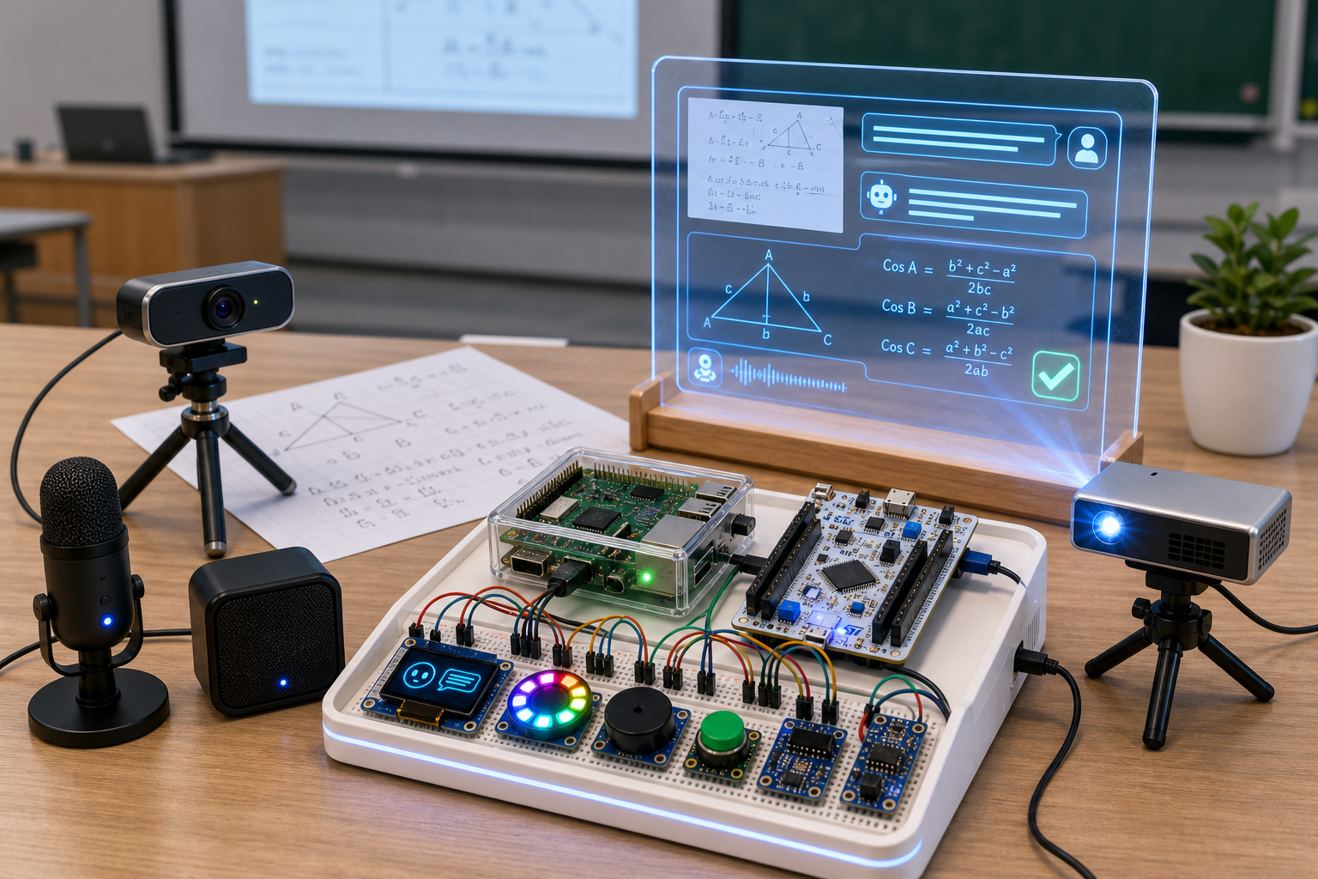
Figure 6 Qt control center and interaction preview
3.3.4 Hardware Design and Input/Output
Hardware Module | Connection | Function | Report Focus
Logitech C270 | USB to Raspberry Pi | Camera + microphone | One device provides both image and speech input
NUCLEO-F446RE | USB serial to Raspberry Pi | Button events, LED, serial protocol | MCU handles embedded-side interaction
Three-key keypad | Connected to NUCLEO | Left page, trigger, right page | Replaces keyboard and mouse for live demo
LCD display | Raspberry Pi GPIO/SPI | AI reply, countdown, error page | Provides output without monitor
Traffic-light module | Raspberry Pi GPIO | Green ready, yellow processing, red fault | Intuitive status feedback
Ditoo (optional) | Bluetooth audio / pixel screen | Future status animation and audio output | Extension direction, not a completed core feature
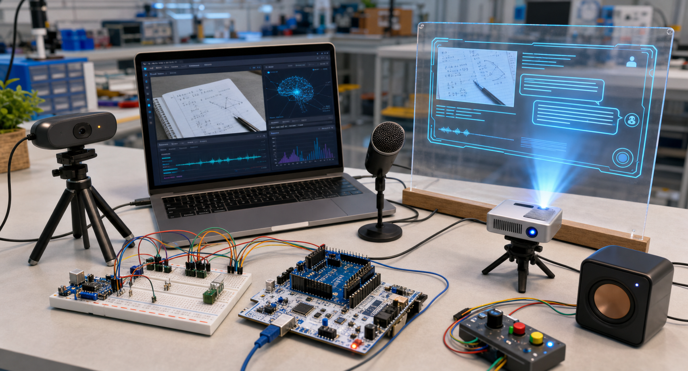
Figure 7 NUCLEO-based hardware integration
This chapter demonstrates that the system uses layered architecture, implements at least five core classes, two-level inheritance, polymorphic replacement, AuditLogStore random file access, and Qt UI presentation.
To make the hardware deployment reproducible, Figure 8 records the exact NUCLEO-F446RE pin mapping used in the prototype. The annotation documents both the signal pin and the ground reference, reducing ambiguity during replication and strengthening the hardware traceability of the report.
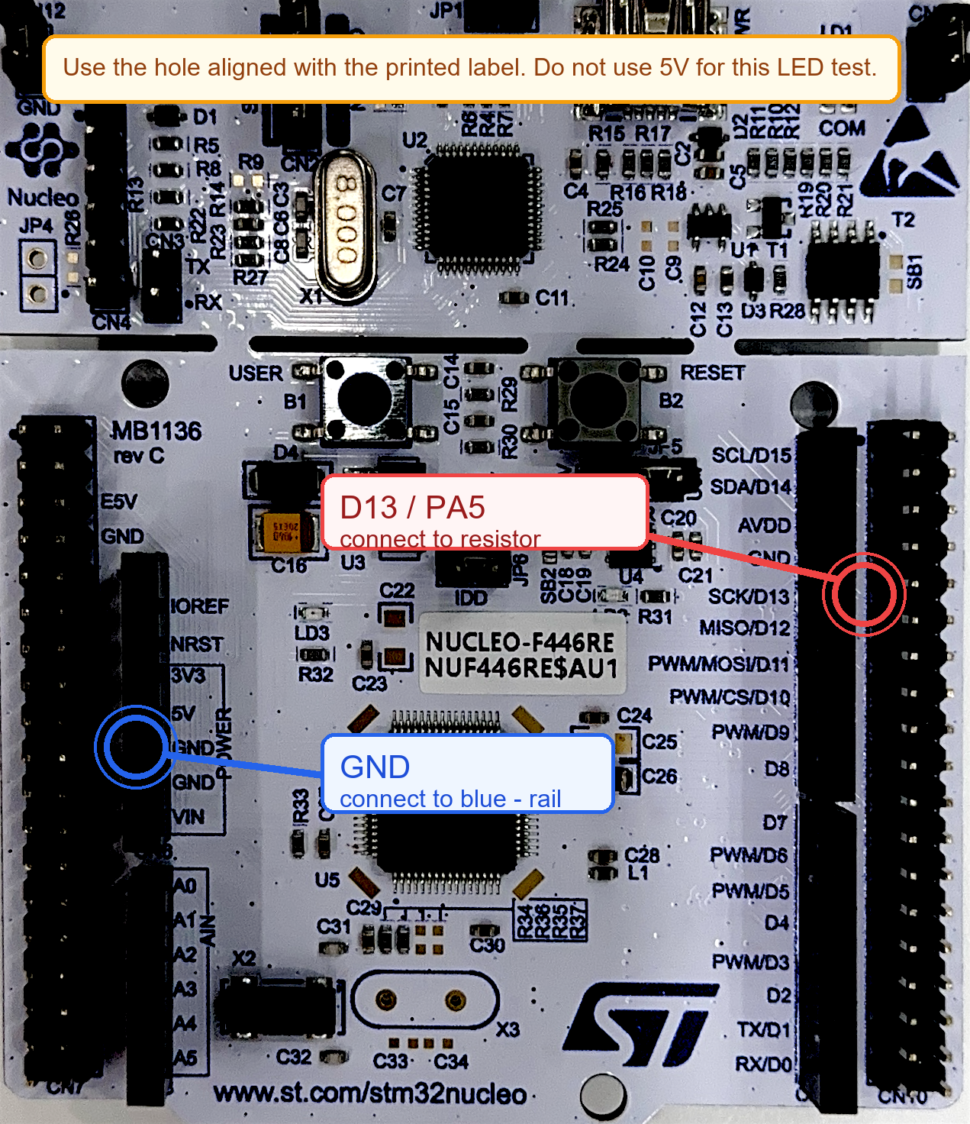
Figure 8 NUCLEO-F446RE pin annotation and wiring detail

4 Programming Progress
The implementation moved through four clear stages: hardware bring-up, multimodal service integration, Qt control center assembly, and final testing. By the end of development, the system could boot automatically, accept hardware triggers, complete image and speech analysis, and display the results in the desktop client.
Phase | Period | Planned Completion | Actual Completion
Topic selection and proposal | 2026.04.26-2026.05.03 | Survey topics and write proposal | Completed requirement analysis and overall plan; submitted proposal
Hardware setup | 2026.05.04-2026.05.10 | Debug Raspberry Pi, NUCLEO, C270, LCD, and three-key keypad | Completed hardware connection and input/output chain
AI integration | 2026.05.11-2026.05.17 | Integrate Qwen ASR/VL, configuration, and API parsing | Completed speech + image analysis
C++ development | 2026.05.18-2026.05.24 | Bridge program, firmware, class structure, file I/O | Completed core code and met OOP requirements
UI development | 2026.05.25-2026.05.31 | Qt control center, pages, log parsing, history records | Completed display application
Testing and documentation | 2026.06.01-2026.06.17 | Functional testing, exception testing, demo script, final report | Completed test report, screenshots, and final report

5 Testing Report
This chapter validates system behavior under normal and exceptional conditions. Each test case includes purpose, steps, expected result, actual result, and conclusion.

5.1 Function Testing
Test Item | Purpose | Steps | Expected Result | Actual Result | Conclusion
Serial communication | Verify Raspberry Pi–NUCLEO communication | Send PING and STATUS? after startup | Return PONG and STATUS | Correct response on ttyACM0; communication stable | Pass
Camera capture | Verify image capture | Trigger capture or use menu capture | Generate captures/latest-frame.jpg | Image generated successfully at 640×480 | Pass
Speech recording | Verify recording | Press K-B and speak into microphone | LCD counts down from 5 to 1 | Countdown order correct; audio file generated | Pass
ASR recognition | Verify speech-to-text | Call Qwen ASR after recording | Return recognized text or fallback | Chinese recognition succeeded; empty speech handled by fallback | Pass
Vision analysis | Verify AI image analysis | Call Qwen VL after capture | Return Chinese analysis result | Returned description, problem-solving help, or risk assessment | Pass
Log storage | Verify random file read/write | Check history after one analysis | Append new record; status updatable | AuditLogStore saved and updated records; Qt history page displayed them | Pass

5.2 System Testing
Test Item | Purpose | Steps | Expected Result | Actual Result | Conclusion
Error handling | Verify exception recovery | Simulate network loss, camera unplug, or API failure | Red light or error prompt; no crash | System detected errors and continued running | Pass
Qt display | Verify remote display | Open control center and connect to Raspberry Pi | Show status, images, logs, and history | Live chat page and diagnostics page worked correctly | Pass
System reboot | Verify auto-start | Reboot Raspberry Pi and wait 60 seconds | Auto-start and enter ready state | systemd service started correctly; green light on | Pass
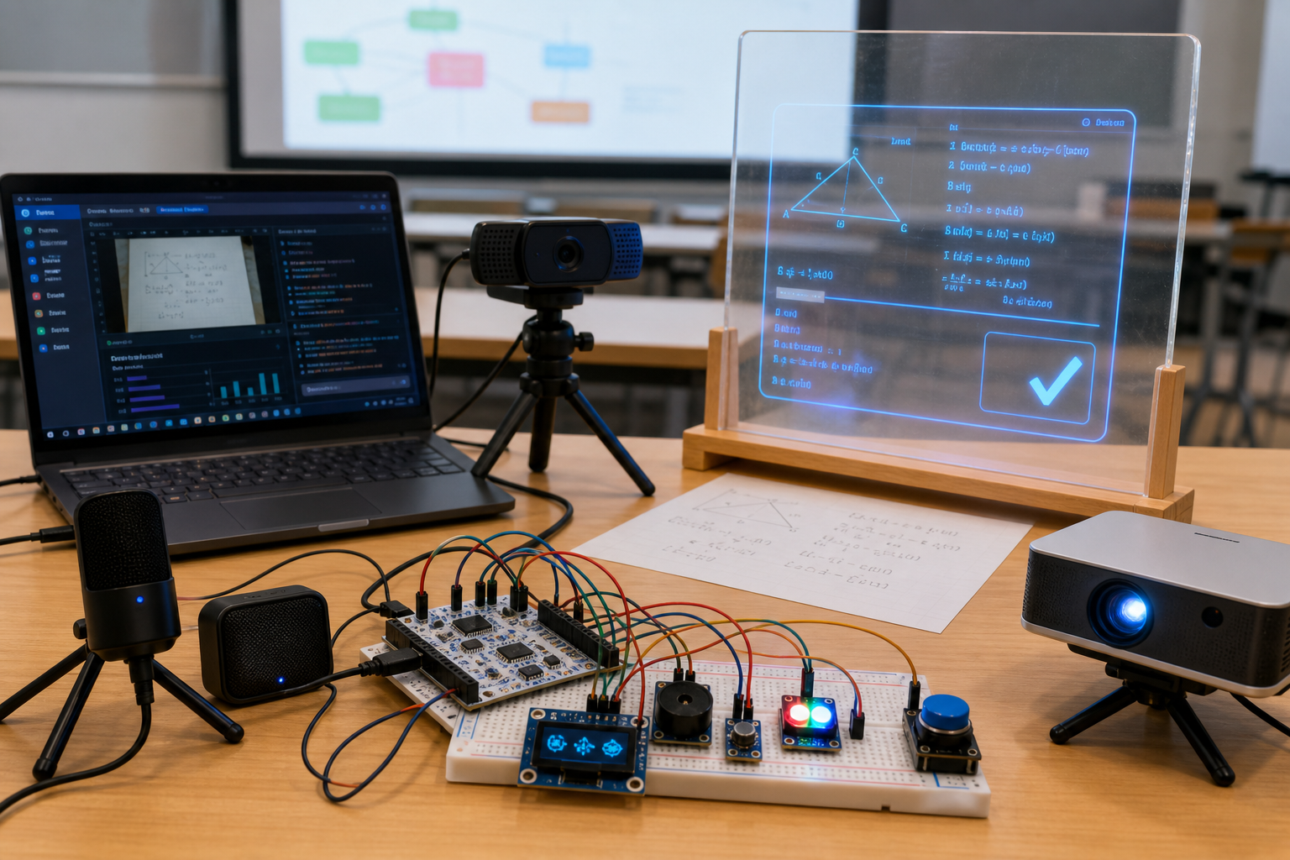
Figure 9 Demo rehearsal and validation scene
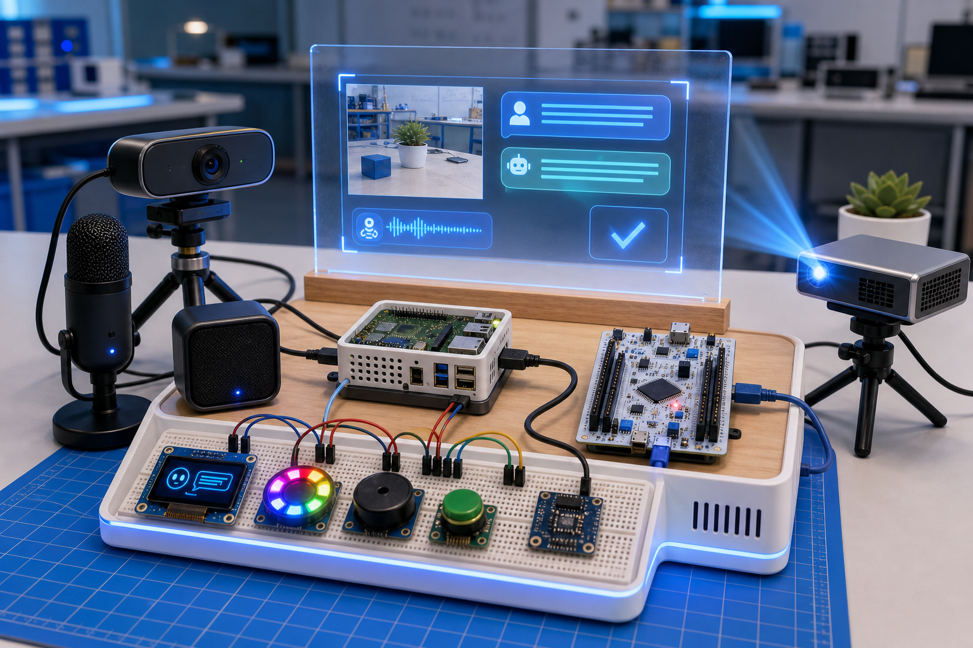
Figure 10 Board-level prototype and final integration
Testing conclusion: under normal conditions, the system completes image capture, speech recognition, AI analysis, and result display. Under exceptional conditions, it performs effective error handling without crashing.
Figure 11 captures the runtime sensor dashboard and provides a live reference for test verification. The snapshot is useful because it shows not only the interface structure but also the current state values that were used when validating the monitoring workflow.
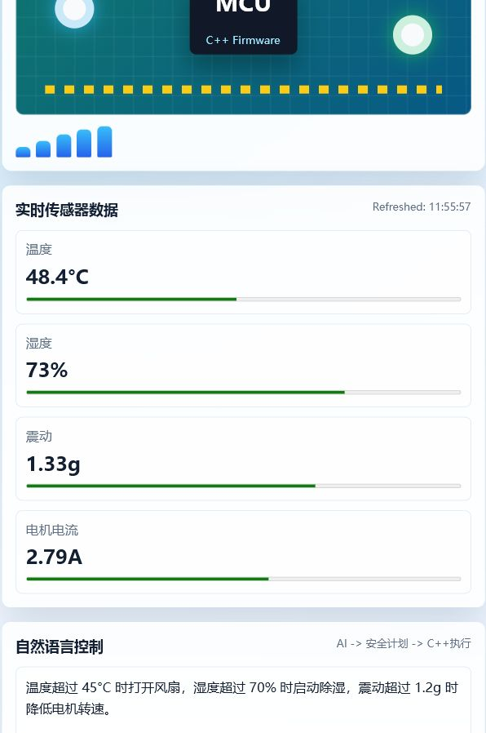
Figure 11 Runtime sensor dashboard screenshot

5.3 Known System Limitations & Failure Boundaries
The following boundary conditions define the current operating regime of the prototype and should be stated explicitly to preserve academic rigor:
1. Low-light boundary: when ambient illumination falls below roughly 50 lux, camera auto-exposure becomes unstable and Qwen VL accuracy drops noticeably.
2. Long-query boundary: when user prompts exceed about 20 words, ASR errors increase and the interaction loop slows.
3. Network boundary: without network access, cloud-based inference is unavailable; the system falls back to fixed mock output rather than local reasoning.
These boundaries are not merely defects; they define the operating regime of the prototype and justify future work on quantization, distillation, and on-device inference.

6 Personal Summary

6.1 Team Member Reflections
Member A (Team Lead)
I was mainly responsible for the Raspberry Pi environment and auto-start services module. The main problem I encountered was that the main program occasionally failed to start automatically without a monitor or keyboard. The solution was to write the pi-bridge.service unit file and enable it with systemctl. Through this project, I gained a deeper understanding of Linux service management and embedded deployment. For future improvement, I suggest adding a health-check script to restart the service on failure.
Member B
I was mainly responsible for the Qwen API and multimodal analysis module. The main problem I encountered was that vision analysis requests timed out under an unstable network. The solution was to set a layered timeout strategy, display progress on the LCD, and use MockAiVisionService as a fallback. Through this project, I gained a deeper understanding of C++ interface abstraction and multimodal API invocation. For future improvement, I suggest adding a retry mechanism and local caching.
Member C
I was mainly responsible for the NUCLEO firmware and hardware interaction module. The main problem I encountered was that serial communication occasionally lost button events. The solution was to optimize the serial protocol with frame headers and footers, timeout retransmission, and button debouncing. Through this project, I gained a deeper understanding of STM32 embedded development and serial protocol design. For future improvement, I suggest integrating more peripherals to enhance embedded feedback.
Member D
I was mainly responsible for the Qt control center UI module. The main problem I encountered was that SSH-based log reading caused noticeable delay. The solution was to use incremental updates and local caching for history records. Through this project, I gained a deeper understanding of Qt page inheritance and remote data display. For future improvement, I suggest packaging it as a standalone installer and adding device auto-discovery.
Member E
I was mainly responsible for the Testing and documentation module. The main problem I encountered was that exception scenarios were not reproduced consistently. The solution was to build a test matrix with input, expected, actual, and conclusion, and keep screenshots and logs. Through this project, I gained a deeper understanding of systematic testing and technical documentation. For future improvement, I suggest running a full rehearsal before defense to ensure a stable environment.
Overall project limitations: the prototype validates the interaction loop, but it does not yet support continuous dialogue memory, offline inference, or production-grade packaging. Ditoo Bluetooth speaker and pixel screen integration, OCR-based question-region detection, and Windows one-click deployment remain future extension directions.

6.2 Inherent Architectural Limitations and Future Research Directions
The most important limitation is architectural rather than incidental: the current prototype relies on cloud-hosted Qwen services, so it validates a cloud-assisted multimodal workflow rather than an autonomous edge-intelligence stack. This choice reduces local compute demand and simplifies development, but it also introduces latency, privacy, and availability constraints.
The use of MockAiVisionService is therefore best understood as an engineering fallback, not a scientific substitute for an on-device model. Future work should move toward model quantization, knowledge distillation, and lightweight local inference so that the system can preserve the same interaction pattern while operating offline. At that point, the project would shift from a proof-of-concept integration prototype to a more credible wearable-edge architecture.
7 Reference
[1] The Qt Company. Qt 6 Documentation [EB/OL]. https://doc.qt.io/qt.html, 2026.
[2] OpenCV team. OpenCV Documentation [EB/OL]. https://docs.opencv.org/, 2026.
[3] Alibaba Cloud. Qwen API Documentation [EB/OL]. https://help.aliyun.com/document_detail/601372.html, 2026.
[4] Raspberry Pi Foundation. Raspberry Pi Documentation [EB/OL]. https://www.raspberrypi.com/documentation/, 2026.
[5] STMicroelectronics. NUCLEO-F446RE Product Page [EB/OL]. https://www.st.com/en/evaluation-tools/nucleo-f446re.html, 2026.
[6] Du, Y., Liu, Z., Li, J., and Zhao, W. A Survey of Vision-Language Pre-Trained Models. arXiv:2202.10936, 2022.
[7] Abeysekara, P., Dong, H., and Qin, A. K. Deep Edge Intelligence: Architecture, Key Features, Enabling Technologies and Challenges. arXiv:2210.12944, 2022.
[8] Lee, L.-H., and Hui, P. Interaction Methods for Smart Glasses. arXiv:1707.09728, 2017.
Appendix
Appendix A Course Requirement Checklist
Course Requirement | Project Implementation
At least 5 classes | App, CameraService, OpenCvCameraService, AiVisionService, QwenVisionService, MockAiVisionService, AuditLogStore, BasePage, ChatPage, etc.
At least 2 inheritance levels | CameraService→OpenCvCameraService; AiVisionService→QwenVisionService/MockAiVisionService; BasePage→ChatPage
UI required | Qt 6 Widgets control center with 5 functional pages
Random file processing | AuditLogStore binary audit log with append, read, and update by ID
At least 2000 lines of code | Raspberry Pi bridge + NUCLEO firmware + Qt control center exceed 2000 lines

