Giang Thị Sông Hằng

BTHT3-lab3

B1: Installing Ubuntu Guest Edition

B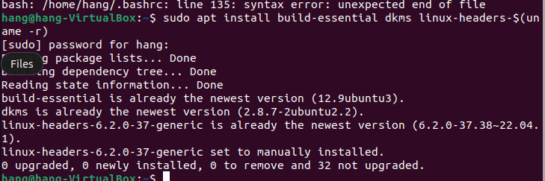2: Installing Python

Sudo apt python 3

B3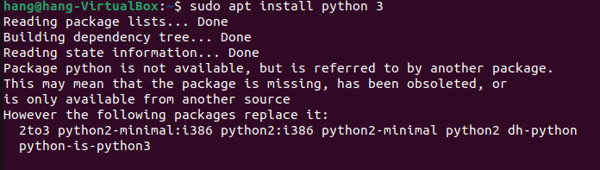:

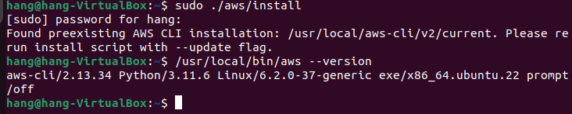B4: