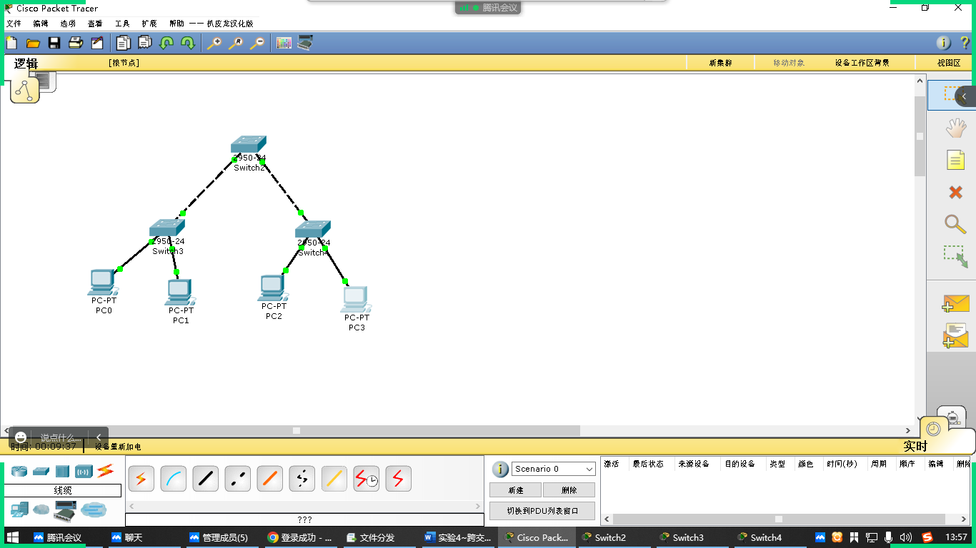

|  |  |  |  |  |
| --- | --- | --- | --- | --- |
| 设备名称 | 设备型号 | IP地址 | 与交换机连接的端口 | 所属网络 |
| PC1 | PC-PT | 192.168.10.1/24 | Fa0/1 | VLAN 11 |
| PC2 | PC-PT | 192.168.20.2/24 | Fa0/2 | VLAN 22 |
| PC3 | PC-PT | 192.168.10.3/24 | Fa0/1 | VLAN 11 |
| PC4 | PC-PT | 192.168.20.4/24 | Fa0/2 | VLAN 22 |
| Switch2 | 2950-24 | —— | 2950-24 | Switch3 |
| Switch2 | 2950-23 | —— | 2950-24 | Switch4 |

PC0 ping PC1, PC0 ping PC3