



**Auto Collect Report Guideline**

**Table of Content**

I. Introduction 4

II. GUI of Auto Collect Report 4

1. Report Info GUI 4

2. Template GUI 5

3. Collected Data GUI 6

III. Main Functions 7

1. Filter Ignore Test cases 7

2. Filter Test cases 7

3. End Excel processes 7

4. Show Collected Data 8

5. Fill Data Into Output File 9

**Revision History**

|  |  |  |  |
| --- | --- | --- | --- |
| **Name** | **Date** | **Reason For Changes** | **Version** |
| Breeze Team | May 10 2019 |  | 1.0 |
|  |  |  |  |
|  |  |  |  |
|  |  |  |  |
|  |  |  |  |
|  |  |  |  |
|  |  |  |  |
|  |  |  |  |

**Review and Approval**

|  |  |  |  |
| --- | --- | --- | --- |
| **Date** | **Role** | **Signature** | **Action** |
|  |  |  |  |
|  |  |  |  |

# Introduction

The main purpose of this document is an introduction document about Auto Collect Report (ACR) tool.

# GUI of Auto Collect Report

## Report Info GUI

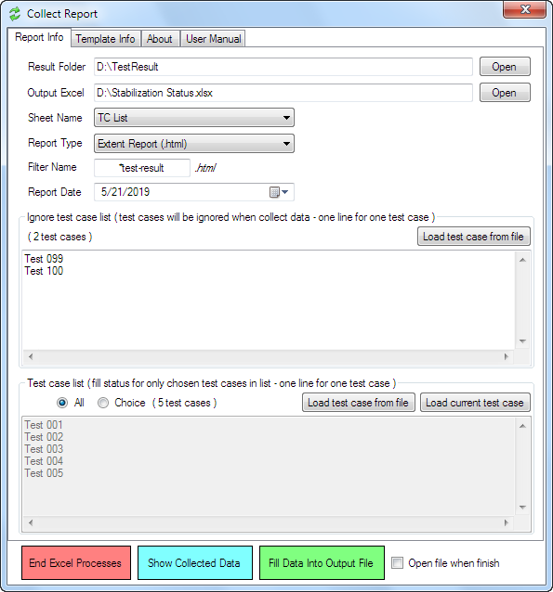

**Result Folder:** Folder contain html (xml/json) report files.

**Output Excel:** The target Excel file want to fill data from collected result.

**Sheet Name:** Sheet’s name users want to update. Sheet name list will be collected from **Output Excel** file

**Report Type:** The tool has 3 kind of reports:

* Extent Report (.html).
* TestNG Report (.xml).
* Allure Report (.json).

**Filter Name:** In case you want to specific the prefix file name of result file to get data (can use * to filter).

Ex:

* “*test-result” (2019-05-19-**test-result**.html, abc123**test-result**.html …)
* “*test-result*” (2019-05-19-**test-result**-ground1.html, abc123**test-result**-ground2.html …)

**Report Date:** Target report date users want to fill result.

## Template GUI

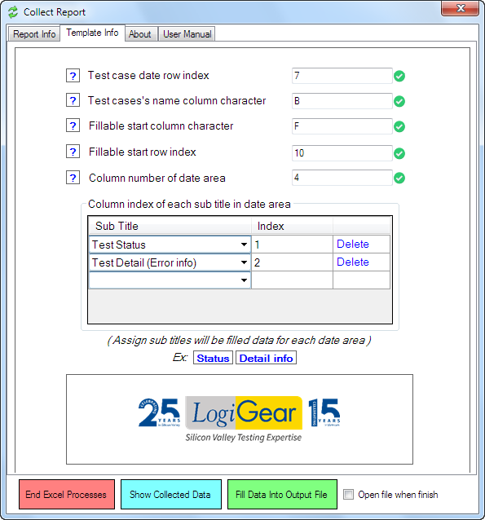

In this GUI, we have specific guidelines for each field to configure suitably with template. User can hover the Question Icon () to know more details.

**Sub Title list:** User can chose which data type will be fill by choosing one of value in Sub Title list and assign and define the column index of this data in each date area.

Ex: If user want to fill test status in the first column, just select “Test Status” on combobox and input Index = 1 (index start from 1)

## Collected Data GUI

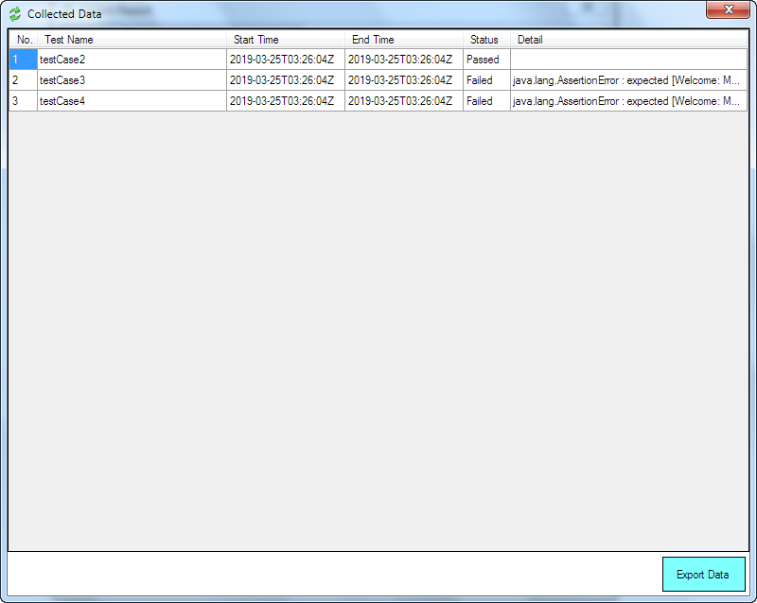

In this GUI, user can see all history of collected test results.

# Main Functions

## Filter Ignore Test cases

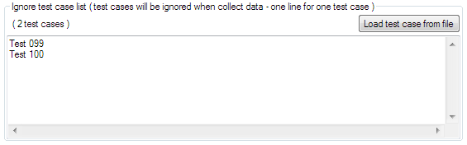

This function is used to specific which test case will be ignored from collected result.

**Load test case from file:** Load ignore test cases from specific file to filter.

## Filter Test cases

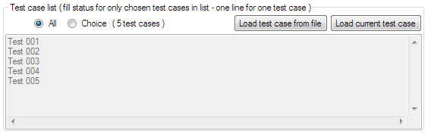

This function is used to specific which test case will be filled data from collected result.

**Load test case from file:** Load test cases from specific file to filter.

**Load test current test case:** Load current test cases existed in chosen sheet of **Output Excel** to filter.

**All** checkbox:Select all test cases.

**Choice** checkbox: Select specific test cases.

## End Excel processes



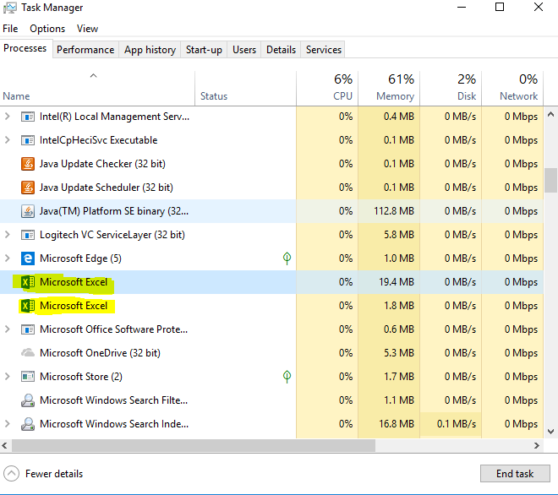

This function will kill all Excel processes running in background to make this tool (ACR) run smoothly.

## Show Collected Data



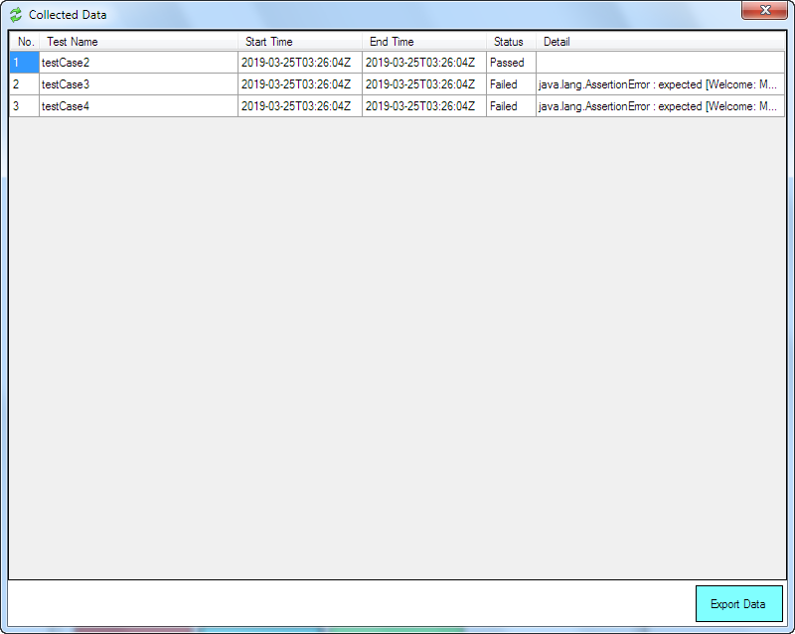

This function shows all test’s name, execute times, status and error message that collected in **Result Folder**.

**Export Data:** Select this button if user want to export data on screen to csv file.

## Fill Data Into Output File



This is a main function of the ACR tool. It will collect all test cases ID from **Result Folder** to fill in the report template from **Output Excel** base on **Sheet Name** and **Collect Date**.

**Open file when finish:** Check on if user want to open Output File after process finished.