Week 1_DSA

Group 5
Members:
1). Rorn Hangsovoleak (Leader)
2). Yin Soriya
3). Leang Piseth
4). Po Pagnaboth
5). Prak Linna (A)

Topic: Angkor Heritage Site Navigation System

Problem:
- Visitors struggle to locate temples efficiently due to the large and complex layout of the Angkor Heritage Site
- There is no simple tool to calculate the shortest route, distance, and travel time between multiple temples
- Temple information is scattered across different sources, making it difficult to access quickly
- Visitors may miss nearby or lesser-known temples due to a lack of location based recommendations
- First-time visitors and independent travelers face challenges planning efficient itineraries without tour guides
- Tourists also want to discover new Khmer temples and hidden place by themselves, without depending on tour guides.

Solution:
- The system helps users search for temples, view organized temple information, and find the shortest route between attractions using fundamental data structures and algorithms
- Allow users to search for a temple by entering its name
- Instantly retrieve temple information using a hash table
- Organize 15 predefined temples in a tree structure to display their categories and recommended related temples
- Represent the connections between temples as a graph with weighted edges based on distance
- Use Dijkstra’s Algorithm to calculate and display the shortest route from the user’s current temple to the selected destination
- Display all results, including the recommended route, total distance, and estimated travel information, directly in the python terminal.

System design:
Hash Table
- check duplicate key
- stores temple data for fast access
- converts a temple name into an array index easy for user to search and using
- Note: if duplicate(Collision) uses Linear Probing to resolved
- each table index(key) maps to a stored temple(value)

Key | Value
0 | Neak Poan Temple
1 | Preah Khan Temple
2 | Angkor Wat
3 | Banteay Srei
4 | Phnom Bakheng Temple
5 | Baphuon Temple
6 | Pre Rup Temple
7 | Ta Keo Temple
8 | Banteay Kdei Temple
12 | Bayon Temple
13 | Prasat Chau Say Tevoda
14 | Thommanon Temple
16 | Ta Som
18 | Ta Prohrn Temple
19 | Eastern Mebon Temple

Tree
- draw tree base on distance from Angkor Wat temple to each temple
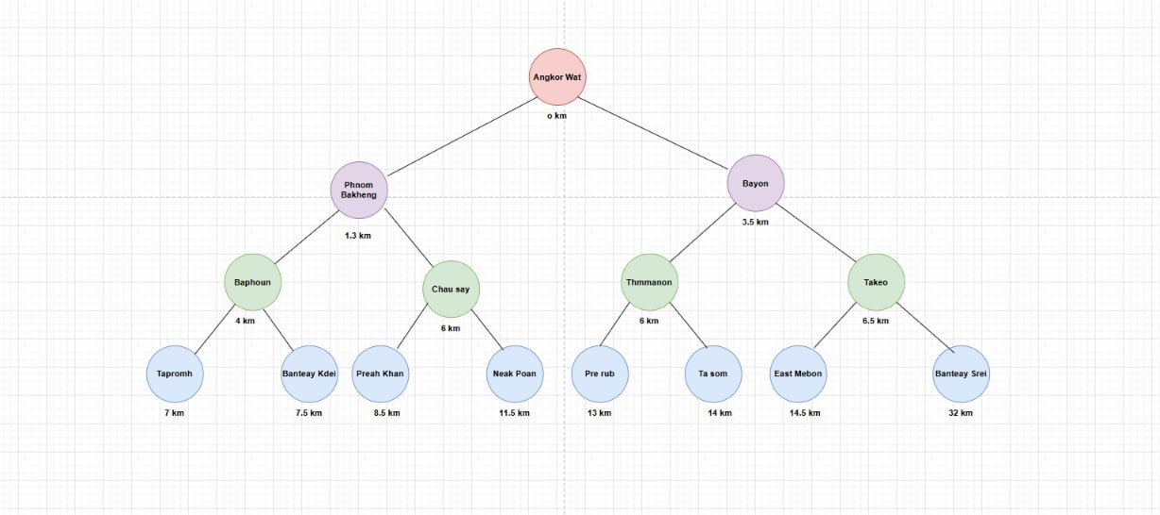
Graph
- Make it as Directed Graph in Non-Linear Data Structure

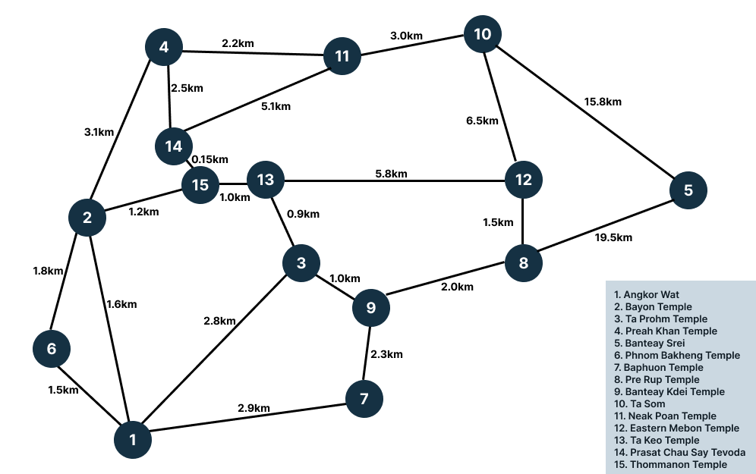

Role:
- Rorn Hangsovoleak: Designed slides presentation, implementation with Graph, find resources
- Leang Piseth & Prak Linna: Implementation with Hash Table
- Po Pagnaboth: Designed System Flow and structure of project
- Yin Soriya: Implementation with Tree

References:
- https://www.visit-angkor.org/angkor-map/
- https://helloangkor.com/navigating-angkors-temples-the-small-circuit-the-grand-circuit-map-guide/

