**Group 5: Linh, Hanh, Phong.**

**Cosc 2436**

**Software Development Life Cycle**

**I. Planning:**

We have customers who are selling onlines and ship order directly from their warehouse. They keep their inventory on spreadsheet, whenver they have a order to fullfill they have to scan the barcode, take out the product and look it up in the spreedsheet to decide the shipping taks. If they have mutitle order to ship, the customer waste a lot of time on deciding the shipping tasks.

Our job is to design a program that helps automate shipping taks. 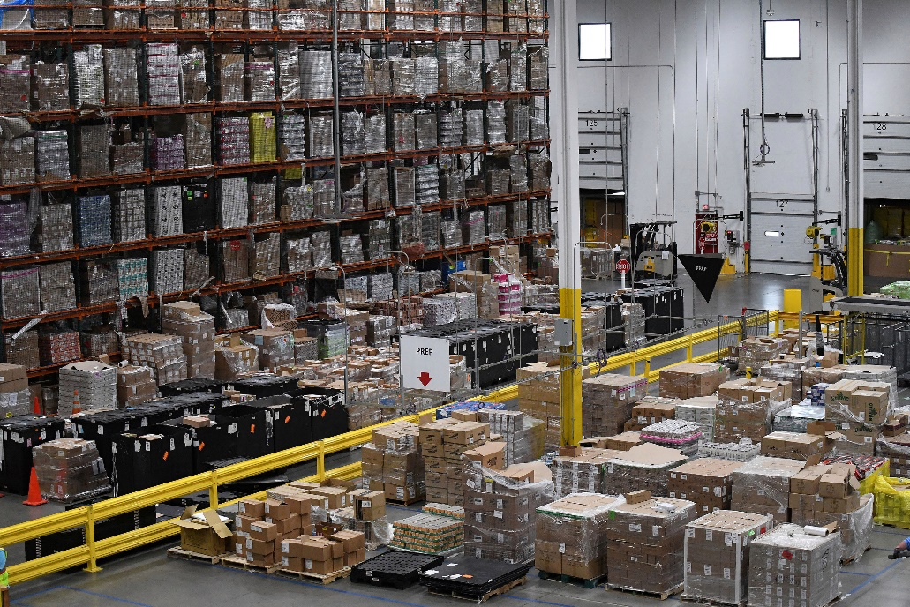

**II. Planning Requirement:**

The customer want an application that can do the following tasks:

Read the data from the spreadsheet and decide the shipping tasks.

Display the inventory.

Deleted shipped item from the inventory

Update the spreadsheet

III. **Requirement analysic:**

**1. Shipping tasks**

* Look up the location on the inventory
* Return the address of the item.
* Access the dimension, weight, fragile property and decided shipping taskincluded: detail of product, type of wrapping, box siz, delivery.
* Delete the item from the inventory after shipment.

**-** If the item is not found, the user should be able to manually enter the data.

**2. Display the inventory**

Print out all the item from the inventory included:

* The sku (custom barcode)
* The dimension, weight

**3. Sort the inventory from new to old.**

- Display the inventory from new to old.

**4. Update the inventory to spreadsheet**

* Count the unshipped item on the inventory
* Export all unshipped items to the new spreadsheet.

**IV. Design**

* Design user interface: 5 buttons in the menu
* Programming language: python

**IV: Implementation and the coding of the application**

**Physical hardware:**

**Developer:**

Global frame: Node, Product, Quue

Queue Class attributes:

Add

Addsku

Delete

Getsize

Getitem_location

Shipping

**Desginer: continue designing userinterface**

**V. Testing and improvement**

**First test:**

* The program is not user friendly. The user needs to know the syntax to use the program.
* **Revisement:** 🡺 design a menu that the user can choose each option that will operate a separate task.

**Second test:**

1. Last item on the list does not print.

* **Revisement:** 🡺 the problem was dectected at the get item adrress function. The function was revised to work properly.
* **2. The menu doesn’t loop correctly.**
* The code for looping is not correct.
* **Revisement:**🡺 The menu is fixed.

**VI. Deployment**

**User documentation**

***How to use the automate shipping tasks program?***

* Open pycharm.
* Click on the run tasks.
* To select a task enter a number from 0 to 5:
* Enter 1 to shipping an item
* Enter 2 to display the item
* Enter 3 to display the item from new to old
* Enter 4 to update the inventory to spreadsheet
* Enter 5 to quit the program
* Enter 0 to come back to the main menu.

**For any techincal issue, contact: afasfaf@gmail.com**