**HOÀNG ANH**

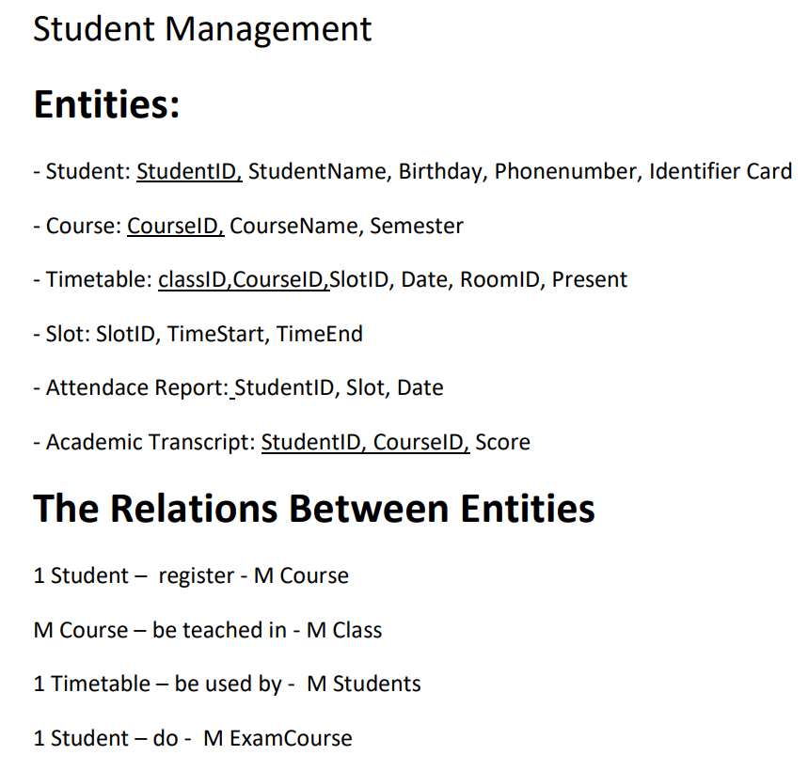

https://online.visual-paradigm.com/community/share/student-mangement-144mfefr5m

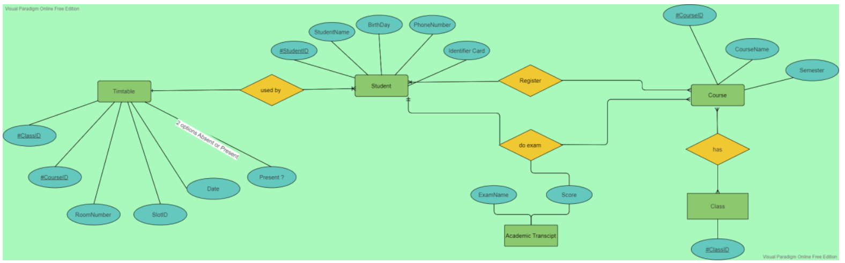

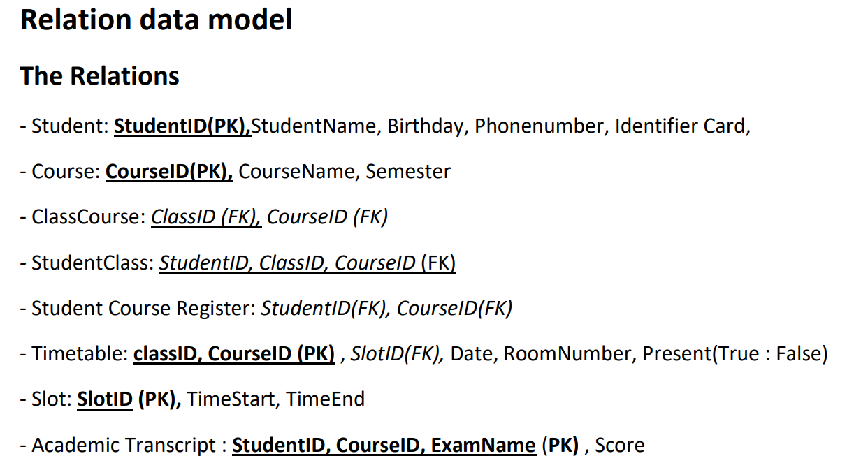

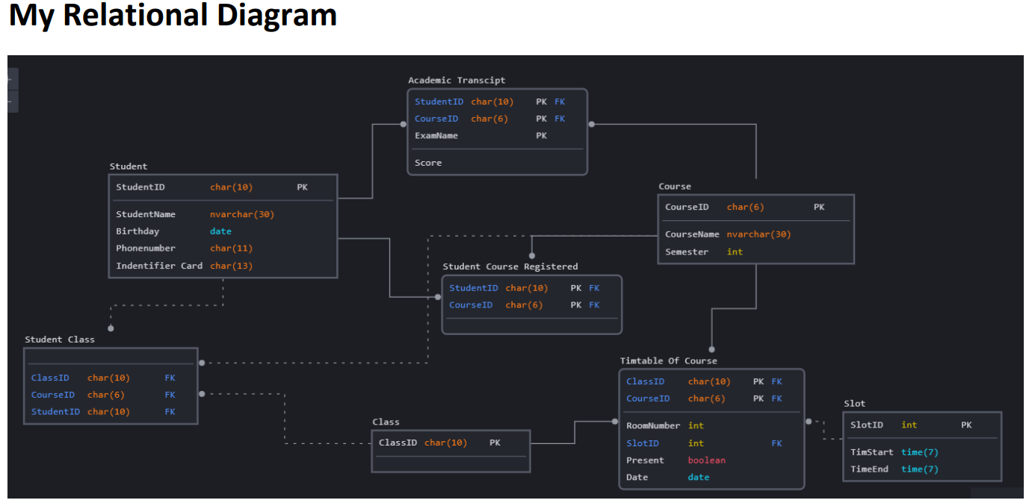

Product(productID, productName, productType, size, unitprice)

productID -> productName, productType, size, unitprice

Store(storeID, storeAddress)

storeID -> storeAddress

Employee(employeeID, employeeName, employeePhone, identityNumber, birthday, employeeAddress, position, storeID)

Orders Bill(orderID, dateOrder, productId, quantity, storeID, totalPay) //số lượng đơn đặt hàng của của hàng