Lab 4: Simulation

Hanh Nguyen

Spring 2022

#### Packages needed: knitr, xtable, pander

## Task 1: Evaluation of a standard random number generator

### Code set-up

The code chunk below presents R code for the RANDU random number generator presented in the video lectures. The code chunk generates 100 pseudo-random numbers from using the RANDU generator and presents a histogram, empirical cdf, and Kolmogorov-Smirnov test to evaluate the performance of the algorithm. Try running it.

# generate random variates according to the RANDU generator  
# X_{n+1} = 65539 X_n mod 2^31  
n<-100 # number of variates  
x<-1 # seed  
for(i in 1:n){  
 x<-c(x, (65539*x[i])%%(2^31))  
}  
x<-x/2^31  
x<-x[2:n]  
  
#par(mfrow=c(2,1))  
# histogram of the n RANDU variates  
hist(x, main="", xlab="RANDU variates", ylab="Frequencies")

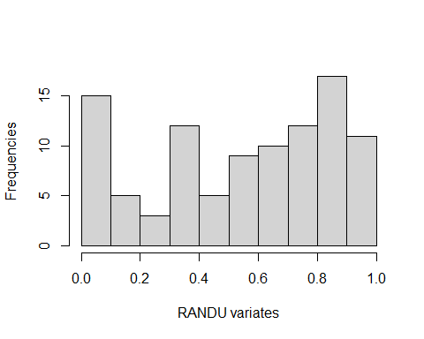

# empirical distribution function of the n RANDU variates and  
# uniform(0, 1) probability plot  
plot.ecdf(x, verticals= TRUE, do.p = FALSE, main="", ylab="Probability")  
abline(0,1)

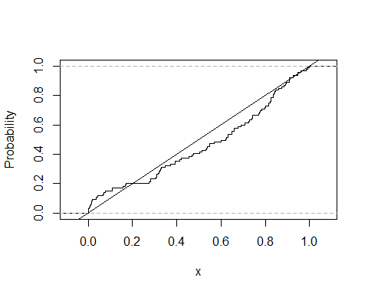

# Kolmogorov-Smirnov test of RANDU variates against U(0, 1) distribution  
ks.test(x,"punif",0,1)

##   
## Exact one-sample Kolmogorov-Smirnov test  
##   
## data: x  
## D = 0.12773, p-value = 0.07229  
## alternative hypothesis: two-sided

### The problem

In this task, we will evaluate an original implementation of the rand command in *Matlab* for generating uniform random numbers. The random number generator has formulation

$$X_{n+1}=16807X_{n}mod\left(2^{31}−1\right).$$

Ammend the code chunk above to generate 1000 random uniform variates from this random number generator.

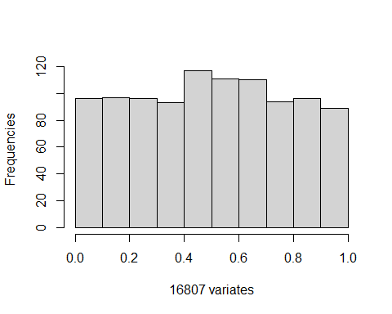

## Warning in plot.window(...): "ylan" is not a graphical parameter

## Warning in plot.xy(xy, type, ...): "ylan" is not a graphical parameter

## Warning in axis(side = side, at = at, labels = labels, ...): "ylan" is not a  
## graphical parameter  
  
## Warning in axis(side = side, at = at, labels = labels, ...): "ylan" is not a  
## graphical parameter

## Warning in box(...): "ylan" is not a graphical parameter

## Warning in title(...): "ylan" is not a graphical parameter

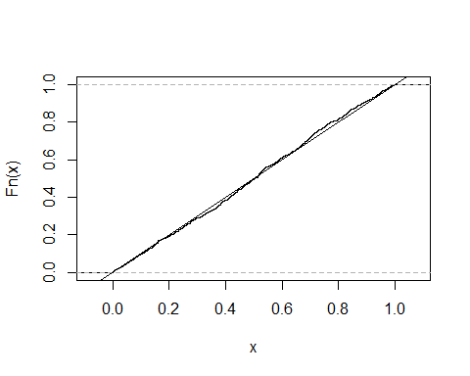

##   
## Asymptotic one-sample Kolmogorov-Smirnov test  
##   
## data: x  
## D = 0.028771, p-value = 0.38  
## alternative hypothesis: two-sided

### Report the following: (these are all outputs of the code chunk above already)

* Present a histogram of the 1000 variates you generated.
* Present the empirical distribution function of your data and a probability plot under the assumption of independent and identically distributed data points (on the same set of axes as we did in the online lecture).
* Use your generations from (a) to perform a Kolmogorov-Smirnov test to validate the routine.

### Questions:

* Do the pseudo-random numbers appear uniformly distributed? Why or why not?

*No, the pseudo-random numbers do not appear uniformly distributed. This is due to the fact that the RANDU generator is a linear congruential generator and has some serious shortcomings that can lead to non-randomness and non-uniformity in the generated sequence of numbers. It must be a type of probability distribution in which all outcomes are equally likely.*

* What are your conclusions from the Kolmogorov-Smirnov test at the $α=0.05$ level?

*The Kolmogorov-Smirnov test compares the empirical distribution function of the generated numbers with the cumulative distribution function of the uniform distribution. The null hypothesis is that the generated numbers are uniformly distributed.In this case, the p-value obtained from the KS-test is 0.38 which is greater than the significance level of 0.05.Therefore, we fail to reject the null hypothesis and conclude that there is not enough evidence to suggest that the generated numbers are not uniformly distributed.*

## Task 2: Simulation of discrete distributions

A bag contains one red, two blue, three green, and four yellow marbles. A sample of three marbles is taken without replacement. Let B denote the number of blue marbles and Y denote the number of yellow marbles in the sample. The probabilities of each outcome is as follows:

# we will create a table using xtable and pander  
library(knitr)  
library(xtable)  
library(pander)  
table.elts = rbind(  
 c(0, "4/120", "24/120", "24/120", "4/120", "56/120"),  
 c(1, "12/120", "32/120", "12/120", "0/120", "56/120"),  
 c(2, "4/120", "4/120", "0/120", "0/120", "8/120"),  
 c("Yellow marg", "20/120", "60/120", "36/120", "4/120", "1"))  
#row.names(table.elts) = cbind("# coin tosses", "Number of heads", "Proportion of heads")  
colnames(table.elts) = cbind("B/Y", "0", "1", "2", "3", "Blue marg")  
lab3.table = xtable(table.elts, caption = "Discrete distribution of marble game.", label="distr_table", align = "|l|rrrr|rr")  
pander(lab3.table, hline.after = c(3))

Discrete distribution of marble game.

| B/Y | 0 | 1 | 2 | 3 | Blue marg |
| --- | --- | --- | --- | --- | --- |
| 0 | 4/120 | 24/120 | 24/120 | 4/120 | 56/120 |
| 1 | 12/120 | 32/120 | 12/120 | 0/120 | 56/120 |
| 2 | 4/120 | 4/120 | 0/120 | 0/120 | 8/120 |
| Yellow marg | 20/120 | 60/120 | 36/120 | 4/120 | 1 |

### Code set-up

We can use the sample function of R to randomly generate from any sequence, including characters. For example, we can code the bag of marbles as

pop = c("r","b","b","g","g","g","y","y","y","y")

We may then sample from this bag of letters (marbles). The following code chunk draws three marbles (so one run of the experiment). We record the number of blue marbles and yellow marbles from this draw.

# True values:  
# P(0 blue) = 56/120; P(1 blue) = 56/120; P(2 blue) = 8/120  
# P(0 Y) = 20/120; P(1 Y) = 60/120; P(2 Y) = 36/120; P(3 Y) = 4/120  
  
# Bag of marbles (population)  
pop = c("r","b","b","g","g","g","y","y","y","y")  
samp = sample(pop,3) # draw 3 marbles  
blues = sum(samp=="b") # number of blue marbles drawn  
yellows = sum(samp=="y") # number of yellow marbles drawn  
c(blues, yellows) # just checking how many blue and yellow marbles are drawn

## [1] 1 0

For this task, you will repeat this experiment 10,000 times. You still need to store the number of blue and yellow marbles from each experiment. The easiest way is to just turn the blue and yellow variables into vectors in which to store the values each step of a for-loop over the 10,000 experiments.

A note, the table command in R is a handy way of summarizing output. In particular, if you have a storage vector blues of the number of blue marbles for each of 10,000 experiments, table(blues) will tabulate the number of experiments with 0 blue marbles drawn, 1 blue marble drawn, 2 blue marbles drawn, and 3 blue marbles drawn.

### The problem

Perform a simulation experiment of drawing three marbles from the bag 10,000 times. I have initialized storage vectors for you.

# True values:  
# P(0 blue) = 56/120; P(1 blue) = 56/120; P(2 blue) = 8/120  
# P(0 Y) = 20/120; P(1 Y) = 60/120; P(2 Y) = 36/120; P(3 Y) = 4/120  
simnum = 10000 # number of experiments  
# Initialize storage vectors for the number of blue and yellow marbles drawn   
# for each of the 10,000 runs of the experiment.  
blues=numeric(simnum); yellows=numeric(simnum)  
  
# [Place code here]  
# Conduct simulation experiment of drawing three marbles from the bag 10,000 times   
for (i in 1:simnum){  
 samp = sample(pop, 3) #draw 3 marbles   
 blues[i] = sum(samp == "b") #number of blue marbles drawn  
 yellows[i] = sum(samp == "y") #number of yellow marbles drawn   
}  
table(blues)

## blues  
## 0 1 2   
## 4650 4669 681

table(yellows)

## yellows  
## 0 1 2 3   
## 1696 4962 3001 341

### Reporting and questions

It is up to you how you want to present the values requested. Rather than getting into R Markdown tables (xtable and pander) for this lab report, I recommend using R data frames (data.frame command). The command setNames allows you to rename the columns of a data frame for purposes of clear labeling.

By empirical pmf (probability mass function), we mean the proportion of experiments in which we draw 0 marbles of the given color, 1 marble of the given color, 2 marbles of the given color, and 3 marbles of the given color. So if $B$ is a random variable denoting the number of blue marbles drawn, the empirical pmf is an estimate of $P\left(B=0\right)$, $P\left(B=1\right)$, $P\left(B=2\right)$, and $P\left(B=3\right)$.

* Present the empirical pmf of the number of blue marbles drawn.
* Present the empirical pmf of the number of yellow marbles drawn.
* Present the mean and variance of the number of blue marbles drawn.
* Present the mean and variance of the number of yellow marbles drawn.

# Empirical pmf of the number of blue marbles drawn  
blue_pmf <- data.frame(table(blues)/simnum)  
names(blue_pmf) <- c("Blue", "Empirical Probability")  
cat("\nEmpirical pmf of the number of blue marbles drawn:\n")

##   
## Empirical pmf of the number of blue marbles drawn:

print(blue_pmf)

## Blue Empirical Probability  
## 1 0 0.4650  
## 2 1 0.4669  
## 3 2 0.0681

# Empirical pmf of the number of yellow marbles drawn  
yellow_pmf <- data.frame(table(yellows)/simnum)  
names(yellow_pmf) <- c("Yellow", "Empirical Probability")  
cat("\nEmpirical pmf of the number of yellow marbles drawn:\n")

##   
## Empirical pmf of the number of yellow marbles drawn:

print(yellow_pmf)

## Yellow Empirical Probability  
## 1 0 0.1696  
## 2 1 0.4962  
## 3 2 0.3001  
## 4 3 0.0341

# Mean and variance of the number of blue marbles drawn  
mean_blue <- mean(blues)  
var_blue <- var(blues)  
cat("\nMean and variance of the number of blue marbles drawn:\n")

##   
## Mean and variance of the number of blue marbles drawn:

cat(paste0("Mean: ", mean_blue, "\n"))

## Mean: 0.6031

cat(paste0("Variance: ", var_blue, "\n"))

## Variance: 0.37560795079508

# Mean and variance of the number of yellow marbles drawn  
mean_yellow <- mean(yellows)  
var_yellow <- var(yellows)  
cat("\nMean and variance of the number of yellow marbles drawn:\n")

##   
## Mean and variance of the number of yellow marbles drawn:

cat(paste0("Mean: ", mean_yellow, "\n"))

## Mean: 1.1987

cat(paste0("Variance: ", var_yellow, "\n"))

## Variance: 0.56667497749775

* Compare the empirical pmf with the true values.

# True values  
true_blue_probs <- c(56/120, 56/120, 8/120)  
  
  
# Empirical pmf of blue marbles  
blue_pmf <- table(blues) / simnum  
names(blue_pmf) <- c(0, 1, 2)  
  
blueDifference = c((sum(blues == 0)/simnum) - (56/120),   
 (sum(blues == 1)/simnum) - (56/120),   
 (sum(blues == 2)/simnum) - (8/120))  
  
data.frame(blue_pmf, true_blue_probs, blueDifference, row.names = c("0", "1", "2"))

## Var1 Freq true_blue_probs blueDifference  
## 0 0 0.4650 0.46666667 -0.0016666667  
## 1 1 0.4669 0.46666667 0.0002333333  
## 2 2 0.0681 0.06666667 0.0014333333

#true values  
true_yellow_probs <- c(20/120, 60/120, 36/120, 4/120)  
  
#Empirical pmf of yellow marbles   
yellow_pmf = table(yellows)/ simnum  
names(yellow_pmf) = c(0, 1, 2, 3)  
  
yellowDifference = c((sum(yellows == 0)/simnum) - (20/120),   
 (sum(yellows == 1)/simnum) - (60/120),   
 (sum(yellows == 2)/simnum) - (36/120),   
 (sum(yellows == 3)/simnum) - (4/120))  
  
data.frame(yellow_pmf, true_yellow_probs, yellowDifference, row.names = c("0", "1", "2", "3"))

## Var1 Freq true_yellow_probs yellowDifference  
## 0 0 0.1696 0.16666667 0.0029333333  
## 1 1 0.4962 0.50000000 -0.0038000000  
## 2 2 0.3001 0.30000000 0.0001000000  
## 3 3 0.0341 0.03333333 0.0007666667

*With the differences at such small values, it is reasonable to say that the epmf matches the true values*