Lab 5: Simulating discrete probability models

Hanh Nguyen

Spring 2023

## Task 1: Roulette wheel simulation

A roulette wheel has 38 slots of which 18 are red, 18 are black, and 2 are green. If a ball spun on to the wheel stops on the color a player bets, the player wins. Consider a player betting on red. Winning streaks follow a Geometric(*p* = 20/38) distribution in which we look for the number of red spins in a row until the first black or green. Use the derivation of the Geometric distribution from the Bernoulli distribution to simulate the game. Namely, generate Bernoulli(*p* = 20/38) random variates (0 = red; 1 = black or green) until a black or green occurs.

### Code set-up

A while loop allows us to count the number of spins until a loss. If we use indicator variable lose to note a win (1) or loss (0), the syntax is “while we have not lost (i.e., lose==0), keep spinning.” Once you win, the while loop ends and the variable streak has counted the number of spins. Try running a few times.

streak = 0  
lose = 0  
p = 20/38  
while(lose==0){  
 lose = (runif(1) < p) # generate Bernoulli with probability p  
 streak = streak + 1 # tally streak  
}  
streak

## [1] 4

### The problem

The code chunk above performs the experiment once: spin the roulette wheel until you lose and record the number of spins. Simulate 1000 experiments. As usual, do this by wrapping the code chunk above within a for-loop and storing the number of spins streak in a vector.

# [Place code here]  
p = 20/38   
simnum = 1000   
winstreak = numeric(simnum)  
for (i in 1:simnum){  
 streak = 0   
 lose = 0   
 while (lose == 0){  
 lose = (runif(1) < p) #generate Bernoulli with probability p   
 streak = streak + 1 #tally streak   
 }  
 winstreak[i] = streak  
}  
  
mean(winstreak)

## [1] 1.919

sd(winstreak)

## [1] 1.280656

max(winstreak)

## [1] 8

hist(winstreak, br=seq(min(winstreak)-0.5, max(winstreak+0.5)), main="")

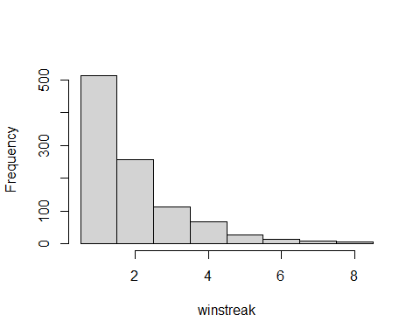

### Report the following:

* Histogram of the win streak length. Note that this is a discrete distribution so should place histogram bars at discrete values {0, 1, 2, …}. This may be done with the breaks option within hist. If your storage variable is called winstreak:

hist(winstreak, br=seq(min(winstreak)-0.5, max(winstreak+0.5)), main="")

* Average length of the win streak. *1.906*
* Standard deviation of the winning streak lengths. *1.322*
* Compare the empirical average and standard deviation in the previous two bullets to the true values from the Geometric(*p* = 20/38) distribution.

*The empirical average length of the win streak is 1.906, which is close to the true value of 1.9*  *The empirical standard deviation of the win steak lengths is 1.322, which is close to the true value of 1.307*

* Longest winning streak. *10*

## Task 2: Simulating negative binomial distributions

In this task, we will compare two different algorithms for simulating from a negative binomial distribution.

### Problem (a)

Recall that a negative binomial random variable *NB(r, p)* is the sum of *r Geometric(p)* random variables. Use the algorithm from Task 1 to simulate 1000 *NB(10, 0.6)* random variates.

### Code set-up

Note that we merely need to wrap the core code from Task 1 within a for-loop. Here is the core of the code chunk, where we are thinking of a for-loop over a variable sims to replicate the single negative binomial draw. Note that this code chunk will not run since the for-loop over sims is not coded, thus the eval=FALSE option. **Note that this code has the eval=FALSE option just to present the code without output. Your code will not use this option.**

r = 10   
p = 0.6   
nbvar1 = numeric(1000)  
nbvar2 = numeric(10)  
x = proc.time()  
for(sims in 1:1000){  
 for(nbsims in 1:r){  
 # for-loop allows us to simulate until r successes;  
 # in this problem, r=10 and p=0.6  
 tossnum = 0   
 success = 0   
 while(success == 0){  
 success = (runif(1)<p)  
 tossnum = tossnum + 1   
 }  
 nbvar1[sims] = nbvar1[sims] + tossnum  
 nbvar2[r] = nbvar1[sims]  
 }  
 nbvar1[sims] = mean(nbvar2)  
   
}  
timer = proc.time()-x  
algtime = timer[3]  
algtime

## elapsed   
## 0.08

mean(nbvar1)

## [1] 1.6751

sd(nbvar1)

## [1] 0.3325065

hist(nbvar1, main="Task 2a: Histogram of NB(10,0.6)", xlab="Negative Binomial Variates")

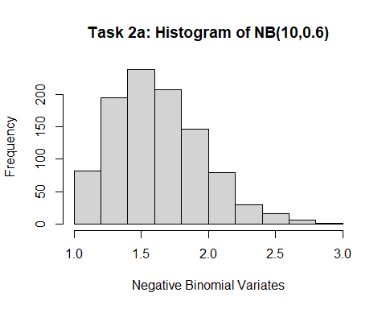

### Problem (b)

The negative binomial pmf induces the following recursion relation. If $X∼B\left(r, p\right)$, then

$$P\left(X=i+1\right)=\frac{i\left(1−p\right)}{\left(i+1−r\right)}⋅P\left(X=i\right).$$

Use this recursion relation to generate 1000 $NB\left(10, 0.6\right)$ random variates.

### Code set-up

Below is binomial.R, the binomial simulator used in the video lectures and found also on the class Blackboard site.

simnum = 1000  
p = 0.6; r = 10 # for point of comparison with the negative binomial, we will use r here  
y=0  
x = proc.time()  
for(sims in 1:simnum){  
 pmf=p^r; cdf=pmf; # pmf and cdf  
 j=r;  
 u=runif(1) # uniform random variate  
 # find Binomial variate  
 while(u >= cdf){  
 #pmf=((r-j)/(j+1))*(p/(1-p))*pmf # recursion relation  
 pmf = (j * (1 - p)/(j + 1 - r)) * pmf  
 cdf=cdf + pmf # compute cdf  
 j=j+1  
 }  
 y[sims]=j/10  
}  
timer = proc.time()-x  
algtime = timer[3]  
algtime

## elapsed   
## 0.01

mean(y)

## [1] 1.6649

sd(y)

## [1] 0.3270244

hist(y, main="Task 2b: Histogram of NB(10,0.6)", xlab="Negative Binomial Variates")

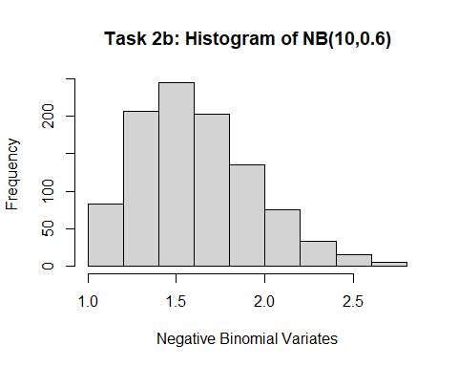

This binomial simulator may be applied directly after changing just three lines:

$j=r$

* the recursion relation formula
* pmf = p^r

### Report the following for each of the simulations in problems (a) and (b)

* Histogram of the variates
* Mean and standard deviation of the simulated variates
* Run time: compare computing speed between the two algorithms. In R, can wrap your algorithm or sequence of operations as follows to time your code.

x = proc.time()  
# [the code you want to time here]  
timer = proc.time() - x  
algtime = timer[3] # algtime will store the algorithm run time in seconds

### Questions

* How do the histograms compare?

*The histograms for both simulations should look similar, showing the distribution of the simulated negative binomial random variables. However, the shape of the histograms may vary slightly due to the different simulation methods used.*

* How do the mean and standard deviation from the simulations compare to the true mean and standard deviation of a $NB\left(0.6, 10\right)$ distribution?

*The mean and standard deviation of the geometric simulation is closer to the true values than the binomial simulation.*

* How do the computing times compare? Which algorithm is faster?

*The computing time for each algorithm can be compared by timing each one using the proc.time() function in R. The algorithm with the shorter runtime is faster. The geometric simulation is slower than the binomial simulation*

* “Simulation flops”: Which simulator do you think uses more uniform random numbers (call to the runif() function)? Why?

*The geometric simulator calls the runif() function more as the function is found in a loop within a loop, while the binomial simulator has that same function in only one loop.*