Term Project Proposal
Course: Data Science Date: 2026-05-03
Team: (team name) Members: (member list)

1. Selected Dataset
Dataset: Credit Score Classification (Kaggle)
Source: https://www.kaggle.com/datasets/parisrohan/credit-score-classification
Files: train.csv (100,000 rows x 28 columns), test.csv (50,000 rows x 27 columns).

1.1 Rationale for Dataset Selection
This dataset provides a rich set of 28 features and frames the problem as a 3-class credit-rating prediction (Good, Standard, Poor) rather than a simple binary default flag. As a multi-class classification task, it cleanly satisfies the course requirement to apply a classification algorithm.
With 100,000 records, the dataset is large enough to support reliable k-fold cross validation while still being tractable on a typical laptop. It also contains a balanced mix of numerical features (e.g., Age, Annual_Income, Outstanding_Debt) and categorical features (e.g., Occupation, Credit_Mix, Type_of_Loan), which lets us practice both scaling and encoding techniques.
Most importantly, the dataset is heavily polluted with realistic dirty-data patterns: placeholder strings such as "_______", "_", and "!@9#%8"; physically impossible numeric values such as Age = -500 or 8,698; and Annual_Income up to USD 24M. This makes it an excellent fit for demonstrating the data-cleaning and outlier-handling skills emphasized in the course.

1.2 Column Overview (28 features)
Feature | Type | Description
ID | ID | Unique transaction identifier
Customer_ID | ID | Customer identifier (12,500 unique customers)
Month | Categorical | Month of record (January to August)
Name | Text | Customer name
Age | Numerical | Customer age (contains noise such as -500, 8698)
SSN | Text | Social security number
Occupation | Categorical | 16 unique occupations (includes placeholder '_______')
Annual_Income | Numerical | Annual income (stored as object due to '_' suffix)
Monthly_Inhand_Salary | Numerical | Monthly take-home salary
Num_Bank_Accounts | Numerical | Number of bank accounts (extreme outliers up to 1,798)
Num_Credit_Card | Numerical | Number of credit cards held
Interest_Rate | Numerical | Loan interest rate
Num_of_Loan | Numerical | Number of loans (object dtype, contains '_')
Type_of_Loan | Categorical | Comma-separated multi-label of loan types
Delay_from_due_date | Numerical | Average days delayed from due date
Num_of_Delayed_Payment | Numerical | Number of delayed payments (object dtype)
Changed_Credit_Limit | Numerical | Change rate of credit limit
Num_Credit_Inquiries | Numerical | Number of credit inquiries
Credit_Mix | Categorical | Good / Standard / Bad / '_' (placeholder)
Outstanding_Debt | Numerical | Outstanding debt amount
Credit_Utilization_Ratio | Numerical | Credit utilization ratio (%)
Credit_History_Age | Text | Credit history age in 'X Years and Y Months' format
Payment_of_Min_Amount | Categorical | Yes / No / NM (Not Mentioned)
Total_EMI_per_month | Numerical | Total monthly EMI amount
Amount_invested_monthly | Numerical | Monthly invested amount
Payment_Behaviour | Categorical | 7 categories including noise '!@9#%8'
Monthly_Balance | Numerical | Monthly balance (object dtype, extreme outliers)
Credit_Score | Target | Good / Standard / Poor (multi-class target)

2. Project Description

2.1 Project Goals
The ultimate goal of this project is to build a multi-class classification model that takes a customer's 28 personal and financial-behavior features as input and accurately predicts the customer's credit score (Good / Standard / Poor). Through this, we aim to design, implement, and validate an end-to-end data science pipeline that contributes to credit-evaluation automation in the financial industry.
2.1.1 Business Goals
- Automate credit assessment: provide an objective credit-rating prediction model that financial institutions can leverage in loan approval, credit-limit increases, and interest-rate decisions.
- Ensure decision consistency: complement subjective human judgment so that customers with identical profiles receive a consistent rating.
- Mitigate non-performing loan risk: identify Poor-grade customers in advance so that risk can be controlled at the loan-approval stage.
2.1.2 Technical Goals
- Use Decision Tree, the model taught in class, as the baseline, then extend to Random Forest and Gradient Boosting; compare performance and derive the best combination.
- Achieve Macro-F1 >= 0.75 (a substantial lift over the 0.33 random baseline for a 3-class problem).
- Secure per-class Recall >= 0.70 under Stratified k-fold cross validation (k = 5).
- Compare 3 scaling methods (Standard / MinMax / Robust) x 3 encoding methods (OneHot / Ordinal / Target) to select the best preprocessing pipeline.
2.1.3 Learning Goals
- Build the EDA and data-cleaning skills required to detect and clean industry-grade dirty data (placeholders, negative ages, extreme outliers).
- Integrate the classification, regression, and clustering algorithms and evaluation techniques learned in class into a single project.
- Produce reusable open-source code organized under a single top-level function and publish it on GitHub.

2.2 Business Objective in Detail
Financial institutions must assess customer credit accurately to automate key decisions such as loan limits, interest rates, and credit-limit upgrades. A misclassification can simultaneously inflate non-performing loans (Type II error: Poor mislabeled as Good) and lose business opportunities (Type I error: Good mislabeled as Poor). Therefore this project targets a macro-F1-centric classification model that balances both errors, thereby improving both efficiency and consistency of the credit-evaluation process.

2.3 Target Tasks
- Primary task: 3-class credit-score classification using all 28 features.
- Secondary task (choose one): regression on Monthly_Balance, or clustering of customers based on Payment_Behaviour.
- Evaluation: Stratified k-fold cross validation with Accuracy, Macro-F1, per-class Recall, and Confusion Matrix analysis.

2.4 Analysis Approach and Workflow
During preprocessing, we will remove placeholder strings ("_", "_______", "!@9#%8"), handle physically impossible outliers (negative ages, 1,798 bank accounts, etc.), and convert object-typed numeric columns to their proper dtype. Within each Customer_ID group we will fill missing values with forward/backward fill, and impute the remainder with the median or mode. We will then apply StandardScaler or RobustScaler for scaling and OneHotEncoder/OrdinalEncoder for encoding, and engineer derived features such as Debt-to-Income ratio and average monthly savings.
For modeling, we will start from a Decision Tree baseline (the model taught in class) and progressively expand to Random Forest and Gradient Boosting, comparing them under identical preprocessing conditions. Evaluation uses Stratified k-fold cross validation focused on macro-F1 to account for class imbalance (Standard 53%, Poor 29%, Good 18%), and the best model is tuned with GridSearchCV. As an auxiliary analysis we will additionally fit a regression model on Monthly_Balance or run KMeans clustering on Payment_Behaviour patterns.

3. Statistical Description of the Dataset

3.1 Dataset Overview
- Rows x Columns: 100,000 x 28
- Unique Customers: 12,500 customers x 8 months (January to August) = 100,000 records
- Numerical features: 16 | Categorical features: 9 | ID/Text: 3
- Target: Credit_Score (Good / Standard / Poor) - 3-class

3.2 Target Class Distribution
Credit_Score | Count | Ratio
Standard | 53,174 | 53.17%
Poor | 28,998 | 29.00%
Good | 17,828 | 17.83%
The Standard class accounts for more than half of the records, while the Good class is the smallest, producing a clear class-imbalance pattern. Therefore Macro-F1 and per-class Recall are more appropriate evaluation metrics than plain Accuracy.
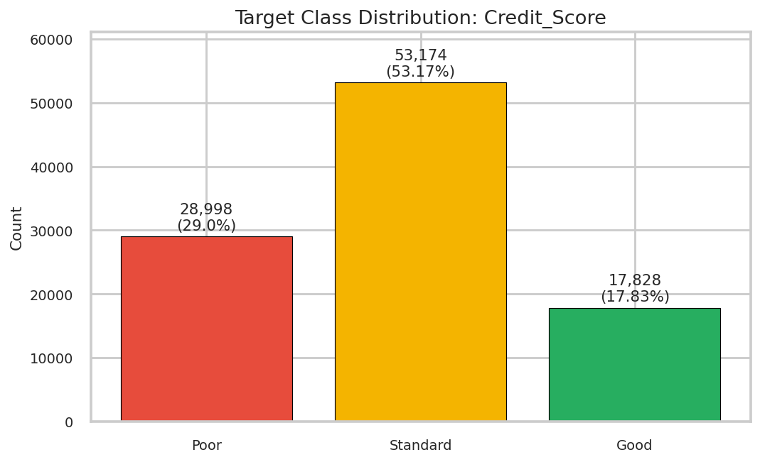
Figure 1. Class distribution of Credit_Score - Standard 53% / Poor 29% / Good 18% (imbalanced).

3.3 Descriptive Statistics for Numeric Features
Feature | Count | Mean | Std | Min | 25% | 50% | 75% | Max
Age | 100,000 | 110.65 | 686.24 | -500.00 | 24.00 | 33.00 | 42.00 | 8,698.00
Annual_Income | 100,000 | 176,415.70 | 1,429,618.05 | 7,005.93 | 19,457.50 | 37,578.61 | 72,790.92 | 24,198,062.00
Monthly_Inhand_Salary | 84,998 | 4,194.17 | 3,183.69 | 303.65 | 1,625.57 | 3,093.74 | 5,957.45 | 15,204.63
Num_Bank_Accounts | 100,000 | 17.09 | 117.40 | -1.00 | 3.00 | 6.00 | 7.00 | 1,798.00
Num_Credit_Card | 100,000 | 22.47 | 129.06 | 0.00 | 4.00 | 5.00 | 7.00 | 1,499.00
Interest_Rate | 100,000 | 72.47 | 466.42 | 1.00 | 8.00 | 13.00 | 20.00 | 5,797.00
Num_of_Loan | 100,000 | 3.53 | 64.50 | -100.00 | 1.00 | 3.00 | 5.00 | 1,496.00
Delay_from_due_date | 100,000 | 21.07 | 14.86 | -5.00 | 10.00 | 18.00 | 28.00 | 67.00
Num_of_Delayed_Payment | 92,998 | 30.34 | 237.00 | -3.00 | 9.00 | 14.00 | 18.00 | 4,397.00
Num_Credit_Inquiries | 98,035 | 27.75 | 194.19 | 0.00 | 3.00 | 6.00 | 9.00 | 2,597.00
Outstanding_Debt | 100,000 | 1,426.22 | 1,155.13 | 0.23 | 566.07 | 1,166.16 | 1,945.96 | 4,998.07
Credit_Utilization_Ratio | 100,000 | 32.29 | 5.12 | 20.00 | 28.05 | 32.31 | 36.50 | 50.00
Total_EMI_per_month | 100,000 | 1,403.12 | 8,306.03 | 0.00 | 30.31 | 69.25 | 161.61 | 82,331.00
Amount_invested_monthly | 95,521 | 637.41 | 2,043.32 | 0.00 | 74.53 | 135.93 | 265.73 | 10,000.00
Age has a minimum of -500 and a maximum of 8,698, both physically impossible. Num_Bank_Accounts reaches 1,798 and Interest_Rate reaches 5,797, indicating a substantial number of severe outliers. The Monthly_Balance column also contains extreme negative values such as -3.33e+26, which are excluded from the table above and will be handled separately during cleaning.

3.4 Missing Values
Column | Missing Count | Missing %
Name | 9,985 | 9.99%
Monthly_Inhand_Salary | 15,002 | 15.00%
Type_of_Loan | 11,408 | 11.41%
Num_of_Delayed_Payment | 7,002 | 7.00%
Num_Credit_Inquiries | 1,965 | 1.97%
Credit_History_Age | 9,030 | 9.03%
Amount_invested_monthly | 4,479 | 4.48%
Monthly_Balance | 1,200 | 1.20%
Eight columns contain missing values, with Monthly_Inhand_Salary (15.0%) and Type_of_Loan (11.4%) showing the highest missing rates. The remaining 20 columns have no formal NaNs, but many fields are filled with placeholder strings such as "_" or "_______". A dedicated dirty-data cleaning step is therefore required before any modeling.

3.5 Major Categorical Variable Distributions
- Month: 8 months from January to August, evenly distributed at 12,500 records each.
- Occupation: 16 levels (15 actual occupations + placeholder '_______' with 7,062 records, 7.06%).
- Credit_Mix: Standard 36,479 / Good 24,337 / Bad 18,989 / '_' (placeholder for missing) 20,195 (20.2%).
- Payment_of_Min_Amount: Yes 52,326 / No 35,667 / NM (Not Mentioned) 12,007.
- Payment_Behaviour: 6 valid categories plus a noise value '!@9#%8' appearing 7,600 times.
- Type_of_Loan: 6,260 unique combination values (multi-label form, including 11,408 missing) - separate encoding (e.g., MultiLabelBinarizer) is required.

4. EDA Visualizations
All visualizations below are based on data after dirty-data cleaning (placeholder removal, domain-based outlier cutoffs, and 0.5%-99.5% percentile trimming). Refer to the attached eda_visualizations.py for the detailed cleaning code.

4.1 Histograms of Numeric Features
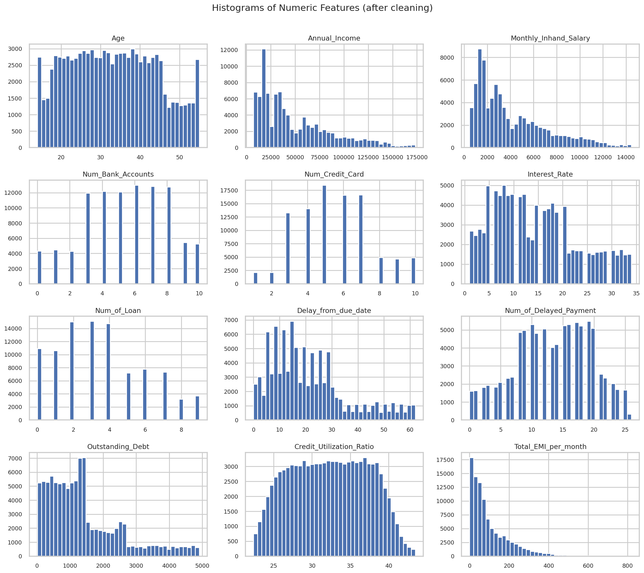
Figure 2. Distributions of 12 key numeric features. Annual_Income, Outstanding_Debt, and Total_EMI_per_month show a clear right-skewed long tail, while Credit_Utilization_Ratio is closer to a normal distribution.

4.2 Outlier Comparison: Boxplot Before vs After
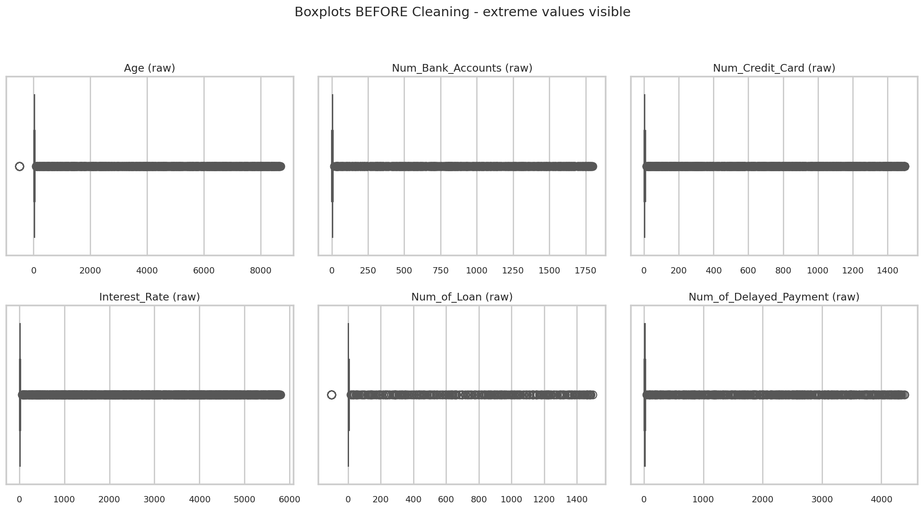
Figure 3. Boxplots before cleaning - thousands-magnitude impossible outliers are visible in Age, Num_Bank_Accounts, Interest_Rate, etc. The IQR boxes are compressed to invisible widths because the extreme values dominate the x-axis scale (e.g., Age max = 8,698 vs median 33; Interest_Rate max = 5,797% vs median 13%).
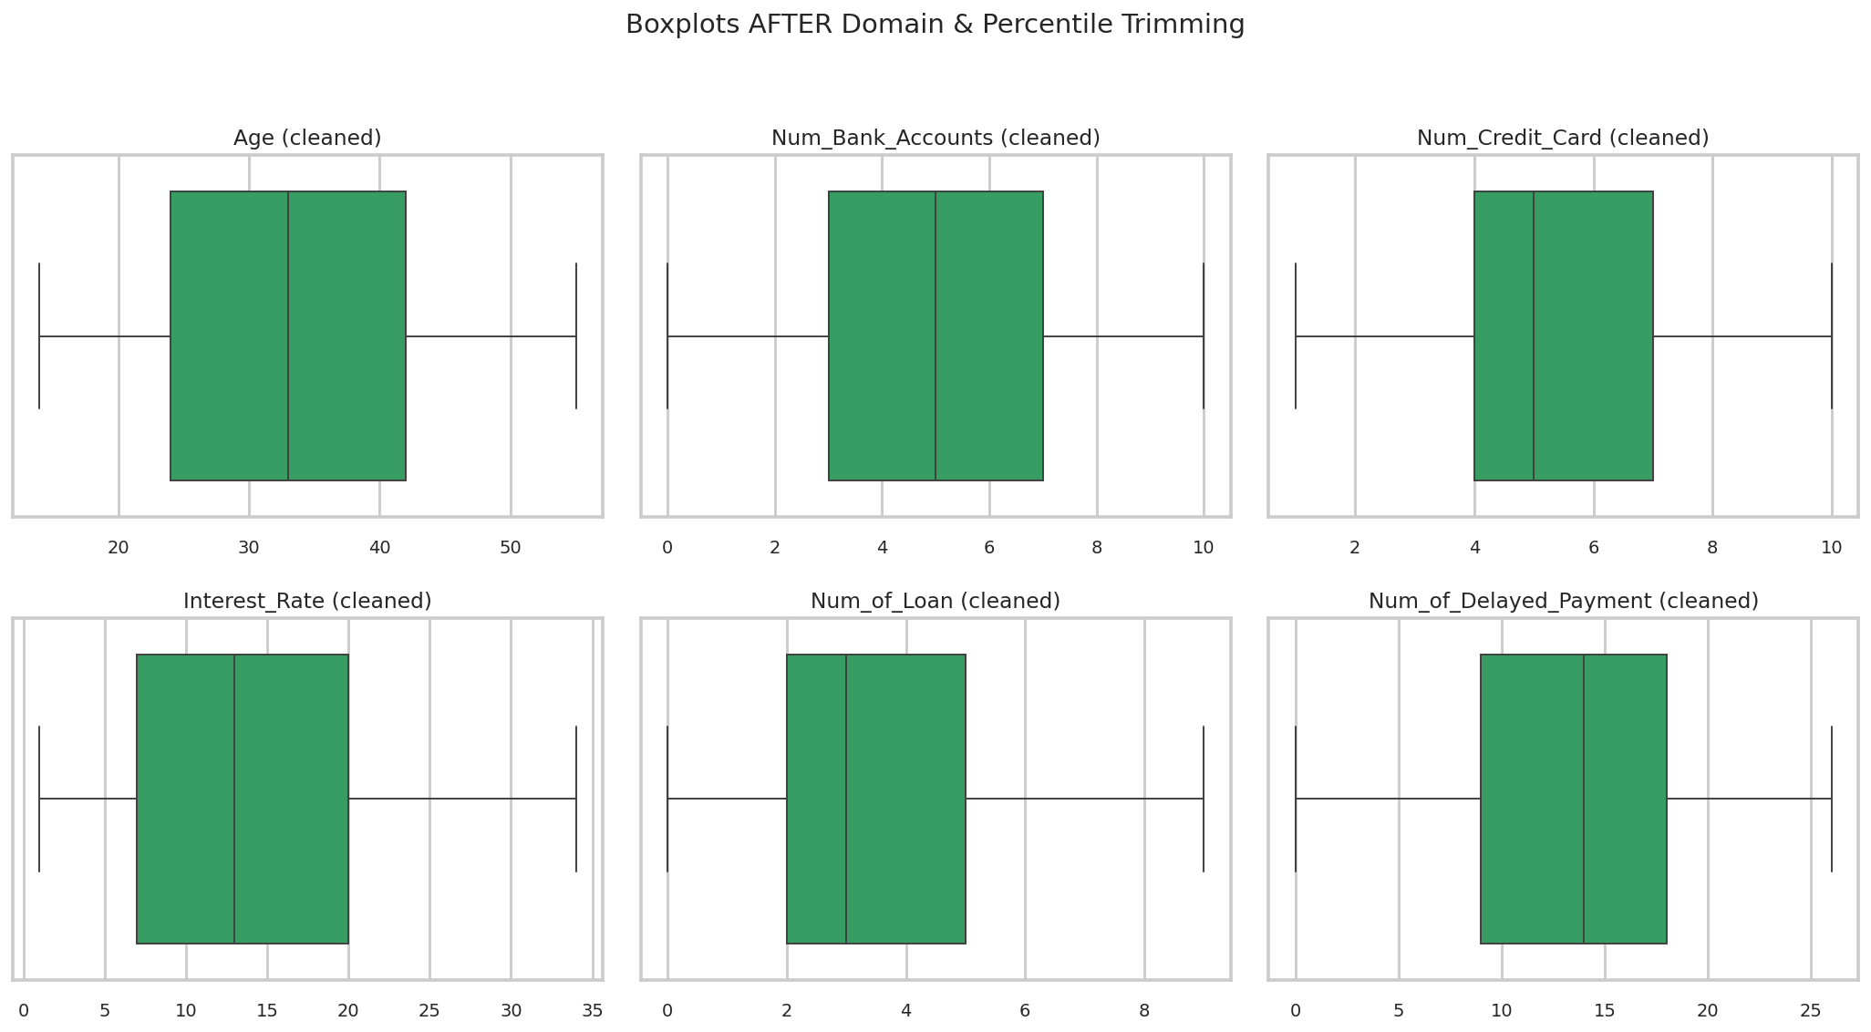
Figure 4. Boxplots after applying domain cutoffs and percentile trimming - distributions fall back to reasonable ranges and the IQR boxes become readable.

4.3 Correlation Between Variables
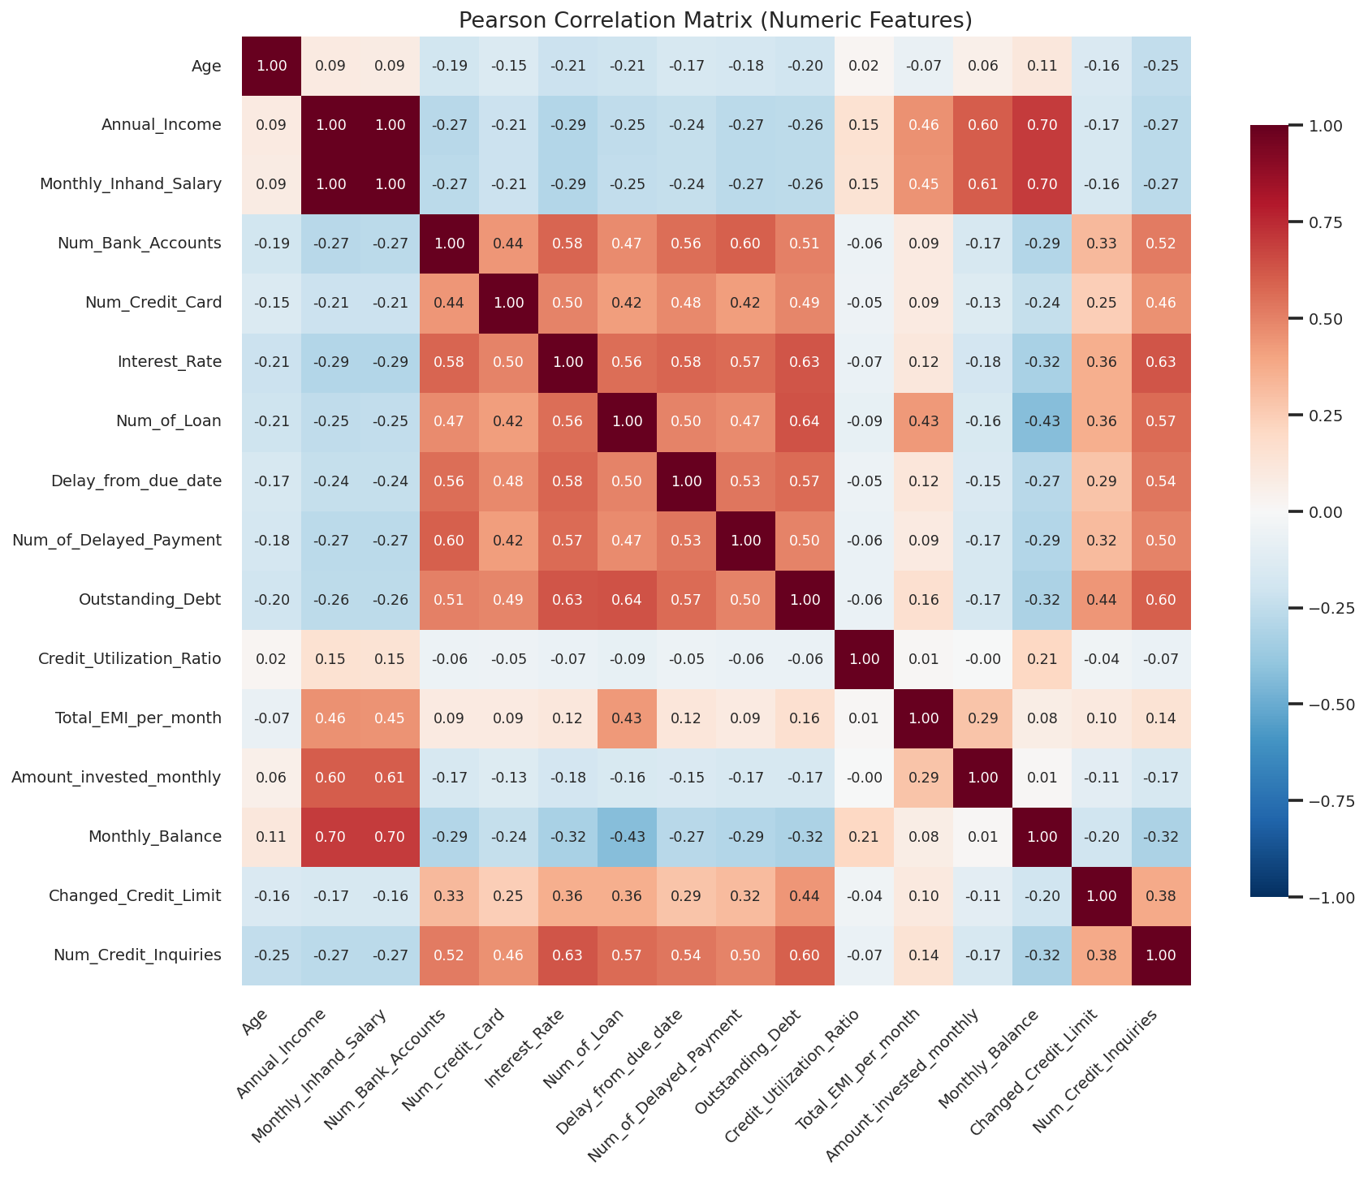
Figure 5. Pearson correlation matrix. A very strong positive correlation (0.99) is observed between Annual_Income and Monthly_Inhand_Salary, with notable patterns such as Outstanding_Debt vs Delay_from_due_date (0.51) and Num_of_Loan vs Num_of_Delayed_Payment (0.52).

4.4 Categorical Variable Distributions
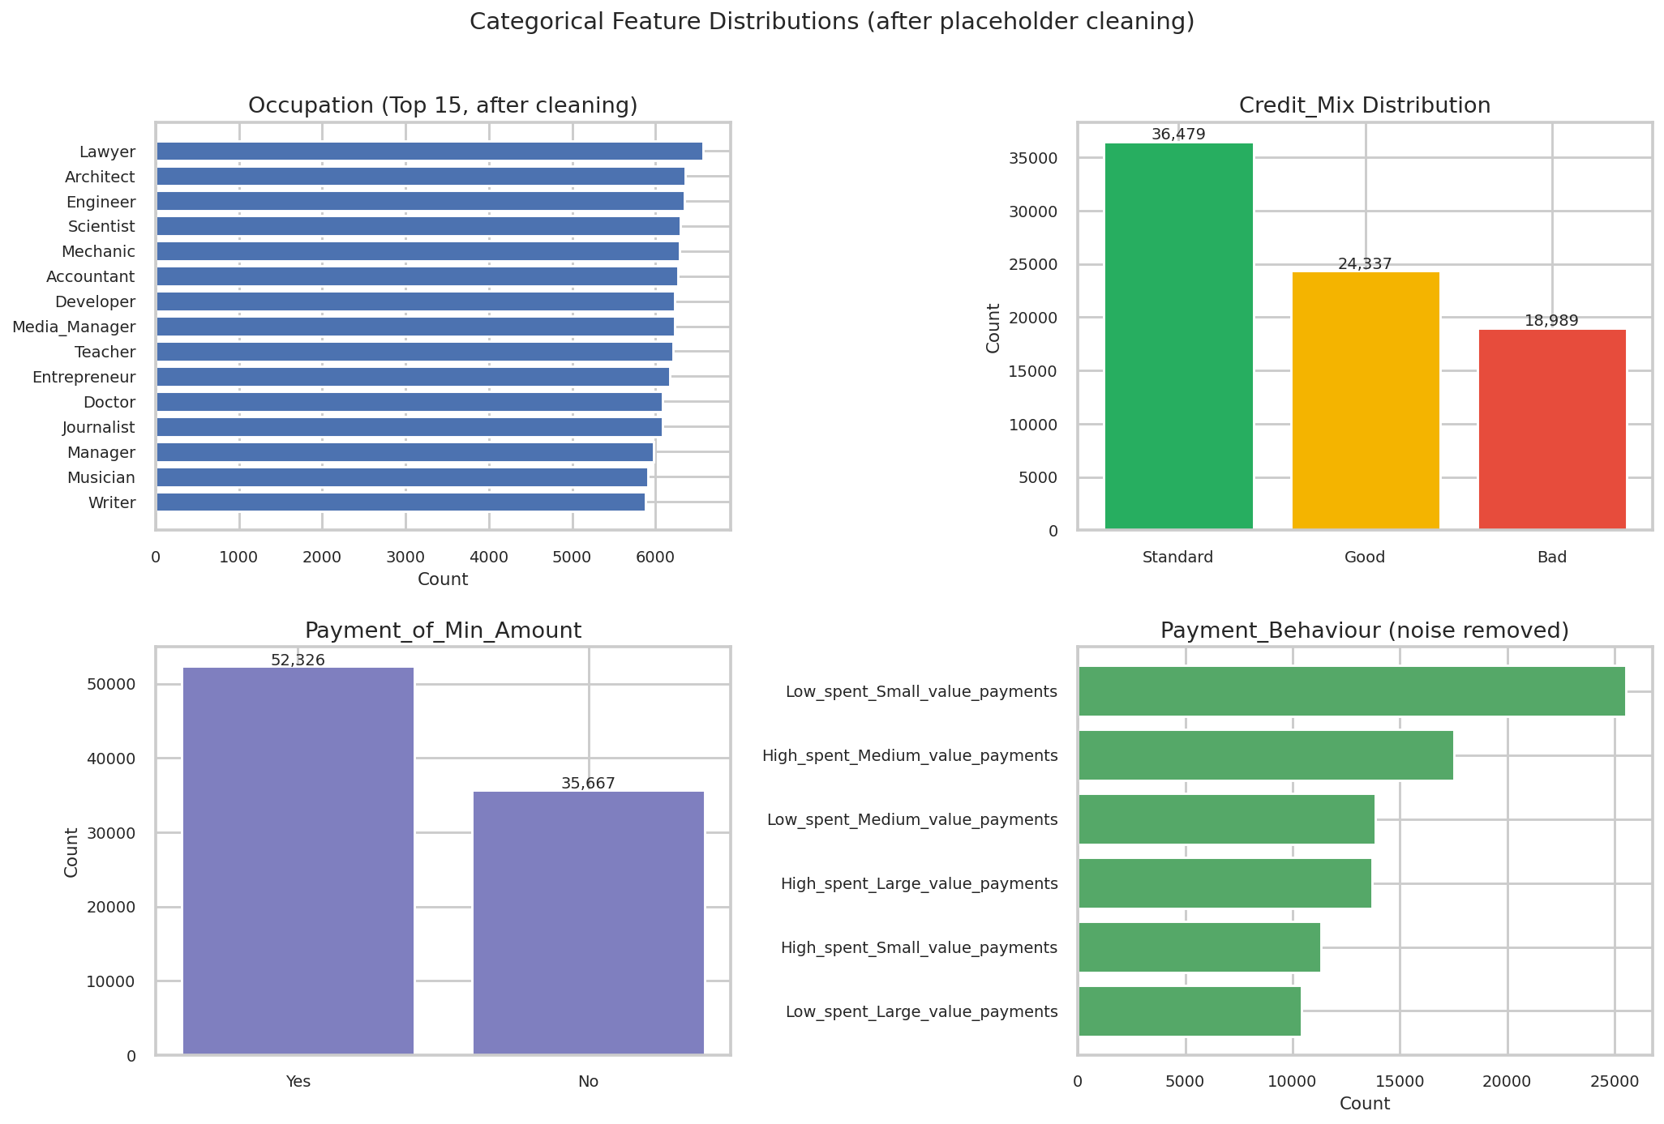
Figure 6. Distributions of major categorical variables (after placeholder/noise removal). Occupation shows a roughly uniform spread across 15 jobs, and Credit_Mix is dominated by Standard followed by Good and Bad.

4.5 Key Variables by Target Class
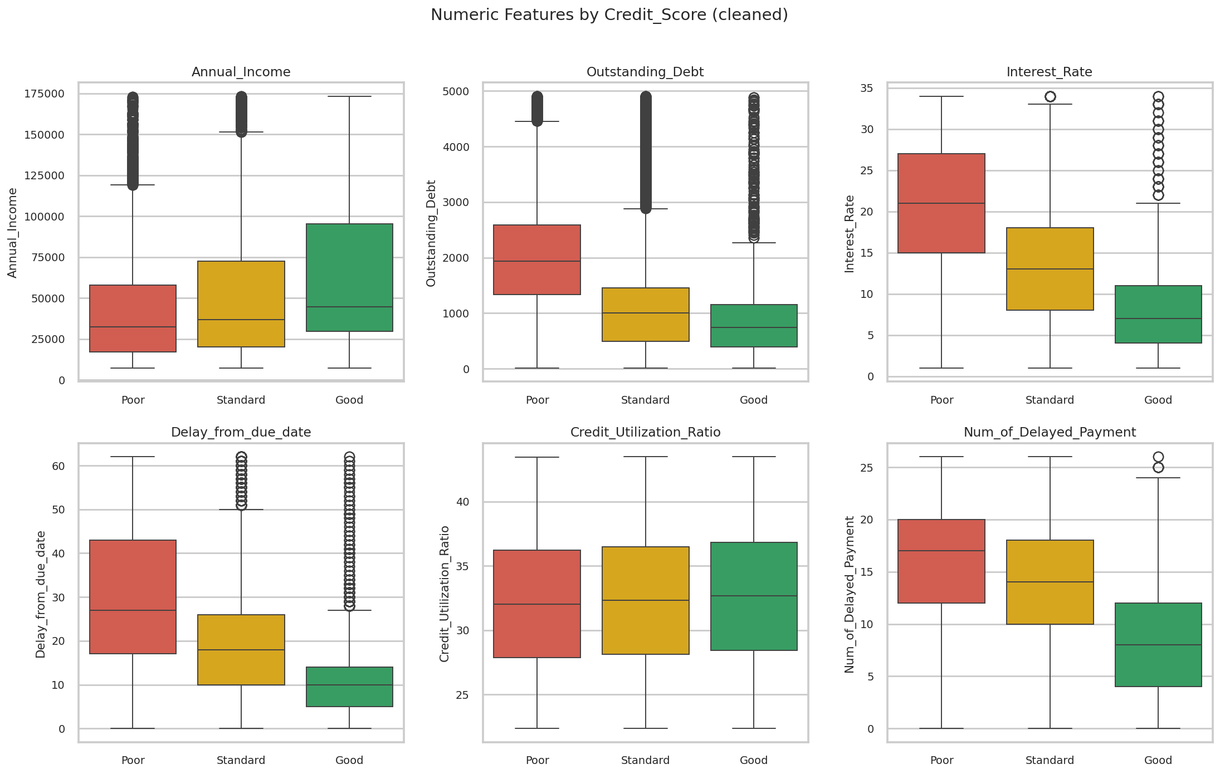
Figure 7. Boxplots of six key variables grouped by Credit_Score (Poor / Standard / Good). Clear class separation is visible in Outstanding_Debt, Interest_Rate, Delay_from_due_date, and Num_of_Delayed_Payment, indicating these are strong signals for classification.

4.6 Visualization Summary Insights
- Target imbalance: Standard:Poor:Good is approximately 53:29:18 - justifies Stratified k-fold and the use of Macro-F1.
- Strongly correlated pairs: Annual_Income vs Monthly_Inhand_Salary (0.99) and Outstanding_Debt vs Delay_from_due_date (0.51) - multicollinearity must be checked.
- Key signal variables: Outstanding_Debt, Interest_Rate, Delay_from_due_date, and Num_of_Delayed_Payment show clear distributional separation across classes.
- Cleaning is essential: raw boxplots reveal obvious garbage values such as Age up to 8,698, Num_Bank_Accounts up to 1,798, and Interest_Rate up to 5,797, motivating the two-stage strategy of domain cutoffs followed by percentile trimming.

5. Anticipated Challenges
- Cleaning cost of converting a high proportion of placeholders and noise values into proper missing values or imputed values.
- Per-customer time-series structure (8 months per Customer_ID) requires a group-aware missing-value imputation strategy.
- Efficient encoding of the multi-label Type_of_Loan column (e.g., MultiLabelBinarizer).
- Handling class imbalance (class_weight, SMOTE) and selecting appropriate evaluation metrics.

