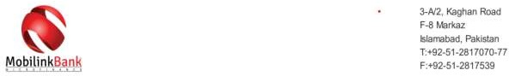

Date:19th-Feb-2025

No Objection Certificate

This is to certify that we have received all amounts due to Mr. /Mrs. ZARAK ABID/ bearing CNIC N0 35202- 7957748-1 against his/her loan facility (the, “Facility”) amounting to Rs. 30000/- availed from Mobilink Microfinance Bank Limited (the “Bank”) under loan account number. LD8340570911733675684546 as of this letter date.

This certificate is being issued (the, “No Objection Certificate”) as a clearance from the Bank that there is no outstanding liability pending with Mr. ZARAK ABID against the above mentioned loan amount.

Please note that history of overdue/write off/late payments and/or any relief availed/reversal of mark- up, if any, will be reported to CIB accordingly and the same will be reflected in credit report for a period of two years.

In case of discrepancy, please contact the Bank.

